下载FFMPEG

将include拷贝到Qt include

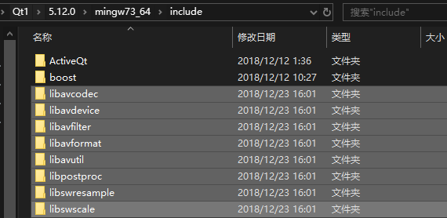

将lib拷贝到Qt lib

msvc：

windows-gcc

将libavcodec.dll.a重命名为libavcodec.a

其余类似

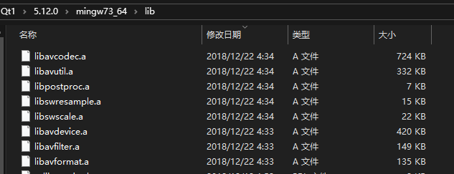

将bin拷贝到Qt bin

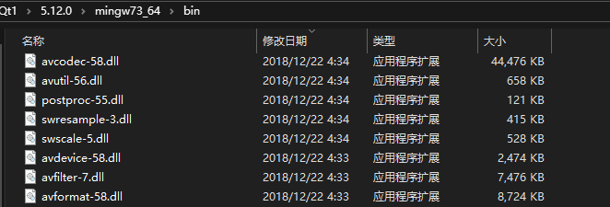

Linux

sudo apt-get install libavcodec-dev  
sudo apt-get install libswscale-dev  
sudo apt-get install libpostproc-dev

sudo apt-get install libavformat-dev

sudo apt-get install libavdevice-dev

sudo apt-get install libavfilter-dev

sudo apt-get install libavresample-dev

sudo apt-get install libavutil-dev