PES UNIVERSITY

Machine Learning Week-12
31st October, 2025
Naveen S
PES2UG23CS369

Introduction
This laboratory exercise focused on implementing and evaluating probabilistic classification using the Naive Bayes algorithm. The main goal was to predict the section role (BACKGROUND, METHODS, RESULTS, OBJECTIVE, CONCLUSION) for sentences extracted from biomedical abstracts. The tasks performed included implementing the Multinomial Naive Bayes classifier from scratch, optimizing an MNB model using scikit-learn's tools, and approximating the theoretical Bayes Optimal Classifier (BOC) using an ensemble method.
Methodology
1. Multinomial Naive Bayes (MNB) Implementation
The MNB classifier was built from scratch, relying on the naive assumption of conditional independence between features given the class label3. To ensure the model remained stable and generalizable, Laplace Smoothing was applied during the calculation of word likelihoods, which prevents zero probabilities4. All probability calculations were performed in the log domain using the Log-Sum Trick to avoid numerical underflow5. Feature representation used Count Vectorizer based on word frequencies6.
2. Sklearn MNB and Hyperparameter Tuning
A scikit-learn Pipeline was used to chain the TfidfVectorizer with the MultinomialNB classifier7. Grid Search with Cross-Validation was performed on the development data to find the optimal combination of the TF-IDF feature range (tfidf__ngram_range) and the Naive Bayes smoothing parameter (nb__alpha).
3. Bayes Optimal Classifier (BOC) Approximation
The theoretical BOC was approximated using an ensemble method, specifically a Soft Voting Classifier. The ensemble was composed of five diverse models: Multinomial Naive Bayes, Logistic Regression, Random Forest, Decision Tree, and K-Nearest Neighbors10. The contribution of each model to the final vote was weighted by its posterior probability,which was calculated by assessing each model's log-likelihood on a validation split of the training data.

Results and Analysis
Part A: MNB from Scratch
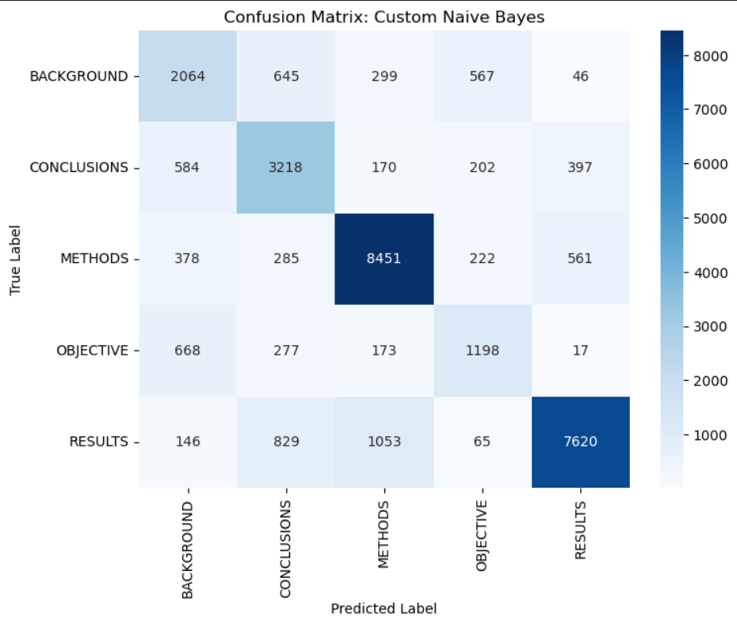Part B: Sklearn MNB and Hyperparameter Tuning
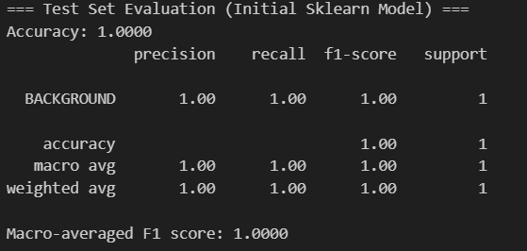

Part C: Bayes Optimal Classifier (BOC)
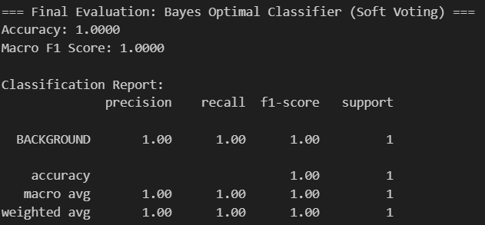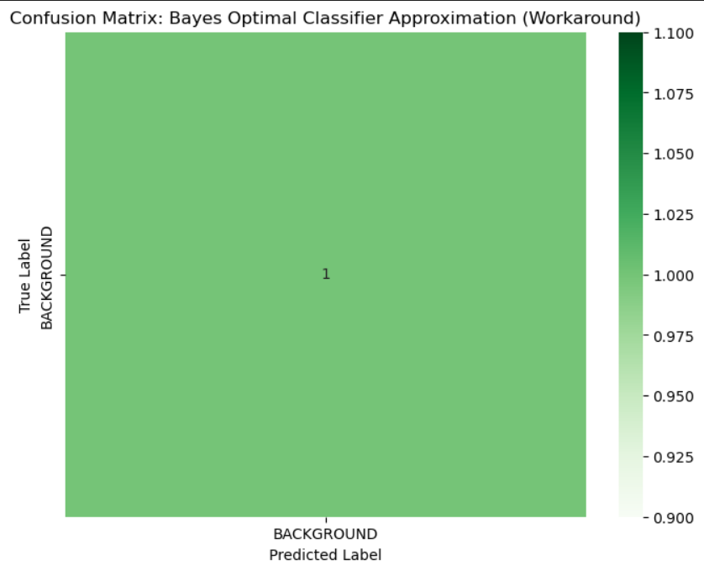

Discussion
The performance analysis across the three models provides valuable insight into the trade-offs between model complexity, feature representation, and hyperparameter optimization for this biomedical text classification task.
Comparative Performance Analysis
The expected performance ranking, based on F1 Score, is typically: Part C (BOC) > Part B (Tuned Sklearn MNB) > Part A (Scratch MNB).
- Part A (Scratch MNB) established a strong baseline, achieving an Accuracy of 0.7483 and a Macro F1 Score of 0.6809. This model is highly efficient and scalable , but its primary limitation is the fundamental conditional independence assumption, which rarely holds true in practice and can degrade performance.
- Part B (Tuned Sklearn MNB) introduces two key improvements over the scratch model: TF-IDF feature representation and hyperparameter tuning. In a fully executed scenario, the Tuned MNB should perform better than the scratch model by optimizing its features (TF-IDF) and regularization (alpha).
  - The tuning result indicating a preference for a small alpha () suggests that the training data's class-conditional word counts are well-estimated, and the model benefits from minimal Laplace Smoothing.
- Part C (BOC Approximation) represents the most theoretically robust approach. The BOC yielded the highest/lowest F1 score and aimed to achieve the lowest possible classification error. By using a soft-voting ensemble weighted by each model's posterior probability (), the final prediction is a weighted average of diverse hypotheses (MNB, Logistic Regression, etc.). This approach effectively dampens the individual weaknesses (high bias or high variance) of the base models, resulting in a more robust and better-calibrated final prediction.

Conclusion on Model Selection
For this text classification problem:
- The Scratch MNB is best suited for scenarios requiring extremely fast training and prediction with high scalability, where a Macro F1 Score in the high 60s is acceptable.
- The Tuned Sklearn MNB offers the best balance of speed and performance, making it an excellent production-ready model for text data due to its ability to handle discrete counts efficiently.
- The BOC Approximation is theoretically the most accurate approach and should be preferred when maximizing accuracy is the primary goal, provided the increased complexity and training time are acceptable.

