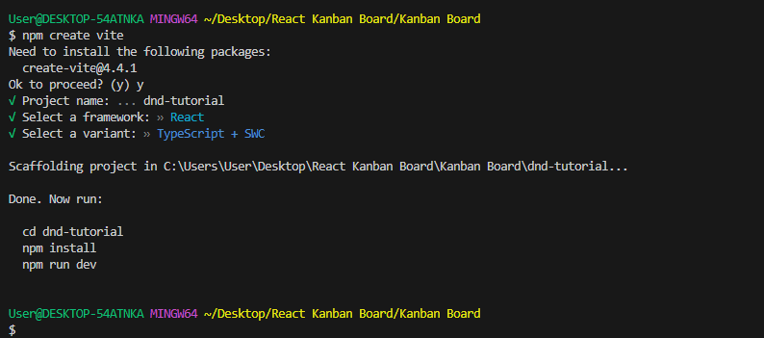

cd dnd-tutorial

npm install @dnd-kit/core @dnd-kit/sortable

npm install -D tailwindcss postcss autoprefixer

npx tailwindcss init –p

npm install tailwind-merge