BOM
Reference | Value | Manufacturer No | Qty
C1,C9 | 22n | K223K15X7RF5UH5 | 2
C2 | 1n | K102J15C0GF53L2 | 1
C4 | 100p | K101J15C0GF53L2 | 1
C5 | 2.2u | 50ML2R2MEFC4X5 | 1
C6,C7 | 4.7u | 50MS54R7M0557 | 2
C8 | 3.3n | MCRR50332X7RK0100 | 1
C10,C13,C19 | 1u | MCGPR50V105M5X11 | 3
C11 | 100u | 25YXJ100M5X11 | 1
C12 | 0.1u | K104K15X7RF53L2 | 1
C14 | 10u | MCGPR25V106M5X11 | 1
C15 | 22u | MCGPR25V226M5X11 | 1
C16 | 68p | K680J15C0GF53L2 | 1
C17 | 47p | K470J15C0GF53L2 | 1
C18, C21 | 470n | MCRR50474Z5UM0050 | 2
C20 | 220n | K224K20X7RF53L2 | 1
C22 | 33p | K330J15C0GF53L2 | 1
D1,D2 | 1N914 | 1N914 | 2
D3 | 1N4002 | 1N4002G | 1
D4,D5,D6 | Red | MP006838 | 3
D7,D8 | BAT41 | BAT41 | 2
J1,J2 | AudioJack2 | NYS229 | 2
J6 | Barrel_Jack | PPW01004 | 1
Q1 | J111 | J111 | 1
R1,R2,R8,R14,R18 | 1M | MF12 1M | 5
R3,R6 | 1K | MF50 1K | 2
R4,R10 | 47Ω | MF50 47R | 2
R5 | 560Ω | MF50 560R | 1
R7 | 1.5K | MCF 0.5W 1K5 | 1
R9 | 10K | MF50 10K | 1
R11,R12 | 100K | MF50 100K | 2
R13 | 2.2k | MF50 2K2 | 1
R15,R16,R17 | 22k | MF50 22K | 3
RV1-GAIN1,RV2-FILTER1 | B100K | RD901F-40-15K-B100K | 2
RV3-VOL1 | A100K | RD901F-40-15K-A100K | 1
RV4-BLEND1 | B100K | RD902F-40-15K-B100K | 1
S1 | SWITCH-3PDT |  | 1
SW3 | SW_Rotary4x3 | CK1052 | 1
SW8 | SW_Rotary2x6 | CK1050 | 1
U1 | OP07CP | OP07CP | 1
U2,U3 | TL072ACP | TL072CP | 2
Yellow Enclosure | 1590 | 1590BBYL | 1
Soldering guide
Break off the two sub-boards (2: tone selecta, 3: stompy) from the main board (1: the meat and potatoes). The break-points are labelled on the bottom side of the board.
With reference to the BOM, work through soldering each component. Start with low-profile components (resistors, diodes, capacitors) and work up to high-profile components (potentiometers, rotary switches).
Leave the connections between boards, and with the off-board components (audio and power jacks), they will be added last.

Enclosure guide

Top side
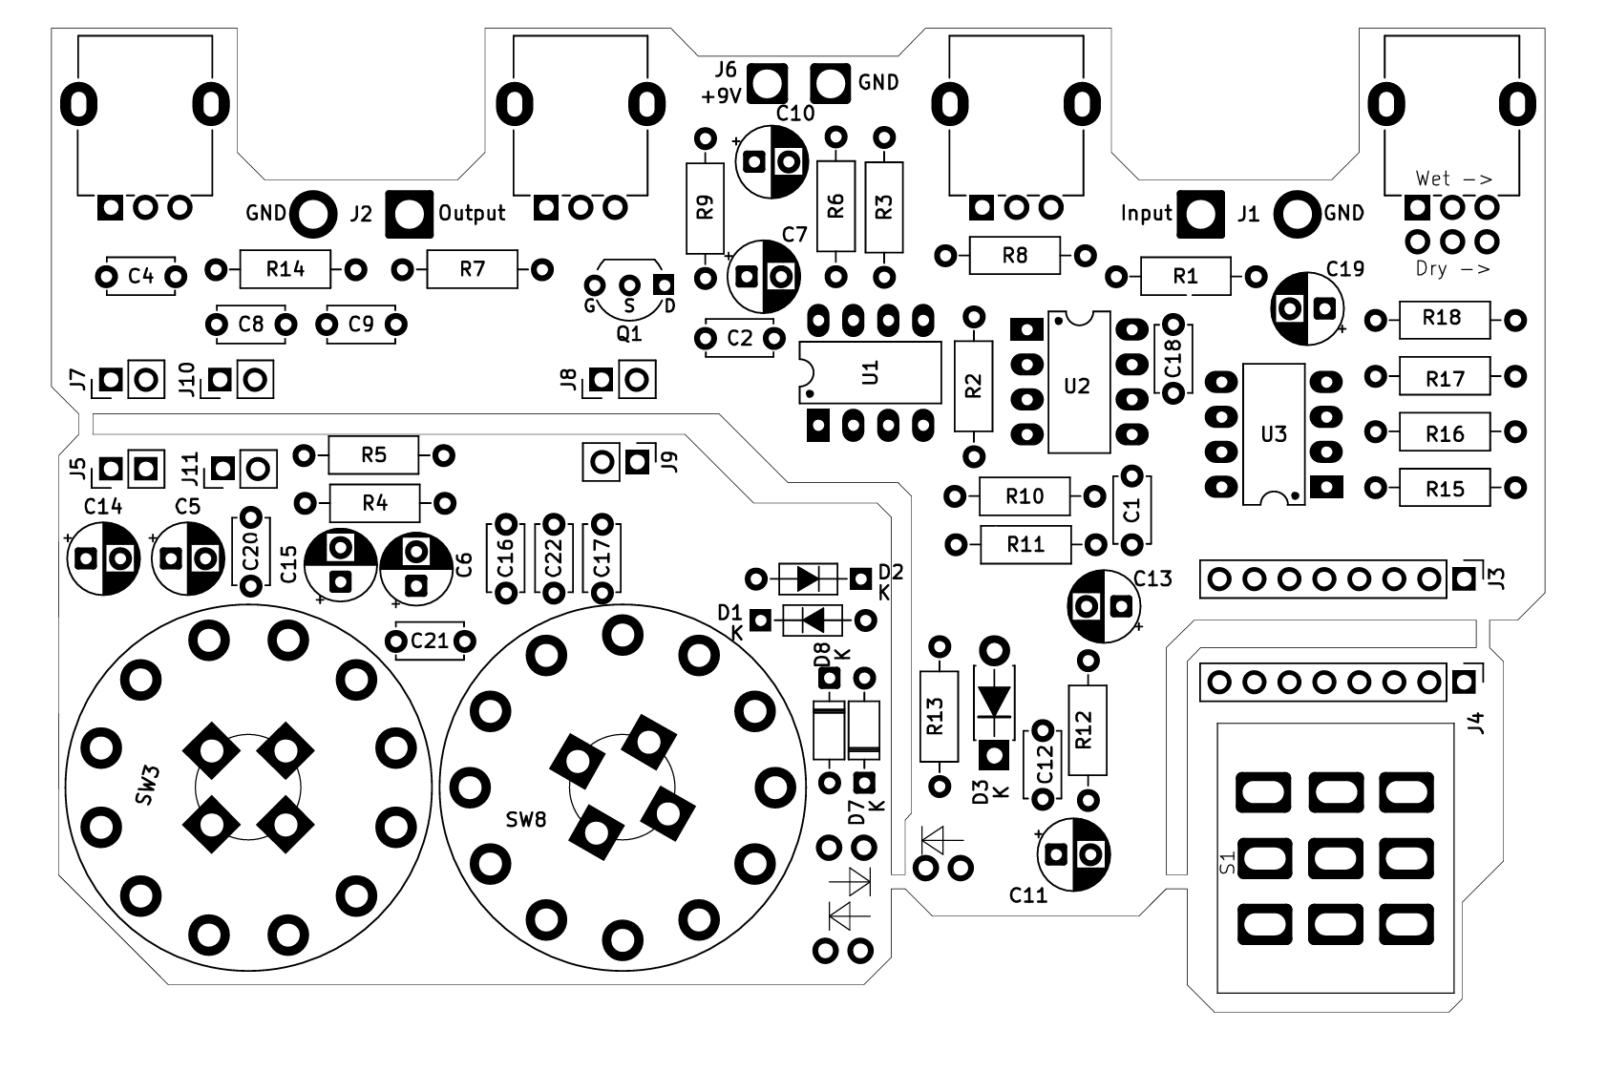

Bottom Side
