New Horizons 3000

Broadcast Software

Documentation

Draft Feb 2026 by Ed lang

Table of Contents
Purpose 3
Roles 3
Security 3
Definitions 3
Systems 3
Overview 4
WWW – HTTPS access for daily content providers and billing administrators. 4
VPN – Gives remote desktop and SSH access. 4
Installation and Configuration 4
Access 5
VPN 6
GUI 7
Messages 8
Reports 9
Inventory 10
Field Definitions 12
Users 13
Field Definitions 15
Schedule 15
Field Definitions 17
Category 17
Field Definitions 18
Hours 18
Days 18
Enc/Dec 18
Settings 18
Password Reset 19
Field Definitions 19
HTTPS 20
SSH 21
Table of Figures
Figure 1: Layered Security 5
Figure 2: Network Overview 6
Index of Tables
Table 1: Inventory Fields 12
Table 2: User Fields 15
Table 3: Schedule Fields 17
Table 4: Category Fields 18
Table 5: Category Definitions 18
Table 6: Reset Definitions 19

Purpose

Provide non technical workflow documentation for end user. Technical documentation can be found at https://github.com/nh3000-org/broadcast/tree/main.

The wiki (https://github.com/nh3000-org/broadcast/wiki) with the source code is designed for system builders and programmers.

The workflow is divided into functional sections defined by user roles.

Roles
Administrator – Full access to system
DJ – Disk Jockey access to specialty categories.
NWS – News Weather Sports access.
Music Director – Web access to manage music/shows playlist’s.
Accounting – Access to historical advertising data and current advertising campaigns.

Security

Security is achieved by limiting access to the system using commonly accepted measures.

Definitions

VPN – Provided by router. User VPN credentials are managed here.
WEB – HTTPS connections through port 3000, managed by Cloudflare tunneling technology

Use VPN to access entire system GUI, Terminal and DJ systems
Use WEB for remote content management and reporting.

Systems

GUI – Accessed through VPN as a remote desktop, GOD mode.
WEB – WWW access using keys, user, and password combinations.
SSH – Terminal access though VPN to provide real time status of system.

Overview

The system is divided into functional categories which provide secure access to the system from:

WWW – HTTPS access for daily content providers and billing administrators.

VPN – Gives remote desktop and SSH access.

The functions and use cases balance security with ease of use.
Cloudflare is used to expose port 3000 to the world without punching a hole in the firewall. It provides 2-factor authentication and proxy services for HTTPS access.

For increased functionality, a VPN is used to tunnel to the server and other network available resources.
The VPN encrypts the traffic and traffic is encrypted within the VPN tunnel.

Installation and Configuration

The system uses NATS for storage, POSTGRESQL for database and GO as the programming language. Hardware requirements include enough space for 3 times the actual space used for music libraries and a high end sound card. The detailed documentation can be found at : https://github.com/nh3000-org/broadcast/wiki

Access

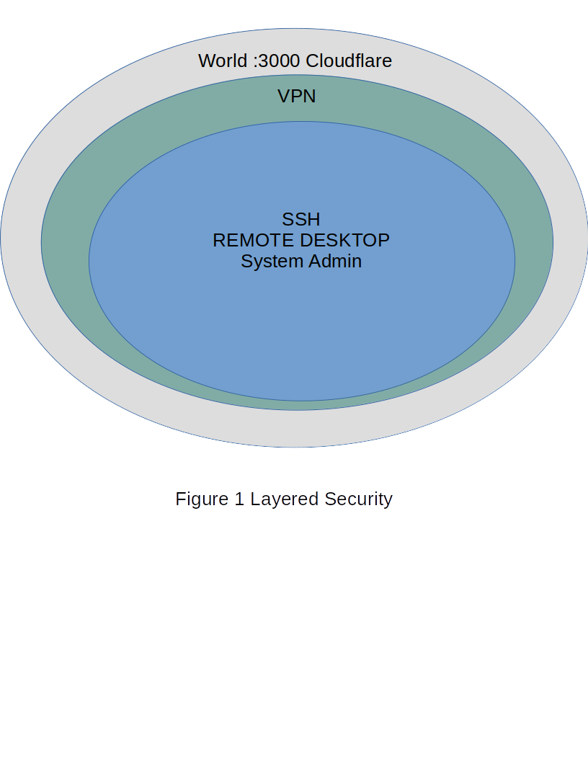Figure 1: Layered Security

VPN

A Virtual Private Network extends a private network to the public. It provides Host-to-Network functions allowing users with login credentials to access a private network located behind a Cable Modem or Wireless Modem. This function is provided a a router that is used to establish connectivity between the local network and edge devices. Users are managed on the router. Services like remote-desktop and SSH are usually done through the VPN. This provides a secure transport layer into the private network. See Figure 1.

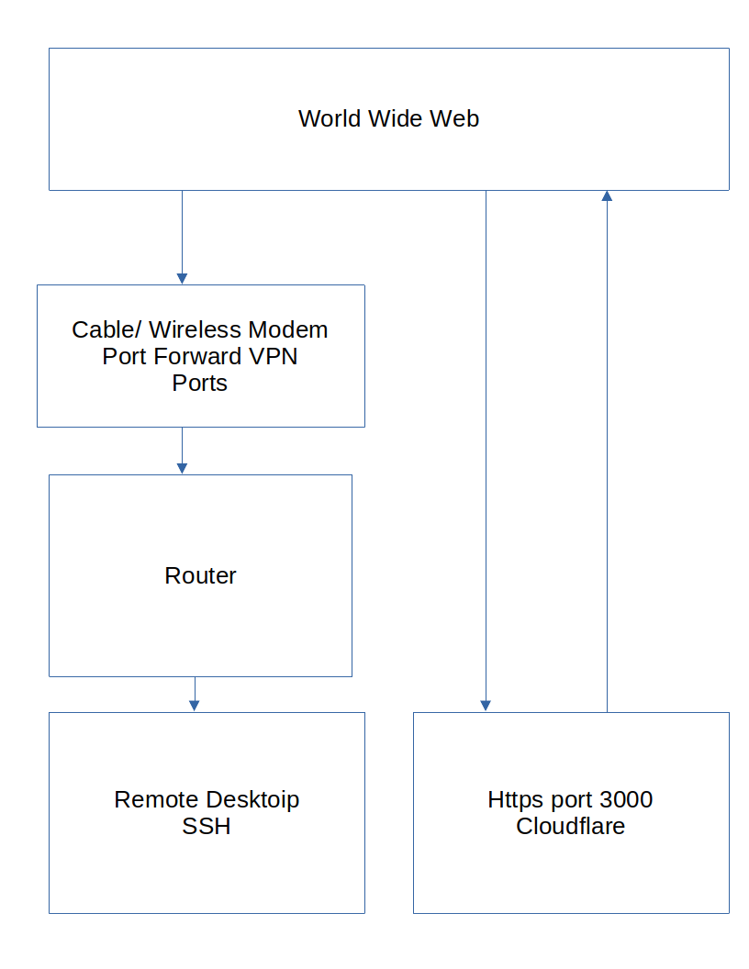Figure 2: Network Overview

GUI

Accessed through the remote-desktop software (no-machine). Provides the Graphical User Interface, DJ Console, and real-time statistics for the system.

On the remote desktop select GUI.
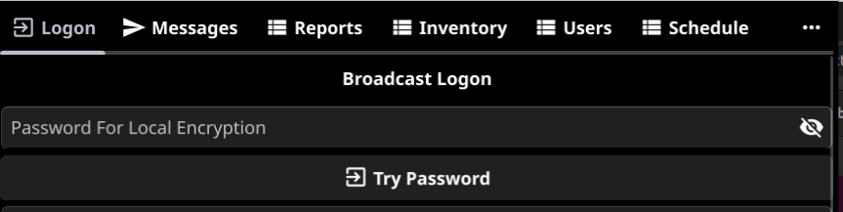
Enter the system password and tap “Try Password”

This will bring up encryption details. User interfaces and other high level data. There is no need to change this, it is presented as information only. If you do change this, the system may fail.

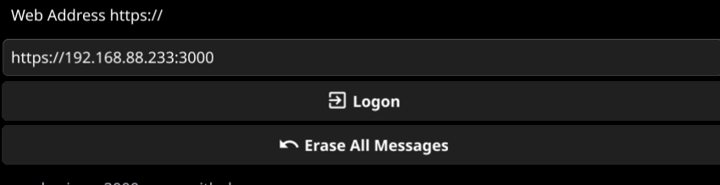
Tap Logon to continue.

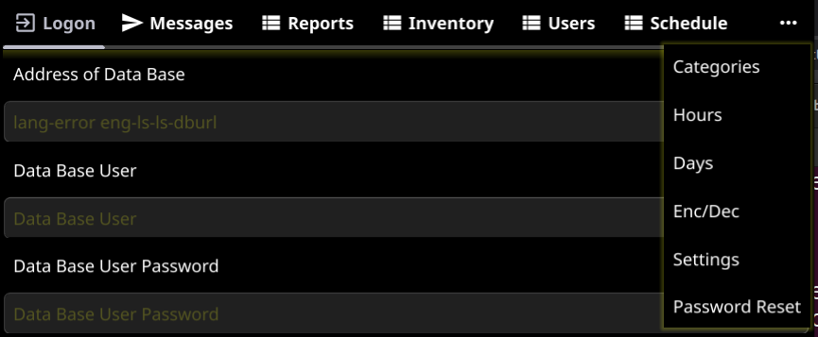
These are the functions available after successful logon.

Messages

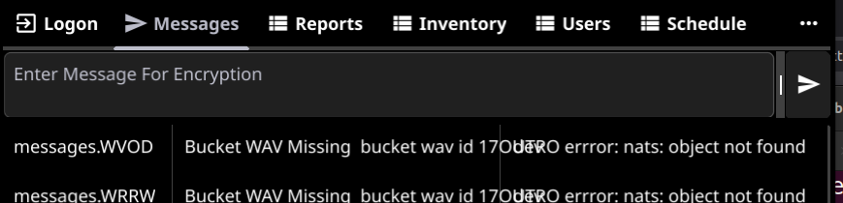
Messages generated from system erros are generated here. Tap on message to see full details.

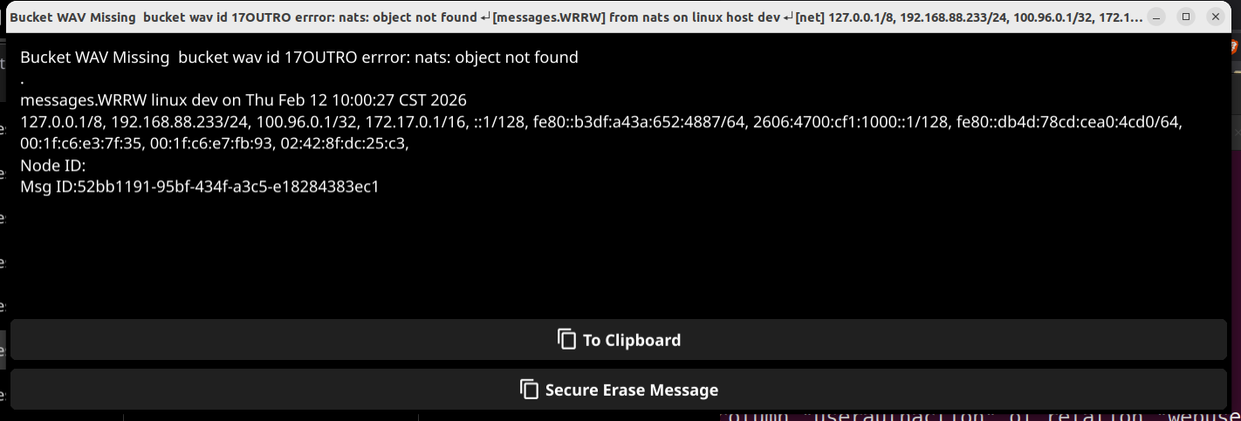

Reports

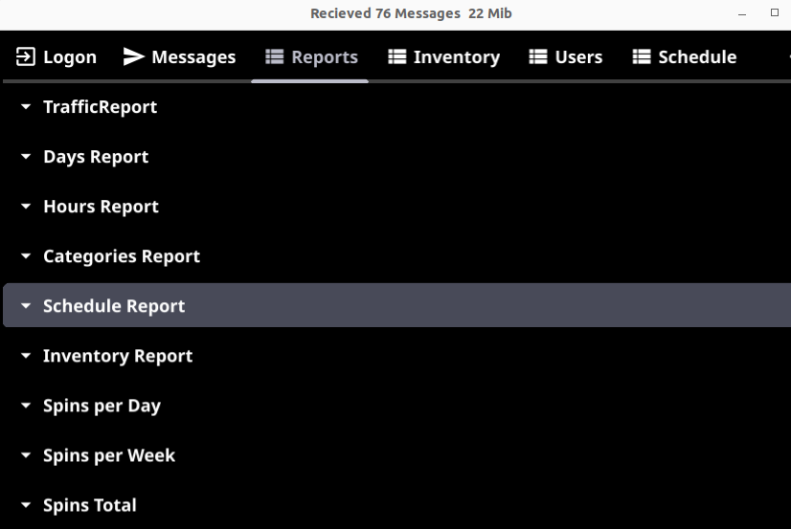
Select6 report, fill in additional filters as required.

Inventory

The content is displayed here sorted by category.
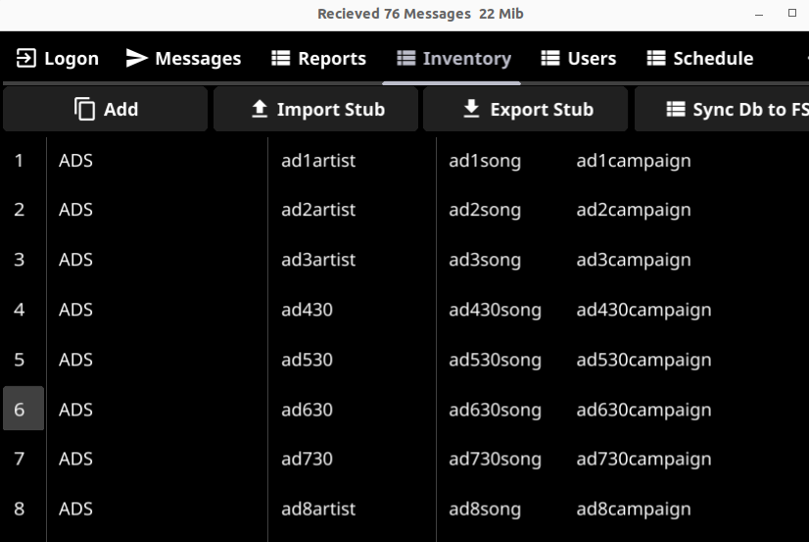
Tap on an item to edit its contents.
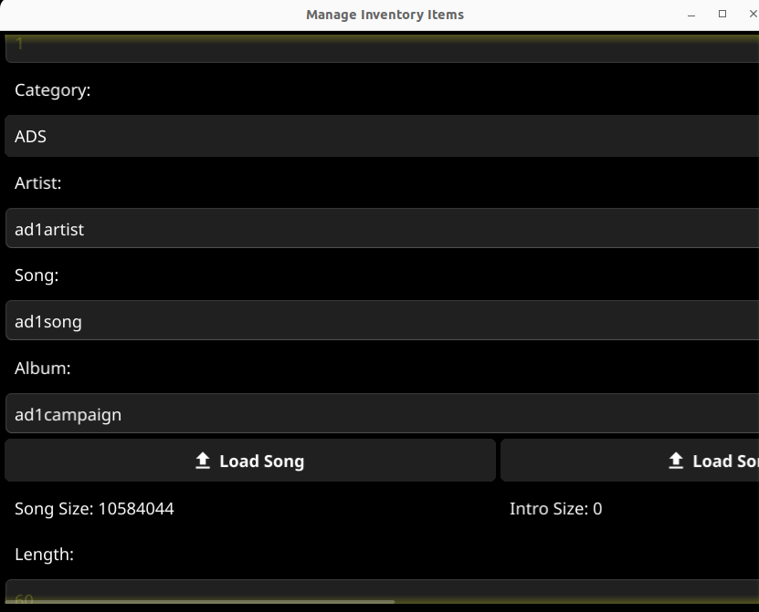
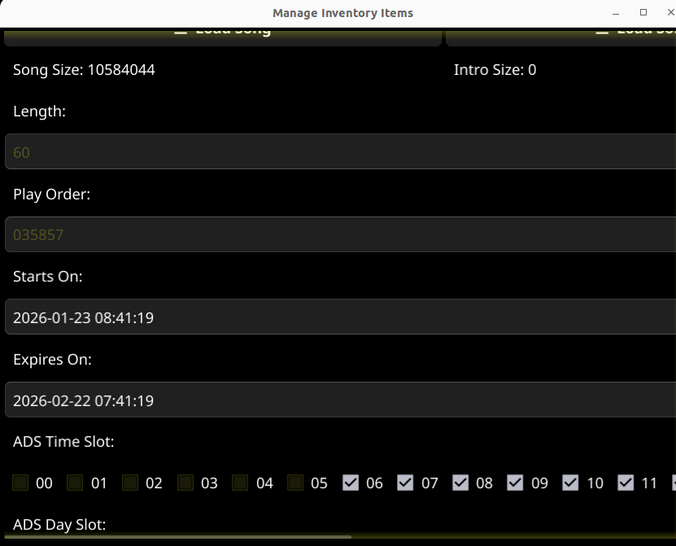
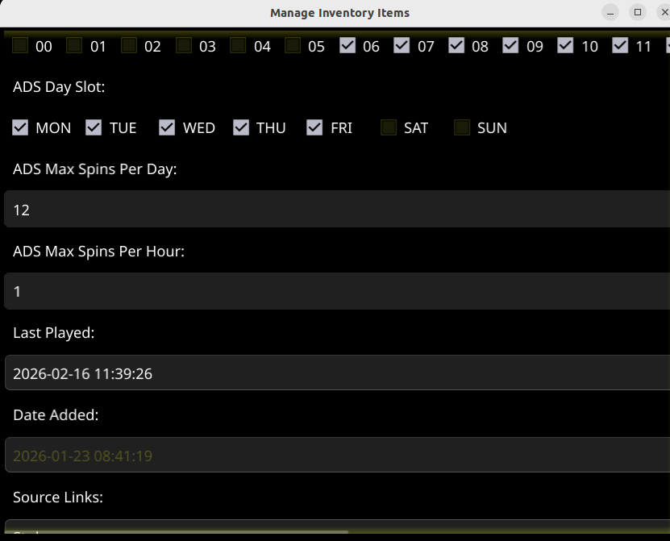
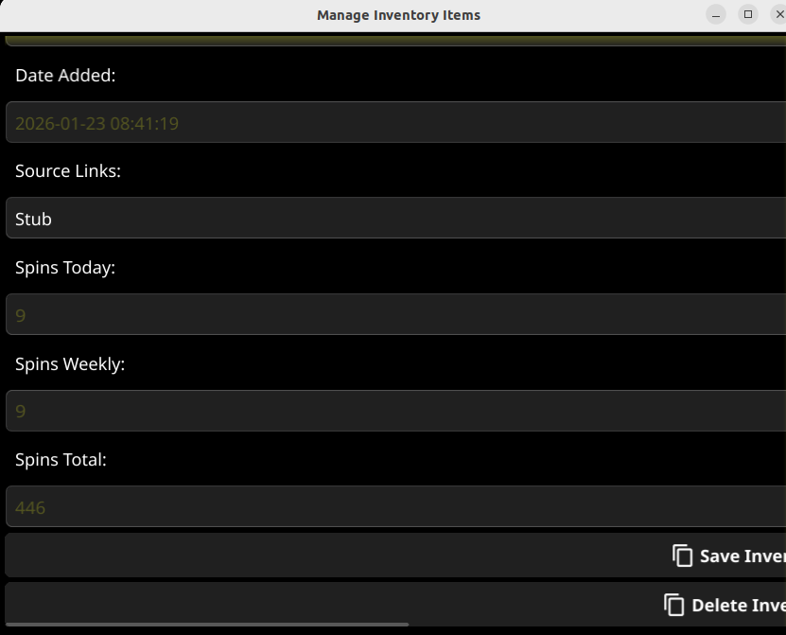

Field Definitions

Table 1: Inventory Fields
Name | Usage
Category | Selectt the category that this item fits. Categories may be added on the Categories tab and put on the schedule on the Schedule tab.
Artist | Name of the artist, segment customer..etc
Song | Identity of audio clip
Album | Name of the album or source this clip is from. ADVERTISING uses this field to match into Quick Books inventory. Reporting is available to detail spin date and time for verifying rotation
Button: Load Song | Save Item First then add content to the store
Button: Load Song Intro | Save Item First then add content to the store
Button: Load Song Outro | Save Item First then add content to the store
Length | Calculated on first play
Play Order | Generated every start of day to randomize inventory play order
Starts On | Day the inventory starts on, usually take default but for Advertising a start date might be required.
Expires on | Day the inventory ends on, usually take default but for Advertising a end date might be required. Promos may also require to end the content on a particular day
Ads Time Slot | Select all the hour parts this add is allowed to play, This provides a means to run daytime, nighttime, late night ads
Ads Day Slot | Select all the days the ad is allowed to play, combined with Ad Time Slot makes for an extensive ad format allowing for different types of ads
Ads Max Spins Per Day | Select a integer number specifying the number of times an ad is allowed to repeat on a given day
Ads Max Spins Per Hour | Select a integer number specifying the number of times an ad is allowed to repeat in a given hour
Last Played | Date of last play
Date Added | Add date
Source Links | Where this item came from
Spins Today
Spins Weekly
Spins Total
Button: Save Inventory Item | Save the inventory item before uploading the content
Button Delete Inventory Item | Deletes inventory from data base and content store

Users

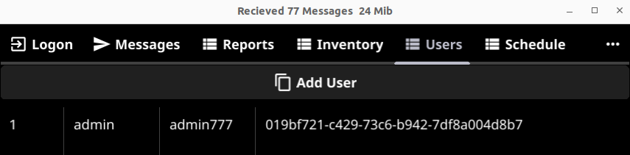
This tab provides security and authentication for HTTPS users. These users have a limited function and the necessary tools are exposed through an HTTPS connection to port 3000 proxied through Cloudflare.
Button: Add User – create a user profile.
Click on a profile to edit.
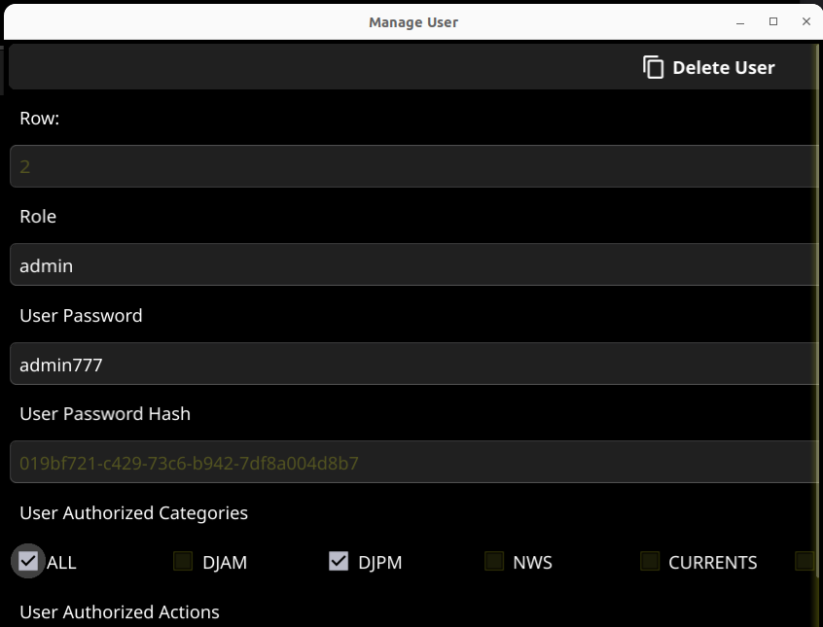
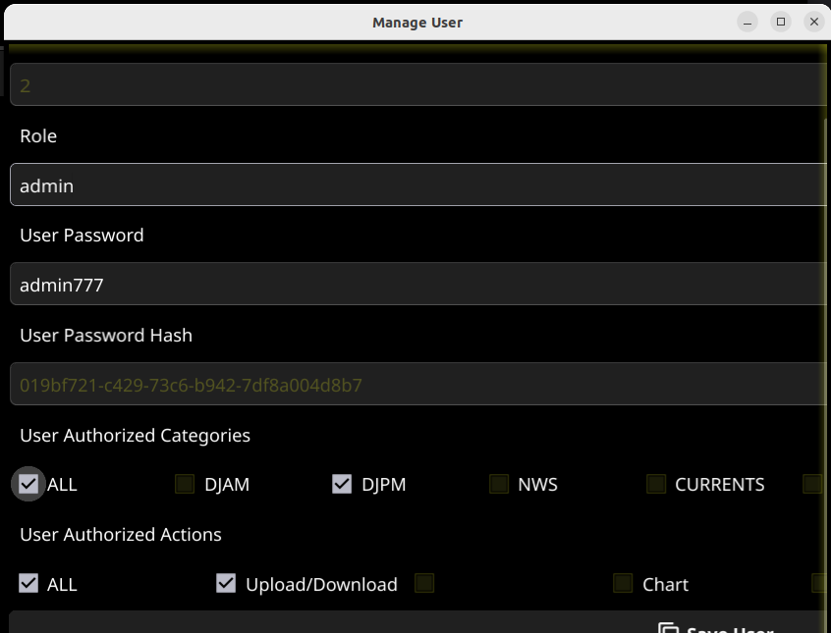

Field Definitions

Table 2: User Fields
Name | Usage
Button: Delete User | Eliminate this user from the HTTPS Web Interface
Role | Name of functional category of this user, News-Weather-Sports might be NWSDon or Disk-Jockey may be DJAM, DJPM, required at each logon
Password | This users password which will be required at every logon
Password Hash | System generated part of the security system.
Authorized Categories | Select all the categories this user should be allowed to access on the Upload content button of the Web Interface
Authorized Actions | Select the actions this user is authorized to perform
Button: Save User

Schedule

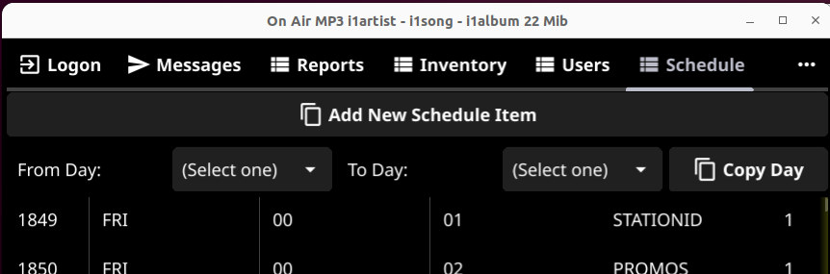
This is the heart and soul of the system. It is where the content is defined for play.
It is extremely important to get this correct while changes can be made, it is much much easier to get the schedule close from inception.
Button: Add new Schedule Item
Tap an item to edit.
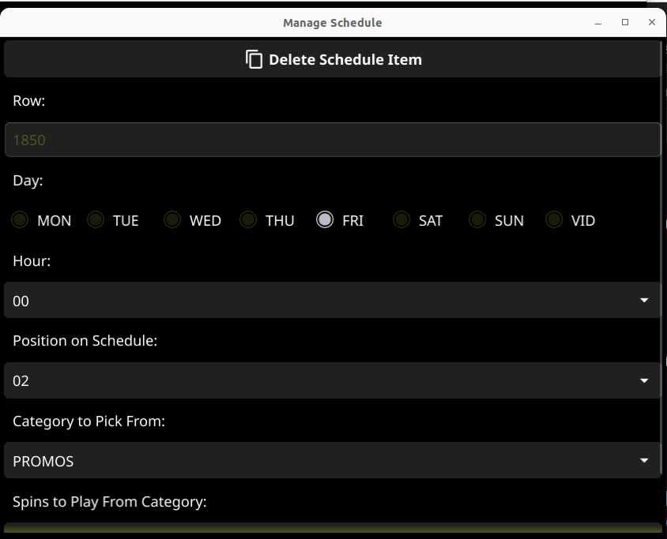
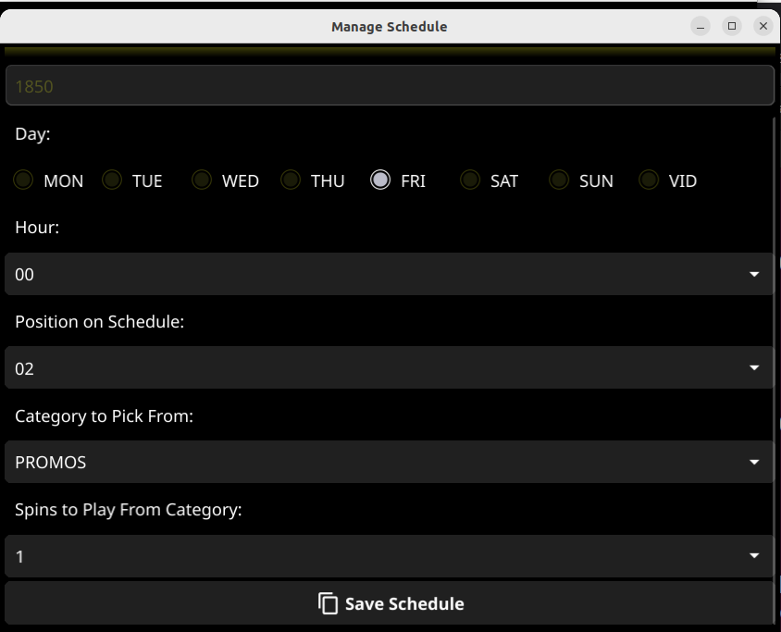

Field Definitions
Table 3: Schedule Fields
Name | Usage
Button: Delete Schedule Item
Day | Day of Week for this schedule item
Hour | Hour part using military time 00 – 23 hour format where 00 is Midnight and 23 is 11:00 PM
Position On Schedule | Is fine tuning for sequencing schedule item within the hour
Category To Pick From | Inventory category for automated selection, STATIONID (Legal Station ID) should always be first and FILTOTOH (Fill To Top of Hour) should always be last.
Spins to Play From Category | Number of inventory items to play from this category.
Button: Save Schedule

Category

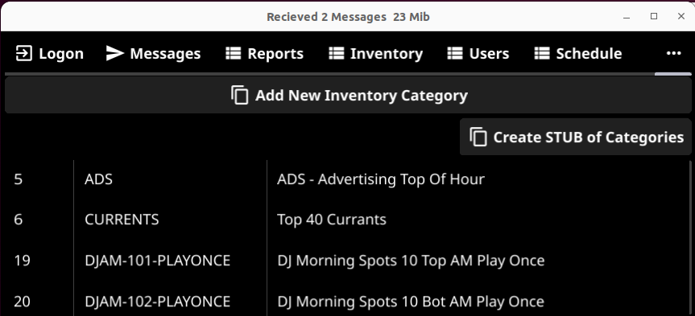
Button: Add New Inventory Category
Button: Create STUB of Categories
The STUB is a generated file system which provides all of the defined categories in an easy to use template for uploading content to the server. The content is placed in the STUB and the directory is ZIP’ed and uploaded to the server through HTTPS Web Interface.

Field Definitions

Table 4: Category Fields
Name | Usage
Category | Name of the category, use PLAYONCE as part of the category to indicate to the schedule player that the content is to be deleted after playing
Description | Alias of the category
Button: Save Inventory Category

Hours
All hours are entered, 00-23 using military time codes

Days
All hours are entered, MON,TUE,WED,THU,FRI,SAT and SUN.

Enc/Dec

Refer to technical documentation. Enc/Dec 24 Character Password sets the encryption key for the system. Change this with caution as you system my become bricked. You can encrypt/decrypt items on this tab

Settings
On the settings tab, various system wide parameters are defined

Table 5: Category Definitions
Name | Usage
Preferred Language | Eng. Spa or Hin
Content Format | Mp3. Mp4, wav once set cannot be changed
Message Max Age in Hours | Number of hour a message will appear on message tab
Advertising Max Minutes | Per segment limit
Omit Connected/Disconnected | Turn of user logging
Button: Change Settings
Button: Dark
Button: Light

Password Reset
Changes the encrypted config.json file to match the compiled password. This is also the System ID on the Web Interface. Change the password here then recompile the interfaces using the new password.

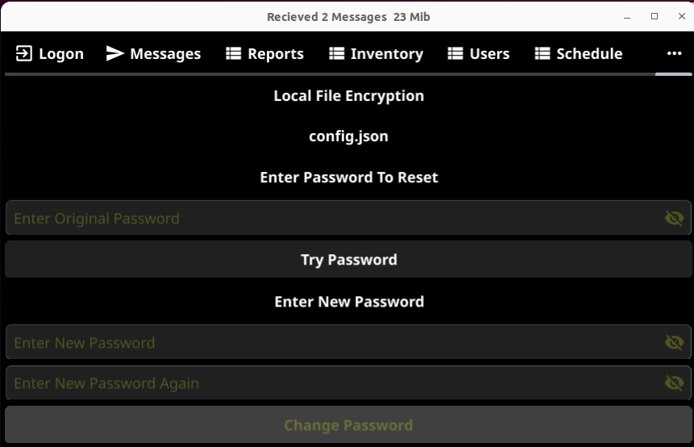

Field Definitions

Table 6: Reset Definitions
Name | Usage
Enter Password to Reset | Original password
Button Try Password | Try original password
Enter New Password | New password
Enter New Password Again | New password again
Button: Change Password

HTTPS Web Interface

SSH

