1 - Creation of ABHA Address- :

Understanding ABHA Address
What is ABHA Address?
ABHA Address is an easy to remember username that enables a user to access their health records digitally and share their records with various healthcare providers. An ABHA address may look like ‘name@abdm’. It is required to sign up on ABHA Application
Every 14-digit ABHA number is automatically issued a default ABHA address on the ABDM HIE-CM, which looks like 14-digit@sbx or 14-digit@abdm.
Create ABHA Address
The user can also create a user defined name on the HIE-CM that can be linked to this ABHA number. for example: ajeet123@abdm, so that’s easy to remember.
It is also possible to create an ABHA address that is not linked to an ABHA number on the HIE-CM using mobile, name, age & gender.

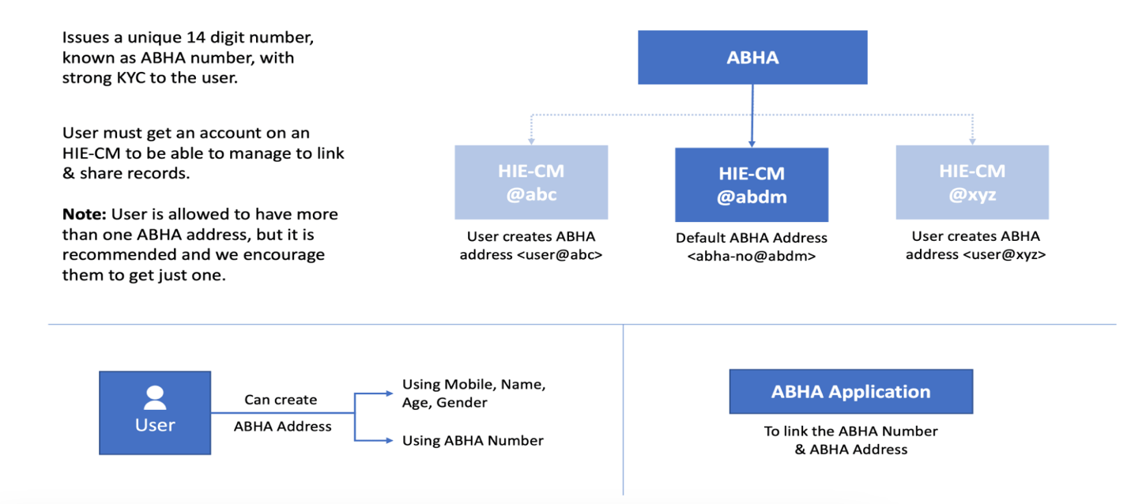

Test Cases Mapping

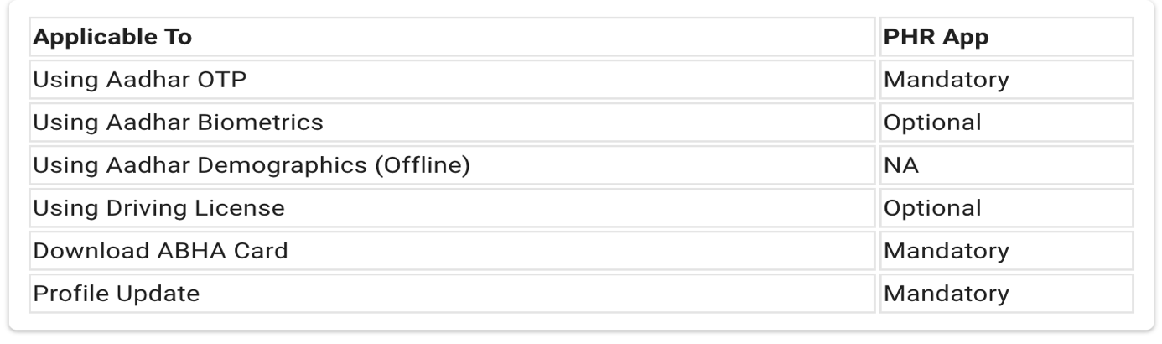 This section covers:
- Using Mobile Number
- Using ABHA Number
- Link of ABHA number & ABHA addressUsing Mobile Number

Using Mobile Number -
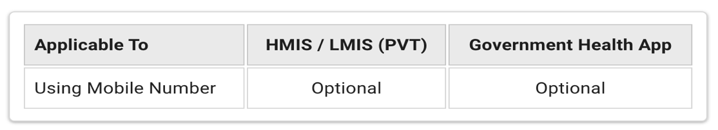
Functionality Overview :-
Description: -Individual enters mobile number/email ID, and it is validated via the added mode of validation
- Create an ABHA address of the format abc@abdm via mobile number using self-declared profile information filled in by an individual, such as photo, name, date of birth, gender, address. Mobile number is entered in profile info, in case a user is registering through mobile number and is entered in profile info in case a user is registering through .
- Individual creates an easy to remember ABHA Address along with its password to login.
- Profile is completed with an ABHA Address and a QR Code (with self-declared information filled in)
- This is a way of ABHA Address Registration with self-declared information.
ABHA Address Policy:-
- Minimum length is 4 including the allowed alphabet, number & dot(.)
- Cannot begin with the Number
- Cannot begin or end with dot(.)
- As a policy we allow creation of all numeric Abha addresses for Abha Number only: 14digit@abdm.
10-digit Mobile number as ABHA Address:-
- For now, we have restricted the creation of (10 digit) MobileNumber@abdm

Creation of (14 digit@abdm):-
- ABHA Address is not allowed however we have the provision for the user to login with same 14digit@abdm both in web PHR and mobile PHR.

Password validation :-
- This has been made optional. You may kindly check the below APIs at your end and reach out to us in case of any issues:

- Registration via ABHA Number, or Mobile Number: https://abhasbx.abdm.gov.in/abha/api/v3/phr/app/enrollment/request/otp

- https://sandbox.abdm.gov.in/sandbox/v3/new-documentation/swagger?integration_label=https://sandboxcms.abdm.gov.in/uploads/PHR_SWAGGER_22_01_b48a913d1d

Test Cases:-

ABHA address creation with mobile number flow (Self Declared Flow - without KYC)

Test Scenario | Optional / Mandatory
Click on "Register" to create a new ABHA address | Mandatory
Select the "Mobile Number" option to create ABHA address via mobile number and click on "Continue" button | Mandatory
Enter the mobile number and click on "Continue" button | Mandatory
Validate mobile OTP received on entered mobile number | Mandatory
Resend mobile OTP after 60 seconds post clicking on "Resend OTP" | Mandatory
Display ABHA addresses linked with entered validated mobile number. So that an individul can select an ABHA address in which one wishes to login. | Mandatory
Click on "Still want to create a new ABHA address" for creation a new ABHA address | Mandatory
Fill following profile details such as:  • First Name  • Middle Name  • Last Name  • Date of Birth - Day, Month and Year  • Gender  • Address  • State  • District  • Pin Code | Mandatory  • First Name  • Year (within Date of Birth)  • Gender  • Address  • State  • District  • Pin Code  Optional  • Middle Name  • Last Name  • Day (within Date of Birth)  • Month (within Date of Birth)
Click on checkbox beside "User Information Agreement" to voluntary share profile details with NHA for creating ABHA address and click on "Continue" button | Mandatory
Create ABHA address as per ABHA address policy.  ABHA address policy:  Minimum length 8 including alphabet, number & dot (.) are allowed. Number cannot be in beginning and dot (.) cannot be in beginning & end. | Mandatory
Suggestions to create ABHA address as per an individual's name & username of e-mail ID needs to be displayed while creating it. | Optional
Create password, confirm password and click on "Submit" button. Password needs to be created as per password policy.  Password policy:  8 characters or longer, one A-Z, one a-z, one 0-9, atleast one symbol, no space and not more than 2 consecutive characters or keyboard keys. | Mandatory
Congratulation Screen is displayed stating "Congratulations! ABHA address is created successfully " and click on "dashboard" button | Mandatory

API Sequence Diagram -: PHR_Enrollment - Registration via Mobile Number
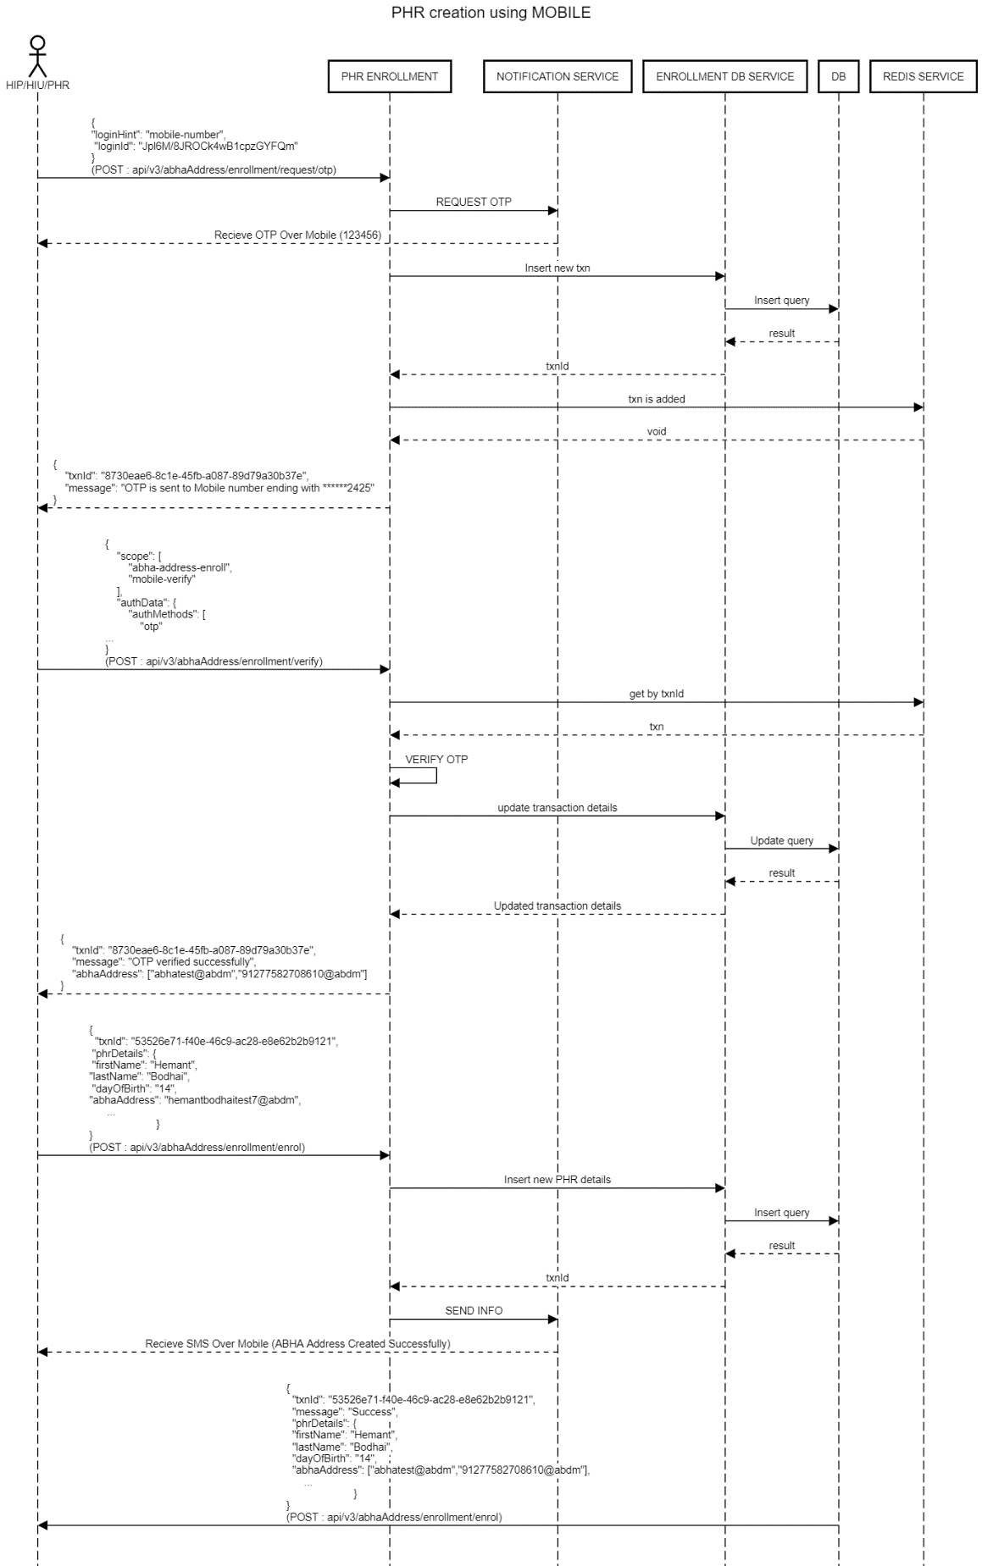

Using ABHA Number - :
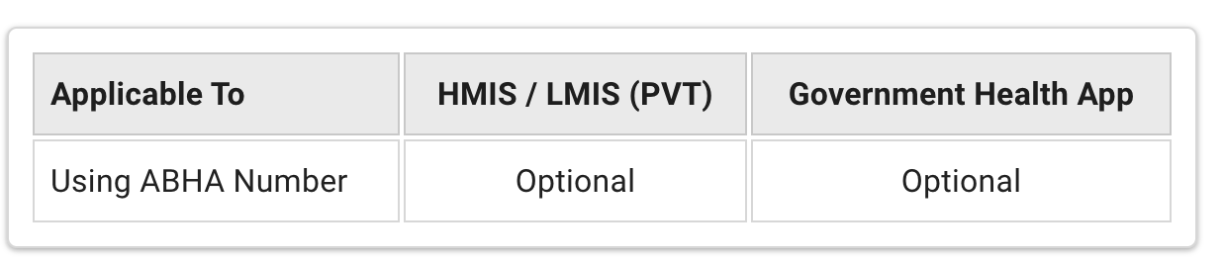

Description: Individual enters ABHA address (xyz@abdm), and it is validated depending on auth mode
of validation such as mobile OTP/aadhar OTP/ password to login.

- In this flow, individual is given an option of creating ABHA address through ABHA (Number) via KYC document. Please note, the list of KYC documents may be revised from time to time.
- Create an ABHA address of the format abc@abdm via 14-digit ABHA (Number). In this case, profile details like photo, name, date of birth, gender, mobile number, , and address are fetched from the ABHA system.
- Individual creates an easy to remember ABHA Address along with its password to login
- ndividuals link ABHA (Number) with ABHA address as per their choice.

ABHA Address Policy:
- Minimum length is 4 including the allowed alphabet, number & dot(.)
- Cannot begin with Number
- Cannot begin or end with dot(.)
- As a policy, we allow creation of all numeric ABHA addresses for ABHA Number only: 14digit@abdm.

10-digit Mobile number as ABHA Address:
  - For now, we have restricted the creation of (10 digit) MobileNumber@abdm
Creation of (14 digit@abdm):
  - ABHA Address is not allowed however, we have the provision for the user to login with the same 14digit@abdm both in web PHR and mobile PHR.
Password validation :
- This has been made optional. You may kindly check the below APIs at your end and reach out to us in case of any issues:
Registration via ABHA Number, or Mobile Number: https://abhasbx.abdm.gov.in/abha/api/v3/phr/app/enrollment/request/otp

- https://sandbox.abdm.gov.in/sandbox/v3/new-documentation/swagger?integration_label=https://sandboxcms.abdm.gov.in/uploads/PHR_SWAGGER_22_01_b48a913d1d

Test Cases
Using ABHA Number - :
Registration Flow : ABHA address creation with ABHA number flow (KYC verified flow)
Click on "Register" to create a new ABHA address | Mandatory
Select the "ABHA number" option to create ABHA address via ABHA number and click on "Continue" button | Mandatory
Enter the 14 - digit ABHA number and click on "Continue" button | Mandatory
Validate ABHA number by entering Aadhaar OTP/mobile OTP received on mobile number linked with entered ABHA number. | Mandatory
Resend Aadhaar OTP / mobile OTP after 60 seconds. | Mandatory
Display ABHA addresses linked with entered validated ABHA number. So that an individul can select an ABHA address in which one wishes to login. | Mandatory
Click on "Still want to create a new ABHA address" for creation a new ABHA address | Mandatory
Following profile details are auto-populated from ABHA portal:  • First Name  • Middle Name  • Last Name  • Date of Birth - Day, Month and Year  • Gender  • Mobile number  • Address  • State  • District  • Pin Code | Mandatory  • Full Name (First Name, Middle Name and Last Name)  • Year (within Date of Birth)  • Gender  • Mobile Number  • Address  • State  • District  • Pin Code  Optional  • Day (within Date of Birth)  • Month (within Date of Birth)  • Email ID
Click on checkbox beside "User Information Agreement" to voluntary share profile details with NHA for creating ABHA address and click on "Continue" button | Mandatory
Create ABHA address. ABHA address needs to be created as per ABHA address policy  ABHA address policy:  Minimum length 4 including alphabet, number & dot (.) are allowed. Number cannot be in beginning and dot (.) cannot be in beginning & end. | Mandatory
Suggestions to create ABHA address as per an individual's name & username of e-mail ID needs to be displayed while creating it. | Optional
Create password, confirm password and click on "Submit" button. Password needs to be created as per password policy.  Password policy:  8 characters or longer, one A-Z, one a-z, one 0-9, atleast one symbol, no space and not more than 2 consecutive characters or keyboard keys. | Mandatory
Congratulation Screen is displayed stating "Congratulations! ABHA address name@abdm is created successfully " and click on "Login" button | Mandatory
Click on "I Agree" against "Personal Data Processing Consent Form". Post this user is able to successfully  “Dashboard” | Mandatory

API Sequence Diagram -:
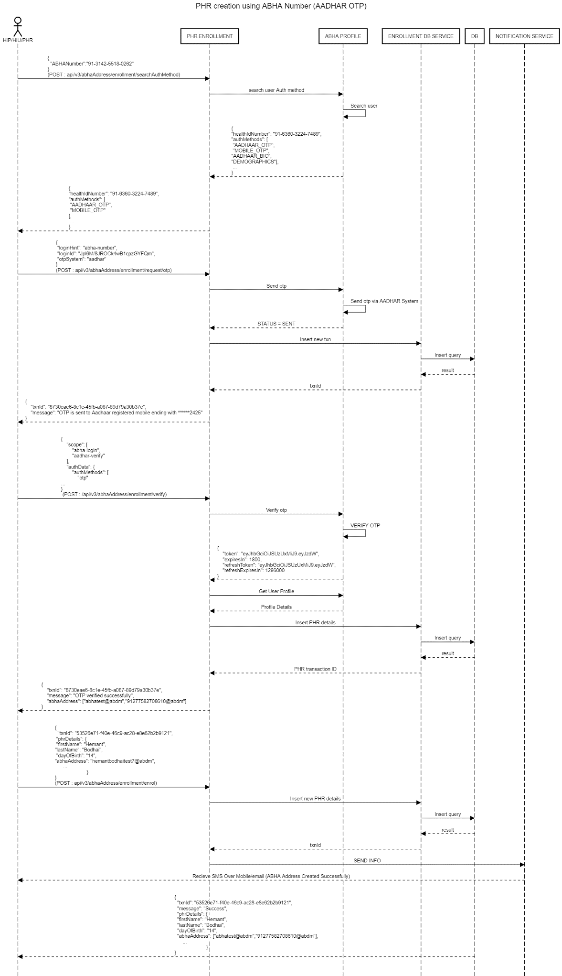

Link ABHA Address -:

Functionality Overview -:

ABDM has now segregated the identity layer from the consent layer, which will ensure that the ABHA Number (earlier known as Health ID) provides a strong identity to an individual whereas an ABHA Address (earlier known as PHR Address) enables an individual to share their health records with different healthcare providers and payers.
- API links the given ABHA Address to the ABHA number and defines whether it is the preferred ABHA Address
- An ABHA address can be created without KYC, using just the mobile number, name, YearOfBirth, gender.
- Users can have more than one ABHA address. ABDM encourages users to have just one ABHA address.
- Users can have only a unique KYC-verified ABHA number.
- There are several scenarios where a strong KYC may be required (example: Insurance) for your ABHA address. This is achieved by linking your ABHA address with your ABHA number.
- Alternatively, several people who use public health facilities may be issued an ABHA number as part of the process.
- They can create an ABHA address and link it to their ABHA number.
- Remember that the ABHA number acts as an ABHA Address like “14digit@abdm”

Step 1: User must create an ABHA number,
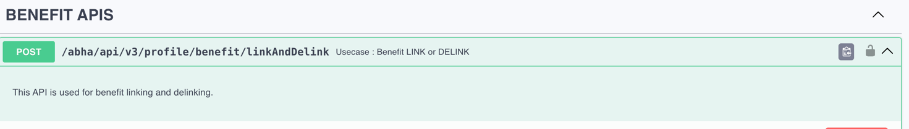
https://sandbox.abdm.gov.in/sandbox/v3/new-documentation/swagger?integration_label=https://sandboxcms.abdm.gov.in/uploads/ABHA_API_V3_SWAGGER_31_07_2025_981273d127
Step 2: Users can link an existing ABHA address to this ABHA number, OR you can create and link a new ABHA address
Test Cases
S.No. | Functionality | Test Case | Steps To Be Executed
1 | Mandatory Linking of ABHA Number and ABHA Address (LINK_ABHA_701) | System should have provision to link the created ABHA number with existing ABHA address | 1. User will create ABHA number as defined in the above scenerios.  2. user should be able to link ABHA number with existing ABHA address
S.No | Functionality | Test Case | Steps To Be Executed
1 | Mandatory Link ABHA number to the ABHA address | Click on “Link ABHA Number” option provided beside “Self Declared” in home screen
2 | Mandatory Link ABHA number to the ABHA address | Enter 14-digit ABHA number
3 | Mandatory Link ABHA number to the ABHA address | Validate ABHA number via aadhar OTP / mobile OTP | Check that an individual is able to validate ABHA number via both aadhar OTP / mobile OTP
4 | Mandatory Link ABHA number to the ABHA address | Resend OTP | if OTP is not received in 60 seconds,check that resend OTP option is provided after 60 seconds for both aadhar OTP / mobile OTP
5 | Mandatory Link ABHA number to the ABHA address | Displaye message: “Congratulations! Your ABHA number is now linked to your existing ABHA address. ABHA number is visible on your profile. | Check that post OTP validation of ABHA number, message is displayed that ABHA number is successfully linked with the ABHA address and ABHA number is visible in profile. Also ABHA number policy will supersede ABHA address. Hence profile details will change as per ABHA number. In addition to this “Self-Declared” status is changed to “KYC Verified” in home screen.
6 | Mandatory Link ABHA number to the ABHA address | Click on “Go back to home screen” tab to go back to profile | Check that after clicking on “Go back to home screen” tab an individual is able to go back to home screen

API Sequence Diagram -:
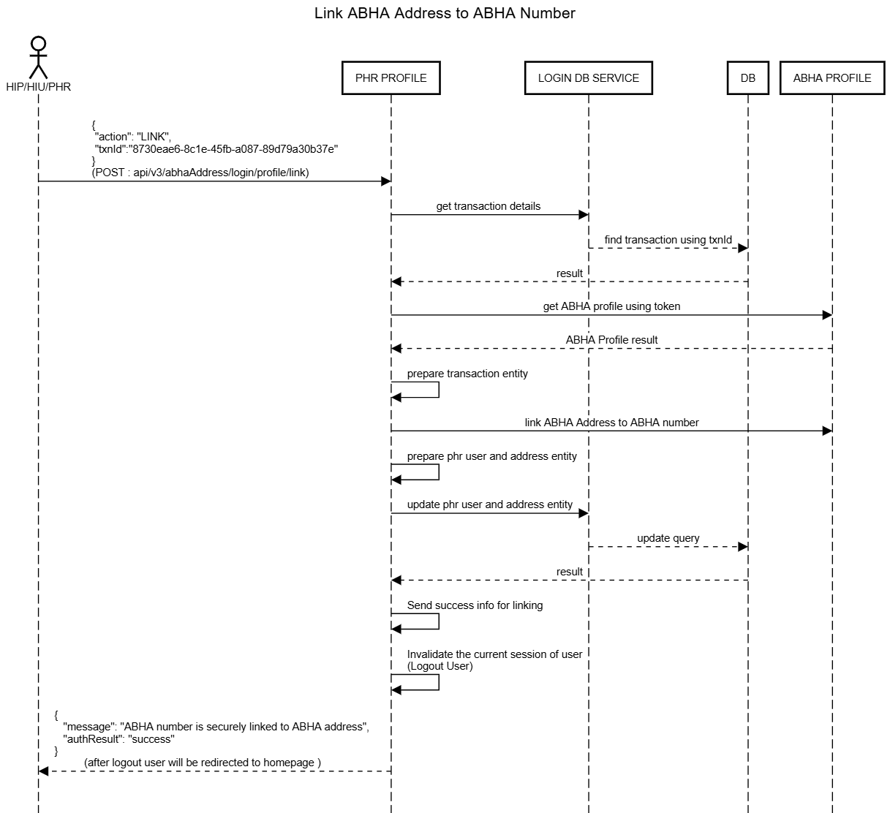

Login to PHR App -:

Functionality Overview-:

The PHR Application should allow users to log in using any of the supported authentication methods.

To improve the user experience, the application may securely store the refresh token and use it to extend the user session, reducing the need for frequent logins.

The application should also support multiple user profiles within a single PHR App instance by providing sign-in and sign-out functionality for different users.

Additional Information

Every PHR Application user must have an ABHA Address (also referred to as a PHR Address). An ABHA Address is a unique identifier in the format:
username@abdm

This ABHA Address can be used for authentication, consent management, and accessing health records within the ABDM ecosystem.
Different ways of logging in to PHR Application
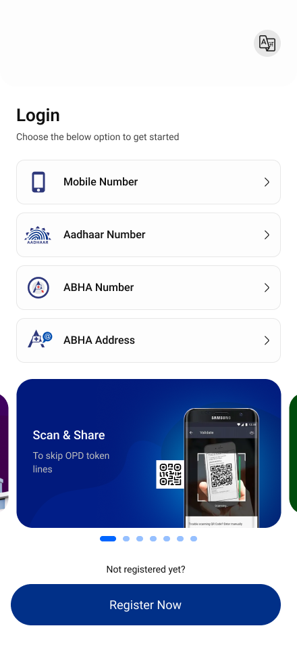

Test Cases-:

S.No | Functionality | Test Case | Steps To Be Executed
1. | Mandatory Login with mobile number flow | Enter mobile number linked with ABHA address
2. | Mandatory Login with mobile number flow | Validate mobile number via mobile OTP | Check if an individual receives mobile OTP and able to login with mobile number
3. | Mandatory Login with mobile number flow | Resend Mobile OTP after 60 seconds post clicking on “Resend OTP”.
4. | Mandatory Login with mobile number flow | Display ABHA addresses linked with entered validated mobile number. So that an individul can select an ABHA address in which one wishes to login.
9. | Mandatory Login with easy to remember ABHA address (name@abdm) flow | Enter easy to remember ABHA address - name@abdm
10. | Mandatory Login with easy to remember ABHA address (name@abdm) flow | Validate ABHA address via password / mobile OTP / aadhar OTP as per auth mode | Check if an individual is able to login with easy to remember ABHA address via password
11. | Mandatory Login with easy to remember ABHA address (name@abdm) flow | Validate ABHA address via password / mobile OTP / aadhar OTP as per auth mode | Check if an individual is able to login with easy to remember ABHA address via mobile OTP / aadhar OTP as per auth mode
12. | Mandatory Login with easy to remember ABHA address (name@abdm) flow | Resend aadhar OTP / mobile OTP after clicking on “Resend OTP | Check if an individual receive aadhar OTP / mobile OTP after 60 seconds and an individual is able to login post validation of ABHA address
13. | Mandatory Login with default ABHA address (14-digit@abdm) flow | Enter default ABHA address such as 14-digit@abdm
14. | Mandatory Login with default ABHA address (14-digit@abdm) flow | Validate ABHA address via mobile OTP / aadhar OTP | Check if aadhar OTP / mobile OTP is received and post validation of ABHA number, an individual is able to successfully login
15. | Mandatory Login with default ABHA address (14-digit@abdm) flow | Resend aadhar OTP / mobile OTP after clicking on “Resend OTP” | Check if an individual receive aadhar OTP / mobile OTP after 60 seconds and an individual is able to login post validation of ABHA address
16. | Mandatory Login with ABHA number flow | Enter 14 digit ABHA number
17. | Mandatory Login with ABHA number flow | Validate ABHA number via aadhar OTP / mobile OTP | Check if aadhar OTP / mobile OTP is received and post validation of ABHA number, an individual is able to successfully login
18. | Mandatory Login with ABHA number flow | Resend aadhar OTP / mobile OTP after clicking on “Resend OTP | Check if an individual receive aadhar OTP / mobile OTP after 60 seconds and an individual is able to login post validation of ABHA number
19. | Mandatory Reset Password | Login with any mode - mobile number / default ABHA address / easy to remember ABHA address / ABHA number | Check if password can be updated by an individual post login with any mode
20. | Mandatory Reset Password | Post successful login, click on reset password withing setting of the menu bar
21. | Mandatory Reset Password | Create password as per password policy. Password policy: 8 characters or longer, one A-Z, one a-z, one 0-9, atleast one symbol, no space and not more than 2 consecutive characters or keyboard keys. | Check if password is created as per password policy
22. | Mandatory Reset Password | Confirm password | Check new password is created only after same password is confirmed again
23. | Mandatory Reset Password | A message is displayed called “Your password is successfully changed” | Check if an individual new password is created by login with new password

API Sequence Diagram
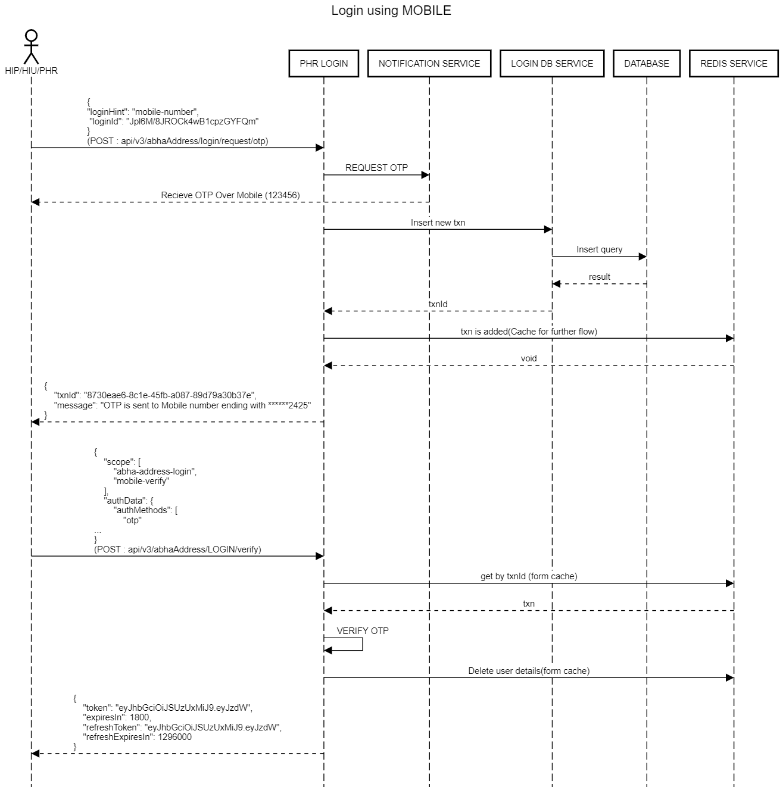

API Information Request Response
Different Methods Of Login –
- Login Using ABHA Address –
- Login Using ABHA Number / Mobile Number –
https://sandbox.abdm.gov.in/sandbox/v3/new-documentation/swagger?integration_label=https://sandboxcms.abdm.gov.in/uploads/PHR_SWAGGER_22_01_b48a913d1d
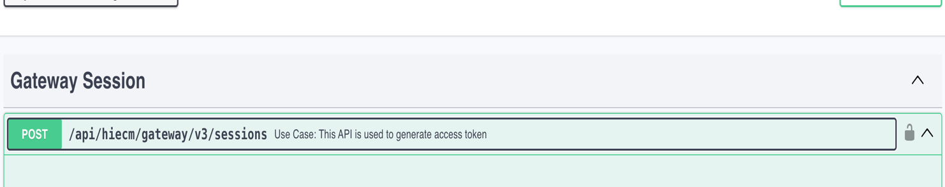
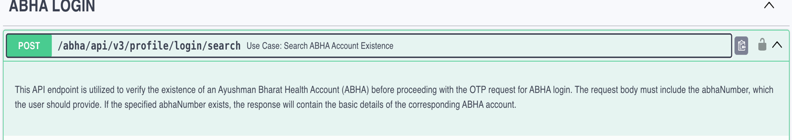

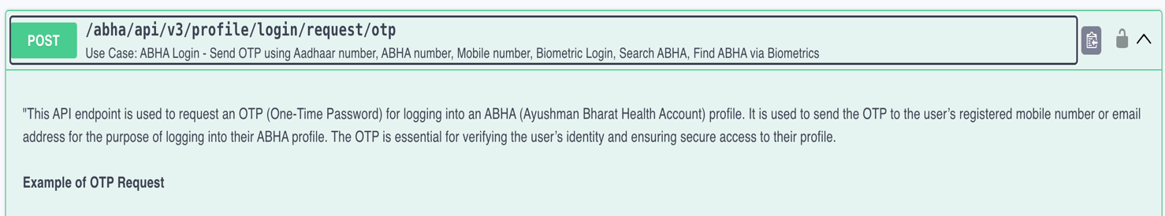

Manage PHR App User’s Profile - :

Functionality Overview
PHR applications need to have a (this) section, where users can view their demographic details and update (edit) their information.
- The section should also display ABHA QR code as part of the Profile information
- They should also be able to set/change password from this section.
- The user should also be able to upload a profile photo from this section.

Test Cases
Display Profile Details with status as KYC Verified / Self-Declared –:
S.No | Functionality | Test Case | Steps To Be Executed
1 | Mandatory Showing individual’s profile details in the PHR app | Individual’s profile is displayed in the PHR app with their status such as KYC verified and Self-Declared. | Display all profile details filled by the individual, when individual click on Profile after Login. Also display KYC Verified with green tick mark for those profiles where ABHA address is linked with ABHA number. Display Self Delared with exclaimation mark for those profiles where ABHA address is not linked with ABHA number. ABHA number is visible in KYC verified profile and ABHA number is not visible in Self-Declared profile.

Download ABHA address card in the PDF format -:

S.No | Functionality | Test Case | Steps To Be Executed
1 | Mandatory Download ABHA address card | Post clicking on “QR Code” icon, an individual can scan QR Code, share ABHA address card and download ABHA address card | Following fields will be displayed in the ABHA address card: Profile Photo, Full Name, ABHA number - It will be displayed if, 14-digit Health ID number is linked to the ABHA address. ABHA number is displayed as 91-0098-2416-3421 , ABHA address - It will be displayed as ajeetabdm@abdm , QR Code, Date of Birth, Gender, Mobile Number

Edit Profile -:
S.No | Functionality | Test Case | Steps To Be Executed
1 | Mandatory Edit profile for KYC verified profiles | Update mobile number | Mobile OTP is received on updated mobile number. Post mobile OTP validation, mobile no is updated.
2 | Mandatory Edit profile for KYC verified profiles | Update address | All fields of address such as address line 1, district, state and pin-code can be updated.
4 | Mandatory Edit profile for Self-Declared profile | Update Photo | Photo can be edited by an individul taking the picture from mobile camera / upload photo from gallery of the device
5 | Mandatory Edit profile for Self-Declared profile | Update Full Name | Update First Name, Middle name and Last Name
6 | Mandatory Edit profile for Self-Declared profile | Update Gender | Update Gender
7 | Mandatory Edit profile for Self-Declared profile | Update DoB | Update Day, Month and Year
8 | Mandatory Edit profile for Self-Declared profile | Update Mobile No | Mobile OTP is received on updated mobile number. Post mobile OTP validation, mobile number is updated.
10 | Mandatory Edit profile for Self-Declared profile | Update Address | All fields of address such as address line 1, district, state and pin-code can be updated.

API Sequence Diagram
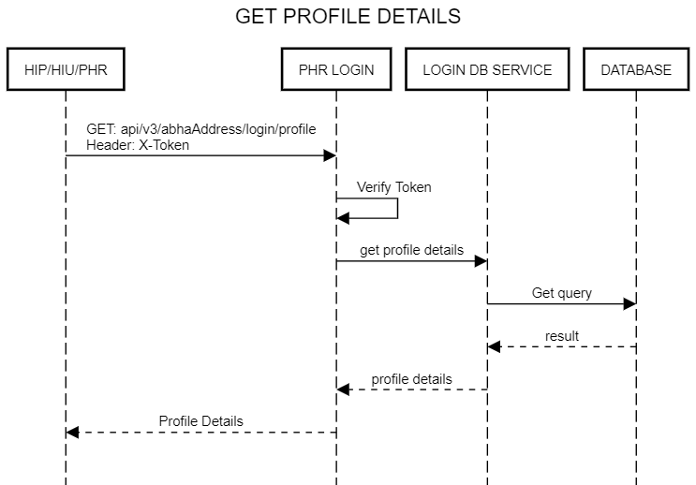

API Information Request Response -:
Manage User Profiles -:
Profile Collection API link -:
https://sandbox.abdm.gov.in/sandbox/v3/new-documentation/swagger?integration_label=https://sandboxcms.abdm.gov.in/uploads/Latest_Swagger_1_a273bf0c85
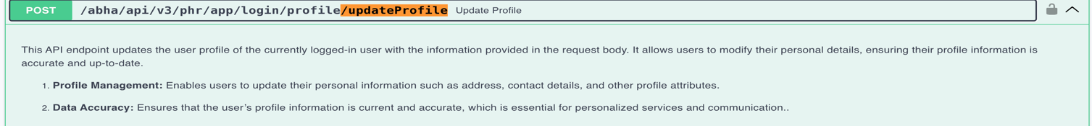
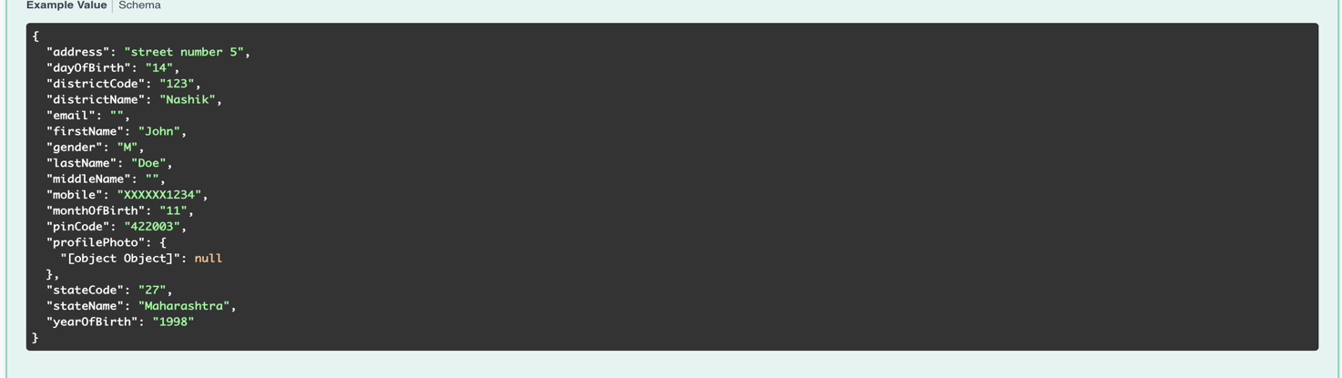

Scan and Share - :( OPD Token Generation) -:

Functionality Overview -:

The User/Patient can share his/her basic KYC information with the
HMIS/LIMS by scanning the QR Code using the integrator application (Example: ABHA App), which enables them to complete the seamless profile share during their visit.
1 - The authenticity of the profile information is verified by the HIE-CM internally before sharing with the HMIS/LIMS.

2 - The content of the QR code is a URL (sample for reference:
https://www.youtube.com/watch?v=a5PgWTmyjCg ) that contains 2 parameters:
- The HIP ID
- Facility defined context (for example: counter code)

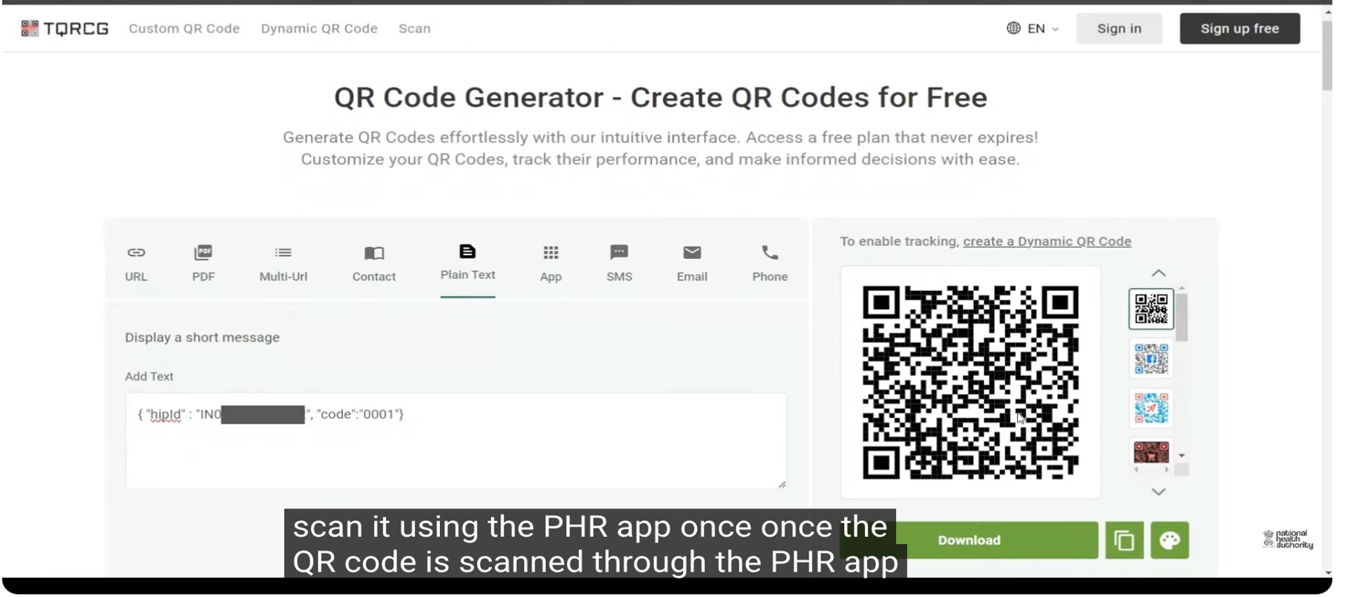
3 - Once the QR code has been scanned, the PHR App must present to the user all the information that will be shared and obtain a consent with the ABDM specified language. The consent says “You agree to share your ABHA Address and profile information with this facility for the purpose of registration and the facility can link any health records generated by….” (take reference from the screenshot attached)
4 - Once the user consents, the PHR App can call the HIE-CM API to share the details with the health facility.
5 - The Health facility is currently expected to respond within 30 seconds.
6 - The facility can optionally share a token number.
7- The PHR app must display a token number and not allow the user to generate a second token number for the next 60 minutes.
Note: The counter naming guidelines are as follows:
- Counter name can be up to 20-character alphanumeric value with no special character.
- Possible counter name examples- OPD, OPD1, OPD cardio, OPD ENT, OPDE2, IPD1, Pharmacy, Pharmacy 1, General OPD, staff, senior citizen etc.
- Counter name cannot be the HFR facility ID, HPID, HIP ID or HIP name
- Counter name should not be any randomly absurd name
Screenshot attached –

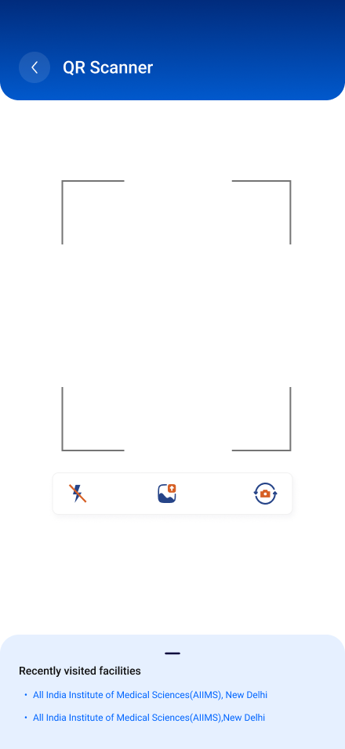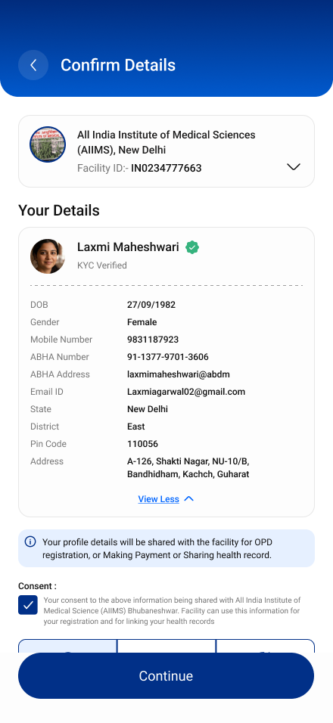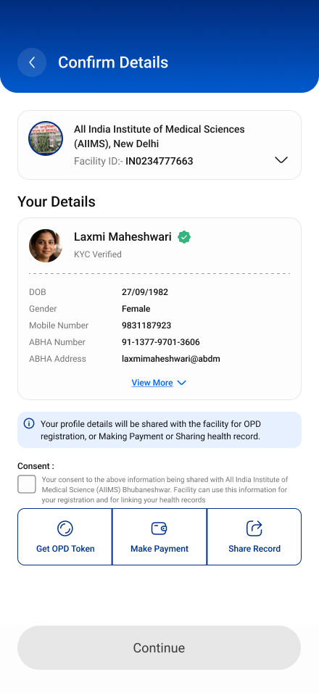

Test Cases
Scan and Share - Scan the QR code to share information.
Scan QR Code at the ABDM compliant health facility to get token number for better queue management and completing faster patient registration.
There are 2 use-cases here: 1. Use-case 1: Patients can scan the Health Facility QR Code using any PHR application
S.No | Functionality | Test Scenario | Steps To Be Executed
1. | Mandatory Scan Health QR Code using PHR App | Use-case 1 - Patient can scan the QR Code using any PHR app such as ABHA mobile app | Check that, patient is able to login to any PHR app such as ABHA mobile app.
2. | Mandatory Scan Health QR Code using PHR App | Use-case 1 - Patient can scan the QR Code using any PHR app such as ABHA mobile app | Check that patient is able to click on “QR Code icon” and scan the QR Code at ABDM compliant health facility.
3. | Mandatory Scan Health QR Code using PHR App | Use-case 1 - Patient can scan the QR Code using any PHR app such as ABHA mobile app | Check that, post clicking on share button, patient profile details are successfully shared to the HMIS side with consent of the patient.
4. | Mandatory Scan Health QR Code using PHR App | Use-case 1 - Patient can scan the QR Code using any PHR app such as ABHA mobile app | Check thatnotification is displayed for patient to know that profile details are successfully shared with the hospital and token number is also displayed.
5. | Mandatory Scan Health QR Code using PHR App | Use-case 1 - Patient can scan the QR Code using any PHR app such as ABHA mobile app | Check that post click on “OK” button, token number is displayed and it is valid for next 30 minutes. This time duration is configurable.
2. Use-Case 2: Scan the QR Code through third party scanner / phone camera
S.No | Functionality | Test Scenario | Steps To Be Executed
1. | Mandatory Scan Health QR Code using 3rd party camera | ABDM compliant PHR application is already installed in patient’s mobile and patient is already logged on in the PHR app | Check that, QR Code is scanned using phone camera or any 3rd party QR scanner
2. | Mandatory Scan Health QR Code using 3rd party camera | ABDM compliant PHR application is already installed in patient’s mobile and patient is already logged on in the PHR app | Check that installed ABDM Compliant PHR apps and browser is displayed. Patient can click on chrome browser to open the user initiated deep link web page to see the complete listing of ABDM compliant PHR apps.
3. | Mandatory Scan Health QR Code using 3rd party camera | ABDM compliant PHR application is already installed in patient’s mobile and patient is already logged on in the PHR app | Check that post clicking on any one of the PHR apps, patient is redirected to share profile page of PHR app as patient is logged-in to the PHR app
4. | Mandatory Scan Health QR Code using 3rd party camera | ABDM compliant PHR application is already installed in patient’s mobile and patient is already logged on in the PHR app | Check that post clicking on share button, patient profile details are successfully shared to the HMIS side with consent of the patient.
5. | Mandatory Scan Health QR Code using 3rd party camera | ABDM compliant PHR application is already installed in patient’s mobile and patient is already logged on in the PHR app | Check that notification is displayed, that the profile details are shared with the hospital and token number is also displayed.
6. | Mandatory Scan Health QR Code using 3rd party camera | ABDM compliant PHR application is already installed in patient’s mobile and patient is already logged on in the PHR app | Check that post click on “OK” button, token number is displayed and it is valid for next 30 minutes. This time duration is configurable.
7. | Mandatory Scan Health QR Code using 3rd party camera | ABDM compliant PHR application is already installed in patient’s mobile but patient is not logged on in the PHR app | Check QR Code can be scanned using phone camera or any 3rd party QR scanner.
8. | Mandatory Scan Health QR Code using 3rd party camera | ABDM compliant PHR application is already installed in patient’s mobile but patient is not logged on in the PHR app | Check that installed ABDM Compliant PHR apps and browser is displayed. Patient can click on chrome browser to open the user initiated deep link web page to see the complete listing of ABDM compliant PHR apps.
9. | Mandatory Scan Health QR Code using 3rd party camera | ABDM compliant PHR application is already installed in patient’s mobile but patient is not logged on in the PHR app | Post clicking on any one of the PHR apps, patient is redirected to login page of PHR app as patient is not logged-in to the PHR app
10. | Mandatory Scan Health QR Code using 3rd party camera | ABDM compliant PHR application is already installed in patient’s mobile but patient is not logged on in the PHR app | Check that post successful login, patient is redirected to share profile page of PHR app.
11. | Mandatory Scan Health QR Code using 3rd party camera | ABDM compliant PHR application is already installed in patient’s mobile but patient is not logged on in the PHR app | Check that post clicking on share button, patient profile details are successfully shared to the HMIS side with consent of the patient.
12. | Mandatory Scan Health QR Code using 3rd party camera | ABDM compliant PHR application is already installed in patient’s mobile but patient is not logged on in the PHR app | Check that notification is displayed, that the profile details are shared with the hospital and token number is also displayed.
13. | Mandatory Scan Health QR Code using 3rd party camera | ABDM compliant PHR application is already installed in patient’s mobile but patient is not logged on in the PHR app | Check that post click on “OK” button, token number is displayed and it is valid for next 30 minutes. This time duration is configurable.
14. | Mandatory Scan Health QR Code using 3rd party camera | No ABDM compliant PHR application is installed in patient’s mobile device. | Check that QR Code can be scanned using phone camera or any 3rd party QR scanner
15. | Mandatory Scan Health QR Code using 3rd party camera | No ABDM compliant PHR application is installed in patient’s mobile device. | Check that User Initiated Deep Link Web Page opens, and patient can see the complete listing of ABDM compliant PHR apps.
16. | Mandatory Scan Health QR Code using 3rd party camera | No ABDM compliant PHR application is installed in patient’s mobile device. | Check that once patient selects any one of the PHR app, he/she is redirected to Google Play Store / app store to download / install the selected mobile PHR app
17. | Mandatory Scan Health QR Code using 3rd party camera | No ABDM compliant PHR application is installed in patient’s mobile device. | Check that, selected PHR app is launched after installation and patient will create ABHA address and password

API Sequence Diagram -:

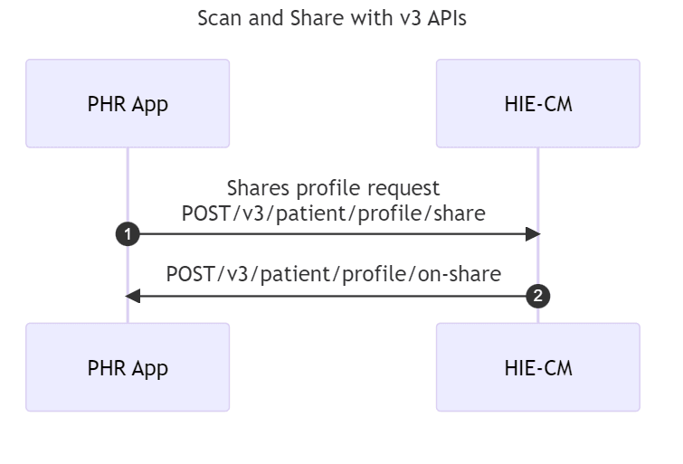

V3 APIs
2. Share Patient/User Profile
https://sandbox.abdm.gov.in/sandbox/v3/new-documentation/swagger?integration_label=https://sandboxcms.abdm.gov.in/uploads/patient_share_1_8ea5baf0e1

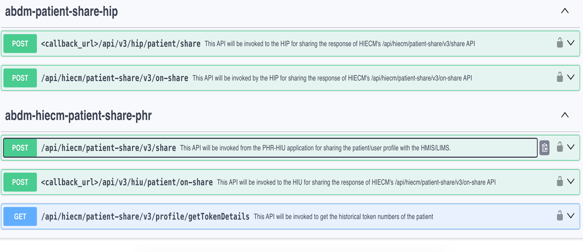

Setting up & Managing Subscriptions ,Handling Notifications -:

Functionality Overview - :

Functionality Overview
In ABDM, any HIU or PHR Application can subscribe (that will help to watch for changes to PHR address) for notifications to be received on its callback URL whenever there is a change in the care context linked to a ABHA Address.
- Every PHR App must set up a subscription for the ABHA address:
  - When it creates ABHA address
  - User logs in with a new ABHA address
- PHR applications are expected to provide a UI layer where the user can:
  - View the list of subscriptions
  - Approve subscriptions
  - Deny subscriptions
- The PHR app is responsible for showing up notifications on the Mobile application (for example using Firebase in Android).
Note: Users must be explicitly asked to provide a consent to setup the subscription.
- When the user approves the subscription, HIU/PHR App is notified whenever a new care context is linked or updated to the PHR address.
- Once subscribed, the PHR app will receive notifications in the following events:
  - New care context
  - Modified care context
  - New consent request
  - New subscription request
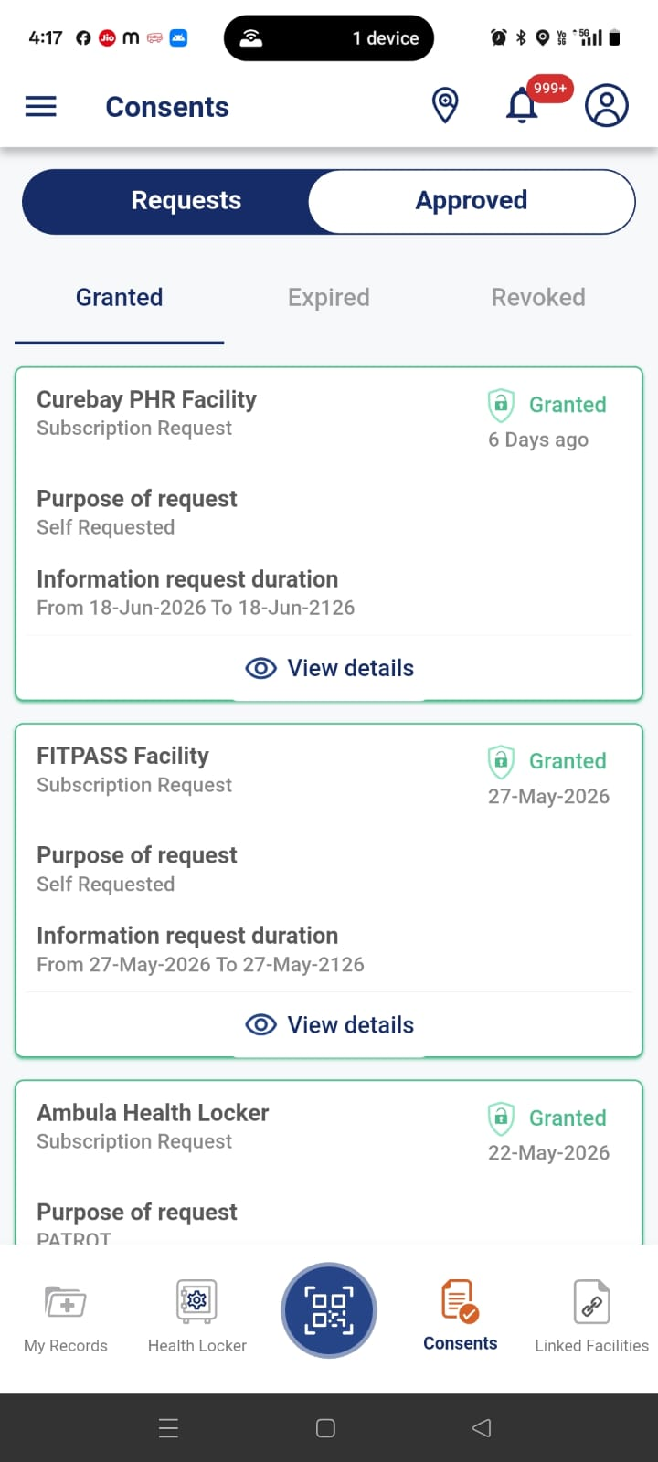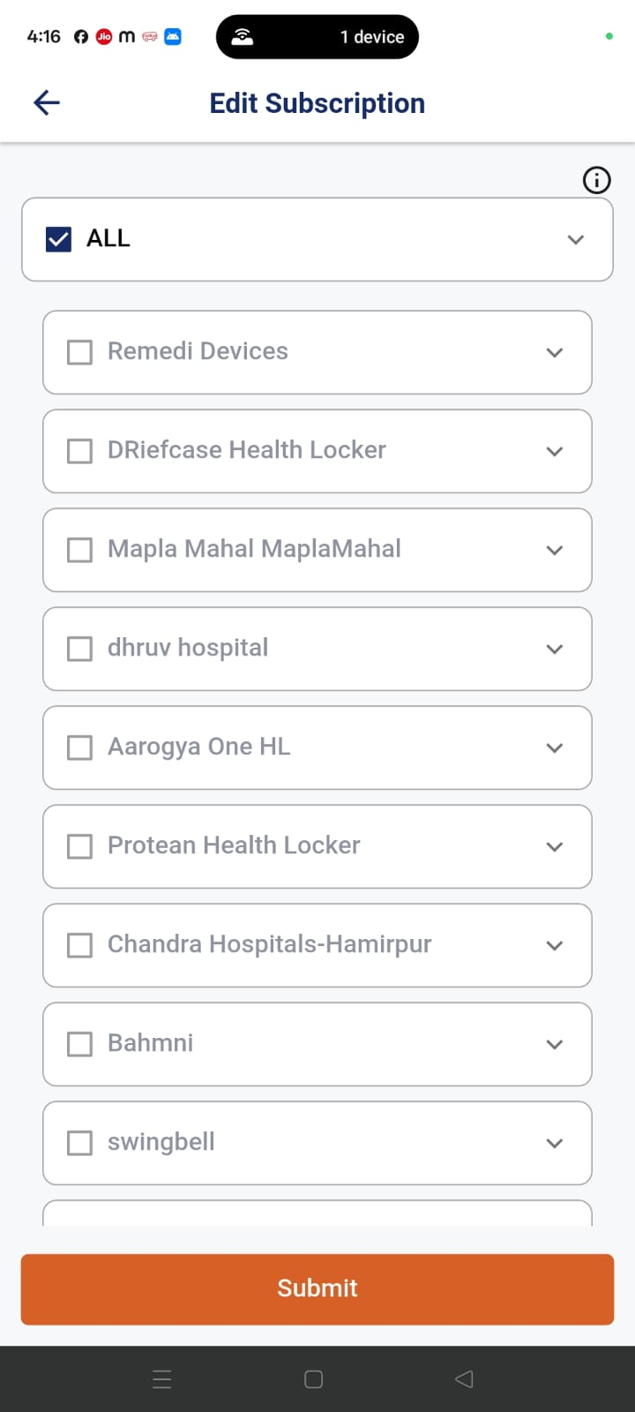
List of Subscriptions Request Edit of Subscriptions Request

User Experience API - :

https://sandbox.abdm.gov.in/sandbox/v3/new-documentation/swagger?integration_label=https://sandboxcms.abdm.gov.in/uploads/subscription_1_9f3475b623

Test Cases-:

Tabs in PHR app (My Records/Linked Facility/Subscriptions)-:

S.No | Functionality | Test Case | Steps To Be Executed
1 | Mandatory “Requests” section in the “Subscriptions” tab of PHR app | 1) Requested - Not yet any action is taken by individual on consent request received from HIU to PHR app. | All request (consent / subscription / locker) sent by HIU to patiet are seen in “Requested” dropdown within “Requests” section of PHR app
2 | Mandatory “Requests” section in the “Subscriptions” tab of PHR app | 2) Denied - Individual have “Denied” consent request received from HIU to PHR app. | All denied request (consent / subscription / locker) by patient are seen in “Denied” dropdown within “Requests” section of PHR app.
3 | Mandatory “Requests” section in the “Subscriptions” tab of PHR app | 3) Expired - Requests is expired because patient have not acted on consent request received in PHR app within the time duration set by HIU | All expired request (consent / subscription / locker) by patient are seen in “Expired” dropdown within “Requests” section of PHR app.
4 | Mandatory “Approved” section in the “Subscriptions” tab of PHR app | 1) Granted - Patient had granted the consent request received from HIU to PHR app | All granted request (consent / subscription / locker) by patient are seen in “Granted” dropdown within “Approved” section of PHR app.
5 | Mandatory “Approved” section in the “Subscriptions” tab of PHR app | 2) Revoked - Patient had revoked consent requests after granting it in PHR app. | All revoked request (consent / subscription / locker) by patient are seen in “Revoked” dropdown within “Approved” section of PHR app.

Edit Subscription Request/Disable auto approval request-:

S.No | Functionality | Test Case | Steps To Be Executed
1 | Mandatory Edit active subscription request | Already granted subscription request can be edited | Check if HI types, types of visit and time period can be edited and saved by clicking on “Save Changes” button"
2 | Mandatory Disable auto approval requests | Already granted auto approval policy can be disabled | Check if already granted auto approval policy for health locker can be disabled by clickicking on “Disable” button. Post disble of auto - approval policy locker request is received from health locker for each record.

API Information Request Response - :
1. Request For Subscription -:
https://sandbox.abdm.gov.in/sandbox/v3/new-documentation/swagger?integration_label=https://sandboxcms.abdm.gov.in/uploads/subscription_1_9f3475b623

API Sequence Diagram -:

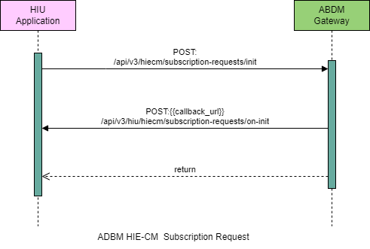

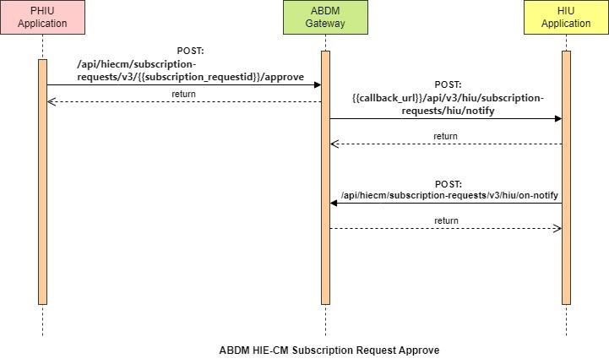

Setting up Auto-Approval – (Consent manager flow)

Functionality Overview -:
- The PHR App should get confirmation from the user that it can automatically retrieve any new linked health records and save a copy in the PHR application.
- On confirmation from the user, the PHR app can set up an auto-approval policy with the HIE-CM.
- The HIE-CM responds with an auto-approval ID that must be saved by the PHR app.
- When the PHR App receives a notification for a new care context or update of a care context, it is expected to initiate a consent request to the HIE-CM for access to the linked care context
- Since the auto approval policy is in place the HIE-CM will immediately respond with a consent grant to the PHR app.
- The PHR App can now use the approved consent to retrieve a copy of the health record and save it.

1 -HIE-CM – Consent Auto Approve -:

This API is invoked by the Health Information User (HIU) to create Auto Approval policy for consent request. This includes the list of HI types, the purpose and a date range between the policy will be active. Whenever a HIU that have an active auto approval policy raises a consents, the consent will be auto approved.

API Information Request Response - :

https://sandbox.abdm.gov.in/sandbox/v3/new-documentation/swagger?integration_label=https://sandboxcms.abdm.gov.in/uploads/consent_management_data_flow12_jan_ded6ab978d
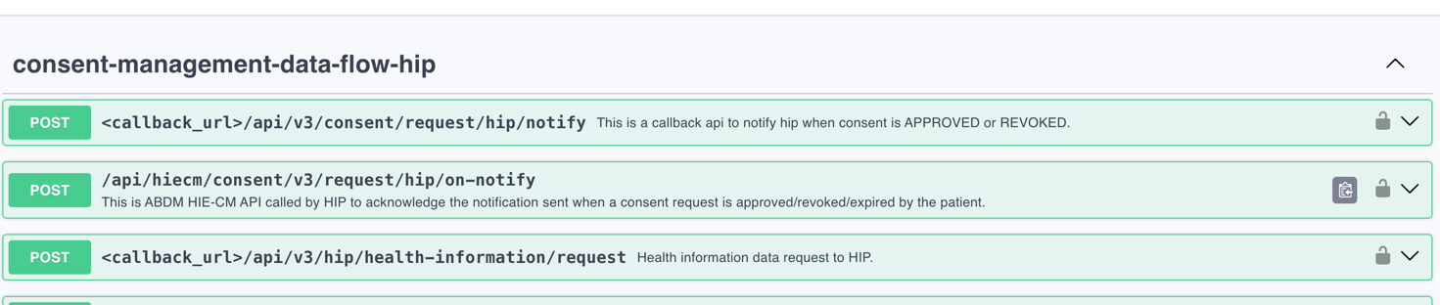

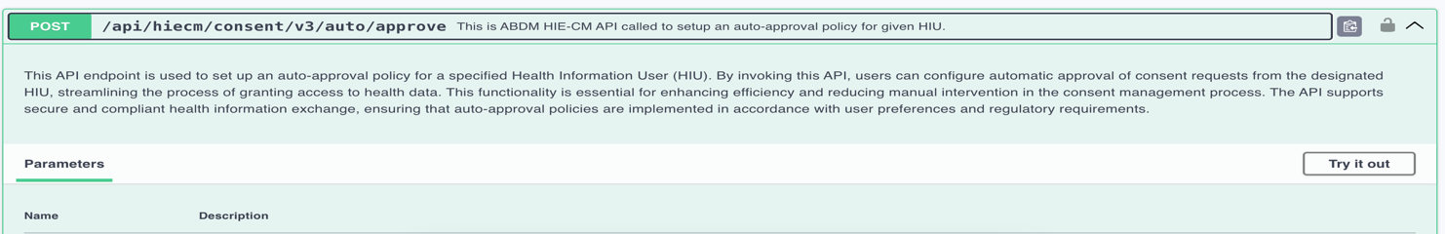

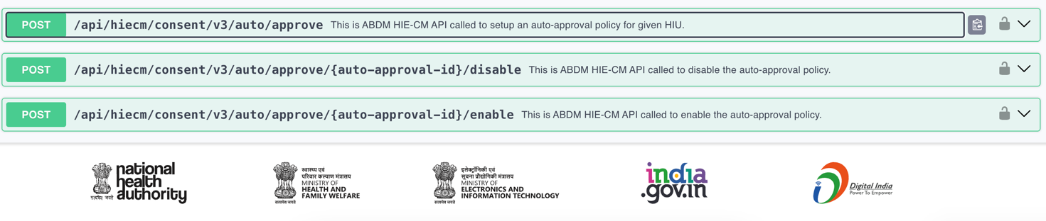

Discovery and Linking of Records & User-Initiated Linking

Functionality Overview
This feature is applicable when a patient has not shared their ABHA Address during a visit to a healthcare facility. It also enables users to discover and link their historical health records from ABDM-compliant healthcare providers.
User-Initiated Linking is a process through which a patient searches for their health records from ABDM-compliant healthcare facilities and links the discovered records (Care Contexts) to their ABHA Address for future access and sharing.
The user must have a Patient HIU (PHR App) to initiate the discovery and linking process.

Process Flow
- The user searches for a healthcare facility they have previously visited.
- The selected healthcare facility must be registered as a HIP (Health Information Provider) and linked to an HRP (Health Repository Provider) for discovery support.
- The user initiates a discovery request through the PHR App.
- The PHR App shares the following patient details with the HIP/HRP:
  - Name
  - Year/Date of Birth
  - Gender
  - Verified Mobile Number
  - ABHA Address
  - (Optional) Patient Registration Number issued by the healthcare provider
- The HIP/HRP searches its records for matching patient data.
- If matching records are found, the HIP/HRP returns the available Care Contexts.
- If no matching records are found, an appropriate error response is returned.
- The user selects the discovered Care Contexts and initiates the linking process.
- The HIP validates the user's identity by sending an OTP to the registered mobile number.
- Upon successful OTP verification, the Care Contexts are linked to the user's ABHA Address.

How It Works
- The PHR App should allow users to search for healthcare providers by name.
- This feature can also be used to discover and link records from large government programs such as CoWIN.
- Only healthcare providers participating in the ABDM ecosystem will be available for discovery.
- After selecting a healthcare provider, the PHR App sends a discovery request to the HIE-CM with the patient's details.
- The HIE-CM forwards the discovery request to the selected HIP.
- The HIP is expected to respond to the discovery request within 10 seconds.
- If records are found, the HIP returns the list of available Care Contexts, which are displayed in the PHR App.
- The user can then initiate the linking of the selected Care Contexts with their ABHA Address.
- Before completing the linkage, the HIP verifies the user's identity using OTP-based authentication.
- After successful authentication, the selected Care Contexts are linked to the user's ABHA Address and become available for future access.

Expected Outcome
- Users can discover historical health records from ABDM-compliant healthcare providers.
- Users can securely link discovered records to their ABHA Address.
- Linked records become available for consent-based health information sharing through the ABDM ecosystem.
- OTP-based verification ensures secure and authorized linkage of health records.

Screen -:

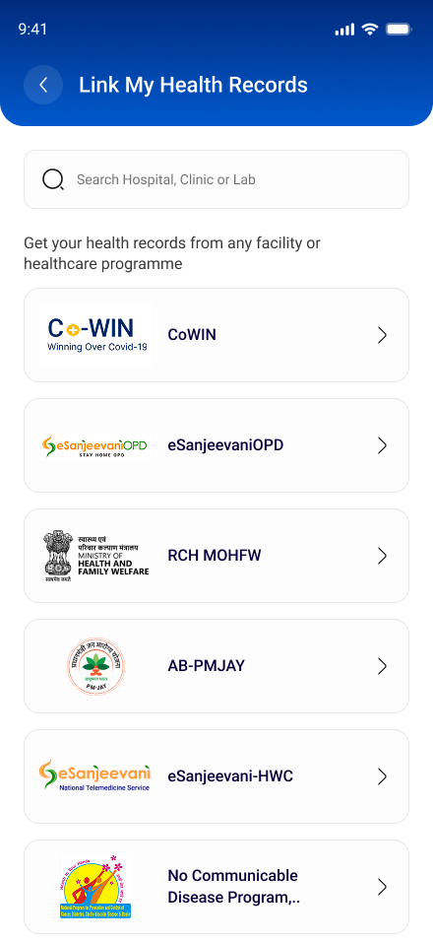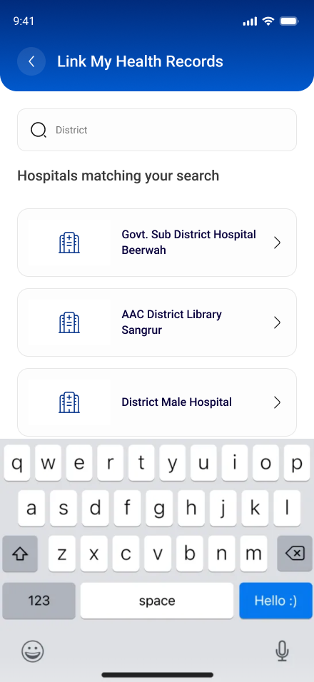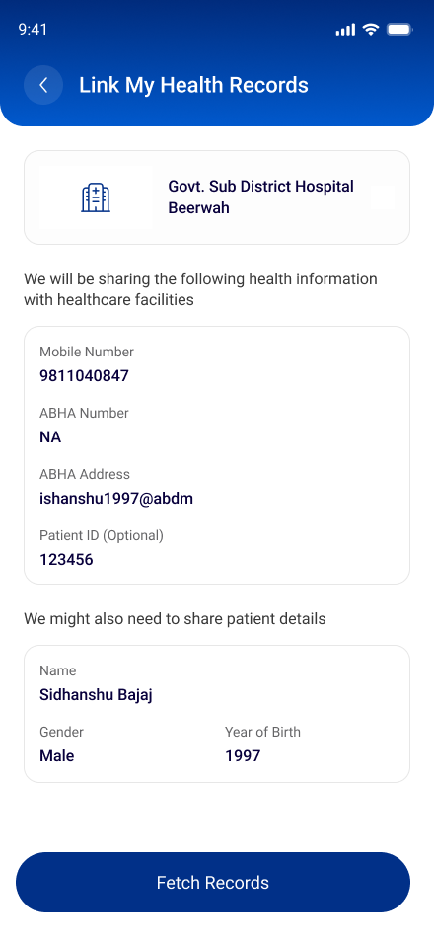

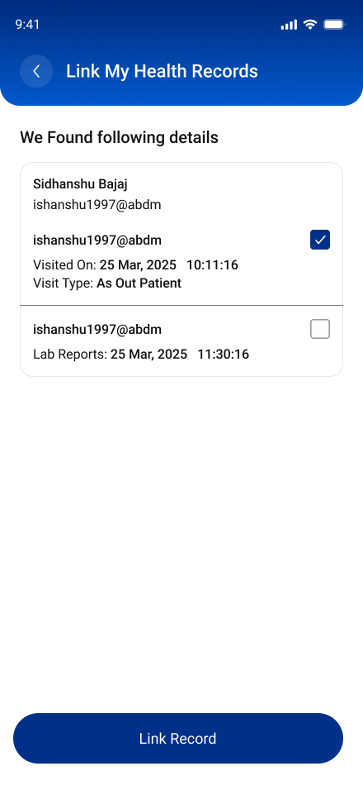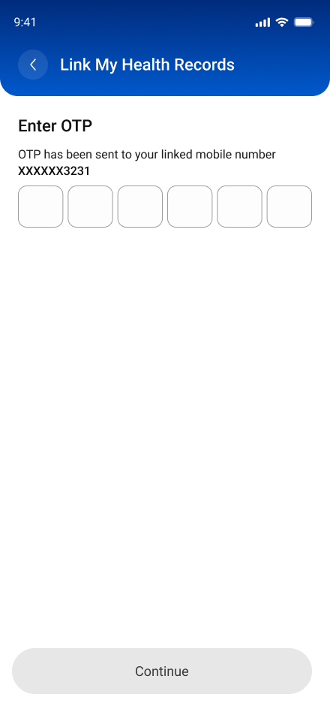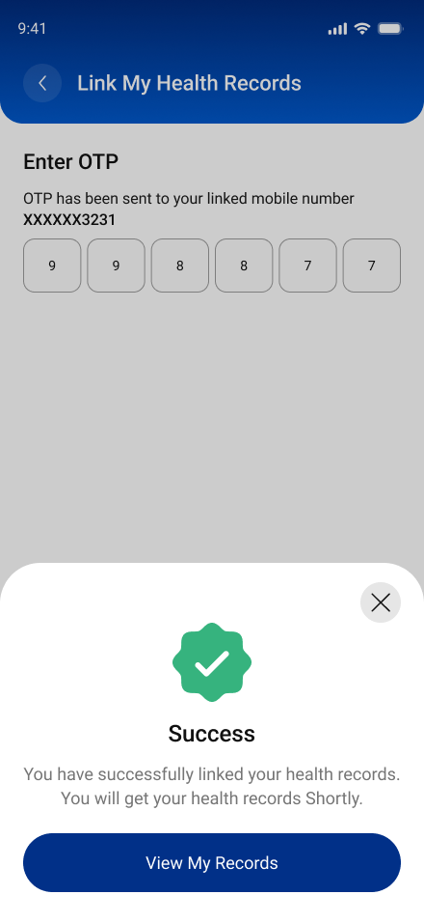

Test Cases -:
Health and Facility records linking: User initiated linking flow (Discovery Flow) - Complete Discovery of HIP, linking, fetching and viewing of records in PHR app,
S.No | Functionality | Test Case | Steps To Be Executed
1. | Mandatory Link HIP | After Login : Click on “Link my Health Records” tab in “My Records” tab | Click on “Link my Health Records” tab / “+” symbol in “Linked Facility” tab to search records in HIP
2. | Mandatory Discover HIP | Search HIP ’s such as hospital, clinic, lab to discover them based on typed string by the individual | When individual will search the visited facilty (HIP), the entire facilty name with complete address will be discovered by the individual. This “Search” is based on string, i.e HIP name entered by the patient in the search bar of PHR app.
3. | Mandatory Display of patient details | After searching facility: The details visible to patient on the PHR app are: Verified mobile number, ABHA address, ABHA number, Patient ID, Full Name, Year of Birth, Gender. | Details of Patient will be visible when individual search for the HIP in PHR app while user initiated linking flow.
4. | Mandatory Fill Patient ID (Optional) | This customizable lable is: Patient ID - In case of linking health records created at health facility. And this field is optional for patient to enter. | Check, if exact match of record is found after entering correct Patient ID
5. | Mandatory Matching of API specifications to link record | Click on “Fetch Records”. After matching following fields, records will be fetched from facility (HIP) to PHR app: Name (Mandatory), Year of Birth (Mandatory), Gender (Mandatory), Mobile Number (Mandatory), Patient ID (Optional) | Ensure that already linked care context should not be discovered in PHR mobile app. If all care context of discovered facilty are already linked, then display message called “All your existing records are linked. No additional records availaible for linking”. Ensure that the linked care context is shown in the “Linked Facility” tab of the PHR mobile app
6. | Mandatory Link records | Display of records details like HI type | Display of all correct details of records, after matching of API specifications. Select the record which patient wants to link and click on “Link Selected”
7. | Optional Fill mobile OTP received to complete linking of record. | Mobile OTP will be received once individual clicks on fetch records. After successful validation of OTP, display message called “Records are successfully linked”. This OTP is sent by HIP to the patient’s mobile. | Fill mobile OTP for successful linking of facility. Error message display, for following scenarios : Scenario 1: If there is Communication Gap, between HIP and individual – Due to some technical issue at HIP end like if server is down then, error message is displayed as “Couldn’t Connect: We are sorry. Unable to contact your hospital. Please try again later”. Scenario 2: If individual have never visited the hospital – An error message is displayed as “No health records found”. Scenario 3: Records of all visits are already linked and there is nothing new to link - – An error message is displayed as “No new health record to link: Records of all visits are already linked and there is nothing new to link
8. | Mandatory Linked facility will be visible in “Linked Facility” tab. Click on “Pull Records” button to fetch and view records. | Ensure that the patient’s health-records are getting fetched. | 1. Check that PHR app sends data transfer request to HIP within 5 minutes after an individual click on “Pull Records” button. 2. Ensure that the patient health records are fetched within 2 hours in the PHR mobile app. Ensure that the patient’s health-records are fetched without ERRORED"
9. | Optional Display message regarding fetching of records may take time in “My Records” tab | 1. Keep “I” button in “My Records”, so that message is displayed regarding fetching of records may take time when patient hovers over i button. 2. Check that proper error or status message will be displayed if records are taking time in fetching. For e.g. Refresh to fetch record, Data fetch in progress etc.. | Since, fetching of records take time. Display message called “Recently linked records might take some time to show” when patient hover over “i button” in “My Records” tab.
10. | Optional Records will be displayed in “My Records” tab. | Click on the attached report to view the health record. | After clicking on record: Details of health record will be displayed alongwith an attachment consisting of record. Details of health record included structured data such as: Facility Name, Visit type, Prescribed By, Date and Time
11. | Optional View record in mobile device | Record will open when individual clicks on the attachment consisting health record | Records will open in the device and patient can view it

Health Programme records linking, fetching and viewing of records: User initiated linking (Discovery Flow) -:
S.No | Functionality | Test Case | Steps To Be Executed
1. | Mandatory Link Programme | After Login : Click on “Link my Health Records” tab in “My Records” section | Click on “Link my Health Records” tab / “+” symbol in “Linked Facility” tab to search records in HIP.
2. | Mandatory Select Health Programme | Select programme name whose record patient wants to link, fetch and view in PHR app. Currently, government health programmes such as “CoWIN”, “AB-PMJAY”, e-Sanjeevani OPD, e-Sanjeevani HWC, RCH programme. Going forward, other health programmes will also integrate with PHR app" | Check, if patient is able to select the integrated government health programme with the PHR app.
3. | Mandatory Display of patient details | After clicking on programme name, the details visible to patient are: Verified mobile number, ABHA address, ABHA number, CoWIN registered mobile no (Customizable Label - Optional), Full Name, Year of Birth, Gender | In User initiated linking (Discovery Flow), details of patient will be visible when individual select government health programme in PHR app.
4. | Mandatory Fill PM-JAY ID (Optional) | This customizable label is: 1. PMJAY ID - In case of linking health records from AB-PMJAY programme. 2. CoWIN Registered Mobile No - In case of linking health records from CoWIN. | Check, if exact match of patient records are found, after entering correct PMJAY ID / CoWIN registered mobile number
5. | Mandatory Matching of API specifications | “Click on “Fetch Records”. After matching following fields, records will be fetched from programme to PHR mobile app: Name (Mandatory), Year of Birth (Mandatory), Gender (Mandatory), Mobile Number (Mandatory), Patient ID (Optional) | Ensure that already linked care context should not be discovered in PHR mobile app. If all care context of selected government health programme are already linked, then display message called “All your existing records are linked. No additional records availaible for linking”. Ensure that the linked care context is shown in the “Linked Facility” tab of the PHR mobile app
6. | Mandatory Link records | Display of records details such as Dose 1, Dose 2 and Dose 3 (Precautionary dose) in case of CoWIN programme. | Display of all correct details of records, after matching of API specifications
7. | Mandatory Display of records details such as Dose 1, Dose 2 and Dose 3 (Precautionary dose) in case of CoWIN programme. | Select the record which patient wants to link and click on “Link Selected”
8. | Optional Fill mobile OTP received to complete linking of record. | Mobile OTP will be received once individual clicks on fetch records. After successful validation of OTP, display message called “Records are successfully linked”. This OTP is sent by government health programme to the patient’s mobile. | Fill mobile OTP for successful linking of facility.
9. | Optional Fill mobile OTP received to complete linking of record. | Mobile OTP will be received once individual clicks on fetch records. After successful validation of OTP, display message called “Records are successfully linked”. This OTP is sent by government health programme to the patient’s mobile. | Fill mobile OTP for successful linking of facility
10. | Mandatory Linked programme will be visible in “Linked Facility” tab. Click on “Pull Records” button to fetch and view records | Ensure that the patient’s health-records are getting fetched | 1. Check that PHR app sends data transfer request to HIP within 5 minutes after an individual click on “Pull Records” button. 2. Ensure that the patient health records are fetched within 2 hours in the PHR mobile app
11. | Mandatory Linked programme will be visible in “Linked Facility” tab. Click on “Pull Records” button to fetch and view records | Ensure that the patient’s health-records are getting fetched | Ensure that the patient’s health-records are fetched without ERRORED
12. | Optional Display message regarding fetching of records may take time in “My Records” tab. | 1. Keep “I” button in “My Records”, so that message is displayed regarding fetching of records may take time when patient hovers over i button. 2. Check that proper error or status message will be displayed if records are taking time in fetching. For e.g. Refresh to fetch record, Data fetch in progress etc. | Since, fetching of records take time. Display message called “Recently linked records might take some time to show” when patient hover over “i button” in “My Records” tab.
13. | Optional Records will be displayed in “My Records” tab. Click on the attached report to view the health record. | After clicking on record: Details of health record will be displayed alongwith an attachment consisting of record | Details of health record included structured data such as: Facility Name, Visit type, Prescribed By, Date and Time
14. | Optional View record in mobile device | Record will open when individual clicks on the attachment consisting health record | Records will open in the device and patient can view it

API Collection - :

https://sandbox.abdm.gov.in/sandbox/v3/new-documentation/swagger?integration_label=https://sandboxcms.abdm.gov.in/uploads/abdm_user_initiated_linking_phr_28_08_eff559a758

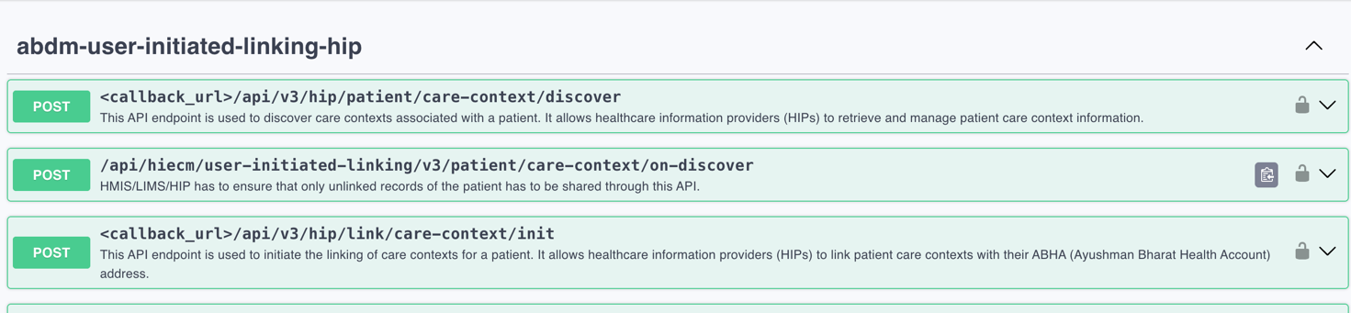

API Sequence Diagram - :

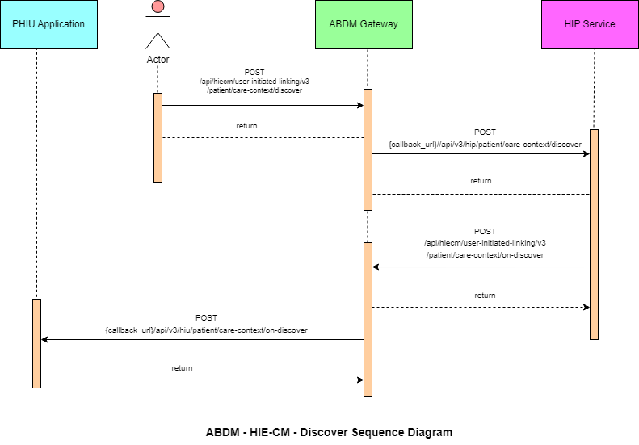
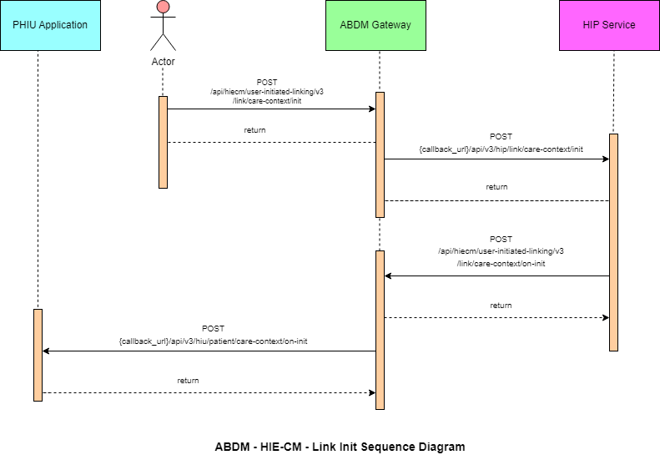

Support Deep Links

Functionality Overview
Deep Linking enables users who have visited a healthcare facility without sharing their ABHA Address to discover, link, and access their health records through an ABDM-compliant PHR application.

User Flow -:
- A patient visits a healthcare facility and registers using:
  - Name
  - Date of Birth
  - Gender
  - Mobile Number
The patient does not provide an ABHA Address during registration.
- If the healthcare facility is participating in the ABDM ecosystem, it notifies ABDM whenever a new health record is created for the patient. The notification contains:
  - Patient Mobile Number
  - Facility Identifier (HIPCODE)
- ABDM sends an SMS to the patient's registered mobile number containing a Deep Link.
- When the patient clicks the Deep Link:
  - A list of ABDM-approved ABHA Mobile Applications is displayed.
  - Only applications that have successfully completed functional and security testing and received production approval are shown.
  - Applications are displayed in a random order each time.
  - The displayed list is specific to the user's operating system (Android or iOS).
- After selecting an application:
  - If the application is already installed, it is launched directly.
  - If not installed, the user is redirected to the Google Play Store or Apple App Store.
  - The Deep Link passed to the application contains the HIPCODE.
- The ABHA Mobile Application assists new users in:
  - Registration
  - Creating an ABHA Address using Name, Date of Birth, Gender, and Mobile Number
- The application must detect that it was launched through a Deep Link and automatically initiate a Discovery Request for the HIPCODE received through the Deep Link.
- The application should guide users to enter the same:
  - Name
  - Date of Birth
  - Gender
  - Mobile Number
that was originally provided to the healthcare facility. Any mismatch may prevent successful record discovery.
- ABDM forwards the Discovery Request to the participating healthcare facility.
- The Discovery Request includes:
  - ABHA Address
  - Name
  - Date of Birth
  - Gender
  - Mobile Number
- The healthcare facility searches its records for matching patient information.
- If matching records are found:
  - The facility returns the available Care Contexts.
  - The PHR application displays the Care Contexts to the user.
- The user can:
  - Link Care Contexts with the ABHA Address
  - Provide required consent
  - Fetch health records
  - View records within the applicatio

Deep Link Support Requirements
To enable Deep Link support, the PHR application must submit the following details during Sandbox Exit approval:
Required Information | Example
Application Name | Aarogya Setu
Play Store URL. | https://play.google.com/store/apps/details?id=nic.goi.aarogyasetu&hl=en_IN
App Store URL | iOS App Link https://apps.apple.com/in/app/aarogyasetu/id1505825357

Important Notes
- The Deep Link format may vary between applications.
- Support for receiving the HIPCODE parameter is mandatory.
- The application must correctly process the HIPCODE and initiate the discovery workflow.

Demonstrating Deep Link Support During Sandbox Exit

Configuration
The PHR application must be configured on the ABDM Sandbox implementation environment.
If the application is provided as an APK for sideloading, only the "already installed application" scenario can be validated.

Test Environment
The EMR Sandbox application can be used to validate the Deep Linking flow.

Test Steps
- Login to the EMR Sandbox application.
- Register a new patient without providing an ABHA Address.
- Enter:
  - Name
  - Date of Birth
  - Gender
  - Mobile Number
- Create a new health record for the patient.
- An SMS notification containing a Deep Link is sent to the registered mobile number.
- Open the Deep Link.
- Verify application behavior for both scenarios:

Scenario 1: New User
- User selects the application from the Deep Link page.
- Application is downloaded and installed.
- User registers and creates an ABHA Address.
- Discovery is initiated automatically.
- Records are discovered, linked, and displayed successfully.

Scenario 2: Existing User
- Application is already installed.
- Application launches directly through the Deep Link.
- Discovery process starts automatically using the received HIPCODE.
- Available Care Contexts are displayed.
- User links records and accesses health information successfully.

Special Requirement for PHR Applications
Normally, a PHR application starts with:
- Login Screen, or
- Home Screen (for logged-in users)
When launched through an ABDM Deep Link, the application must bypass the standard flow and navigate the user directly to the Deep Link-specific workflow, enabling automatic record discovery and linkage based on the HIPCODE received in the Deep Link.

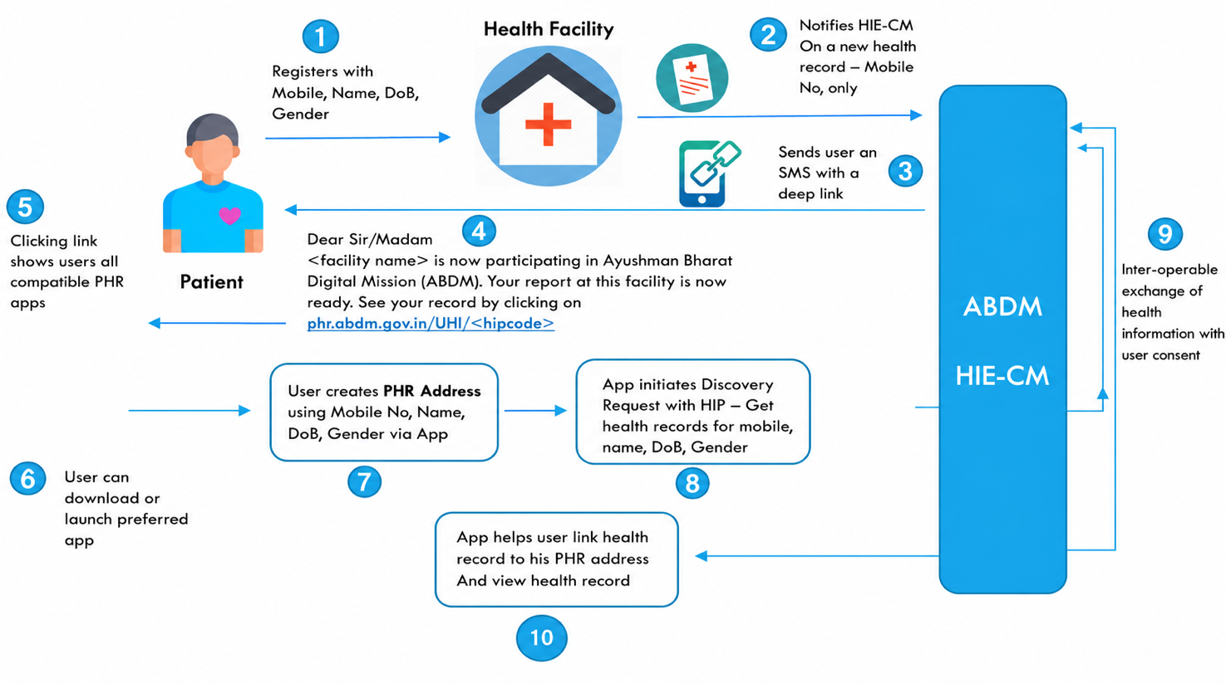

Test Cases -:
Deep Link Flow : Send SMS to patient mobile to initiate record linking and fetching in PHR app
S.No | Functionality | Test Case | Steps To Be Executed
1 | Mandatory | In case patient visits the health facility and do not provide the ABHA address for linking of health records. Then, ABDM compliant health facility will notify ABDM when there is a new health record created of the patient. ABDM will send a deep link SMS is to the patient’s mobile for fetching and viewing records in PHR app using User Initiated Linking Flow (Discovery Flow) | Patient visits a health facility and registers by providing Name, DateOfBirth, Gender and Mobile. Patient does not share any ABHA Address with the facility.
2 | Mandatory | In case patient visits the health facility and do not provide the ABHA address for linking of health records. Then, ABDM compliant health facility will notify ABDM when there is a new health record created of the patient. ABDM will send a deep link SMS is to the patient’s mobile for fetching and viewing records in PHR app using User Initiated Linking Flow (Discovery Flow) | If the Health Facility is participating in ABDM, then it will notify ABDM when there is a new health record for this patient. Only the mobile number and the ID of the facility is notified. Facilities are identified by the facility’s HIPCODE. This can be obtained by registering the facility using the Health Facility Registry and linking the facility to a ABDM approved Health Repository Provider Software.
3 | Mandatory | In case patient visits the health facility and do not provide the ABHA address for linking of health records. Then, ABDM compliant health facility will notify ABDM when there is a new health record created of the patient. ABDM will send a deep link SMS is to the patient’s mobile for fetching and viewing records in PHR app using User Initiated Linking Flow (Discovery Flow) | ABDM will send an SMS to the user with a deep link as shown below: Dear Madam/Sir, (facility name) is now participating in Ayushman Bharat Digital Mission (ABDM). Your report at this facility is now ready. See your record by clicking on phr.abdm.gov.in/uhi/(hipcode)
4 | Mandatory | In case patient visits the health facility and do not provide the ABHA address for linking of health records. Then, ABDM compliant health facility will notify ABDM when there is a new health record created of the patient. ABDM will send a deep link SMS is to the patient’s mobile for fetching and viewing records in PHR app using User Initiated Linking Flow (Discovery Flow) | Clicking on the link will show the list of all ABDM compliant PHR applications.

Post clicking on deep link by patient -:

Use Case 1: In case ABDM compliant PHR application is not installed in PHR app, then user is redirected to download and install it from play store/app store."
S.No | Functionality | Test Case | Steps To Be Executed
1 | Mandatory | Post clicking on deep link by patient | Check that, if no ABDM compliant PHR application is installed in phone - Navigate patient to play store / app store to install the selected PHR application from the list of all ABDM compliant PHR applications.
2 | Mandatory | Post clicking on deep link by patient | Check that, post installing the PHR app. New user is able to create the ABHA address and Password by providing basic details such as Name, DateOfBirth, Gender, Mobile Number, Address

Use Case 2: In case ABDM compliant PHR application is already installed in PHR app, then app will directly launch and initiate the User Initiated Linking (Discovery Flow)
S.No | Functionality | Test Case | Steps To Be Executed
1 | Mandatory | Post clicking on deep link by patient | Check that selected PHR app from the list of all ABDM compliant PHR app’s is launched successfully.
2 | Mandatory | Post clicking on deep link by patient | Check that post launch, PHR app initiates the discovery request with HIP where patient health records were created

Fetching and Display of Records

Functionality Overview
Every PHR Application must also implement the functionality of a Health Information User (HIU). The detailed process for implementing the HIU component is covered in Milestone 3.
Once a new Care Context is linked to a user's ABHA Address, the PHR application receives a notification through the ABDM ecosystem.
The record fetching process is as follows:
- The PHR App receives a notification when a new Care Context is linked to the user's ABHA Address.
- The PHR App creates a consent request for the linked health record and submits it to the HIE-CM.
- If an auto-approval policy is configured, the consent request is approved automatically.
- The PHR App initiates a Health Information Request along with the approved consent artefact.
- The corresponding HIP (Health Information Provider) shares the health records with the PHR App through the ABDM network.
- The PHR App securely stores the fetched health records for long-term access by the user.
- The application displays the retrieved health records in an organized and user-friendly manner, preferably arranged in chronological order.

Key Requirements
- Implement HIU functionality as per ABDM specifications.
- Receive notifications for newly linked Care Contexts.
- Generate and manage consent requests.
- Fetch records using approved consent.
- Provide secure long-term storage of health records.
- Display records clearly and chronologically within the application.
- Ensure compliance with ABDM security, privacy, and consent management guidelines.

Simplified Flow
Care Context Linked
│
▼
PHR App Receives Notification
│
▼
Create Consent Request
│
▼
Consent Approved
(Auto or Manual)
│
▼
Initiate Health Information Request
│
▼
HIP Shares Health Records
│
▼
Store Records Securely
│
▼
Display Records to User
(Chronological View)

This flow ensures that users can seamlessly access, store, and view their health records within the PHR application while maintaining consent-based data sharing as mandated by ABDM.

Test Cases -:

Sharing of health records with patient’s consent to the HIU

S.No | Functionality | Test Case | Steps To Be Executed
1 | Mandatory HIU should be able to view the health data of a APPROVED consent request | Check whether HIU individual is able to fetch health data for the consent request created for a patient and APPROVED by the patient. | Check whether HIU individual is able to fetch health data for the consent request created for a patient and APPROVED by the patient.(HI Type = DiagnostocReport Structured)
2 | Mandatory HIU should be able to view the health data of a APPROVED consent request | Check whether HIU individual is able to fetch health data for the consent request created for a patient and APPROVED by the patient. | Check whether HIU individual is able to fetch health data for the consent request created for a patient and APPROVED by the patient.(HI Type = DiagnostocReport Un-Structured)
3 | Mandatory HIU should be able to view the health data of a APPROVED consent request | Check whether HIU individual is able to fetch health data for the consent request created for a patient and APPROVED by the patient. | Check whether HIU individual is able to fetch health data for the consent request created for a patient and APPROVED by the patient.(HI Type = Prescription-Structured)
4 | Mandatory HIU should be able to view the health data of a APPROVED consent request | Check whether HIU individual is able to fetch health data for the consent request created for a patient and APPROVED by the patient. | Check whether HIU individual is able to fetch health data for the consent request created for a patient and APPROVED by the patient.(HI Type = Prescription-Un-Structured)
5 | Mandatory HIU should be able to view the health data of a APPROVED consent request | Check whether HIU individual is able to fetch health data for the consent request created for a patient and APPROVED by the patient. | Check whether HIU individual is able to fetch health data for the consent request created for a patient and APPROVED by the patient.(HI Type = DischargeSummary-Structured)
6 | Mandatory HIU should be able to view the health data of a APPROVED consent request | Check whether HIU individual is able to fetch health data for the consent request created for a patient and APPROVED by the patient. | Check whether HIU individual is able to fetch health data for the consent request created for a patient and APPROVED by the patient.(HI Type = DischargeSummary-Un-Structured)
7 | Mandatory HIU should be able to view the health data of a APPROVED consent request | Check whether HIU individual is able to fetch health data for the consent request created for a patient and APPROVED by the patient. | Check whether HIU individual is able to fetch health data for the consent request created for a patient and APPROVED by the patient.(HI Type = CosultingNote-Structured)
8 | Mandatory HIU should be able to view the health data of a APPROVED consent request | Check whether HIU individual is able to fetch health data for the consent request created for a patient and APPROVED by the patient. | Check whether HIU individual is able to fetch health data for the consent request created for a patient and APPROVED by the patient. (HI Type = CosultingNote-Un-Structured)
9 | Mandatory HIU should be able to view the health data of a APPROVED consent request | Check whether HIU individual is able to fetch health data for the consent request created for a patient and APPROVED by the patient. | Check whether HIU individual is able to fetch health data for the consent request created for a patient and APPROVED by the patient. (HI Type = Immunization record-Structured)
10 | Mandatory HIU should be able to view the health data of a APPROVED consent request | Check whether HIU individual is able to fetch health data for the consent request created for a patient and APPROVED by the patient. | Check whether HIU individual is able to fetch health data for the consent request created for a patient and APPROVED by the patient. (HI Type = Immunization record-Un-Structured)
11 | Mandatory HIU should be able to view the health data of a APPROVED consent request | Check whether HIU individual is able to fetch health data for the consent request created for a patient and APPROVED by the patient. | Check whether HIU individual is able to fetch health data for the consent request created for a patient and APPROVED by the patient/ (HI Type = Wellness Record-Structured)
12 | Mandatory HIU should be able to view the health data of a APPROVED consent request | Check whether HIU individual is able to fetch health data for the consent request created for a patient and APPROVED by the patient. | Check whether HIU individual is able to fetch health data for the consent request created for a patient and APPROVED by the patient. (HI Type = Wellness Record-Un-Structured)
13 | Mandatory HIU should be able to view the health data of a APPROVED consent request | Check whether HIU individual is able to fetch health data for the consent request created for a patient and APPROVED by the patient. | Check whether HIU individual is able to fetch health data for the consent request created for a patient and APPROVED by the patient. (HI Type = Health Record-Structured)
14 | Mandatory HIU should be able to view the health data of a APPROVED consent request | Check whether HIU individual is able to fetch health data for the consent request created for a patient and APPROVED by the patient. | Check whether HIU individual is able to fetch health data for the consent request created for a patient and APPROVED by the patient. (HI Type = Health Record-Un-Structured)

Tabs in PHR app (My Records/Linked Facility/Consents) - :

S.No | Functionality | Test Case | Steps To Be Executed
1 | Mandatory “Requests” section in the “Consents” tab of PHR app | 1) Requested - Not yet any action is taken by individual on consent request received from HIU to PHR app. | All request (consent / subscription / locker) sent by HIU to patiet are seen in “Requested” dropdown within “Requests” section of PHR app
2 | Mandatory “Requests” section in the “Consents” tab of PHR app | 2) Denied - Individual have “Denied” consent request received from HIU to PHR app. | All denied request (consent / subscription / locker) by patient are seen in “Denied” dropdown within “Requests” section of PHR app.
3 | Mandatory “Requests” section in the “Consents” tab of PHR app | 3) Expired - Requests is expired because patient have not acted on consent request received in PHR app within the time duration set by HIU | All expired request (consent / subscription / locker) by patient are seen in “Expired” dropdown within “Requests” section of PHR app.
4 | Mandatory “Approved” section in the “Consents” tab of PHR app | 1) Granted - Patient had granted the consent request received from HIU to PHR app | All granted request (consent / subscription / locker) by patient are seen in “Granted” dropdown within “Approved” section of PHR app.
5 | Mandatory “Approved” section in the “Consents” tab of PHR app | 2) Revoked - Patient had revoked consent requests after granting it in PHR app. | All revoked request (consent / subscription / locker) by patient are seen in “Revoked” dropdown within “Approved” section of PHR app.
6 | Mandatory View patient helth records in “My Records” tab of PHR app | To view records, post linking and fetching from healthcare providers (health locker, health facility and health programme) | Click on record fetched in the “My Records” tab
7 | Mandatory View patient helth records in “My Records” tab of PHR app | To view records, post linking and fetching from healthcare providers (health locker, health facility and health programme) | Details of records are viewed with attachment
8 | Mandatory View patient helth records in “My Records” tab of PHR app | To view records, post linking and fetching from healthcare providers (health locker, health facility and health programme) | Click on the attachment to view the health record / report in the device
9 | Mandatory “Linked Facility” tab in PHR app | Linked providers includes health lockers | health facility and health programme

Managing Consents -:

Functionality Overview -:

Consent Management in PHR Application

The primary role of a PHR Application is to enable users to securely manage their health data sharing preferences through a consent-based framework. The PHR App acts as the user's interface for reviewing, approving, denying, and managing consent requests received through the ABDM ecosystem.

PHR App Requirements
The PHR Application must provide the following consent management capabilities:

1. View Consent Requests
- Display all consent requests received by the user.
- Show relevant details such as:
  - Requesting HIU
  - Purpose of data access
  - Data types requested
  - Date range
  - Consent validity period
  - Request status

2. Modify Consent Requests
- Allow users to review and modify consent parameters before approval, where permitted.
- Users should be able to adjust:
  - Data access duration
  - Record date range
  - Data categories being shared
  - Consent validity period

3. Grant or Deny Consent
- Allow users to:
  - Approve a new consent request.
  - Reject a consent request.
- The user's decision should be communicated to the HIE-CM.

4. View Active Consents
- Display all currently granted consents.
- Show consent details and current status.
- Allow users to track which organizations have access to their health information.

5. Revoke Consent
- Allow users to withdraw previously granted consent at any time.
- Upon revocation, the consent status should be updated in the HIE-CM.
- Future data sharing under that consent must stop immediately.

Consent Management Flow
Consent Request Received
│
▼
Display Request to User
│
▼
Review & Modify Parameters
(Optional)
│
▼
┌───────────────┬───────────────┐
│ │ │
▼ ▼ ▼
Approve Reject Ignore
│
▼
Consent Granted
│
▼
Listed Under Active Consents
│
▼
User May Revoke Anytime
│
▼
Consent Status Updated
in HIE-CM

User Experience -:
Here’s a reference of an ABHA App to help you understand how PHR Applications can do this:

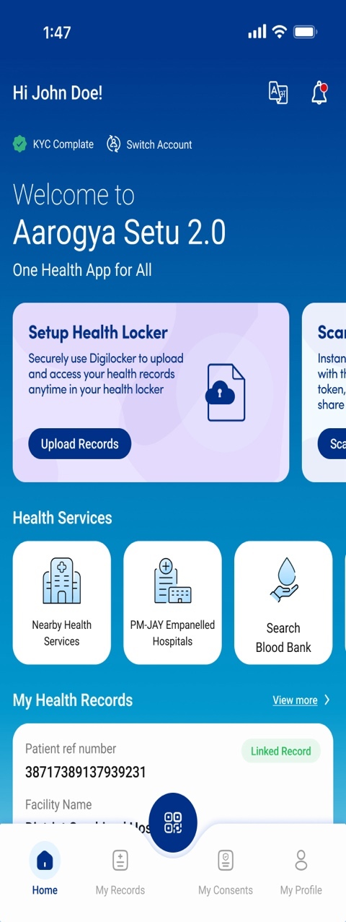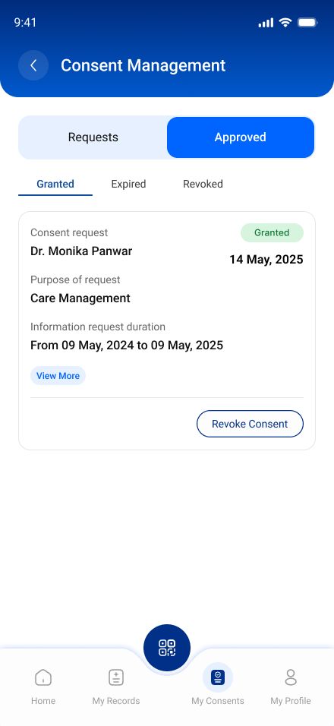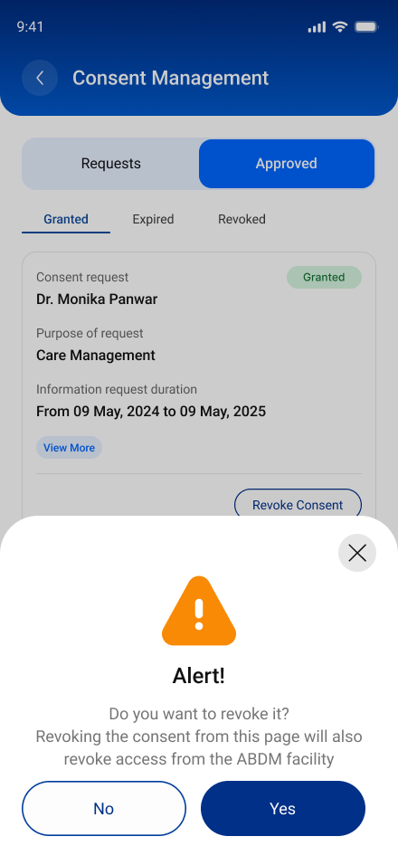

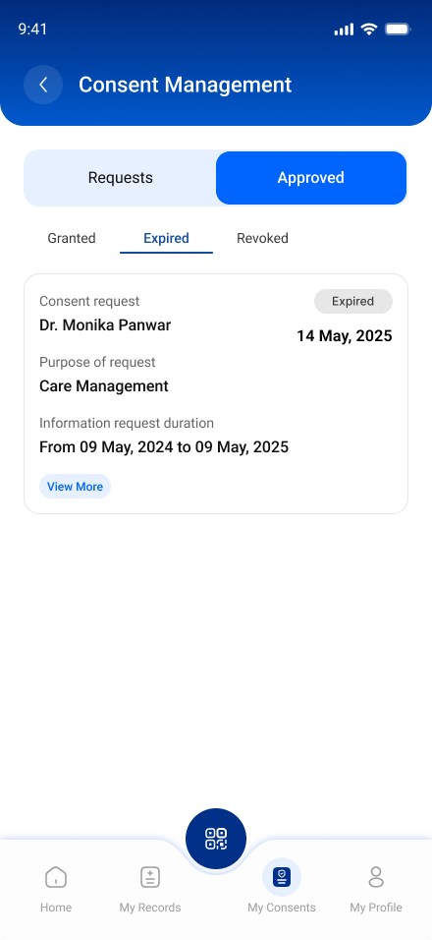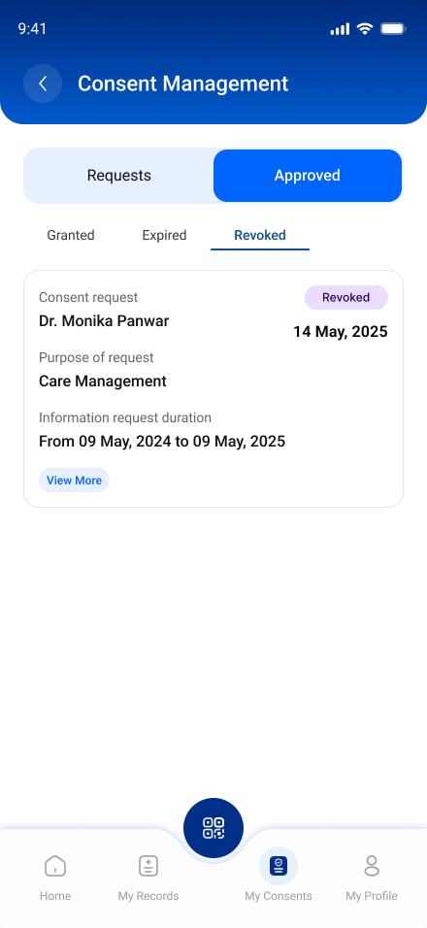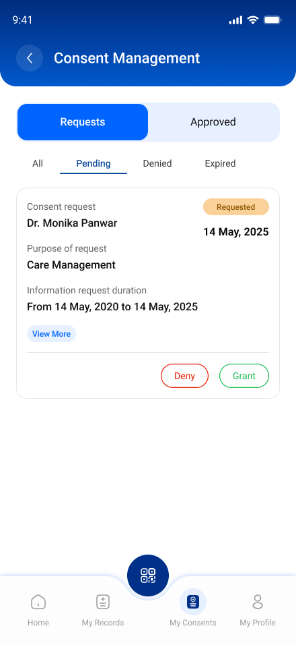

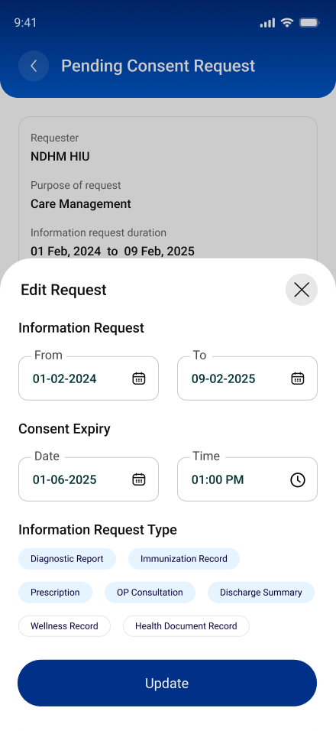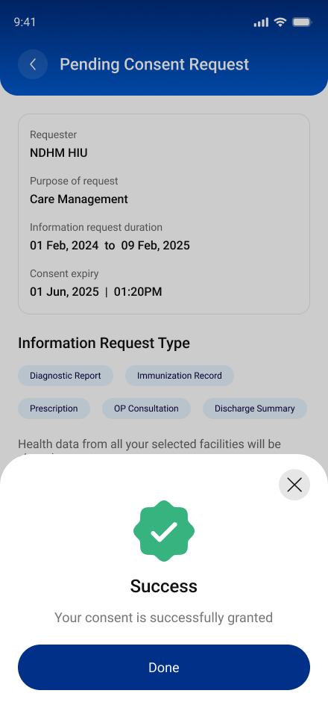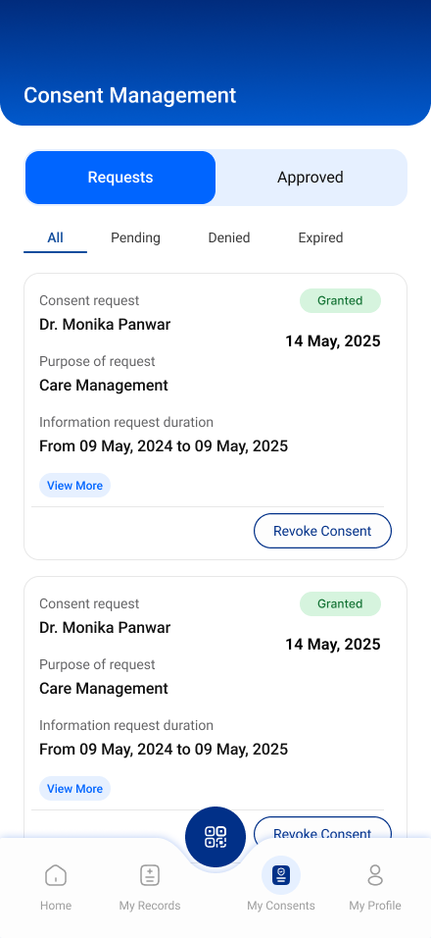

Test Cases-:

Tabs in PHR app (My Records/Linked Facility/Consents)

S.No | Functionality | Test Case | Steps To Be Executed
1 | Mandatory “Requests” section in the “Consents” tab of PHR app | 1) Requested - Not yet any action is taken by individual on consent request received from HIU to PHR app. | All request (consent / subscription / locker) sent by HIU to patiet are seen in “Requested” dropdown within “Requests” section of PHR app
2 | Mandatory “Requests” section in the “Consents” tab of PHR app | 2) Denied - Individual have “Denied” consent request received from HIU to PHR app. | All denied request (consent / subscription / locker) by patient are seen in “Denied” dropdown within “Requests” section of PHR app.
3 | Mandatory “Requests” section in the “Consents” tab of PHR app | 3) Expired - Requests is expired because patient have not acted on consent request received in PHR app within the time duration set by HIU | All expired request (consent / subscription / locker) by patient are seen in “Expired” dropdown within “Requests” section of PHR app.
4 | Mandatory “Approved” section in the “Consents” tab of PHR app | 1) Granted - Patient had granted the consent request received from HIU to PHR app | All granted request (consent / subscription / locker) by patient are seen in “Granted” dropdown within “Approved” section of PHR app.
5 | Mandatory “Approved” section in the “Consents” tab of PHR app | 2) Revoked - Patient had revoked consent requests after granting it in PHR app. | All revoked request (consent / subscription / locker) by patient are seen in “Revoked” dropdown within “Approved” section of PHR app.

API Information -:

https://sandbox.abdm.gov.in/sandbox/v3/new-documentation/swagger?integration_label=https://sandboxcms.abdm.gov.in/uploads/consent_management_data_flow12_jan_ded6ab978d

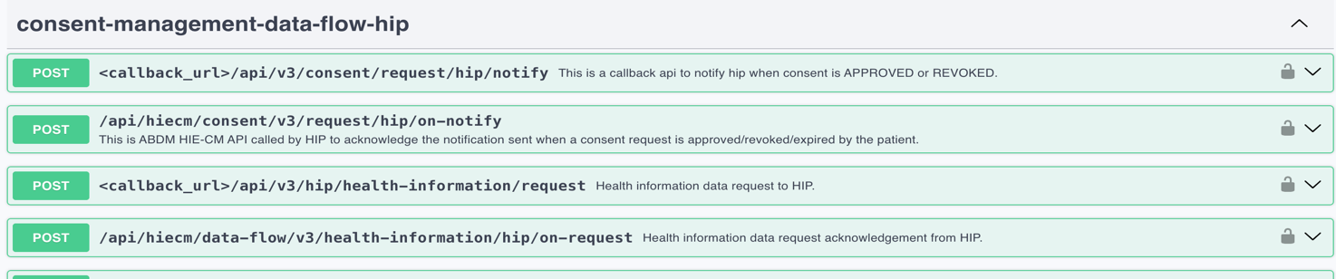

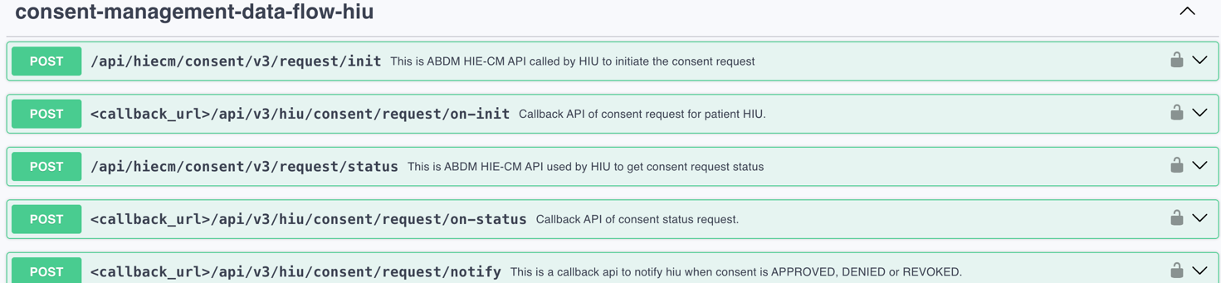

API Sequence Diagram -:

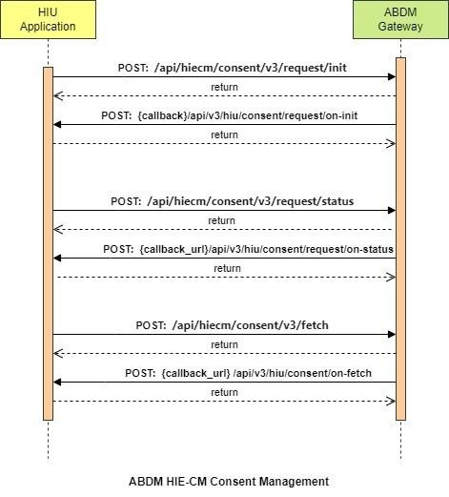

Uploading User Record (Locker) -:

Functionality Overview -:

- PHR Applications must allow users to scan and upload any records that they may have with them.
- This includes: physical records, output from IoT devices like BP meter, Glucose meters; and health devices like fit-bit, smartwatches etc
- The PHR application can decide the HI type of the record based on the contents or user input. If the HI type cannot be determined the PHR app is expected to use HI type as “HealthDocumentRecord”.
- The PHR Application needs to get a linking token in order to link these health records as a care context to the ABHA address. This is done using the APIs specified in Milestone 1.
- The PHR Application must add a care context to the ABHA address of the user for the uploaded records using HIP initiated linking.
- The PHR Application needs to ensure the uploaded records can be shared in the ABDM ecosystem. This is achieved by supporting the Health Information Transfer APIs which are specified as part of Milestone 2.

API Information -:

https://sandbox.abdm.gov.in/sandbox/v3/new-documentation/swagger?integration_label=https://sandboxcms.abdm.gov.in/uploads/subscription_1_9f3475b623

