- Description of all body parameters should be there.(Post swagger updation)

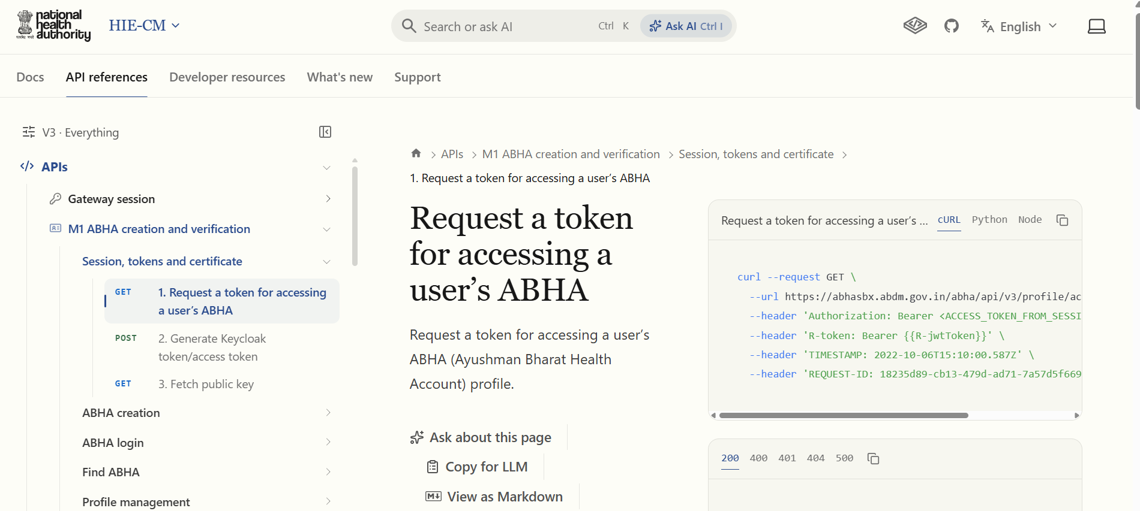

This API is for fetching profile, This should not be in session heading. In this heading, keep 2 APIs : Session API and Fetch Public Key API.
Keycloak term should be removed, Rename it to Generate Access Token.

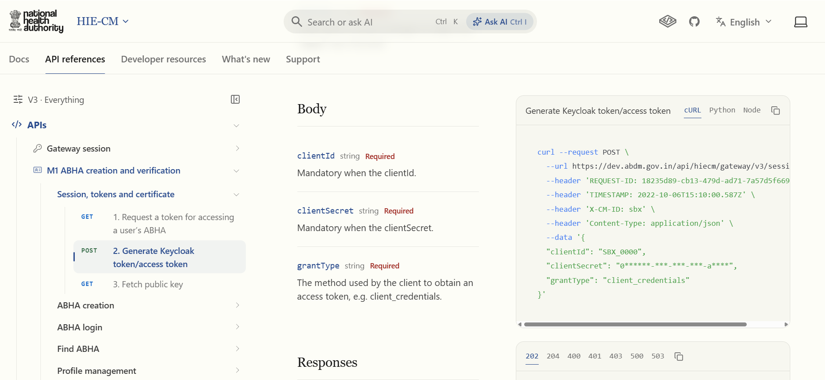

Inconsistent explanation of Client Id and Client secret.

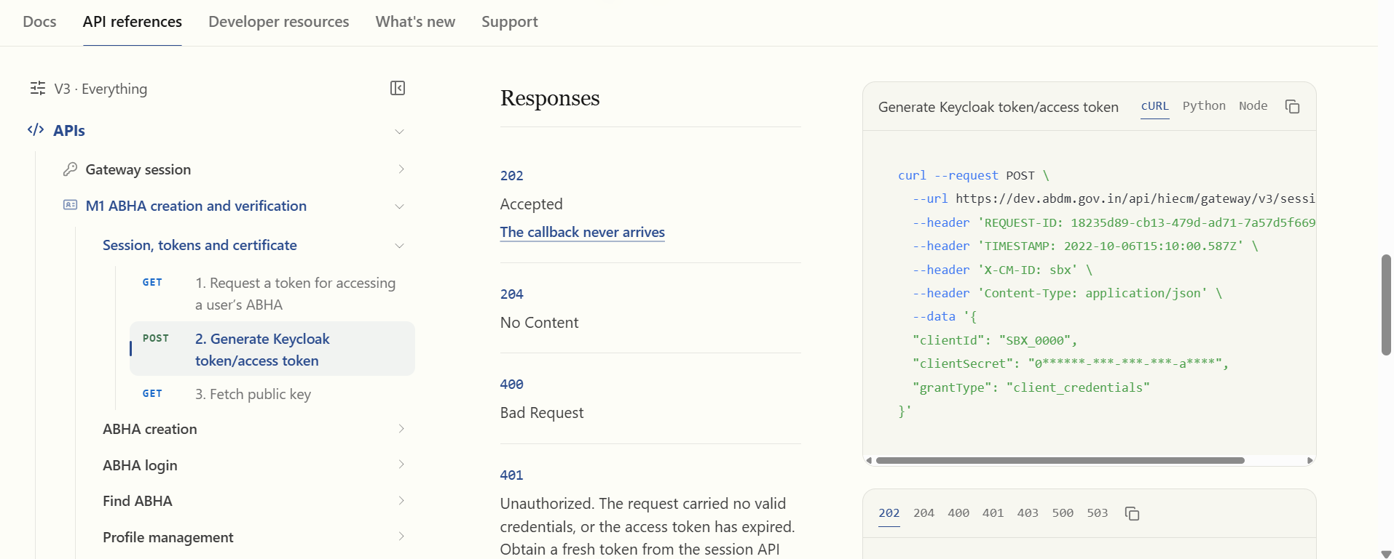

Why is there mention of callback in M1 Session API. Remove this.

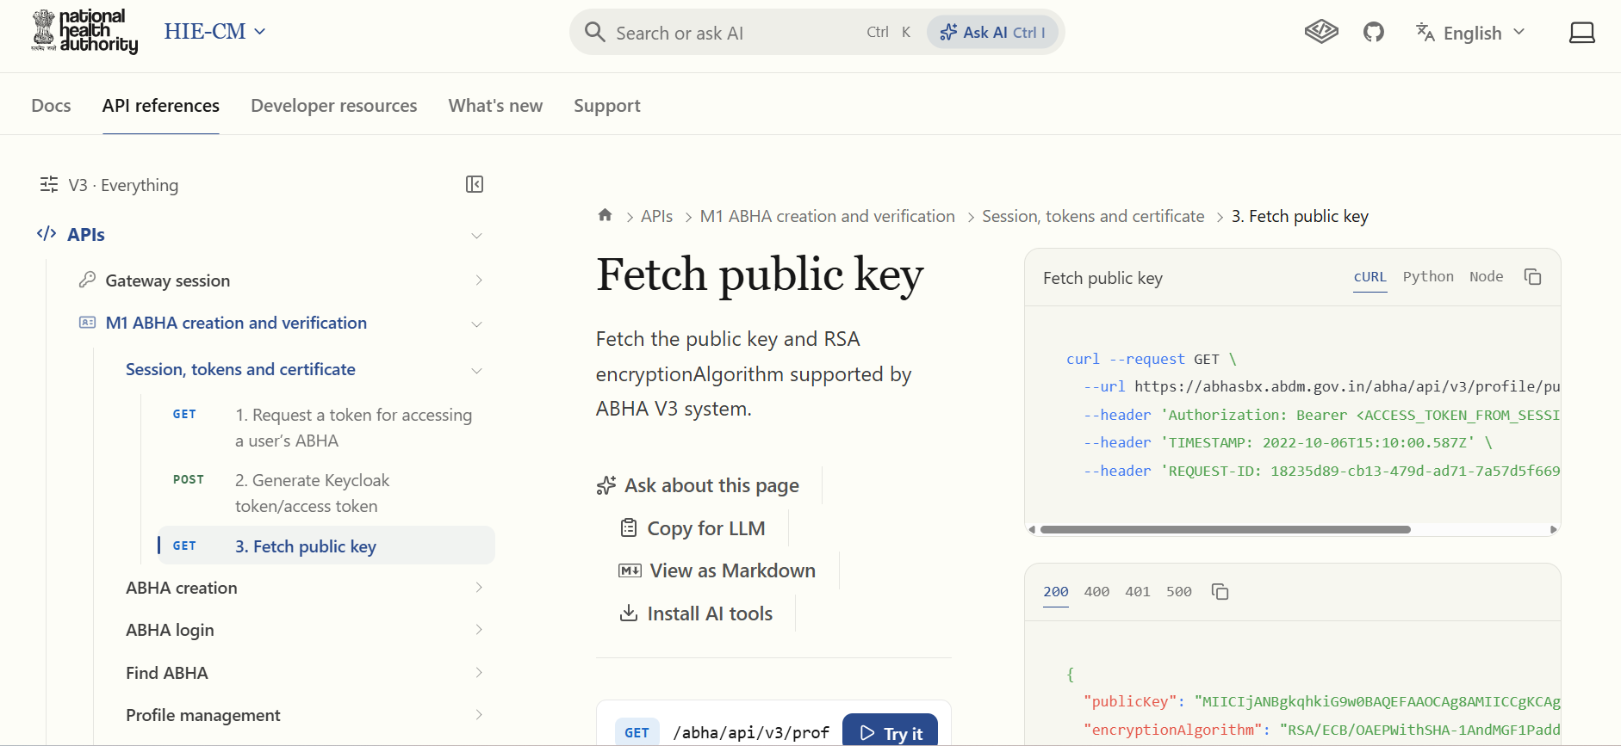
Correct this English. This API is for fetching Public key used for encryption of Aadhar, OTP, Mobile and other fields which require encryption.

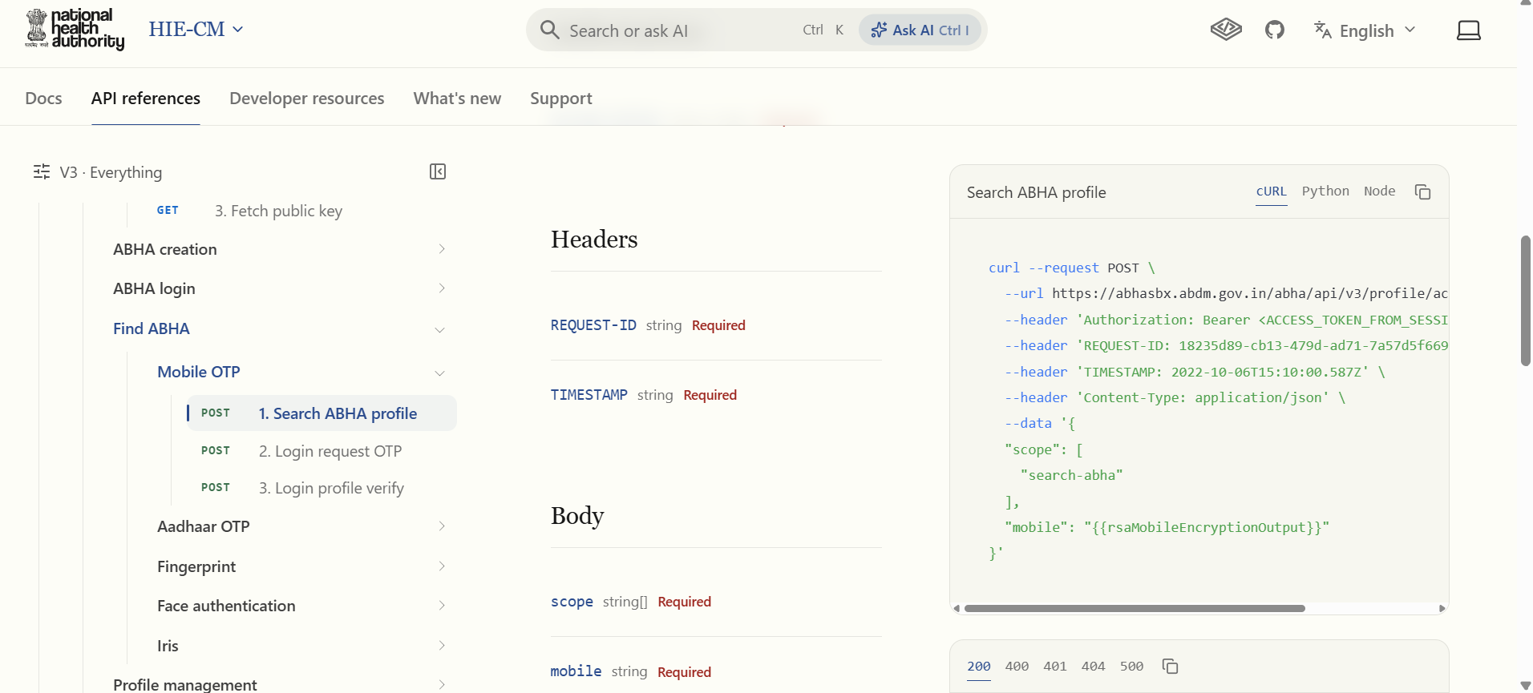
In scope search abha should be there.

