<https://pypi.org/project/deepsurvk/>

<https://github.com/arturomoncadatorres/deepsurvk/>

[https://github.com/nhabibi/deepsurvk/](https://github.com/nhabibi/deepsurvk/settings/access?guidance_task=)

Directory structure:

└── arturomoncadatorres-deepsurvk/

├── README.md

├── AUTHORS.rst

├── CONTRIBUTING.rst

├── environment.yml

├── HISTORY.rst

├── LICENSE

├── Makefile

├── MANIFEST.in

├── setup.cfg

├── setup.py

├── tox.ini

├── .editorconfig

├── .readthedocs.yml

├── .travis.yml

├── deepsurvk/

│ ├── __init__.py

│ ├── cli.py

│ ├── deepsurvk.py

│ ├── version.py

│ ├── applications/

│ │ └── recommender.py

│ ├── datasets/

│ │ ├── __init__.py

│ │ └── data/

│ │ ├── README.md

│ │ ├── metabric.h5

│ │ ├── rgbsg.h5

│ │ ├── simulated_gaussian.h5

│ │ ├── simulated_linear.h5

│ │ ├── simulated_treatment.h5

│ │ ├── support.h5

│ │ └── whas.h5

│ ├── network/

│ │ ├── deepsurvk.py

│ │ ├── optimization.py

│ │ └── parameters.py

│ ├── utils/

│ │ └── concordance.py

│ └── visualization/

│ ├── dsk_metrics.py

│ └── survival.py

├── docs/

│ ├── api.rst

│ ├── authors.rst

│ ├── conf.py

│ ├── contributing.rst

│ ├── deepsurvk.datasets.rst

│ ├── history.rst

│ ├── index.rst

│ ├── installation.rst

│ ├── make.bat

│ ├── Makefile

│ ├── readme.rst

│ ├── usage.rst

│ └── artwork/

├── examples/

│ ├── 00_understanding_deepsurv.ipynb

│ ├── 00_understanding_deepsurv.py

│ ├── 01_deepsurvk_quickstart.ipynb

│ ├── 01_deepsurvk_quickstart.py

│ ├── 02_treatment_recommendation.ipynb

│ ├── 02_treatment_recommendation.py

│ ├── 03_parameter_optimization.ipynb

│ └── 03_parameter_optimization.py

├── requirements/

│ ├── base_requirements.txt

│ ├── dev_requirements.txt

│ └── doc_requirements.txt

├── tests/

│ ├── __init__.py

│ └── test_deepsurvk.py

└── .github/

└── ISSUE_TEMPLATE/

├── bug_report.md

├── config.yml

├── documentation_improvement.md

├── feature_suggestion.md

└── other.md

pip install -r requirements.txt

tensorflow==2.2.0

keras==2.3.1

numpy==1.18.0

scipy==1.4.1

pandas==1.0.3

lifelines==0.24.15

matplotlib==3.2.1

seaborn==0.10.1

scikit-learn==0.22.2.post1

pydot==1.4.1

graphviz==0.14.1

autograd==1.3

autograd-gamma==0.5.0

python3 -m venv deepsurvk_fix

source deepsurvk_fix/bin/activate

pip install ipykernel

python -m ipykernel install --user --name=deepsurvk-fix --display-name "Python (deepsurvk-fix)"

!cd /path/to/deepsurvk_source_code

!pip install -e .

DeepSurvK Compatibility Table: Dependencies & Code Fixes

|  |  |  |  |  |
| --- | --- | --- | --- | --- |
| **📦 Package** | **🧓 Original Version** | **🆙 Newer Safe Version** | **⚠️ Required Code Fixes** | **💬 Notes** |
| tensorflow | 2.2.0 | 2.13.0 or 2.4.0 | ✅ None if using tensorflow.keras; ❌ Use tensorflow.keras, not standalone keras | Keep all imports as tensorflow.keras.X. Avoid keras.models. |
| keras | 2.3.1 | 2.13.1 | ✅ Use only for early versions; ❌ Remove entirely when using tensorflow.keras | Separate keras is deprecated in TF ≥2.6. Use tensorflow.keras only. |
| numpy | 1.18.0 | 1.24.3 | ✅ Replace np.int, np.float, np.bool → int, float, bool | NumPy 1.20+ removed deprecated aliases. |
| scipy | 1.4.1 | 1.10.1 | ✅ If using old functions like scipy.stats.chisqprob, refactor | Mostly backward compatible; some functions removed in 1.11+. |
| pandas | 1.0.3 | 1.5.3 or 2.0.0 | ✅ Watch for .ix[] usage → replace with .loc[] or .iloc[] | .ix[] deprecated; ensure indexing is modern. |
| lifelines | 0.24.15 | 0.30.0 | ✅ Watch for parameter renames in CoxPHFitter, etc. | Some arguments renamed; consult [lifelines changelog](https://lifelines.readthedocs.io). |
| matplotlib | 3.2.1 | 3.9.0 | ✅ Use plt.subplots() not plt.subplot() for clarity | Stable, just stylistic recommendations. |
| seaborn | 0.10.1 | 0.13.2 | ✅ Some plot args deprecated (ax, data) → use keyword args | Older versions accepted positional args more flexibly. |
| scikit-learn | 0.22.2 | 1.2.2 or 1.3.0 | ✅ Replace fit_transform(X, y=None) if X is sparse | Some signatures and returns changed slightly. |
| pydot | 1.4.1 | 3.0.4 | ❌ None | Should work without changes. |
| graphviz | 0.14.1 | 0.20.3 | ❌ None | Make sure system install of graphviz exists (brew install graphviz). |
| autograd | 1.3 | 1.7.0 | ✅ If custom gradients used, update decorators | Some changes in Jacobian/Hessian APIs. |
| autograd-gamma | 0.5.0 | 0.5.0 | ❌ None | No API changes. |

fix_legacy_apis.py**:** Fix Deprecated APIs in DeepSurvK Codebase

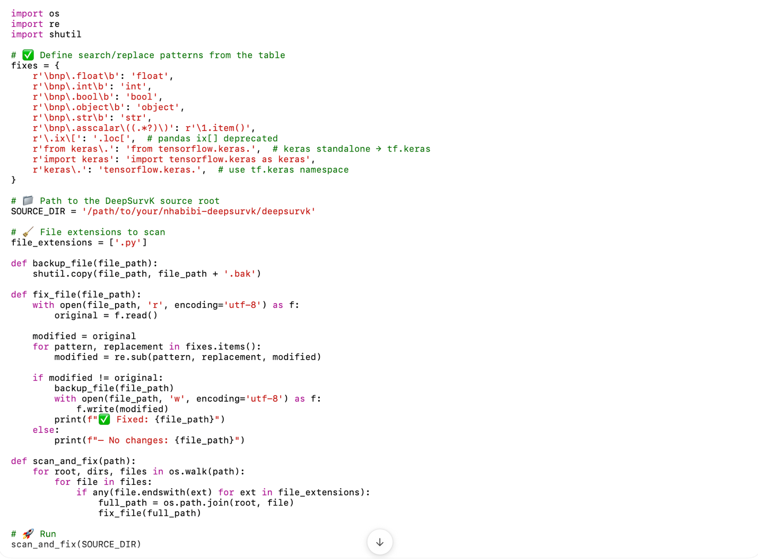

import os

import re

import shutil

# ✅ Define search/replace patterns from the table

fixes = {

r'\bnp\.float\b': 'float',

r'\bnp\.int\b': 'int',

r'\bnp\.bool\b': 'bool',

r'\bnp\.object\b': 'object',

r'\bnp\.str\b': 'str',

r'\bnp\.asscalar\((.*?)\)': r'\1.item()',

r'\.ix\[': '.loc[', # pandas ix[] deprecated

r'from keras\.': 'from tensorflow.keras.', # keras standalone → tf.keras

r'import keras': 'import tensorflow.keras as keras',

r'keras\.': 'tensorflow.keras.', # use tf.keras namespace

}

# 📁 Path to the DeepSurvK source root

SOURCE_DIR = '/path/to/your/nhabibi-deepsurvk/deepsurvk'

# 🧹 File extensions to scan

file_extensions = ['.py']

def backup_file(file_path):

shutil.copy(file_path, file_path + '.bak')

def fix_file(file_path):

with open(file_path, 'r', encoding='utf-8') as f:

original = f.read()

modified = original

for pattern, replacement in fixes.items():

modified = re.sub(pattern, replacement, modified)

if modified != original:

backup_file(file_path)

with open(file_path, 'w', encoding='utf-8') as f:

f.write(modified)

print(f"✅ Fixed: {file_path}")

else:

print(f"— No changes: {file_path}")

def scan_and_fix(path):

for root, dirs, files in os.walk(path):

for file in files:

if any(file.endswith(ext) for ext in file_extensions):

full_path = os.path.join(root, file)

fix_file(full_path)

# 🚀 Run

scan_and_fix(SOURCE_DIR)