Rhamnose-Only Soft-Sensor Model Comparison
Academic comparison of input strategies and model families for rhamnose concentration prediction. All Rha (5) examples are excluded to match the current corrected sensitivity-analysis workflow.

Executive Result
The best cross-validated result is EEM full + PARAFAC + Random forest (n=250,max_depth=4), with mean RMSE 0.3438 g/L and mean R2 0.193.

Pipeline
- Raw inputs: EEM matrices, Raman spectra, processed Raman features, EEM PARAFAC scores, and fused feature tables.
- Preprocessing: missing-value imputation, variance filtering, univariate feature selection inside each training fold, standard scaling, and grouped train/test splits by plate/well/treatment label.
- Models: statistical baselines and linear models, chemometric PLS/PCR models, classical ML models, XGBoost, and a neural-network MLP regressor.
- Outputs: RMSE, MAE, R2, best-strategy tables, predicted-vs-true plots, residual diagnostics, and academic interpretation.

Figures
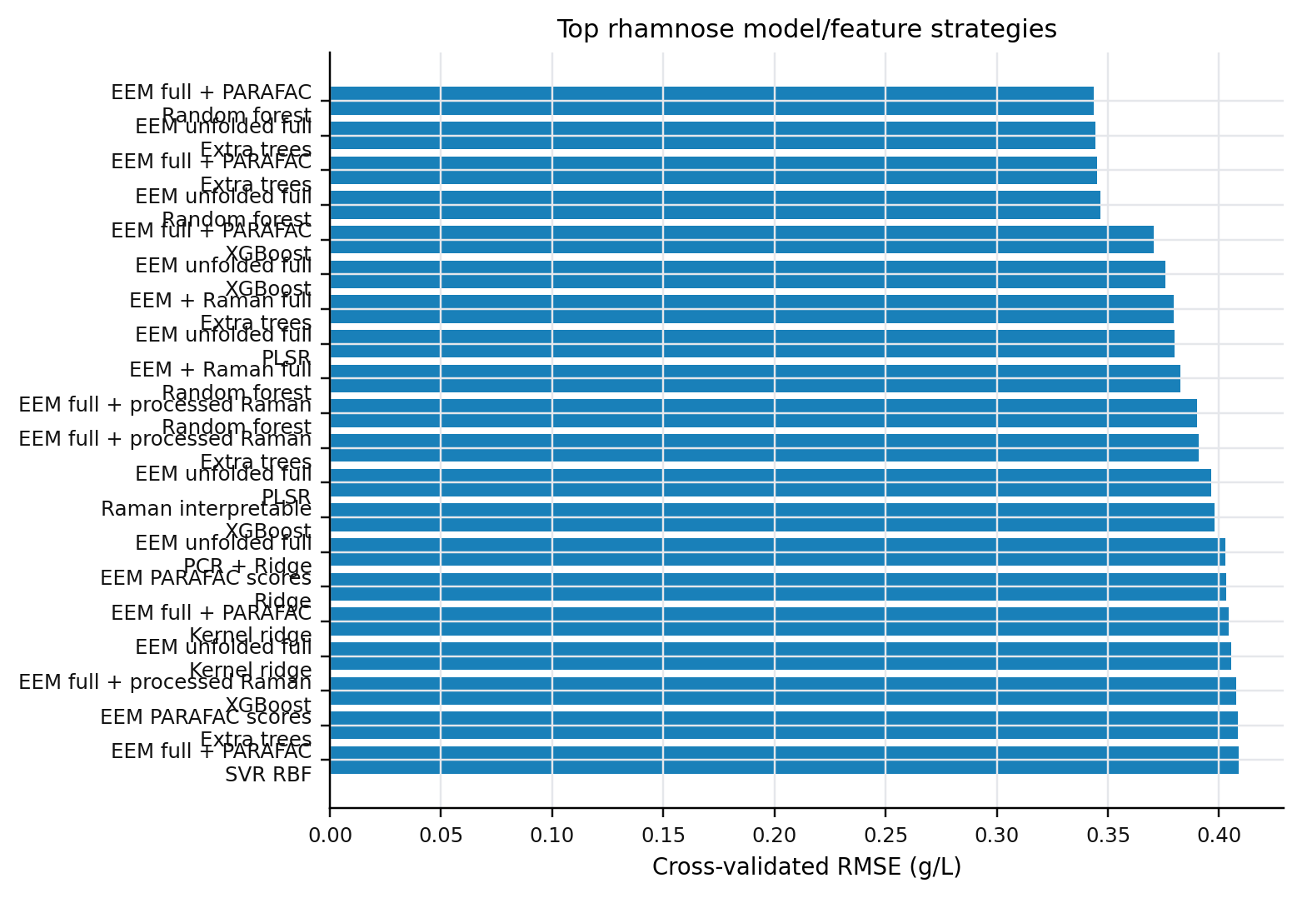
Figure 1. Top 20 rhamnose model and input-strategy combinations ranked by grouped cross-validated RMSE.
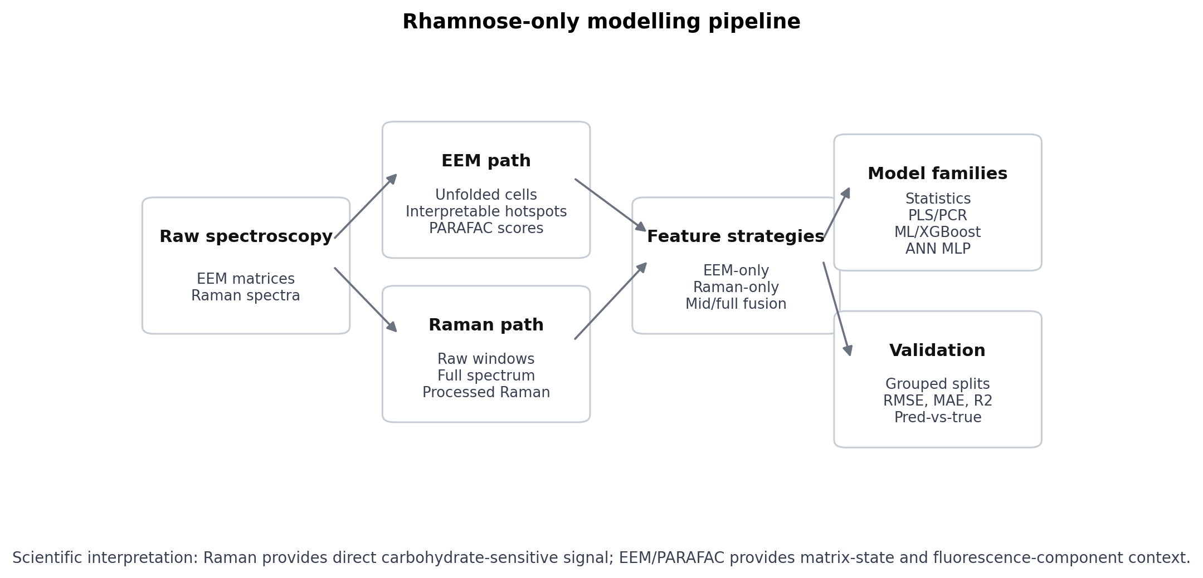
Figure 2. End-to-end rhamnose-only modelling pipeline.
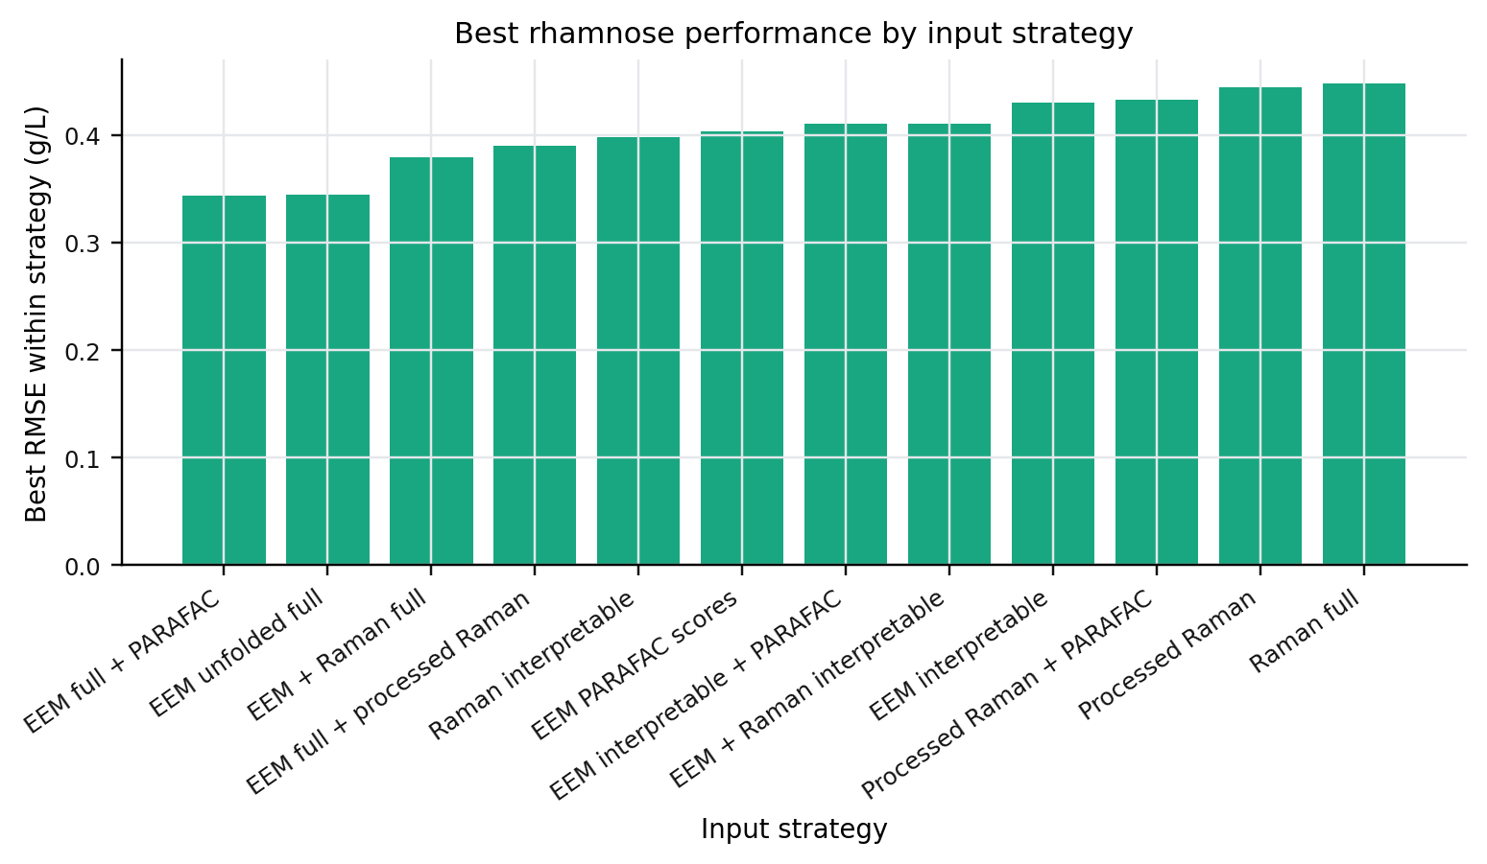
Figure 3. Best model within each input strategy.
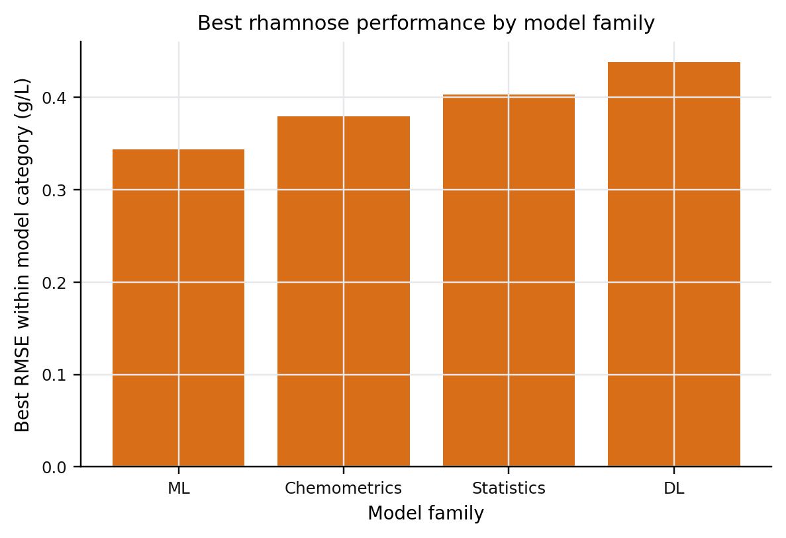
Figure 4. Best model within each model family.
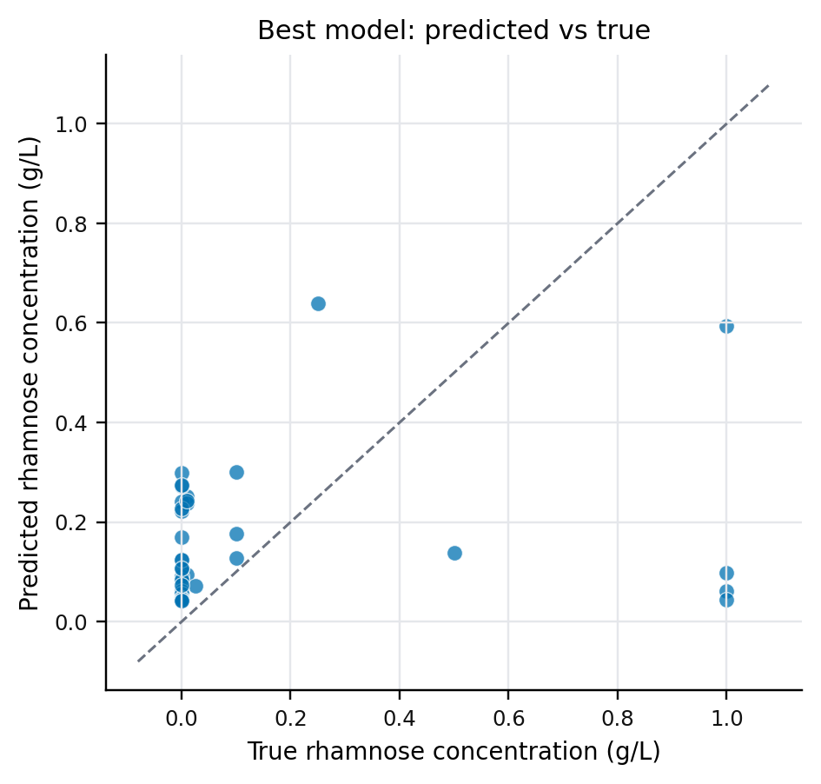
Figure 5. Predicted versus true rhamnose concentration for the best model.
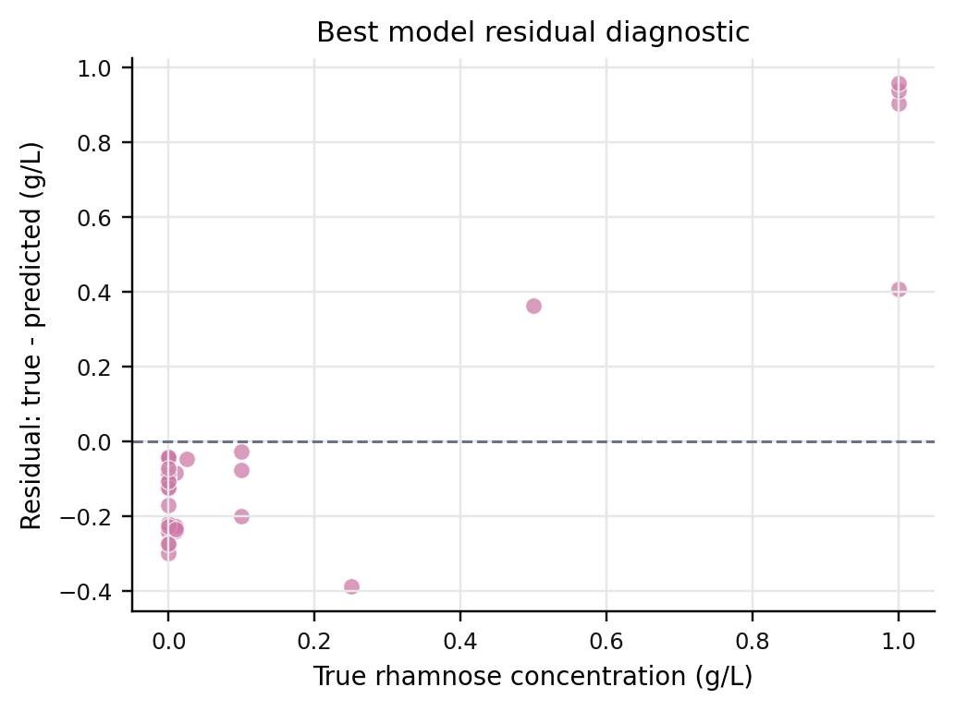
Figure 6. Residual diagnostic for the best model.

Best Models by Input Strategy
Input strategy | Model family | Best model | RMSE | R2
EEM full + PARAFAC | ML | Random forest | 0.3438 | 0.193
EEM unfolded full | ML | Extra trees | 0.3445 | 0.198
EEM + Raman full | ML | Extra trees | 0.3794 | 0.026
EEM full + processed Raman | ML | Random forest | 0.3901 | -0.015
Raman interpretable | ML | XGBoost | 0.3981 | 0.001
EEM PARAFAC scores | Statistics | Ridge | 0.4032 | -0.001
EEM interpretable + PARAFAC | Statistics | Ridge | 0.4104 | -0.054
EEM + Raman interpretable | ML | XGBoost | 0.4109 | -0.015
EEM interpretable | ML | Extra trees | 0.4305 | -0.124
Processed Raman + PARAFAC | Chemometrics | PCR + Ridge | 0.4325 | -0.128
Processed Raman | Chemometrics | PCR + Ridge | 0.4446 | -0.139
Raman full | Statistics | Mean baseline | 0.4477 | -0.155

Top Ranked Configurations
Input strategy | Family | Model | Config | RMSE | R2
EEM full + PARAFAC | ML | Random forest | n=250,max_depth=4 | 0.3438 | 0.193
EEM unfolded full | ML | Extra trees | n=250,max_depth=4 | 0.3445 | 0.198
EEM full + PARAFAC | ML | Extra trees | n=250,max_depth=4 | 0.3450 | 0.195
EEM unfolded full | ML | Random forest | n=250,max_depth=4 | 0.3467 | 0.178
EEM full + PARAFAC | ML | XGBoost | n=250,depth=2,eta=0.05 | 0.3708 | 0.042
EEM unfolded full | ML | XGBoost | n=250,depth=2,eta=0.05 | 0.3760 | 0.006
EEM + Raman full | ML | Extra trees | n=250,max_depth=4 | 0.3794 | 0.026
EEM unfolded full | Chemometrics | PLSR | n_components=5 | 0.3798 | 0.078
EEM + Raman full | ML | Random forest | n=250,max_depth=4 | 0.3826 | -0.014
EEM full + processed Raman | ML | Random forest | n=250,max_depth=4 | 0.3901 | -0.015
EEM full + processed Raman | ML | Extra trees | n=250,max_depth=4 | 0.3909 | 0.024
EEM unfolded full | Chemometrics | PLSR | n_components=2 | 0.3966 | -0.022
Raman interpretable | ML | XGBoost | n=250,depth=2,eta=0.05 | 0.3981 | 0.001
EEM unfolded full | Chemometrics | PCR + Ridge | n_components=5 | 0.4028 | -0.052
EEM PARAFAC scores | Statistics | Ridge | alpha=10 | 0.4032 | -0.001
EEM full + PARAFAC | ML | Kernel ridge | rbf,alpha=0.1 | 0.4043 | 0.025
EEM unfolded full | ML | Kernel ridge | rbf,alpha=0.1 | 0.4055 | 0.018
EEM full + processed Raman | ML | XGBoost | n=250,depth=2,eta=0.05 | 0.4076 | -0.097
EEM PARAFAC scores | ML | Extra trees | n=250,max_depth=4 | 0.4083 | -0.016
EEM full + PARAFAC | ML | SVR RBF | C=10,epsilon=0.05 | 0.4087 | -0.056

Academic Analysis
The comparison is strongest as a calibration and method-selection study. Raman should be interpreted as the most direct rhamnose-sensitive modality, while EEM and PARAFAC features provide indirect matrix-state and fluorescence-component information.
The main limitation is target quality: the current labels are standards and known spike concentrations parsed from treatment labels. Quantitative culture-sample HPLC concentrations are still required before claiming biological deployment performance.

