User Housing Preferences Analysis Project (Azura + PowerPI)
_________________________________________________

TOOLS AND TECHNOLOGY:
—------------------------------------
Data Ingestion: Azure Data Factory (ADF)
Data Storage: Azure Data Lake Storage (Gen2)
Data Processing: Azure Databricks (PySpark)
Data Visualization: Microsoft Power BI

Technical Architecture & Data Pipeline:
—-----------------------------------------------------
First, We collected the data from the Airbnb website By doing Webscraping on the website to get the data we need.

Second, We used the pipeline following a modern Medallion Architecture (Bronze-Silver-Gold) implemented entirely on Microsoft Azure.
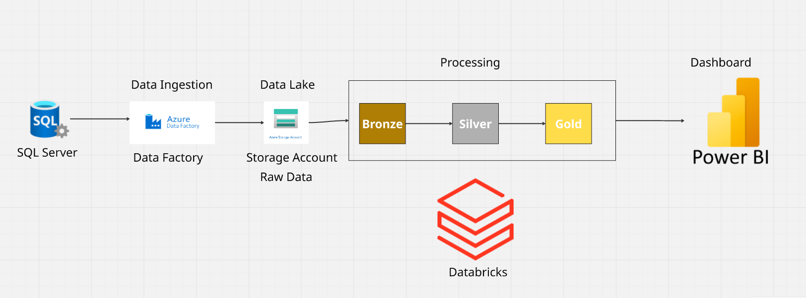

1. Data Ingestion (Source → Bronze Layer)
Raw data from the source tables was ingested using Azure Data Factory (ADF) pipelines. This raw, untouched data was landed in Azure Data Lake Storage (Gen2) as the Bronze layer.

2. Pipeline Description (Using Bronze → Silver → Gold)

🟫 Bronze Layer — Raw Airbnb Data Collection
In the Bronze layer, we collected raw housing data directly from Airbnb.
This data included listings, host information, pricing details, location metadata, and availability calendars.
At this stage, the data was stored exactly as received, without any cleaning or transformation.

⚪ Silver Layer — Data Cleaning and Standardization
In the Silver layer, we processed and cleaned the collected Airbnb datasets.
This included:
- removing duplicates
- handling missing or invalid values
- standardizing column names and formats
- joining related datasets (listings, hosts, pricing, etc.)
- enforcing a clean and consistent schema
The goal of this stage was to create a reliable and analytics-ready dataset.

🟨 Gold Layer — Curated Dataset for Power BI Visualization
In the Gold layer, we prepared the final curated dataset specifically for business analysis and visualization in Power BI.
This included:
- creating aggregated metrics (average price, occupancy rate, host statistics)
- generating location-based insights
- structuring the dataset for efficient visual reporting
This final Gold dataset was then used to build dashboards and visual insights in Power BI.

📊 Airbnb Data Analytics Dashboard
An interactive web dashboard designed to analyze Airbnb market data across various cities. The application allows users to select a city and instantly explore insights through dynamic visualizations, pricing trends, availability patterns, and AI-powered recommendations. Built for data-driven decision-making, the dashboard provides a clear and intuitive interface for hosts, analysts, and researchers.

🏠Choosing the region

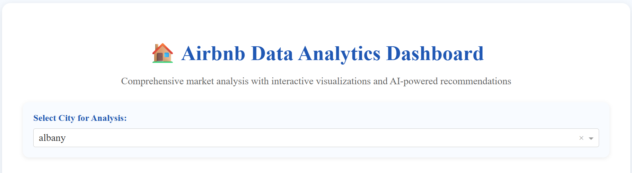

🌍 Geographic Distribution of Listings
An interactive map showing the location of Airbnb listings in the selected city, with marker color and size representing price levels.

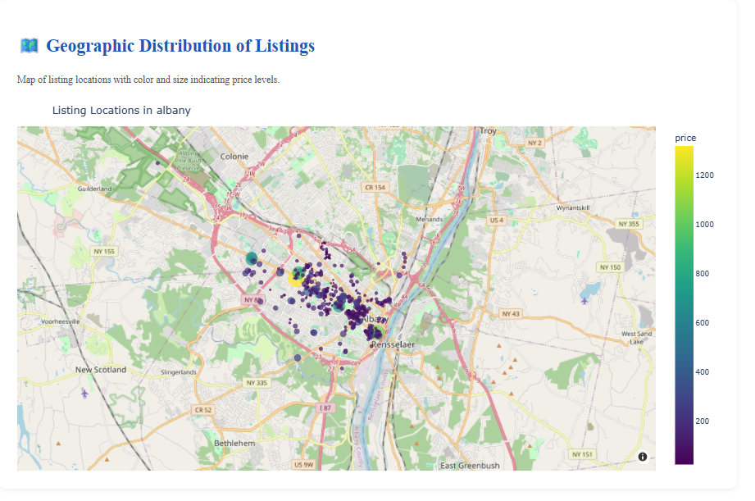

💰 Price Distribution Analysis
A histogram that visualizes the range of nightly prices in the selected city, helping users identify common price levels and spot outliers in the market.

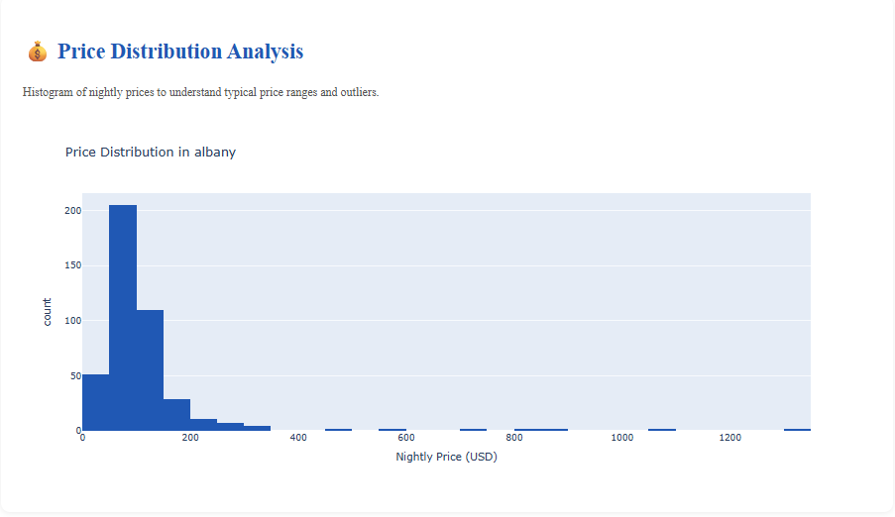

🏡 Property Type Market Composition

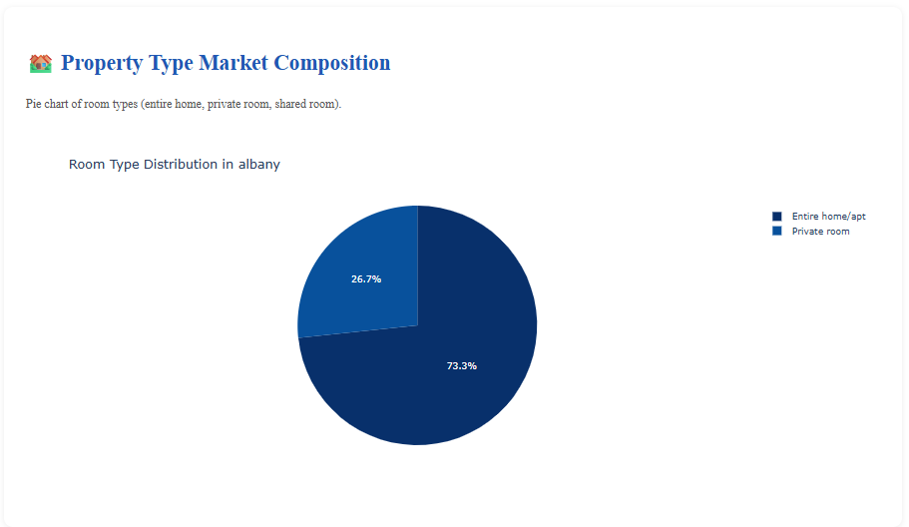

🌟 Guest Activity & Booking Frequency
This box plot shows how many reviews listings in Albany receive each month, serving as an indicator of booking activity. Most listings get only a few monthly reviews, while a few have much higher guest engagement, shown by the outliers.
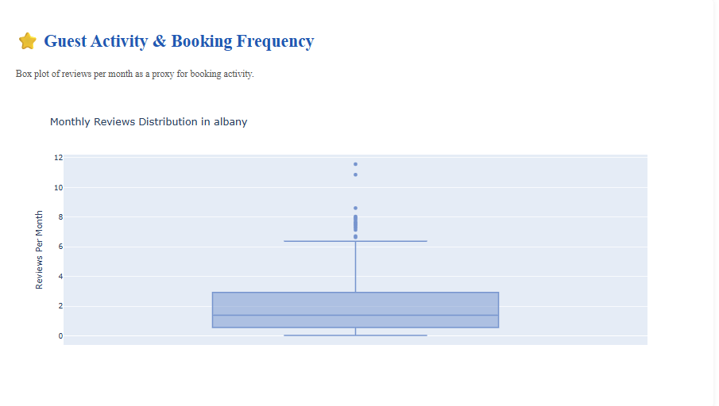

📊 Quick Market Summary
This section provides a snapshot of Albany’s Airbnb market. The average nightly price is about $111, and listings receive around 2 reviews per month, indicating moderate guest activity.

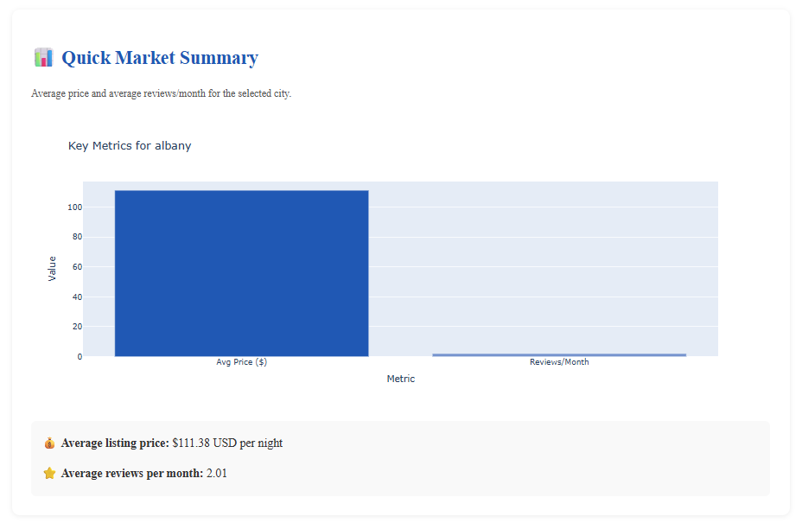

`

🤖 Personalized AI Recommendation
This tool generates tailored Airbnb insights based on the user’s age, gender, and hosting experience to help guide smarter hosting decisions.

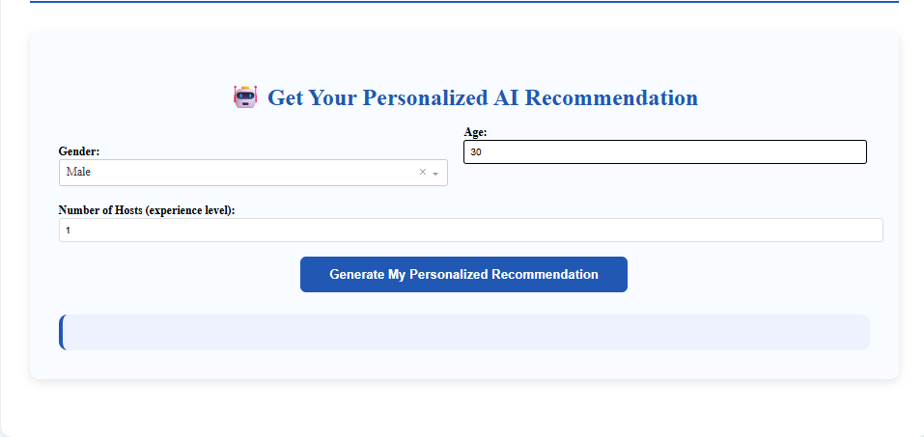

👤 Authors
Omar Farag
Bassem Ahmed
Rana Ehab
Mohamed Mosad

