Brain–Computer Interface for Assistive Control:
A Fine-Tuned MIRepNet and P300 Hybrid System with Real-Time Simulation

1. Introduction
People with severe motor disabilities (ALS, spinal cord injuries, paralysis) often lose the ability to communicate or control their environment. Traditional assistive tools (eye-tracking, letter boards) are slow and uncomfortable.
This project proposes a Brain–Computer Interface (BCI) that uses EEG signals and AI models to classify motor imagery (MI) and P300 responses, enabling users to perform essential tasks such as:
- Moving a wheelchair (forward, left, right, stop).
- Simple communication (yes/no).
- Safe control with an emergency stop mechanism.
We will fine-tune a state-of-the-art foundation model (MIRepNet) on public EEG datasets, implement a real-time simulation pipeline, and demonstrate practical assistive control without physical hardware.

2. Problem Statement
Current EEG-based assistive systems face key challenges:
- Noise and artifacts in EEG signals reduce accuracy.
- Single-task focus: most systems are either spellers (typing) or wheelchair demos, rarely hybrid.
- Offline evaluation: many studies stop at classification accuracy without building interactive systems.
- Lack of safety: unintended movements can be dangerous in wheelchair use.

3. Objectives
- Fine-tune MIRepNet on motor imagery datasets (BCI Competition IV-2a, PhysioNet EEG Motor Imagery).
- Implement multi-class classification (Forward, Left, Right, Stop).
- Integrate a binary P300-based Yes/No classifier as an emergency stop.
- Build a real-time simulation of wheelchair control.
- Evaluate performance with accuracy, latency, and usability metrics.

4. System Design and Architecture
4.1 Data Source
Since we do not have access to real EEG devices, we will rely entirely on public datasets that are widely used in BCI research. These datasets are recorded from real human subjects performing motor imagery or P300 tasks.
We can simulate real-time data by streaming dataset signals using Lab Streaming Layer (LSL), so our system can be tested as if it were running on live EEG input.
Datasets to be used:
- BCI Competition IV-2a (Motor Imagery Dataset)
  - Tasks: Left hand, right hand, both feet, tongue.
  - Link: BNCI Horizon 2020 – Dataset 004-2014
- PhysioNet EEG Motor Movement/Imagery Dataset (EEGMMIDB)
  - Tasks: Motor imagery and executed movement (hands, feet).
  - Link: PhysioNet EEGMMIDB
- BNCI Horizon 2020 additional datasets
  - Large-scale EEG datasets for BCI research.
  - Link: BNCI Horizon 2020

4.2 Baseline vs Fine-Tuned Model
- Baseline Models (EEGNet, FBCNet)
  - Chosen because they are lightweight CNN-based architectures widely used as benchmarks in BCI research.
  - EEGNet: Designed specifically for EEG classification with very few parameters, good for small datasets.
  - FBCNet: Incorporates filter banks to capture frequency-specific features in EEG.
  - They provide a fair reference point to show the improvements achieved by transfer learning with MIRepNet.
- Fine-Tuned Model (MIRepNet)
  - A foundation model trained on large EEG corpora using supervised and self-supervised learning.
  - Designed to capture spatial, spectral, and temporal EEG patterns.
  - By fine-tuning, we adapt the pretrained knowledge to our motor imagery dataset, expecting improved performance compared to baseline models.
  - GitHub Link: staraink/MIRepNet: The first EEG foundation model explicitly tailored for the motor imagery (MI) paradigm.
  - Huggingface Link: Paper page - MIRepNet: A Pipeline and Foundation Model for EEG-Based Motor Imagery Classification

4.3 Modules Overview
- Data Source: Public EEG datasets → simulated as real-time input.
- Preprocessing: Signal filtering, artifact removal, segmentation.
- Feature Extraction: Embeddings from MIRepNet.
- Classification:
  - Multi-class MI classifier (Forward, Left, Right, Stop).
  - Binary P300 classifier (Yes/No → Emergency Stop).
- Decision Layer: Threshold + majority voting.
- Application Layer: Wheelchair simulator interface.
- Monitoring & Logging: Accuracy, latency, error analysis.

4.4 Diagrams
System Architecture Diagram
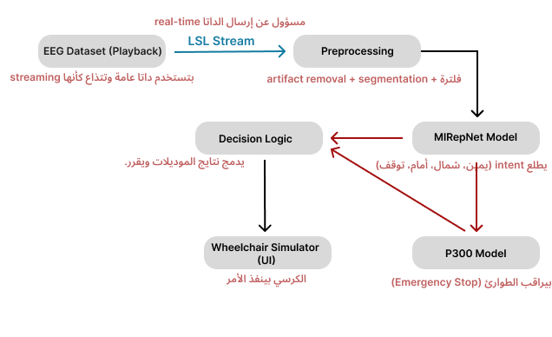
Activity Flow Diagram
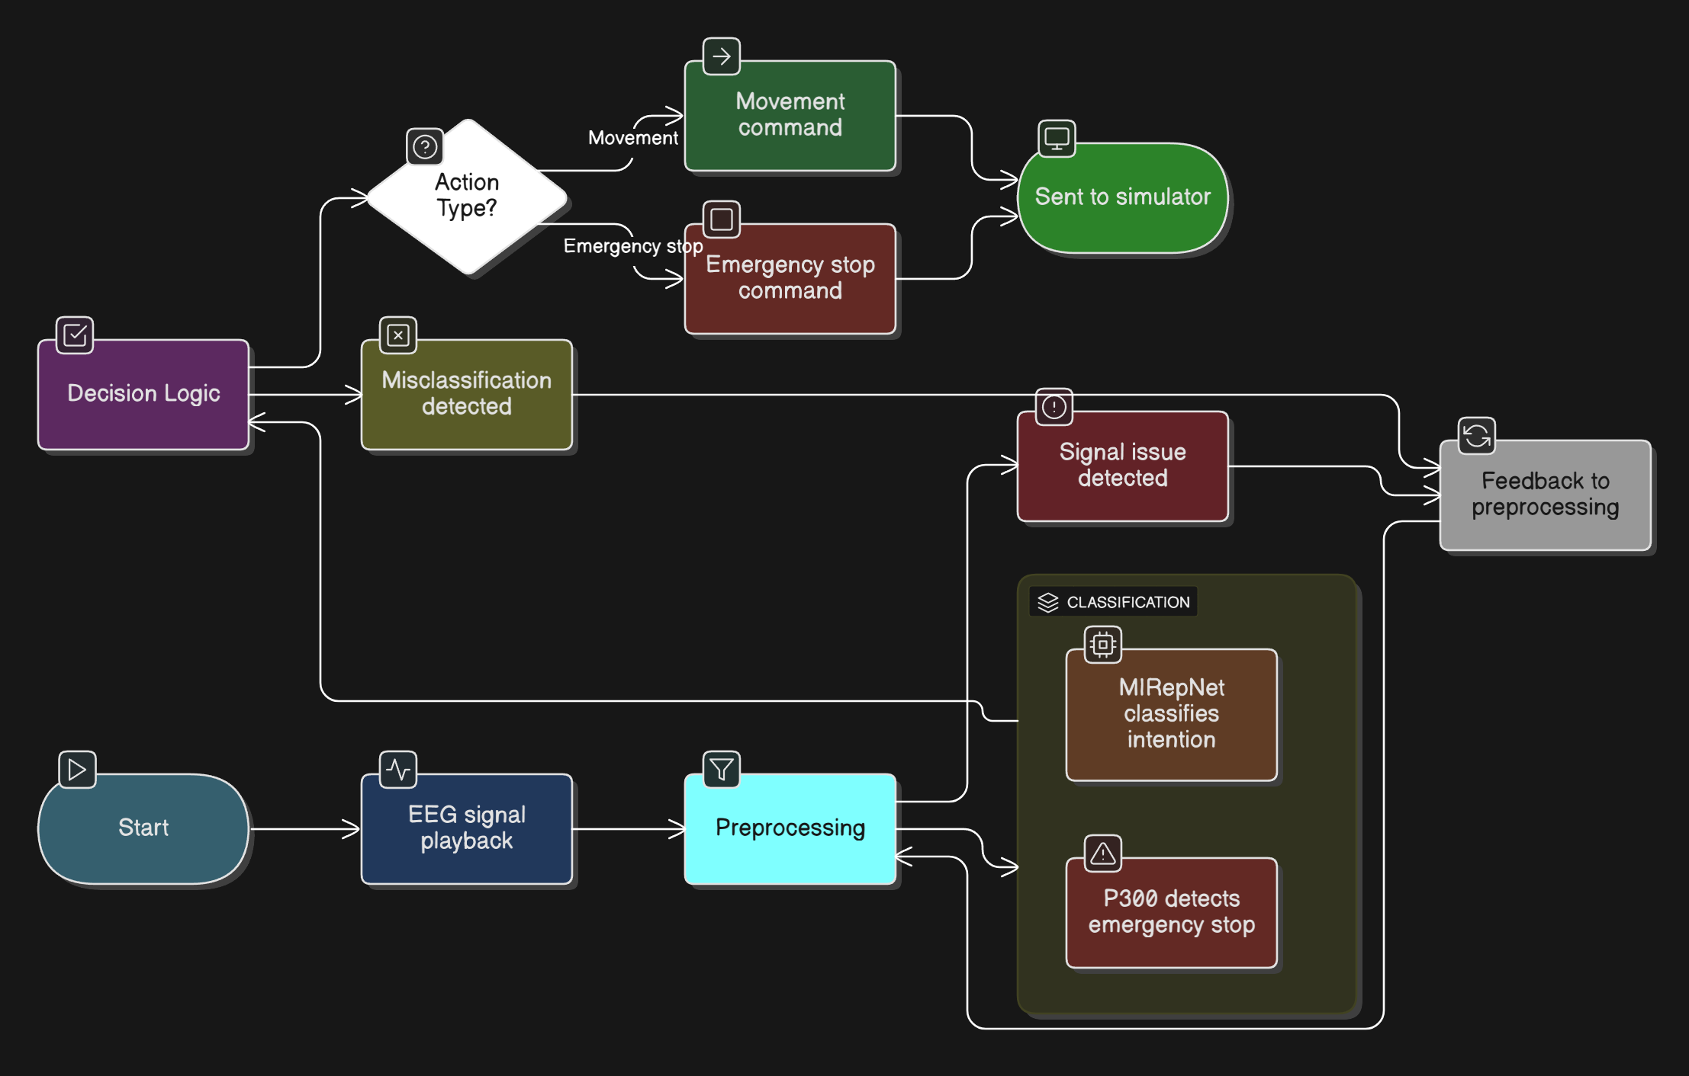
- EEG signal playback starts.
- Preprocessing cleans signal.
- MIRepNet classifies intention.
- P300 detects emergency stop.
- Decision logic validates action.
- Action sent to simulator.
Deployment Diagram
User (Researcher)
|
→ Data Source (Public EEG datasets)
→ Streamer (pylsl)
→ Preprocessing + MIRepNet (PyTorch)
→ Decision Layer (Python/Flask)
→ Simulator (Unity3D / Pygame)

5. Tools and Technologies
- Data: BCI Competition IV-2a, PhysioNet EEG Motor Imagery, BNCI Horizon 2020.
- Frameworks: PyTorch, MNE, TorchEEG.
- Model: MIRepNet (fine-tuned), EEGNet (baseline), FBCNet (baseline), P300 CNN.
- Streaming: Lab Streaming Layer (pylsl).
- Simulation: Unity3D or Pygame.
- Deployment: Python + Docker (optional).
- Evaluation: Accuracy, Balanced Accuracy, F1-score, Latency, ITR.

6. Research Methodology
6.1 Data Preparation and Preprocessing
EEG signals are very noisy, so preprocessing is critical. We will apply:
- Resampling → Standardize to 250 Hz.
- Band-pass filter (0.5–40 Hz) → Keep EEG activity, remove irrelevant frequencies.
- Notch filter (50 Hz) → Remove power line noise.
- Artifact removal → Remove blinks/muscle noise using ICA or ASR.
- Re-referencing (CAR) → Improve spatial consistency.
- Segmentation → Split signals into windows (1–2 seconds).
- Normalization → Scale for stable training.

6.2 Model Selection & Baseline
- Train EEGNet and FBCNet as baseline models.
- Purpose: Provide a benchmark accuracy to compare improvements.
- Literature shows these models are standard in motor imagery classification.
📑 Reference Paper (Baseline)
- AMEEGNet: “Attention-based multiscale EEGNet for effective motor imagery EEG decoding,” 2024.
https://pubmed.ncbi.nlm.nih.gov/39911854/

6.3 Fine-Tuning MIRepNet (Detailed Steps)
- Load Pretrained Model (weights from MIRepNet foundation model).
- Stage A – Head Training
  - Freeze backbone.
  - Replace classification head for 4-class MI.
  - Train only head.
- Stage B – Partial Unfreeze
  - Unfreeze last layers of backbone.
  - Train with low learning rate.
- Stage C – Full Fine-Tuning
  - Unfreeze full model if dataset/time allows.
  - Full task adaptation.
- Save best model based on validation performance.
📑 Reference Paper (Fine-Tuning)
- MIRepNet: “A Pipeline and Foundation Model for EEG-Based Motor Imagery Classification,” 2025.
https://arxiv.org/abs/2503.13860

6.4 Real-Time Simulation (Detailed)
Since no hardware is available, we simulate real-time streaming using dataset signals:
- Streamer: Replay dataset signals sample-by-sample with pylsl.
- Preprocessing: Apply filters and windowing online.
- Sliding Window Classification: Every 0.5s, run MIRepNet on last 1s of data.
- Decision Logic: Accept command if probability > threshold.
- Simulator:
  - Unity3D → Virtual wheelchair in 3D environment.
  - Pygame → 2D wheelchair navigation grid.
  - Commands: Forward, Left, Right, Stop, Emergency Stop.
This pipeline acts online, simulating real-time device input. Offline training and evaluation will be performed first, but the demo will showcase online performance.

6.5 Evaluation Metrics
General Classification Metrics
- Accuracy
- Precision
- Recall
- F1-score
- Confusion Matrix
BCI-Specific Metrics
- Information Transfer Rate (ITR, bits/min)
- Decision Latency (ms)
- Navigation Success Rate
- False Positive Rate (critical for safety)
📑 Reference Paper (P300)
- Evaluation of Data Processing and Machine Learning Techniques in P300-based Authentication using Brain-Computer Interfaces, 2023.
https://arxiv.org/abs/2311.05270

7. Timeline (3 Months – DEPI Scope)
Month 1 (Weeks 1–4)
- Literature review & dataset download.
- Preprocessing pipeline (offline).
- Baseline model training (EEGNet/FBCNet).
Month 2 (Weeks 5–8)
- Fine-tune MIRepNet on 4-class MI.
- Train P300 binary classifier.
- Implement streaming pipeline with pylsl.
Month 3 (Weeks 9–12)
- Integrate decision logic + safety layer.
- Build wheelchair simulation (Unity/Pygame).
- Run evaluations (offline + simulated online).
- Write report + demo video.

8. Expected Outcomes
- Working BCI pipeline (offline + simulated online).
- Fine-tuned MIRepNet with improved accuracy vs baselines.
- Wheelchair simulator controlled by EEG data.
- Safety layer with P300-based emergency stop.
- Academic-style report + demo.
- Presentation

9. Future Work
- Real hardware integration with actual EEG devices (OpenBCI, g.tec).
- Adaptive personalization (few-shot learning per user).
- Hybrid multimodal BCI (EEG + eye-tracking).
- Full keyboard speller system for richer communication.
- Clinical testing with ALS/paralysis patients.

