Traffic Data Simulation and Ingestion

ALX3_AIS5_S2 Microsoft Data Engineer
Instructor : eng\ Ahmed Azab

Team Member:
Mariam Zakaria
Gehad Helmy
Amr Khaled
Youssef Abdelrahman

Milestone 1 :Traffic Data Simulation and Ingestion
1. Introduction
This milestone focuses on building the first component of a real-time traffic analytics system. The goal is to simulate realistic traffic data and ingest it into Microsoft Azure services for real-time analytics, alerts, and dashboards that will be built in later milestones..
2. Objectives
Milestone 1 includes two main objectives:
1. Traffic Data Simulation
o Create a Python script that simulates vehicle movement parameters such as:
- Average Speed
- Vehicle count(cars,trucks,bikes)
- Timestamp
- location
- weather condition
- Total traffic volume
2. Data Ingestion into Azure
o Stream the generated data into Azure Event Hubs, which will act as the streaming ingestion layer for the system
3. Task Breakdown
3.1 Traffic Data Simulation (Python Script)

The following script was developed to simulate live traffic events and send each event to Azure Event Hubs.
It generates new data every second and transmits it as a JSON object

3.2 Azure Event Hub Setup
An Azure Event Hub was configured to receive traffic data streams:
1. Created Event Hubs Namespace
Used Azure Portal to create a secure namespace.
2. Created Event Hub (mariam-hub)
This hub serves as the ingestion endpoint for the real-time traffic data.
3. Configured Shared Access Policy
A policy with Send permissions was generated to allow the Python script to push events.
4. Connected Python Script to Event Hub
- Installed the azure-eventhub SDK) Software Development Kit(
- Inserted connection details in the script
- Verified messaging
5. Validation
In Azure Portal→ Traffic-hub → mariam-hub → Data Explorer → View Events, the Messages showed continuous incoming events every second.

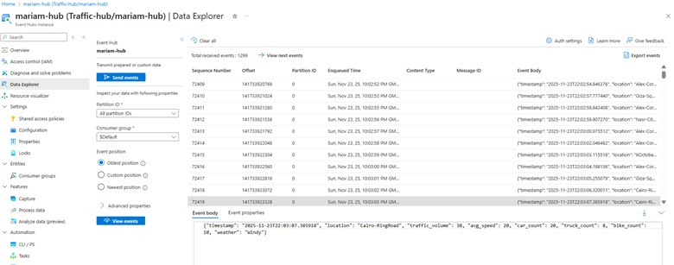

Milestone 2: Real-Time Processing

1. Introduction
Milestone 2 focuses on transforming raw streaming traffic data into meaningful, actionable insights using Azure Stream Analytics (ASA). After the simulated traffic data is ingested into Azure Event Hubs (Milestone 1), the Stream Analytics job processes the data in real time to detect congestion, overspeeding, and possible accident indicators.
The processed events are then forwarded to Azure Data Lake Storage Gen2 for storage and to Power BI for real-time visualization.
2. Objectives
Milestone 2 includes the following key objectives:

1. Build Real-Time Analytics Pipeline
- Connect Azure Stream Analytics to Event Hub as the input source.
- Use SQL-like queries to process real-time traffic data streams.

2. Detect Events and Generate Alerts
Using custom real-time logic, detect:
- Traffic congestion
- High-speed incidents
- Possible accident/anomaly patterns

3. Output Processed Insights
- Send the results to Power BI for real-time dashboards.
- Store all processed data in Azure Data Lake Gen2 for long-term analysis.

3. Task Breakdown

3.1 Azure Stream Analytics Job Setup

1. Created ASA Job
A cloud-based Stream Analytics job was created in the Azure Portal.

2. Input Configuration
- Input Source: Azure Event Hub (mariam-hub)
- Serialization: JSON
- Timestamp Handling: timestamp field used for event ordering

3. Output Configuration
Two outputs were configured:
1) Power BI:
1. Dataset name: Real-Time-traffic
2. Used for live dashboards and alert visuals
2) Azure Data Lake Storage Gen2
1. Container receives processed JSON output
2. Used for reporting, archived logs, and downstream analytics

4. Streaming Units
- Job ran using 1 streaming unit (SU), sufficient for real-time load.

3.2 Real-Time Query Development
The following Stream Analytics SQL queries were developed to detect key traffic events.
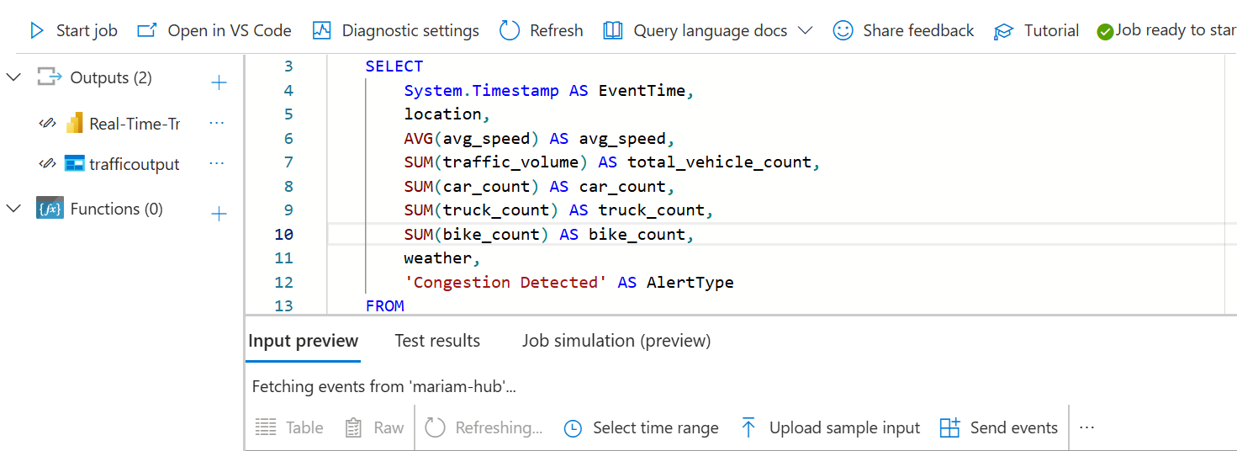

3.3 Description of Detection Logic

1. Congestion Detection
- Triggered when traffic volume > 25 vehicles per minute
- Aggregates data by:
  - 1-minute tumbling windows
  - location
  - weather

2. High Speed Detection
- Triggered when avg_speed > 100 km/h
- Flags speeding events for safety alerts

3. Accident / Anomaly Detection
Triggered when:
- avg_speed < 40 km/h,
- traffic_volume > 20,
- weather = Rainy, Foggy, or Windy
Simulates conditions that may indicate:
- sudden braking
- difficult road conditions
- potential collisions

4. Outputs and Validation

Output 1: Power BI (Real-Time Dashboard)
- Stream Analytics pushes results directly into Power BI.
- A live dataset (Real-Time-traffic) is used to show:
  - Congestion alerts
  - High-speed events
  - Accident indicators

Output 2: Azure Data Lake Gen2
- All processed events were saved as JSON to the container.
- Files appear in the Data Lake within seconds of event detection.

Validation Steps
- Verified Stream Analytics job inputs using "Sample Data" feature.
- Confirmed the query compiled without warnings.
- Checked Power BI → Streaming Dataset → Data View → live incoming records.
- Confirmed Data Lake folders receiving event JSON files.

5. Summary
Milestone 2 successfully implemented a real-time processing pipeline using Azure Stream Analytics.
Your role included:
- Writing Stream Analytics SQL queries
- Creating anomaly and congestion detection logic
- Sending results to Power BI and Azure Data Lake Gen2
- Validating end-to-end real-time event flow
This stage converts raw traffic data into valuable insights that will be used in Milestone 3 for dashboards and real-time alerting.

Milestone 3: Dashboard and Alerting

1. Executive Summary
A Power BI report provides a comprehensive view of traffic conditions across five major strategic locations. It is designed to assist traffic management and city planning teams in monitoring vehicle flow, weather impacts on driving, and safety alerts in real-time. The report is divided into two primary views: a general Traffic Overview and a focused Alerts & Safety Monitoring page.

2. Report Structure & Navigation

Global Slicers (Left Sidebar)
A persistent navigation pane on the left allows users to filter data across the entire report by specific Locations:
- 6th October Bridge
- Alex-Corniche
- Cairo-RingRoad
- Giza-Square
- Nasr-City

3. Page 1: Traffic Overview
Purpose: To analyze general traffic behavior, vehicle composition, and the correlation between weather and speed.
Key Performance Indicators (KPIs):
- Locations: Total active monitoring points (5).
- Weather Conditions: distinct weather types recorded.
- Vehicle Total No.: Total count of vehicles detected (2,711).
- Vehicles Average Speed: The mean speed across all locations (78.55 km/h).
Visualizations:
- Average Speed by Location (Column Chart): Compares average traffic speeds across the five distinct locations to identify fast-moving or slow zones.
- Vehicle Composition (Stacked Bar Chart): Breaks down the traffic count by vehicle type (Cars, Trucks, Bikes) per location.
- Weather Impact (Pie Chart): Analyzes "Average Speed by Weather," showing how conditions like Rain, Fog, or Wind affect driving speeds.
- Traffic Volume Trends (Area/Line Chart): Displays the "Average of Total Vehicle By Location," highlighting which areas have the highest traffic density (e.g., Nasr-City appears to have the highest volume).

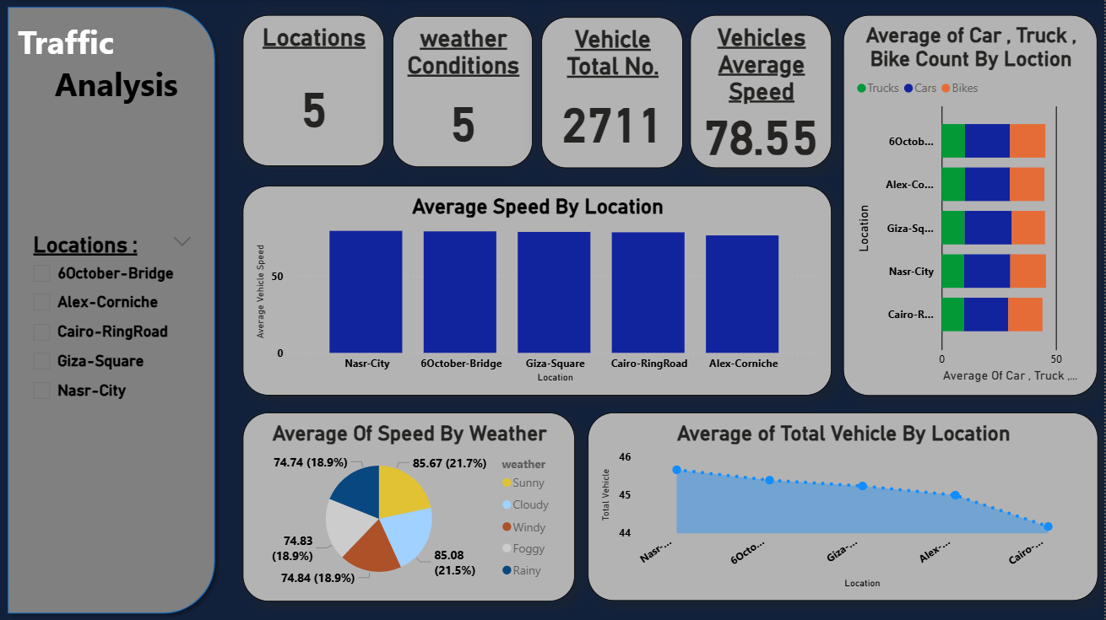

4. Page 2: Alerts Monitoring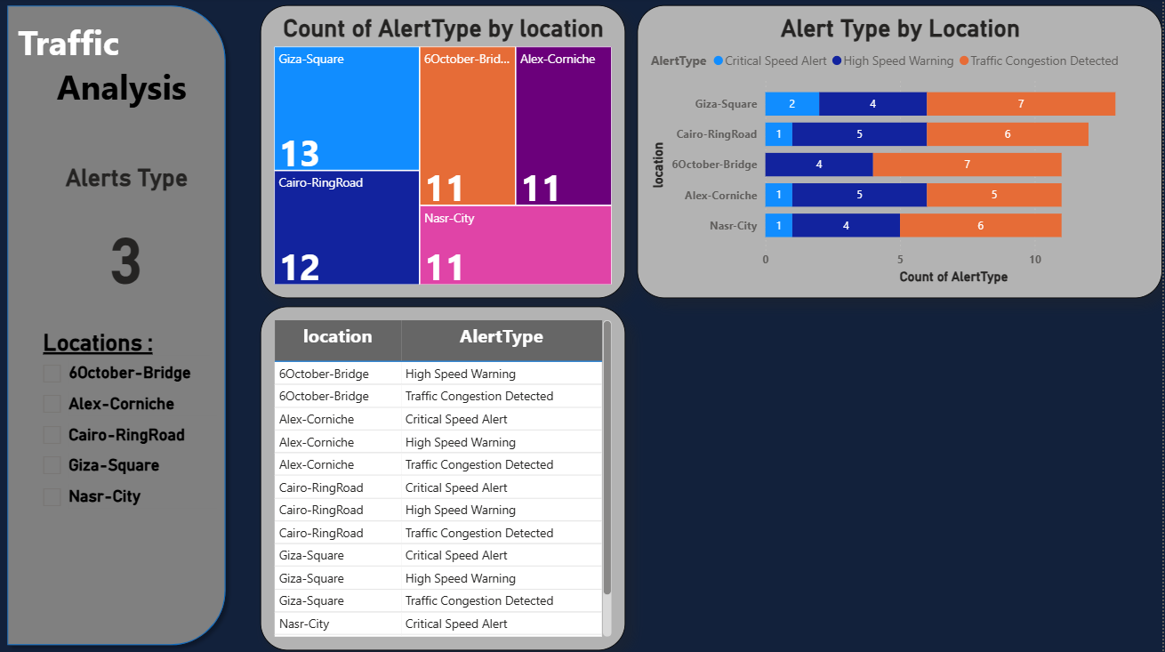

Purpose: To highlight safety violations, congestion events, and critical warnings.
Key Metrics:
- Alerts Type: Indicates the number of unique alert categories being tracked (3).
Visualizations:
- Alert Distribution (Treemap): "Count of AlertType by location" provides a heat map of where the most alerts are occurring. Giza-Square currently shows the highest frequency (13 alerts).
- Alert Categorization (Stacked Bar Chart): Breaks down alerts into three specific categories:
  - Critical Speed Alert: (Light Blue)
  - High Speed Warning: (Dark Blue)
  - Traffic Congestion Detected: (Orange) - This appears to be the most common issue.
- Detailed Incident Log (Table): A distinct list showing the specific Location combined with the exact Alert Type for granular analysis.

Milestone 4 :Traffic Alert Detection & Notification System

1. System Overview

This project implements a real-time Traffic Alert System using Azure Stream Analytics, Azure Blob Storage, and an automated Python service that detects critical traffic events and sends email notifications. The system processes streaming data, identifies high-speed or congestion alerts, stores results in Azure Blob Storage, and triggers email alerts for critical-level events.

2. Azure Stream Analytics – Query Logic
The Stream Analytics job is responsible for analyzing real-time traffic data coming from the Event Hub.
To detect abnormal situations, the job applies two main types of analysis windows:

A. Congestion Detection (1-minute window)
This part of the logic monitors traffic jams by observing data for every minute for each location. Stream Analytics groups the incoming records into a 1-minute tumbling window, then calculates:
· Average Speed of vehicles
· Total Vehicle Count during that minute
After this aggregation, the logic determines whether the location is experiencing congestion based on two conditions:
1. Average speed drops below normal levels
2. Traffic volume becomes unusually high
Depending on how severe the congestion is, an Alert Level is assigned:
· Level 3: Very slow speed & very high traffic → Critical Congestion
· Level 2: Slow speed & moderately high traffic → Warning
· Level 0: No congestion detected
Only alerts with level 2 or higher are sent to the output.

B. Speed Alerts (30-second window)
This logic focuses on detecting dangerous or abnormal speeds.
Stream Analytics processes data every 30 seconds and calculates:
· Average Speed per location
Then it compares the value against predefined thresholds:
· Above 95 km/h → Critical Speed Alert (Level 3)
· Between 80 and 95 km/h → High Speed Warning (Level 2)
· Below 80 km/h → Normal
Again, only alerts with level ≥ 2 are written to the output stream to be picked up by the Python automation script.

3. Python Automation Service
A Python script continuously monitors the Azure Blob Storage output folder. Whenever a new file arrives, the system inspects the alert levels and sends an email for each alert with AlertLevel = 3 (Critical).
Below is the main summary of the automation logic:

1. Connect to Azure Blob Storage.
2. Track processed files to avoid duplicate alerts.
3. Read JSON traffic alert files.
4. Filter rows where AlertLevel = 3.
5. Send email using Gmail SMTP with an app password.
6. Save processed files locally.

4. Email Output Example
The following screenshot shows a real email generated by the system:
