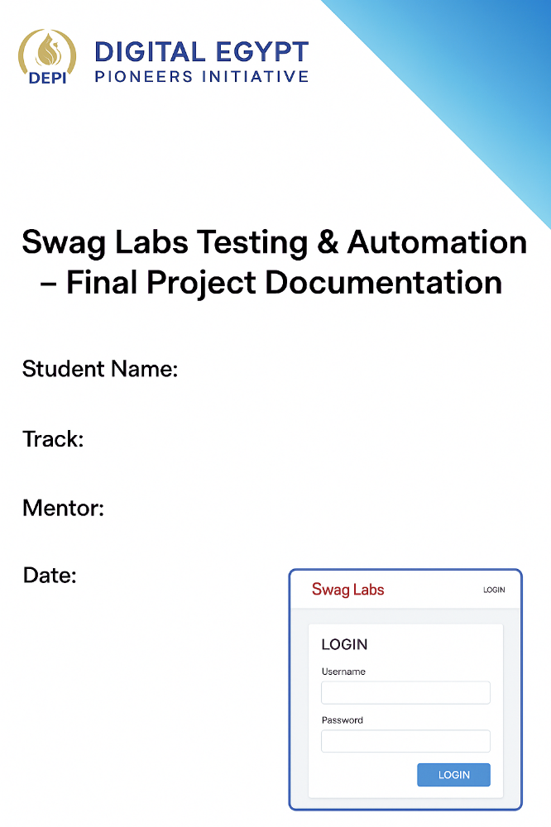

- Introduction
This project is part of the Digital Egypt Pioneers Initiative (DEPI). The main objective is to perform Manual Testing and Automation Testing on Swag Labs (

Swag Labs ) — an educational e-commerce demo website used for QA training.
The website includes the following flows:
- Login Page
- Inventory Page
- Product Details Page
- Shopping Cart
- Checkout Process
- Special User Types

Project Goals
- Ensure Functional Accuracy
- Validate User Experience
- Design and Execute Test Cases
- Report and Document Bugs Effectively
- Automate critical scenarios using Selenium WebDriver (Java).

2.Project Scope
.In Scope
- Login Functionality
- Inventory page
- Product details page
- Shopping Cart
- Checkout Process
- Manual Test Cases
- Bug Reporting
- Test Automation (Selenium)

.Out of Scope
.Penetration Testing
. Integration With External Systems
. Load/Stress Testing

3. Test Strategy
. Environments: (saucedemo.com)
. Testing Type : Functional , Negative , Usability , Regression
. Testing Approach: Manual Testing , Automation Testing
. Browsers: Google Chrome
. Tools:
Test Management : Google Sheets
Automation: Selenium WebDriver + Java
API

4. Test Strategy
. Requirements:
Req-01
Description : User must be able to successfully log in using valid standard
credentials (standard_user).

Req-02
Description : The system must display a specific error message for failed login
attempts (invalid password).

. User Stories:
US-01
As a customer, I want to successfully log into the system with valid
credentials, so that I can begin shopping immediately.
AcceptanceCriteria :
Valid credentials make User redirects to HomePage

US-02
As a standard user, I want to browse inventory and view product details so that I can select items to purchase.

US-03
As a Shopper, I want the Cart Page to display product details so that I can confirm I am buying the correct items.

. Test Cases (Example) :
TC_ID | Title | Test Steps | Expected Result
TC_001 | Valid Login | 1. Enter valid Username. 2. Enter valid Password. 3. Click Login. | User is redirected to /inventory.html.
TC_002 | Invalid Pass | 1. Enter valid Username. 2. Enter invalid Password. 3. Click Login. | Error message (R-A02) is displayed.
TC_003 | Invalid User | 1. Enter invalid Username. 2. Enter valid Password. 3. Click Login. | Error message (R-A02) is displayed (Generic Error).

Bug ID | Title / Summary | Priority | Steps to Reproduce
Bug_69 | Verify that each product displays the correct image on the Home Page | High | 1) Open login page  2) Enter valid username (problem_user)  3) Enter valid Password  4) Click on login button  5)Click on any product to open its  Product Page.
. Bug Report (Example) :

