Predictive Maintenance Data Warehouse
📘 1. Project Overview
Purpose
A predictive maintenance data warehouse designed to:
- Detect equipment failures early
- Support optimized maintenance scheduling
- Improve machine availability and operational efficiency
Scope
- Sources: Machine telemetry, operations logs, maintenance records
- Layers: Bronze → Silver → Gold
- Users: Maintenance, operations, data scientists
- Scale: ~10M telemetry records

🏗️ 2. Architecture Overview
Medallion Layers
Raw CSV → Bronze (staging) → Silver (cleaned & enhanced) → Gold (dimensions + fact + views)
Layer Responsibilities
Bronze Layer
- Raw, uncleaned data
- VARCHAR columns
- May contain duplicates & NULLs
Silver Layer
- Standardized & validated data
- Outlier handling
- Imputation tracking
- Machine statistics
Gold Layer
- Star schema (dimensions + fact table)
- Analytical and ML feature views
- Business-ready tables

🔄 3. Data Pipeline Summary
Step 1 — Ingestion
- Load CSV files into staging_tbl
- All fields stored as text
Step 2 — Bronze Cleanup
- Deduplication
- Basic filtering
Step 3 — Silver Transformation
- Type casting
- NULL handling and multi-stage imputation
- Outlier removal
- Enhanced table: silver_telemetry_enhanced
Step 4 — Statistics Generation
- Table: machine_statistics
- Stores machine averages, medians, and baseline metrics
Step 5 — Dimension Population
Gold dimensions include:
- dim_time
- dim_machine
- dim_component
- dim_operator
- dim_material
- dim_tool
- dim_batch
Step 6 — Fact Table
- fact_machine_telemetry
- Granularity: 30-second telemetry record
- Contains measurements, derived metrics, & quality flags

🗃️ 4. Schema Summary
Fact Table: fact_machine_telemetry
Contains:
- Dimension foreign keys
- Sensor values (temperature, vibration, power)
- Production metrics (quality, units)
- Derived metrics
- Failure indicators

Key Dimensions
dim_time
- Date & time hierarchy
- Shift, weekend flags
dim_machine
- Machine metadata
- Department, model, capacity
- Baseline sensor values
dim_component
- Component type
- Expected lifetime
- Maintenance properties
dim_operator
- Experience level
- Department
- Shift history
dim_material
- Material category
- Hardness, supplier
dim_tool
- Tool category
- Expected lifespan
dim_batch
- Batch metadata
- Quality, duration, product type

📈 5. Analytical Views (High-Level)
gold_ml_features
- Machine learning feature dataset
- Includes raw sensors, deviations, rolling averages, temporal features
gold_equipment_health
- Machine health score
- Maintenance priority classification
gold_maintenance_signals
- Alerting view with CRITICAL / HIGH / MEDIUM signals
- Suggests recommended actions
gold_production_efficiency
- Batch-level performance and KPIs

🤖 6. Machine Learning Features (Overview)
Feature Categories
- Temporal: hour, shift, weekend
- Sensor-derived: deviations, % change, Z-scores
- Rolling metrics: 6-minute and 30-minute windows
- Contextual: operator skill, machine criticality
- Historical: days since last repair, failure history
Targets
- failure_imminent (binary)
- component_failed (multiclass)

📐 7. Data Quality Framework
Monitors four dimensions:
1. Completeness
- NULL rates
- Imputation percentage
2. Consistency
- Type validation
- Range enforcement
3. Accuracy
- Outlier detection
- Baseline comparisons
4. Timeliness
- 30-second interval gap checks
Main Quality View
- gold_data_quality_report

🔧 8. Maintenance & Operations (High-Level)
Daily
- Check record counts
- Monitor imputation rates
Weekly
- Refresh statistics
- Review index performance
Monthly
- Archive old fact data (>13 months)

React Manufacturing Operations Dashboard — Documentation
1. Overview
Purpose
A real-time manufacturing operations dashboard built with React, TailwindCSS, Lucide Icons, and Recharts, providing unified visibility across:
- Live production floor
- Department health
- Fleet (machine) management
- Operator management
- Alert & safety center
- Cost analysis
- Quality & yield tracking
- Drill-down dashboards for machines, operators, departments, and batches
Core Features
- Real-time machine status visualization
- Department drill-down to individual machine cards
- Predictive maintenance alerts
- Live KPIs (machine uptime, safety, output)
- Fleet asset cards with RUL, safety, cost
- Batches progress tracking
- Operator profiles with safety scorecards
- Cost analytics (trend, waterfall, departmental breakdown)
- Quality & yield charts

2. Architecture Overview
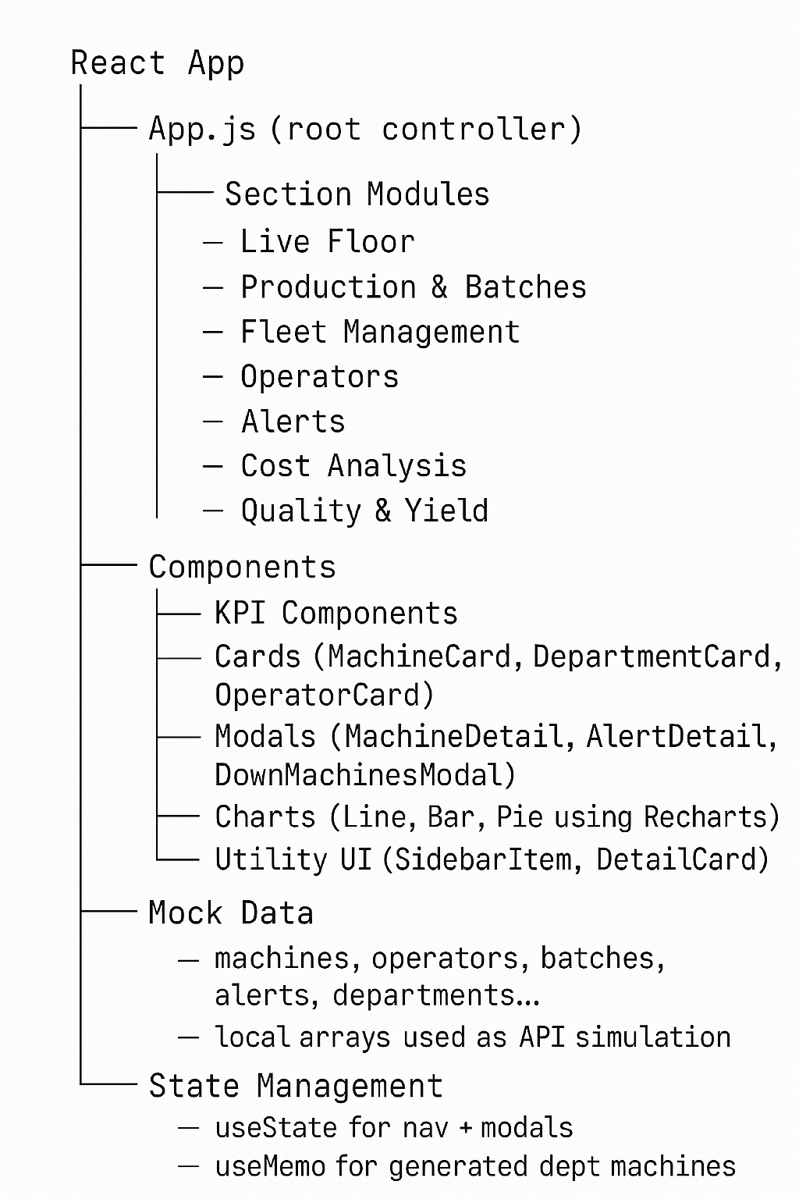

3. Data Sources (Mocked)
The UI uses mock data arrays for simulation:
- KPI_DATA – Active machines, down machines, output
- DEPARTMENTS – Name, units, status
- FLEET_DATA – Each fleet machine: temperature, RUL, operator, cost, image
- DOWN_MACHINES_LIST – For downtime modal
- OPERATORS_DATA – Operator profiles + safety
- ALERT_DATA – Safety & predictive alerts
- BATCH_DATA – Production & yield
- QUALITY_KPI_DATA & INCIDENTS
- COST_KPI_DATA

4. Main Screens (High-Level)
4.1 Live Production Floor
Includes:
- KPI Cards
- Department Overview (interactive)
- Batch Activity Feed
- Drill-down:
  - Department → Machines
  - Machine → Live Telemetry
4.2 Production & Batches
Displays:
- Batch progress
- Stage completion %
- Machines & operators involved
- Quality & defect stats
4.3 Fleet Management
Features:
- Machine cards with images
- Safety, cost, RUL, temperature
- Operator assignment
- Full machine report drill-down

4.4 Operators
Includes:
- Operator cards
- Role, shift, safety score
- Drill-down to:
  - Safety scorecard
  - Compliance
  - Assigned machines
4.5 Alert Center
Shows:
- Safety alerts
- Predictive-maintenance alerts
- Filters (Critical, Safety, Predictive)
- Alert detail modal
4.6 Cost Analysis
Includes:
- KPI cards
- Cost per Unit Trend
- Waterfall: revenue → losses → total
- Cost by department
4.7 Quality & Yield
Shows:
- Quality KPIs
- Yield trend
- Defects by machine/operator
- Yield by department
- Recent quality incidents table

5. Core Components Summary
SidebarItem
Navigation entry with active highlighting.
KPICard / CostKPICard / QualityKPICard
Reusable mini metric cards.
DepartmentCard
Interactive card:
- Unit counts
- Status (warning/critical)
- Drill-down handler
MachineCard
Machine tile with:
- Status dot
- Temperature
- Output
- Critical badge
DepartmentDetail
Displays all machines in a department with search.
MachineDetail
Full drill-down:
- Real-time telemetry
- Today’s production
- Asset metadata
- Maintenance logs
FleetCard
Modern asset card with:
- Animated image
- Operator avatar
- Safety / RUL / Cost
BatchCard
Shows batch process completion + breakdown.
OperatorCard / OperatorDetail
Operator profile & performance breakdown.
AlertCard / AlertDetailModal
Alert list and detailed modal.
Charts
Charts built using Recharts:
- Trend lines
- Waterfalls
- Bar charts
- Pie/Donut

