Travel Data Analysis Report

1. Data Sources & Structure
- df: Main travel dataset with trip details including destination, dates, duration, demographics, costs, transportation, and accommodation.
- Columns: Id, Destination, Start_date, End_date, Duration_days, Age, Gender, Nationality, Acc_type, Transport_type,
Accommodation_cost, Transportation_cost, total_cost, trip_year, trip_month, Demographics, Cost_per_day, Trip_season.

2. Data Cleaning Steps
- Stripped column names of extra spaces and standardized underscores.
- Checked and corrected missing or invalid data in critical columns (Destination, total_cost, Gender, etc.).
- Calculated Cost_per_day and ensured numeric types for cost columns.
- Final dataset contains 137 rows after cleaning.

3. Sample Tables

Sample of Travel Dataset
Id | Destination | Start_date | End_date | Duration_days | Age | Gender | Nationality | Acc_type | Transport_type | Accommodation_cost | Transportation_cost | total_cost | trip_year | trip_month | Demographics | Cost_per_day | Trip_season | Transport_type_encoded
1 | London | 2023-05-01 00:00:00 | 2023-05-08 00:00:00 | 7 | 35 | Male | American | Hotel | Airplane | 1200 | 600 | 1800 | 2023 | May | Adult | 257.14285714285717 | Spring | 0
2 | Phuket | 2023-06-15 00:00:00 | 2023-05-09 00:00:00 | 5 | 28 | Female | Canadian | Resort | Airplane | 800 | 500 | 1300 | 2023 | June | Young Adult | 260.0 | Spring | 0
3 | Bali | 2023-07-01 00:00:00 | 2023-05-10 00:00:00 | 7 | 45 | Male | Korean | Villa | Airplane | 1000 | 700 | 1700 | 2023 | July | Middle Aged | 242.85714285714286 | Summer | 0
4 | NewYork | 2023-08-15 00:00:00 | 2023-05-11 00:00:00 | 14 | 29 | Female | British | Hotel | Airplane | 2000 | 1000 | 3000 | 2023 | August | Young Adult | 214.28571428571428 | Summer | 0
5 | Tokyo | 2023-09-10 00:00:00 | 2023-05-12 00:00:00 | 7 | 26 | Female | Vietnamese | Airbnb | Train | 700 | 200 | 900 | 2023 | September | Young Adult | 128.57142857142858 | Summer | 6

4. Insights & Charts
Figure: Top 10 Travel Destinations
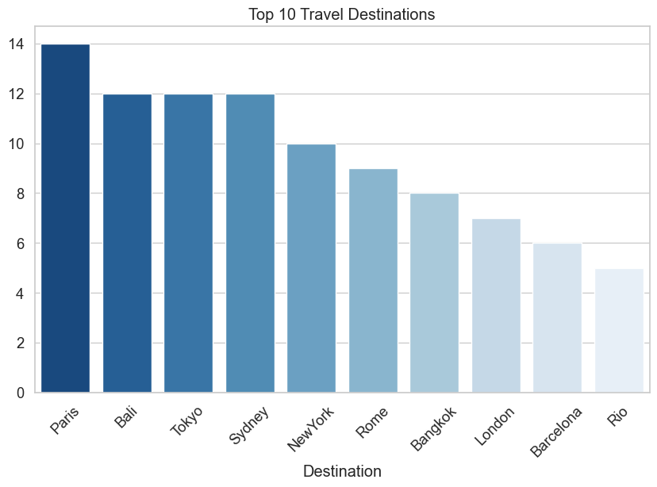
Figure: Average Trip Cost by Accommodation Type
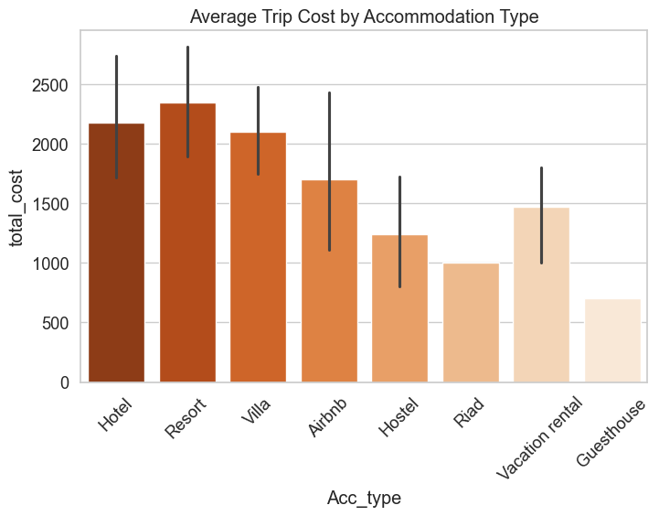
Figure: Transportation Preference by Gender
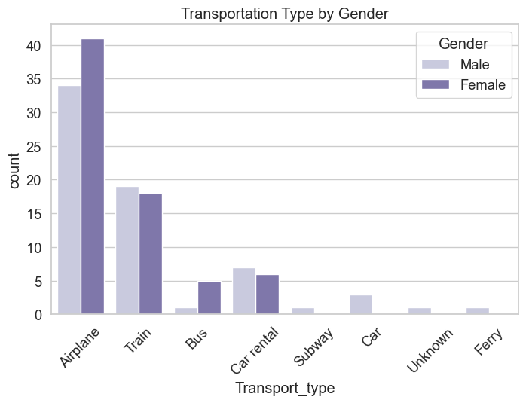
Figure: Top 10 Months by Number of Trips
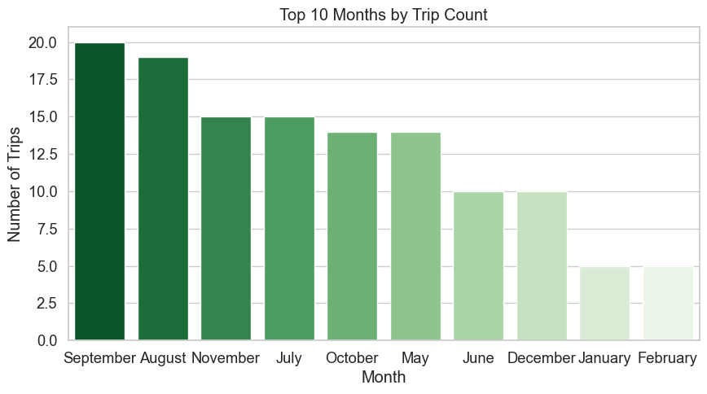
Figure: Top 10 Nationalities by Total Spending
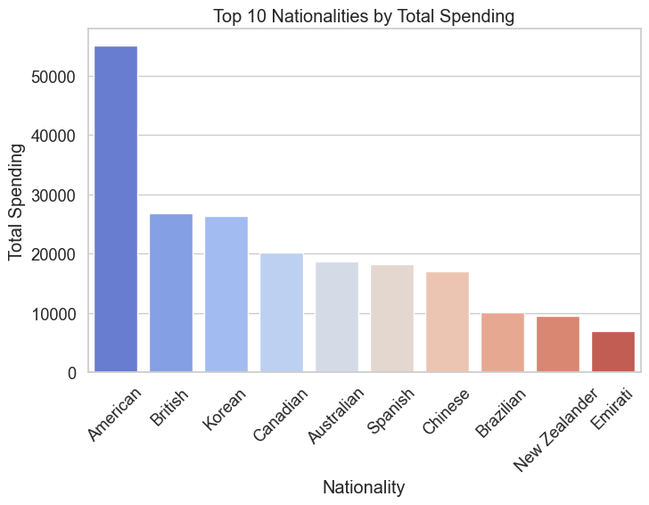

5. Key Findings
- Most popular destinations: Paris, Bali, Tokyo.
- Most preferred accommodation types: Hotel, Airbnb, Hostel.
- Top transport types by gender: Airplane, Train, Car rental.
- Most frequent travel months: September, August, November.
- Nationalities with highest total spending: American, British, Korean.

