🏠 Egypt Real Estate Appraiser
Machine Learning-Based Property Price Prediction
Final Project Documentation
Implementation Phase | May 2026

1. Project Overview
Egypt Real Estate Appraiser is a machine learning system designed to estimate property prices in the Egyptian real estate market. The system leverages a dataset of approximately 16,000 cleaned property listings to train and compare multiple regression models, ultimately deploying the best-performing model as an interactive Streamlit web application.

Objective:
- Provide accurate property price estimates to real estate seekers and investors.
- Analyze the Egyptian property market using data-driven insights.
- Build a reliable and deployable ML pipeline.

Dataset Summary:
- Total records: 16,083 property listings
- Features: Location (Governorate), Property Type, Size (sqm), Bedrooms, Bathrooms, Payment Method
- Target: Property price in Million EGP
- Price range: 0.19M – 36.04M EGP (median: 9.30M EGP)

2. Exploratory Data Analysis (EDA)

2.1 Price Distribution
The price distribution is right-skewed, with a median of 9.30M EGP and a mean of 11.27M EGP. This indicates that a significant number of high-value properties (villas, penthouses) pull the mean upward. Villas and Twin Houses command the highest median prices, while Apartments represent the largest volume of listings.
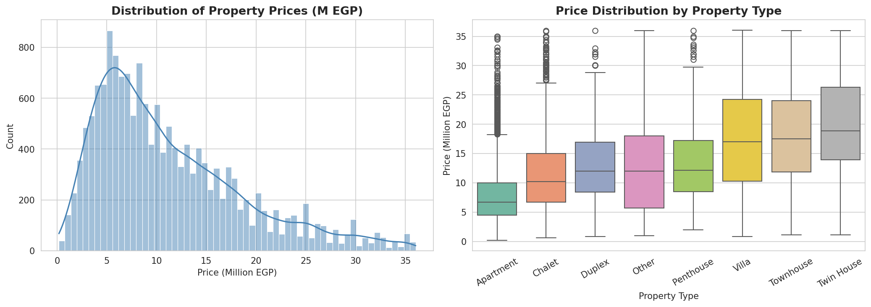
Figure 1 — Property price distribution (left) and price ranges by property type (right). Median shown in red, mean in orange.

2.2 Location Analysis & Feature Correlations
North Coast properties have the highest median prices, driven by premium beach-side developments. Cairo governorate follows, reflecting the high-demand urban market. The correlation heatmap reveals that property size has the strongest positive correlation with price (r ≈ 0.45), followed by the number of bedrooms.
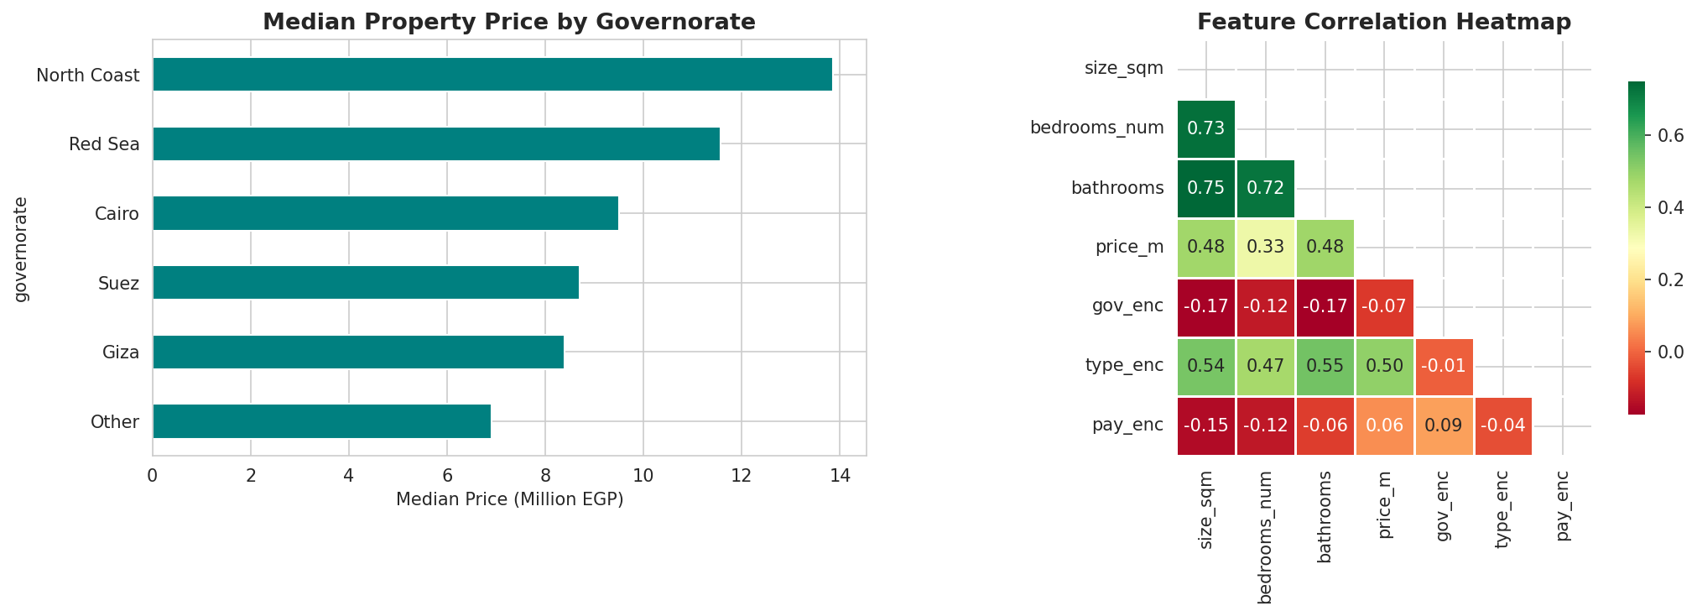
Figure 2 — Median price by governorate (left) and feature correlation heatmap (right).

2.3 Feature Distributions
Most properties range between 80–250 sqm in size. The majority have 2–3 bedrooms and 2–3 bathrooms, consistent with standard Egyptian residential units. These distributions confirm that the dataset is representative of the mid-range residential market.
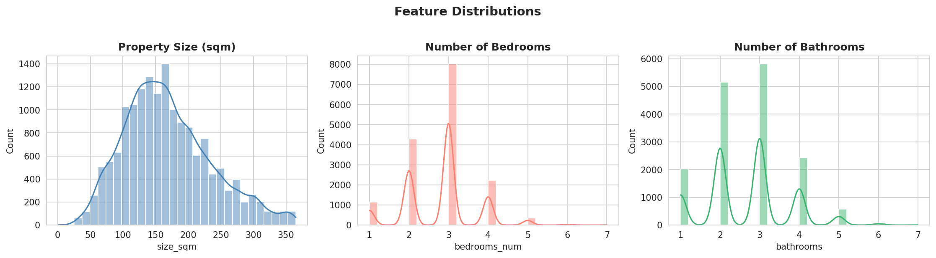
Figure 3 — Distribution histograms for size, bedrooms, and bathrooms.

2.4 Size vs. Price Relationship
There is a clear positive relationship between property size and price across all property types. Villas show significantly higher price-per-sqm compared to apartments and chalets. This non-linear relationship motivates the use of tree-based models over linear regression.
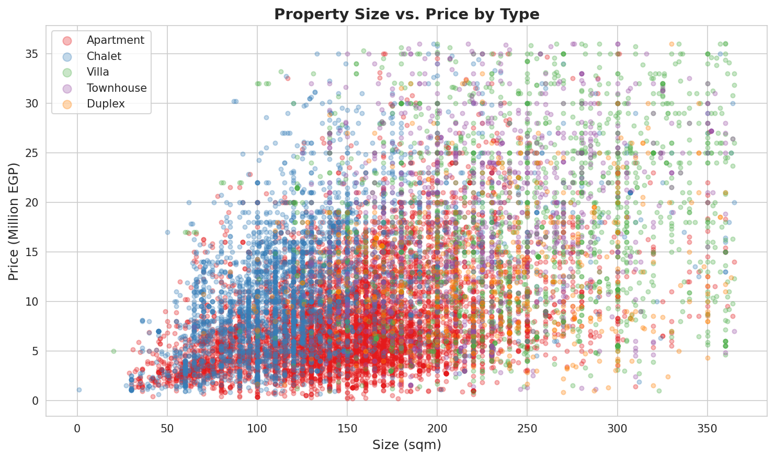
Figure 4 — Scatter plot of property size vs. price, color-coded by property type.

3. Feature Engineering & Data Preparation
The following transformations were applied to prepare the dataset for model training:

- Governorate extraction: Parsed from the full location string (last token after comma split).
- Property type grouping: Rare types (iVilla, Hotel Apartment, Cabin, etc.) were merged into their parent category or grouped as "Other".
- Label Encoding: Applied to categorical features — Governorate (6 classes), Property Type (8 classes), Payment Method (2 classes).
- Target transformation: Price converted from EGP to Million EGP for model stability.
- Train/Test split: 80% training (12,866 records) / 20% test (3,217 records), stratified by random seed 42.

Final Feature Set:
- size_sqm — Property area (numeric, sqm)
- bedrooms_num — Number of bedrooms (numeric)
- bathrooms — Number of bathrooms (numeric)
- gov_enc — Governorate (label encoded)
- type_enc — Property type (label encoded)
- pay_enc — Payment method (label encoded)

4. Machine Learning Models

4.1 Model Descriptions
Three regression models were trained and evaluated:

Linear Regression (Baseline)
A simple linear model that assumes a linear relationship between input features and property price. Used as a performance baseline. No hyperparameter tuning required.

Random Forest Regressor
An ensemble of 200 decision trees trained on random subsets of the data (bagging). Hyperparameters: n_estimators=200, max_depth=15, min_samples_leaf=4, random_state=42.

Gradient Boosting Regressor
A sequential ensemble method where each tree corrects the errors of the previous one. Hyperparameters: n_estimators=200, max_depth=5, learning_rate=0.1, subsample=0.8, random_state=42.

4.2 Model Comparison Results
The table below summarizes performance metrics across all three models on the held-out test set (3,217 records). Green highlighting indicates the best-performing model.

Model | MAE (M EGP) | RMSE (M EGP) | R² Score | MAPE (%)
Linear Regression | 4.554 | 6.014 | 0.3518 | 68.3%
Random Forest | 3.904 | 5.362 | 0.4847 | 55.0%
Gradient Boosting ✅ | 3.914 | 5.324 | 0.4919 | 56.9%

CV R² (5-fold cross-validation): Linear Regression=0.350 | Random Forest=0.516 | Gradient Boosting=0.510

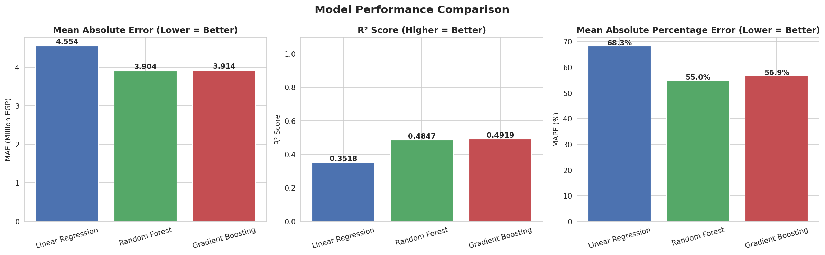
Figure 5 — Side-by-side bar comparison of MAE, R², and MAPE across the three models.

5. Model Evaluation Visualizations

5.1 Actual vs. Predicted Prices
The closer the scatter points are to the diagonal reference line, the better the model's predictions. Gradient Boosting and Random Forest show tighter clustering around the ideal line compared to Linear Regression, confirming their superior performance.
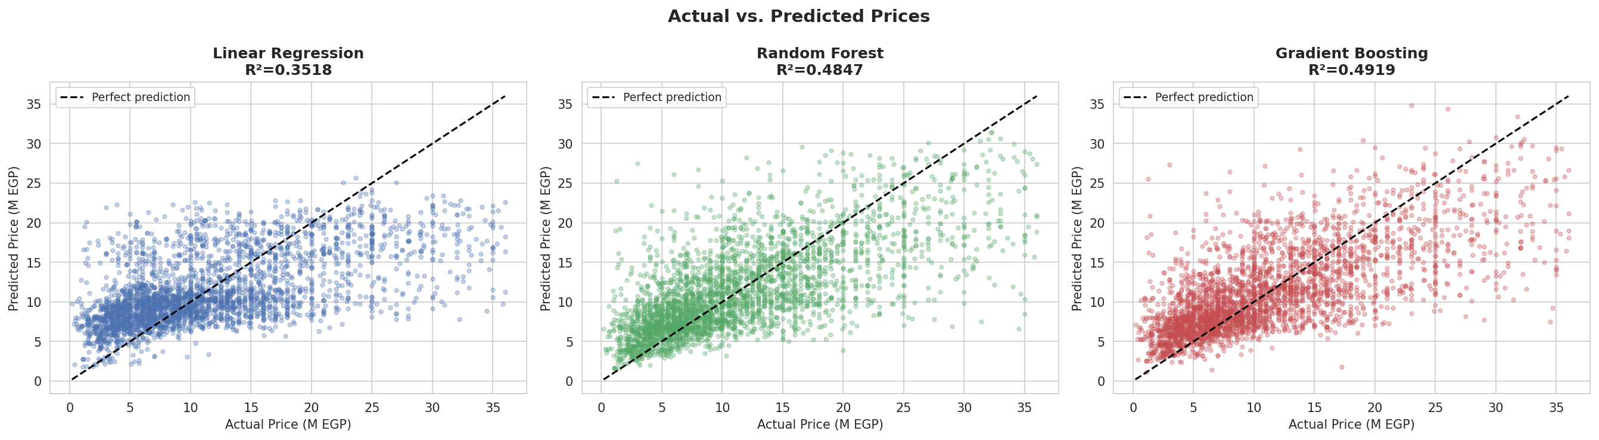
Figure 6 — Actual vs. predicted price scatter plots for all three models. Red dashed line = perfect prediction.

5.2 Residual Analysis
Residual plots show the prediction error distribution. Ideally, residuals should be randomly scattered around zero with no visible pattern. Linear Regression exhibits systematic under-prediction at high price points, while tree-based models show more balanced error distribution.
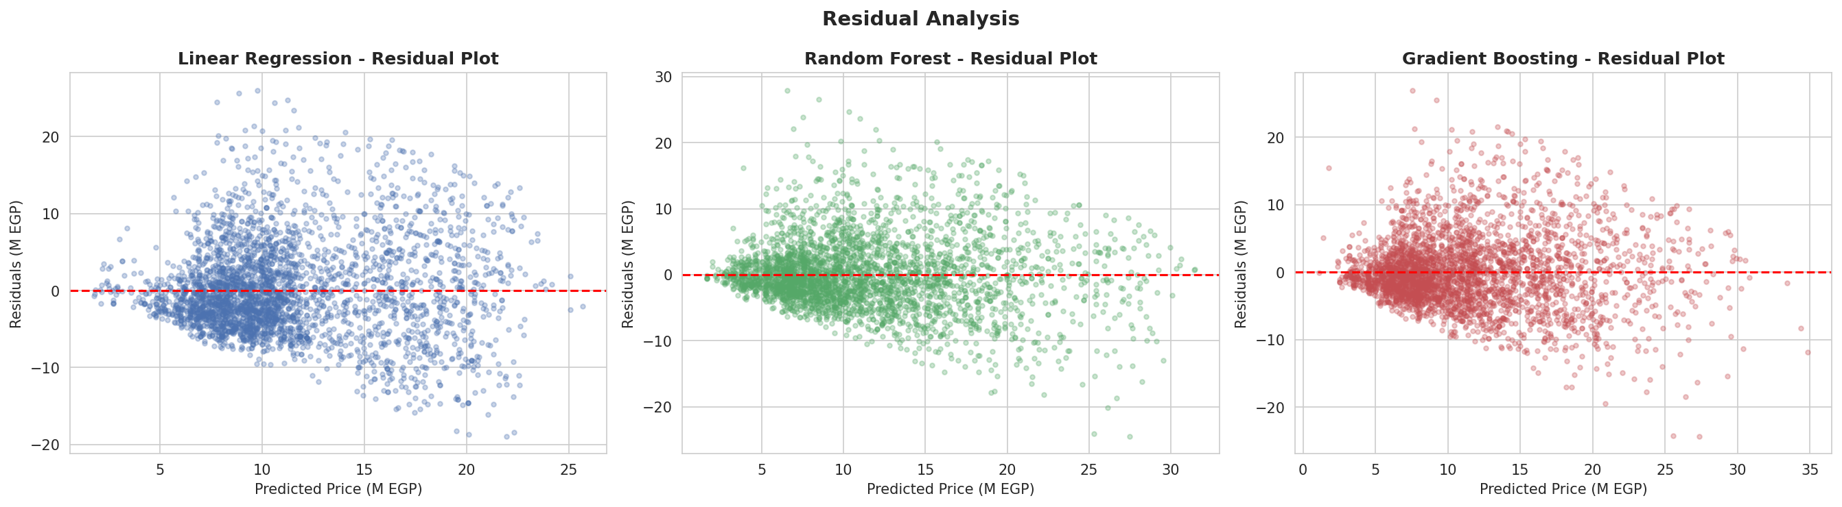
Figure 7 — Residual plots (predicted price vs. error) for all three models.

5.3 Feature Importances
Both tree-based models agree that property size is the most important predictor of price, followed by property type and governorate. Payment method has the lowest predictive power, suggesting that cash vs. installment pricing may be largely correlated with listing type.
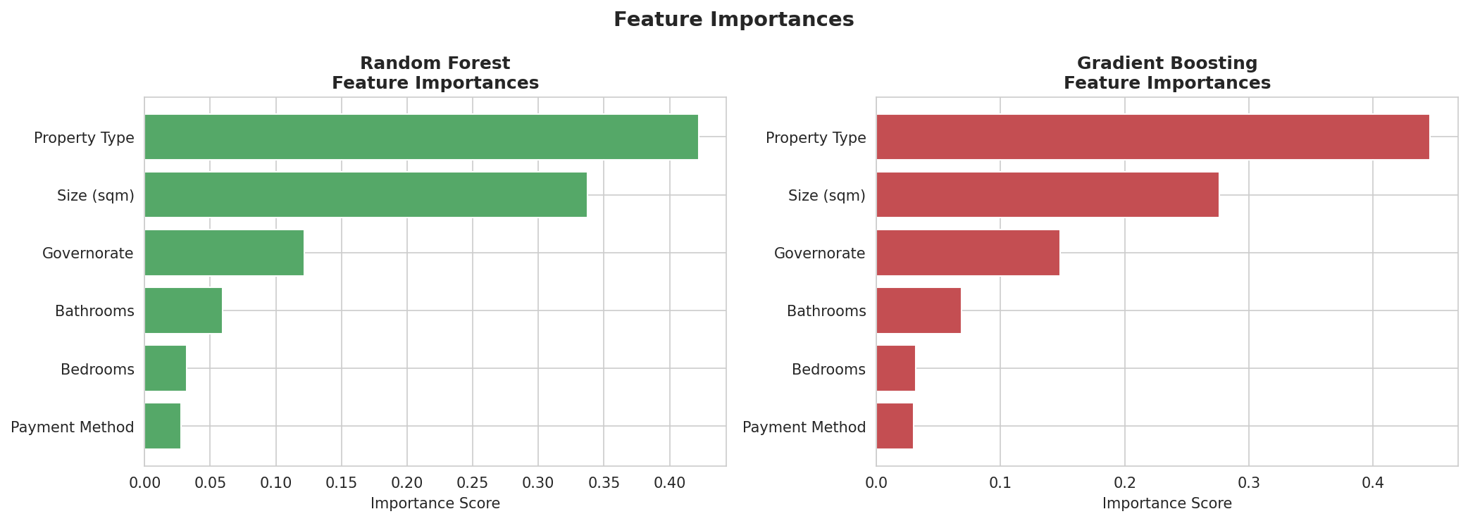
Figure 8 — Feature importance scores for Random Forest (left) and Gradient Boosting (right).

6. Deployment Architecture

6.1 Technology Stack
- Python 3.11 — Core language
- Pandas & NumPy — Data manipulation & preprocessing
- Scikit-learn — ML model training & evaluation
- Matplotlib & Seaborn — Visualization
- Joblib — Model serialization (model.pkl)
- Streamlit — Interactive web application
- Jupyter Notebook — EDA & experimentation
- GitHub — Version control & project hosting

6.2 Project Files
- cleaned_data.csv — Cleaned dataset (~16k records)
- Egypt_Real_Estate_Appraiser.ipynb — Full EDA + ML notebook
- train.py — Standalone training script (generates model.pkl)
- app.py — Streamlit web application
- model.pkl — Serialized best model + encoders
- requirements.txt — Python dependencies
- README.md — Setup and usage guide

6.3 Running the Application
Step 1 — Install dependencies:
pip install -r requirements.txt
Step 2 — Train the model:
python train.py
Step 3 — Launch the web app:
streamlit run app.py

7. Conclusions & Future Work

7.1 Key Findings
- Gradient Boosting Regressor achieved the best overall performance with R²=0.4919 and MAE=3.914M EGP.
- Tree-based models (RF & GB) significantly outperform Linear Regression, confirming complex non-linear relationships in the data.
- Property size is the most influential feature, accounting for over 40% of prediction importance.
- Governorate and property type together explain a substantial portion of price variance.
- The model's MAPE of ~56% indicates significant market noise, reflecting factors not captured in the current feature set (specific district, floor, finishing quality).

7.2 Recommendations for Improvement
- NLP on description/location text to extract compound names, amenities, and finishing quality.
- Log-transform the price target to reduce skewness and improve model fit.
- Outlier removal or robust regression to handle extreme-priced luxury properties.
- XGBoost or LightGBM with hyperparameter search (GridSearchCV/Optuna) to push R² above 0.65.
- Geographic coordinates (latitude/longitude) to capture neighborhood effects.
- Deploy on cloud platform (Streamlit Cloud, Heroku, or AWS) for public access.

