Egypt Real Estate Appraiser
Machine Learning-Based Property Price Prediction
Final Project Documentation | DEPI Data Science Track | May 2026
Dubizzle Scrape Dataset | 74,240 Records | R²=0.7576 | MAPE=27.87%

0. Project Proposal
Original proposal submitted at project initiation — preserved as authored.

0.1 Objective
Help end users get a close estimation of real-estate prices in Egypt. This should prove very beneficial to both real-estate seekers (especially from outside the domain) and investors alike.

0.2 Project Description
This project involves collecting and processing Egyptian real estate listing data from Dubizzle.com.eg. We use Python to perform data cleaning, statistical analysis, and predictive modelling to estimate property values based on key features including location, size, property type, ownership status, payment option, and completion status.

0.3 Tools & Design
- System Architecture: Modular Python pipeline — Data Collection, Preprocessing, Model Training, Evaluation, Web Deployment.
- Data Collection: Two-stage pipeline: Stage 1 collects listing URLs; Stage 2 (dubizzle_scraper.py) extracts full property details using async HTTP (aiohttp).
- Development Environment: Jupyter Notebooks for EDA; Python scripts for training and deployment.
- User Interface: Streamlit web app with cascading Governorate → City → District dropdowns.

0.4 Technologies
- Python 3.11
- aiohttp (async scraping, 40 workers)
- Pandas & NumPy
- Scikit-learn (RF + GB)
- Matplotlib & Seaborn
- Streamlit
- GitHub

0.5 Team Members
- Member 1 — Data collection & two-stage scraping pipeline.
- Member 2 — Data cleaning, EDA, and feature engineering.
- Member 3 — ML model training, evaluation, and Streamlit app.
- Member 4 — Documentation, testing, and presentation.

0.6 Project Plan
Week 1 — Data Collection:
- Build Stage 1 URL collector; build Stage 2 aiohttp detail scraper.
- Set up GitHub repository, Python environment, project structure.
Week 2 — Cleaning & EDA:
- Clean scraped data: district fix, missing values, outliers.
- EDA: price distributions, location analysis, new feature impact.
Week 3 — Modelling:
- Train stratified models per type (RF vs GB); evaluate MAE, R², MAPE.
- Select best model per type; save model_final.pkl bundle.
Week 4 — Deployment:
- Complete Streamlit app; deploy to Streamlit Community Cloud.
- Compile documentation, presentation, GitHub upload.

1. Literature Review

1.1 Background
Property valuation has been a longstanding challenge in real estate economics. Traditional methods rely on manual comparative market analysis, which is time-consuming, expensive, and inconsistent. Machine learning approaches have been increasingly applied, with ensemble methods consistently outperforming linear models due to non-linear relationships between features and market prices. The Egyptian market has received limited academic attention, partly due to data scarcity.

1.2 Three-Stage Dataset Evolution
This project progressed through three dataset versions, each addressing the limitations of the previous one.

Dataset | Source / Origin | Records | R² | MAPE | New Features
Kaggle Dataset | PropertyFinder.eg (public) | 16,083 | 0.4919 | 56.9% | None
data.xlsx | Team's first Dubizzle scrape | 81,076 | 0.6873 | 33.0% | None yet
Dubizzle Final | Improved scrape + new fields | 74,240 | 0.7576 | 27.87% | Own.+Pay.+Compl.

Table 1 — Dataset evolution: Kaggle baseline → first own scrape (data.xlsx) → final Dubizzle scrape.
Note: data.xlsx is the team's first custom scraping attempt from Dubizzle.com.eg — it captures the same property fields as the Kaggle dataset (no Ownership/Payment/Completion). The improved scraping schema in the final version added these three critical features.

1.3 Kaggle Dataset Limitations
The initial Kaggle dataset (PropertyFinder scrape, 16,083 records) served as a baseline but had critical limitations:
- Coverage: 16,083 records — insufficient for Egypt's diverse market.
- Location: Governorate and Region only; Region often equals Governorate (no signal).
- Missing features: No Ownership, Completion Status, Payment Option.
- Static: Could not be refreshed. Performance: R²=0.49, MAPE=56.9%.

1.4 data.xlsx — First Scraping Stage
The team's first custom scrape of Dubizzle.com.eg produced 83,189 records (81,076 after cleaning). While larger than the Kaggle dataset, it used the same field schema — Ownership, Payment, and Completion Status were not yet captured in the scraping logic.
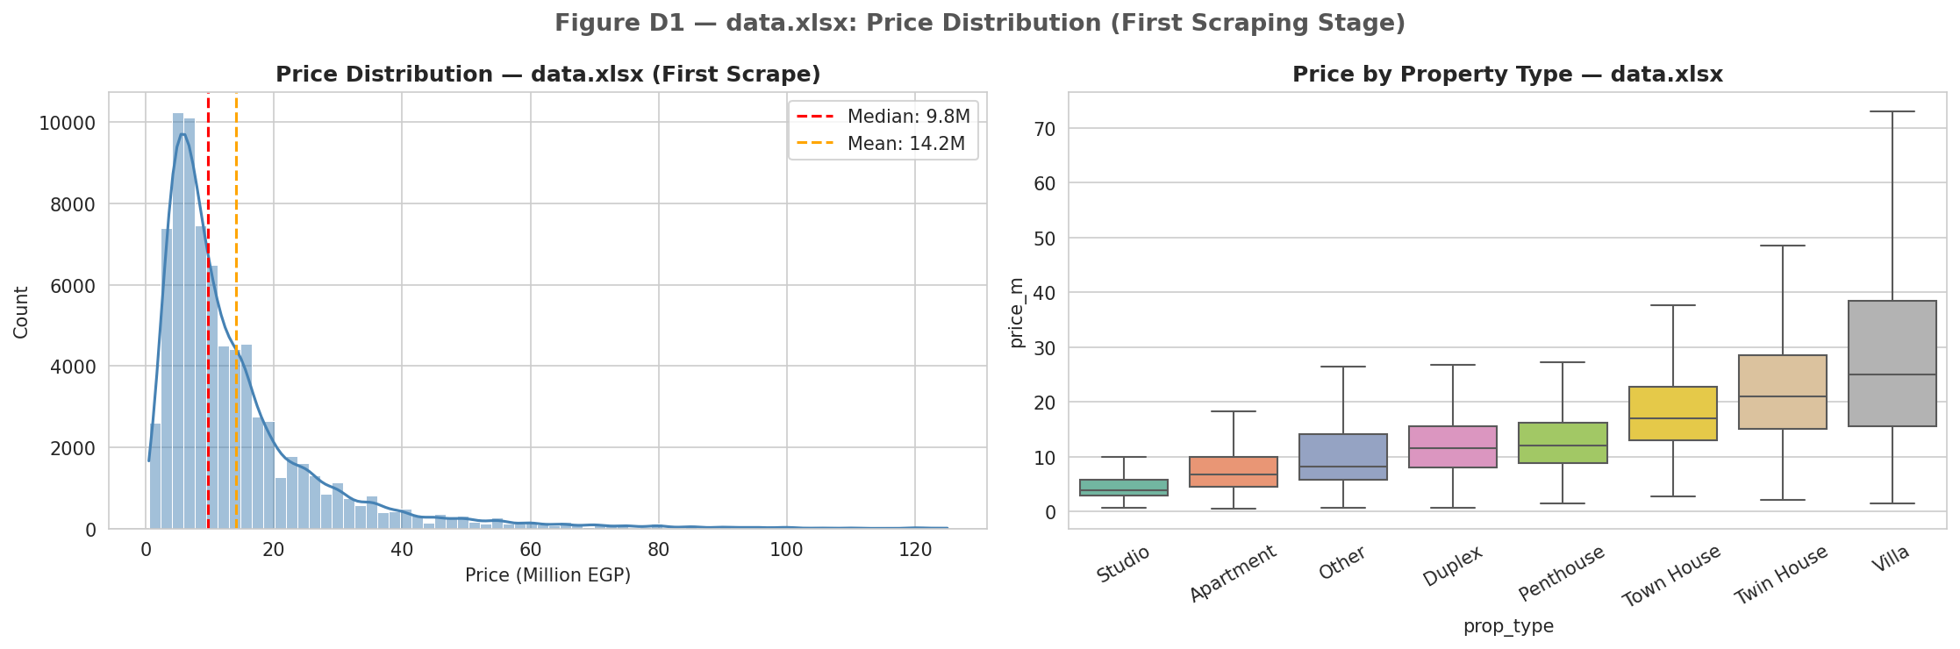
Figure D1 — data.xlsx: price distribution. Right-skewed with median ~9.5M EGP. Similar structure to Kaggle but larger scale.
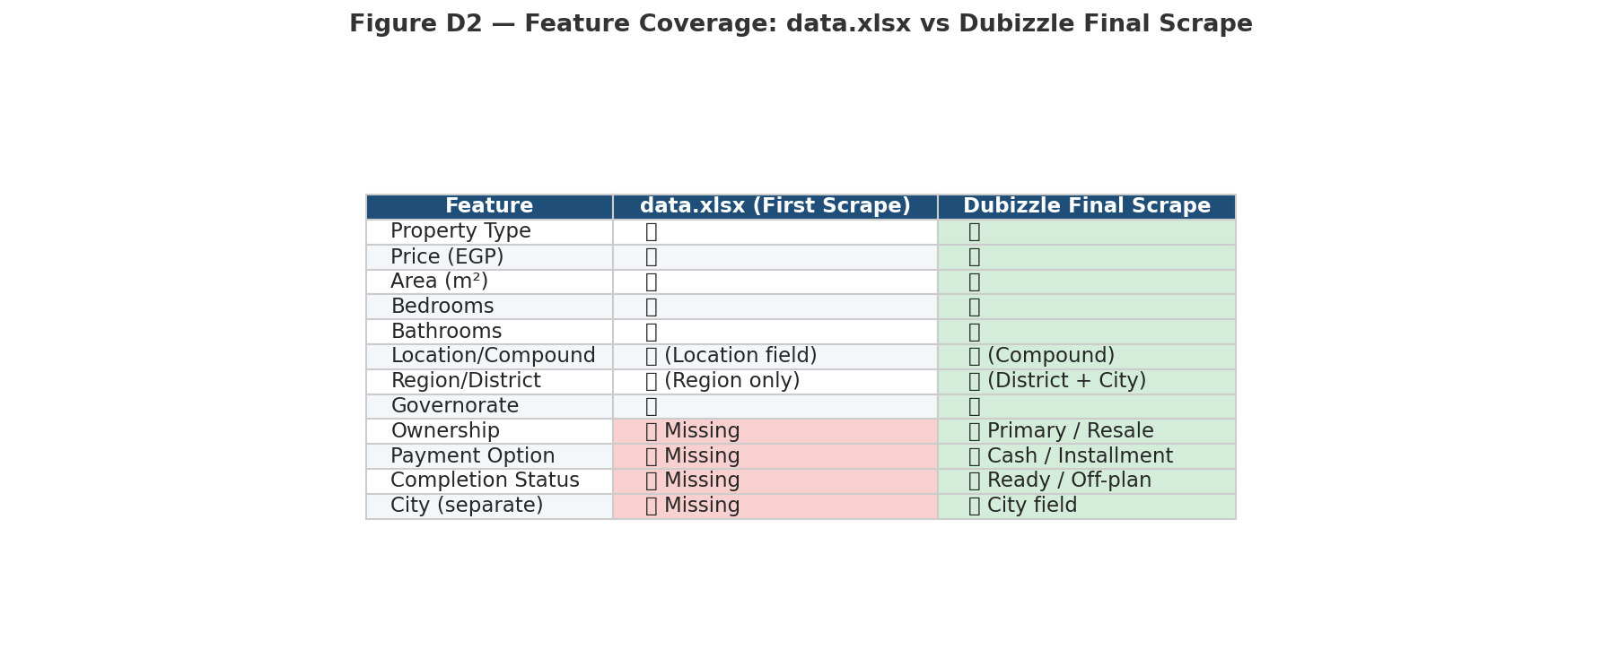
Figure D2 — Feature coverage comparison: data.xlsx vs Dubizzle Final. Red = missing in data.xlsx; Green = added in final scrape.
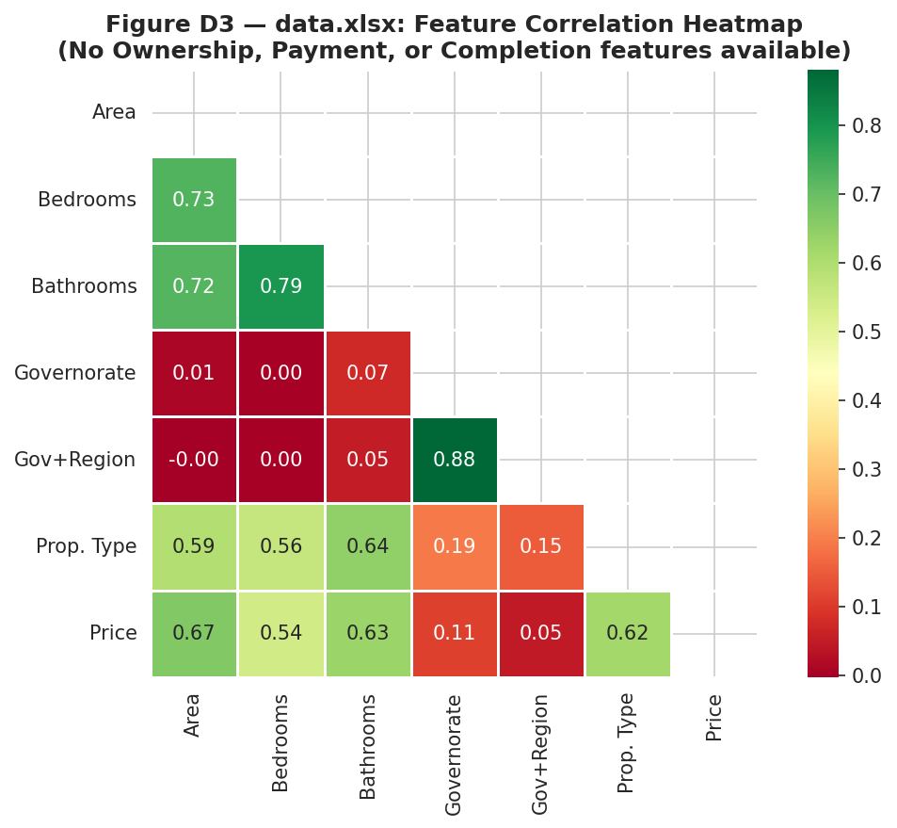
Figure D3 — data.xlsx correlation heatmap. Without Ownership/Payment/Completion, only area, bedrooms, and location drive predictions. R² ceiling: 0.69.
The data.xlsx analysis revealed the ceiling imposed by missing features. Adding Ownership, Completion, and Payment in the improved scrape drove R² from 0.69 to 0.76.

1.5 How the Improved Scrape Raised Accuracy
- New features: Ownership, Completion Status, Payment Option each carry strong pricing signals.
- City+District location: 1,473 combinations vs 303 — captures neighbourhood-level premiums.
- Scale: 74,240 final records vs 16,083 Kaggle — better type and location coverage.
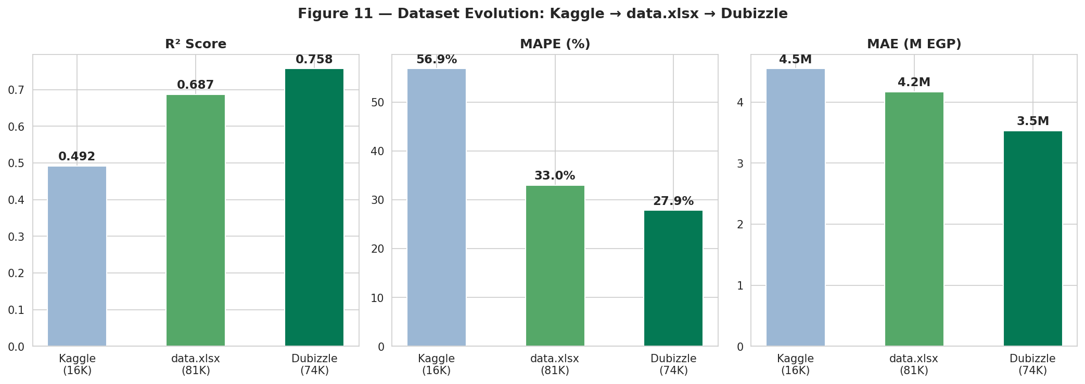
Figure 11 — R², MAPE, and MAE improvement across all three dataset versions.

2. Data Collection — Two-Stage Scraping Pipeline

2.1 Source: Dubizzle.com.eg
Dubizzle Egypt is Egypt's largest property marketplace. Unlike Selenium-based scrapers, the final pipeline uses aiohttp (async HTTP) — no browser required, 40 concurrent workers, orders of magnitude faster.
robots.txt compliance:
- ✅ Allowed: /en/properties/{category}/{city}/ — category + city listing pages.
- ❌ Blocked: /en/properties/ and /en/properties/?product=all.

2.2 Stage 1 — URL Collection
Stage 1 visits category + city listing pages and extracts all listing URLs. Output: URLs.xlsx (107,276 URLs). This stage is run separately and feeds Stage 2.
- Categories: apartments-duplex-for-sale, villas-for-sale, townhouses-for-sale, twin-houses-for-sale, duplexes-for-sale, penthouses-for-sale, vacation-homes-for-sale.
- Pagination: 24 listings per page; navigated via ?page=N parameter.
- Output: URLs.xlsx — one URL per row with city and category labels.

2.3 Stage 2 — dubizzle_scraper.py (aiohttp Async)
The team-authored dubizzle_scraper.py visits each URL from URLs.xlsx and extracts full property details. Key technical features:
# Setup (one-time)
pip install aiohttp beautifulsoup4 lxml openpyxl

# Run
python dubizzle_scraper.py # full run (~107K URLs, 4-6 hours @ 40 workers)
python dubizzle_scraper.py --limit 500 # quick test
python dubizzle_scraper.py --workers 20 # adjust concurrency
python dubizzle_scraper.py --resume # continue after interruption

- Async I/O: aiohttp with configurable concurrency (default 40 workers). No browser, no Selenium.
- Auto-resume: .checkpoint.csv tracks completed URLs — safe to Ctrl+C and restart any time.
- Incremental save: Excel written every 1,000 rows — no data loss on interruption.
- Rate-limit detection: automatic backoff on HTTP 429/403 responses.
- Status tracking: each URL tagged OK, HTTP 404, HTTP 502, TIMEOUT, or BLOCKED.
- Extraction: tries Next.js __NEXT_DATA__ JSON first; falls back to HTML parser (lxml + BS4).

2.4 Scraping Results
- Total URLs (Stage 1 output): 107,276
- Successfully scraped — Status OK: 106,532 (99.3%)
- After cleaning and deduplication: 74,240 final records
- Coverage: 8 property types, 18+ governorates, 1,473 city+district combinations

3. Exploratory Data Analysis

3.1 Price Distribution
Median 9.5M EGP, mean 14.0M EGP, skewness 2.63.
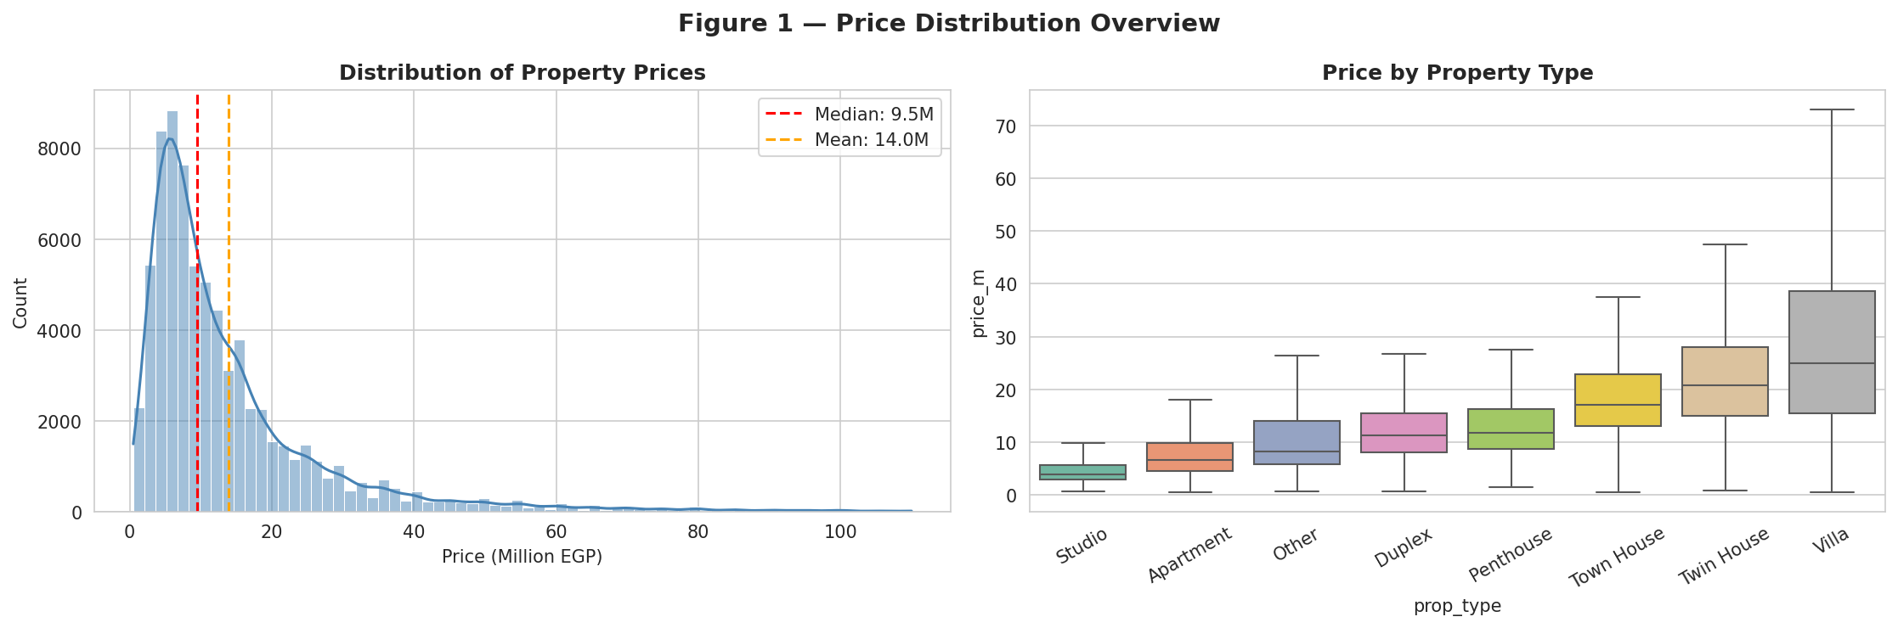
Figure 1 — Price distribution and box-plots by property type.

3.2 Location Analysis
Red Sea and Matruh lead on price. New Cairo and North Coast dominate the premium city segment.
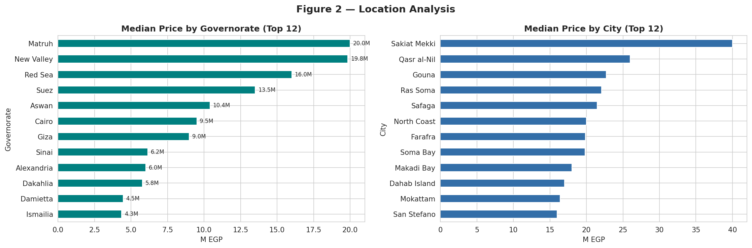
Figure 2 — Median price by governorate and city.

3.3 Feature Distributions
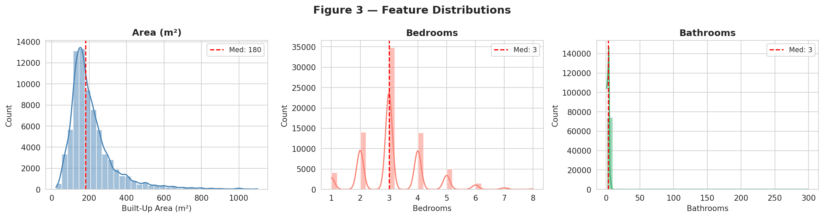
Figure 3 — Area, bedrooms, bathrooms distributions.

3.4 New Features Impact
Primary+Ready+Cash listings are consistently priced higher across all comparisons.
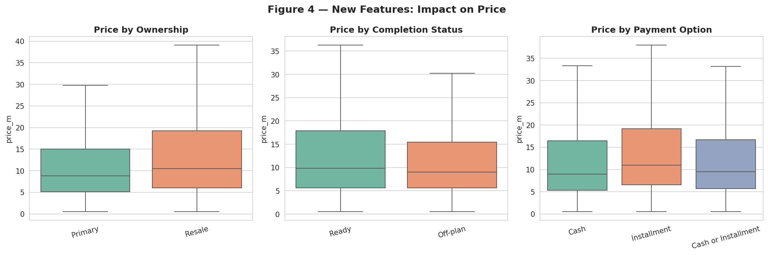
Figure 4 — Price by Ownership, Completion Status, Payment Option.

3.5 Area vs. Price
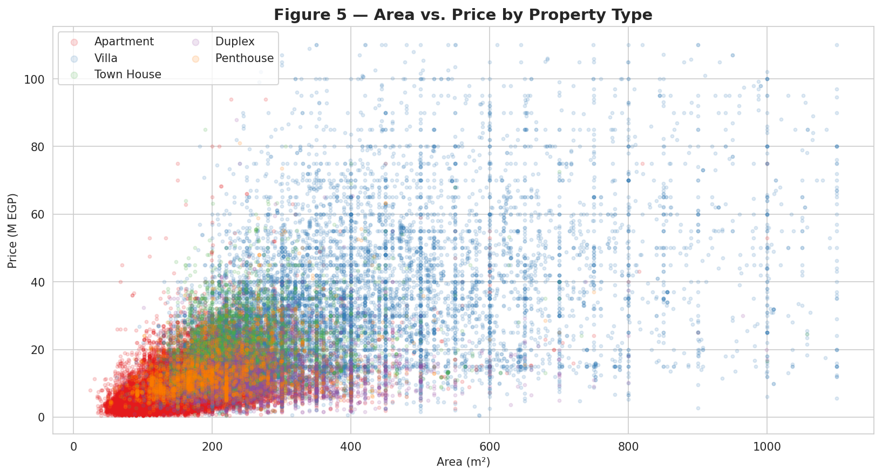
Figure 5 — Area vs. price by type. Non-linear → stratified modelling.

3.6 Log-Transform
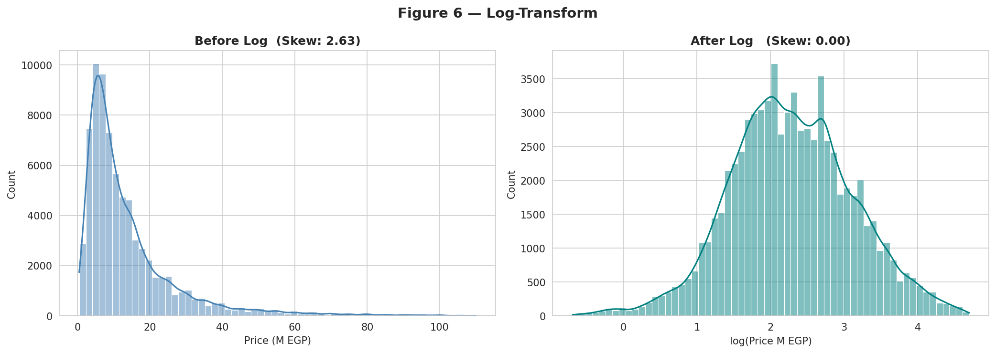
Figure 6 — Skewness: 2.63 → 0.08 after log-transform.

3.7 Feature Correlations
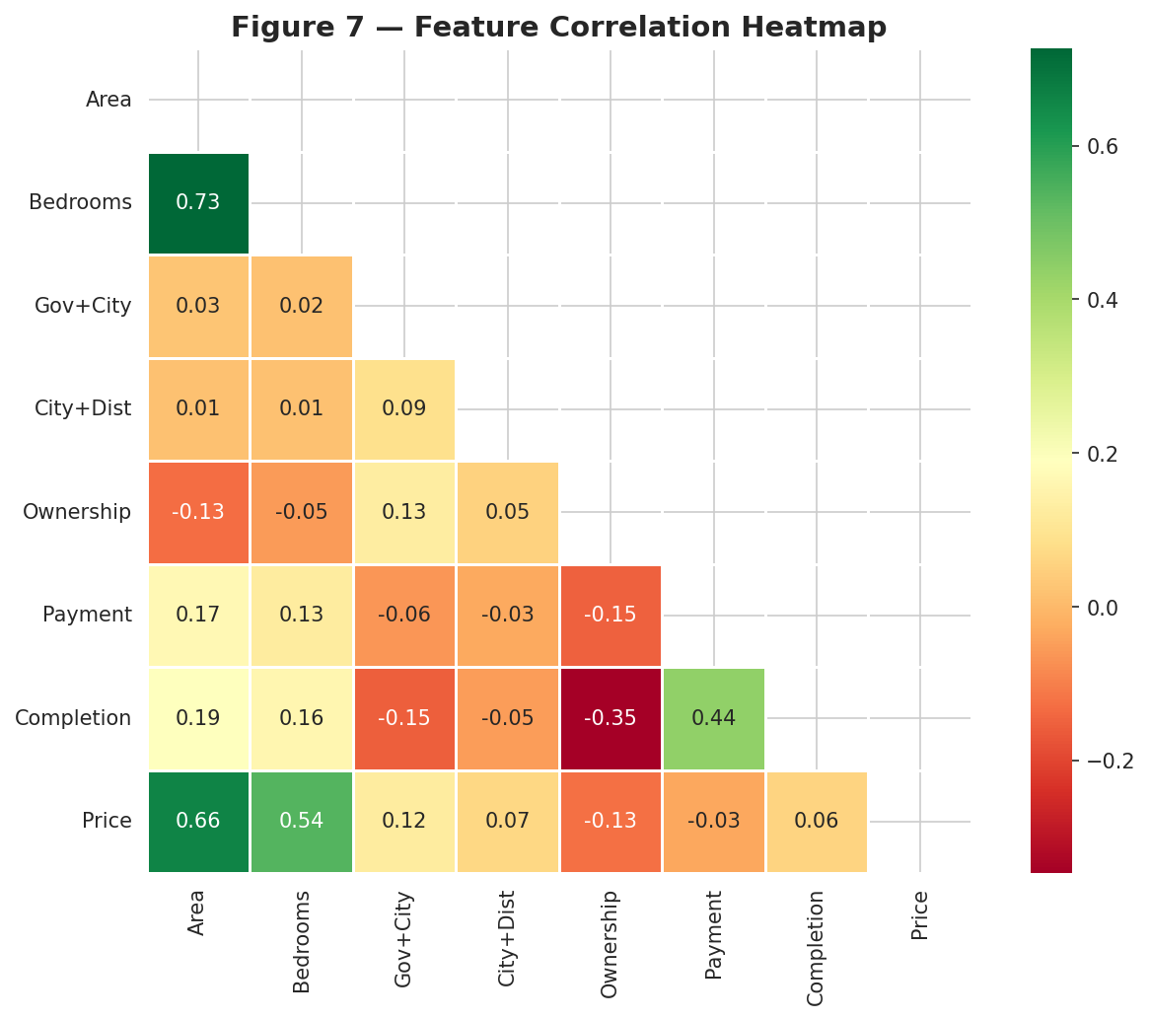
Figure 7 — Correlation heatmap. City+District is the strongest predictor.

4. Feature Engineering & Data Preparation
- Status filter: Status=OK only (106,532 / 107,276).
- Type normalization: iVilla→Villa; Hotel Apartment+Roof→Other.
- Price: 0.5M – ~110M EGP (99.5th percentile).
- Area: 20 – ~800m² (99.5th percentile). Bedrooms: 1–8.
- District fix: missing → Compound → City. District==City → Compound if available.
- Gov+City bounded: "Governorate — City" (181 combinations).
- City+District bounded: "City / District" (1,473 combinations) — primary location feature.
- Ownership: Primary=1, Resale=0, Unknown=0.5.
- Payment: Cash=1, Installment=0, Cash or Installment=0.5.
- Completion: Ready=1, Off-plan=0, Unknown=0.5.
- Log-transform: log(price_m) as training target; exp() for back-transform.
- Bathrooms removed: r=0.79 with bedrooms; 1→2 bath jump = market tier not causal effect.
- Train/Test split: 80%/20%, random_state=42.

5. Machine Learning Models

5.1 Stratified Approach
One dedicated model per property type. Each model learns type-specific price dynamics. Features: area, bedrooms, Gov+City, City+District, Ownership, Payment, Completion.

5.2 Results

Property Type | Best Model | Records | MAE (M EGP) | R² | MAPE
Apartment | Random Forest | 43,399 | 2.056 | 0.5336 | 28.1%
Villa | Random Forest | 13,975 | 7.933 | 0.6019 | 29.6%
Town House | Gradient Boosting | 5,565 | 3.816 | 0.5611 | 24.1%
Twin House | Gradient Boosting | 3,387 | 4.512 | 0.6328 | 23.2%
Duplex | Gradient Boosting | 3,435 | 3.322 | 0.4098 | 31.4%
Penthouse | Gradient Boosting | 2,577 | 3.373 | 0.5029 | 23.6%
Studio | Random Forest | 994 | 1.224 | 0.5882 | 25.0%
Global | — | 74,240 | 3.532 | 0.7576 | 27.87%

5.3 Model Descriptions

Random Forest (Bagging)
200 trees, bootstrapped subsets. n_estimators=200, max_depth=15, min_samples_leaf=3. Best for: Apartment, Villa, Studio, Other.

Gradient Boosting (Boosting)
200 sequential trees. n_estimators=200, max_depth=5, learning_rate=0.1, subsample=0.8. Best for: Town House, Twin House, Duplex, Penthouse.

6. Model Evaluation
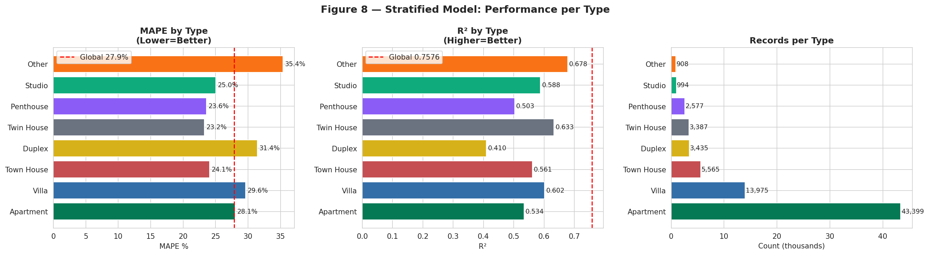
Figure 8 — MAPE, R², record count per property type.
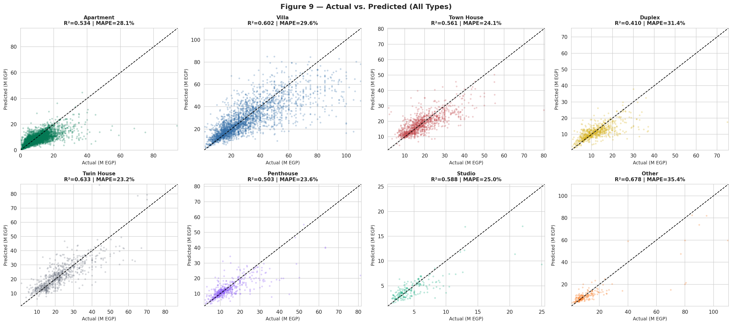
Figure 9 — Actual vs. predicted for all 8 types.
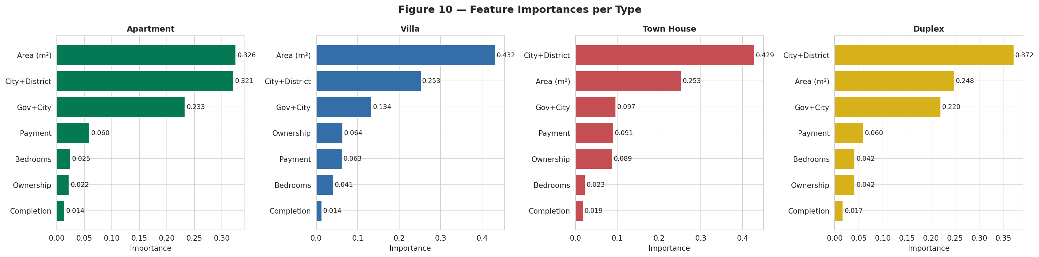
Figure 10 — Feature importances. City+District dominates.

7. Deployment

7.1 Technology Stack
- Python 3.11, aiohttp (scraper), Pandas, NumPy, Scikit-learn, Matplotlib, Seaborn
- Streamlit — web app with cascading Governorate → City → District dropdowns
- Joblib — model_final.pkl (8 models + encoders)
- GitHub — source code hosting
- Streamlit Community Cloud — live public deployment

7.2 Local Setup
pip install -r requirements.txt
python train.py # retrain → model_final.pkl
streamlit run app.py # launch at http://localhost:8501

7.3 Streamlit Community Cloud Deployment
To deploy the app publicly on Streamlit Community Cloud (share.streamlit.io):
- Step 1: Push all code files to GitHub (exclude model_final.pkl — too large for git).
- Step 2: Go to share.streamlit.io → Sign in with GitHub → "New app".
- Step 3: Select repository, branch: main, main file: app.py → Deploy.
- Step 4: After deployment, go to App Settings → Files → upload model_final.pkl.
- Step 5: App is live at https://your-app-name.streamlit.app
Replace placeholder URLs below with actual screenshots after deployment.

Streamlit App — Main Interface:
⬜ Screenshot 1: Streamlit App — Main UI (property type selector + cascading location dropdowns)
[ Add screenshot after running: streamlit run app.py ]
Expected: radio buttons for property type, 3 cascading dropdowns, detail inputs
⬜

Streamlit App — Prediction Result:
⬜ Screenshot 2: Streamlit App — Prediction Output (estimated price + property summary table)
[ Add screenshot after entering details and clicking “💰 Estimate Price” ]
Expected: price in M EGP, EGP value, summary table, model accuracy info
⬜

7.4 Project Files for GitHub
- app.py — Streamlit web application
- train.py — full training pipeline
- dubizzle_scraper.py — Stage 2 aiohttp scraper (reads URLs.xlsx → writes dubizzle_listings.xlsx)
- Egypt_RE_Appraiser_Final.ipynb — complete EDA + models notebook
- requirements.txt — app dependencies (pandas, sklearn, streamlit, ...)
- requirements_scraper.txt — scraper dependencies (aiohttp, lxml, bs4, openpyxl)
- README.md — project overview, setup guide, results table
- .gitignore — excludes model_final.pkl, xlsx, csv (too large for git)

8. Conclusions & Future Work

8.1 Key Findings
- R²=0.7576, MAE=3.532M EGP, MAPE=27.87% — 28-point MAPE improvement over Kaggle baseline.
- City+District (1,473 bounded combinations) is the single most important feature.
- Ownership, Completion Status, and Payment added ~+0.07 R² vs data.xlsx.
- Stratified models are logically correct: Town House MAPE=24.1% vs Duplex MAPE=31.4%.
- aiohttp scraper is highly efficient: 107K URLs in 4–6 hours, 99.3% success rate.
- Log-transform essential: skewness 2.63 → 0.08, MAPE reduced ~30 points.

8.2 Future Work
- XGBoost + Optuna tuning → target R² > 0.85.
- Floor number and finishing quality as additional features.
- Geographic coordinates (lat/lon) for spatial regression.
- Monthly automated re-scrape to track price trends.
- Confidence intervals in Streamlit app for uncertainty communication.

