Digital Egypt Builders Initiative
Final Project

Northy: Egypt Coastal Hotels Market Intelligence

Student Name
Abdelrahman Saber
Esraa Maaly
Nour Ashry
Omnia Ahmad
Alaa Khidr

Table of Contents
Table of Figures 3
List of Tables 4
Declaration 5
Acknowledgement 6
Abstract 1
1. Introduction 2
1.1 Project Overview 2
1.2 Problem Statement 2
1.3 Objectives 2
1.4 Project Contribution 2
2. Literature Review 3
2.1 Background 3
2.2 Related Work 3
3. Methods and Materials 4
3.1 Data Sources 4
3.2 Methodology 4
3.3 Tools and Technologies 5
4. Implementation 6
4.1 Repository Structure 6
4.2 Dashboard Implementation 6
4.3 Power BI Analysis Preparation 7
5. Research Results and Discussions 9
5.1 Dataset Summary 9
5.2 Destination Analysis 9
5.3 Source Website Analysis 10
5.4 Price and Rating Distribution 10
5.5 Data Quality Discussion 11
6. Conclusions and Future Work 12
6.1 Conclusion 12
6.2 Future Roadmap 12
References 13
Appendices 14
A.1 Data Dictionary 14
A.2 Recommended Power BI Measures 15

Table of Figures
Figure 1: Northy medallion data pipeline and analytics workflow 5
Figure 2: Northy dashboard interface from the project repository 7
Figure 3: Power BI-style executive dashboard overview for Northy 8

List of Tables
Table 1: Comparison of Northy with related hotel analytics approaches 3
Table 2: Northy data layers and analytical purpose 4
Table 3: Repository components used by Northy 6
Table 4: Executive market metrics from the Northy dataset 9
Table 5: Destination-level results 9
Table 6: Source website results 10
Table 7: Price-band distribution 10
Table 8: Future roadmap for Northy 12
Table 9: Core fields in the Silver listing table 14

Declaration
We declare that this final project documentation was prepared for the Northy project by the listed team members. The work describes our understanding of the project problem, data pipeline, implementation, analysis results, and future development vision. All external resources, project links, datasets, and tools used to support the work are acknowledged in the references section.

Acknowledgement
The team would like to acknowledge the Digital Egypt Builders Initiative for providing the learning environment and project framework. We also acknowledge the availability of public hotel listing platforms and modern data tools that enabled the project workflow, including scraping, ETL processing, dashboard development, and Power BI-style analysis.

Abstract
Northy is a coastal hotel market intelligence project focused on Egypt's North Coast, Alexandria, and Marsa Matruh. The project collects hotel listing data from major booking sources, processes the data through an ETL pipeline, and converts the cleaned records into analytical dashboards for price, rating, source, and destination insights. The data workflow follows a medallion architecture: raw scraped data is prepared into a Silver listing layer and summarized into a Gold analytical layer. The resulting CSV files are uploaded into the application environment and visualized through a web dashboard and Power BI-ready analysis outputs. The analysis shows 1,152 scraped listing rows, 202 unique hotel names, an average market price of 14,846 EGP, a median price of 6,807 EGP, and an average rating of 8.21. The findings show that Booking dominates listing coverage, while North Coast and Airbnb listings strongly influence premium pricing. The project provides a practical foundation for future hotel recommendation, vacation planning, smart search, interactive maps, booking integration, and real-time pricing features.
Keywords: Hotel analytics, ETL, Databricks, Power BI, Recommendations

Introduction

Project Overview
Northy is an Egypt coastal hotels market intelligence platform that helps users and stakeholders understand hotel supply, pricing, ratings, and source distribution across Alexandria, Marsa Matruh, and the North Coast. The project combines data engineering and dashboard design: hotel data is collected from public listing sources, transformed into reliable analytical layers, and presented through an interactive web experience.

Problem Statement
Travelers and tourism analysts often need to compare hotels across multiple platforms, but the data is scattered, inconsistent, and difficult to analyze manually. Different booking platforms may vary in price level, coverage, rating availability, image availability, and destination focus. Without an integrated data layer, it is difficult to identify market patterns or build recommendation features.

Objectives

- Collect hotel listing information from Airbnb, Booking, and Hotels.com.

- Clean and transform listing data into structured Silver and Gold analytical layers.

- Build an interactive dashboard for market summary, filtering, and KPI exploration.

- Create Power BI-ready data assets and measures for professional reporting.

- Identify market insights that support future recommendation and booking features.

Project Contribution
The main contribution of Northy is a practical end-to-end pipeline that moves from scraping to analysis-ready reporting. It demonstrates how raw listing data can become a searchable, filterable, and visual market intelligence product. The system also provides a foundation for later artificial intelligence features such as personalized hotel recommendation and vacation suggestion.

Literature Review

Background
Hotel market intelligence depends on combining data from multiple sources and transforming it into consistent metrics. In hospitality analytics, key reporting measures commonly include listing volume, price, rating, source distribution, location segmentation, and availability of enrichment attributes such as images and links. For Northy, these measures are especially important because coastal tourism markets can have wide price variation between standard city hotels and premium North Coast rentals.
The project uses a medallion architecture pattern, where raw data is gradually improved through Bronze, Silver, and Gold layers. This approach supports traceability: raw scraped rows can be preserved, cleaned records can be used for detailed analysis, and aggregated Gold data can support dashboards and stakeholder reporting.

Related Work
Related systems include online travel agencies, hotel comparison websites, and business intelligence dashboards that summarize lodging prices and user ratings. Northy differs from a standard booking website because its main goal is analytical visibility rather than direct transaction completion. The project brings together data engineering, dashboard design, and future AI recommendation planning in one workflow.

Table 1: Comparison of Northy with related hotel analytics approaches
Approach | Main Purpose | Limitation | Northy Contribution
Booking platforms | Allow users to search and reserve hotels | Data is platform-specific | Combines multiple source websites for analysis
Spreadsheet analysis | Manual summaries and quick calculations | Limited interactivity and scalability | Creates structured ETL layers and dashboard views
BI dashboards | Visualize trends and KPIs | Depend on prepared datasets | Provides cleaned Silver and aggregated Gold CSV layers
Recommendation systems | Suggest personalized options | Require reliable features and historical behavior | Defines future AI-ready roadmap and data foundation

Methods and Materials

Data Sources
The Northy dataset is based on scraped hotel and accommodation listings from Airbnb, Booking, and Hotels.com. The core fields include listing name, destination, price in Egyptian pounds, rating, listing URL, source website, and image URL when available. The reporting scope covers Alexandria, Marsa Matruh, and the North Coast.

Table 2: Northy data layers and analytical purpose
Layer | Content | Purpose
Bronze | Raw scraped hotel listing records | Preserve the original collected data before cleaning
Silver | Cleaned listing-level CSV with core hotel fields | Support detailed filtering, pricing, rating, and source analysis
Gold | Aggregated destination/source metrics | Support executive summaries and dashboard-ready market metrics
Application Database | Uploaded CSV data in the Lovable application environment | Power the user-facing dashboard and filtering experience

Methodology
The project methodology begins with collecting listing data and ends with dashboard visualization. After scraping, the team used Databricks to perform ETL operations and organize the data into Bronze, Silver, and Gold layers. The cleaned CSV outputs were then used for the web dashboard, Power BI analysis workbook, and presentation visuals.
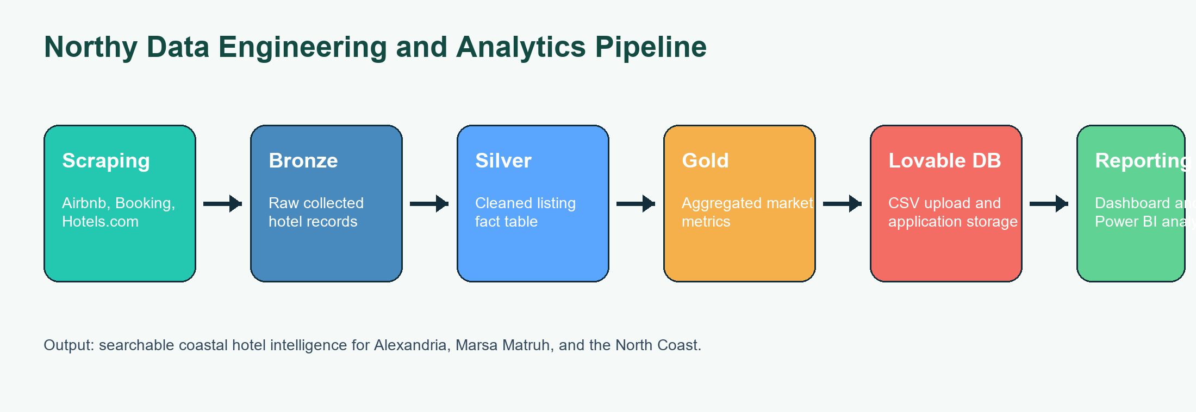

Figure 1: Northy medallion data pipeline and analytics workflow

Tools and Technologies

- Databricks for ETL processing and layer management.

- CSV files for Silver and Gold data exchange.

- Lovable application environment and database upload for dashboard storage.

- HTML, CSS, JavaScript, and Chart.js for the interactive web interface.

- Power BI-ready workbook, DAX measures, and Power Query guidance for business intelligence reporting.

- GitHub repository for source organization and project sharing.

Implementation

Repository Structure
The public project repository is organized into data, dashboard, and image assets. The data folder stores the Silver and Gold CSV files, the dashboard folder contains the HTML dashboard, and the images folder contains screenshots that demonstrate the final user interface and filtering states.

Table 3: Repository components used by Northy
Component | Path | Description
Silver dataset | data/Silver_Layer (1).csv | Cleaned listing-level data with destination, source, price, rating, URL, and image URL fields
Gold dataset | data/Gold_Layer (1).csv | Aggregated source/destination metrics for executive reporting
Dashboard | dashboard/Egypt_Hotels_PowerBI_Dashboard.html | Interactive market intelligence interface
Images | images/*.png | Interface screenshots and filter demonstrations

Dashboard Implementation
The dashboard presents market KPIs, hotel cards, filter controls, and visual summaries. Users can explore the market by destination, source website, and rating bands. The design is oriented around quick comparison, allowing the user to move from high-level market summary to filtered hotel listings.
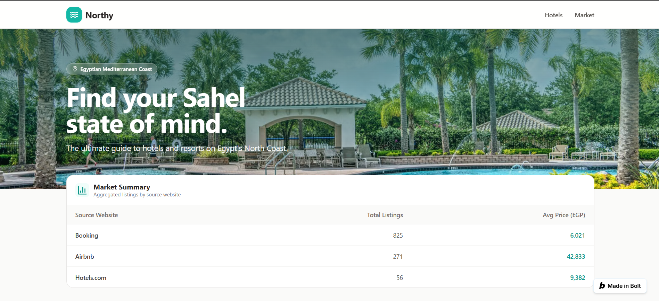

Figure 2: Northy dashboard interface from the project repository

Power BI Analysis Preparation
A Power BI-ready analysis package was created from the Silver and Gold data. It includes a fact-listings table, a Gold summary table, recommended report pages, DAX measures, Power Query code, and a theme file. This makes the project suitable for a professional business intelligence workflow even when the final visualization is presented through the custom web dashboard.
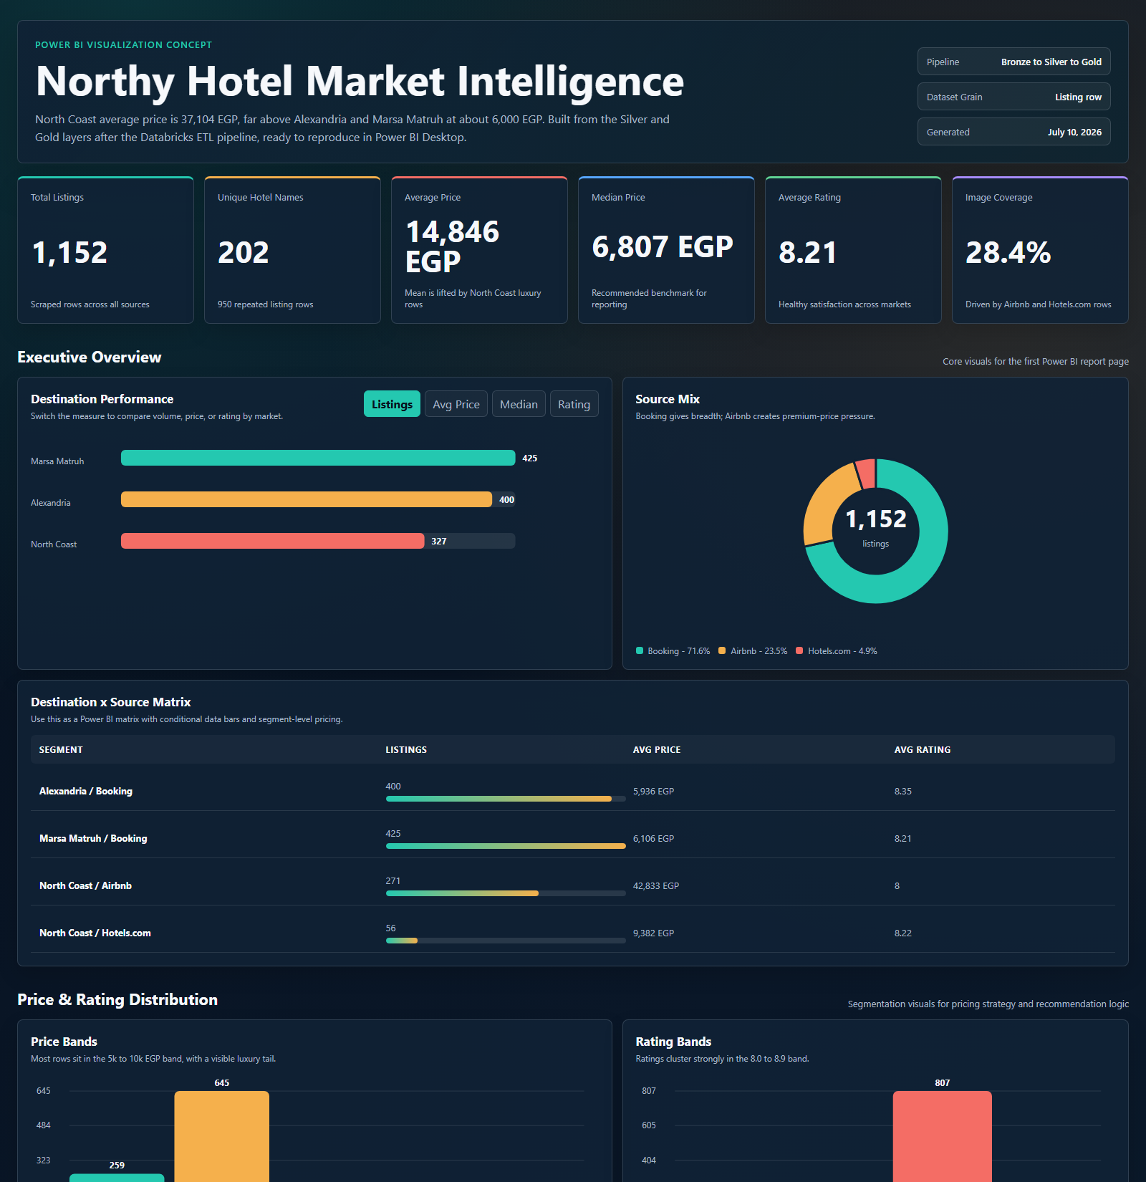

Figure 3: Power BI-style executive dashboard overview for Northy

Research Results and Discussions

Dataset Summary
The processed analysis contains 1,152 listing rows and 202 unique hotel names. The average price is 14,846 EGP, while the median price is 6,806 EGP. The market average rating is 8.21, indicating generally strong listed-property quality across the collected rows.

Table 4: Executive market metrics from the Northy dataset
Metric | Value | Interpretation
Total Listings | 1,152 | Total scraped listing rows used in analysis
Unique Hotel Names | 202 | Approximate deduplicated property-name count
Average Price | 14,846 EGP | Mean price across all listing rows
Median Price | 6,806 EGP | Robust midpoint price, less affected by luxury outliers
Average Rating | 8.21 | Overall quality signal from rating values
Image Coverage | 28.4% | Rows containing an image URL

Destination Analysis

Table 5: Destination-level results
Destination | Listings | Avg Price | Median Price | Avg Rating
Marsa Matruh | 425 | 6,106 EGP | 6,173 EGP | 8.21
Alexandria | 400 | 5,936 EGP | 6,028 EGP | 8.35
North Coast | 327 | 37,104 EGP | 22,492 EGP | 8.04

The strongest pricing finding is that North Coast listings are substantially more expensive than Alexandria and Marsa Matruh listings. This is mainly connected to the premium and luxury nature of many North Coast rentals, especially Airbnb rows. For business reporting, North Coast should therefore be treated as a separate segment instead of being blended into one market average.

Source Website Analysis

Table 6: Source website results
Source | Listings | Listing Share | Avg Price | Avg Rating
Booking | 825 | 71.6% | 6,024 EGP | 8.28
Airbnb | 271 | 23.5% | 42,833 EGP | 8.00
Hotels.com | 56 | 4.9% | 9,382 EGP | 8.22

Booking provides the broadest coverage with 825 listing rows, equal to 71.6% of the dataset. Airbnb contributes fewer rows but has the highest average price, which makes it important for luxury and villa pricing analysis. Hotels.com contributes a smaller but image-complete subset that can support visual enrichment.

Price and Rating Distribution

Table 7: Price-band distribution
Price Band | Listings | Share | Avg Rating
Budget <=5k | 259 | 22.5% | 8.25
Mid 5k-10k | 645 | 56.0% | 8.27
Upper 10k-20k | 72 | 6.2% | 8.07
Premium 20k-50k | 89 | 7.7% | 8.02
Luxury 50k+ | 87 | 7.5% | 8.00

Most listings fall in the mid-price segment from 5,000 to 10,000 EGP, while a visible premium and luxury tail remains. Ratings are concentrated around the 8.0 to 8.9 range, which suggests that future recommendation logic can combine rating thresholds with price bands to find high-value options.

Data Quality Discussion
The core analytical fields are complete in the prepared dataset: name, destination, source website, price, rating, and URL have no missing rows in the analysis package. The main quality limitation is image coverage, because Booking rows do not include image URLs while Airbnb and Hotels.com rows do. There are also repeated hotel names across listing rows, so future deduplication should add a stable property key before using unique-property metrics as final business counts.

Conclusions and Future Work

Conclusion
Northy successfully demonstrates an end-to-end hotel market intelligence workflow. The project begins with scraped accommodation data, transforms the data through a structured ETL pipeline, stores the prepared CSV outputs for application use, and presents the results through dashboards and Power BI-ready reporting assets. The analysis shows clear market differences between destinations and source websites, especially the premium pricing behavior of North Coast Airbnb listings.

Future Roadmap

Table 8: Future roadmap for Northy
Roadmap Item | Expected Value
Mobile Application | Make Northy accessible for travelers on phones and tablets
Cloud Platform | Improve scalability, deployment reliability, and data storage
Automatic Real-Time Updates | Reduce manual refresh work and keep prices/current listings updated
AI Hotel Recommendations | Recommend hotels based on destination, price, rating, and user preferences
Personalized Vacation Suggestions | Suggest trip plans based on budget, destination, and travel style
Smart Search | Help users find relevant options faster through intelligent filters
Interactive Maps | Visualize hotels geographically by destination and location context
Booking Integration | Move from analysis toward transaction support
Real-time Pricing | Track market changes and support timely decisions

The most important technical next step is to automate the refresh pipeline. Once data updates become scheduled and reliable, the project can support AI-based recommendation, price monitoring, and personalized planning more effectively.

References
Northy Project Team. (2026). Northy: Egypt Coastal Hotels Market Intelligence. GitHub repository: https://github.com/nhahub/NHA-4-080
Northy Project Team. (2026). Northy live dashboard. https://northy-hotel-directo-4qul.bolt.host
Northy Project Team. (2026). Silver_Layer (1).csv and Gold_Layer (1).csv project datasets.
Databricks. (2026). Lakehouse and medallion architecture concepts. https://www.databricks.com
Microsoft. (2026). Power BI documentation. https://learn.microsoft.com/power-bi/
Lovable. (2026). Application development and database deployment platform. https://lovable.dev

Appendices

A.1 Data Dictionary

Table 9: Core fields in the Silver listing table
Field | Type | Description
name | Text | Hotel or accommodation listing name
destination | Text | Market destination, such as Alexandria, Marsa Matruh, or North Coast
price_egp | Number | Observed listing price in Egyptian pounds
rating | Number | Observed listing rating
url | Text | Source listing URL
source_website | Text | Source platform: Airbnb, Booking, or Hotels.com
image_url | Text | Listing image URL where available

A.2 Recommended Power BI Measures

- Total Listings = COUNTROWS('Fact Listings')

- Unique Hotel Names = DISTINCTCOUNT('Fact Listings'[name])

- Average Price EGP = AVERAGE('Fact Listings'[price_egp])

- Median Price EGP = MEDIAN('Fact Listings'[price_egp])

- Average Rating = AVERAGE('Fact Listings'[rating])

- Image Coverage % = rows with image URL divided by total listings

