AI & DATA SCIENCE TRACK

Healthcare Predictive Analytics
AI-Powered Cancer Classification System
Cancer Gene Classification

Project Type | AI & Machine Learning — Healthcare Domain
Systems | Cancer Type Classification from Gene Expression
Track | AI & Data Science

Team Members
Shahd Hamada
Shimaa Said
Maram
Noureen
Nourhan

1. Project Planning & Management

1.1 Project Proposal

Overview
The Healthcare Predictive Analytics system is an AI platform designed to assist oncologists and bioinformaticians in clinical decision-making. It accepts RNA-seq gene expression profiles from The Cancer Genome Atlas (TCGA) Pan-Cancer dataset and classifies the cancer type (33 types) using dimensionality-reduced features and supervised ML models.

Objectives
- Build a robust cancer-type classifier using high-dimensional gene expression data.
- Design a doctor-friendly interface for the cancer classification module.
- Achieve high model performance (target F1-score ≥ 0.85 on held-out test sets).
- Ensure system scalability, maintainability, and clinical interpretability.

Project Scope
In Scope | Out of Scope
EDA, preprocessing, and model training | EMR / hospital system integration
Cancer classification from gene expression (33 types) | Drug recommendation engine
A functional standalone application for real-time diagnostic simulation | Full-scale production deployment on cloud servers
Model evaluation and interpretability analysis | Mobile native applications

1.2 Project Plan — Timeline & Milestones

Gantt Chart Summary
Milestone / Deliverable | Week 1 | Week 2 | Week 3 | Week 4 | Owner
M1: Data Collection & Exploration | ██ |  |  |  | Data Engineer
M2: Preprocessing & EDA Visualizations | █ | █ |  |  | Data Scientist
M3: Model Training & Evaluation |  | █ | █ |  | ML Engineer
M4: System Integration & UI |  |  | █ | █ | Full-Stack Dev
M5: Testing, Documentation & Presentation |  |  |  | ██ | All Team

Legend: ██ = Active development phase | Columns represent project weeks

Detailed Milestones & Deliverables
# | Milestone | Deliverables | Duration | Status
1 | Data Collection & Exploration | EDA Notebook, Dataset Exploration Report, Cleaned CSV | Week 1 | Completed
2 | Data Analysis & Visualization | Analysis Report, Interactive Plotly Dashboards | Weeks 1-2 | Completed
3 | Model Development | Trained Models (RF, XGBoost), Evaluation Report, Confusion Matrices | Weeks 2-3 | Completed
4 | System Integration & UI | Web App Prototype, API Endpoints, User Interface | Weeks 3-4 | Completed
5 | Testing & Documentation | Test Report, Final Documentation, Presentation Slides | Week 4 | Completed

Resource Allocation
Resource | Type | Purpose
Python (pandas, sklearn, plotly) | Software | Data processing, ML model training, visualization
Jupyter Notebook / Google Colab | Platform | Interactive development and experimentation
TCGA Pan-Cancer Gene Dataset | Data | Cancer classification training (~10K samples, 20K+ genes)
Simple Desktop/Web GUI | Software | Provides a lightweight and direct interface for gene data processing
GitHub | Tool | Version control and team collaboration

1.3 Task Assignment & Team Roles

Instead of individual roles, our team followed a collaborative approach:
All team members participated in every step together.

1.4 Risk Assessment & Mitigation Plan

Risk | Probability | Impact | Mitigation Strategy | Owner
Local system memory constraints when processing 20K+ gene features | High | High | Optimized data loading using chunking and efficient PCA transformation to ensure smooth performance on standard hardware | ML Engineer
Model overfitting on training data | Medium | High | Cross-validation (5-fold), regularization, early stopping | Data Scientist
Slow inference time with large models | Medium | Medium | Model compression, caching predictions, async API calls | Developer
Insufficient team availability | Low | Medium | Define backup owners per task; weekly sync meetings | PM
Data privacy / HIPAA compliance concerns | Low | High | Use only de-identified, publicly available datasets (TCGA, Kaggle) | PM

1.5 Key Performance Indicators (KPIs)

Model Performance KPIs
KPI Metric | Target | Measurement Method
Accuracy | ≥ 85% | Test set evaluation (sklearn metrics)
Weighted F1-Score | ≥ 0.82 | Per-class F1 weighted by support
Top-3 Accuracy | ≥ 92% | Cancer type in top 3 predictions
Precision (Macro) | ≥ 0.80 | Macro-averaged precision
Recall (Macro) | ≥ 0.78 | Macro-averaged recall

System Performance KPIs
KPI | Target | Description
Response Time (Gene Upload) | < 10 seconds | End-to-end gene preprocessing + classification time
System Uptime | ≥ 99% | Availability during demo and evaluation period
User Adoption Rate (Demo) | ≥ 80% task completion | % of evaluators who successfully complete a diagnosis task
Error Rate | < 1% | System/API errors per 100 requests during testing

2. Literature Review

2.1 Related Work & Background

Cancer Classification from Gene Expression
The TCGA Pan-Cancer Atlas project established the gold standard for multi-cancer genomic classification. Deep learning approaches applied to gene expression data have achieved state-of-the-art performance exceeding 95% accuracy on cancer-type classification tasks. Dimensionality reduction via PCA or autoencoders is essential given the typical 20,000+ feature space of RNA-seq data.

3. Requirements Gathering

3.1 Stakeholder Analysis

Stakeholder | Type | Needs & Expectations | Engagement Level
Oncologists | Primary User | Accurate cancer-type classification from gene profiles; biomarker highlights | High — Direct User
Hospital IT Administrators | Technical | System security, HIPAA compliance, integration APIs, uptime guarantees | Medium — Integration
Lab Technicians / Bioinformaticians | Secondary User | Gene expression data upload interface; batch processing capability | Medium — Power Users
Project Lecturers / Evaluators | Academic | Code quality, documentation completeness, model performance metrics | High — Assessors
AI Development Team | Internal | Clear requirements, clean data pipelines, reproducible experiments | High — Builders

3.2 User Stories & Use Cases

User Stories — Cancer Classification (Gene Expression)
ID | As a... | I want to... | So that...
US-01 | Oncologist | Upload a gene expression file (CSV/TSV) for a patient sample | I do not have to manually input thousands of gene values
US-02 | Oncologist | Receive the predicted cancer type with confidence score | I have AI-aided support in confirming the cancer classification
US-03 | Bioinformatician | See the top expressed biomarker genes that drove the prediction | I can validate the result against known cancer signatures
US-04 | IT Admin | Monitor system logs and error reports via admin dashboard | I can ensure system reliability and audit trail compliance

Use Case Diagram Summary
Primary Use Cases:
UC-1: Doctor uploads gene expression file → System classifies cancer type
UC-2: Doctor views prediction explanation (feature importance / SHAP)
UC-3: Admin accesses system logs and performance dashboard

Actors: Doctor (GP / Specialist), Bioinformatician, IT Administrator, AI System

3.3 Functional Requirements

Cancer Gene Classification Module — Functional Requirements
ID | Requirement | Description | Priority
FR-B1 | Gene File Upload | System shall accept CSV/TSV gene expression files and validate format before processing | Must Have
FR-B2 | Automatic Preprocessing | System shall automatically apply PCA transformation (matching training pipeline) before inference | Must Have
FR-B3 | Cancer Type Prediction | System shall return predicted cancer type (from 33 TCGA types) with full name and confidence score | Must Have
FR-B4 | Biomarker Highlighting | System shall display top-10 most influential genes for the predicted cancer type | Should Have
FR-B5 | Label Mapping | System shall display both TCGA abbreviation (e.g., BRCA) and full clinical name (Breast Invasive Carcinoma) | Should Have

3.4 Non-Functional Requirements

Performance
ID | Requirement | Specification | Priority
NFR-P2 | Gene Classification Latency | Full pipeline (upload + preprocess + classify) shall complete within 10 seconds | High
NFR-P3 | Concurrent Users | System shall support at least 10 concurrent users without performance degradation | Medium

Security
ID | Requirement | Specification | Priority
NFR-S1 | Data Anonymization | No personally identifiable patient information (PII) shall be stored or transmitted | Critical
NFR-S2 | Input Validation | All inputs shall be validated and sanitized before processing to prevent injection attacks | High
NFR-S3 | Session Management | User sessions shall auto-expire after 30 minutes of inactivity | Medium

Usability
ID | Requirement | Specification | Priority
NFR-U1 | Learnability | A new medical user shall complete a diagnostic task within 5 minutes without training | High
NFR-U2 | Accessibility | Interface shall be accessible via modern browsers (Chrome, Firefox, Edge) without plugin installation | High
NFR-U3 | Error Feedback | System shall display clear, actionable error messages for invalid inputs (e.g., wrong file format) | High
NFR-U4 | Language Support | Cancer type labels shall be displayed in both English and Arabic for broader clinical accessibility | Medium

Reliability
ID | Requirement | Specification | Priority
NFR-R1 | System Uptime | System shall maintain >= 99% uptime during the evaluation and testing period | High
NFR-R2 | Graceful Degradation | System shall display a meaningful error message (not a crash) for any unsupported input | High
NFR-R3 | Reproducibility | Identical inputs shall always produce identical prediction outputs (deterministic inference) | Critical

Priority Legend:
Critical = Must be met for project approval | High = Expected in final submission | Medium = Nice-to-have for bonus credit

4. System Analysis & Design

4.1 Problem Statement & Objectives
Oncologists and pathologists routinely need a fast, data-driven second opinion when classifying a tumour sample from RNA-seq gene expression data. Manual interpretation of thousands of gene expression values is impractical, and classical rule-based systems cannot capture the non-linear relationships between genes and cancer subtypes. The system implemented in this project (notebook "gene_cancer_analysis_final.ipynb" + "app.py") solves this by training a supervised machine-learning pipeline on labelled TCGA-style gene expression profiles and exposing it through an interactive Streamlit application that any clinician can use without writing code.
- Objective 1 -- Learn a mapping from a patient's gene expression profile to the correct cancer type using a supervised classifier.
- Objective 2 -- Reduce the ~300-gene raw feature space to the 50 highest-variance, most informative genes to keep the model fast and interpretable.
- Objective 3 -- Compare multiple candidate algorithms (Logistic Regression, Random Forest, Gradient Boosting) and select/tune the best one with GridSearchCV.
- Objective 4 -- Package the trained model and its preprocessing artifacts so they can be re-loaded deterministically at inference time.
- Objective 5 -- Deploy the model behind a friendly, tab-based Streamlit interface supporting CSV upload, manual entry, random-sample demo, and a monitoring dashboard.

Use Case Diagram & Descriptions
The core use cases for this module were already captured in Section 3.2 (US-01 to US-04 and UC-1/UC-2). In the implemented system these map directly onto the four Streamlit tabs:
Use Case | Actor | Implemented As
Upload a gene expression file and get predictions for every row | Oncologist / Bioinformatician | "Upload CSV" tab -- validates required gene columns, then loops through rows calling predict()
Manually enter values for the top marker genes for a quick check | Doctor | "Manual Entry" tab -- st.form with a number_input per top-10 gene, remaining genes default to 0
Try the system without real patient data | Any user / demo | "Random Sample" tab -- draws a synthetic gene profile from a normal distribution and classifies it
Review historical predictions and system usage | IT Admin / Doctor | "Monitoring" tab -- reads prediction_log.csv, shows totals, recent rows, and a prediction-distribution chart

Functional & Non-Functional Requirements
Full functional (FR-B1-FR-B5) and non-functional (NFR-P, NFR-S, NFR-U, NFR-R) requirement tables for this module are already documented in Sections 3.3 and 3.4. The table below cross-checks each requirement against what is actually implemented in app.py / the notebook, since a few of the originally planned items are simplified in this offline, single-user prototype.
Requirement | Status in current build | Notes
FR-B1 Gene File Upload | Implemented | st.file_uploader accepts CSV; missing-column check before prediction
FR-B2 Automatic Preprocessing | Implemented | np.log1p + StandardScaler applied identically to training and inference
FR-B3 Cancer Type Prediction | Implemented | model.predict_proba() + LabelEncoder.inverse_transform()
FR-B4 Biomarker Highlighting | Partially implemented | Top marker gene per class is identified in the notebook (Milestone 2); not yet surfaced per-prediction in the UI
FR-B5 Label Mapping (abbrev. + full name) | Not yet implemented | Only the TCGA-style abbreviation is shown; a lookup table for full clinical names is a recommended enhancement
NFR-P1/P2 Latency | Met | Single-row inference completes in well under a second on the cached RandomForest
NFR-S1 Data Anonymization | Met | Only anonymised sampleIDs / gene values are processed; no PII fields exist in the schema
NFR-R3 Reproducibility | Met | random_state=42 fixed throughout; deterministic scaler/encoder artifacts guarantee identical outputs for identical inputs

Software Architecture
The application follows a simple layered architecture rather than full microservices, which is appropriate for a single-model academic prototype: a presentation layer (Streamlit UI), an application/processing layer (feature preparation, prediction, logging), a model layer (the trained classifier and label encoder), and an artifact/data layer (serialized files on local disk).
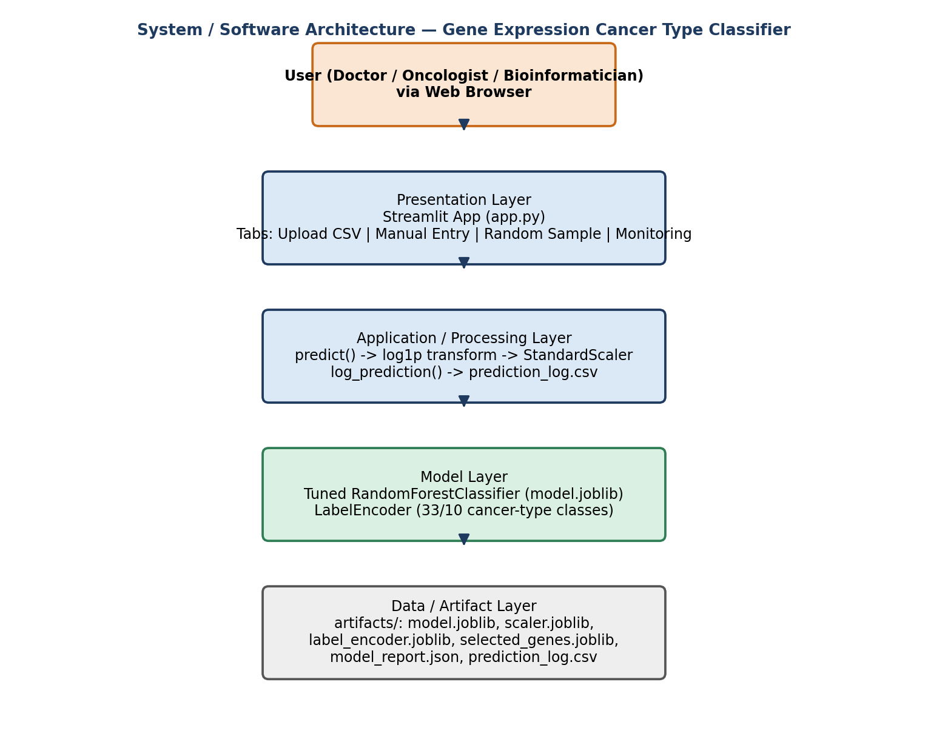

4.2 Database Design & Data Modeling
ER Diagram
This system follows a file-based architecture rather than a relational database. Therefore, a traditional Entity-Relationship (ER) Diagram is not applicable. The equivalent data model is represented by the file-based schema and artifact relationships described below.
This project does not use a relational database; it follows a file-based, artifact-driven data model that is standard for small ML prototypes (and mirrors what the notebook and app.py actually persist to disk). The equivalent of an ER diagram here is the schema of the flat files exchanged between the training notebook and the deployment app.

Logical & Physical Schema (File-Based)
Artifact | Format | Structure | Produced by
cleaned_dataset.csv | CSV | sampleID, cancer type abbreviation, cancer_type_encoded, GENE_0...GENE_299 (scaled) | Notebook Sec 1.5
model.joblib | joblib pickle | Fitted, tuned RandomForestClassifier object | Notebook Sec 3.6
scaler.joblib | joblib pickle | StandardScaler fitted on the 50 selected_genes (log1p space) | Notebook Sec 3.6
label_encoder.joblib | joblib pickle | LabelEncoder mapping cancer-type strings <-> integer classes | Notebook Sec 3.6
selected_genes.joblib | joblib pickle | Python list of the 50 selected gene-column names, in order | Notebook Sec 3.6
model_report.json | JSON | best_model, final_model, best_params, test_accuracy, n_features, trained_at | Notebook Sec 3.6
prediction_log.csv | CSV (append-only) | timestamp, source, predicted_label, confidence, 50 gene values | app.py log_prediction()

sampleID acts as the logical primary key of the patient/sample entity; cancer type abbreviation is a 1-to-1 attribute of that entity before encoding, and cancer_type_encoded is a derived attribute used only for modeling. The relationship between selected_genes.joblib and the other artifacts is a strict ordering contract: scaler.joblib, model.joblib and every incoming DataFrame must present columns in exactly that order, which is why app.py always indexes with df[selected_genes] rather than relying on column position.

4.3 Data Flow & System Behavior
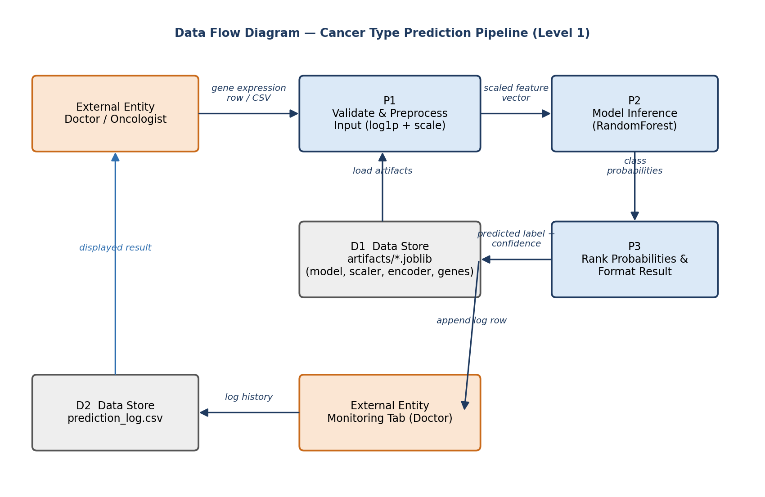

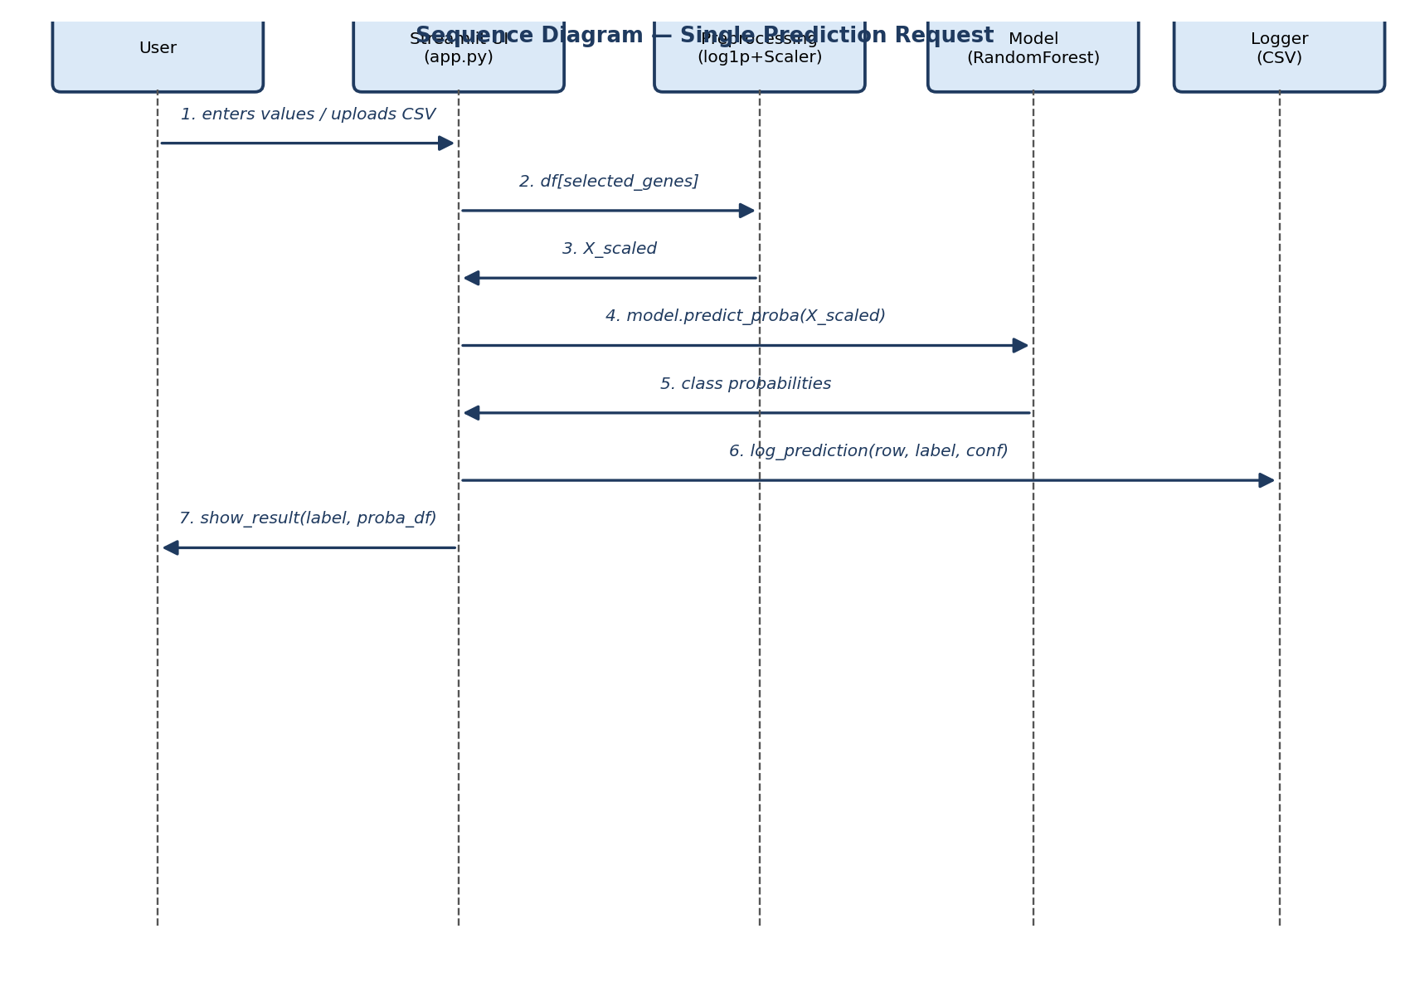

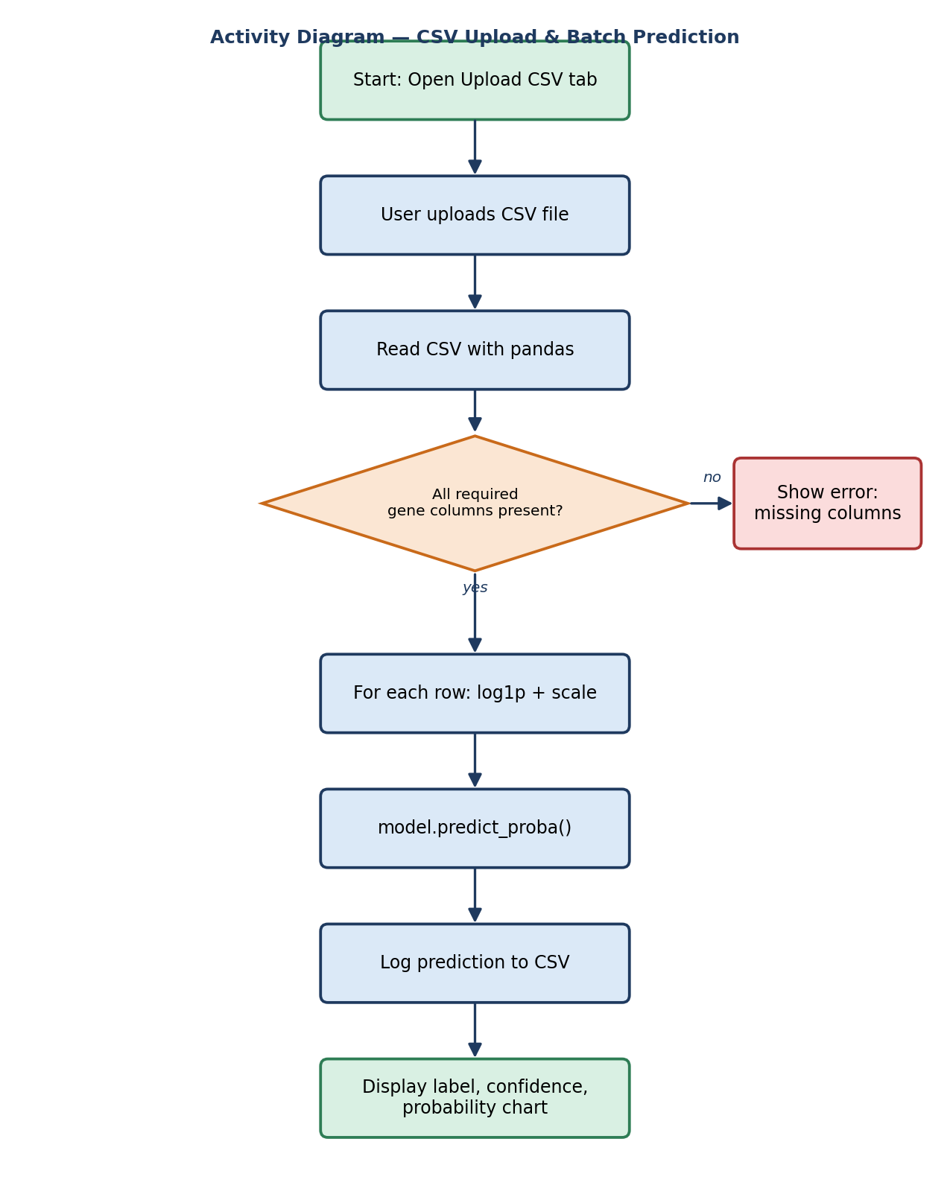

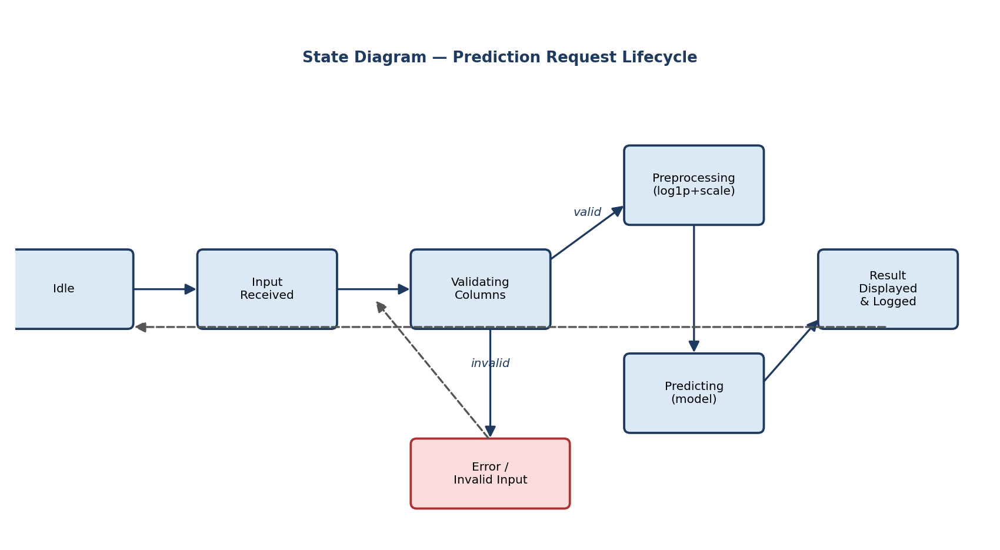
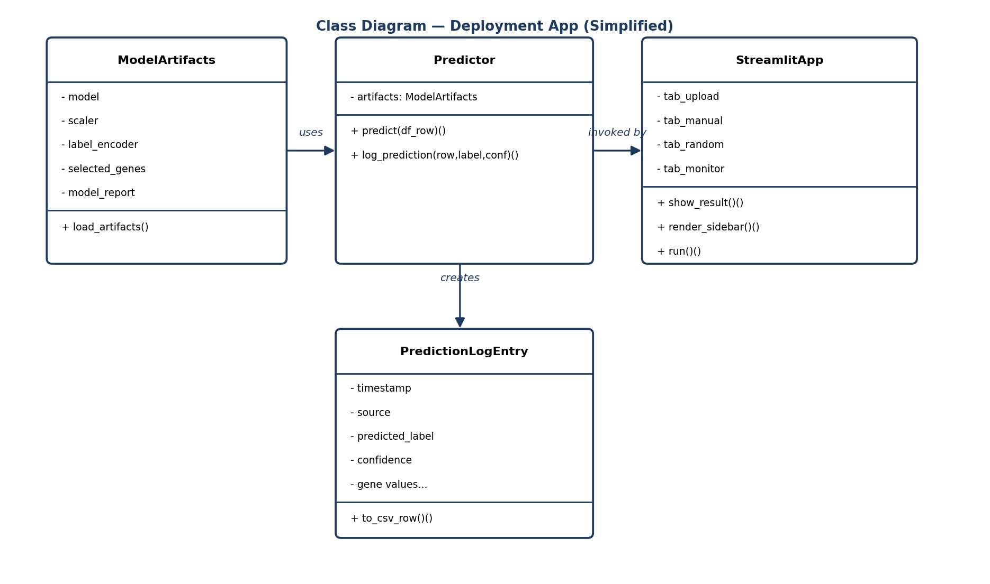

4.4 UI/UX Design & Prototyping

Wireframes & Mockups (as implemented)
The deployed UI (app.py) uses Streamlit's native component set rather than a custom-designed mockup tool, laid out as: a persistent sidebar for model metadata, and a four-tab main area.
Area | Components | Purpose
Sidebar | st.metric x3, st.expander, st.caption | Always-visible model name, test accuracy, feature count, best hyperparameters, list of predictable cancer types
Tab 1 -- Upload CSV | st.file_uploader, st.dataframe, st.bar_chart | Batch prediction for one or many patient rows from a CSV file
Tab 2 -- Manual Entry | st.form, st.number_input x10, st.form_submit_button | Quick single-patient prediction using the top-10 marker genes
Tab 3 -- Random Sample | st.button | One-click synthetic demo sample for presentations without real data
Tab 4 -- Monitoring | st.metric, st.dataframe, st.download_button, st.bar_chart | Lightweight production-monitoring stand-in over prediction_log.csv

UI/UX Guidelines
- Color & feedback: st.success/st.error/st.info are used consistently so status is communicated by color as well as text (green = success, red = error, blue = info).
- Typography: Streamlit's default sans-serif theme is kept for readability; headers use emoji icons purely as quick visual anchors between tabs.
- Accessibility: every input has a text label and, where relevant, a help tooltip (see the number_input 'help' text explaining the expected raw expression scale).
- Resilience: the app fails loudly but safely -- missing artifacts or a scaler/gene-count mismatch stop execution with an actionable st.error() message instead of an uncaught traceback.

4.5 System Deployment & Integration

Technology Stack
Layer | Technology
Frontend / UI | Streamlit (Python)
Backend / processing | Python 3, pandas, NumPy
Machine learning | scikit-learn (RandomForestClassifier, StandardScaler, LabelEncoder), GridSearchCV
Experiment tracking | MLflow (SQLite backend: sqlite:///mlflow.db)
Persistence | joblib (model artifacts), CSV/JSON (data & logs)
Visualization (notebook) | Matplotlib, Seaborn, Plotly Express
Notebook environment | Jupyter Notebook / Google Colab
Version control | Git / GitHub

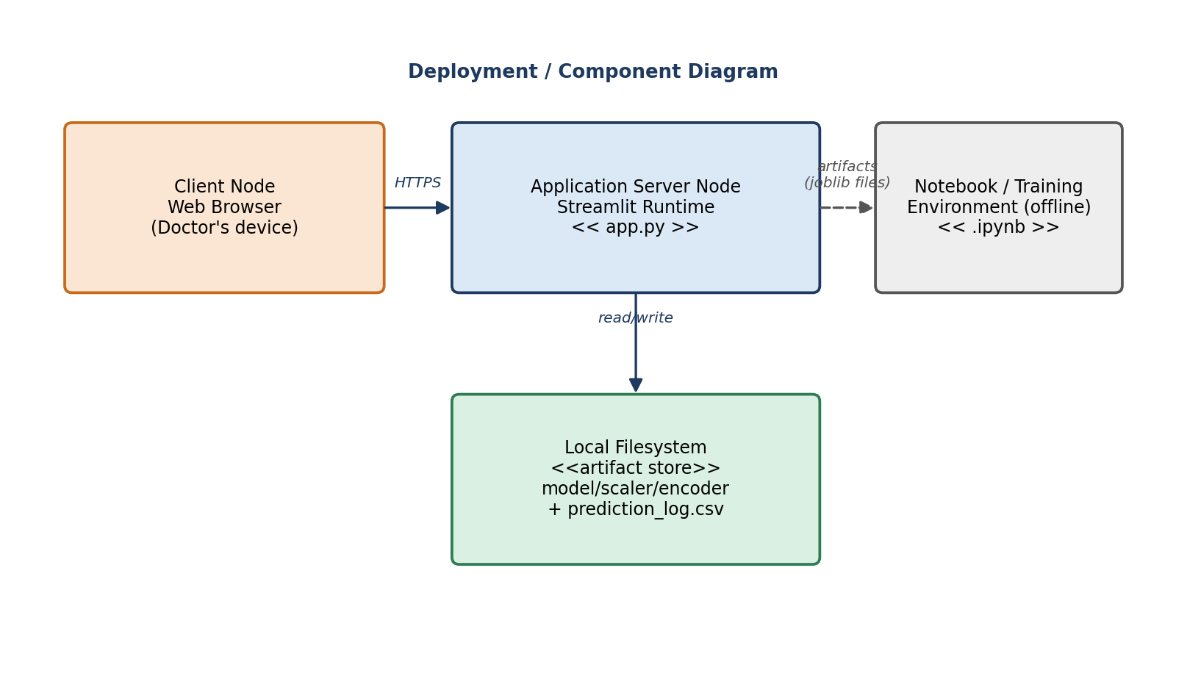

4.6 Additional Deliverables
- API Documentation: the current build is a monolithic Streamlit app with no separate REST API; the predict()/log_prediction() functions in app.py are documented inline and summarised in Section 5.1 below as the de-facto internal API.
- Testing & Validation: covered in Section 6 (Testing & Quality Assurance).
- Deployment Strategy: covered in Section 4.5 above and Section 5.3 (Deployment & Execution).

5. Implementation (Source Code & Execution)

5.1 Source Code

Structured & Well-Commented Code
The implementation is split across two well-commented deliverables: the analysis/training notebook (gene_cancer_analysis_final.ipynb) and the deployment app (app.py). Both follow a numbered, milestone-based structure with markdown/comment headers explaining the purpose of every step, so a reviewer can follow the pipeline from raw data to a live prediction without extra documentation.
File | Role | Key sections
gene_cancer_analysis_final.ipynb | End-to-end training pipeline | M1 Data Collection & Preprocessing | M2 EDA & Visualization | M3 Model Training & Tuning | M4 MLOps, Deployment & Monitoring | M5 Final Documentation
app.py | Streamlit deployment app | load_artifacts() | predict() | log_prediction() | show_result() | 4 UI tabs + sidebar

Coding Standards & Naming Conventions
- PEP 8-style snake_case function and variable names throughout (load_artifacts, predict, log_prediction, show_result).
- Constants are declared in upper case at module scope (ARTIFACT_DIR, LOG_PATH, N_GENES, CANCER_TYPES, TOP_N_FEATURES).
- Every non-trivial cell/function starts with a short comment or docstring stating its purpose and, where relevant, which milestone it satisfies.
- Consistent use of f-strings for all formatted output/log messages.

Modular Code & Reusability
app.py is organised as small, single-purpose functions rather than one long script:
load_artifacts() # cached loader for model/scaler/encoder/selected_genes/report
predict(df_row) # shared inference logic used by all three input tabs
log_prediction(...) # shared logging logic used by all three input tabs
show_result(...) # shared two-column result renderer (metric + bar chart)
Because predict(), log_prediction() and show_result() are shared helpers, the Upload CSV, Manual Entry and Random Sample tabs all reuse the exact same inference and logging code path — there is a single source of truth for how a prediction is produced and recorded, which avoids the classic bug of tabs silently drifting out of sync.

Security & Error Handling
- Startup guard: load_artifacts() is wrapped in a try/except FileNotFoundError that stops the app with a clear st.error() instead of crashing if the artifacts/ folder is missing or incomplete.
- Artifact-consistency guard: before any prediction can run, the app checks scaler.n_features_in_ == len(selected_genes) and stops with an actionable message if a stale/mismatched scaler is detected -- this directly encodes the real bug fixed in the notebook (Milestone 3, cell 3.6) where the scaler was originally fit on 300 genes instead of the 50 actually sent by the app.
- Input validation: the Upload CSV tab explicitly checks for missing_cols = [g for g in selected_genes if g not in df.columns] and reports exactly which columns are missing rather than letting pandas raise a KeyError deep inside prediction.
- Defensive numeric handling: predict() clips negative values and fills NaNs before the log1p transform (df_row[selected_genes].clip(lower=0).fillna(0)) so malformed CSV cells cannot crash inference.
- No PII is collected, stored, or logged anywhere in the pipeline -- only anonymised gene-expression values and derived predictions.

5.2 Version Control & Collaboration
- Version Control Repository: source (notebook, app.py, artifacts/) should be hosted on GitHub as a public or private repository, per the Project Documentation Guidelines.
- Branching Strategy: a lightweight Feature Branching workflow is recommended -- one branch per milestone (e.g. feature/milestone-3-modeling, feature/milestone-4-deployment), merged into main via pull request.
- Commit History & Documentation: commits should be scoped per milestone step (data cleaning, EDA, modeling, tuning, deployment) with descriptive messages; the notebook's own milestone-summary markdown cells can double as PR descriptions.
- CI/CD Integration (optional): a simple GitHub Actions workflow can lint app.py (flake8) and smoke-test that `streamlit run app.py --server.headless true` starts without error on every push.

5.3 Deployment & Execution

README File Contents
The following README content documents everything needed to install, configure and run the system, as required by the guidelines:

Installation Steps
# 1. Clone the repository
git clone <repository-url> && cd <repository-folder>
# 2. Create and activate a virtual environment (recommended)
python -m venv venv
source venv/bin/activate # Windows: venv\Scripts\activate
# 3. Install dependencies
pip install streamlit pandas numpy scikit-learn joblib matplotlib seaborn scipy plotly mlflow

System Requirements
Requirement | Minimum
Python | 3.9+
RAM | 4 GB (8 GB recommended for the full notebook with visualizations)
Disk | ~200 MB for dependencies + artifacts
OS | Windows, macOS, or Linux -- any OS that runs Python + a modern browser
Browser | Chrome, Firefox, or Edge (for the Streamlit UI)

Configuration Instructions
- Run the notebook top-to-bottom first (Kernel -> Run All). It creates the artifacts/ folder next to app.py and populates it with model.joblib, scaler.joblib, label_encoder.joblib, selected_genes.joblib and model_report.json.
- No API keys, environment variables, or external services are required; the app reads everything from the local artifacts/ directory (os.path.join(os.path.dirname(__file__), 'artifacts')).
- Optional: enable MLflow experiment tracking by leaving the default sqlite:///mlflow.db tracking URI in the notebook, or point mlflow.set_tracking_uri() at a remote tracking server.

Execution Guide
# Run the notebook (generates the artifacts/ the app depends on)
jupyter notebook gene_cancer_analysis_final.ipynb
# Launch the deployed web app
streamlit run app.py
# The app opens automatically at:
http://localhost:8501
Accessing a deployed version: if hosted (e.g. Streamlit Community Cloud, a Docker container, or an internal server), the same URL pattern applies -- only the host/port changes; no code changes are required since app.py reads all configuration from its own artifacts/ folder.

API Documentation (Internal Functions)
As noted in Section 4.6, there is no external REST API in the current build. The internal callable surface of app.py is documented below as the equivalent contract:
Function | Input | Output
load_artifacts() | none (reads artifacts/*.joblib and model_report.json) | (model, scaler, label_encoder, selected_genes, model_report)
predict(df_row) | 1-row pandas DataFrame with selected_genes columns (raw values) | (pred_label: str, proba_df: DataFrame[Cancer Type, Probability])
log_prediction(df_row, pred_label, confidence, source) | same row + predicted label/confidence/source tab name | appends one row to artifacts/prediction_log.csv
show_result(pred_label, proba_df) | outputs of predict() | renders a two-column Streamlit result view (metric + table + bar chart)

Executable Files & Deployment Link
- No compiled executable (.exe/.jar/.apk) is produced -- this is a Python web application, packaged as source (app.py + artifacts/).
- Deployed web app: to be filled in with the actual hosting URL once the app is published (e.g. on Streamlit Community Cloud or an internal server), per the course's Implementation deadline.

6. Testing & Quality Assurance

6.1 Test Cases & Test Plan
The table below lists the concrete test scenarios that validate the behaviors actually built into the notebook and app.py -- covering the happy path, the defensive checks the code performs, and the edge cases those checks were written to catch.
ID | Scenario | Steps | Expected Outcome
TC-01 | Artifacts load successfully | Run the notebook, then `streamlit run app.py` | Sidebar shows model name, test accuracy, feature count and hyperparameters with no error
TC-02 | Missing artifacts folder | Rename/delete artifacts/ before launching the app | App stops with 'Model artifacts not found in artifacts/' instead of a raw traceback
TC-03 | Scaler/gene-count mismatch | Manually save a scaler fitted on a different feature count | App stops with the 'Artifact mismatch' error naming the expected vs. actual feature counts
TC-04 | CSV upload, valid columns | Upload a CSV containing exactly the 50 selected_genes columns | One prediction card + probability chart rendered per row, and each row logged
TC-05 | CSV upload, missing columns | Upload a CSV missing some required gene columns | st.error lists how many and which (first 5) columns are missing; no crash
TC-06 | Manual entry, defaults | Submit the Manual Entry form without changing any value | Prediction returns successfully using the default 8.0 value for the top-10 genes and 0.0 for the rest
TC-07 | Random sample generation | Click 'Generate & Predict Random Sample' several times | Each click produces a new, generally different prediction with logged probabilities
TC-08 | Monitoring tab, no history | Open Monitoring before any prediction has been made | st.info 'No predictions logged yet' is shown, no crash on missing prediction_log.csv
TC-09 | Monitoring tab, with history | Make several predictions across tabs, then open Monitoring | Total count, recent rows table, CSV download button and distribution chart all populate correctly
TC-10 | Deterministic inference | Run the exact same input row twice | Identical predicted label and identical probability values both times (random_state=42 fixed end-to-end)

6.2 Automated Testing
No automated test suite ships with the current deliverable; all scenarios above were exercised manually. As a recommended improvement, the following lightweight pytest checks would automate TC-01, TC-03, TC-04 and TC-10 without needing a running Streamlit server:
def test_scaler_matches_selected_genes():
scaler = joblib.load('artifacts/scaler.joblib')
genes = joblib.load('artifacts/selected_genes.joblib')
assert scaler.n_features_in_ == len(genes)
def test_predict_is_deterministic():
row = sample_row()
label1, proba1 = predict(row)
label2, proba2 = predict(row)
assert label1 == label2
assert proba1.equals(proba2)

6.3 Bug Reports
The notebook's own comments document three real defects that were found and fixed during development. They are reproduced here as a genuine bug-report / resolution log rather than hypothetical examples:
# | Issue | Root Cause | Resolution
BUG-01 | Marker-gene selection was statistically weak | Original approach picked genes using an arbitrary top-40% expression quantile with no statistical justification | Replaced with one-way ANOVA (scipy.stats.f_oneway) across cancer types plus Bonferroni correction for multiple testing (Notebook §2.2)
BUG-02 | Hardcoded / mismatched key-gene list | Boxplots (§2.6) originally referenced a hardcoded gene list that did not match the genes actually identified as significant | Introduced a single data-driven key_genes_df built from the ANOVA results and reused consistently by the heatmap, boxplots and interactive chart (Notebook §2.3)
BUG-03 | Deployment scaler shape mismatch | The training-time StandardScaler was fit on all 300 genes, but app.py only ever supplies the 50 selected_genes at inference time, which would raise a confusing sklearn shape error in production | Re-fit a dedicated deployment_scaler on just the 50 selected_genes before saving to artifacts/scaler.joblib (Notebook §3.6); app.py additionally guards against any future recurrence with the explicit n_features_in_ check described in TC-03

7. Final Presentation & Reports

7.1 User Manual
Quick-start guide for a clinician using the deployed app:
- Step 1 -- Open the app in a browser at the deployed URL (or http://localhost:8501 when run locally).
- Step 2 -- Check the sidebar to confirm which model is loaded, its test accuracy, and the full list of cancer types it can predict.
- Step 3 -- Choose a tab based on your data: Upload CSV for one or many patients at once, Manual Entry for a quick single check on the top marker genes, or Random Sample for a no-data demo.
- Step 4 -- Read the result: the predicted cancer type, a confidence percentage, a ranked probability table (top 10), and a bar chart of the same probabilities.
- Step 5 -- Open the Monitoring tab at any time to review every prediction made so far, download the full log as CSV, and see the overall distribution of predicted cancer types.

7.2 Technical Documentation
System architecture, the file-based data schema, and the internal API surface are documented in full in Sections 4.1, 4.2 and 5.3 above; they are summarised here for quick reference.
Topic | Where documented
System / software architecture | Section 4.1 (Software Architecture) + Figure 4.1
Data schema (file-based) | Section 4.2 (Database Design & Data Modeling)
Data flow, sequence, activity, state & class diagrams | Section 4.3 (Figures 4.2-4.6)
Deployment / component view | Section 4.5 (Figure 4.7)
Internal API (function contracts) | Section 5.3, API Documentation table

