Multi-Agent AI Business Intelligence System
Project Planning & Management Document

1. Project Proposal

1.1 Overview
This project delivers an AI-powered Business Intelligence and Decision Support System built on a multi-agent architecture. Instead of relying on a single model, the system coordinates a team of specialized AI agents — retrieval, analytics, web search, and response formatting — supervised by an orchestrator, to turn raw business data into actionable insights, dashboards, and recommendations.

1.2 Objectives
- Build a multi-agent pipeline (Orchestrator, RAG, Analytics, Web Search, Response agents) that collaborates to answer business questions.
- Support Retrieval-Augmented Generation (RAG) over uploaded PDF, Word, and text documents using a Chroma vector store.
- Auto-generate interactive dashboards and KPI cards from uploaded CSV/Excel data using Plotly.
- Provide short-term and long-term semantic memory so the system retains context across a conversation.
- Support bilingual interaction (Arabic and English) with automatic language detection.
- Deploy a working chat-based interface using Streamlit, powered by Groq-hosted LLaMA 3.3 70B.

1.3 Scope
In scope: file ingestion (CSV, Excel, PDF, DOCX, TXT), query routing between specialized agents, dashboard/chart generation, conversational memory, guardrails against prompt injection, and Streamlit-based deployment.
Out of scope: multi-user authentication, production-grade horizontal scaling, and real-time streaming data sources. These are noted as candidate items for a future phase.

2. Project Plan.

2.1 Milestones
Milestone | Target Date | Description
M1 — Kickoff & Architecture | Apr 26, 2026 | Requirements finalized, repo structure and architecture agreed.
M2 — Core Agents Ready | May 10, 2026 | Orchestrator, RAG agent, and Streamlit shell functional.
M3 — Full Agent Suite | May 28, 2026 | Analytics, Response, Web Search agents + Memory/Cache/SQL engine integrated.
M4 — Dashboards & Utils | June 15, 2026 | Auto-dashboard, vector store, LLM client, guardrails complete.
M5 — Integration Complete | June 30, 2026 | End-to-end query flow tested across all agents.
M6 — Deployment & Handover | July 10, 2026 | Deployed on Streamlit; README and documentation finalized.

2.2 Deliverables
- Functional multi-agent BI application (Streamlit) deployed and accessible via a public link.
- Source code repository with agents, memory, tools, and utils modules.
- Updated README with setup and installation instructions.
- Project planning documentation (this document) and one system sequence diagram.
- Sample dataset and demo walkthrough (video/LinkedIn post).

2.3 Resource Allocation
Team Member | Allocated Modules
Ahmed Mostafa | app.py, RAG Agent, Orchestrator
Mahmoud Tamer | Response Agent, Web Search Agent, Analytics Agent
Omnia Magdy | Memory Module, Cache, SQL Engine
Salma | Utils folder (Guardrails, Language Detector)
Yousef Badr | Auto Dashboard, LLM Client, Vector Store

3. Task Assignment & Roles
Each team member owns a clear slice of the codebase, mapped directly to the repository structure so that ownership and accountability are unambiguous.
Team Member | Role | Owned Components | Responsibilities
Ahmed Mostafa | App & Orchestration Lead | app.py, agents/orchestrator.py, agents/rag_agent.py | Streamlit UI/UX, session state, query routing logic, RAG document ingestion & retrieval.
Mahmoud Tamer | Agents Developer | agents/response_agent.py, agents/web_search_agent.py, agents/analytics_agent.py | Response formatting/translation, live web search integration, data-analysis code generation & chart output.
Omnia Magdy | Backend & Data Engineer | memory/memory_module.py, tools/cache.py, tools/sql_engine.py | Short/long-term memory, caching layer for web search, structured (SQL) querying support.
Salma | Utilities & Safety Engineer | utils/ (guardrails.py, language_detector.py) | Prompt-injection guardrails, sensitive-data filtering, Arabic/English language detection.
Yousef Badr | Visualization & Infra Engineer | tools/auto_dashboard.py, tools/llm_client.py, tools/vector_store.py | Auto-generated dashboards & KPIs, unified LLM client (Groq/OpenAI/Anthropic), Chroma vector store integration.

\

3.1 Key Performance Indicators (KPIs)
Suggested metrics to evaluate the success of the system, covering performance, reliability, quality, and adoption:
KPI | Target | Why it matters
Average query response time | < 5 seconds per chat query | Keeps the assistant usable in real-time conversation.
System uptime (Streamlit app) | > 99% during evaluation period | Ensures the app is reliably reachable for demos and users.
Agent routing accuracy | > 90% correct agent selected | Confirms the orchestrator sends queries to the right specialist agent.
Dashboard generation success rate | > 95% of valid CSV/Excel uploads | Measures reliability of the auto-dashboard pipeline.
User adoption / active sessions | Track weekly active sessions | Indicates real usage and engagement over time.
Guardrail catch rate | 0 unblocked injection attempts in testing | Validates the safety layer is effective.
Cache hit rate (web search) | > 30% after first week of use | Shows caching is reducing redundant search calls.

4. System Analysis & Design

4.1. Data Flow & System Behavior
Sequence Diagrams – Process flow representation of key interactions between components:

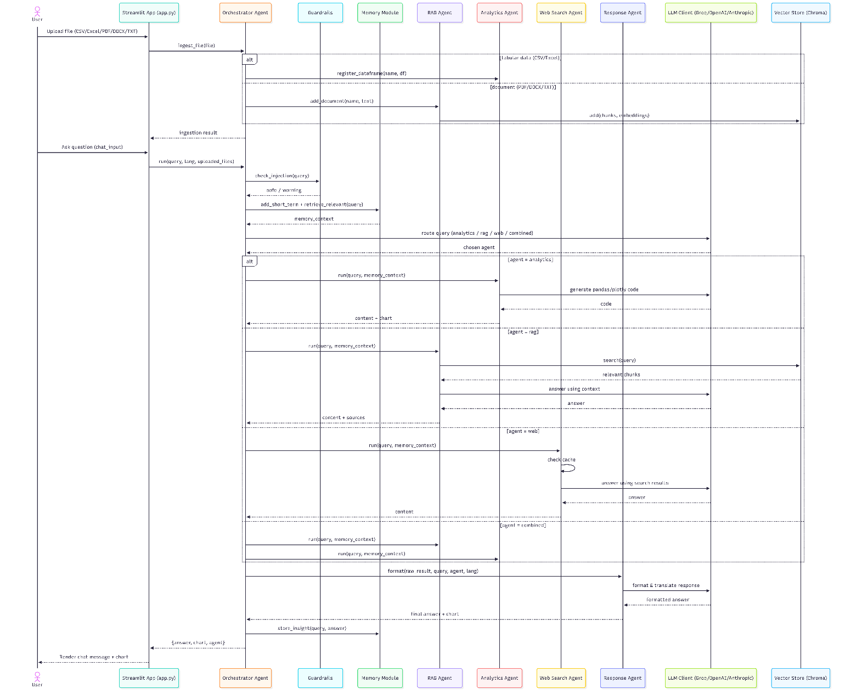

5. Deployment & Execution
The application has been deployed using Streamlit. Full installation and run instructions have been added to the repository's README.md file, covering environment setup, dependency installation, API key configuration, and how to launch the app locally.

