Digital Egypt Pioneers Initiative (DEPI)
Generative AI Track — Round 4
Graduation Project Documentation
NHA RAG Assistant — Alies AI
Multi-Modal · Voice-Enabled · Retrieval-Augmented Generation Chatbot
Team Members
Mohamed Ebrahim · Youssef Hesham · Mohamed Hassan · Lina Essam
Date: July 2026
Stack: Python · Streamlit · Ollama (Qwen2.5 / Whisper) · Qdrant Cloud · OpenAI API

Abstract
This document provides the complete technical documentation for the NHA RAG Assistant, marketed as "Alies AI" — a multi-modal, locally-hosted Retrieval-Augmented Generation (RAG) chatbot built as a DEPI Round 4 graduation project by a team of four. The system integrates five pipeline modes (Standard Chat, Document RAG, Web Search, Web Scraping, and Image/OCR), a smart multi-model LLM router with automatic intent classification, short- and long-term conversation memory, cross-encoder reranking, page-accurate source citations, vision-language image analysis, and a Voice Assistant module that provides end-to-end speech interaction in both English and Arabic.

This document covers the project rationale, team and feature overview, system architecture, all six UML diagrams (Activity, Sequence, Class, Collaboration, Package, Architecture/Deployment) with the actual diagram images, detailed component specifications, functional and non-functional requirements, implementation details, deployment guide, evaluation framework, literature review, and references.

1. Introduction and Rationale
Knowledge workers and students increasingly need a single intelligent workspace that can query their own documents, search live web content, and support multi-modal interaction — all without sending data to cloud services. Existing tools either hallucinate without document grounding, require GPU hardware, or lack voice and image capabilities. The NHA RAG Assistant solves all of these problems in a single CPU-deployable, privacy-preserving, open-source application.

The system is named "Alies AI" in the user interface and runs entirely on a standard developer laptop using locally-hosted Ollama models, with optional cloud augmentation through the OpenAI API. No user data leaves the machine unless the OpenAI backend is explicitly selected.

1.1 Team Members and Roles

Name | Role / Contribution
Mohamed Ebrahim | Core RAG pipeline, vector store, reranker, evaluation framework
Youssef Hesham | LLM router, intent routing, OpenAI client, query rewriting, fine-tuning pipeline
Mohamed Hassan | Voice Assistant (STT + TTS), document processor, web scraper
Lina Essam | Streamlit UI, conversation memory, long-term memory, system integration & testing

1.2 Project Objectives
- Five pipeline modes: Standard Chat, Document RAG, Web Search, Web Scraping, and Image/OCR.
- Smart LLM routing: automatic classification to code-specialist, vision, or general-chat backend per question.
- High retrieval precision via two-stage retrieval: cosine vector search + cross-encoder reranking.
- Coherent multi-turn dialogue through rolling conversation memory and query rewriting.
- Page-accurate, traceable source citations for every document-backed answer.
- Persistent user facts across sessions via SQLite-backed long-term memory.
- Voice interaction: Faster-Whisper STT + Edge-TTS TTS with automatic Arabic/English language detection.
- Image analysis and OCR via local Qwen2.5-VL vision model (privacy-preserving, no API cost).
- Conversation export as .docx file.
- Optional QLoRA fine-tuning pipeline for domain adaptation.

1.3 Technology Stack

Layer | Technology | Purpose
UI | Streamlit 1.58 | Multi-chat web interface, sidebar navigation, file upload
Voice I/O ★NEW | faster-whisper (WhisperModel, int8) | Speech-to-text with automatic language detection
Voice I/O ★NEW | edge-tts (Microsoft Edge TTS) | Text-to-speech, Arabic (ar-EG-ShakirNeural) & English (en-US-GuyNeural)
LLM — Chat | Ollama · Qwen2.5:1.5b | Local general-purpose inference, no GPU needed
LLM — Code | Ollama · Qwen2.5-coder:1.5b | Code generation and explanation
LLM — Vision | Ollama · Qwen2.5-VL | Image analysis and OCR
LLM — Cloud | OpenAI GPT-4o / GPT-4o-mini | Optional high-quality cloud fallback
Embeddings | nomic-embed-text (via Ollama) | 768-dimensional dense text vectors
Vector Store | Qdrant Cloud (HNSW indexing) | Scalable semantic search with session isolation
Reranker | sentence-transformers cross-encoder | Post-retrieval precision improvement
Short-term Memory | ConversationMemory (in-process) | Rolling 6-turn per-session context
Long-term Memory | SQLite + LongTermMemory | Persistent user facts, importance-scored
Intent Routing | IntentRouter (regex + LLM) | Code vs. chat per-question classification
Web Search | DuckDuckGo API | Live web augmentation
Web Scraping | BeautifulSoup4 | URL content extraction
Doc Processing | pdfplumber · python-docx · python-pptx · openpyxl | Multi-format ingestion with page tags
Fine-tuning | QLoRA via PEFT + bitsandbytes | Domain adaptation pipeline
Export | python-docx | Chat export to .docx

2. System Features

2.1 Multi-Chat Management
Alies AI supports an unlimited number of named conversations in the left sidebar. Users can create new chats, rename existing ones via an inline popover, delete chats, and switch between them freely. Every chat maintains its own message history, document context, and pipeline mode independently. A new session UUID is generated for each chat, providing complete data isolation in the vector store and memory layers.

2.2 Pipeline Modes

Mode | Trigger | Context Source | Typical Use
Standard Chat | Default | Empty (pure LLM) | General questions, brainstorming
Use Uploaded Files (RAG) | Upload document | Qdrant vector store (session-filtered) | Research papers, manuals, reports
Web Search | Select mode | DuckDuckGo top-5 results + scraped content | Current events, live data
Web Scraping | Paste URL | Single scraped page, chunked in Qdrant | Deep analysis of one website
Image / OCR ★NEW | Attach image | Vision model (Qwen2.5-VL) | Charts, screenshots, scanned docs

2.3 Smart LLM Routing
IntentRouter — Stage 1 (instant keyword): A compiled regex checks for programming keywords in English (code, function, class, bug, error, python, sql, api, ``` fences, etc.) and Arabic (كود، دالة، فنكشن، باج، اصلح الكود...). Match → classify as "code" with zero latency.

IntentRouter — Stage 2 (LLM fallback): Ambiguous questions are sent to Qwen2.5:1.5b with a strict one-word prompt ("CODE or CHAT?", temperature 0). Errors default to "chat".

LLMRouter backend selection: Image attached → Vision (Qwen2.5-VL). Intent = code → CodeBackend (Qwen2.5-coder). Mode = openai → OpenAI primary → OpenAI secondary → local fallback. Mode = local → OllamaClient directly.

The last_used_backend name is displayed as a small badge in the chat UI so users always know whether GPT or the local model answered.

2.4 Document Ingestion and Multi-Format Support

Format | Library | Page-Level Tag
PDF | pdfplumber (primary) · PyPDF2 (fallback) | Yes — page number
DOCX (Word) | python-docx | No page concept in XML
PPTX (PowerPoint) | python-pptx | Yes — slide number
XLSX (Excel) | openpyxl | Yes — sheet name
TXT / Markdown | Built-in | No
CSV | pandas | No
Web URL | requests + BeautifulSoup4 | No (treated as one document)

Chunks: 1,000-character size · 200-character overlap · LangChain RecursiveCharacterTextSplitter. Every chunk carries source name, session_id, and page/slide/sheet label — propagated all the way to the citation shown in the UI.

2.5 Two-Stage Retrieval and Reranking
Stage 1 — Vector Search: The (possibly rewritten) question is embedded by nomic-embed-text. Qdrant retrieves an over-fetched shortlist of max(k×4, 15) candidate chunks using HNSW approximate nearest-neighbour search, filtered strictly by session_id.

Stage 2 — Cross-Encoder Reranking: The Reranker encodes each (question, chunk) pair jointly with a multilingual sentence-transformers cross-encoder. Joint encoding captures token-level interactions invisible to independent cosine similarity. Top-k by reranker score are selected for context assembly.

2.6 Query Rewriting and Conversation Memory
ConversationMemory: Rolling window of last 6 turns per session (in-process, keyed by session_id). 4 turns formatted into the LLM prompt; all 6 passed to the QueryRewriter.

QueryRewriter: Follow-up questions like "what about that?" are rewritten into standalone form before embedding, preventing retrieval failures caused by missing context in the query vector.

2.7 Long-Term Memory
The LongTermMemory module stores durable user facts in a local SQLite database (memory.sqlite). The MemoryImportanceScorer evaluates each message through two stages: (1) rule-based pattern matching for name declarations, preferences, skills, goals — in English and Egyptian Arabic; (2) LLM fallback for ambiguous cases. Only messages scoring above threshold (default: 0.80) are written. Up to 3 relevant memories are retrieved per query by blending semantic similarity, recency, importance, and usage count. Semantically similar memories of the same type are updated, not duplicated. Any SQLite error is swallowed silently — the chat never crashes.

2.8 Web Search and Web Scraping
Web Search: DuckDuckGo top-5 results fetched, top-2 fully scraped via WebScraper, rest as snippets. All labelled "(web search)" in citations.

Web Scraping: User pastes a URL; BeautifulSoup4 removes navigation/scripts/ads, returning clean prose. Chunked and stored in Qdrant like an uploaded document.

2.9 Image Analysis and OCR ★ NEW
The QwenVisionClient routes image-bearing queries to Qwen2.5-VL via Ollama. The image is base64-encoded and sent alongside the question. Supports any image format (PNG, JPEG, WebP). All processing is local — no image data leaves the machine, no API cost after model download. Use cases: reading text from screenshots, analysing charts and graphs, describing product images, extracting data from scanned forms. Optional context (retrieved chunks) can be prepended for smarter answers.

2.10 Voice Assistant Module ★ NEW
Speech-to-Text (Faster-Whisper): User clicks Audio button → records via microphone → audio saved as temp_audio/input.wav → VoiceAssistant.speech_to_text() calls WhisperModel.transcribe(beam_size=5) → returns transcript + detected_language + language_probability.

Dynamic voice selection: If language_probability < 0.5 → default Arabic voice (ar-EG-ShakirNeural). If detected_language == "en" → English voice (en-US-GuyNeural). Otherwise → Arabic voice.

Text-to-Speech (Edge-TTS): VoiceAssistant.text_to_speech() calls edge_tts.Communicate(text, voice).save(output.mp3). MP3 played to user. VoiceAssistant.clean_up() removes all temp .wav/.mp3 files. Transcript processed by the same RAG pipeline as typed text.

Note: Edge-TTS requires internet access to call the Microsoft Edge online TTS service. Audio files are saved and played locally. The voice feature currently shows a "Voice input coming soon!" placeholder in the deployed UI pending full audio recording integration.

2.11 Code Generation and Syntax Highlighting
IntentRouter classifies code questions → LLMRouter routes to OllamaClient(role="code") → qwen2.5-coder:1.5b generates response. The response (containing Markdown fences) is processed by render_response() in app.py: a regex splits prose and code chunks. Code chunks render with st.code() (Pygments-backed syntax highlighting) and a language badge. Applied both live and when redrawing chat history.

2.12 Conversation Export to DOCX
export_to_docx() converts any chat's message list to a .docx file via python-docx, with bold role labels (USER / ASSISTANT) per message. Offered as a download via st.download_button() from each chat's options popover.

2.13 QLoRA Fine-Tuning Pipeline
- 1_prepare_dataset.py — converts source documents to instruction-tuning pairs.
- 2_train_qlora.py — fine-tunes with QLoRA adapters via PEFT + bitsandbytes (4-bit, CPU-compatible).
- 3_merge_adapter.py — merges LoRA adapter into base model weights.
- 4_convert_to_gguf.sh — converts to GGUF format for Ollama serving.
- 5_create_ollama_model.sh — registers converted model with local Ollama server.

3. UML Diagrams
All diagrams below reflect the final system architecture including the Voice Assistant addition (marked «NEW»). They were produced using a UML diagramming tool and are embedded here at original quality.

3.1 Architectural / Deployment Diagram
Shows the full deployment topology across five zones: Client Layer (Web Browser + Microphone/Speaker), Application Server/Python (Streamlit App, Voice Assistant Module «NEW», RAG Core, LLM Orchestration, Memory), Local AI Layer/Ollama (WhisperModel «NEW», Vision Model, Code Model, Chat Model, Fine-tuned Model), External Services (OpenAI API, edge-tts «NEW», Web Search API, Public Websites), and Storage (memory.sqlite, Vector Index, Uploaded Files).

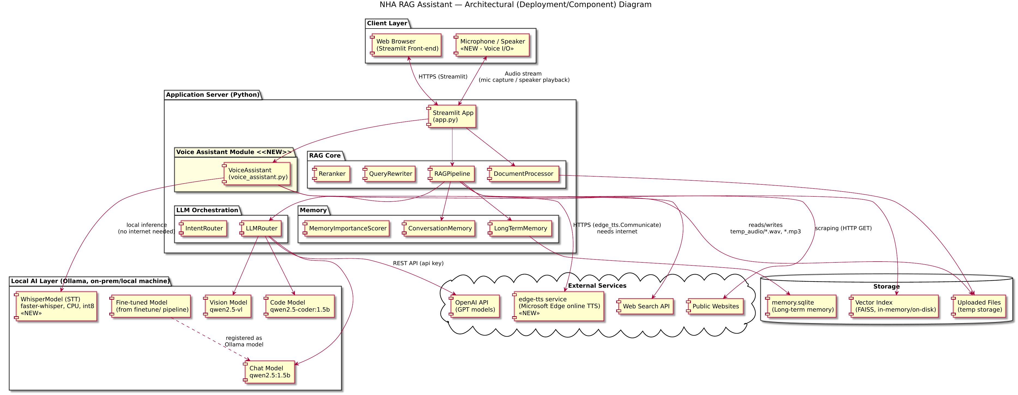
Figure 1: NHA RAG Assistant — Architectural (Deployment/Component) Diagram

3.2 Package Diagram
Illustrates module-level dependency structure. The ui package (app.py) depends on src.core (rag_pipeline) and the new src.voice (voice_assistant.py). src.core orchestrates src.documents, src.retrieval, src.memory, and src.llm. The finetune package produces a registered Ollama model that feeds back into src.llm.

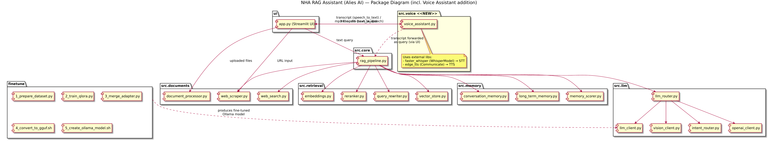
Figure 2: Package Diagram (incl. Voice Assistant addition)

3.3 Class Diagram
Shows all system classes with attributes, methods, multiplicities, and relationships. Key relationships: StreamlitApp aggregates RAGPipeline, ConversationMemory, LLMRouter, and uses VoiceAssistant. VoiceAssistant owns WhisperModel (stt_model: 1) and creates edge_tts.Communicate per TTS call. RAGPipeline aggregates QdrantVectorStore, LLMRouter, EmbeddingClient, Reranker, QueryRewriter, ConversationMemory, LongTermMemory (0..1), MemoryImportanceScorer (0..1). LLMRouter contains OllamaClient (local + code), OpenAIChatClient (0..2), QwenVisionClient (1), and IntentRouter.

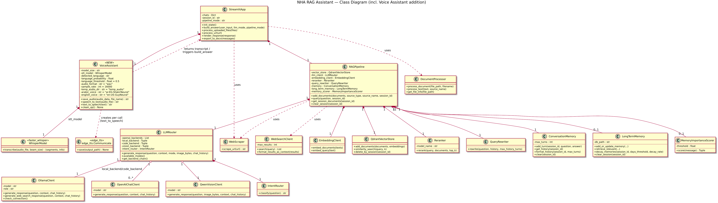
Figure 3: Class Diagram (incl. Voice Assistant addition)

3.4 Activity Diagram — User Query Flow
Traces the complete lifecycle of a user query for both text and voice input paths, including the pipeline mode branch (RAG / Web Search / Standard Chat), LLM routing branch (Vision / Code / Chat-OpenAI), and the voice output branch with dynamic voice selection based on language_probability and detected_language.

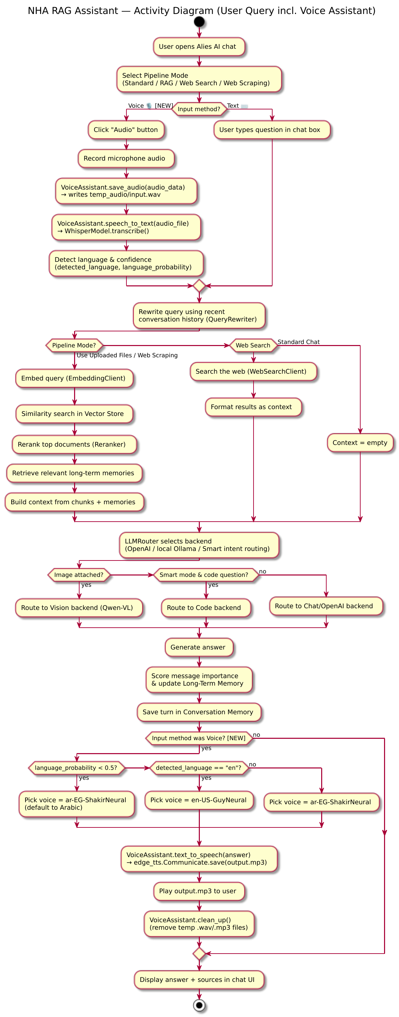
Figure 4: Activity Diagram — User Query incl. Voice Assistant

3.5 Sequence Diagram — Voice Query
Shows the 33-step message exchange across all system participants for a complete voice query: User, Streamlit UI, VoiceAssistant «NEW», WhisperModel, RAGPipeline, QueryRewriter, VectorStore, Reranker, LLMRouter, OllamaClient/OpenAIChatClient, ConversationMemory, LongTermMemory, and edge_tts.Communicate «NEW». Steps 1-8 cover audio capture and transcription; 9-23 cover the full RAG pipeline; 24-29 cover TTS synthesis; 30-33 cover audio playback, cleanup, and UI update.

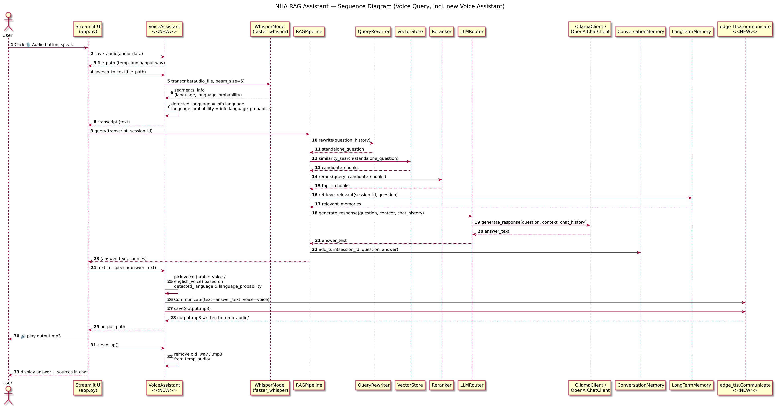
Figure 5: Sequence Diagram — Voice Query (incl. Voice Assistant)

3.6 Collaboration Diagram — Voice Query
Shows the same 20 numbered interactions as the Sequence Diagram in an object-relationship layout, emphasising which objects communicate directly. The central hub is the StreamlitApp (UI), coordinating between VoiceAssistant, RAGPipeline, and the User. RAGPipeline communicates with VectorStore (9: similarity_search), Reranker (10: rerank), LLMRouter → OllamaClient (11-13: generate), and ConversationMemory (14: add_turn).

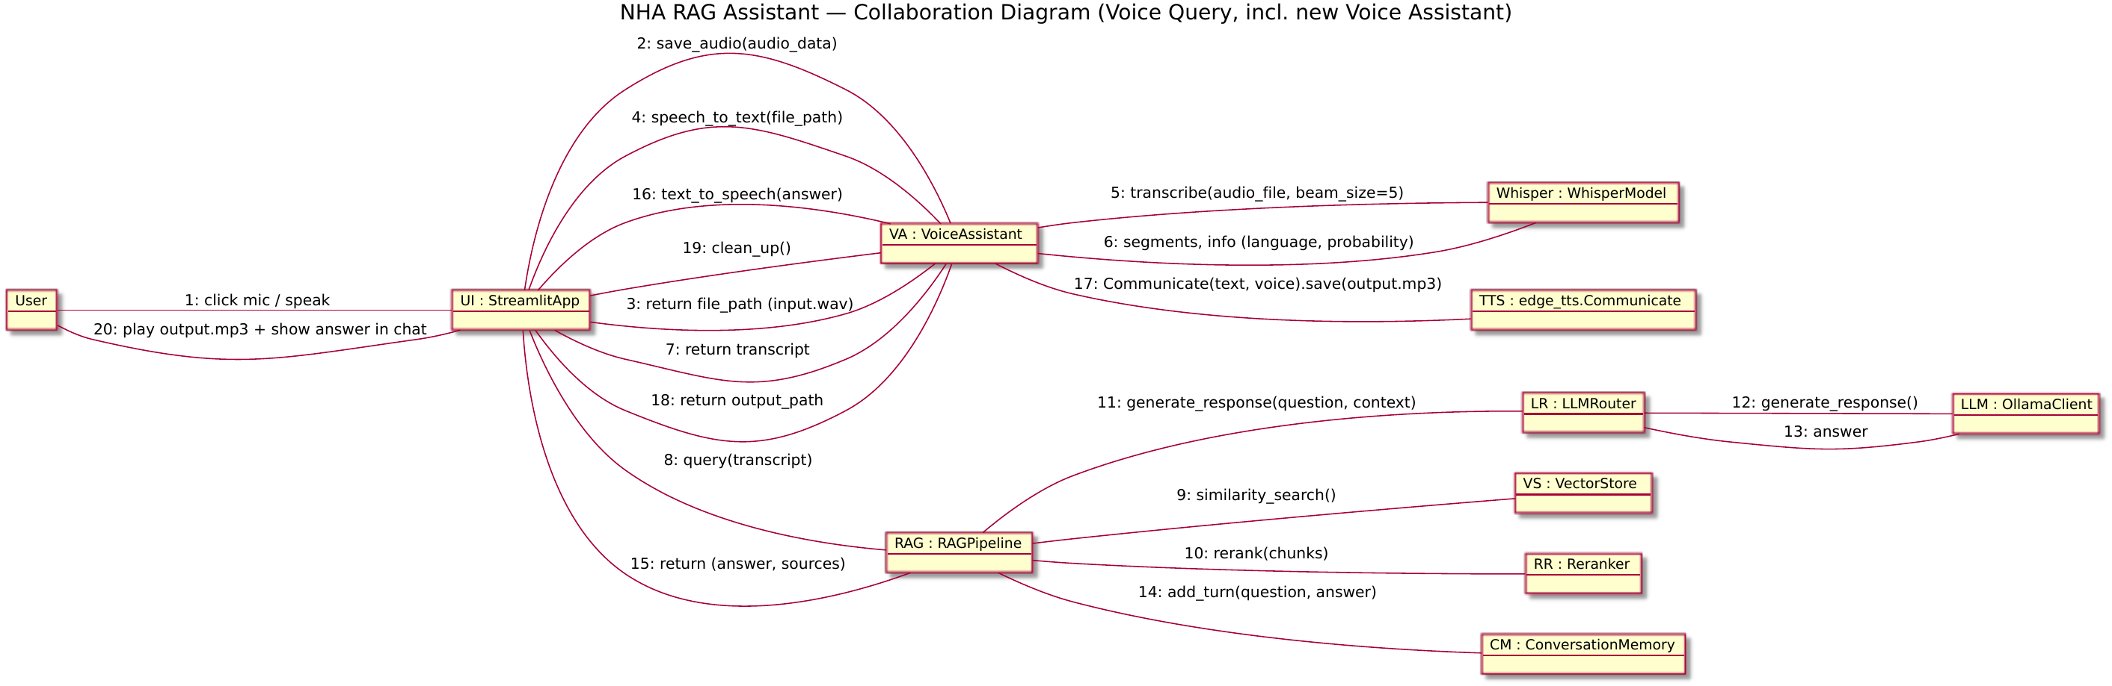
Figure 6: Collaboration Diagram — Voice Query (incl. Voice Assistant)

3.7 STT Architecture Comparison Diagram
Compares the three Speech-to-Text architecture levels considered during design: (1) Basic — generic STT without language awareness; (2) Current (adopted) — Faster-Whisper → Language Detection → Dynamic Voice Selection → Edge-TTS, chosen for fast response, modularity, and acceptable performance; (3) Advanced (future) — full streaming STT with Intent Recognition, Context Manager, Emotion Detection, and Neural TTS.

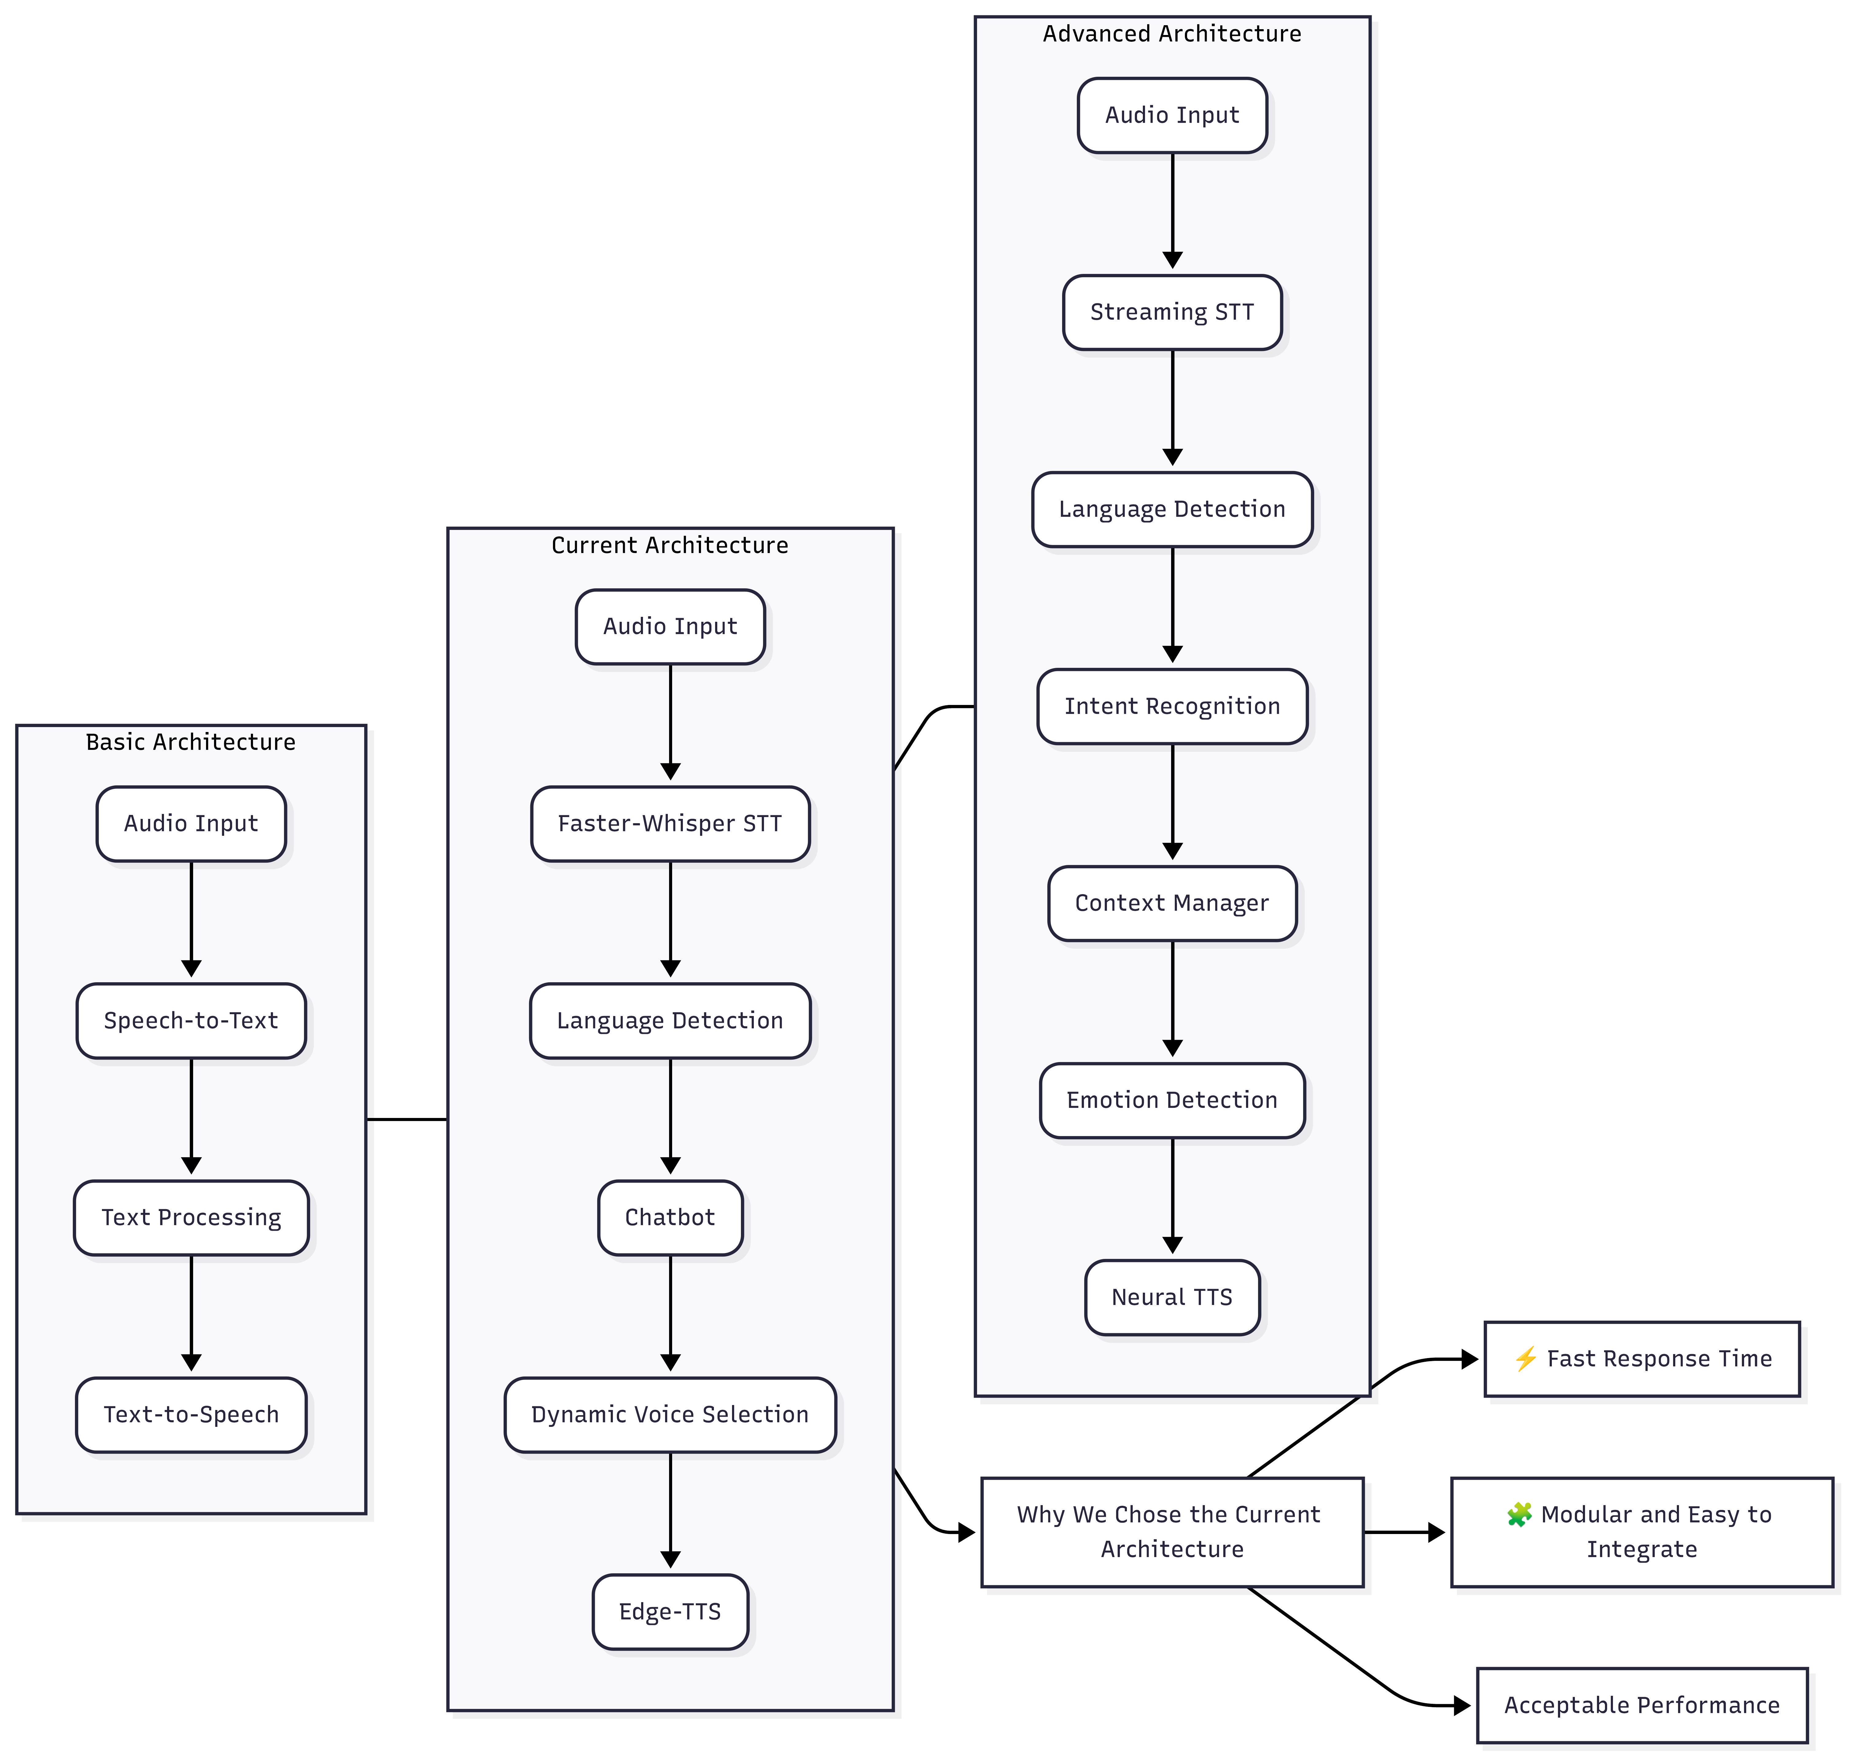
Figure 7: STT Architecture Comparison — Basic vs Current vs Advanced

4. Requirements

4.1 Functional Requirements

ID | Requirement | Component
FR-01 | Multi-chat management: create, rename, delete, switch | StreamlitApp
FR-02 | Five pipeline modes: Standard, RAG, Web Search, Web Scraping, Image/OCR | StreamlitApp + RAGPipeline
FR-03 | Upload and process PDF, DOCX, PPTX, XLSX, TXT, CSV, MD | DocumentProcessor
FR-04 | Extract content from arbitrary web URLs | WebScraper
FR-05 | Dense vector embeddings for all ingested content | EmbeddingClient
FR-06 | Session-isolated vector storage in Qdrant Cloud | QdrantVectorStore
FR-07 | Two-stage retrieval: cosine + cross-encoder reranking | Reranker
FR-08 | Conversational query rewriting for follow-up questions | QueryRewriter
FR-09 | Smart LLM routing: code / vision / chat / OpenAI | LLMRouter + IntentRouter
FR-10 | Grounded answers with page-accurate citations | RAGPipeline
FR-11 | Rolling 6-turn short-term conversation memory | ConversationMemory
FR-12 | Persistent user facts in SQLite with importance scoring | LongTermMemory + MemoryImportanceScorer
FR-13 | Live web search augmentation via DuckDuckGo | WebSearchClient
FR-14 | Image analysis and OCR via local vision model ★NEW | QwenVisionClient
FR-15 | Voice STT with language detection ★NEW | VoiceAssistant / WhisperModel
FR-16 | Voice TTS with Arabic/English dynamic voice selection ★NEW | VoiceAssistant / edge-tts
FR-17 | Export chat history as downloadable .docx | export_to_docx()
FR-18 | Code generation with syntax-highlighted output | IntentRouter + render_response()
FR-19 | QLoRA fine-tuning pipeline for domain adaptation | finetune/ package
FR-20 | Evaluation: Precision@k, Faithfulness, Answer Relevance | src/eval/ package

4.2 Non-Functional Requirements

ID | Requirement | Target
NFR-01 | STT latency (30-second audio, CPU) | < 5 seconds
NFR-02 | TTS audio synthesis latency | < 3 seconds
NFR-03 | RAG query end-to-end (local Ollama) | < 15 seconds
NFR-04 | Session data isolation | 100% via Qdrant session_id filters
NFR-05 | Privacy | No data sent to cloud without explicit OpenAI mode
NFR-06 | Long-term memory fail-safety | SQLite errors never crash the chat
NFR-07 | Voice temp file hygiene | WAV/MP3 deleted after each query via clean_up()
NFR-08 | Supported file formats | PDF, DOCX, PPTX, XLSX, TXT, CSV, MD, web URLs
NFR-09 | Deployment | Single Python process; no GPU required
NFR-10 | Code highlight persistence | Applied live and on chat history redraw

5. System Analysis & Design

5.1 Problem Statement
Existing AI chat tools either hallucinate without document grounding, return whole documents instead of answers, require GPU hardware, do not support voice or image input, or send private data to cloud APIs. The NHA RAG Assistant solves all five problems simultaneously in a CPU-deployable, local-first, multi-modal system.

5.2 Software Architecture Pattern
The system follows a Pipeline-and-Filter architecture at the query level (each step transforms its input and passes it to the next) and a Facade pattern at the component level (RAGPipeline hides the complexity of its subsystems behind a clean interface). The Streamlit UI acts as View, RAGPipeline as Controller, and Qdrant + SQLite as Model — a loose MVC appropriate for a data-pipeline application.

5.3 Key Design Decisions
Shared RAGPipeline instance: Instantiated once via @st.cache_resource, shared across all browser tabs. Safe because all per-user state is keyed by session_id. Eliminates repeated cross-encoder model load time (2-3 s) on new chats.

Over-fetch then rerank: Retrieving 4× the desired top-k and reranking with a cross-encoder outperforms pure cosine search at a small CPU overhead. The shared pipeline instance ensures the reranker is loaded only once.

Voice as a thin wrapper: VoiceAssistant wraps STT/TTS without touching the RAG pipeline. The transcript is treated identically to typed text. Isolated and independently testable.

Edge-TTS for Arabic support: High-quality neural Arabic (ar-EG-ShakirNeural) and English (en-US-GuyNeural) voices without a local TTS model, keeping CPU load low.

Keyword-first intent routing: Most code questions matched by regex in < 1 ms, avoiding an LLM API call. LLM fallback only for ambiguous inputs.

Fail-safe long-term memory: Any SQLite or scoring exception is caught and swallowed. The conversation always continues.

5.4 Data Flow — Text Query
User types → build_answer() called → pipeline_mode branch: if RAG/Scraping: EmbeddingClient embeds → Qdrant searches (session-filtered) → Reranker reranks → context assembled; if Web Search: DuckDuckGo fetched + scraped; if Standard: empty context; if Image/OCR: VisionClient called directly. Then: LongTermMemory retrieves relevant facts → ConversationMemory loads recent turns → QueryRewriter rewrites if needed → LLMRouter selects backend → answer generated → citations extracted → ConversationMemory stores turn → MemoryImportanceScorer evaluates → LongTermMemory updated if important → response returned to UI.

5.5 Data Flow — Voice Query ★ NEW
User clicks Audio → records mic → StreamlitApp calls VoiceAssistant.save_audio() → WAV saved to temp_audio/ → speech_to_text() calls WhisperModel.transcribe(beam_size=5) → transcript + language + probability returned → transcript processed through the same pipeline as Section 5.4 → after answer generated: text_to_speech(answer) called → voice selected per language_probability / detected_language → edge_tts.Communicate saves MP3 → audio played → clean_up() removes temp files → answer displayed in chat simultaneously.

6. Implementation Details

6.1 Project File Structure

Path | Description
app.py | Streamlit UI — multi-chat, pipeline modes, export, voice trigger
src/voice_assistant.py ★NEW | VoiceAssistant: STT (Whisper) + TTS (Edge-TTS) + language detection
src/rag_pipeline.py | Central orchestrator coordinating all subsystems
src/llm_router.py | LLMRouter: backend chain (OpenAI → Ollama fallback) + mode logic
src/intent_router.py | IntentRouter: regex keyword + LLM one-word classifier
src/llm_client.py | OllamaClient: chat + code roles with different system prompts
src/openai_client.py | OpenAIChatClient with QuotaOrAuthError handling
src/vision_client.py | QwenVisionClient: base64 image + question to Qwen2.5-VL
src/document_processor.py | Multi-format ingestion with page/slide/sheet metadata tagging
src/vector_store.py | Qdrant wrapper with session-filtered similarity search
src/embeddings.py | nomic-embed-text embedding client (768d)
src/reranker.py | Cross-encoder reranker (4× over-fetch → top-k reranked)
src/query_rewriter.py | Conversational query rewriting using local LLM
src/conversation_memory.py | Rolling 6-turn in-process memory keyed by session_id
src/long_term_memory.py | SQLite user fact store with decay and deduplication
src/memory_scorer.py | Rule-based + LLM importance scoring (threshold: 0.80)
src/web_search.py | DuckDuckGo live search + top-2 scrape + snippets
src/web_scraper.py | BeautifulSoup4 URL content extractor
src/eval/metrics.py | Precision@k, Faithfulness (LLM-judge), Answer Relevance (LLM-judge)
src/eval/run_eval.py | CLI evaluation runner
src/eval/eval_dataset.json | Sample evaluation test set
finetune/1_prepare_dataset.py | Instruction-tuning data preparation
finetune/2_train_qlora.py | QLoRA fine-tuning (PEFT + bitsandbytes)
finetune/3_merge_adapter.py | LoRA adapter merge into base model
finetune/4_convert_to_gguf.sh | GGUF conversion for Ollama serving
finetune/5_create_ollama_model.sh | Ollama model registration
memory.sqlite | Long-term memory database (auto-created on first run)
.env.example | Environment variable template
requirements.txt | Full Python dependency lockfile

6.2 Environment Configuration

Variable | Required | Default / Notes
QDRANT_URL | Yes | Qdrant Cloud cluster URL
QDRANT_API_KEY | Yes | Qdrant Cloud API key
COLLECTION_NAME | Yes | rag_documents
OLLAMA_BASE_URL | No | http://localhost:11434
OLLAMA_MODEL | No | qwen2.5:1.5b
OLLAMA_CODE_MODEL | No | qwen2.5-coder:1.5b
OLLAMA_VISION_MODEL | No | qwen2.5-vl
WHISPER_MODEL_SIZE ★NEW | No | base (tiny/small/medium also supported)
OPENAI_API_KEY_PRIMARY | No | Optional cloud primary tier
OPENAI_MODEL_PRIMARY | No | gpt-4o
OPENAI_API_KEY_SECONDARY | No | Optional cloud secondary tier
OPENAI_MODEL_SECONDARY | No | gpt-4o-mini
ENABLE_LONG_TERM_MEMORY | No | true
MEMORY_THRESHOLD | No | 0.80
MEMORY_DB | No | memory.sqlite

7. Deployment & Installation

7.1 Prerequisites
- Python 3.9 or higher
- Ollama installed and running: ollama serve
- Models pulled: ollama pull qwen2.5:1.5b && ollama pull qwen2.5-coder:1.5b && ollama pull qwen2.5-vl && ollama pull nomic-embed-text
- Qdrant Cloud account (free tier: 1 GB / 100K vectors)
- For Voice Assistant: ffmpeg installed (required by faster-whisper) ★NEW
- Internet access for edge-tts (Microsoft Edge online TTS service) ★NEW

7.2 Installation (Linux / macOS)
- git clone <repo-url> && cd rag-assistant-ollama
- python -m venv venv && source venv/bin/activate
- pip install -r requirements.txt
- cp .env.example .env # fill in QDRANT_URL and QDRANT_API_KEY
- streamlit run app.py
- Open http://localhost:8501 in your browser

7.3 Cloud Deployment Options
- Streamlit Cloud: direct GitHub integration, free tier, set secrets in dashboard.
- Railway / Render: Docker-based, automatic HTTPS.
- AWS ECS / GCP Cloud Run: container-based, production scale.
- Note: Ollama must run as a sidecar or dedicated instance alongside the Streamlit server.

8. Testing and Evaluation

8.1 Automated Evaluation Framework (src/eval/)
Precision@k: Fraction of top-k retrieved chunks whose source matches expected sources in the test set. Deterministic.
Faithfulness: LLM-as-judge evaluates whether every claim in the answer is grounded in the retrieved context. Score 0–1.
Answer Relevance: LLM-as-judge evaluates whether the answer actually addresses the question asked. Score 0–1.

Run: python src/eval/run_eval.py (reads eval_dataset.json, prints results to console, writes JSON report).

8.2 Voice Assistant Manual Test Scenarios

Scenario | Input | Expected Behaviour
Arabic speech, high confidence | Arabic spoken phrase, probability > 0.5 | Transcript in Arabic → ar-EG-ShakirNeural voice used
English speech, high confidence | English spoken phrase, probability > 0.5 | Transcript in English → en-US-GuyNeural voice used
Low confidence | Noisy/ambiguous audio, probability < 0.5 | Default to ar-EG-ShakirNeural regardless of detected language
Voice + RAG | Arabic question about uploaded PDF | Transcript sent through RAG; answer played in Arabic
Temp file cleanup | Any voice query | temp_audio/*.wav and *.mp3 removed after playback
Image/OCR pipeline | PNG with printed text, question: "what does this say?" | Qwen2.5-VL reads text accurately; displayed in chat
Session isolation | Two browser tabs, different PDFs | Each tab only sees its own documents
LLM fallback | OpenAI key not set | System falls back to local Ollama; no crash

9. Literature Review

9.1 Retrieval-Augmented Generation
Lewis et al. (2020) formalised the RAG paradigm, demonstrating that augmenting a generative language model with differentiable dense retrieval substantially improves performance on knowledge-intensive NLP tasks without encoding all facts in model parameters. The central engineering insight — that the knowledge store can be updated independently of model weights — directly motivates this project's use of Qdrant as a session-updatable vector store separate from fixed Ollama model weights. Izacard and Grave (2020, Fusion-in-Decoder) showed that presenting multiple retrieved passages as numbered entries before generation improves multi-document reasoning; this project's context format ("[1] (source, page):\n...") is directly inspired by this approach.

9.2 Dense Retrieval and Vector Indexing
Karpukhin et al. (2020, DPR) established that dual-encoder models trained with in-batch negatives substantially outperform sparse BM25 retrieval on open-domain QA benchmarks. The nomic-embed-text model belongs to this family, fine-tuned for long-document semantic similarity. Malkov and Yashunin (2018, HNSW) provide the approximate nearest-neighbour algorithm used internally by Qdrant, enabling sub-linear query time with high recall on large vector collections.

9.3 Cross-Encoder Reranking
Nogueira and Cho (2019) demonstrated that a BERT-based cross-encoder reranker applied to BM25 output substantially improves ranking precision on MS MARCO. Reimers and Gurevych (2019, sentence-transformers) released pre-trained cross-encoders for multilingual reranking — the specific model family adopted in this project's Reranker component. The multilingual capability is important for Arabic-language queries.

9.4 Automatic Speech Recognition
Radford et al. (2022, Whisper) introduced a large-scale supervised ASR model trained on 680,000 hours of multilingual web audio, achieving near-human accuracy across diverse accents and languages including Arabic. SYSTRAN (2023, Faster-Whisper) reimplemented Whisper using CTranslate2 for 4× faster CPU inference with int8 quantisation, making real-time transcription practical without GPU hardware — a key requirement for this project's deployment target.

9.5 Neural Text-to-Speech
Microsoft Edge-TTS provides access to Azure Cognitive Services neural TTS voices through a Python library. The service offers high-quality Arabic (ar-EG-ShakirNeural) and English (en-US-GuyNeural) voices with sub-second synthesis latency. Using a cloud TTS service with local audio file playback was chosen over a local TTS model to avoid the memory and CPU overhead of running a second large model alongside Whisper and the LLM — a practical engineering trade-off appropriate for CPU-only deployment.

9.6 Conversational RAG and Query Rewriting
Anantha et al. (2021, ConvDR) and Lin et al. (2021) demonstrated that rewriting context-dependent follow-up questions into standalone form before retrieval consistently improves recall on conversational QA benchmarks. This project's QueryRewriter implements this pattern using the local Qwen model, adding zero external API dependency.

9.7 Long-Term Memory in Dialogue Systems
Xu et al. (2022, MemoryBank) proposed structured external memory for chatbots using semantic similarity retrieval over summarised past interactions. Wu et al. (2024, MemGPT) extended this to OS-style memory management with paging. This project adopts a pragmatic middle ground: rule-based pattern matching with an LLM fallback for importance scoring, and SQLite for zero-infrastructure persistence. The fail-safe design — any exception is caught and the conversation continues — reflects a production-oriented reliability priority over research sophistication.

9.8 MLOps and Evaluation for RAG
Gao et al. (2023, RAGAS) introduced a reference-free evaluation framework for RAG systems using LLM-as-judge methodology for Faithfulness and Answer Relevance, complemented by deterministic Precision and Recall metrics. This project's evaluation framework (src/eval/) adopts the same hybrid approach. Sculley et al. (2015) identified hidden technical debt in ML systems, arguing that systematic MLOps practices — versioning, monitoring, CI/CD — are essential for long-term maintainability; the fine-tuning pipeline addresses this by producing versioned, Ollama-registered models.

9.9 Summary of Related Work

Reference | Year | Contribution | Adopted In
Lewis et al. (RAG) | 2020 | RAG paradigm | Core architecture
Karpukhin et al. (DPR) | 2020 | Dense passage retrieval | nomic-embed-text embedding
Malkov & Yashunin (HNSW) | 2018 | Approx. nearest-neighbour indexing | Qdrant HNSW
Nogueira & Cho | 2019 | Cross-encoder reranking | Reranker component
Reimers & Gurevych | 2019 | sentence-transformers library | Cross-encoder model
Anantha et al. (ConvDR) | 2021 | Conversational query rewriting | QueryRewriter
Radford et al. (Whisper) | 2022 | Multilingual ASR | VoiceAssistant STT ★NEW
SYSTRAN (Faster-Whisper) | 2023 | CPU-efficient Whisper int8 | WhisperModel ★NEW
Microsoft Edge-TTS | 2023 | Neural Arabic/English TTS | VoiceAssistant TTS ★NEW
Xu et al. (MemoryBank) | 2022 | Persistent dialogue memory | LongTermMemory design
Gao et al. (RAGAS) | 2023 | LLM-as-judge RAG evaluation | src/eval/ framework
Sculley et al. | 2015 | ML technical debt / MLOps | Fine-tuning pipeline design
This Project | 2026 | Multi-modal voice-enabled RAG + Voice + OCR | Full system

10. References
Anantha, R., Varma, S., Xiong, C., & Callan, J. (2021). Open-domain question answering goes conversational via question rewriting. NAACL-HLT 2021.
Gao, Y., et al. (2023). Retrieval-augmented generation for large language models: A survey. arXiv:2312.10997.
Izacard, G., & Grave, E. (2020). Leveraging passage retrieval with generative models for open domain question answering. EACL 2021.
Karpukhin, V., et al. (2020). Dense passage retrieval for open-domain question answering. EMNLP 2020.
Lewis, P., et al. (2020). Retrieval-augmented generation for knowledge-intensive NLP tasks. NeurIPS 2020.
Lin, S.-T., Yang, K.-H., & Chen, H.-H. (2021). Contextualized query reformulation for conversational passage retrieval. arXiv:2208.11589.
Malkov, Y. A., & Yashunin, D. A. (2018). Efficient and robust approximate nearest neighbor search using hierarchical navigable small world graphs. IEEE TPAMI, 42(4), 824–836.
Microsoft Corporation (2023). edge-tts Python library. https://github.com/rany2/edge-tts
Nogueira, R., & Cho, K. (2019). Passage re-ranking with BERT. arXiv:1901.04085.
Qwen Team, Alibaba Group (2024). Qwen2.5 technical report. arXiv:2412.15115.
Radford, A., Kim, J. W., Xu, T., Brockman, G., McLeavey, C., & Sutskever, I. (2022). Robust speech recognition via large-scale weak supervision. ICML 2023.
Reimers, N., & Gurevych, I. (2019). Sentence-BERT: Sentence embeddings using siamese BERT-networks. EMNLP 2019.
Sculley, D., et al. (2015). Hidden technical debt in machine learning systems. NeurIPS 2015.
SYSTRAN (2023). Faster-Whisper: Reimplementation of Whisper using CTranslate2. https://github.com/SYSTRAN/faster-whisper
Wu, Q., et al. (2024). AutoGen: Enabling next-gen LLM applications via multi-agent conversation. ICLR 2024.
Xu, Z., Liu, H., Song, X., & Xiong, C. (2022). MemoryBank: Enhancing large language models with long-term memory. AAAI 2024.

