Stakeholders
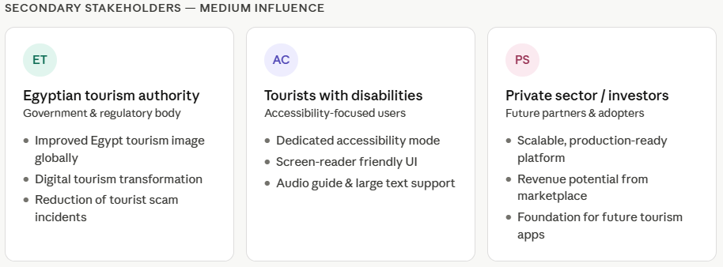
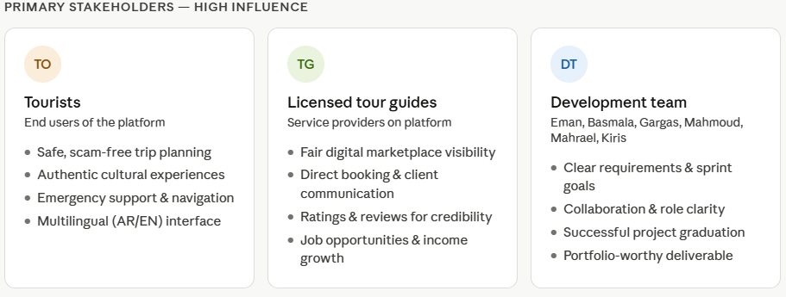

2. User Stories & Use Cases
This section defines the User Stories and Use Cases for Rafiq, a web-based smart tourism platform for Egypt. It describes how each type of user interacts with the system, what goals they aim to achieve, and how the system responds under normal, alternative, and exception scenarios.

2.1 System Actors
Actor | Type | Description
Tourist | Primary | Foreign or domestic visitor using the platform to plan and explore Egypt
Tour Guide | Primary | Licensed freelance guide who registers, manages availability, and receives bookings
Admin | Secondary | Platform operator who moderates content, verifies guides, and manages data
System | Automated | Automated behavior (GPS triggers, AI summarization, notifications) with no human actor

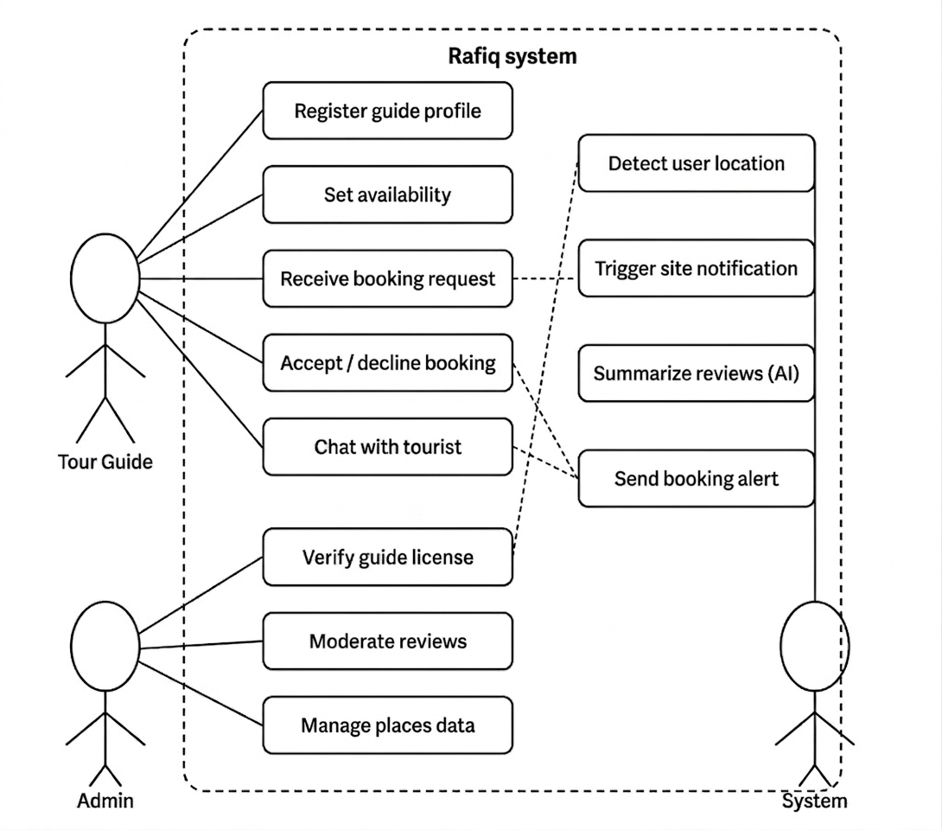

3.2 User Stories Summary
ID | Title | Actor | Module
US-01 | Plan a personalized trip | Tourist | Trip Planner
US-02 | Explore places with cultural tips | Tourist | Places Explorer
US-03 | Book a verified tour guide | Tourist | Guide Marketplace
US-04 | Check fair prices and avoid scams | Tourist | Anti-Scam Assistant
US-05 | Access emergency help quickly | Tourist | Emergency Companion
US-01 | Get a cultural walking route | Tourist | Route With Soul
US-07 | Read AI-summarized reviews | Tourist | Places Explorer
US-08 | Register and manage guide profile | Tour Guide | Guide Marketplace
US-09 | Receive and respond to bookings | Tour Guide | Guide Marketplace
US-10 | Manage and moderate platform content | Admin | Admin Dashboard
US-11 | Send smart notifications at a site | System | Smart Audio Guide
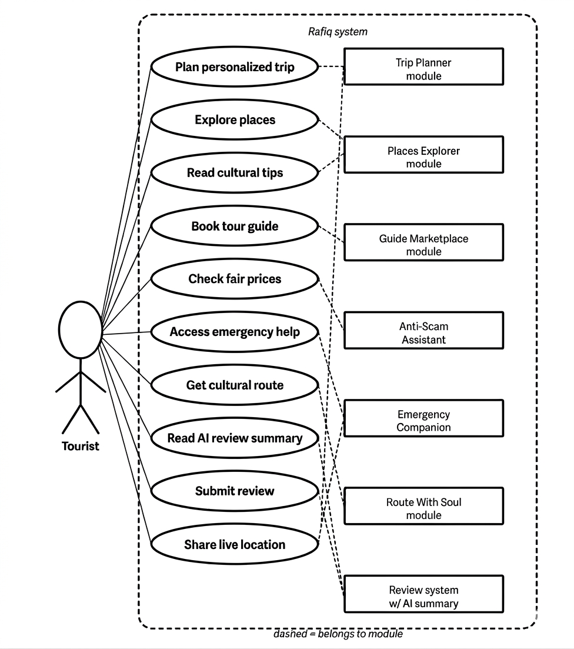

2.3 Detailed Use Cases
Each use case below includes the full flow description: a structured overview table, numbered normal flow steps, alternative flows where applicable, and exception/error handling.

2.3.1 US-01 – Plan a personalized trip
Use Case ID | US-01
Title | Plan a personalized trip
Actor | Tourist
Module | Trip Planner
User Story | As a tourist, I want to create a full travel plan based on my budget, interests, and trip duration, so that I can explore Egypt without wasting time researching.
Preconditions | User is registered and logged in
Postconditions | A trip itinerary is saved to the user's account

Normal Flow
- Tourist opens the Trip Planner module.
- Tourist selects trip duration (e.g. 5 days), budget range, and interests (history, food, beaches).
- System generates a day-by-day itinerary with ordered places, estimated costs, and transport times.
- Tourist reviews the plan and optionally swaps or reorders destinations.
- Tourist saves the itinerary to their profile.

Alternative Flow
- Tourist selects 'A Day as an Egyptian' template instead of custom planning.
- System loads a preset local experience (markets, transport, food) for that city.

Exception / Error Flow
- System cannot find enough places matching the filters → shows partial plan with a note to adjust filters.

2.3.2 US-02 – Explore places with cultural tips
Use Case ID | US-02
Title | Explore places with cultural tips
Actor | Tourist
Module | Places Explorer
User Story | As a tourist, I want to read about famous and local places including cultural norms and prices, so that I behave respectfully and avoid overpaying.
Preconditions | None — available to unauthenticated users
Postconditions | Tourist is informed before visiting the place

Normal Flow
- Tourist searches for a destination (e.g. 'Khan El Khalili').
- System returns a place card with average prices, best visiting time, and user reviews.
- Tourist taps 'Cultural Tips' tab.
- System shows tipping norms, dress code, photography rules, and religious customs.
- Tourist saves the place to their trip or wishlist.

Alternative Flow
- Tourist filters by category (beaches, religious sites, food markets) instead of searching by name.

Exception / Error Flow
- Place has no reviews yet → System shows verified info only and invites the tourist to add a review after visiting.

2.3.3 US-03 – Book a verified tour guide
Use Case ID | US-03
Title | Book a verified tour guide
Actor | Tourist
Module | Guide Marketplace
User Story | As a tourist, I want to browse and book a licensed guide with visible ratings, so that I have a trustworthy companion for my visit.
Preconditions | Tourist is logged in; at least one guide is available for the requested date
Postconditions | Booking is confirmed; tourist and guide receive notifications

Normal Flow
- Tourist opens Guide Marketplace and filters by city, language, and specialty.
- System lists guides with name, photo, rating, languages, and available dates.
- Tourist reviews a guide's profile and reads past reviews.
- Tourist selects a date from the guide's availability calendar and confirms booking.
- System sends a booking confirmation to both parties and opens a chat thread.

Alternative Flow
- Tourist wants a specific guide that is unavailable → System suggests next available date or similar guides.

Exception / Error Flow
- Payment fails → Booking is not confirmed; tourist is prompted to update payment method.

2.3.4 US-04 – Check fair prices and avoid scams
Use Case ID | US-04
Title | Check fair prices and avoid scams
Actor | Tourist
Module | Anti-Scam Assistant
User Story | As a tourist, I want to know the fair price for taxis and market goods, so that I don't get overcharged.
Preconditions | Tourist is at or near the relevant city
Postconditions | Tourist is equipped with correct pricing info and negotiation phrases

Normal Flow
- Tourist opens the Anti-Scam Assistant and selects their current city.
- System displays fair price ranges for taxis, market goods, and common services.
- Tourist reads common scam alerts specific to that city.
- Tourist taps 'Negotiation Phrases' to get ready-to-use Arabic phrases.

Alternative Flow
- Tourist is unsure about a specific price → enters service type and gets an instant estimate.

Exception / Error Flow
- Price data is outdated (flagged by users) → System shows a warning and the last-updated date.

2.3.5 US-05 – Access emergency help quickly
Use Case ID | US-05
Title | Access emergency help quickly
Actor | Tourist
Module | Emergency Companion
User Story | As a tourist in an emergency, I want one-tap access to police, hospitals, and my embassy, so that I can get help immediately.
Preconditions | Tourist has location services enabled
Postconditions | Tourist is connected to emergency services or shares location with a contact

Normal Flow
- Tourist taps the Emergency button from any screen.
- System shows local police, ambulance, tourist police, and nearest hospital with one-tap call.
- Tourist taps 'Share Location' to send live GPS to their guide or trusted contact.

Exception / Error Flow
- No internet connection → System shows pre-cached emergency numbers for the last known city.

2.3.6 US-06 – Get a cultural walking route
Use Case ID | US-01
Title | Get a cultural walking route
Actor | Tourist
Module | Route With Soul
User Story | As a tourist, I want a route that passes through historic streets and local cafes rather than just the fastest path, so that I experience real Egyptian culture.
Preconditions | Tourist has set a start point and destination
Postconditions | Tourist receives a culturally enriched route

Normal Flow
- Tourist enters start and end points in Route With Soul.
- System calculates a route weighted by cultural interest points (historic lanes, local cafes, murals).
- System displays waypoints with brief cultural notes for each stop.
- Tourist follows the route on the map.

Alternative Flow
- Tourist toggles to 'Fastest Route' to skip cultural detours.

Exception / Error Flow
- No cultural points exist between the two locations → System falls back to standard route with a note.

2.3.7 US-07 – Read AI-summarized reviews
Use Case ID | US-07
Title | Read AI-summarized reviews
Actor | Tourist
Module | Places Explorer
User Story | As a tourist, I want to quickly read a summary of what others said about a place, so that I don't have to scroll through dozens of reviews.
Preconditions | Place has at least 5 existing reviews
Postconditions | Tourist gets a reliable sentiment summary in seconds

Normal Flow
- Tourist opens a place page.
- System shows an AI-generated review summary (key positives, common negatives, overall sentiment).
- Tourist reads individual reviews optionally.
- Tourist submits their own review after visiting.

Exception / Error Flow
- AI summarization fails → System falls back to showing the top 3 highest-rated reviews.

2.3.8 US-08 – Register and manage guide profile
Use Case ID | US-08
Title | Register and manage guide profile
Actor | Tour Guide
Module | Guide Marketplace
User Story | As a tour guide, I want to create a verified profile with my specialties and availability, so that tourists can find and book me.
Preconditions | Guide has a valid license number to submit for verification
Postconditions | Profile is live and searchable by tourists

Normal Flow
- Guide registers an account and selects 'Tour Guide' role.
- Guide fills in name, photo, languages, specialties, and bio.
- Guide uploads license document for admin verification.
- Guide sets weekly availability on the calendar.
- Admin approves the profile → Guide appears in the marketplace.

Exception / Error Flow
- License verification fails → Guide receives a rejection note with required corrections.

2.3.9 US-09 – Receive and respond to bookings
Use Case ID | US-09
Title | Receive and respond to bookings
Actor | Tour Guide
Module | Guide Marketplace
User Story | As a tour guide, I want to receive booking notifications and chat with tourists before the tour, so that I can prepare and confirm details.
Preconditions | Guide has an approved profile and available dates set
Postconditions | Tour is scheduled and guide is prepared

Normal Flow
- Guide receives a push notification for a new booking request.
- Guide reviews tourist's profile and the requested tour date.
- Guide accepts the booking.
- System opens an in-app chat thread between guide and tourist.
- Guide and tourist align on meeting point, itinerary, and special needs.

Alternative Flow
- Guide is unavailable for requested date → Guide declines and suggests an alternative date.

Exception / Error Flow
- Tourist cancels within 24 hours → Guide is notified; cancellation policy is applied.

2.3.10 US-10 – Manage and moderate platform content
Use Case ID | US-10
Title | Manage and moderate platform content
Actor | Admin
Module | Admin Dashboard
User Story | As an admin, I want to manage places, guides, and reviews from a dashboard, so that the platform stays accurate and trustworthy.
Preconditions | Admin is logged into the admin dashboard
Postconditions | Content is up-to-date and inappropriate entries are removed

Normal Flow
- Admin opens the dashboard and views pending guide verifications and flagged reviews.
- Admin inspects each item and approves, edits, or rejects.
- Admin adds or updates place information (prices, tips, photos).
- System reflects changes immediately on the public-facing platform.

Exception / Error Flow
- Admin accidentally deletes a place → System keeps a soft-delete log for 30 days with restore option.

2.3.11 US-11 – Send smart notifications at a site
Use Case ID | US-11
Title | Send smart notifications at a site
Actor | System
Module | Smart Audio Guide
User Story | As the system, I should automatically trigger contextual information when a tourist is near a historic site, so that they receive timely, relevant content.
Preconditions | Tourist has location services and notifications enabled
Postconditions | Tourist receives relevant audio/text content without searching

Normal Flow
- System detects tourist's GPS coordinates.
- System matches coordinates to a site within a 100m radius.
- System pushes a notification with the site name and an optional audio story.
- Tourist taps to hear the story or dismiss.

Exception / Error Flow
- Tourist has notifications disabled → System shows an in-app banner when they open the map near the site.

2.4 Notes
- All user stories follow the format: As a [actor], I want [goal], so that [benefit].
- Preconditions define what must be true before the use case begins.
- Postconditions define the system state after successful completion.
- Exception flows cover known failure scenarios and system responses.
- Use Case IDs (US-01 through US-11) correspond to sections 1.3.1 through 1.3.11 of this document.

3. Functional Requirements

Functional Requirements
FR-01 | User Authentication & Account Management
FR-01.1 | Users shall be able to register a new account using email and password.
FR-01.2 | Users shall be able to log in and receive a JWT token for session management.
FR-01.3 | The system shall support three roles: Tourist, Tour Guide, and Admin.
FR-01.4 | Users shall be able to view and update their profile information.
FR-01.5 | The system shall restrict access to protected routes based on user role.
FR-01.6 | Tour Guides shall be able to register with additional details (languages, specialties, photo).
FR-02 | Smart Trip Planner

FR-02.1 | The system shall allow tourists to input trip duration, budget, and interest categories (history, food, adventure, religion, beaches).
FR-02.2 | The system shall generate a full day-by-day travel schedule based on user inputs.
FR-02.3 | The system shall organize places in logical geographic order to minimize travel time.
FR-02.4 | The system shall estimate daily costs and transportation time for each day.
FR-02.5 | The system shall offer pre-built 'A Day as an Egyptian' programs with local experiences.
FR-02.6 | The system shall display the generated plan on an interactive map.

FR-03 | Places Explorer
FR-03.1 | The system shall maintain a database of well-known landmarks and authentic local places across Egypt.
FR-03.2 | Each place shall display average prices, best visiting time, and user reviews.
FR-03.3 | Each place shall include cultural tips: customs, tipping culture, dress code, photography rules, and religious respect notes.
FR-03.4 | Users shall be able to search places by name, city, or category.
FR-03.5 | Users shall be able to filter places by type, price range, and rating.
FR-03.6 | Users shall be able to submit and read reviews for each place.

FR-04 | Guide Marketplace
FR-04.1 | The system shall list verified tour guides with name, photo, languages spoken, and specialties.
FR-04.2 | Each guide profile shall display ratings, reviews, and an availability calendar.
FR-04.3 | Tourists shall be able to filter guides by language, specialty, city, and rating.
FR-04.4 | Tourists shall be able to send a booking request to a guide directly from their profile.
FR-04.5 | The system shall provide an in-app chat for direct communication between tourist and guide.
FR-04.6 | Guides shall be able to accept or decline booking requests and manage their availability.

FR-05 | Anti-Scam Assistant
FR-05.1 | The system shall display fair price indicators for taxis, markets, and common street services per city.
FR-05.2 | The system shall list common scam types and warnings specific to each major city.
FR-05.3 | The system shall provide ready-to-use negotiation phrases in Arabic and English.
FR-05.4 | Admins shall be able to add and update scam warnings and price data.

FR-06 | Emergency Companion
FR-06.1 | The system shall provide one-click access to emergency contacts: police, ambulance, and tourist police per city.
FR-06.2 | The system shall display the nearest hospitals to the user's current location.
FR-06.3 | The system shall display embassy locations for major nationalities in Egypt.
FR-06.4 | Users shall be able to share their live location with their guide or a trusted contact.

FR-07 | Route With Soul
FR-07.1 | The system shall suggest cultural routes that pass through historic streets, local cafes, and authentic neighborhoods.
FR-07.2 | The system shall display cultural route details on an interactive map.
FR-07.3 | Cultural routes shall include estimated walking time and points of interest along the way.

FR-08 | Smart Audio Guide
FR-08.1 | The system shall automatically trigger audio narration when a user is near a registered site.
FR-08.2 | Audio content shall be delivered in a human-style narrative format (not dry historical text).
FR-08.3 | Audio guide content shall be available in English and Arabic.
FR-08.4 | Admins shall be able to manage audio content for each registered site.

FR-09 | Memory Map & Additional Features
FR-09.1 | The system shall generate a shareable map of places visited by the tourist after their trip.
FR-09.2 | The system shall support full Arabic and English language switching across all pages.
FR-09.3 | The system shall provide an Accessibility Mode with wheelchair-friendly places, low-crowd routes, and accessible transport info.
FR-09.4 | The system shall use AI to summarize user reviews for each place.
FR-09.5 | The system shall use AI to optimize suggested routes based on user preferences.

FR-10 | Admin Dashboard
FR-10.1 | Admins shall be able to add, edit, and delete places from the database.
FR-10.2 | Admins shall be able to verify, suspend, or remove tour guide accounts.
FR-10.3 | Admins shall be able to moderate and remove inappropriate user reviews.
FR-10.4 | Admins shall be able to manage anti-scam warnings and fair price data.
FR-10.5 | Admins shall be able to manage audio guide content for all registered sites.
FR-10.6 | The admin dashboard shall display platform statistics: total users, guides, places, and bookings.

4. Non-functional Requirements

1. Performance
The system must provide fast and efficient performance to ensure a smooth user experience for tourists using the platform.
• All main pages should load within 3 seconds under normal network conditions.
• API response time should not exceed 500 milliseconds for standard operations.
• The system should support at least 1,000 concurrent users without noticeable performance degradation.
• Real-time features such as chat (Socket.io) must deliver messages with latency of less than 1 second.
• Images and media content should be optimized to reduce loading time.

2. Security
Security is critical to protect user data and ensure safe interactions between tourists and guides.
• All data must be transmitted securely using HTTPS (SSL/TLS encryption).
• Authentication must be implemented using JWT (JSON Web Tokens).
• Passwords must be hashed using bcrypt before storing in the database.
• Role-Based Access Control (RBAC) must restrict access based on user roles (Tourist, Guide, Admin).
• The system must protect against common vulnerabilities such as: SQL Injection, Cross-Site Scripting (XSS), Cross-Site Request Forgery (CSRF).
• Sensitive operations should require proper authorization and validation.

3. Usability
The platform should be easy to use for both international tourists and local users.
• The interface must be simple, intuitive, and user-friendly.
• The system should support both English and Arabic languages.
• Navigation should be clear and consistent across all pages.
• The platform should include an Accessibility Mode for users with disabilities.
• Error messages should be clear and helpful.

4. Reliability
The system must operate consistently without failures.
• The system should maintain at least 99% uptime.
• Errors should be handled gracefully without crashing the system.
• Logging mechanisms should be implemented to track issues.
• Regular database backups should be maintained to prevent data loss.

5. Scalability
The system should be able to grow with increasing users and data.
• The architecture should support horizontal scaling.
• Cloud platforms like Vercel and Render should handle traffic efficiently.
• The database (MongoDB Atlas) should scale automatically with increasing data volume.

6. Maintainability
The system should be easy to update and maintain.
• Code should follow clean code principles and best practices.
• Proper documentation must be provided for developers.
• Version control should be managed using Git & GitHub.
• The system should be modular to allow easy feature updates.

7. Compatibility
The platform must work across different devices and browsers.
• The system should be fully responsive (mobile, tablet, desktop).
• It should support modern browsers such as: Google Chrome, Microsoft Edge, Mozilla Firefox, Safari.

8. Availability
The system should always be accessible to users.
• The platform must be available 24/7.
• Maintenance downtime should be minimal and scheduled during low-traffic periods.

9. Localization
The system must support multiple languages and cultural formats.
• The platform should support Arabic and English.
• Date, time, and currency formats should adapt to user preferences.

