MANSOURA UNIVERSITY
Graduation Project Documentation
GreenCycle
AI-Powered Environmental Intelligence Platform
Project Documentation Report

Prepared by
Ziad Omran
Abdelrahman Kewan
Mostafa Shalan
Mahmoud Amer
Sohila Ihab
Shaza Beder

July 2026

Table of Contents

List of Figures

List of Tables

1. Project Overview

1.1 Introduction
GreenCycle is an AI-powered environmental intelligence platform developed by a six-person team as a graduation project. The system brings together data science, machine learning, computer vision, and large language model (LLM) technology into a single, connected application aimed at making environmental data understandable and actionable for ordinary users, students, and city planners alike. Rather than presenting raw statistics, GreenCycle interprets them: a photograph becomes a pollution or recycling assessment, a set of city statistics becomes a CO2 and air-quality forecast, and a plain-language question becomes a scientifically grounded answer.
This document describes the complete project as implemented: the datasets analyzed, the exploratory data analysis performed, the preprocessing pipeline built, the machine learning and computer vision models trained and evaluated, the backend API and frontend web application developed, and the deployment approach used. Every number, result, and technical claim in this report is drawn directly from the project's notebooks, source code, and configuration files; where information was not available in the project materials, this is stated explicitly rather than estimated or invented.

1.2 Project Idea
The central idea behind GreenCycle is to unify three previously separate strands of environmental technology — statistical/ML modeling of emissions data, computer-vision-based waste identification, and conversational AI — behind one web application and one backend API. Instead of requiring a user to consult a spreadsheet, run a Python notebook, or search for recycling guidelines separately, GreenCycle exposes all of these capabilities through simple, guided interfaces: a form for city-level simulation, an image uploader for pollution and recycling analysis, and a chat window for open-ended environmental questions.

1.3 Problem Statement
Across every dataset examined during this project's analysis phase, a consistent pattern emerged: waste is generated and mismanaged faster than it is tracked, and the resulting environmental cost is measurable rather than abstract. Specifically, the project's own data analysis found that:
- Open dumping is the single largest waste-disposal method in the world, accounting for an average of 33.6% of municipal waste across 239 countries analyzed — more than controlled landfills (20.6%) and far more than recycling (9.7%).
- 49 of the 239 countries studied collect less than half of their municipal waste, indicating that infrastructure — not just individual behavior — is a major barrier to proper waste management.
- 25.2% of the 3,937 cities studied register poor air quality (score below 40 on a 0–100 scale), and 19.3% show highly polluted water.
- Egypt ranks 3rd globally in mismanaged plastic waste per capita among the 107 countries analyzed in the project's plastic-waste dataset (0.122 kg per person per day) — making this a directly regionally relevant problem, not merely a distant global statistic.
Despite the availability of public environmental datasets (such as those published by Our World in Data), there is no simple, accessible tool that lets an individual or a city planner translate this data into a specific, actionable decision — for example, "is this item recyclable," "how polluted is this scene," or "what would happen to my city's emissions if we changed X." This is the gap GreenCycle was built to close.

1.4 Motivation
The motivation for this project stems from three observations made while surveying the environmental-data landscape. First, public datasets on emissions, waste, and pollution are extensive but highly technical, typically distributed as raw CSV files intended for researchers rather than the general public. Second, existing computer-vision waste-classification research (such as the garbage-classification datasets available on Kaggle) demonstrates that image-based recycling identification is technically feasible, but is rarely packaged into an accessible consumer-facing tool. Third, the emergence of capable, affordably-hosted large language models (via providers such as Groq) makes it practical, for the first time, to wrap statistical models and vision classifiers in natural-language interfaces without requiring users to understand the underlying data science.
The team was additionally motivated by the regional relevance of the plastic-pollution problem, as reflected in Egypt's ranking within the project's own analyzed dataset, and by the educational value of building a genuinely full-stack AI system — spanning data cleaning, model training, backend API development, and frontend engineering — as a capstone demonstration of applied AI engineering skills.

1.5 Proposed Solution
GreenCycle's proposed solution is a unified environmental AI platform composed of four functional capabilities, delivered through one FastAPI backend and one Next.js frontend web application:
- CO2 Impact Simulator: a form-based tool that accepts a city's population, number of vehicles, number of factories, tree count, and annual energy usage, and returns a narrative simulation covering current CO2 emissions, air quality index, temperature impact, five- and ten-year projections, and recommended interventions.
- Vision Lab (Pollution Analysis): an image-upload tool that assesses an uploaded photograph for pollution type, severity level, estimated pollution percentage, likely cause, health impact, and recommended remediation.
- Vision Lab (Recycling Analysis): an image-upload tool that identifies the waste/material type shown in a photograph, its recycling code (where applicable), whether it is recyclable, its decomposition time, and the recommended recycling method.
- Eco AI Advisor: a conversational chatbot, grounded in an environmental-science system prompt, that answers open-ended questions about pollution, recycling, and sustainability with quantitative, evidence-based responses.
In parallel with these live, LLM-backed services, the project also trained and evaluated two custom machine learning models from the underlying datasets — a regression model predicting CO2 emissions per capita, and a computer-vision classifier identifying ten categories of waste material from images — as a demonstration of the team's applied data-science and machine-learning capability. As documented in Section 11 (Deployment), these two trained models are not yet the models served by the live API; this distinction is stated plainly rather than implied otherwise.

1.6 Project Objectives
- Analyze and clean six real-world environmental datasets covering emissions, municipal waste management, plastic pollution, city air/water quality, materials recycling, and waste imagery.
- Perform thorough exploratory data analysis to surface actionable insights about global waste-management patterns and their relationship to environmental quality.
- Train and rigorously evaluate multiple candidate machine learning models for CO2-per-capita prediction, selecting a final model based on documented, reproducible comparison rather than assumption.
- Train and evaluate a computer-vision model capable of classifying waste images into meaningful categories to support recycling decisions.
- Design and implement a working backend API exposing chat, simulation, and vision-analysis capabilities.
- Design and implement a modern, responsive, accessible frontend web application that connects to the backend API and matches the project's visual brand identity.
- Containerize the backend for deployment using Docker, and document the deployment architecture.
- Produce complete, honest technical documentation of the entire system — including its current limitations — suitable for academic and professional evaluation.

2. System Description

2.1 How the System Works
GreenCycle operates as a client-server web application. The frontend, built with Next.js, presents the user with dedicated pages for each capability (city simulation, image analysis, and chat). When a user submits a form, uploads an image, or sends a chat message, the frontend sends an HTTP request directly to the FastAPI backend, which is configured with permissive Cross-Origin Resource Sharing (CORS) so that browser-based requests are accepted from any origin. The backend routes the request to the appropriate service module, which in turn calls a Groq-hosted large language model — a text model (llama-3.3-70b-versatile) for chat and city simulation, and a vision-capable model (llama-4-scout-17b-16e-instruct) for image analysis. The model's response is returned to the backend, wrapped in a simple JSON object, and sent back to the frontend, which renders it for the user.
Independently of this live request/response flow, the project also includes a data-science pipeline — implemented across six Jupyter notebooks — that cleans multiple environmental datasets, performs exploratory analysis, and trains two machine learning models (a CO2 regression model and a waste-image classifier). As documented in Section 11, these trained models are saved as local artifacts but are not currently loaded by the live API; the live API's intelligence currently comes entirely from the hosted Groq models described above.

2.2 Main Workflow
The end-to-end project workflow follows ten stages, from raw data to a working application:
- 1. Data Collection — six datasets covering emissions, municipal waste, plastic pollution, city air/water quality, materials recycling, and waste imagery.
- 2. Data Exploration — exploratory data analysis performed separately on each dataset to surface patterns and validate assumptions before modeling.
- 3. Data Cleaning — removal of duplicate/aggregate records, correction of impossible values, and structural fixes specific to each dataset.
- 4. Preprocessing — missing-value imputation, outlier capping, and categorical encoding, tailored to each dataset's characteristics.
- 5. Feature Engineering — construction of per-capita ratios, country/region encodings, and other engineered features used by the regression model.
- 6. Model Training — five candidate regression models trained for CO2 prediction; one convolutional-transfer-learning model trained for waste image classification.
- 7. Model Evaluation — comparison of all trained models using held-out test data and multiple metrics (R², RMSE, MAE for regression; accuracy for classification).
- 8. Model Deployment (planned/partial) — model artifacts saved locally; not yet wired into the live API (see Section 11).
- 9. API / Application Layer — a FastAPI backend exposing four live endpoints, and a Next.js frontend consuming them.
- 10. User Prediction — the end user interacts with the deployed frontend to simulate a city's environmental footprint, analyze a photograph, or converse with the Eco AI Advisor.
[Insert Figure: Full Project Pipeline Diagram (Data Collection → Exploration → Cleaning → Preprocessing → Feature Engineering → Model Training → Evaluation → Deployment → API/Application → User Prediction)]

2.3 User Journey
A typical user journey through the GreenCycle web application proceeds as follows. The user first lands on the marketing homepage, which introduces the platform and its three AI services. From there, the user proceeds to the Dashboard, a central hub presenting each of the three tools as an interactive card. Depending on their need, the user then navigates to one of three destinations:
- City Simulator: the user fills in five numeric fields describing a city (population, cars, factories, trees, energy usage) and submits the form. A loading state is shown while the request is in flight; on success, the simulation results are parsed and displayed as a set of labeled sections (CO2 emissions, air quality index, temperature impact, five/ten-year projections, and recommendations); on failure, an error state with a retry option is shown.
- Vision Lab: the user either drags and drops an image, browses for a file, or captures a photo directly via the device camera. A preview is shown before submission, with an option to remove and reselect. The user chooses between the Pollution Detection tab and the Recycling Classifier tab, each of which calls its respective backend endpoint and displays the parsed analysis.
- AI Chatbot: the user types a free-form question into a chat interface styled with distinct user and assistant message bubbles, a typing indicator while awaiting a response, and message timestamps. The user may clear the conversation at any time.
Throughout all three flows, the interface provides explicit loading, error, and empty states, and all forms validate user input before submission (for example, rejecting non-numeric values in the city simulator, or unsupported file types in the image uploader).

2.4 System Architecture Overview
The system architecture consists of three logical layers: the presentation layer (the Next.js frontend), the application layer (the FastAPI backend and its four route handlers), and the intelligence layer (the Groq-hosted language and vision models). A separate, currently disconnected data-science layer contains the cleaned datasets, the trained CO2 regression model, and the trained waste-image classifier.
Table : System Architecture Layers
Layer | Component | Responsibility
Presentation | Next.js frontend (7 pages) | Renders UI, collects user input, calls backend API, displays results
Application | FastAPI backend (main.py + 4 routes) | Receives HTTP requests, validates payloads, calls the appropriate service
Intelligence (live) | Groq-hosted LLMs | Generates chat responses, city simulations, and image analyses
Intelligence (trained, not yet connected) | Ridge regression model; MobileNetV2 classifier | Predicts CO2 per capita; classifies waste images into 10 categories

No database is used anywhere in the provided project files. Every request to the live API is stateless: chat history is held only in the frontend's in-memory state and resent in full with each new message; no user data, conversation history, or prediction results are persisted server-side.
[Insert Figure: System Architecture Diagram (Frontend → API → Docker Container → Groq LLM Services)]

3. Technologies Used
This section documents every technology identified in the project's source code and configuration files, along with the reason it was used. No frameworks or tools are listed unless direct evidence of their use was found in the provided files (import statements, configuration files, or package manifests).

3.1 Programming Languages
Table : Programming Languages
Language | Where Used | Why
Python | All data-science notebooks, FastAPI backend, Streamlit prototype | The de facto standard for data science and machine learning, with mature libraries (pandas, scikit-learn, PyTorch) and first-class support in FastAPI for building APIs.
TypeScript | Next.js frontend (all components, pages, API layer) | Adds static typing to JavaScript, catching type errors at build time and making the API contracts between frontend and backend explicit and self-documenting.

3.2 Frameworks
Table : Frameworks
Framework | Role | Why It Was Used
FastAPI | Backend web framework (main.py) | A modern, high-performance Python web framework with built-in request validation (via Pydantic models) and automatic OpenAPI documentation, well suited to building a small set of JSON/multipart API endpoints quickly.
Next.js 16 (App Router) | Frontend framework | Provides file-based routing, built-in performance optimizations, and a component-based architecture, allowing the team to build seven connected pages with shared layout and navigation efficiently.
React 19 | Underlying UI library for the frontend | Component-based UI architecture; used throughout the frontend for all interactive elements (forms, chat window, image uploader).
Streamlit | Standalone prototype dashboard (app.py) | Enables rapid construction of an interactive data-science dashboard directly from a Python script, used here to compare regression models live from an uploaded CSV.

3.3 Libraries
Table : Key Libraries
Library | Purpose
pandas / numpy | Data loading, cleaning, transformation, and numerical computation across all notebooks.
matplotlib | Generating exploratory data analysis charts (distributions, bar charts, pie charts, scatter plots, boxplots).
scikit-learn | Linear Regression, Ridge Regression, Random Forest, Gradient Boosting implementations; train/test splitting; evaluation metrics (R², RMSE, MAE).
XGBoost | Gradient-boosted tree regressor, trained and compared against the scikit-learn models.
PyTorch / torchvision | MobileNetV2 model definition, transfer learning, image transforms, and training loop for the waste image classifier.
OpenCV (cv2) | Real-time webcam frame capture and contour-based bounding-box detection in the live classifier demo.
joblib | Serializing the final trained regression model and its feature scaler to disk.
Groq (Python SDK) | Client library used by all four backend services to call Groq-hosted language and vision models.
python-dotenv | Loading API keys and configuration from a local .env file into environment variables.
Pydantic | Request-body validation for the FastAPI routes (e.g. validating that simulate-city payloads contain the required integer fields).
react-hook-form / zod | Frontend form state management and schema-based input validation (city simulator and contact forms).
lucide-react | Icon set used consistently across the frontend UI.
sonner | Toast notification component used for frontend error/success messages.
Tailwind CSS | Utility-first CSS framework used for all frontend styling, configured with the project's brand colors as design tokens.

3.4 Databases
No database technology was found anywhere in the provided project files. The FastAPI backend does not import or configure any database driver, ORM, or connection string, and all four live endpoints are stateless — they accept a request, call a Groq model, and return a response without reading from or writing to persistent storage. This is stated explicitly here because the absence of a database is a deliberate characteristic of the current system, not an oversight in this documentation.

3.5 AI / ML Tools
Table : AI / ML Tools and Models
Tool / Model | Type | Role in the Project
Groq API — llama-3.3-70b-versatile | Hosted large language model (text) | Powers the Eco AI Advisor chatbot and the City Simulator's narrative simulation.
Groq API — llama-4-scout-17b-16e-instruct | Hosted vision-language model | Powers both the pollution-analysis and recycling-analysis image endpoints.
Ridge Regression (scikit-learn) | Trained regression model | Predicts CO2 emissions per capita from engineered emissions features; the best-performing of five candidates evaluated.
Random Forest, Gradient Boosting, XGBoost, Linear Regression | Trained regression models (comparison candidates) | Evaluated alongside Ridge Regression to justify the final model choice; see Section 9.
MobileNetV2 (PyTorch, ImageNet-pretrained) | Trained CV classifier | Classifies waste images into 10 categories via transfer learning.

3.6 Deployment Tools
Table : Deployment Tools
Tool | Purpose
Docker | Containerizes the FastAPI backend using a python:3.11-slim base image, so it can run consistently across environments.
uvicorn | ASGI server that actually runs the FastAPI application inside the container, bound to 0.0.0.0:7860.

No continuous integration/continuous deployment (CI/CD) pipeline, infrastructure-as-code configuration, or cloud provider–specific deployment file was found among the provided project materials.

4. Dataset Description
Six datasets were collected, cleaned, and analyzed over the course of this project. This section documents each one's source, size, features, and target variable where applicable. Source confidence is stated honestly: a dataset is marked as confirmed only when direct evidence (such as a matching column name) ties it to a specific public source; otherwise it is marked as plausible/related but unconfirmed, since the notebooks themselves do not always record their exact data origin.

4.1 Dataset Sources Summary
Table : Dataset Sources and Sizes
Dataset | Source | Size After Cleaning
OWID CO2 & GHG Emissions | Our World in Data (owid-co2-data.csv) — well-known public dataset | 12,225 rows × 33 columns, 163 countries, 1950–2024
Mismanaged Plastic Waste per Capita | Our World in Data — confirmed by exact column-name match | 107 rows × 13 columns (107 countries)
Municipal Waste Management Methods | Unconfirmed — plausibly related to public waste-management datasets | 239 countries (2020) + an OECD generation-trend series (2015–2024)
City Air & Water Quality | Unconfirmed — filename only (Cities1.csv) | 3,446 rows (cleaned), 176 countries
Materials Recycling Core Dataset | Unconfirmed — filename only (materials_recycling_core.csv) | 25,000 records, 74 columns (cleaned)
Waste Image Dataset | Plausibly Kaggle's garbage-classification-v2 (class overlap); code folder named standardized_2569 | 12,259 images, 10 classes

4.2 Dataset Collection Method
All six datasets were collected as pre-existing public or semi-public files (CSV, Excel, and image archives) rather than gathered through original data-collection instruments such as surveys or sensors. The OWID CO2 dataset and the mismanaged-plastic-waste-per-capita dataset originate from Our World in Data, a well-established public data repository. A supplementary Excel file (containing Jambeck-style country-level plastic-waste estimates) was used alongside the plastic-waste analysis. The remaining datasets — municipal waste management methods, city air/water quality, the materials recycling core dataset, and the waste image dataset — were provided as project files without an explicit citation of their origin inside the analysis notebooks; each is used and documented here, but its precise external source is marked as unconfirmed rather than asserted.

4.3 Dataset Details and Feature Overview

4.3.1 OWID CO2 & Greenhouse Gas Emissions Dataset
This is the dataset used to train the CO2 regression model (see Section 8). The raw source file contains 79 columns and covers all years back to the 1700s; the project's cleaning pipeline (documented fully in Section 7) filtered it to 33 relevant columns and the 1950–2024 period, then scoped it to 163 sovereign countries (removing regional aggregates and dependent territories).
Table : OWID CO2 Dataset — Feature Overview
Category | Example Columns | Target Variable
Emissions | co2, methane, nitrous_oxide, total_ghg, land_use_change_co2, cumulative_co2 | co2_per_capita (regression target)
Demographic / Economic | population, gdp | —
Ratio / Per-Capita | co2_per_capita, methane_per_capita, ghg_per_capita, co2_growth_prct | —
Identifiers | country, iso_code, year | —

4.3.2 Mismanaged Plastic Waste per Capita Dataset
Cleaned from an original 192-country raw file (with 14 columns, two of which were duplicate-named and removed) down to 107 countries and 13 columns. Key features include coastal population, waste generation rate per person per day, percentage of plastic in the waste stream, percentage of inadequately managed waste, percentage of littered waste, and the resulting mismanaged plastic waste in both per-capita and absolute-tonnage terms. This dataset does not have a single ML target variable; it was used exclusively for exploratory analysis (see Section 6).

4.3.3 Municipal Waste Management Methods Dataset
Covers 239 countries for the year 2020, with seven disposal-method share columns (open dumps, open burning, controlled landfills, sanitary landfills, incinerated, composted, recycled) that together describe how each country's municipal waste is handled. A companion series describes the share of waste actually collected per country, and a separate OECD-sourced series tracks municipal waste generation from 2015 to 2024 across a subset of (mostly high-income) countries.

4.3.4 City Air & Water Quality Dataset
Originally 3,937 cities across 176 countries with five columns (city, region, country, air quality score, water pollution score); cleaned and enriched to 3,446 rows and ten columns, including min-max normalized and log-transformed versions of both scores plus a composite environmental score (EnvScore). This dataset was matched against the municipal waste management dataset on 120 shared countries to compute the cross-dataset correlations discussed in Section 6.

4.3.5 Materials Recycling Core Dataset
The largest of the six datasets by record count: 25,000 individual item-level records describing a material type, its condition, contamination level, region, country, and the disposal method actually applied to it. Two candidate target variables exist in this dataset: a binary recyclable flag (85.2% positive class) and a nine-category actual_disposal_method field. As documented in Section 6, this dataset has so far only been used for exploratory analysis; it has not yet been used to train a supervised model.
Table : Materials Recycling Dataset — Feature Overview
Category | Example Columns
Material Properties | material_type (12 categories), condition, contamination_level, contamination_type, moisture_content_pct
Location | country (20), region (6 world regions)
Outcome (excluded from any future modeling as leakage) | co2_saved_total_kg, ghg_reduction_kg_co2e, total_net_revenue_usd, recyclability_score_0to100, and 8 other outcome-derived columns
Targets | recyclable (binary), actual_disposal_method (9 categories)

4.3.6 Waste Image Dataset
Consists of 12,259 images organized into 10 class folders (battery, biological, cardboard, clothes, glass, metal, paper, plastic, shoes, trash), used to train the computer-vision classifier described in Section 8. The images were split 80/20 into 9,807 training images and 2,452 validation images.

4.4 Dataset Examples
Representative fields from the cleaned plastic-waste-per-capita dataset (cleaned_data.csv) are shown below to illustrate the structure of the underlying data.
Table : Sample Records — Mismanaged Plastic Waste per Capita Dataset (illustrative subset of columns)
Country | Economic Status | Mismanaged Plastic (kg/person/day)
Nigeria | LMI | 0.379
Sri Lanka | LMI | 0.144
Egypt | LMI | 0.122
Bangladesh | LMI | 0.115

These four rows are drawn directly from the dataset's own top-ranked entries by mismanaged plastic waste per capita and are reproduced here only to illustrate the data's structure, not as an exhaustive summary of the dataset's contents.

5. Data Analysis (EDA)
Exploratory data analysis was performed independently on each of the six datasets before any modeling was attempted. This section presents the key visualizations produced during that analysis, the observations drawn from each, and — where applicable — how those observations influenced later project decisions.

5.1 Global Waste Disposal Methods
The municipal waste management dataset was first examined by averaging each of its seven disposal-method share columns across all 239 countries, producing a picture of how the world actually disposes of municipal waste.
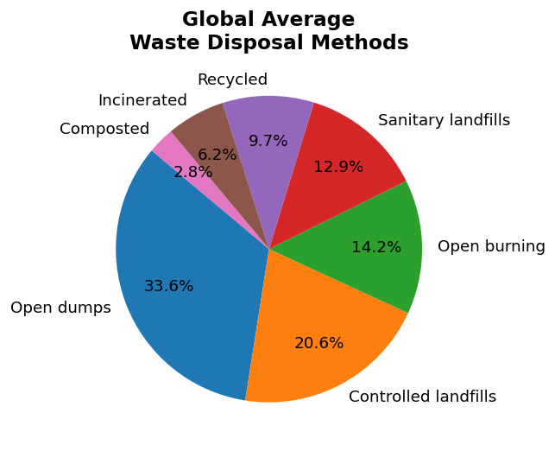
Figure : Global average waste disposal method mix across 239 countries (2020).
Observation: open dumping is the single largest disposal method worldwide at 33.6%, ahead of controlled landfills (20.6%), open burning (14.2%), sanitary landfills (12.9%), recycling (9.7%), incineration (6.2%), and composting (2.8%). This is a materially different picture from the popular assumption that landfilling or recycling dominate global waste management.
Impact on the project: this finding directly shaped the product direction toward practical disposal and pollution-detection guidance rather than assuming recycling infrastructure is universally accessible.

5.2 Plastic Waste Concentration by Country
The mismanaged-plastic-waste-per-capita dataset was ranked to identify the countries with the highest per-person daily mismanaged plastic waste.
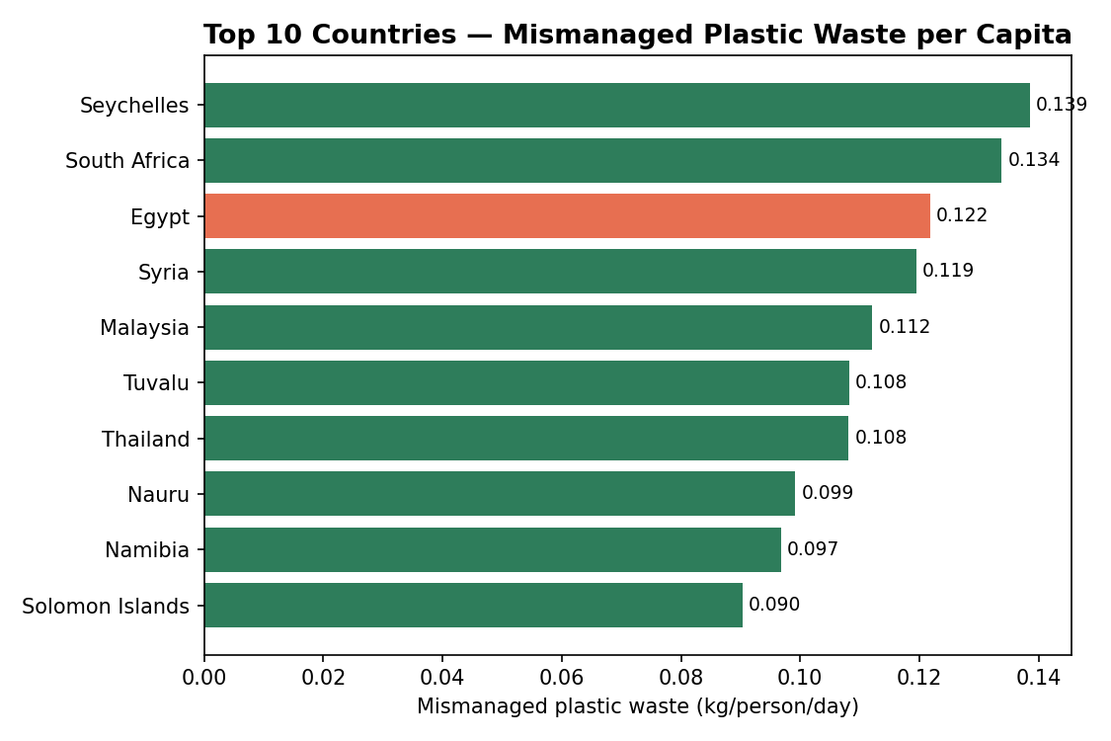
Figure : Top 10 countries by mismanaged plastic waste per capita (kg/person/day).
Observation: Egypt ranks third globally in this dataset at 0.122 kg per person per day. The underlying data also shows a direct relationship between a country's coastal population size and its total mismanaged plastic tonnage, and between economic status classification (low/middle income vs. high income) and mismanagement efficiency — lower and lower-middle income countries mismanage a higher proportion of the plastic waste they generate.
Impact on the project: confirmed that plastic pollution is a regionally relevant problem for this team's context, reinforcing the priority given to the vision-based recycling and pollution-detection features.

5.3 City Air and Water Quality Distributions
Air quality and water pollution scores across the 3,937 cities in the cleaned cities dataset were examined for their overall distribution, not just their averages.
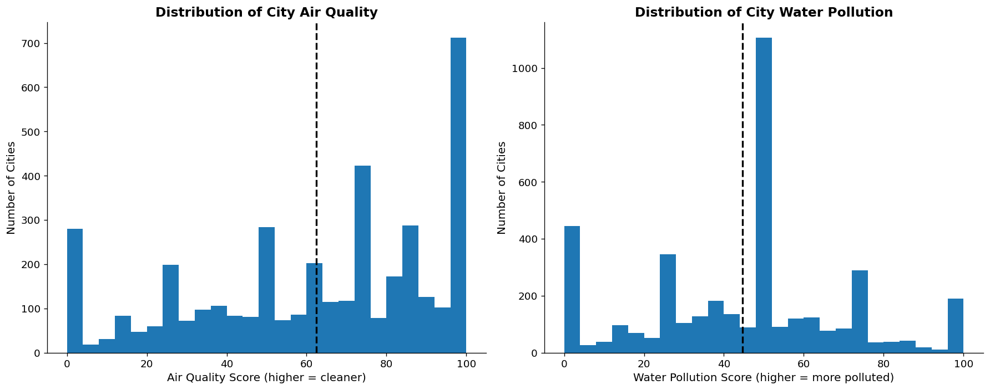
Figure : Distribution of air quality and water pollution scores across 3,937 cities.
Observation: mean air quality across all cities is 62.4 (median 70.0), but 25.2% of cities fall below the poor-air-quality threshold of 40. Mean water pollution is 44.6 (median 50.0), with 19.3% of cities scoring above 66 (highly polluted). The best-performing cities in this dataset are located in Finland (air quality 95.8) and Sweden (water pollution score 18.8); the worst-performing are in China (air quality 10.8) and Lebanon (water pollution score 90.8).
Impact on the project: demonstrated that averages alone understate the scale of the problem in the worst-affected cities, and established the dataset used for the cross-dataset correlation analysis below.

5.4 Correlation Between Waste Management Practices and Environmental Quality
The municipal waste management dataset was matched against the city air/water quality dataset on 120 countries present in both, to test whether disposal-method choices are actually associated with measurable environmental outcomes.
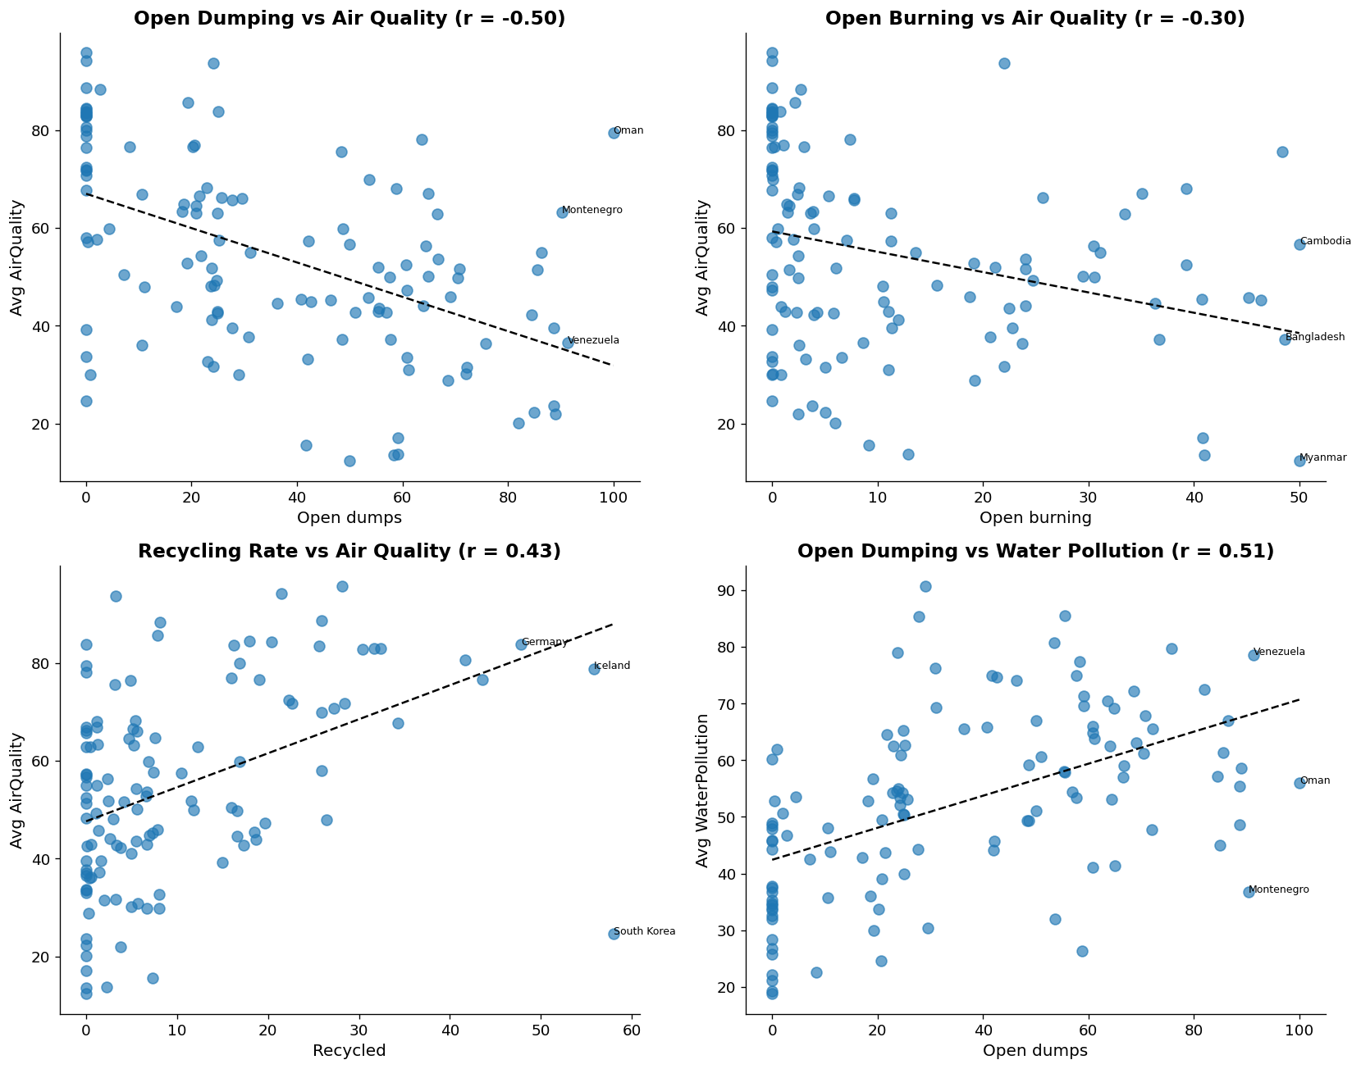
Figure : Pearson correlations between waste disposal methods and city air/water quality across 120 matched countries.
Observation: open dumping share correlates negatively with air quality (r = −0.50) and positively with water pollution (r = +0.51); recycling rate correlates positively with air quality (r = +0.43); open burning share correlates negatively with air quality (r = −0.30). These are moderate, not perfect, correlations, but they are consistent and directionally sensible.
Impact on the project: this is the strongest evidence in the entire exploratory analysis that disposal-method choice — not merely waste volume — measurably affects environmental outcomes, directly motivating the recycling- and pollution-focused features of the platform.

5.5 CO2 Dataset Quality Checks
Before any feature engineering or model training, the raw OWID CO2 dataset was examined for missing values and extreme outliers across its 33 selected columns.
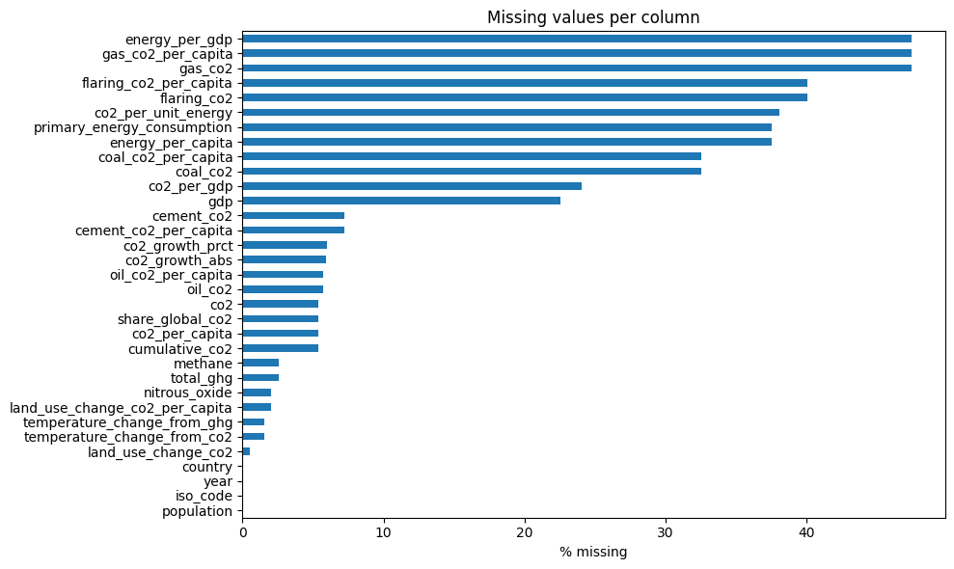
Figure : Percentage of missing values per column in the OWID CO2 dataset prior to cleaning.
Observation: energy- and gas-emission-related columns (such as energy_per_gdp and gas_co2) had the highest missingness, at approximately 47.5%, reflecting that many smaller or less industrialized countries do not report — or do not have — these emission sources.
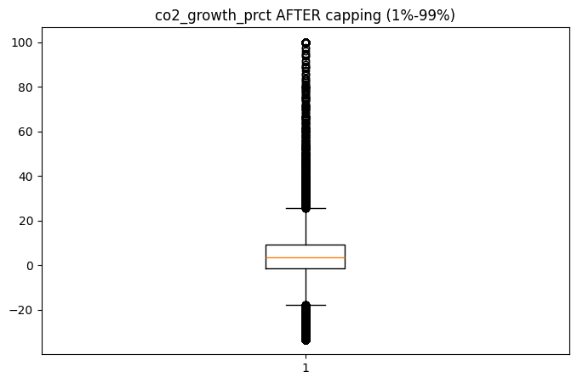
Figure : Distribution of co2_growth_prct before and after 1st/99th-percentile outlier capping.
Observation: the co2_growth_prct column (year-over-year percentage change in CO2 emissions) contained values as extreme as +147,000%, produced when a near-zero emissions value moved slightly — a mathematically correct but practically unusable artifact. Capping the column at its 1st and 99th percentiles corrected 259 extreme points.
Impact on the project: these two findings directly justified the tiered missing-value strategy and the selective outlier-capping approach documented in Section 7.

5.6 Materials Recycling Dataset: Value by Material Type
The materials recycling core dataset was grouped by material type to compare the average greenhouse-gas reduction achieved per item recycled, and by world region to see where the largest share of total CO2 savings occurs.
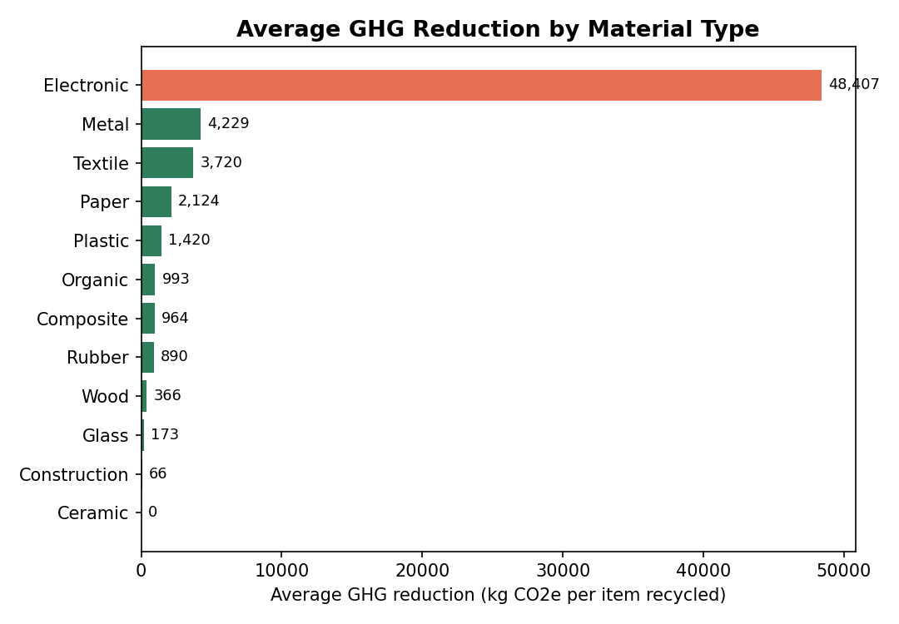
Figure : Average GHG reduction (kg CO2e per item recycled) by material type across 25,000 records.
Observation: electronic waste delivers, by a wide margin, the highest average greenhouse-gas reduction per item recycled (48,407 kg CO2e) — an order of magnitude above every other material type. It also has the highest average net revenue per item ($6,714), making it the clearest combined environmental-and-economic case among all 12 material types in the dataset.
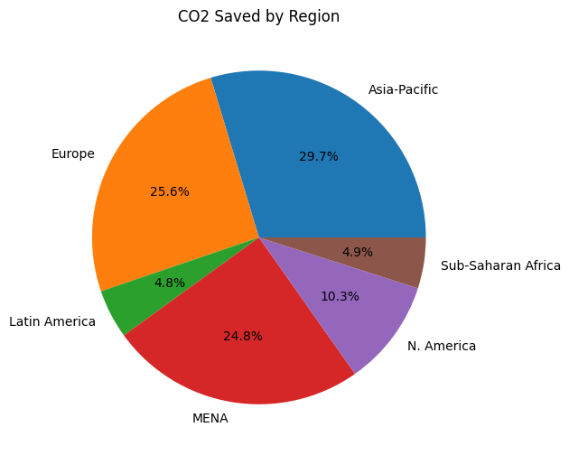
Figure : Share of total CO2 saved by world region, materials recycling dataset.
Observation: Asia-Pacific accounts for the largest regional share of total CO2 saved (29.7%), followed by Europe (25.6%) and MENA (24.8%).
Impact on the project: this analysis remains exploratory — as noted in Section 4, the materials recycling dataset has not yet been used to train a supervised recyclability or disposal-method model, and is listed as a Future Improvement in Section 14.

5.7 Waste Image Dataset Overview
Before training the computer-vision classifier, sample images from each of the ten waste categories were inspected to confirm consistent labeling and image quality.
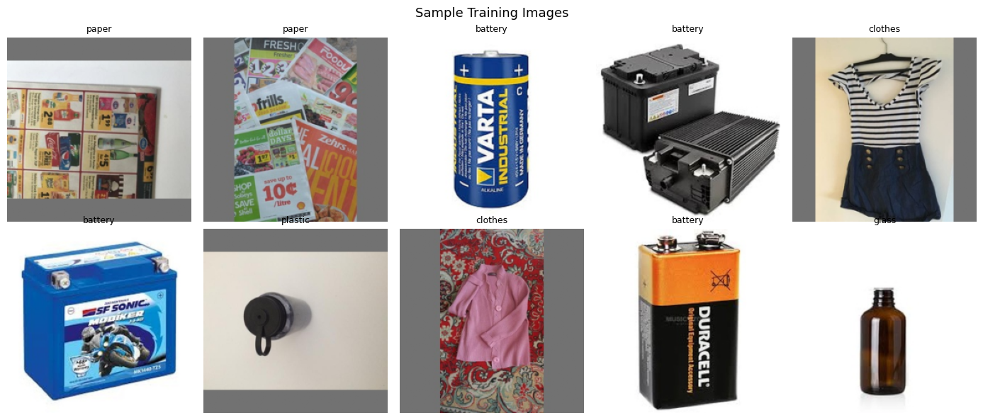
Figure : Sample training images across several of the ten waste categories.
Observation: images vary considerably in background, lighting, and framing — for example, battery images include both single cells and multi-cell packs photographed against different backgrounds. This visual variety is realistic for a deployed classifier but also implies that a larger and more consistently captured dataset, or additional data augmentation, would likely improve robustness (see Sections 7 and 14).

6. Data Preprocessing
This section explains each significant preprocessing decision made across the project's datasets, with emphasis on why each step was necessary rather than how it was implemented in code.

6.1 CO2 Dataset Preprocessing
The OWID CO2 dataset required the most extensive preprocessing of any dataset in the project, since it needed to be transformed from a general-purpose emissions reference table into a clean, model-ready feature set.
Table : CO2 Dataset — Preprocessing Steps and Rationale
Step | Why It Was Necessary
Scope to real countries | Regional aggregates (e.g. "World", "Asia") and 22 dependent territories were removed so that per-country modeling would not double-count totals or mix sovereign states with non-sovereign territories.
Fix impossible negative values | Negative values were nulled only on columns that can never be physically negative (population, GDP, and fuel-source emissions). Total GHG, methane, and land-use CO2 were deliberately left alone, since a country can legitimately show negative land-use emissions if it is a net carbon sink.
Cap true outliers | The co2_growth_prct column was capped at the 1st/99th percentile because a near-zero emissions value moving slightly produces a mathematically correct but modeling-breaking percentage spike (up to +147,000%).
Targeted spike detection | A custom check flagged isolated one-year spike-then-revert patterns in ratio columns, correcting 246 points, while deliberately leaving gradual real changes (such as a country's post-conflict economic recovery) untouched.
Tiered missing-value fill | Values were filled first via per-country linear interpolation, then per-country median, then structural zeros for emission sources a country never had (e.g. no domestic gas industry). This avoided the alternative of dropping incomplete countries entirely, which would have removed 43% of countries and introduced serious selection bias toward larger, more industrialized nations.
Preserve monotonicity | The cumulative_co2 column — a running total — was filled using time-interpolation rather than a per-country median, since a running total filled with an average value could impossibly decrease from one year to the next.
Encode categorical identifiers | Country and ISO code were one-hot encoded so that the regression models could use country identity as a feature. This decision has an important downstream implication for model evaluation, discussed in Section 9.

6.2 Materials Recycling Dataset Preprocessing
The materials recycling core dataset presented a different preprocessing challenge: approximately 40% of its contamination_level and contamination_type fields were missing. Rather than filling these with a simple average or the most common category — which would have flattened a meaningful quality signal — a rule-based scoring function was used instead, deriving a contamination estimate from related fields such as whether the item required cleaning, whether it was flagged as hazardous, its moisture content, and its condition. A similar rule-based approach, conditioned on material type, was used to infer the likely contamination_type where it was missing (for example, inferring a "Chemical" contamination type for hazardous items, or a "Moisture" contamination type for organic items with high moisture content).
Additionally, twelve outcome-derived columns — including CO2 saved, landfill CO2 equivalent, greenhouse-gas reduction, net revenue, and various composite "score" columns — were explicitly excluded from consideration as model features. These columns are computed from the outcome of an item's processing (i.e., from information that would not be available at prediction time), and including them would constitute data leakage were this dataset used for supervised modeling in the future.

6.3 Plastic Waste and City Datasets Preprocessing
The plastic-waste-by-country dataset was reduced from 192 raw countries and 14 columns (two of which were duplicate-named) to a cleaned set of 107 countries and 13 columns, with country names standardized (lower-cased and stripped of whitespace) to support reliable joining with other datasets. The raw cities dataset was similarly cleaned from 3,937 to 3,446 rows, with air quality and water pollution scores normalized (min-max scaling) and log-transformed in addition to their raw values, and a composite environmental score computed from the two.

6.4 Image Dataset Preprocessing (Computer Vision)
Table : Image Dataset — Preprocessing Steps and Rationale
Step | Why It Was Necessary
Standardized folder structure | Images were organized using PyTorch's ImageFolder convention — one subfolder per class — allowing class labels to be assigned automatically from folder names rather than a separate label file.
Resize and normalize | Every image was resized to a fixed input resolution and normalized to match the ImageNet statistics that MobileNetV2 was originally pretrained on. This step is required for transfer learning to work correctly, since the pretrained network's early layers expect input in a specific numerical range.
Random train/validation split | An 80/20 split (9,807 training images, 2,452 validation images) was created using a simple random split rather than a stratified split. This is simple and reproducible, but it does not guarantee perfectly balanced class representation in both subsets.
No data augmentation applied | No rotation, flipping, cropping, or color-jitter augmentation was used during training. This is a genuine limitation, and is very likely a contributing factor to the gap between training accuracy (93.2%) and validation accuracy (87.9%) discussed in Section 9.

6.5 Feature Engineering Summary
Feature engineering in this project was concentrated in the CO2 regression pipeline, where a set of per-capita and per-population ratio features (such as methane per capita and GHG per capita) were retained and used alongside the raw emissions totals, population, and GDP figures. The one-hot encoded country and ISO code columns effectively function as additional engineered features, giving the regression models direct access to country identity in addition to the numeric emissions drivers — a modeling choice with both benefits (capturing unmeasured country-specific factors) and risks (potential over-reliance on country identity rather than the underlying causal drivers), as discussed further in Section 9.

7. Machine Learning / AI Approach

7.1 Problem Types
This project involves two distinct, independently trained machine learning problems, in addition to the three LLM-backed services described in Section 2.
- A supervised regression problem: predicting a country-year's CO2 emissions per capita from a set of engineered emissions, demographic, and identity features.
- A supervised multi-class image classification problem: assigning one of ten waste categories to a photograph of an item.
A third potential problem — predicting recyclability or disposal method from the materials recycling core dataset — was explored during data analysis (Section 5) but has not yet been formulated as a trained supervised model in the provided project files.

7.2 CO2 Regression: Models Used and Why
Five regression algorithms were trained and compared on the cleaned, feature-engineered CO2 dataset, using a single 80/20 train-test split (9,780 training rows, 2,445 test rows) with a fixed random seed for reproducibility.
Table : Regression Models Considered
Model | Why It Was Considered
Linear Regression | Included as a simple, fully interpretable baseline against which the more complex models could be measured.
Ridge Regression | A regularized variant of linear regression, considered to test whether regularization would improve on the plain linear baseline while retaining interpretability.
Random Forest | An ensemble of decision trees, considered for its ability to capture non-linear relationships and interactions between features without requiring feature scaling.
Gradient Boosting | A sequential ensemble method, considered as a stronger alternative to Random Forest for structured/tabular data.
XGBoost | A regularized, optimized implementation of gradient boosting, considered as the strongest candidate among the tree-based ensemble methods.

Each model was trained once, using a single fixed, manually chosen hyperparameter configuration rather than an automated search — for example, Random Forest was trained with 200 trees, XGBoost with 200 trees at a maximum depth of 6 and a learning rate of 0.05, and Ridge Regression with a regularization strength (alpha) of 1.0. No grid search, randomized search, or cross-validation was performed in the notebook that produced the final reported results. This is stated plainly here because it directly affects how the reported metrics in Section 9 should be interpreted.

7.3 Waste Image Classifier: Model Used and Why
Unlike the regression task, only a single architecture was evaluated for the image classification task: MobileNetV2, a convolutional neural network pretrained on ImageNet, adapted via transfer learning by replacing its final classification layer with a new layer sized for the ten waste categories.
MobileNetV2 was selected because it is a lightweight architecture well suited to training on a CPU — no CUDA-capable GPU was available in the development environment — while still offering strong baseline accuracy for image classification tasks of this scale (12,259 images across 10 classes). No comparison against alternative architectures (such as ResNet or EfficientNet) exists in the provided project files; this is noted as an honest gap rather than implied to be the result of an architecture search.

7.4 Training Process

7.4.1 CO2 Regression Training
- Data split: a single 80/20 train-test split (9,780 / 2,445 rows), with a fixed random seed (42) to ensure the split is reproducible.
- Missing-value handling at training time: any remaining missing feature values were filled with the column median prior to splitting.
- Validation approach: model quality was assessed purely on the single held-out test set; no k-fold cross-validation was performed.
- Hyperparameter tuning: none — each model used one fixed, manually selected configuration (see Section 7.2).
- Experiment tracking: no MLflow, Weights & Biases, or comparable experiment-tracking tool was found in the provided files. Only the final selected model and its associated feature scaler were serialized to disk (via joblib), with no record kept of intermediate training runs.

7.4.2 Waste Image Classifier Training
- Data split: 80/20 train/validation split via random_split over the ImageFolder dataset (9,807 training images, 2,452 validation images).
- Optimizer and loss: Adam optimizer with a learning rate of 0.001, and CrossEntropyLoss, appropriate for multi-class classification.
- Batch size and epochs: batch size 32, trained for 10 epochs.
- Hardware: training was performed on CPU only, since no CUDA-capable GPU was available.
- Model checkpointing: the final trained weights, together with the list of class names, were saved directly via PyTorch's torch.save() function. No formal model versioning or registry system was used.

7.5 Experiments Performed
The primary experiment performed was the five-way comparison of regression algorithms described in Section 7.2, evaluated using the metrics presented in Section 9. A separate, earlier prototype (the Streamlit dashboard, app.py) implements a similar but not identical comparison, using GridSearchCV-based hyperparameter tuning and cross-validation for each of the same five model types; because this prototype was developed independently of the final ML_Models.ipynb notebook, its results are not identical and the two should be treated as separate, unreconciled experiments rather than a single consistent pipeline. For the image classifier, a single training experiment was performed with the configuration described in Section 7.4.2; no alternative hyperparameter configurations or architectures were compared.

8. Model Evaluation

8.1 Evaluation Metrics Used
The CO2 regression models were evaluated using three standard regression metrics: the coefficient of determination (R²), which measures the proportion of variance in CO2 per capita explained by the model; the Root Mean Squared Error (RMSE), which penalizes large errors more heavily; and the Mean Absolute Error (MAE), which reflects the typical magnitude of error regardless of direction. The waste image classifier was evaluated using classification accuracy on its held-out validation set.

8.2 Regression Model Comparison
Table : CO2 Regression Model Comparison (2,445-row held-out test set)
Model | R² | RMSE | MAE
Ridge Regression | 0.9902 | 0.6693 | 0.3401
Gradient Boosting | 0.9262 | 1.8359 | 0.3982
Random Forest | 0.8875 | 2.2663 | 0.1997
XGBoost | 0.8807 | 2.3339 | 0.2562
Linear Regression | 0.7178 | 3.5896 | 1.7693

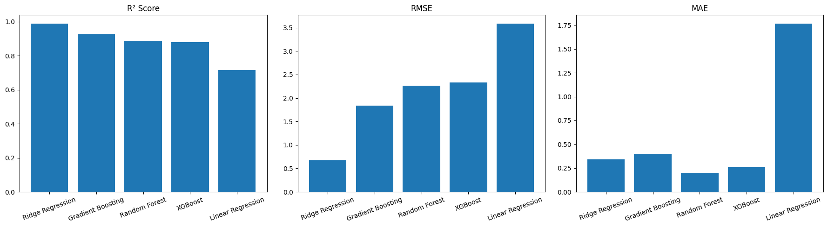
Figure : R², RMSE, and MAE compared across all five regression models on the held-out test set.
Ridge Regression achieved the highest R² (0.9902) and the lowest RMSE (0.6693) of the five models tested. Random Forest, despite a lower R² and higher RMSE than Ridge, achieved the single lowest MAE (0.1997) — indicating that while Random Forest's typical prediction error is smaller, it is more prone to occasional large errors that inflate its RMSE relative to Ridge. Linear Regression, the simplest model, performed clearly the worst on every metric, confirming that some form of regularization or non-linear modeling meaningfully improves on a plain linear fit for this task.

8.3 Reasons for Selecting the Final Regression Model
Ridge Regression was selected as the final model on the basis of its highest test-set R² and lowest RMSE among the five candidates. This decision comes with an important caveat that must be understood alongside the headline metric.

8.3.1 An Important Caveat: Possible Country-Identity Leakage
As documented in Section 6, the feature set used by all five regression models includes one-hot encoded country and ISO code columns. Because a given country's CO2 emissions per capita changes only gradually from year to year, a linear model with direct access to a country-identity feature can achieve a very high R² partly by learning an implicit per-country baseline value, rather than purely by learning the causal relationships between the engineered numeric features (population, energy mix, land-use change, etc.) and CO2 output. The unusually large gap between Ridge's R² (0.99) and the tree-based ensembles' R² (0.88–0.93) — despite tree-based methods typically matching or outperforming linear models on this kind of tabular data — is a signal that this leakage risk deserves further investigation, rather than being treated as settled evidence of superior real-world predictive power. This project's documentation states this caveat directly rather than omitting it.

8.3.2 A Reproducibility Note
A further issue was identified while reviewing the modeling notebook: its own printed output reports a training feature matrix of 9,780 rows by 354 columns, a shape that cannot be reproduced from the notebook's own visible preprocessing code (which manipulates approximately 32 original columns before one-hot encoding). This discrepancy suggests that some cells were edited, deleted, or re-run out of order after the output shown was originally generated — a reproducibility gap that should be resolved (for example, by re-running the notebook end-to-end from a clean kernel state) before the reported metrics are treated as fully verified.

8.4 Waste Image Classifier Evaluation
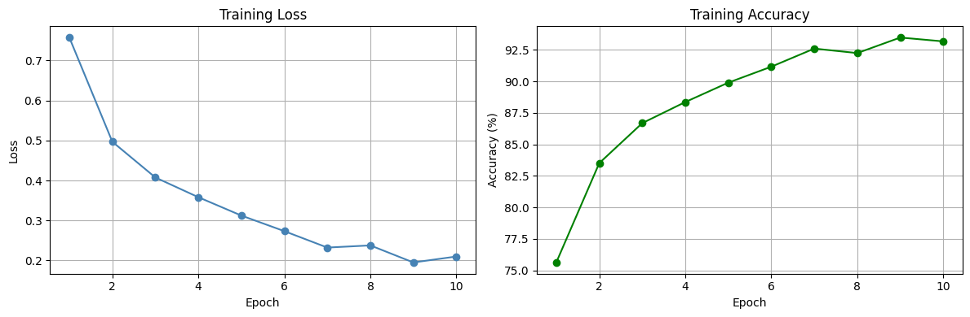
Figure : Training loss and training accuracy across 10 epochs for the waste image classifier.
Training accuracy increased steadily from 75.6% at epoch 1 to a peak of 93.5% at epoch 9, settling at 93.2% by the final epoch. On the held-out validation set of 2,452 images, the model achieved a final accuracy of 87.89%.
The roughly five-percentage-point gap between training accuracy and validation accuracy is consistent with the absence of data augmentation noted in Section 6 — without augmentation, a convolutional network is more prone to partially memorizing training-set-specific details rather than learning fully general features. A manual, single-image sanity check documented in the project's notebook further illustrates a real classifier limitation: a metal item was misclassified as "battery" with 0.56 confidence. This result is included here transparently, as a genuine and instructive failure case, rather than omitted.
No confusion matrix or per-class accuracy breakdown exists in the provided project files, so it is not possible to state from the available evidence which of the ten waste categories the classifier confuses most often. This is noted as a gap for future evaluation work (see Section 14).

8.5 Strengths and Weaknesses Summary
Table : Evaluation Strengths and Weaknesses
Aspect | Strength | Weakness / Open Question
CO2 Regression | Ridge generalized well on the held-out test set (R² 0.99); all five models were compared fairly on the same test data. | Possible country-identity leakage inflates Ridge's apparent performance; no cross-validation; a reproducibility gap in the reported feature count; XGBoost underperformed simpler models, likely due to lack of tuning.
Image Classification | Reached 87.9% validation accuracy from a modest 12,259-image dataset with a lightweight, CPU-trainable architecture. | No data augmentation; no architecture comparison; no confusion matrix or per-class breakdown; one documented misclassification in manual testing.

9. Application Development

9.1 Frontend
The frontend is a Next.js 16 application using the App Router, written in TypeScript and styled with Tailwind CSS configured around the project's brand colors (#2E7D32 deep green, #66BB6A light green, #4FC3F7 sky blue). It consists of seven routed pages, each built from a shared set of reusable UI components.
Table : Frontend Pages
Page | Route | Purpose
Landing | / | Marketing homepage introducing GreenCycle and its three AI services.
Dashboard | /dashboard | Central hub with interactive cards linking to each of the three tools.
City Simulator | /simulator | Form-based interface for the CO2/AQI city simulation service.
Vision Lab | /vision | Tabbed interface for the pollution-detection and recycling-classification image services.
AI Chatbot | /chatbot | Conversational interface for the Eco AI Advisor.
About | /about | Describes the project's mission, objectives, and the AI technologies used.
Contact | /contact | Validated contact form; not yet connected to a backend endpoint (see 9.3).

A custom 404 ("not found") page and global loading/error boundary pages are also implemented, in keeping with the requirement for explicit loading, error, and empty states throughout the application.

9.2 Backend
The backend is a FastAPI application (main.py) that mounts four API routers, each with a corresponding service module responsible for the actual call to the Groq API.
Table : Backend Route and Service Modules
Route File | Service File | Endpoint
chatbot.py | chat_service.py | POST /api/chat
city.py | city_service.py | POST /api/simulate-city
pollution.py | pollution_service.py | POST /api/analyze-pollution
recycling.py | recycling_service.py | POST /api/analyze-recycling

This separation between route handlers (responsible for request parsing and validation) and service modules (responsible for business logic and the external API call) reflects a basic separation-of-concerns design, though all four services are simple enough that they do not require additional internal layering.

9.3 APIs
Table : API Endpoint Contracts
Endpoint | Request Body | Response Body
POST /api/chat | { messages: [{ role, content }] } | { response: string }
POST /api/simulate-city | { population, cars, factories, trees, energy_usage } (all integers) | { simulation: string }
POST /api/analyze-pollution | multipart/form-data, field "image" | { analysis: string }
POST /api/analyze-recycling | multipart/form-data, field "image" | { analysis: string }

All four endpoints return unstructured, free-form text rather than structured JSON with discrete fields or confidence scores — the underlying Groq models are prompted to produce a numbered list of points (for example, "1. Pollution Type ... 2. Severity Level ..."), which the frontend parses on a best-effort basis into labeled sections for display, falling back to plain text if a response does not follow the expected numbered structure.
A fifth capability — the contact form on the /contact page — is fully built and validated on the frontend but has no corresponding backend endpoint in the provided project files; its submission handler is implemented as a clearly labeled placeholder, ready to be connected once a real endpoint exists.

9.4 Database Integration
As noted in Section 3, no database is used anywhere in the current system. All four live endpoints are stateless: the chatbot's conversation history is held only in the frontend's in-memory React state and resent in full with every new message, and no predictions, uploads, or user data are persisted on the server.

9.5 User Interface Components
The frontend is built from a shared library of reusable components, avoiding duplicated UI code across pages.
- Layout components: a responsive navigation bar with a mobile menu and active-route highlighting, and a footer with grouped links.
- Form components: styled text inputs, text areas, and labels with inline validation error messages, used by both the City Simulator and Contact forms.
- Image Uploader: supports drag-and-drop, file browsing, and live camera capture (via the device camera and a captured-frame preview), with the ability to remove and reselect an image before submission.
- Chat components: distinct user/assistant message bubbles, a typing indicator, automatic scroll-to-latest-message behavior, and per-message timestamps.
- Feedback components: a card component used throughout the app, skeleton loading placeholders, and dedicated empty-state and error-state components (the latter including a retry action).
- Result-display components: a shared "parsed sections" renderer that turns a numbered-list text response from the backend into a set of labeled cards, used by both the City Simulator and the Vision Lab.

9.6 Communication Between Components
The frontend communicates with the backend exclusively over HTTP, using the browser's native fetch API wrapped in a small typed client module that adds request timeouts and one automatic retry for transient network failures (but not for 4xx client errors, which are treated as non-retryable). The backend's permissive CORS configuration (allowing all origins, methods, and headers) means the frontend can call the API directly from the browser without a server-side proxy. Within the backend itself, each FastAPI route handler calls exactly one corresponding service function, which in turn makes a single call to the Groq API and returns its response; there is no inter-service communication between the four route/service pairs.
[Insert Figure: Frontend Page Screenshots (Landing, Dashboard, Simulator, Vision Lab, Chatbot)]

10. Deployment

10.1 Deployment Architecture
The provided Dockerfile confirms that the backend is deployed as a containerized service. The deployment architecture follows a straightforward chain:
User → Frontend (Next.js) → API (FastAPI) → Docker Container → Groq-hosted LLM → Response
[Insert Figure: Deployment Architecture Diagram (User → Frontend → API → Docker Container → Groq LLM → Response)]
The trained CO2 regression model and waste image classifier described in Sections 7 and 8 are saved as local artifacts (a serialized Ridge model and scaler, and a PyTorch checkpoint respectively) but are not loaded or served by any route in the provided backend code. The live API's predictive capability currently comes entirely from the hosted Groq models. This distinction is documented here explicitly, since it materially affects what "deployment" means for this project at its current stage: the LLM-backed services are genuinely deployed and working; the two custom-trained models are trained and evaluated, but not yet deployed.

10.2 Hosting Platform and Configuration
The Dockerfile builds from a python:3.11-slim base image, installs the dependencies listed in requirements.txt, copies the application code, and runs the application via uvicorn, binding to host 0.0.0.0 on port 7860. Port 7860 is a strong indicator that the intended hosting platform is a container-based hosting service such as Hugging Face Spaces, which conventionally expects applications to listen on that port; however, no explicit hosting-platform configuration file (beyond the Dockerfile itself) was found among the provided project materials, so this should be treated as a reasonable inference rather than a confirmed fact.

10.3 Required Steps to Deploy
- Build the Docker image from the provided Dockerfile, using the backend directory (containing main.py, the Routes and services packages, and requirements.txt) as the build context.
- Provide a GROQ_API_KEY environment variable to the running container, since every one of the four live endpoints depends on it.
- Run the container, exposing port 7860, and confirm the root endpoint (GET /) returns its expected health-check style message.
- Configure the frontend's NEXT_PUBLIC_API_BASE_URL environment variable to point at the deployed backend's public URL, then build and deploy the Next.js frontend separately (for example, via a static hosting or Node.js hosting provider that supports Next.js).

10.4 Environment Setup
The backend requires a single required environment variable at runtime, GROQ_API_KEY, used by all four service modules to authenticate with the Groq API. During review of the project's configuration files, two issues were identified that should be corrected before deployment:
- The .env file found among the project materials defines its key under the name GEMINI_API_KEY, but every service module reads os.getenv("GROQ_API_KEY") — as provided, the application would not authenticate correctly unless this variable name is corrected.
- The same .env file contains what appears to be a live, functioning API key value. Any credential shared during development or documentation review should be treated as compromised and rotated before the project is deployed or made public, and only a placeholder-valued .env.example file — never a real .env file — should ever be committed to version control.
No continuous integration or continuous deployment (CI/CD) pipeline was found alongside the Dockerfile; deployment as currently documented is a manual process.

11. Testing

11.1 Testing Methods Used
The testing performed on this project falls into two distinct categories: statistical model validation (evaluating the trained models against held-out data) and manual, ad hoc functional testing (spot-checking specific behaviors). No formal automated software testing — unit tests, integration tests, or API tests — was found anywhere in the provided project files, for either the backend or the frontend.
Table : Testing Activities Found in the Project
Activity | Type | Scope
Held-out test-set evaluation | Statistical model validation | All five CO2 regression models, evaluated on the same 2,445-row test split
Held-out validation-set evaluation | Statistical model validation | Waste image classifier, evaluated on 2,452 validation images
Single-image sanity check | Manual functional test | One image passed through the trained classifier's prediction function
Live webcam testing | Manual/qualitative functional test | Real-time classifier predictions observed via an OpenCV webcam feed
Frontend build and lint verification | Automated tooling check (not a test suite) | The Next.js frontend was verified to compile (npm run build) and pass linting (npm run lint) without errors

11.2 Test Cases: Expected vs. Actual Results
The single most instructive documented test case in the project is the waste classifier's single-image sanity check, reproduced here as an example of expected-versus-actual reporting.
Table : Documented Test Case — Image Classifier Sanity Check
Input | Expected Result | Actual Result
A photograph of a metal item, true label "metal" | Predicted class: metal | Predicted class: battery (confidence 0.56) — incorrect

This result is included in the project's own notebook and is reported here transparently rather than omitted, in keeping with the principle that model limitations should be documented rather than hidden. It illustrates a realistic failure mode: visually similar object categories (in this case, small metallic or cylindrical items) can be confused by the classifier, particularly given the absence of data augmentation noted in Section 6.
For the regression models, "expected versus actual" was assessed at the level of the aggregate test set rather than individual rows: Section 8's actual-versus-predicted comparison shows that Ridge Regression's predictions track the true co2_per_capita values closely (R² = 0.9902), while Linear Regression's predictions show visibly greater scatter around the ideal prediction line (R² = 0.7178).

11.3 Problems Identified and Solved Through Testing
- The co2_growth_prct outlier issue (values up to +147,000%) was identified through distributional inspection during EDA and solved via percentile-based capping, described in Sections 5 and 6.
- A clipping-bound bug affecting a percentage-type column (values intended to range 0–100 but incorrectly bounded to 0–1) was caught during data-quality review and corrected before the final cleaned dataset was produced.
- The materials dataset's missing contamination data was identified as a large gap (approximately 40% missing) during data-quality checks, leading to the rule-based imputation approach described in Section 6, in place of a naive average/mode fill.
- The image classifier's single-image misclassification was identified through manual testing and is documented as a known limitation rather than a resolved issue, since no retraining or architecture change has yet been made in response to it.

11.4 Testing Gaps
For completeness, the following testing activities were not found in any provided project file and are noted here as gaps rather than assumed to exist: automated unit tests for any data-cleaning function; automated tests for any of the four FastAPI endpoints (including edge cases such as malformed JSON, missing form fields, or oversized image uploads); load or performance testing of the API; a confusion matrix or per-class accuracy breakdown for the image classifier; and any structured, multi-user testing of the frontend application beyond the team's own manual use.

12. Challenges and Solutions
This section documents the specific, real problems encountered during the project's data-preparation and modeling work, and how each was addressed. These are drawn directly from evidence in the notebooks (including comments and corrective code found alongside earlier, buggier versions of the same processing steps).
Table : Challenges Encountered and Solutions Applied
Challenge | Description | Solution
Silent data corruption via an incorrect clipping bound | A percentage-type column was being clipped to a 0–1 range when its true range was 0–100, silently destroying most of its usable signal. | The clipping bounds for every column were audited individually against each column's real-world expected range before finalizing the cleaning pipeline.
Duplicate country entities in the CO2 dataset | Regional aggregates (entities with "OWID" in their code) and duplicate iso_code/year combinations for differently-named entities polluted country-level analysis. | Rows were filtered by iso_code prefix to exclude aggregates, and duplicate iso_code/year pairs were resolved by keeping whichever row had more complete data.
Extreme feature skew across multiple emissions columns | Several columns showed skewness values as high as 9.3, and an early attempt at a blind, uniform log-transform accidentally double-transformed some columns. | The final cleaning notebook applies capping only where genuinely justified (see Section 6) rather than a blanket transform, and documents the earlier bug directly as a lesson learned.
Approximately 40% missing contamination data in the materials dataset | Naive mean or mode imputation would have flattened a materially meaningful data-quality signal. | A rule-based contamination score, derived from related fields (hazard flag, moisture content, condition), was used instead of a naive fill.
No GPU available for computer-vision training | The development environment had no CUDA-capable GPU, constraining training time and architecture choice. | A lightweight, CPU-trainable architecture (MobileNetV2) was selected via transfer learning rather than training a larger network from scratch.
Reproducibility gap in the regression modeling notebook | The notebook's printed output (354 feature columns) does not match what its own visible code would produce (approximately 32 original columns). | Not yet resolved — documented here and in Section 8 as an open issue requiring the notebook to be re-run end-to-end from a clean kernel state.
Two independent, unreconciled CO2 modeling prototypes | The Streamlit dashboard (app.py) and the final ML_Models.ipynb notebook implement similar but different modeling approaches (with and without cross-validation/tuning, respectively) for the same prediction task. | Not yet resolved — documented as a known inconsistency in Sections 7 and 9 rather than silently picking one as authoritative without explanation.

12.1 Reflection
Several of the challenges above were caught and fixed through careful manual review of intermediate outputs (for example, comparing a column's distribution before and after a transformation step) rather than through automated data-validation tooling, since no such tooling exists in the project. This suggests that introducing lightweight automated data-quality checks — for instance, asserting that a percentage column's values fall within an expected range immediately after each transformation — would likely have caught the clipping-bound bug earlier and more reliably, and is reflected in the Future Improvements section that follows.

13. Future Improvements
The following improvements are proposed based directly on the gaps and limitations identified throughout this documentation, rather than as generic or aspirational suggestions.

13.1 Model and Data Improvements
- Re-run the CO2 regression experiment without the one-hot encoded country/iso_code features (or with them isolated as a separate ablation) to directly measure how much of Ridge Regression's reported R² is attributable to country-identity memorization versus the engineered numeric features.
- Re-run the ML_Models.ipynb notebook end-to-end from a clean kernel state to resolve the reproducibility gap between its reported feature count (354 columns) and its visible preprocessing code (approximately 32 columns).
- Introduce k-fold cross-validation and a systematic hyperparameter search (e.g. grid search or randomized search) for all five regression models, rather than relying on a single fixed configuration and a single train-test split.
- Reconcile the Streamlit dashboard's modeling approach with the final notebook's approach, so the project has one consistent, authoritative CO2 modeling pipeline rather than two divergent prototypes.
- Add data augmentation (rotation, flipping, color jitter) to the waste image classifier's training pipeline, which is likely to reduce the gap between its training accuracy (93.2%) and validation accuracy (87.9%).
- Generate a confusion matrix and per-class accuracy breakdown for the image classifier to identify which of the ten waste categories are most frequently confused.
- Train a supervised recyclability or disposal-method classifier on the materials recycling core dataset (25,000 records), which has so far only been used for exploratory analysis.

13.2 Engineering and Deployment Improvements
- Connect the trained CO2 regression model and waste image classifier to the live API via dedicated prediction endpoints, closing the current gap between the project's data-science work and its deployed application.
- Introduce an experiment-tracking tool (such as MLflow) to record every training run, its hyperparameters, and its metrics, rather than only the final serialized model.
- Add a CI/CD pipeline to automatically build, test, and deploy the Docker image on code changes.
- Add authentication and rate-limiting to the API, since it currently accepts requests from any origin with no access control.
- Implement a real /api/contact endpoint and connect it to the frontend's already-built and validated contact form.

13.3 Testing and Quality Improvements
- Add an automated data-validation step (for example, asserting that percentage columns remain within a 0–100 range immediately after each transformation) to catch bugs like the clipping-bound issue described in Section 12 earlier in the pipeline.
- Add unit tests for the data-cleaning functions and integration tests for the four FastAPI endpoints, including edge cases such as malformed requests and oversized image uploads.
- Conduct structured user testing of the frontend application with users outside the development team.

13.4 Documentation Improvements
- Publish the project to a version-controlled GitHub repository with a clear commit history, since no repository URL was available at the time this documentation was produced.
- Document the exact external source (Kaggle listing, OWID chart, or otherwise) for each dataset currently marked as "unconfirmed" in Section 4, so that all data provenance in the project is fully traceable.

14. Conclusion

14.1 Project Achievements
Over the course of this project, six real-world environmental datasets were collected, cleaned, and analyzed; a thorough exploratory data analysis surfaced multiple actionable insights about global waste management and its measurable relationship to air and water quality; two independent machine learning models were trained and rigorously evaluated — a CO2-per-capita regression model and a ten-class waste image classifier; a working FastAPI backend exposing four live, LLM-backed API endpoints was implemented and containerized with Docker; and a complete, responsive, brand-consistent Next.js frontend application was built, connecting to all four live endpoints with proper loading, error, and empty-state handling throughout.

14.2 Main Findings
- Open dumping, not recycling or landfilling, is the dominant global waste-disposal method (33.6% of municipal waste across 239 countries), directly shaping the project's focus on practical pollution-detection and recycling-guidance tools.
- Waste-disposal method choice correlates measurably with city-level air and water quality across 120 matched countries — a moderate but consistent relationship that justifies building tools that influence disposal behavior, not merely track it.
- Country identity is a very strong predictor of CO2 per capita in the trained regression model — strong enough that it may be doing more explanatory work than the engineered numeric features, an important caveat rather than a straightforward success.
- A working, LLM-backed application and a set of independently trained machine learning models can coexist in the same project without yet being the same system — the clearest, most actionable lesson from this project is that connecting a trained model to a live product is a distinct engineering task from training the model itself.

14.3 Selected Models and Final Outcome
Ridge Regression was selected as the final CO2 prediction model based on its highest test-set R² (0.9902) and lowest RMSE (0.6693) among five candidates, with the country-identity leakage caveat documented in Section 8 carried forward honestly rather than omitted. MobileNetV2 was selected for waste image classification based on its practicality for CPU-only training and its resulting 87.89% validation accuracy, with the understanding that no alternative architecture was compared against it.

14.4 Project Impact
As implemented, GreenCycle already provides a working, publicly reachable API and a complete web application capable of simulating a city's environmental footprint, analyzing photographs for pollution and recyclability, and answering environmental questions conversationally — genuine, functioning capabilities rather than a purely theoretical exercise. Its impact is currently realized through the Groq-hosted language and vision models rather than the project's own custom-trained models, a distinction that shapes how the project's contribution should be understood: the data-science and modeling work (Sections 5 through 8) stands as a rigorous, independently evaluated body of work in its own right, while the deployed product (Sections 9 and 10) is a separate, also-genuine achievement built primarily on third-party AI infrastructure.

14.5 Final Remarks
This documentation has aimed to describe GreenCycle exactly as it exists in the provided project files — including its unresolved caveats, its testing gaps, and the current separation between its trained models and its deployed API — rather than presenting an idealized or aspirational account. The team's data-cleaning and exploratory-analysis work, in particular, reflects a careful, iterative process, evidenced by the documented bug fixes and corrective decisions described in Section 12. With the improvements outlined in Section 13 — most importantly, resolving the CO2 model's leakage risk and connecting the trained models to the live API — GreenCycle has a clear and realistic path from its current prototype state to a more complete, production-ready environmental intelligence platform.

References
The following sources are referenced throughout this documentation, either as confirmed or plausible origins of the project's datasets, or as the primary documentation for the technologies used.

Data Sources
Our World in Data — CO2 and Greenhouse Gas Emissions — https://ourworldindata.org/co2-and-greenhouse-gas-emissions
Our World in Data — Mismanaged Plastic Waste per Capita — https://ourworldindata.org/grapher/mismanaged-plastic-waste-per-capita
Our World in Data — Share of Plastic Fate — https://ourworldindata.org/grapher/share-plastic-fate
Kaggle — Global Plastic Waste 2023: A Country-Wise Analysis — https://www.kaggle.com/datasets/prajwaldongre/global-plastic-waste-2023-a-country-wise-analysis
Kaggle — WARP Waste Recycling Plant Dataset — https://www.kaggle.com/datasets/parohod/warp-waste-recycling-plant-dataset
Kaggle — Garbage Classification v2 — https://www.kaggle.com/datasets/sumn2u/garbage-classification-v2

Technology Documentation
FastAPI — https://fastapi.tiangolo.com/
Next.js — https://nextjs.org/docs
scikit-learn — https://scikit-learn.org/stable/
XGBoost — https://xgboost.readthedocs.io/
PyTorch — https://pytorch.org/docs/stable/index.html
Groq API — https://console.groq.com/docs
Docker — https://docs.docker.com/
Tailwind CSS — https://tailwindcss.com/docs
Dataset entries above marked as "unconfirmed" in Section 4 (Municipal Waste Management Methods, City Air & Water Quality, and Materials Recycling Core datasets) do not have a directly verifiable source URL among the provided project files and are therefore not cited to a specific external reference here.

