Requirements Gathering
Customer Intelligence & Retention Platform (CIRP)

Project | Customer Churn Prediction & Segmentation Platform (CIRP)
Track | DEPI - AI & Machine Learning
Project Leader | Mohamed Atef Mohamed Abdo
Version / Date | v1.0 - October 2026
Priority scale | Must = required for the final delivery; Should = important, include if time allows; Could = optional extension

1. Introduction
This document lists what CIRP must do and for whom. The requirements come from the project brief (churn prediction and customer segmentation), the data analysis already done by the data team, the literature review, and discussions inside the team. The platform has three parts: a data package, two machine learning models (churn prediction and segmentation) and a Streamlit application used by a marketing team.

Key terms
- Churn: a customer makes no order in the 90 days after the snapshot date.
- Snapshot: the state of a customer at one quarterly date (5 snapshots from Sep 2010 to Sep 2011).
- Segment: a group of customers with similar behavior, with a business name and description.
- Churn risk: the predicted probability of churn and its level (High / Medium / Low).

2. Stakeholder Analysis
Stakeholder | Description | Needs and expectations | Influence | Interest
Marketing specialists | Primary users of the app; design offers and campaigns. | See who may leave and why; understand each segment in plain language; get a list of customers to contact. | Medium | High
Retention / CRM manager | Decides retention actions and budget. | Prioritized list of at-risk customers; churn rate per segment; trust in the model results. | High | High
Business management | Sponsors the use of the platform. | Reduced churn and better use of marketing budget; simple summary of results. | High | Medium
Data & Preprocess team | Prepares the data package. | Clear data contract; models and app use the data as documented. | Medium | High
Model Training team | Builds the churn and segmentation models. | Clean, leakage-free data; clear evaluation protocol; a defined output format for the app. | Medium | High
Application team | Builds the Streamlit app and the integration. | Saved models, feature list and preprocessor; a stable interface; sample data for testing. | Medium | High
DEPI lecturers / evaluators | Assess the project. | Complete documents, working code in GitHub, reproducible results, a clear final presentation. | High | High
Customers (indirect) | People described by the data. | Privacy respected; offers relevant to them. | Low | Low

3. User Stories & Use Cases

3.1 User stories
ID | User story | Acceptance criteria | Priority
US-01 | As a marketing specialist, I want to see the churn risk of a customer, so that I can decide whether to contact him/her. | After choosing a customer, the app shows the churn probability and a risk level (High / Medium / Low). | Must
US-02 | As a marketing specialist, I want to see the main reasons behind a customer's churn risk, so that I can choose a suitable message. | The app shows the top factors for that customer in plain words (for example "has not bought for a long time"). | Must
US-03 | As a marketing specialist, I want to know the segment of a customer with a clear description, so that I can adapt the offer. | The app shows the segment name, a short description and a suggested action. | Must
US-04 | As a retention manager, I want an overview of all segments, so that I can prioritize my actions. | A page shows, for each segment: size, average recency / frequency / monetary value and churn rate. | Should
US-05 | As a retention manager, I want to upload a file of customers and get results for all of them, so that I can work on a full list. | A CSV with the required columns is scored; the results table can be downloaded. | Should
US-06 | As a retention manager, I want to filter customers by segment and risk level, so that I can build a target list. | Filters by segment and risk level update the table; the filtered list can be exported. | Could
US-07 | As a user, I want clear messages when my input is wrong, so that I can fix it. | Missing or invalid values produce a readable message and the app does not crash. | Must
US-08 | As a model engineer, I want a documented dataset with train / validation / test files, so that experiments are comparable. | Data package with a data dictionary, a time-based split and a saved preprocessor is available in the repository. | Must
US-09 | As a model engineer, I want to compare several algorithms with the same metrics, so that I can choose the best one. | A table compares the algorithms on Precision, Recall, F1 and ROC-AUC / PR-AUC; experiments are tracked. | Must
US-10 | As an app developer, I want a fixed interface for the models, so that I can integrate them without guessing. | A document lists the feature names and order, the model files and the output format. | Must
US-11 | As a lecturer, I want to run the project from GitHub with a README, so that I can verify the results. | Following the README on a fresh clone installs the libraries and runs the notebooks and the app. | Must

3.2 Use case diagram
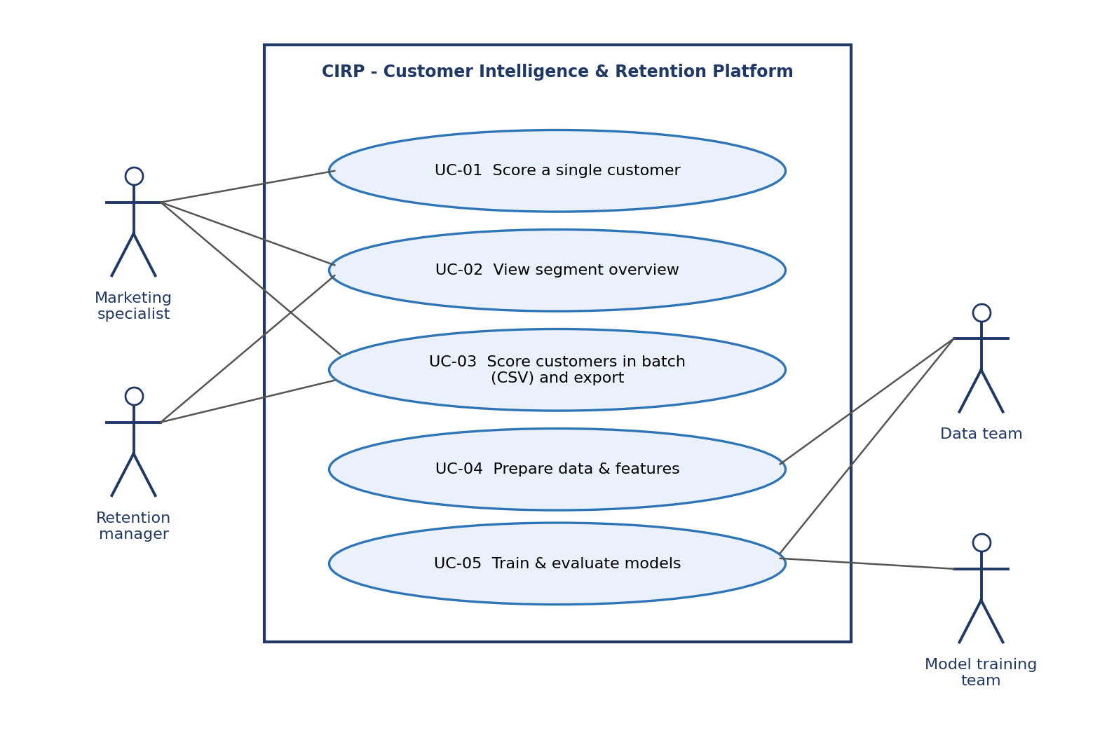
Figure 1: CIRP use cases and actors

3.3 Use case descriptions
UC-01 | Score a single customer
Actor | Marketing specialist (also retention manager)
Goal | Know the churn risk, the reasons and the segment of one customer.
Preconditions | The app is running; the trained models and the preprocessor are available.
Main flow | 1. The user opens the "Customer" page.  2. The user selects a customer ID from the provided data, or enters the feature values.  3. The app validates the input.  4. The app applies the same preprocessing as in training.  5. The app shows the churn probability and risk level, the top factors, and the segment with its description and suggested action.
Alternative flow | Invalid or missing values (step 3): the app shows a message and asks the user to correct them.
Postcondition | The result is displayed; nothing is stored.

UC-02 | View segment overview
Actor | Marketing specialist, retention manager
Goal | Understand the customer groups and compare their churn.
Preconditions | Segment profiles are available (from the segmentation model).
Main flow | 1. The user opens the "Segments" page.  2. The app shows each segment with its name, size, average recency / frequency / monetary value and churn rate.  3. The user selects a segment to read its description and suggested action.
Postcondition | The user knows which segments need attention first.

UC-03 | Score customers in batch and export
Actor | Retention manager
Goal | Get churn risk and segment for a list of customers.
Preconditions | A CSV file with the required columns (see the data dictionary).
Main flow | 1. The user uploads the CSV file.  2. The app checks the columns and values.  3. The app scores all rows and shows a results table.  4. The user filters by segment or risk level and downloads the result.
Alternative flow | Wrong or missing columns (step 2): the app lists the problem and does not score the file.
Postcondition | A results file is available to the user; the uploaded data is not kept.

UC-04 / UC-05 | Prepare data; train and evaluate models (offline)
Actors | Data & Preprocess team; Model Training team
Goal | Produce the data package, then the saved models and their evaluation.
Main flow | 1. The data team cleans the transactions, builds the features, splits the data by time, scales it and selects features.  2. The model team trains and compares the algorithms on train and validation data, chooses the threshold, and evaluates once on test data.  3. The model team clusters the customers, profiles and names the segments.  4. The final models and the feature list are saved for the app.
Postcondition | Data package, evaluation tables and saved models are available in the repository.

4. Functional Requirements

Data
ID | Requirement | Priority | Source
FR-D1 | Provide a cleaned customer-level dataset (22 features, 5 quarterly snapshots) with the churn label. | Must | US-08
FR-D2 | Split the data by time into train, validation and test sets, and provide a full-train set (train + validation). | Must | US-08, US-09
FR-D3 | Provide scaled versions of the sets and the saved preprocessor (fitted on train only). | Must | US-08, US-10
FR-D4 | Provide one row per customer for segmentation. | Must | US-03
FR-D5 | Provide a data dictionary and an EDA report. | Should | US-08
FR-D6 | Provide a feature selection result (selected and dropped features, with the reason). | Should | US-09

Churn prediction model
ID | Requirement | Priority | Source
FR-P1 | Train and compare at least three classifiers (Logistic Regression, Decision Tree, SVM). | Must | US-09
FR-P2 | Evaluate with Precision, Recall, F1, ROC-AUC and PR-AUC on validation and test data. | Must | US-09
FR-P3 | Choose the decision threshold on the validation set and document it. | Must | US-01
FR-P4 | Output a churn probability and a risk level for each customer. | Must | US-01
FR-P5 | Explain predictions: top factors per customer and global feature importance. | Must | US-02
FR-P6 | Save the final model and the ordered feature list. | Must | US-10
FR-P7 | Track experiments (parameters, metrics, models) with MLflow. | Should | US-09

Segmentation model
ID | Requirement | Priority | Source
FR-S1 | Cluster customers with K-Means and DBSCAN and compare them. | Must | US-03
FR-S2 | Evaluate clusters with Silhouette, Davies-Bouldin and an elbow plot. | Must | US-03
FR-S3 | Apply a log transform and scaling to the skewed features before clustering. | Must | US-03
FR-S4 | Profile every segment (size, mean recency / frequency / monetary value, churn rate) and give it a business name, description and suggested action. | Must | US-03, US-04
FR-S5 | Assign a segment to a new customer using the saved scaler and model. | Must | US-03
FR-S6 | Mark points that DBSCAN treats as noise as "Unclassified" (if DBSCAN is selected). | Could | US-03

Application (Streamlit)
ID | Requirement | Priority | Source
FR-A1 | Let the user select a customer from the provided data or enter feature values manually. | Must | US-01
FR-A2 | Show churn probability, risk level and top factors. | Must | US-01, US-02
FR-A3 | Show the segment name, description and suggested action. | Must | US-03
FR-A4 | Show a segment overview page with size, averages and churn rate per segment (tables and charts). | Should | US-04
FR-A5 | Allow CSV upload for batch scoring and download of the results. | Should | US-05
FR-A6 | Filter results by segment and risk level and export the list. | Could | US-06
FR-A7 | Validate inputs and show clear error messages. | Must | US-07

Integration
ID | Requirement | Priority | Source
FR-I1 | Load the saved models and the preprocessor at startup and apply exactly the same preprocessing as in training. | Must | US-10
FR-I2 | Document the interface: feature names and order, data types and the output format of each model. | Must | US-10
FR-I3 | Run locally with documented commands in the README. | Must | US-11
FR-I4 | Cloud deployment (for example Azure): decision pending; not required for the final delivery. | Could | Open decision

5. Non-Functional Requirements
Numeric targets are proposed and will be confirmed after the first measurements on the team's machines.
ID | Category | Requirement
NFR-1 | Performance | Scoring one customer takes 2 seconds or less; scoring 5,253 customers in batch takes 30 seconds or less; the app starts in 10 seconds or less (local run).
NFR-2 | Model quality | The final churn model reaches the targets in the Project Planning document (for example Recall >= 0.80 and ROC-AUC >= 0.80 on the test set); segments reach Silhouette >= 0.30.
NFR-3 | Reliability | Experiments are reproducible (fixed random seeds, pinned library versions); invalid input never crashes the app.
NFR-4 | Data integrity | No data leakage: split by time; scalers, clustering and feature selection are fitted on training data only; the test set is used once.
NFR-5 | Security & privacy | Only the public, anonymized dataset is used (customer numbers only); uploaded files are not stored; no passwords or keys in the repository; raw data is excluded from GitHub.
NFR-6 | Usability | A user who did not build the app can find a high-risk customer and read the segment in 3 minutes or less; labels are in plain business language; the interface is in English.
NFR-7 | Explainability | Explanations are given in words that marketing can understand, not only technical feature names.
NFR-8 | Maintainability | The repository follows the agreed structure (data, notebooks, src, models, reports, app, docs, tests); code is commented; changes go through pull requests.
NFR-9 | Portability | Runs on Windows, macOS and Linux with one agreed Python version and the versions in requirements.txt (scikit-learn 1.9.0).
NFR-10 | Scalability | Designed for the current dataset (5,253 customers). Larger data and cloud scaling are outside the current scope.

6. Constraints, Assumptions and Open Decisions

Constraints
- Fixed DEPI dates: system analysis & design 6 Nov, implementation 30 Nov, final presentation 4 Dec 2026.
- Team of six students; no paid services; the application uses Streamlit and runs locally.
- Only the Online Retail II dataset is available; it has no product categories and no price before discount.

Assumptions
- The 90-day rule is an acceptable definition of churn for this retailer.
- The latest snapshot (9 Sep 2011) represents the current state of each customer for segmentation.
- Marketing users have no machine learning background.

Open decisions
- Cloud deployment: decision pending. The platform runs locally for now.
- Final algorithms and number of segments: to be decided after the experiments.
- Exact app pages and layout: to be confirmed in the system analysis & design phase (by the Application team).

