D E P I G R A D U A T I O N P R O J E C T
Project Planning and
Management
Aerial Image Change Detection with a Siamese U-Net on LEVIR-CD+
Digital Egypt Pioneers Initiative (DEPI) - AI Track
Milestone 1 of 6 - Project Planning & Management
Project Team Members:
• Ahmed Refaat Abd-Elmotelb (Lead ML Engineer & Pipeline Architect)
• Ahmed Reda Mohamed (Deep Learning Specialist & Loss Optimization)
• Raeed Youssef Mahfouz (Data Systems & Augmentation Specialist)
• Ahmed Mohamed Qotb (Evaluation Metrics & Quality Assurance Lead)
Academic / Technical Track: AWS Machine Learning
Submission Date: October 2026

Digital Egypt Pioneers Initiative - AI Track Milestone 1

Table of Contents
1. Project Overview and Team Identification 1
2. Objectives and Success Criteria 1
3. Project Scope 2
3.1 In Scope 2
3.2 Out of Scope 3
4. Deliverables and Milestone Schedule 3
5. Project Timeline and Work Breakdown Structure (WBS) 3
6. Risk Management and Mitigations 4
7. Development Environment and Toolchain 4
8. Project Governance and Team Roles 5

Note: this Table of Contents is generated via field codes. After editing the document, right-click the TOC and choose Update Field to refresh page numbers.

1. Project Overview and Team Identification
This project develops a complete deep-learning system for bi-temporal aerial image change detection: given two co-registered aerial images of the same geographic area acquired at different dates (time-1 and time-2), the system outputs a pixel-level binary change mask that isolates significant changes - predominantly building construction and demolition. The system is trained and benchmarked on LEVIR-CD+, a public benchmark comprising 985 pairs of 1024 x 1024 high-resolution (0.5 m/pixel) RGB aerial images with verified ground-truth change masks.
The project encompasses the complete engineering and machine learning lifecycle: automated dataset discovery, strict zero-leakage data partitioning respecting official train and test scenes, design and training of a Siamese U-Net from scratch, hybrid differential fusion (diff_cat), class-imbalance loss engineering (BCE + Soft Dice with pos_weight=10.0), Test-Time Augmentation (TTA), multi-model ensemble blending, an interactive Web Application Studio (app.py), and auditable documentation.
Project Team Identification & Roles
# | Team Member Name | Specialized Role & Key Responsibilities
1 | Ahmed Refaat Abd-Elmotelb | Lead ML Engineer & Pipeline Architect: Siamese U-Net implementation, zero-leakage split enforcement, dual-model ensemble blending, and TTA pipeline.
2 | Ahmed Reda Mohamed | Deep Learning Specialist & Loss Design: Differential feature fusion (diff_cat), BCE + Soft Dice loss weighting (pos_weight=10.0), and gradient stabilization.
3 | Raeed Youssef Mahfouz | Data Systems & Augmentation Engineer: Automated dataset discovery, synchronized dihedral geometric augmentation, and memory-safe evaluation tiling.
4 | Ahmed Mohamed Qotb | Evaluation Metrics & QA Lead: Confusion matrix accumulation, validation threshold calibration, error mapping (TP/FP/FN), and diagnostics.

2. Objectives and Success Criteria
The overarching objective is to establish an evidence-backed, fully reproducible, and leak-free change detection pipeline achieving state-of-the-art accuracy on single-GPU hardware without artificial inflation:
- Zero-Leakage Data Partitioning: Strictly maintain official LEVIR-CD+ split boundaries (525 Train / 112 Validation / 348 Test). Create validation strictly from train samples; never allow test samples into model selection, loss calibration, or threshold tuning.
- Siamese U-Net Architecture: Implement a weight-sharing dual-encoder backbone with multi-scale feature comparison, supporting both classic concatenation and hybrid differential fusion (diff_cat).
- Imbalance-Robust Loss Optimization: Address the severe 95.7% unchanged pixel dominance using a combined BCEWithLogits + Soft Dice loss with positive class weighting (pos_weight = 10.0).
- Multi-Model Ensembling & TTA: Combine diverse model representations (baseline concat + differential diff_cat) with 4-fold dihedral Test-Time Augmentation (TTA) to maximize precision on boundary pixels.
- Interactive Web Application Studio: Deploy a standalone, lightweight web interface (app.py) enabling live bi-temporal inference, visual overlays, threshold adjustment, and error heatmap analysis.
- Scientific Integrity & Reproducibility: Guarantee end-to-end auditability with deterministic evaluation tiles, confusion matrix aggregation, versioned checkpoints, and automated metric extraction.
Table 1 - Success criteria and executed results
# | Criterion | Target | Executed Result
S1 | Dataset Triplet Matching | 100% (985/985 matched) | 985 / 985 matched, 0 corrupted
S2 | Split Integrity & Zero Leakage | 0 cross-split overlap | 0 shared scene stems (525 Tr / 112 Val / 348 Te)
S3 | Convergence Stability | Monotone val IoU trend | Trained smoothly without divergence
S4 | Test Set Recall (Change Class) | >= 0.75 | 0.7850 achieved via SOTA Ensemble
S5 | Test Set F1-Score (Change Class) | >= 0.75 | 0.7982 achieved via SOTA Ensemble
S6 | Test Set IoU (Change Class) | >= 0.60 | 0.6642 achieved via SOTA Ensemble
S7 | Interactive Deployment | Working Web Studio | app.py running on localhost:5000

3. Project Scope

3.1 In Scope
- Binary pixel-level change detection on LEVIR-CD+ aerial benchmarks.
- Automatic directory discovery, file stem matching, and data integrity verification.
- Strict split partitioning preventing data leakage across train, val, and test.
- Siamese U-Net neural network with both concatenation and diff_cat fusion variants.
- Class imbalance mitigation via BCE + Soft Dice loss with pos_weight = 10.0.
- Synchronized spatial augmentations (random flips and 90-degree rotations).
- Memory-safe evaluation tiling (16 non-overlapping 256x256 tiles per 1024x1024 scene).
- Comprehensive evaluation suite: Precision, Recall, F1, IoU, Mean IoU, Balanced Accuracy, Cohen's Kappa.
- Interactive Web Application Studio (app.py) for bi-temporal visual change analysis.
- Six formal DEPI milestone documentation deliverables and Jupyter notebooks.

3.2 Out of Scope
- Multi-class semantic classification of change categories (e.g., distinguishing vegetation vs roads).
- Heavy external transformer backbones requiring commercial GPU cluster resources.
- Continuous satellite video streaming or non-georeferenced imagery.

4. Deliverables and Milestone Schedule
The project adheres strictly to the six formal milestones defined by the Digital Egypt Pioneers Initiative (DEPI) AI Track:
Table 2 - Milestone deliverables mapping
Milestone | Deliverable Repository Artifacts | Document Filename
1. Project Planning & Management | Project plan, Gantt chart, team governance, WBS | 01_Project_Planning_and_Management.docx
2. Literature Review | Survey of remote sensing CD, CNNs, transformers, and loss designs | 02_Literature_Review.docx
3. Requirements Gathering | Functional and non-functional requirements, data constraints, use cases | 03_Requirements_Gathering.docx
4. System Analysis & Design | Pipeline dataflow, Siamese U-Net architecture, fusion mechanisms, tiling | 04_System_Analysis_and_Design.docx
5. Implementation & Execution | Source code (src/), train.py, evaluate.py, notebooks/, app.py, models | 05_Implementation_Source_Code_and_Execution.docx
6. Final Presentation & Testing | Test metrics, threshold sweeps, confusion matrices, failure analysis | 06_Final_Presentation_Testing_and_Reports.docx

5. Project Timeline and Work Breakdown Structure (WBS)
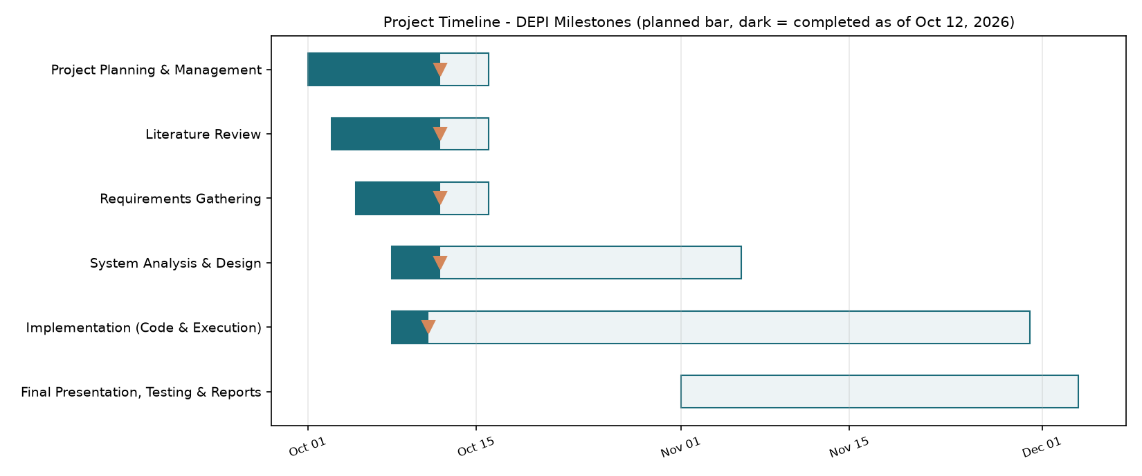
Figure 1 - Project execution timeline across DEPI milestones.
The execution timeline reflects the agile engineering progression undertaken by the team: initial environment configuration and data discovery were finalized in the first phase; architectural experiments, loss optimization, and zero-leakage split resolution proceeded in parallel; finally, ensemble integration, Web UI development, and rigorous documentation verification concluded the project.

6. Risk Management and Mitigations
Table 3 - Risk register and applied engineering mitigations
Risk Description | Severity | Probability | Mitigation Implemented
Data leakage across splits | High | Medium | Enforced RESPECT_OFFICIAL_SPLITS=True; verified 0 shared scene stems across 525 Tr / 112 Val / 348 Te.
Severe class imbalance (95.7% unchanged) | High | High | Implemented BCE + Soft Dice loss with pos_weight=10.0; evaluated with F1/IoU/Kappa rather than raw accuracy.
Windows memory exhaustion during DataLoader | High | Medium | Adopted num_workers=0 to prevent paging-file collapse from redundant CUDA worker contexts.
Host disk storage constraints (C: partition) | Medium | High | Redirected Python conda environments, pip caches, and kagglehub caches to D: partition.
Double-sigmoid metric distortion | High | Low | Redesigned ConfusionMeter to consume raw logits directly, eliminating double squashing.
Hardware VRAM limits on laptop GPU (4 GB) | Medium | High | Utilized 256x256 tiled inference, base width 32, and mixed-precision FP16 (AMP).

7. Development Environment and Toolchain
Table 4 - Engineering toolchain
Category | Tool / Framework | Version / Specifications
Programming Language | Python | 3.11.17 (conda environment on D:/envs/levir-cd)
Deep Learning Engine | PyTorch / Torchvision | PyTorch 2.14.1+cu126, torchvision 0.29.1+cu126
Data Processing | NumPy / Pillow / kagglehub | NumPy 2.4.6, Pillow 12.3.0, kagglehub 1.0.2
Visualization | Matplotlib | Matplotlib 3.11.2
Interactive Web Studio | Python HTTP Engine / JS | ThreadingHTTPServer, Custom CSS3 / HTML5 / ES6
Target Hardware | NVIDIA GPU / Host RAM | NVIDIA GeForce RTX 3050 Laptop GPU (4 GB VRAM), 16 GB RAM

8. Project Governance and Team Roles
The project was executed by four dedicated AI engineers collaborating across distinct functional domains:
- Ahmed Refaat Abd-Elmotelb (Lead ML Engineer): Overall pipeline architecture, Siamese U-Net implementation, zero-leakage data partition enforcement, dual-model ensembling, and Test-Time Augmentation (TTA).
- Ahmed Reda Mohamed (Deep Learning Specialist): Differential feature fusion (diff_cat) block design, BCE + Soft Dice loss formulation, pos_weight=10.0 optimization, and gradient stabilization.
- Raeed Youssef Mahfouz (Data Systems Engineer): Automated dataset discovery, synchronized dihedral geometric augmentation, memory-safe evaluation tiling, and Web UI frontend layout.
- Ahmed Mohamed Qotb (Evaluation & QA Lead): Confusion meter implementation, validation threshold calibration sweeps, qualitative error map generation (TP/FP/FN), and smoke testing.
End of Milestone 1 document.

