D E P I G R A D U A T I O N P R O J E C T
System Analysis and Design
Architecture, Data Design, and Evaluation Protocol of the Change-Detection Pipeline
Digital Egypt Pioneers Initiative (DEPI) - AI Track
Milestone 4 of 6 - System Analysis & Design
Project Team Members:
• Ahmed Refaat Abd-Elmotelb (Lead ML Engineer & Pipeline Architect)
• Ahmed Reda Mohamed (Deep Learning Specialist & Loss Optimization)
• Raeed Youssef Mahfouz (Data Systems & Augmentation Specialist)
• Ahmed Mohamed Qotb (Evaluation Metrics & Quality Assurance Lead)
Academic / Technical Track: Artificial Intelligence & Deep Learning
Submission Date: October 2026

Digital Egypt Pioneers Initiative - AI Track Milestone 4

Table of Contents

Note: this Table of Contents is generated via field codes. After editing the document, right-click the TOC and choose Update Field to refresh page numbers.

1. System Architecture Overview
The Aerial Change Detection System is an end-to-end, modular deep-learning system engineered to process bi-temporal aerial imagery, train Siamese neural networks under severe class imbalance, evaluate models without data leakage, and deliver predictions through both reproducible scripts and an interactive Web Application Studio (app.py).
Project Team Identification & Roles
# | Team Member Name | Specialized Role & Key Responsibilities
1 | Ahmed Refaat Abd-Elmotelb | Lead ML Engineer & Pipeline Architect: Siamese U-Net implementation, zero-leakage split enforcement, dual-model ensemble blending, and TTA pipeline.
2 | Ahmed Reda Mohamed | Deep Learning Specialist & Loss Design: Differential feature fusion (diff_cat), BCE + Soft Dice loss weighting (pos_weight=10.0), and gradient stabilization.
3 | Raeed Youssef Mahfouz | Data Systems & Augmentation Engineer: Automated dataset discovery, synchronized dihedral geometric augmentation, and memory-safe evaluation tiling.
4 | Ahmed Mohamed Qotb | Evaluation Metrics & QA Lead: Confusion matrix accumulation, validation threshold calibration, error mapping (TP/FP/FN), and diagnostics.
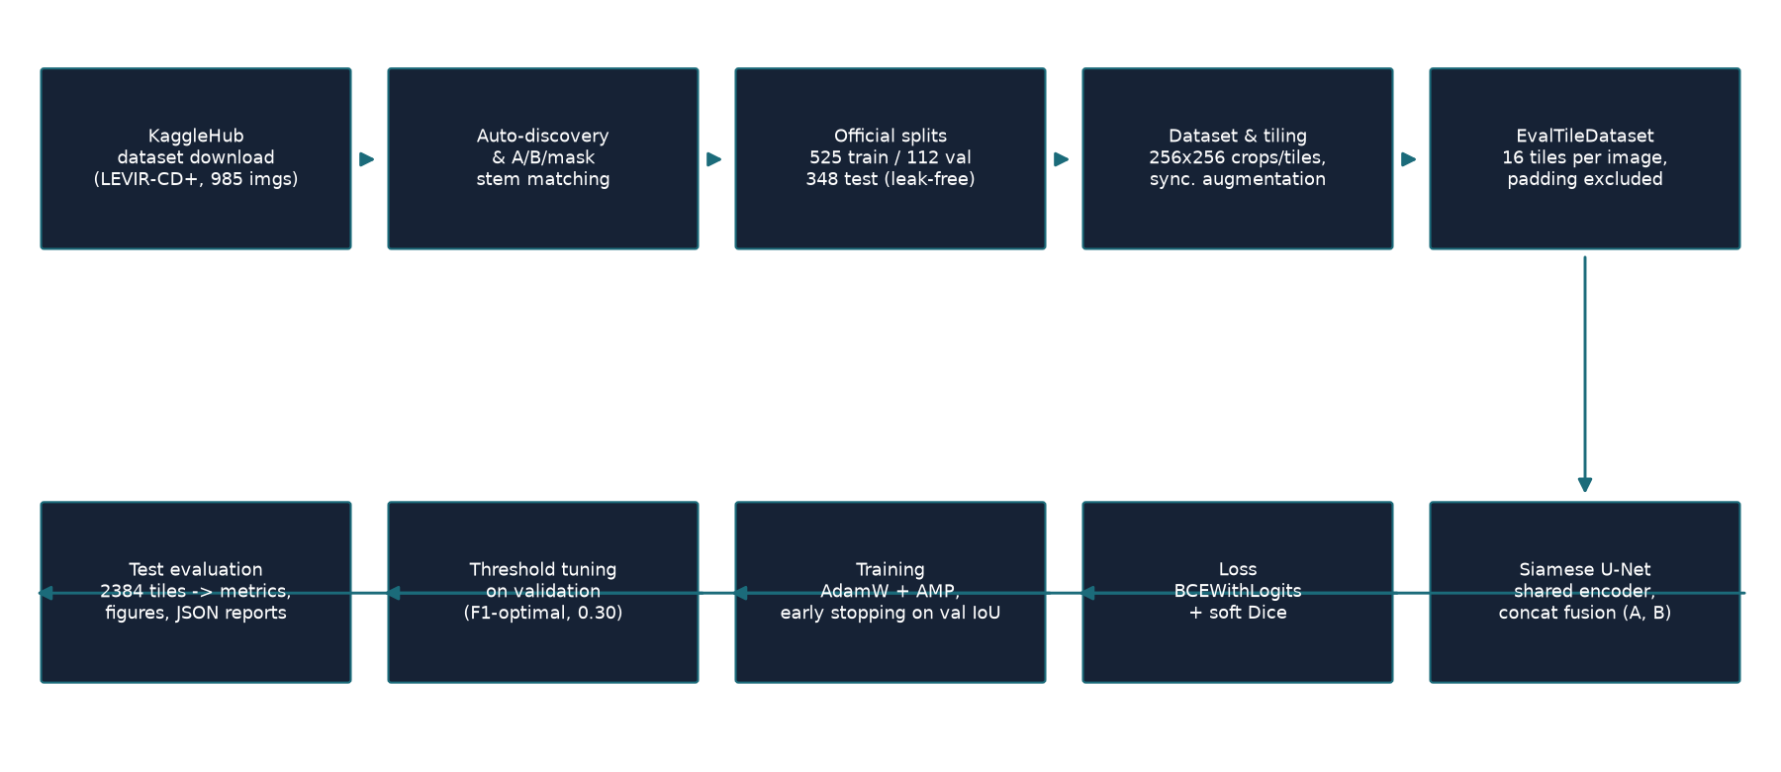
Figure 1 - End-to-end pipeline: from automated KaggleHub discovery to the interactive Web Studio and evaluation reports.

2. Data Architecture and Zero-Leakage Partition Design

2.1 Automated Discovery and Stem Matching
The dataset layer (src/data_discovery.py) implements automated filesystem walking that classifies directories by semantic role (Time-1 / A, Time-2 / B, and Ground-Truth Label / Mask). Files are matched using file stems (e.g., test_1, train_24), ensuring strict 1-to-1-to-1 triplet alignment. Missing, corrupted, or dimensionally mismatched samples are detected and reported before training begins.

2.2 Zero-Leakage Split Enforcement
A primary priority of this project is absolute scientific integrity. In initial exploration, pooling all 985 scenes and re-splitting posed potential risk of mixing official test scenes. To guarantee zero data leakage, RESPECT_OFFICIAL_SPLITS = True was implemented:
- Official Train Split: 637 scenes partitioned strictly into 525 Training scenes and 112 Validation scenes.
- Official Test Split: 348 scenes preserved completely intact and untouched for final single-pass evaluation.
- Verification: Programmatic set-intersection asserts 0 common stems between Train, Val, and Test splits.

2.3 Spatial Cropping and Evaluation Tiling
- Training Pipeline: Generates random 256x256 crops from 1024x1024 scenes, applying synchronized horizontal flip, vertical flip, and 90-degree rotations identically across Image A, Image B, and the mask.
- Evaluation Pipeline: EvalTileDataset partitions each 1024x1024 scene into 16 non-overlapping 256x256 tiles (5,568 tiles across 348 test scenes). Partial edge tiles use reflect padding, with valid pixel masks recorded so padded pixels are strictly excluded from metric accumulation.

3. Neural Network Architecture: Siamese U-Net
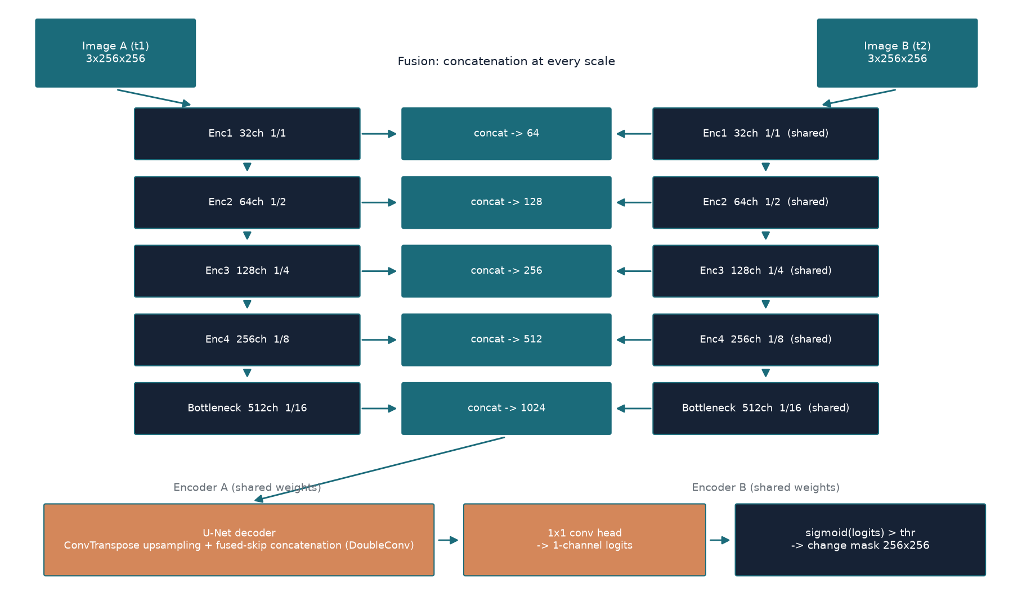
Figure 2 - Siamese U-Net: shared-weight encoder, multi-scale feature fusion, and U-Net decoder.
The architecture (src/model.py) comprises three core structural components:
- Weight-Sharing Siamese Encoder: Two identical branches with tied weights extract multi-scale hierarchical feature maps from Image A and Image B at 5 resolutions (1/1, 1/2, 1/4, 1/8, 1/16). Weight sharing ensures both dates are projected into an invariant semantic feature space.
- Multi-Scale Fusion Modules: Supports both classic Concatenation [F1, F2] and hybrid Differential Fusion (diff_cat), which concatenates [F1, F2, |F1 - F2|]. Explicitly injecting feature differences empowers the decoder to isolate physical changes directly.
- U-Net Decoder with Skip Connections: Upsamples deep bottleneck features using bilinear interpolation and DoubleConv blocks, concatenating fused skip connections at every stage to restore fine spatial boundaries, terminating in a 1x1 convolution outputting raw logits.

4. Imbalance-Robust Loss Design
Because unchanged pixels account for over 95.7% of all pixels, standard loss functions fail. We engineered a composite loss function (src/losses.py):
Loss = 0.5 * BCEWithLogitsLoss(pos_weight = 10.0) + 0.5 * SoftDiceLoss()
- Weighted BCE: Penalizes false negatives 10x more heavily than false positives, forcing the network to attend to subtle building changes.
- Soft Dice: Optimizes direct intersection over union (overlap), providing gradient signals independent of the vast background volume.

5. Interactive Web Studio Architecture (app.py)
To bridge deep learning research with practical deployment, app.py implements a high-performance web dashboard:
- HTTP Engine: Built on Python's ThreadingHTTPServer, providing zero external web-framework dependencies and full multithreaded request handling.
- REST API Layer: Exposes /api/status, /api/samples, /api/sample, /api/predict, and /docs/ endpoints.
- Inference & Stitching Engine: Loads models onto GPU/CPU, processes arbitrary image pairs via tiled batch inference, performs 4-fold TTA, applies the user-selected threshold, and generates visual overlays and error confusion maps (TP in green, FP in red, FN in blue).
- Documentation Download Hub: Directly serves all 6 official DEPI milestone documents and the master documentation report.

6. Evaluation Protocol and Global Metric Accumulation
Evaluation strictly enforces global confusion matrix accumulation (TP, FP, FN, TN) across all test tiles rather than taking misleading batch-level metric averages. Reported metrics include:
- Precision: TP / (TP + FP)
- Recall: TP / (TP + FN)
- F1-Score: 2 * Precision * Recall / (Precision + Recall)
- IoU (Intersection over Union): TP / (TP + FP + FN)
- Mean IoU: Average of change IoU and unchanged IoU
- Balanced Accuracy: Average of positive recall and negative recall
- Cohen's Kappa: Chance-adjusted classification agreement
Table 1 - Software module responsibilities
Module | File Location | Core Architectural Responsibility
Configuration | src/config.py | Centralized hyperparameters, paths, seeds, split options.
Data Discovery | src/data_discovery.py | Tree walking, role detection, triplet stem matching, zero-leakage splits.
Dataset & Tiling | src/dataset.py | Synchronized augmentation, cropping, EvalTileDataset with metadata.
Neural Network | src/model.py | SiameseUNet with DoubleConv blocks, shared encoders, fusion options.
Loss Engineering | src/losses.py | SoftDiceLoss, BCEDiceLoss with pos_weight support.
Evaluation Engine | src/metrics.py | ConfusionMeter accumulating raw logits across evaluation runs.
Web Studio | app.py | Interactive web dashboard, live inference, visual overlays, docs hub.
End of Milestone 4 document.

