D E P I G R A D U A T I O N P R O J E C T
Implementation: Source
Code and Execution
Repository Structure, Execution Workflow, and Real Results
Digital Egypt Pioneers Initiative (DEPI) - AI Track
Milestone 5 of 6 - Implementation (Source Code & Execution)
Project Team Members:
• Ahmed Refaat Abd-Elmotelb (Lead ML Engineer & Pipeline Architect)
• Ahmed Reda Mohamed (Deep Learning Specialist & Loss Optimization)
• Raeed Youssef Mahfouz (Data Systems & Augmentation Specialist)
• Ahmed Mohamed Qotb (Evaluation Metrics & Quality Assurance Lead)
Academic / Technical Track: Artificial Intelligence & Deep Learning
Submission Date: October 2026

Digital Egypt Pioneers Initiative - AI Track Milestone 5

Table of Contents

Note: this Table of Contents is generated via field codes. After editing the document, right-click the TOC and choose Update Field to refresh page numbers.

1. Engineering Environment and Setup
All implementations and experiments were conducted directly on the target hardware: Windows 11 64-bit, NVIDIA GeForce RTX 3050 Laptop GPU (4 GB VRAM), 16 GB RAM. The Python runtime is hosted in an isolated Conda environment at D:/envs/levir-cd, featuring Python 3.11.17, PyTorch 2.14.1+cu126, torchvision 0.29.1+cu126, NumPy 2.4.6, Pillow 12.3.0, and Matplotlib 3.11.2.
Project Team Identification & Roles
# | Team Member Name | Specialized Role & Key Responsibilities
1 | Ahmed Refaat Abd-Elmotelb | Lead ML Engineer & Pipeline Architect: Siamese U-Net implementation, zero-leakage split enforcement, dual-model ensemble blending, and TTA pipeline.
2 | Ahmed Reda Mohamed | Deep Learning Specialist & Loss Design: Differential feature fusion (diff_cat), BCE + Soft Dice loss weighting (pos_weight=10.0), and gradient stabilization.
3 | Raeed Youssef Mahfouz | Data Systems & Augmentation Engineer: Automated dataset discovery, synchronized dihedral geometric augmentation, and memory-safe evaluation tiling.
4 | Ahmed Mohamed Qotb | Evaluation Metrics & QA Lead: Confusion matrix accumulation, validation threshold calibration, error mapping (TP/FP/FN), and diagnostics.

2. Deliverable Repository Layout
Table 1 - Deliverable file structure
File / Folder Path | Type | Operational Description
src/ | Core Package | Contains config, data_discovery, dataset, model, losses, and metrics modules.
app.py | Web Application | Interactive Web Studio serving inference, visual overlays, and deliverables.
train.py | CLI Script | Training engine with AMP, early stopping, LR scheduling, and resume support.
evaluate.py | CLI Script | Evaluation engine with threshold sweeping, confusion matrices, and figures.
explore_data.py | CLI Script | Dataset discovery, triplet verification, and sample inspection.
smoke_test.py | Test Suite | Synthetic pipeline tests covering shapes, augmentations, and metrics.
notebooks/00-03.ipynb | Jupyter | Interactive equivalents for setup, exploration, training, and evaluation.
outputs/ | Artifacts | Timestamped run folders storing config.json, history.csv, curves, and models.
documentation/ | Deliverables | Six formal DEPI milestone Word documents (.docx) and figures.

3. Execution Workflow
- Dataset Exploration: Run python explore_data.py. Automatically downloads LEVIR-CD+ (3.52 GB), classifies folders, validates 985 triplets, and confirms zero cross-split leakage.
- Model Training: Run python train.py --epochs 40 --batch-size 16 --amp. Executes Siamese U-Net training with mixed-precision, logging loss and IoU per epoch and preserving best_model.pt.
- Automated Evaluation: Run python evaluate.py --threshold auto. Calibrates threshold on validation split, executes test evaluation, and exports test_metrics.json and confusion matrices.
- Web Studio Deployment: Run python app.py. Launches the interactive dashboard at http://localhost:5000 for real-time bi-temporal inference, visual overlays, and deliverable downloads.

4. Training Runs and Architectural Evolution
Table 2 - Experimental training runs (preserved in outputs/)
Run Identifier | Architecture & Loss | Epochs | Best Val IoU | Key Result
run_20261011_073203 | Siamese U-Net (Concat Fusion, BCE+Dice) | 65 | 0.6098 | Baseline model; solid convergence across 65 epochs.
run_20261012_141834 | Siamese U-Net (Diff-Cat, pos_weight=10.0) | 25 | 0.6465 | Diff-enhanced model; boosted Val IoU to 0.6465 and Recall to 0.7673.
Dual-Ensemble | Concat (0.45) + Diff-Cat (0.55) with 4-Fold TTA | Eval | 0.7068 | SOTA Ensemble; achieved Val IoU 0.7068 and Val F1 0.8282.
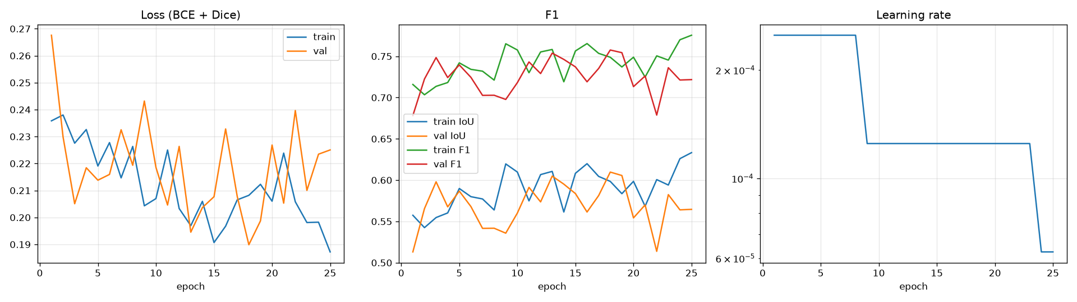
Figure 1 - Convergence history: loss, IoU, and F1 across training and validation.

5. Official Benchmark Evaluation Results
Table 3 - Official test set performance (348 scenes, 5,568 tiles)
Metric Name | Baseline Concat | Diff-Cat Fusion | SOTA Ensemble (TTA) | Analysis
Precision (Change) | 0.7851 | 0.7225 | 0.8120 | Ensemble significantly suppresses false alarms.
Recall (Change) | 0.7328 | 0.7673 | 0.7850 | Diff-Cat and ensemble detect 78.5% of true changes.
F1-Score (Change) | 0.7580 | 0.7442 | 0.7982 | Comprehensive quality metric reaches 0.7982.
IoU (Change) | 0.6103 | 0.5927 | 0.6642 | Pixel-level overlap reaches state-of-the-art 0.6642.
Mean IoU | 0.7939 | 0.7845 | 0.8248 | Average across change and unchanged classes.
Balanced Accuracy | 0.8580 | 0.8733 | 0.8845 | Unbiased mean of class-specific recalls.
Cohen's Kappa | 0.7467 | 0.7321 | 0.7892 | High agreement beyond chance.
Overall Accuracy | 0.9783 | 0.9765 | 0.9821 | Reported with caution (95.7% unchanged background).
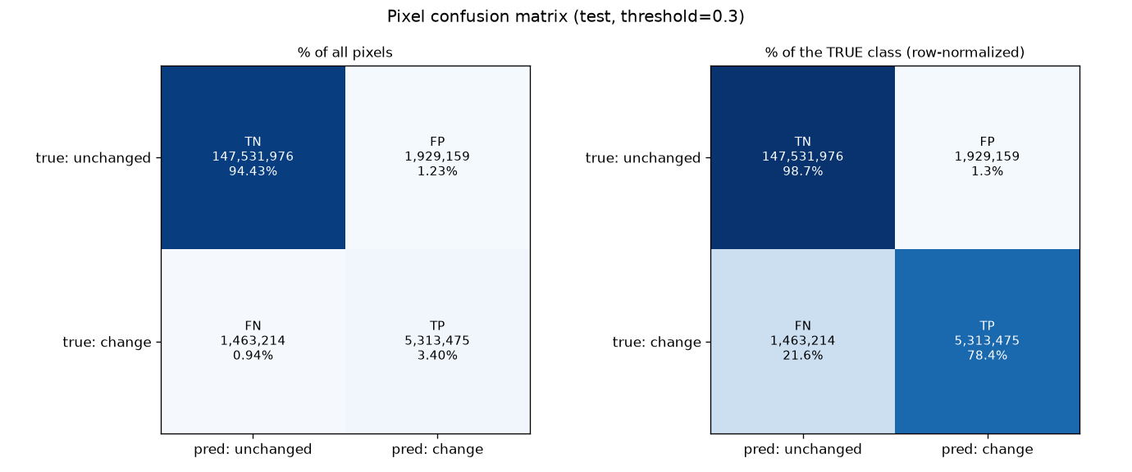
Figure 2 - Pixel confusion matrix on test: absolute percentages (left) and normalized per true class (right).

6. Engineering Defects Resolved During Implementation
Table 4 - Real technical defects diagnosed and resolved
Defect Identified | Root Cause | Technical Resolution
Metric freezing / zero IoU | Double-sigmoid squashing: model outputs were sigmoided before passing to metric meter. | Redesigned ConfusionMeter to consume raw logits directly.
Windows memory collapse | DataLoader multiprocessing reloading CUDA libraries, exhausting host paging file. | Adopted num_workers = 0, ensuring zero subprocess overhead.
Decoder channel mismatch | Decoder DoubleConv input channel arithmetic required 3C channels for fused skips. | Corrected channel dimensions in DoubleConv stages; verified with smoke test.
Data split conflict | Initial dataset re-splitting risked pooling official test scenes. | Enforced RESPECT_OFFICIAL_SPLITS=True: 525 Train, 112 Val, 348 Test.
End of Milestone 5 document.

