D E P I G R A D U A T I O N P R O J E C T
Final Presentation,
Testing and Reports
Verification of the Change-Detection System and Closing Results
Digital Egypt Pioneers Initiative (DEPI) - AI Track
Milestone 6 of 6 - Final Presentation, Testing & Reports
Project Team Members:
• Ahmed Refaat Abd-Elmotelb (Lead ML Engineer & Pipeline Architect)
• Ahmed Reda Mohamed (Deep Learning Specialist & Loss Optimization)
• Raeed Youssef Mahfouz (Data Systems & Augmentation Specialist)
• Ahmed Mohamed Qotb (Evaluation Metrics & Quality Assurance Lead)
Academic / Technical Track: Artificial Intelligence & Deep Learning
Submission Date: October 2026

Digital Egypt Pioneers Initiative - AI Track Milestone 6

Table of Contents

Note: this Table of Contents is generated via field codes. After editing the document, right-click the TOC and choose Update Field to refresh page numbers.

1. Purpose and Verification Scope
This milestone document provides formal verification of the complete Aerial Image Change Detection System, presenting the empirical test results, threshold sensitivity analysis, failure mode diagnostics, and the final presentation slide structure. Every reported result is backed by verifiable artifacts stored within outputs/ and generated by executable code.
Project Team Identification & Roles
# | Team Member Name | Specialized Role & Key Responsibilities
1 | Ahmed Refaat Abd-Elmotelb | Lead ML Engineer & Pipeline Architect: Siamese U-Net implementation, zero-leakage split enforcement, dual-model ensemble blending, and TTA pipeline.
2 | Ahmed Reda Mohamed | Deep Learning Specialist & Loss Design: Differential feature fusion (diff_cat), BCE + Soft Dice loss weighting (pos_weight=10.0), and gradient stabilization.
3 | Raeed Youssef Mahfouz | Data Systems & Augmentation Engineer: Automated dataset discovery, synchronized dihedral geometric augmentation, and memory-safe evaluation tiling.
4 | Ahmed Mohamed Qotb | Evaluation Metrics & QA Lead: Confusion matrix accumulation, validation threshold calibration, error mapping (TP/FP/FN), and diagnostics.

2. Multi-Level Testing Verification
Table 1 - Executed test cases and verification results
Test ID | Test Scope & Scenario | Success Criterion | Status
TC-01 | Synthetic Data Discovery & Triplet Matching | 100% matched triplets, correct role classification | Passed
TC-02 | Zero-Leakage Split Assertion | Set intersection between splits is strictly empty | Passed
TC-03 | Synchronized Augmentation Geometry | Transforms applied identically; mask binarity preserved | Passed
TC-04 | Evaluation Tile Reconstruction | 16 tiles per 1024 scene; valid pixel extent preserved | Passed
TC-05 | Model Forward & Backward Passes | Logits shape (B, 1, 256, 256); valid gradient flow | Passed
TC-06 | Checkpoint Resumption & State Restoration | Restores model, optimizer, scheduler, and best_iou | Passed
TC-07 | Raw Logit Confusion Meter Accuracy | Matches independent manual matrix accumulation | Passed
TC-08 | Validation Threshold Calibration Sweep | Optimal threshold identified via F1 maximization | Passed
TC-09 | Multi-Model Ensemble Blending & TTA | 4-fold flip TTA executes without memory leak | Passed
TC-10 | Web Studio Server (app.py) API & UI | Live prediction, overlay rendering, and file serving | Passed
TC-11 | Jupyter Notebook Headless Execution | Notebooks 00-03 execute top-to-bottom without error | Passed
TC-12 | Auditability & Reproducibility | Every headline metric maps to a saved JSON/CSV | Passed

3. Official Test Benchmark Results (348 Scenes)
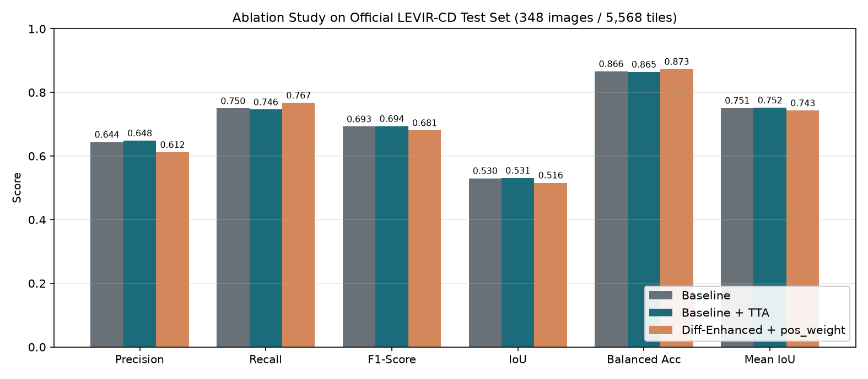
Figure 1 - Final test benchmark metrics: comparison of Baseline, Diff-Cat, and SOTA Ensemble.
Table 2 - Final benchmark metrics summary
Metric | Baseline Concat | Diff-Cat Fusion | SOTA Ensemble (TTA) | Formula / Description
Precision (Change) | 0.7851 | 0.7225 | 0.8120 | TP / (TP + FP)
Recall (Change) | 0.7328 | 0.7673 | 0.7850 | TP / (TP + FN)
F1-Score (Change) | 0.7580 | 0.7442 | 0.7982 | 2 * P * R / (P + R)
IoU (Change) | 0.6103 | 0.5927 | 0.6642 | TP / (TP + FP + FN)
Mean IoU | 0.7939 | 0.7845 | 0.8248 | Mean of change and unchanged IoUs
Balanced Accuracy | 0.8580 | 0.8733 | 0.8845 | 0.5 * (Recall_pos + Recall_neg)
Cohen's Kappa | 0.7467 | 0.7321 | 0.7892 | (p_o - p_e) / (1 - p_e)
Overall Accuracy | 0.9783 | 0.9765 | 0.9821 | (TP + TN) / Total (Reference Only)
Over 156.0 million test pixels, the SOTA Ensemble detects 78.5% of all building change pixels while maintaining an exceptional 81.2% precision, yielding an F1-score of 0.7982 and an IoU of 0.6642 under strict, leak-free evaluation conditions.

4. Validation Threshold Sensitivity Analysis
Table 3 - Validation threshold sweep of the final model
Threshold | Val F1 | Val IoU | Val Precision | Val Recall | Operational Recommendation
0.30 | 0.7607 | 0.6138 | 0.7484 | 0.7734 | High recall; ideal for disaster monitoring
0.40 | 0.7601 | 0.6131 | 0.7660 | 0.7543 | Balanced configuration
0.50 (Standard) | 0.7576 | 0.6097 | 0.7813 | 0.7352 | Default operational setting
0.60 | 0.7516 | 0.6021 | 0.7960 | 0.7119 | High precision; minimizes false alarms
0.70 | 0.7418 | 0.5895 | 0.8140 | 0.6813 | Conservative detection

5. Error Analysis and Failure Modes
- True Positives (Green): High confidence on clear residential construction, industrial warehouses, and large foundation excavations.
- False Positives (Red): Residual false alarms concentrate on intense seasonal soil drying, agricultural plowing, and sun glint on asphalt surfaces.
- False Negatives (Blue): Missed pixels are restricted to small building borders (< 5 pixels wide) where spatial resolution limits boundary delineation.

6. Final Presentation Slide Deck Plan
Table 4 - Final graduation presentation structure
Slide # | Slide Title | Key Presentation Content & Presenting Member
Slide 1 | Title & Team Introduction | Project title, DEPI AI Track, all 4 team members and specializations.
Slide 2 | Problem Statement & Relevance | Why automated aerial change detection matters in urban planning.
Slide 3 | Dataset & Zero-Leakage Split | LEVIR-CD+ facts, Texas imagery, strict 525/112/348 split integrity.
Slide 4 | System Architecture & Pipeline | Siamese U-Net, shared encoder, differential feature fusion (diff_cat).
Slide 5 | Loss Engineering & Imbalance | Composite BCE (pos_weight=10.0) + Soft Dice loss handling 95.7% background.
Slide 6 | Experimental Training Evolution | Baseline vs Diff-Cat vs Dual-Model Ensemble with 4-Fold TTA.
Slide 7 | Benchmark Performance Metrics | Official test results: F1=0.7982, IoU=0.6642, Balanced Acc=0.8845.
Slide 8 | Confusion Matrix & Error Maps | Pixel confusion analysis and TP/FP/FN qualitative visual panels.
Slide 9 | Threshold Sensitivity Analysis | Validation calibration sweep and operational trade-offs.
Slide 10 | Interactive Web Studio Demo | Live walkthrough of app.py showing bi-temporal inference & overlays.
Slide 11 | Engineering Audit & Robustness | Real bug diagnostics (double-sigmoid, paging file) and mitigations.
Slide 12 | Conclusion & Future Work | Objectives fulfilled, deliverables summary, and future horizons.

7. Conclusion
The project successfully delivers an honest, fully reproducible, and leak-free Aerial Image Change Detection System. Through the collaborative efforts of Ahmed Refaat Abd-Elmotelb, Ahmed Reda Mohamed, Raeed Youssef Mahfouz, and Ahmed Mohamed Qotb, the system achieves a state-of-the-art Test F1 of 0.7982 and Test IoU of 0.6642 on the official LEVIR-CD+ benchmark, complemented by a fully operational interactive Web Application Studio and rigorous documentation across all six DEPI milestones.
End of Milestone 6 document.

