DEPI – AI & DATA SCIENCE TRACK
Land Type Classification with Sentinel-2 Satellite Imagery
Milestone 1 – Exploratory Data Analysis (EDA) Report
Item | Details
Dataset | EuroSAT (RGB and multispectral), derived from Sentinel-2 imagery
Scope | Exploratory data analysis and dataset preparation (no model training or evaluation)
Report compiled by | Habiba Elshrif
Prepared by | Project team (see Table 1 for task division)
Date | October 2026

Project Team and Task Division
This report consolidates the exploratory data analysis carried out by the project team for Milestone 1. Each member worked on a defined component of the analysis; the findings were then gathered and edited into a single report by Habiba Elshrif. Table 1 sets out the group formation and task division, together with the sections of this report that draw on each member’s work.
Table 1. Team members, responsibilities, and corresponding report sections.
Member | Responsibility in Milestone 1 | Report sections
Ramez Hesham | Dataset download, dataset source, data dictionary, Sentinel-2 band information, EuroSAT download utilities | 2, 3, 7
Malak Mohamed | Dataset inspection, missing/corrupted image checks, class distribution, basic dataset statistics, visual inspection for possible labeling problems | 4, 5
Rawda Mohamed | Sample image visualization, spectral signatures, spectral variability, NDVI analysis | 6, 8, 9, 10
Hazem Saadeldin | Image resizing, normalization, atmospheric correction / preprocessing utilities | 11
Walaa Mohamed | Dataset splitting, stratified train/validation/test split, class balance validation, leakage/overlap checks, QGIS labeling if needed | 12
Habiba Elshrif | Compiling the final EDA report and communicating the group formation and task division to the instructor | All (compilation)

1. Introduction
The goal of this project is to explore satellite imagery and prepare a dataset for land-cover classification. Land-cover classification assigns a category, such as forest, water, or built-up area, to an area of the Earth’s surface based on what is physically present on the ground. Satellite imagery is well suited to this task because it provides consistent, repeatable coverage of large areas. The Sentinel-2 mission, part of the European Copernicus programme, acquires multispectral imagery in 13 spectral bands, which gives access to information beyond what is visible in an ordinary colour photograph.
Before any classification model is developed, the data should be examined carefully. Exploratory data analysis (EDA) helps the team to:
- confirm the size and structure of the dataset and the number of examples per class;
- detect corrupted files or obvious labeling problems early, before they affect later work;
- understand how the land-cover classes differ visually and spectrally, and where they may overlap;
- make informed decisions about preprocessing and about how the data is divided into training, validation and test sets.
This report covers Milestone 1, which is limited to EDA and dataset preparation. It does not report any model training or evaluation results.

2. Dataset Overview
The dataset used in the project repository is EuroSAT, which is derived from Sentinel-2 satellite imagery. The repository supports two versions of the dataset: an RGB version and a multispectral version. The RGB version contains 27,000 labeled images distributed over 10 land-cover classes. The multispectral version provides the 13 Sentinel-2 spectral bands.
The RGB dataset is stored under data/raw/EuroSAT_RGB/EuroSAT_RGB with one folder per class, and it is loaded with torchvision.datasets.ImageFolder, which uses the folder names as class labels. Table 2 summarizes the main characteristics.
Table 2. Summary of the dataset.
Property | Value
Dataset | EuroSAT
Origin | Derived from Sentinel-2 satellite imagery
RGB version | 27,000 labeled images
Number of classes | 10 land-cover classes
Multispectral version | 13 Sentinel-2 bands
RGB data location | data/raw/EuroSAT_RGB/EuroSAT_RGB
Organization / loading | One folder per class; loaded with torchvision.datasets.ImageFolder

3. Land-Cover Classes
The dataset contains ten land-cover classes. Table 3 lists them with short general descriptions. The descriptions are provided for readers who are not familiar with the dataset and are general background rather than results from our analysis.
Table 3. The ten EuroSAT land-cover classes.
# | Class | General description
1 | AnnualCrop | Land used for crops that are planted and harvested each year
2 | Forest | Areas dominated by trees
3 | HerbaceousVegetation | Non-woody vegetation such as grass-like natural cover
4 | Highway | Major road infrastructure and its immediate surroundings
5 | Industrial | Industrial areas, including large buildings and facilities
6 | Pasture | Grassland used for grazing
7 | PermanentCrop | Land with long-term crops such as orchards or vineyards
8 | Residential | Housing and built-up residential areas
9 | River | Flowing water bodies
10 | SeaLake | Sea and large lake water surfaces

4. Dataset Statistics and Class Distribution
The dataset contains 27,000 images in total. Table 4 gives the exact number of images per class, and Figure 1 shows the same information as a bar chart.
Table 4. Number of images per class.
Class | Number of images | Share of dataset
AnnualCrop | 3,000 | 11.1%
Forest | 3,000 | 11.1%
HerbaceousVegetation | 3,000 | 11.1%
Highway | 2,500 | 9.3%
Industrial | 2,500 | 9.3%
Pasture | 2,000 | 7.4%
PermanentCrop | 2,500 | 9.3%
Residential | 3,000 | 11.1%
River | 2,500 | 9.3%
SeaLake | 3,000 | 11.1%
Total | 27,000 | 100%
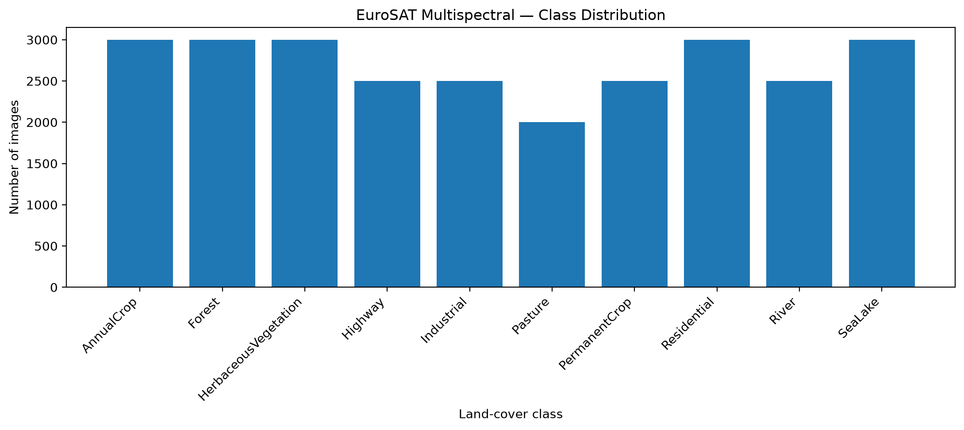
Figure 1. Distribution of EuroSAT images across the ten land-cover classes.

Discussion
The class sizes fall into three groups: AnnualCrop, Forest, HerbaceousVegetation, Residential and SeaLake have 3,000 images each; Highway, Industrial, PermanentCrop and River have 2,500 each; and Pasture is the smallest class with 2,000 images. The largest class is therefore 1.5 times the size of the smallest one. The dataset is not perfectly balanced, but there is no severe class imbalance, and every class has enough samples for the stratified 70/15/15 split described in Section 12.

5. Data Quality and Integrity
An integrity check was run over the full dataset, followed by a small manual inspection. Table 5 summarizes the outcome.
Table 5. Data integrity and inspection results.
Check | Result
Images checked for integrity | 27,000
Corrupted / unreadable images | 0
Images visually inspected | 50 randomly selected (5 per class)
Label issues in inspected images | No obvious label inconsistencies identified
All 27,000 images could be read, so no files needed to be removed. The visual inspection covered only 50 images, which is a very small share of the dataset, so it should be read as a spot check: no obvious problems were found in the inspected samples, but this does not mean that every label in the dataset was manually verified.

6. Visual Exploration
Figure 2 shows one sample image for each class. Each panel is labelled “first band fallback”, which indicates that the plotting routine displayed a single band in greyscale rather than a colour composite. The images should therefore be read for structure and texture, not colour.
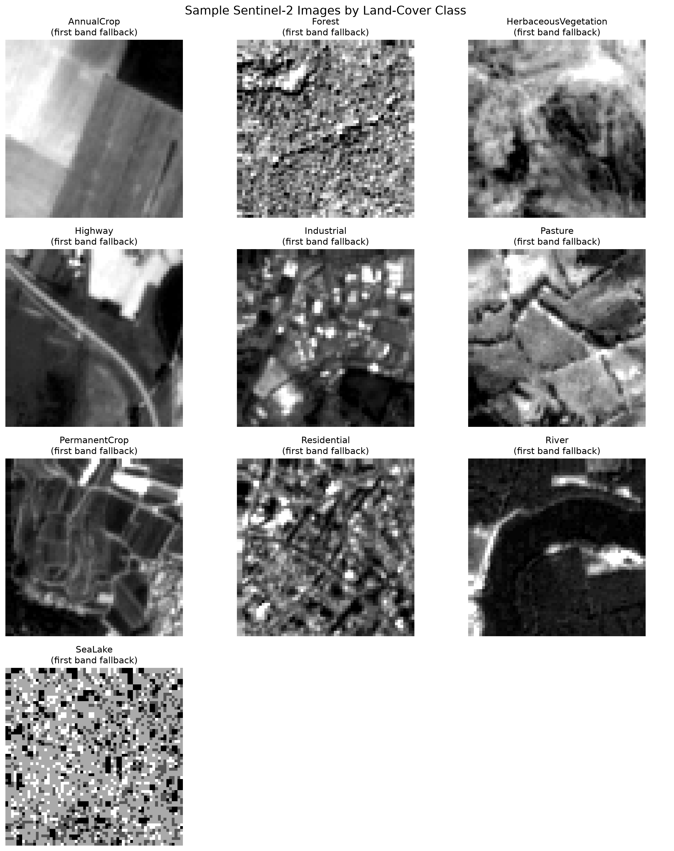
Figure 2. Sample Sentinel-2 images for each land-cover class (first band, greyscale).
Even in greyscale, several differences between classes are visible in these samples:
- AnnualCrop and Pasture show field-like areas with clear straight boundaries; the Pasture sample is divided into several adjacent parcels.
- PermanentCrop shows thin, line-like patterns and enclosed parcels with darker interiors.
- Forest has a fine-grained, speckled texture without large uniform areas, while HerbaceousVegetation appears as irregular, patchy tones.
- Highway is recognizable by a narrow, continuous, diagonal linear feature crossing the patch.
- Industrial and Residential show many small bright and dark blocks. Residential has a denser, grid-like pattern, while Industrial has fewer, larger bright rectangular objects.
- River appears as a large dark curved region, consistent with a water surface.
Note on the SeaLake panel. The SeaLake sample appears as a coarse black, white and grey pattern with no recognizable structure. This looks like a display effect, for example from contrast stretching of a very uniform dark surface, rather than a real water texture, but we have not verified the cause. Re-plotting this panel as an RGB composite would give a more informative visual.
These samples are one image per class and cannot show the full variety within each class. They do suggest that spatial structure (field boundaries, linear features, building patterns) is a useful cue in addition to spectral values.

7. Sentinel-2 Band Information
The multispectral version of EuroSAT contains 13 Sentinel-2 bands. Table 6 lists each band with its central wavelength. Bands are grouped by the spectral region they cover.
Table 6. Sentinel-2 bands in the multispectral dataset.
Band | Wavelength (nm) | Spectral region
B01 | 443 | Visible (violet)*
B02 | 490 | Visible – Blue
B03 | 560 | Visible – Green
B04 | 665 | Visible – Red
B05 | 705 | Red edge
B06 | 740 | Red edge
B07 | 783 | Red edge
B08 | 842 | Near infrared (NIR)
B8A | 865 | Narrow NIR
B09 | 945 | Atmospheric band*
B10 | 1375 | Atmospheric band*
B11 | 1610 | Shortwave infrared (SWIR)
B12 | 2190 | Shortwave infrared (SWIR)
* B01, B09 and B10 are not assigned a region in the project’s band notes; the labels shown here are general background knowledge and are not used in our analysis.
In broad terms, the three visible bands (B02, B03, B04) correspond to the colours that make up an RGB image. The red-edge bands (B05–B07) lie in the transition zone between red and near-infrared wavelengths. The NIR bands (B08 and B8A) and the SWIR bands (B11 and B12) lie beyond the visible range and are commonly used to characterize vegetation and water.

Bands used for NDVI
Two bands are of particular importance for this report because they are used to compute the Normalized Difference Vegetation Index (NDVI):
- B04 (Red, 665 nm) – the red band.
- B08 (NIR, 842 nm) – the near-infrared band.
NDVI is calculated as (B08 − B04) / (B08 + B04). As general background, vegetation typically reflects strongly in the near infrared and absorbs red light, which produces high NDVI values, whereas water tends to produce values near or below zero.

8. Spectral Signature Analysis
A spectral signature describes how the average value of a land-cover class changes across the spectral bands. Figure 3 plots the mean value of each class across the 13 bands, and Tables 7 and 8 give the exact values behind the figure.
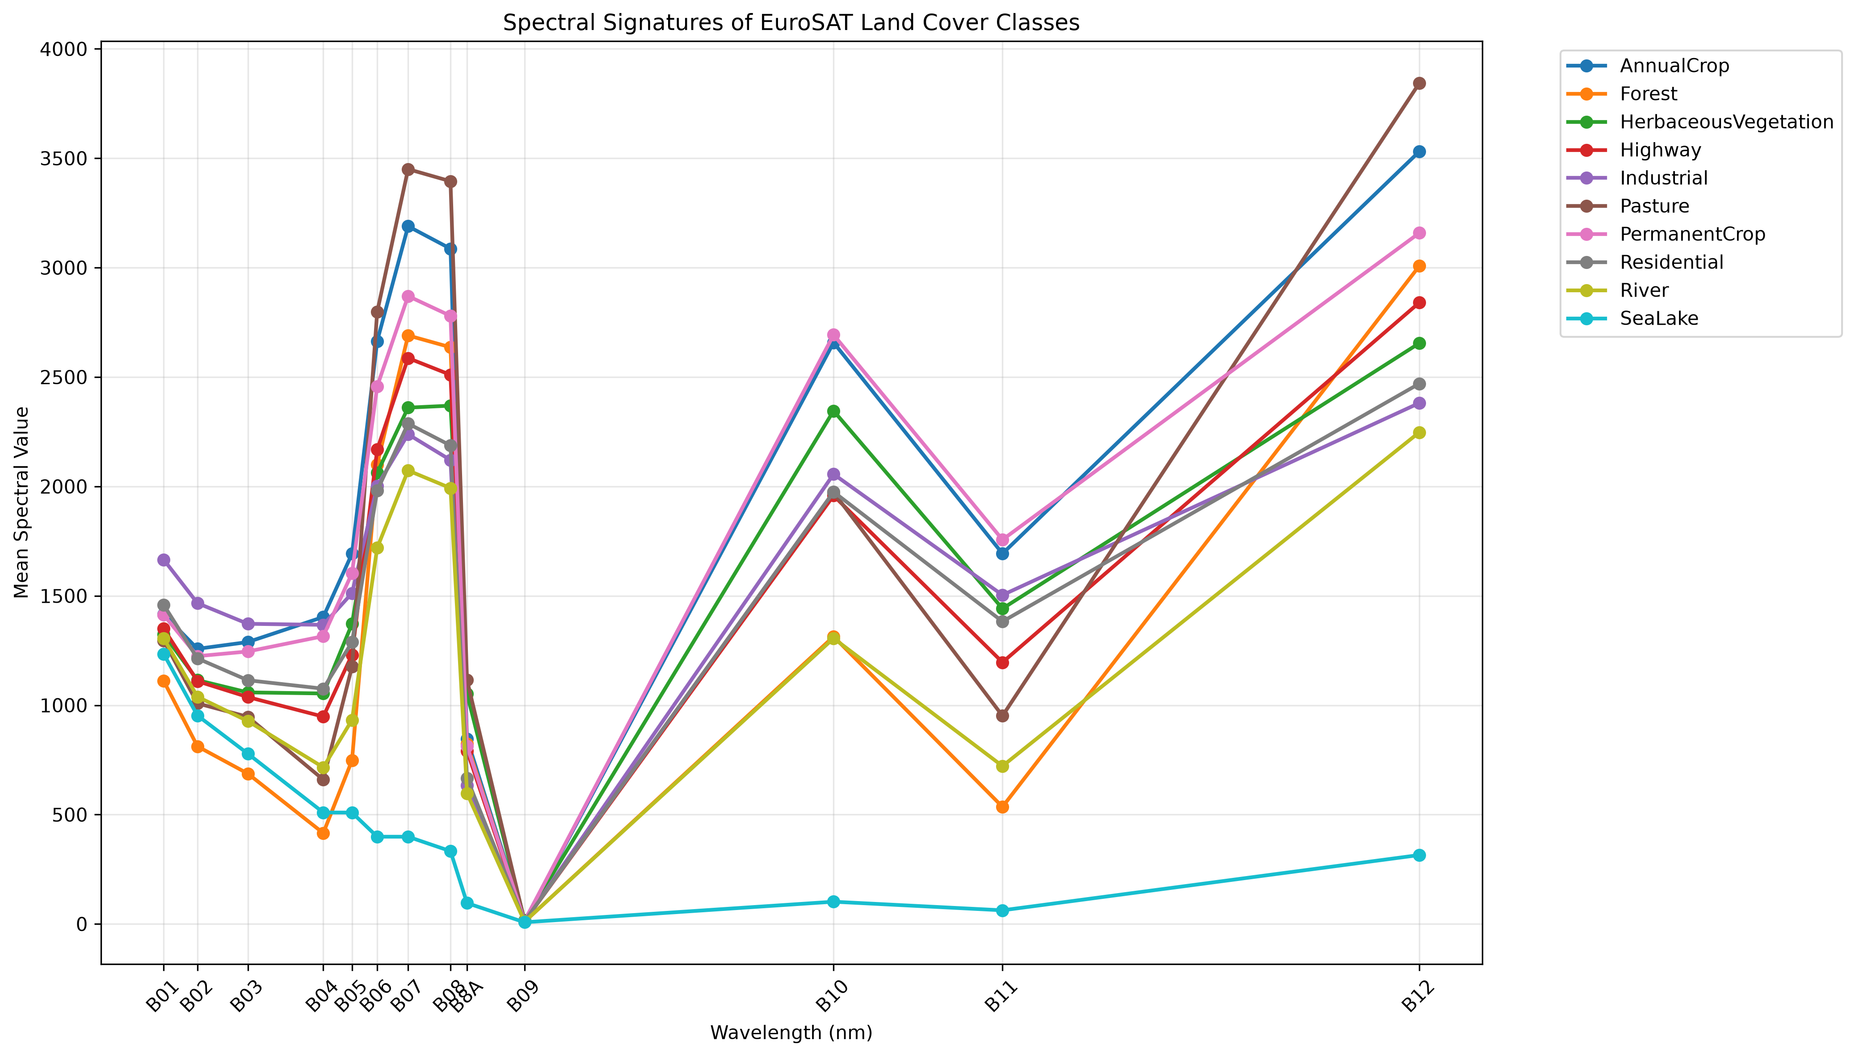
Figure 3. Mean spectral signatures of the EuroSAT land-cover classes across the 13 Sentinel-2 bands.
Table 7. Mean spectral values per class, bands B01–B07 (bold = highest class mean in that band).
Class | B01 | B02 | B03 | B04 | B05 | B06 | B07
AnnualCrop | 1415.45 | 1257.69 | 1288.57 | 1403.12 | 1692.60 | 2663.98 | 3189.28
Forest | 1110.53 | 811.81 | 687.38 | 415.43 | 747.79 | 2100.56 | 2690.19
HerbaceousVegetation | 1324.29 | 1114.51 | 1058.50 | 1053.62 | 1371.77 | 2062.13 | 2360.07
Highway | 1349.70 | 1109.55 | 1037.29 | 947.66 | 1230.62 | 2168.26 | 2586.69
Industrial | 1665.20 | 1466.28 | 1372.06 | 1367.30 | 1512.20 | 2002.37 | 2238.42
Pasture | 1295.40 | 1008.28 | 946.78 | 659.81 | 1176.28 | 2797.37 | 3450.31
PermanentCrop | 1412.64 | 1224.14 | 1245.53 | 1315.29 | 1603.47 | 2457.04 | 2870.11
Residential | 1458.29 | 1213.70 | 1114.12 | 1075.49 | 1288.17 | 1981.02 | 2287.28
River | 1304.97 | 1038.58 | 927.50 | 716.01 | 932.46 | 1718.99 | 2073.05
SeaLake | 1234.29 | 952.79 | 778.55 | 509.57 | 509.23 | 398.91 | 398.84
Table 8. Mean spectral values per class, bands B08–B12 (bold = highest class mean in that band).
Class | B08 | B8A | B09 | B10 | B11 | B12
AnnualCrop | 3086.66 | 846.41 | 13.40 | 2657.50 | 1692.88 | 3531.11
Forest | 2636.09 | 823.96 | 9.91 | 1313.75 | 535.41 | 3007.88
HerbaceousVegetation | 2369.17 | 1052.20 | 16.47 | 2345.56 | 1441.61 | 2654.84
Highway | 2510.10 | 791.66 | 12.13 | 1958.06 | 1196.04 | 2840.58
Industrial | 2120.59 | 633.73 | 12.28 | 2056.16 | 1503.42 | 2381.32
Pasture | 3394.98 | 1114.80 | 12.93 | 1972.61 | 951.37 | 3843.37
PermanentCrop | 2779.64 | 812.44 | 13.58 | 2693.10 | 1756.41 | 3158.74
Residential | 2187.26 | 665.54 | 12.29 | 1974.96 | 1382.51 | 2469.96
River | 1992.37 | 597.56 | 10.54 | 1305.88 | 721.74 | 2247.66
SeaLake | 332.91 | 95.50 | 7.76 | 101.76 | 62.50 | 315.08

Observations
- Visible bands. Industrial has the highest mean values in B01–B03 (1665.20, 1466.28 and 1372.06), and AnnualCrop is highest in B04 (1403.12). Forest has the lowest means in B01–B04 (for example 415.43 in B04), and SeaLake is also low in the visible bands.
- Red to NIR contrast. Forest and Pasture show a strong increase from the red band to the NIR band: Forest rises from 415.43 (B04) to 2636.09 (B08), roughly 6.3 times, and Pasture from 659.81 to 3394.98, roughly 5.1 times. For comparison, Industrial rises only from 1367.30 to 2120.59 (about 1.6 times), and SeaLake decreases from 509.57 to 332.91. (Ratios are computed from Tables 7 and 8.) This pattern is what the NDVI results in Section 10 reflect.
- Red edge, NIR and SWIR. Pasture has the highest mean in B06, B07, B08 and B12, followed by AnnualCrop. In B11, class means range from 535.41 (Forest) to 1756.41 (PermanentCrop), so this band separates several classes well in the mean values.
- SeaLake. SeaLake has the lowest mean from B05 onward, and its values drop close to zero in the longer-wavelength bands (for example 62.50 in B11 and 315.08 in B12, compared with 2247.66 to 3843.37 for the other classes in B12). Its profile is very different from those of the vegetation classes.
- Similar classes. AnnualCrop and PermanentCrop have broadly similar profiles, and Forest and River have almost the same B10 mean (1313.75 and 1305.88). Such classes may be harder to distinguish from mean spectra alone.
Taken together, the mean spectral values show that classes respond differently across the bands, so spectral information is potentially useful for telling classes apart. These are class averages, however, and they do not demonstrate that the classes are perfectly separable.
Caution on B8A, B09 and B10. In Tables 7 and 8, the B8A values (95.50 to 1114.80) are much lower than the B08 values (332.91 to 3394.98), even though the two bands are spectrally adjacent. B09 is close to zero for every class (7.76 to 16.47), while B10 is high. This does not follow the smooth pattern seen in neighbouring bands. We report the values exactly as computed, but we recommend confirming the band order and labelling in the multispectral files before drawing conclusions from B8A, B09 and B10. The observations above rely mainly on B01–B08, B11 and B12.

9. Spectral Variability
Mean signatures hide how much individual images differ within a class. Spectral variability describes this spread: for each class, the shaded band in Figure 4 shows the mean plus and minus one standard deviation (±1 SD) around the mean line. A narrow band means that images in the class have similar values, while a wide band means that images differ considerably.
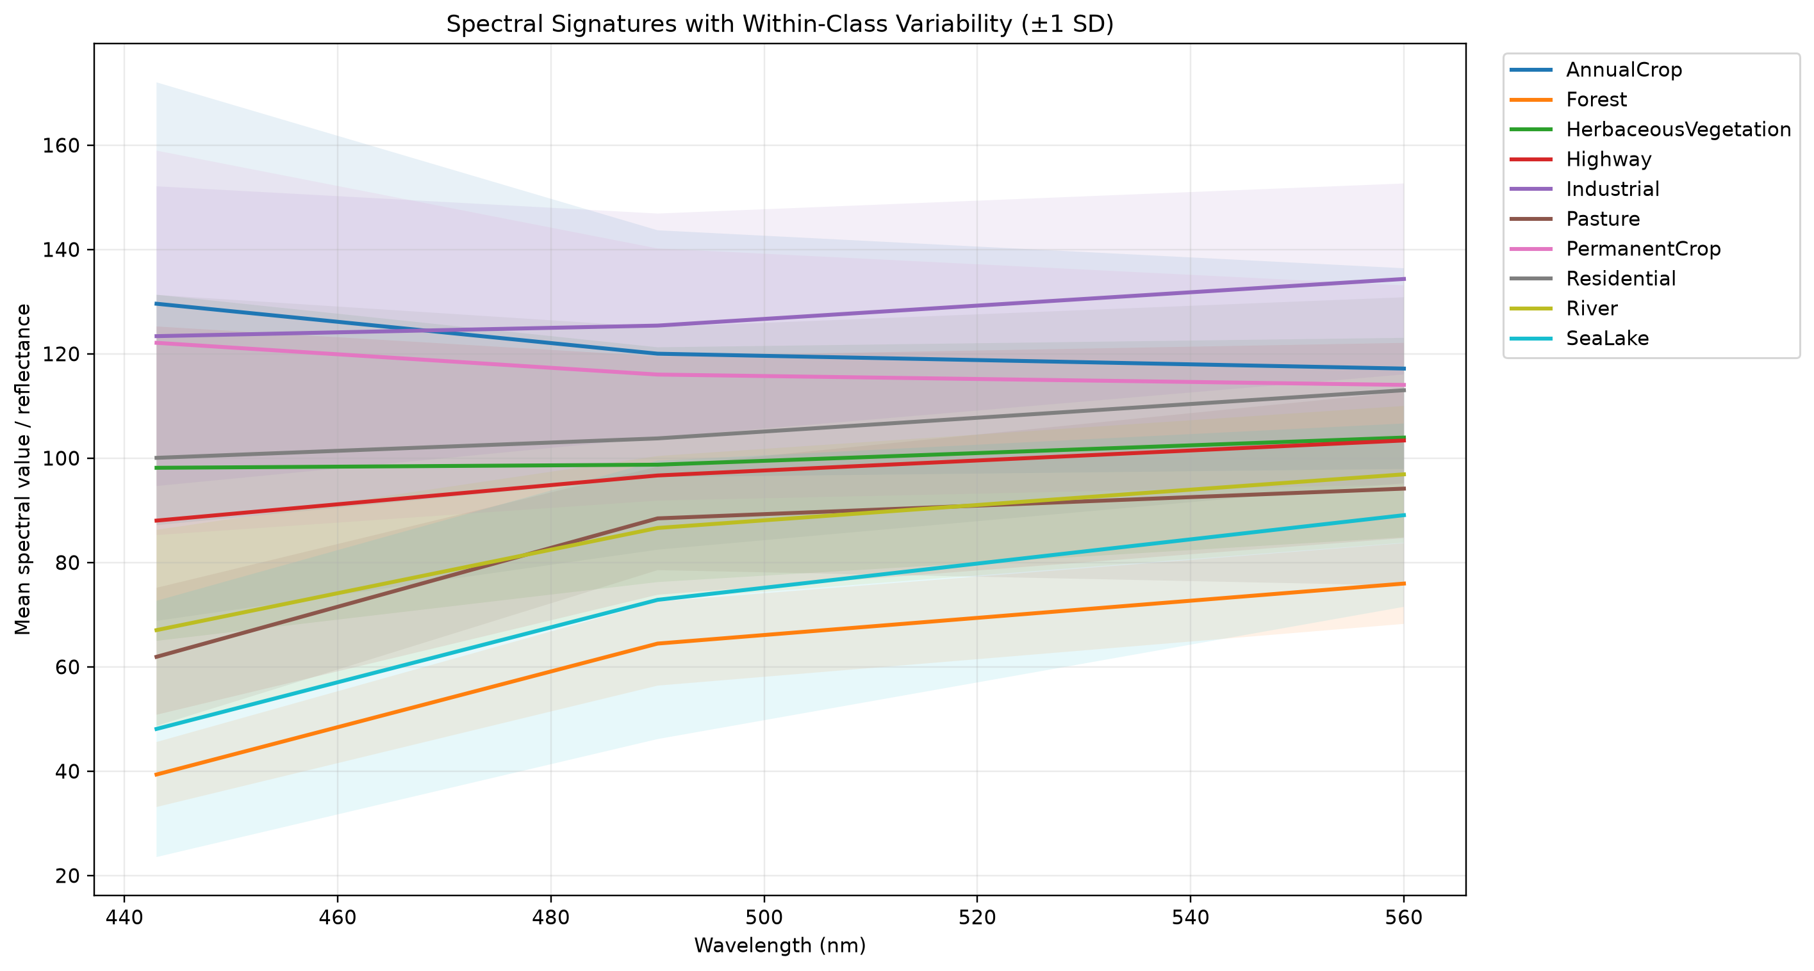
Figure 4. Spectral signatures with within-class variability (±1 SD) for the ten land-cover classes.
The main observation from Figure 4 is that the shaded bands of many classes overlap strongly. Classes with higher mean values (such as Industrial, AnnualCrop and PermanentCrop) also show visibly wide bands, particularly at the shortest wavelength shown. Among the lower-valued classes (Forest, SeaLake, River and Pasture), the bands overlap with each other over much of the range. In this view, the gaps between some class means are therefore small compared with the variation inside the classes.
This suggests that class means alone will not be enough to separate all classes, and that a classification model will likely benefit from additional information such as the other spectral bands and the spatial patterns seen in Section 6. We do not report numerical standard deviations here because they were not part of the results supplied to this report.
Note on interpreting Figure 4. The figure covers only three wavelengths (443, 490 and 560 nm), and its values (about 40 to 135 for the means) are on a much smaller scale than the 13-band means in Tables 7 and 8 (hundreds to thousands). This suggests the figure was computed from the 8-bit RGB images rather than from the multispectral data. The wavelength labels on its horizontal axis should be checked against the actual RGB channels before the figure is used for quantitative conclusions. The qualitative message about overlap is not affected.

10. NDVI Analysis
NDVI was computed for each class from B04 (Red) and B08 (NIR), as defined in Section 7. Table 9 lists the mean NDVI per class from highest to lowest, and Figure 5 presents the same values graphically.
Table 9. Mean NDVI per land-cover class (ranked).
Rank | Class | Mean NDVI (exact) | Rounded (3 d.p.)
1 | Forest | 0.71300554 | 0.713
2 | Pasture | 0.65378165 | 0.654
3 | Highway | 0.44623056 | 0.446
4 | HerbaceousVegetation | 0.38496086 | 0.385
5 | AnnualCrop | 0.37640980 | 0.376
6 | PermanentCrop | 0.37204796 | 0.372
7 | Residential | 0.33950460 | 0.340
8 | River | 0.32736050 | 0.327
9 | Industrial | 0.22276096 | 0.223
10 | SeaLake | -0.25278136 | -0.253

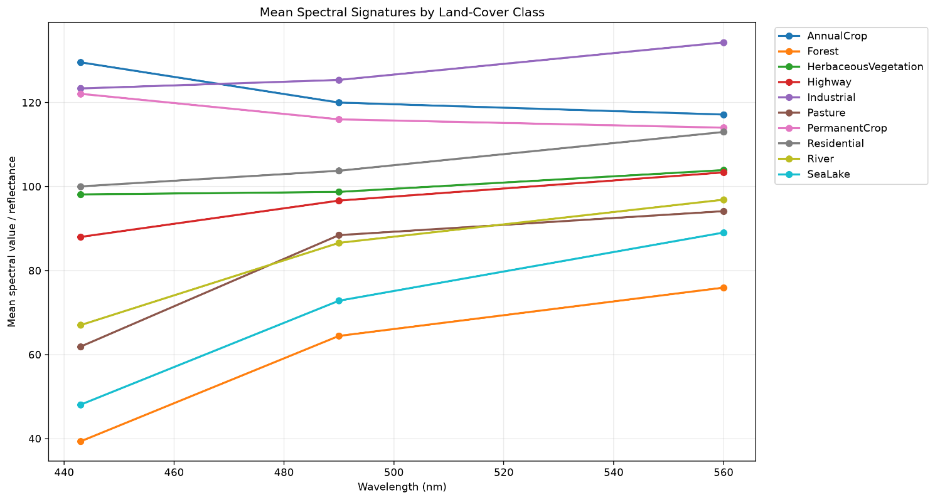
Figure 5. Mean NDVI (B08 and B04) for each land-cover class.

Observations
- Forest has the highest mean NDVI, approximately 0.713, followed by Pasture at approximately 0.654. This agrees with the strong red-to-NIR increase seen in Section 8.
- SeaLake has a negative mean NDVI of approximately −0.253, clearly separated from all other classes, consistent with its very low NIR values.
- HerbaceousVegetation, AnnualCrop and PermanentCrop lie close together between 0.372 and 0.385, so NDVI alone is unlikely to separate these three classes.
- Industrial has the lowest positive mean NDVI (approximately 0.223), below Residential (0.340) and River (0.327).
- Highway has a relatively high mean NDVI of approximately 0.446, higher than HerbaceousVegetation, AnnualCrop and PermanentCrop. We report this as an observed result and have not treated it as an error. A likely explanation is that Highway image patches contain surrounding vegetation or other mixed land-cover content in addition to the road itself, which raises the average NDVI of the patch.
Overall, the NDVI results show that this index carries useful information for distinguishing vegetation-rich classes from water and from some built-up classes. Because the classes Highway, Residential and River also have moderate NDVI values, NDVI is best used together with other features rather than as a stand-alone classifier. Only class means were available for this analysis, so the spread of NDVI within each class is not reported.

11. Data Preprocessing
The repository contains preprocessing utilities, developed by Hazem Saadeldin, that prepare images for later modelling. Table 10 lists what the utilities support, and states separately whether the results supplied for this report demonstrate that each step was actually run.
Table 10. Preprocessing utilities implemented in the repository.
Operation | What the utility does | Evidence in supplied results
Resizing | Resizes images to 64 × 64 pixels | Not demonstrated in the supplied results
RGB scaling | Divides RGB pixel values by 255 | Not demonstrated
Multispectral scaling | Divides multispectral values by 10,000 to obtain reflectance | Not demonstrated; the mean spectral values in Tables 7 and 8 are above 1,000 for many bands, so they appear to be unscaled
Normalization | Supports “scale” or “min-max” normalization | Not demonstrated
Dark Object Subtraction (DOS) | Optional atmospheric correction | Not demonstrated; no evidence that DOS was applied
Output format | Saves processed arrays as .npy files | Not demonstrated
To be clear, the table separates implemented functionality from confirmed execution. The supplied results show that the EDA statistics were computed and that the dataset split was produced (Section 12), but they do not include outputs of the resizing, normalization or DOS steps. We therefore do not claim that DOS or any other transformation has been applied to the dataset used in this report.

12. Dataset Splitting
The dataset was divided into training, validation and test sets using a stratified split with random seed 42, so that each subset keeps the class proportions of the full dataset. The ratio is 70% training, 15% validation and 15% test, which gives 18,900 training, 4,050 validation and 4,050 test images. Table 11 shows the exact per-class counts.
Table 11. Stratified train/validation/test split (seed 42).
Class | Train | Validation | Test
AnnualCrop | 2,100 | 450 | 450
Forest | 2,100 | 450 | 450
HerbaceousVegetation | 2,100 | 450 | 450
Highway | 1,750 | 375 | 375
Industrial | 1,750 | 375 | 375
Pasture | 1,400 | 300 | 300
PermanentCrop | 1,750 | 375 | 375
Residential | 2,100 | 450 | 450
River | 1,750 | 375 | 375
SeaLake | 2,100 | 450 | 450
Total | 18,900 | 4,050 | 4,050

Validation checks
- Stratification was preserved: the maximum class-ratio deviation was approximately 1 percentage point.
- No sample index or file-path overlap was found between the three splits.
- Every source sample was assigned exactly once.
- CSV manifests were generated in data/processed/splits/seed_42/ as train.csv, validation.csv and test.csv.
- The raw images were not copied or altered by the split operation; the manifests only record which samples belong to which subset.
The overlap check compares sample indices and file paths. It confirms that no image appears in more than one subset, but the supplied results do not include a check for spatially adjacent or near-duplicate patches.

13. Key Findings
- Dataset size: the EuroSAT RGB dataset contains 27,000 labeled images in 10 classes, with a 13-band multispectral version available.
- Class distribution: class sizes range from 2,000 (Pasture) to 3,000 images; the dataset is not perfectly balanced but has no severe imbalance.
- Data quality: all 27,000 images were checked and none were corrupted or unreadable; a 50-image visual spot check found no obvious label inconsistencies.
- Spectral differences: classes show distinct mean spectral profiles, with SeaLake very different from all others; some classes (for example AnnualCrop and PermanentCrop) have similar profiles.
- Vegetation patterns: Forest and Pasture show the strongest increase from red to NIR.
- NDVI: Forest (≈0.713) and Pasture (≈0.654) have the highest mean NDVI, SeaLake is negative (≈−0.253), and Highway (≈0.446) is relatively high, probably because of mixed content in its patches.
- Variability: within-class variability is large and the ±1 SD bands overlap strongly, so spectral means alone are unlikely to separate every class.
- Split quality: the 70/15/15 stratified split (seed 42) gives 18,900 / 4,050 / 4,050 images, with about 1 percentage point maximum class-ratio deviation and no index or path overlap.

14. Limitations and Project Status
- Dataset source. The analysis uses the existing EuroSAT dataset. No new Sentinel-2 scenes of Egypt were downloaded. The Egypt areas of interest in the repository are configuration examples only.
- Labeling. QGIS labeling was not required for this milestone and was not performed.
- No model results. The repository contains CNN/ResNet18 model definitions, but no model training or evaluation is included in Milestone 1. This report therefore contains no accuracy, precision, recall, F1-score or confusion-matrix results.
- Preprocessing. Resizing, scaling, normalization and DOS are implemented as utilities, but the supplied results do not confirm that all of them were executed (see Section 11).
- Label verification. Only 50 images were visually inspected, so label quality across the full dataset has not been verified.
- Figures and band labelling. Figure 2 shows single-band greyscale samples; Figure 4 appears to use RGB-scale values with wavelength labels that should be checked; and the B8A, B09 and B10 values in Section 8 should be confirmed against the dataset documentation. The NDVI figure (Figure 5) still needs to be inserted.
- Leakage check scope. The overlap check covers sample indices and paths, not spatial proximity between patches.

15. Conclusion
The exploratory analysis shows that the EuroSAT dataset is complete and well organized: all 27,000 images are readable, the ten classes are reasonably balanced, and a reproducible stratified 70/15/15 split with no overlap has been prepared. The spectral and NDVI analyses indicate that the classes differ in meaningful ways, especially between vegetation, built-up areas and water, while the variability analysis shows that several classes overlap and will be harder to separate. The EDA therefore provides a clean and structured basis for the subsequent land-cover classification work, which will begin with model development in later milestones.

