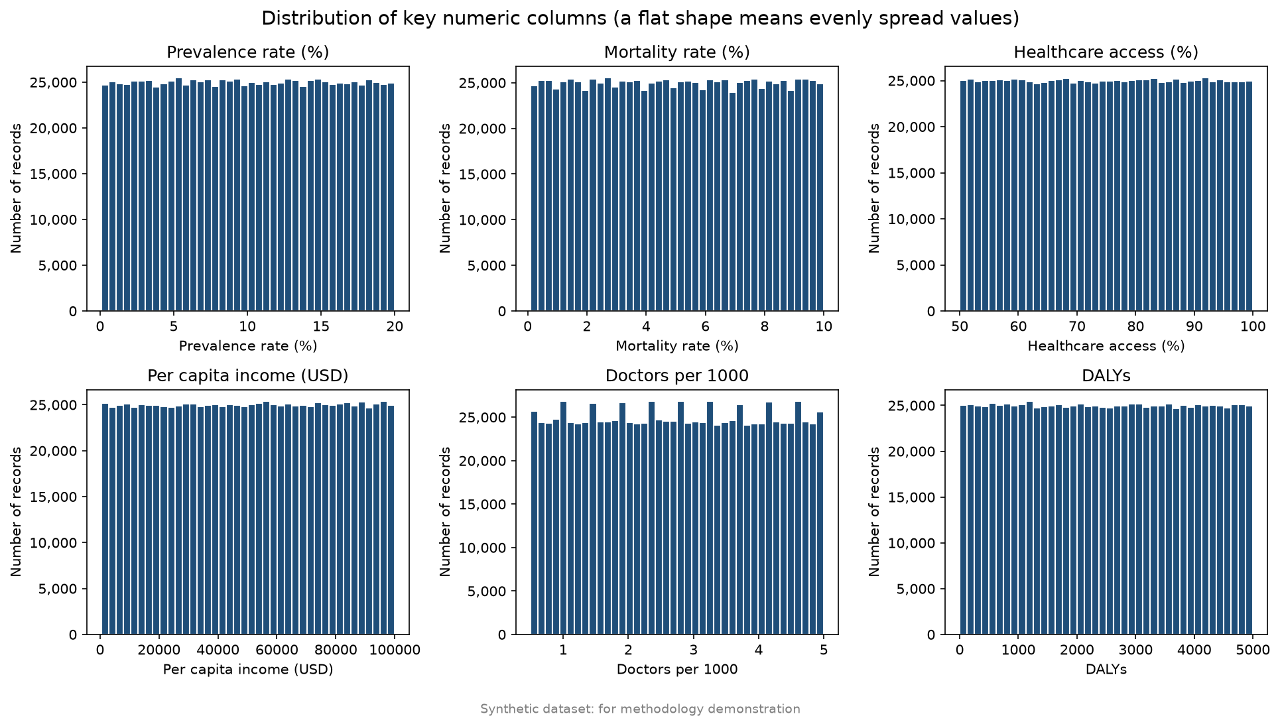
Distributions (Figure 1): all six key numeric columns are spread evenly across their ranges (flat histograms). Real health indicators usually have uneven shapes, so this supports the conclusion that the data is synthetic.

R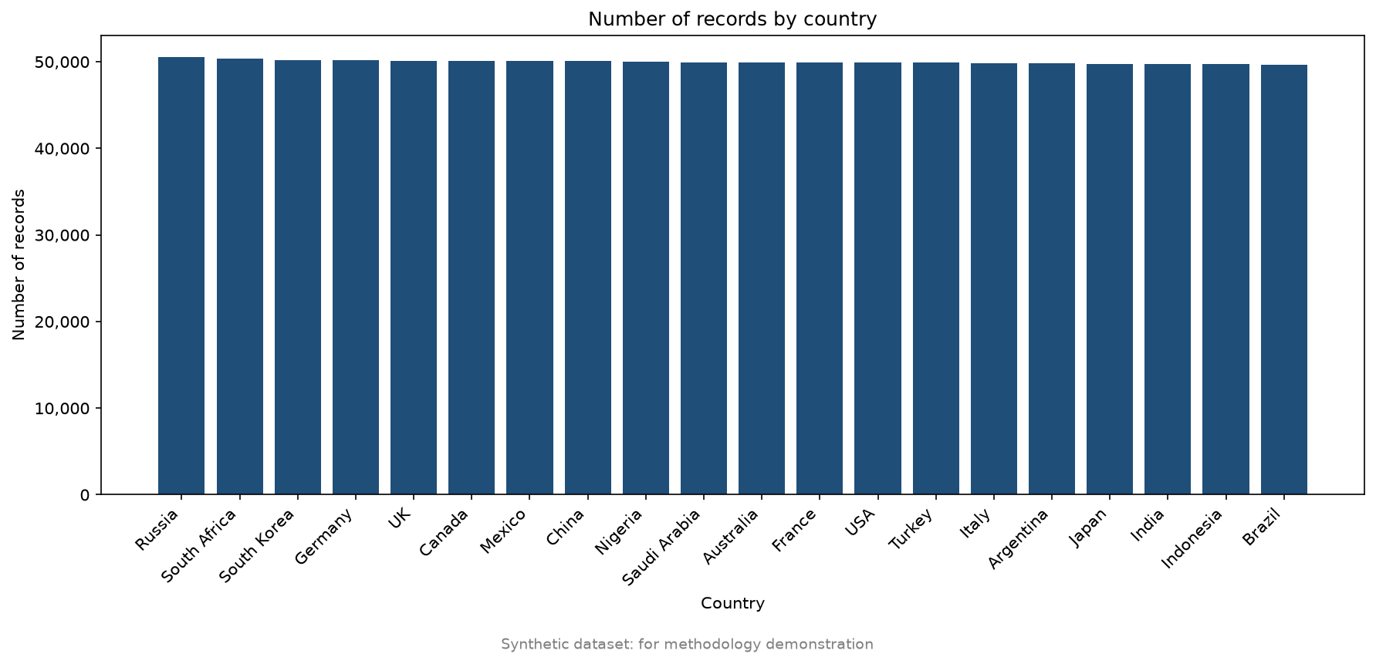ecords by country (Figure 2): each of the 20 countries has between 49,687 and 50,532 records (about 5% each).

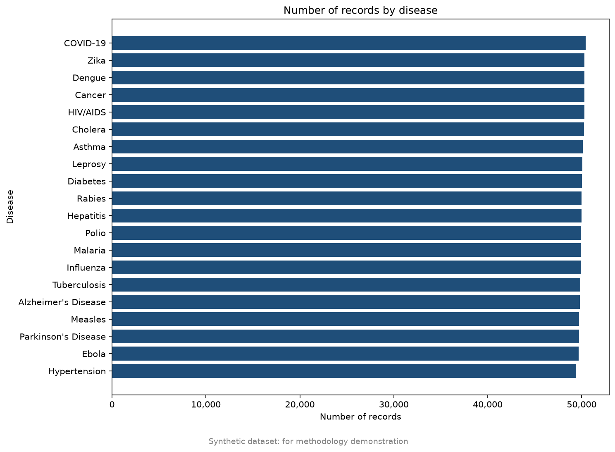
Records by disease (Figure 3): each of the 20 diseases has between 49,391 and 50,404 records.

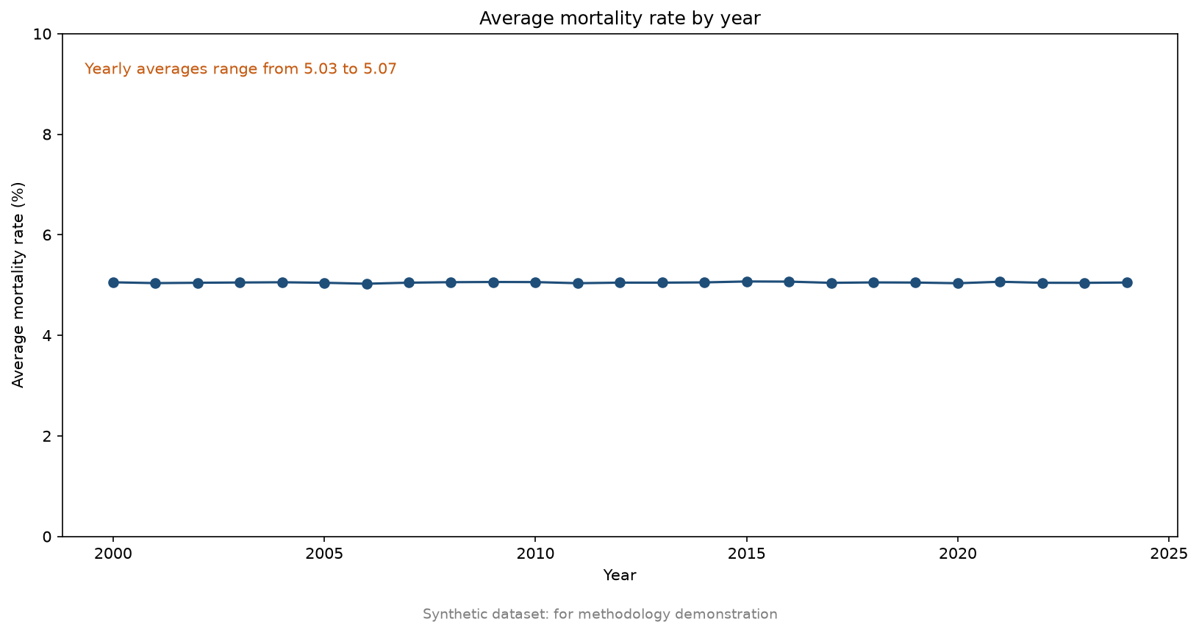
Mortality by year (Figure 4): the yearly average mortality rate stays between 5.03% and 5.07% from 2000 to 2024, so there is no trend. The axis starts at 0 so that these small differences are not exaggerated.
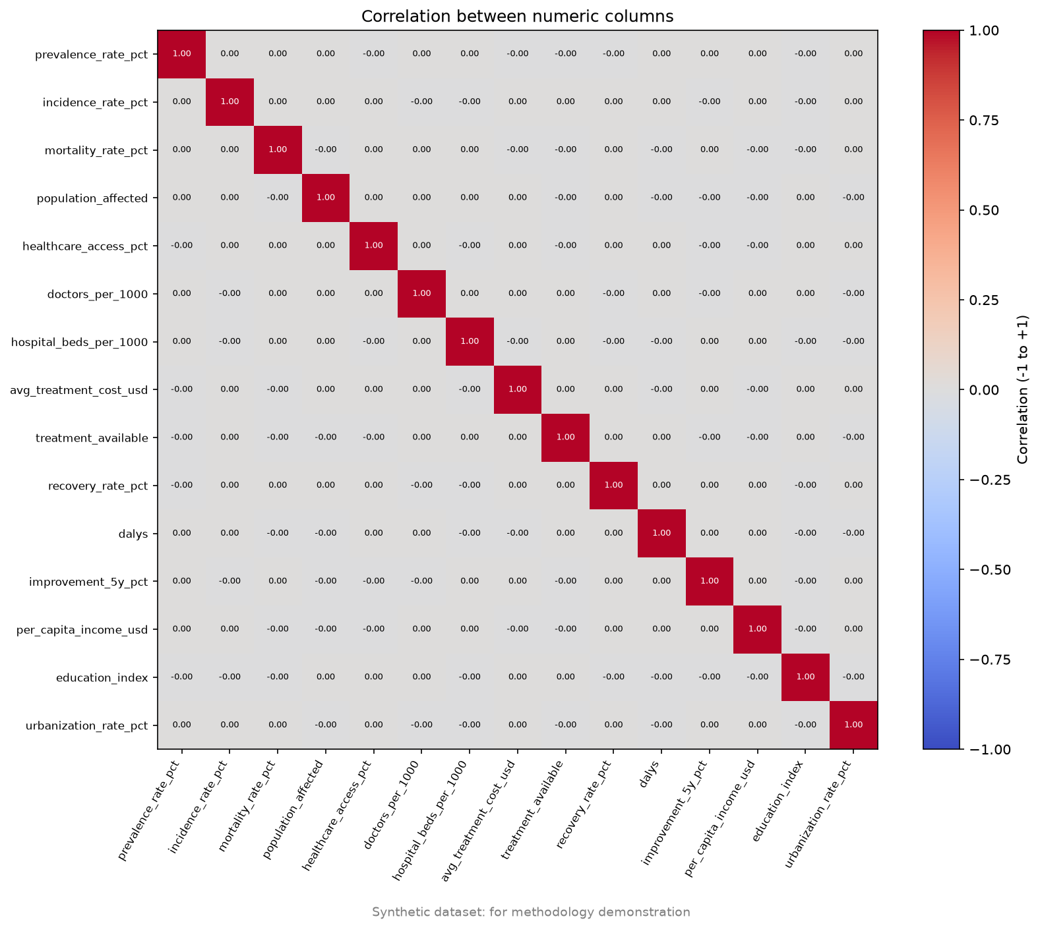
Correlations (Figure 5): correlations between different numeric columns are very close to 0 [replace with the largest absolute value printed by the script], so there are no linear relationships (for example, between income and healthcare access).

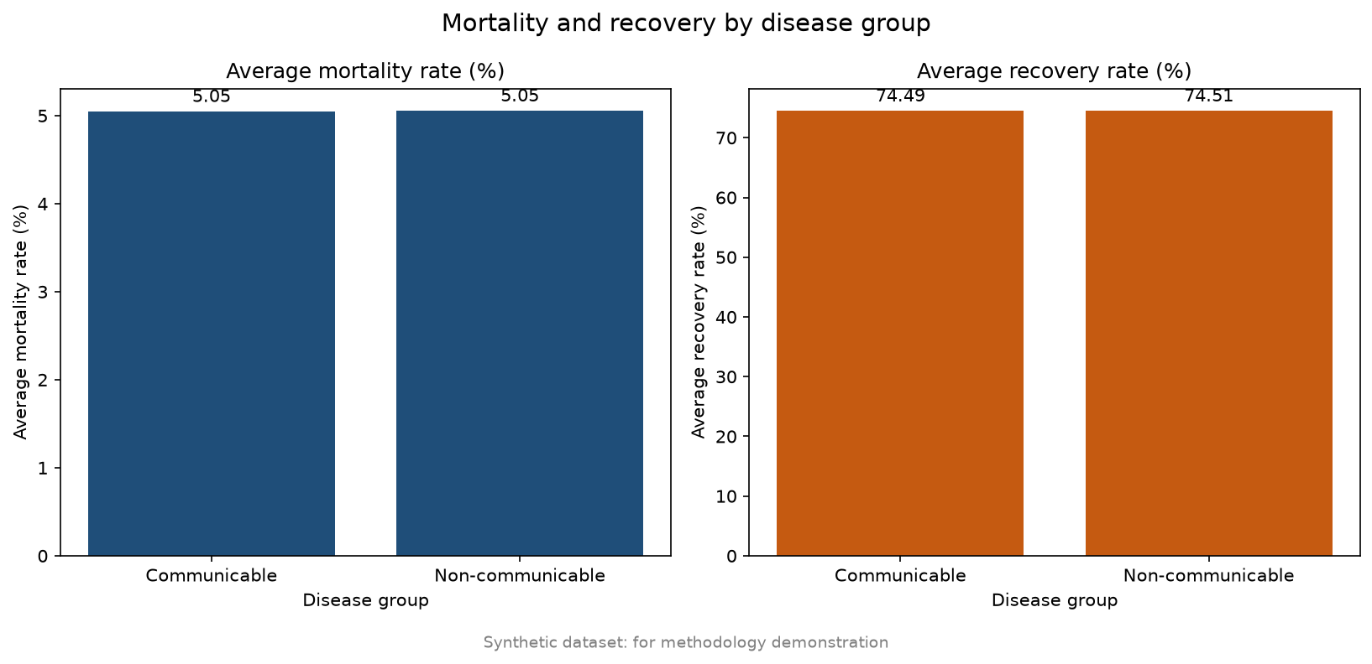
Disease groups (Figure 6): communicable and non-communicable diseases have almost identical average mortality (about 5.05%) and recovery (about 74.5%).

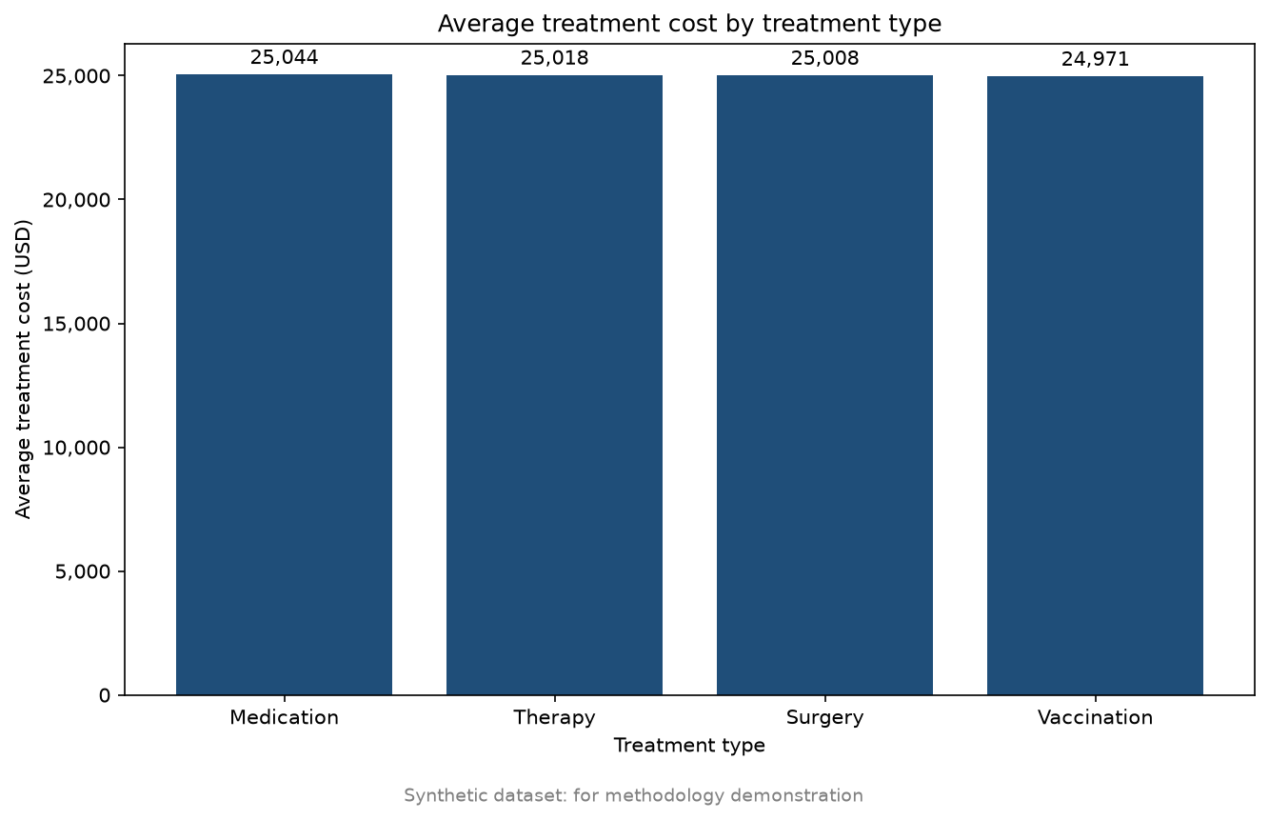
Treatment cost (Figure 7): the average cost is about USD 25,000 for all four treatment types (from 24,971 to 25,044).
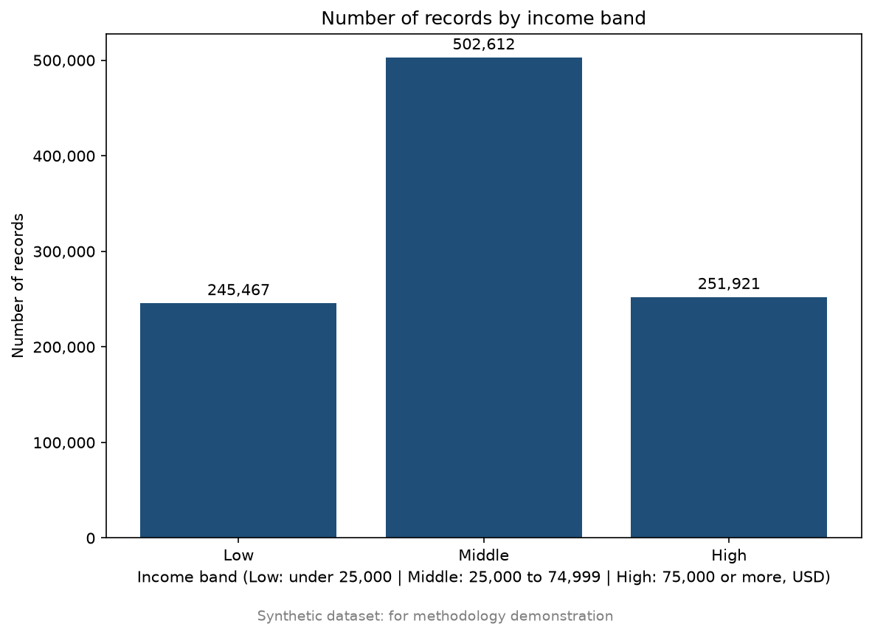Income bands (Figure 8): Low has 245,467 records (24.5%), Middle has 502,612 (50.3%), and High has 251,921 (25.2%). This split follows from applying the team’s thresholds to an evenly spread income column.
Conclusion:
The exploratory analysis is consistent with the Data Quality Assessment. The dataset is suitable for demonstrating the analytics methodology, but not for drawing real-world health conclusions.

