Data Flow and Dashboard Design
Project: Global Health Insights: An End-to-End Analysis of Global Health Statistics
Version: 1.0 (October 2026)

1. Data Flow Diagrams
Notation: rectangles are external entities, rounded shapes are processes, cylinders are data stores, solid arrows are data flows, and dotted arrows are validation flows.

1.1 Context Diagram (Level 0)
The system receives the raw dataset from Kaggle, the project team’s scripts and design decisions, and the filter selections of dashboard users. It returns dashboards and insights to users and delivers code, documents, and dashboards to the GitHub repository for the lecturer and evaluators.
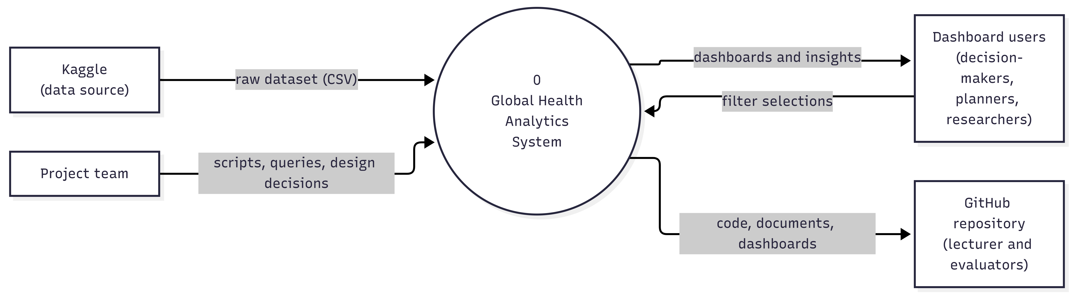

1.2 Level 1 Diagram
The system is decomposed into six processes. Data moves from the raw CSV through quality assessment and cleaning in Python, into SQL Server, through analytical views, and into the Power BI and Tableau dashboards. A separate validation process compares figures from Python, SQL, and the dashboards.
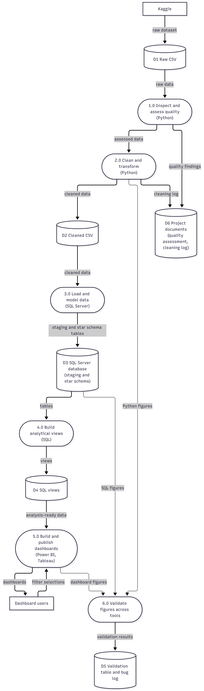

1.3 Process Descriptions
ID | Process | Tool | Inputs | Outputs
1.0 | Inspect and assess quality | Python (Spyder, pandas) | Raw CSV (D1) | Quality findings (D6), assessed data
2.0 | Clean and transform | Python (Spyder, pandas) | Assessed data | Cleaned CSV (D2), cleaning log (D6)
3.0 | Load and model data | SQL Server (SSMS) | Cleaned CSV (D2) | Staging and star schema tables (D3)
4.0 | Build analytical views | SQL Server (SSMS) | Database tables (D3) | SQL views (D4)
5.0 | Build and publish dashboards | Power BI, Tableau Public | SQL views (D4), user filter selections | Dashboards
6.0 | Validate figures across tools | Python, SQL, Power BI, Tableau | Figures from processes 2.0, 3.0, and 5.0 | Validation results (D5)

1.4 Data Stores
ID | Data store | Content | Location
D1 | Raw CSV | Original Kaggle file (1,000,000 rows, 22 columns) | Team members’ computers (not stored on GitHub)
D2 | Cleaned CSV | Cleaned and renamed dataset with derived attributes | Shared team folder
D3 | SQL Server database | Staging table and star schema (1 fact table, 8 dimension tables) | SQL Server instance
D4 | SQL views | Analysis-ready views for Power BI and Tableau | SQL Server instance
D5 | Validation table and bug log | Cross-tool comparison results and issues | GitHub (docs/04_testing)
D6 | Project documents | Data quality assessment and cleaning log | GitHub (docs)

2. Dashboard Design Guidelines
Area | Guideline
Purpose | Power BI is the executive overview with interactive filtering; Tableau Public is a complementary deep dive, so the two dashboards do not duplicate each other.
Layout | Header with title and synthetic-data notice; page navigation tabs; slicer row; KPI cards at the top; main visuals below.
Navigation | The same page order and slicer positions across pages.
Slicers | Year, country, disease, age group, gender, and treatment type where relevant.
Units and labels | Every visual has a clear title; units are shown (%, USD, per 1000); numbers use thousands separators.
Typography | Segoe UI; page title 20 pt bold; visual titles 12 pt bold; labels at least 10 pt.
Color use | Limited palette (below); the same color means the same thing on every page.
Accessibility | High contrast between text and background; color is not the only way to show meaning; alt text is added to visuals.
Transparency | A visible notice on every page: “Synthetic dataset: for methodology demonstration”.

Role | Color | Hex
Primary (headers, main series) | Deep blue | #1F4E79
Accent (highlights, notice) | Orange | #C55A11
Secondary | Teal | #2A9D8F
Neutral (borders, gridlines) | Gray | #BFBFBF
Background | Light gray | #F2F2F2

3. Measure Definitions
Measure | Definition
Total population affected | Sum of population_affected over the selected rows
Total DALYs | Sum of dalys over the selected rows
Average prevalence, incidence, mortality, and recovery rates (%) | Simple average of the row-level values over the selected rows
Average treatment cost (USD) | Simple average of avg_treatment_cost_usd
Average doctors, hospital beds per 1000, and healthcare access (%) | Simple average of the row-level values
Treatment availability rate (%) | Share of selected rows where treatment_available = 1
Rates are unweighted averages because the source data provides no weights. The same definitions are used in Python, SQL, Power BI, and Tableau so that validation figures are comparable.

4. Dashboard Page Specification

4.1 Power BI (7 pages)
# | Page | Purpose | Main visuals | Slicers | Question
1 | Overview | Summary of key measures | 4 KPI cards; line (mortality by year); bar (population affected by disease); column (DALYs by country); 2 donuts | Year, country, disease, age group, gender, treatment type | Q2, Q3, Q6, Q7
2 | Disease Burden | Where the burden is highest | Bar (population affected by disease); column (DALYs by country); stacked column (age group and gender); matrix (disease by country) | Year, country, disease, age group, gender | Q2
3 | Mortality and Recovery | Severity of diseases | Clustered bar (mortality and recovery by disease); bar by disease group (communicable vs. non-communicable); ranked table | Year, country, age group, gender | Q3
4 | Healthcare Capacity | Resources by country | 3 KPI cards; bar (doctors and beds by country); heat map (access by country and year); table (lowest capacity) | Year, country, income band | Q4
5 | Socioeconomic | Income, education, urbanization vs. outcomes | Scatter (income vs. access); scatter (education vs. recovery); column (recovery by income band) | Year, country | Q5
6 | Treatment | Effectiveness and cost | Column (cost by treatment type); column (recovery by treatment type); clustered column (recovery by availability); scatter (cost vs. recovery) | Year, country, disease group | Q6
7 | Trends | Change over time | Line (mortality, prevalence, recovery by year); line (5-year improvement by disease group); yearly summary table | Country, disease, age group | Q7

4.2 Tableau Public (1 dashboard)
Dashboard | Main visuals | Filters | Question
Deep Dive | Map (average mortality by country); heat map (mortality by disease and age group); line (yearly trend); bar (average treatment cost by treatment type) | Year, country, disease group, age group, gender | Q2, Q3, Q6, Q7

5. Wireframes
Each box shows the planned visual and the analytical question it answers (Q2, Q3, and so on). Values in the cards are placeholders. All seven Power BI pages share the same structure: a header with the synthetic-data notice, page tabs, a slicer row, and visuals arranged on a 12-column grid. The Tableau Public dashboard uses a filter pane on the left and four visuals on the right.
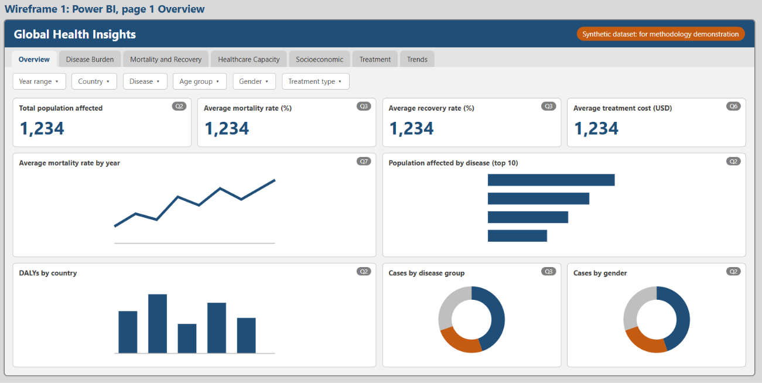
Figure 3: Power BI, page 1 Overview.
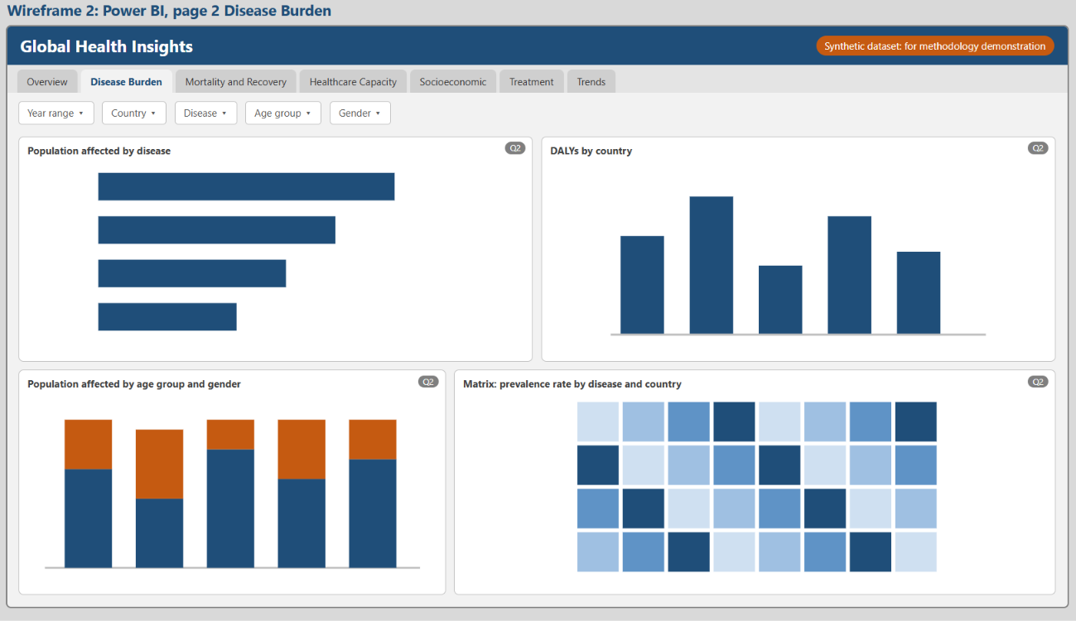
Figure 4: Power BI, page 2 Disease Burden.

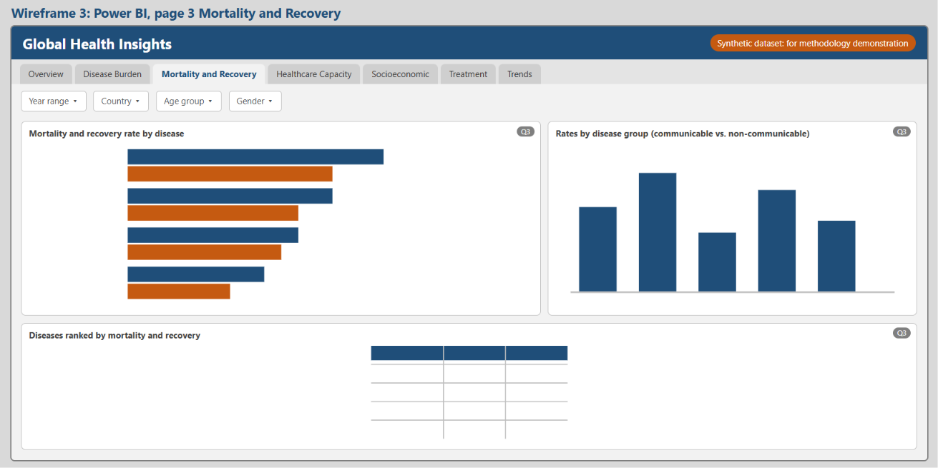
Figure 5: Power BI, page 3 Mortality and Recovery.
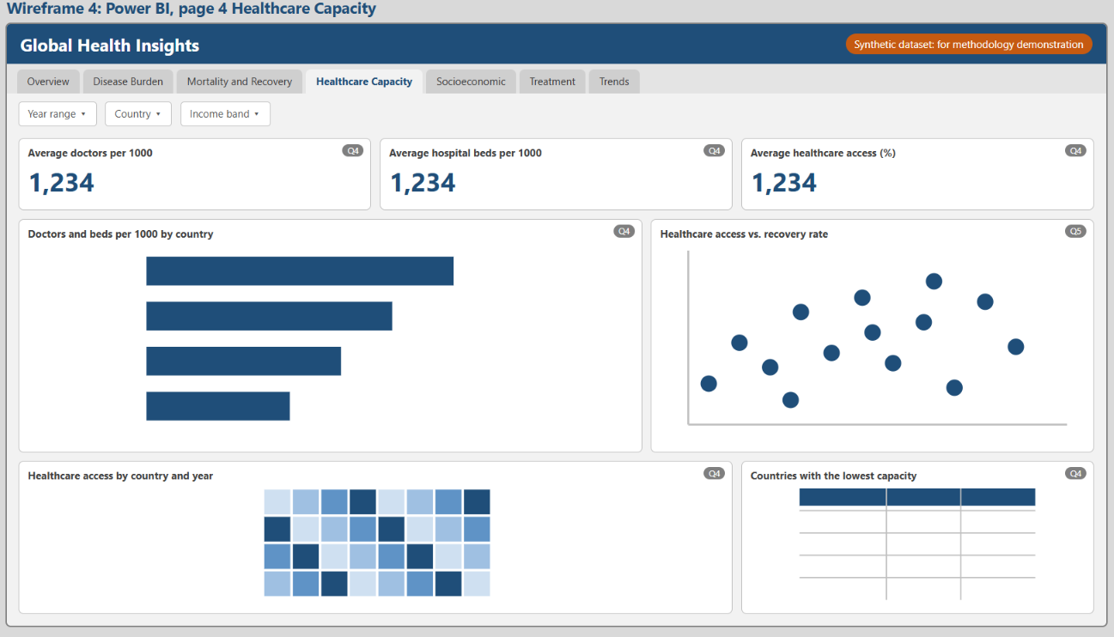
Figure 6: Power BI, page 4 Healthcare Capacity.

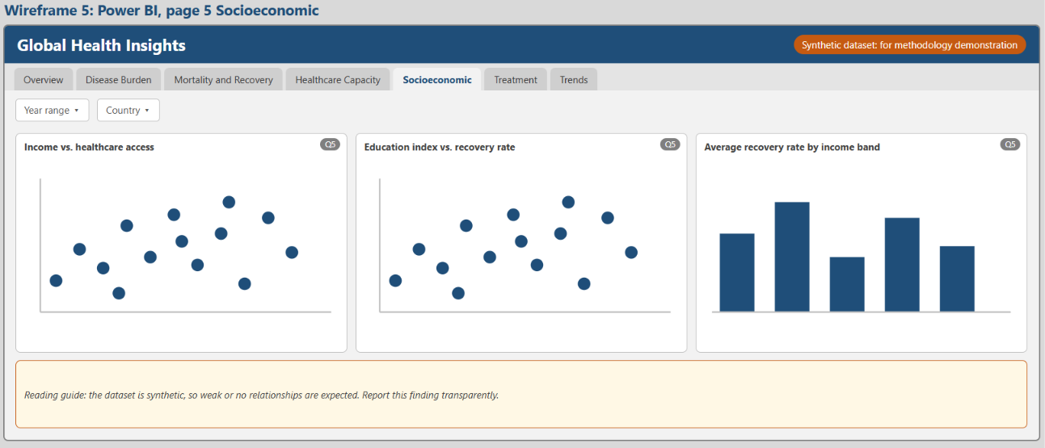
Figure 7: Power BI, page 5 Socioeconomic.
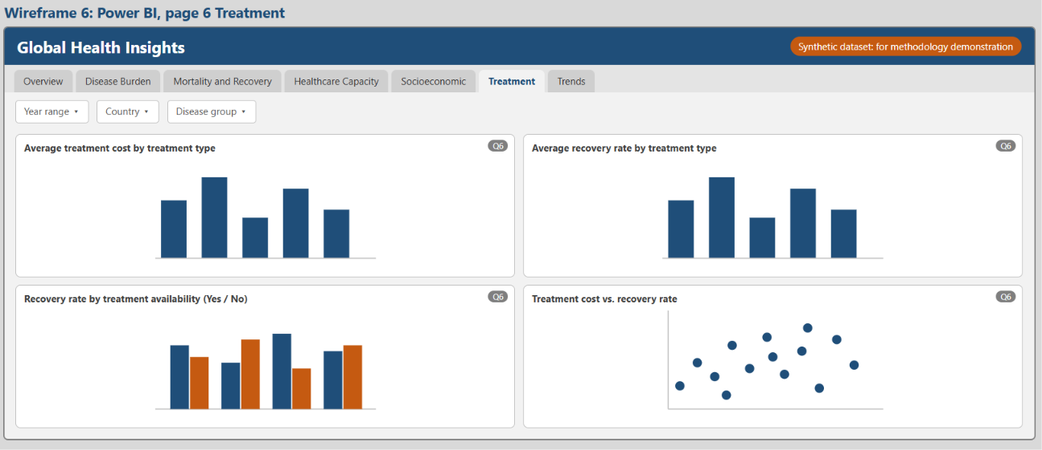
Figure 8: Power BI, page 6 Treatment.

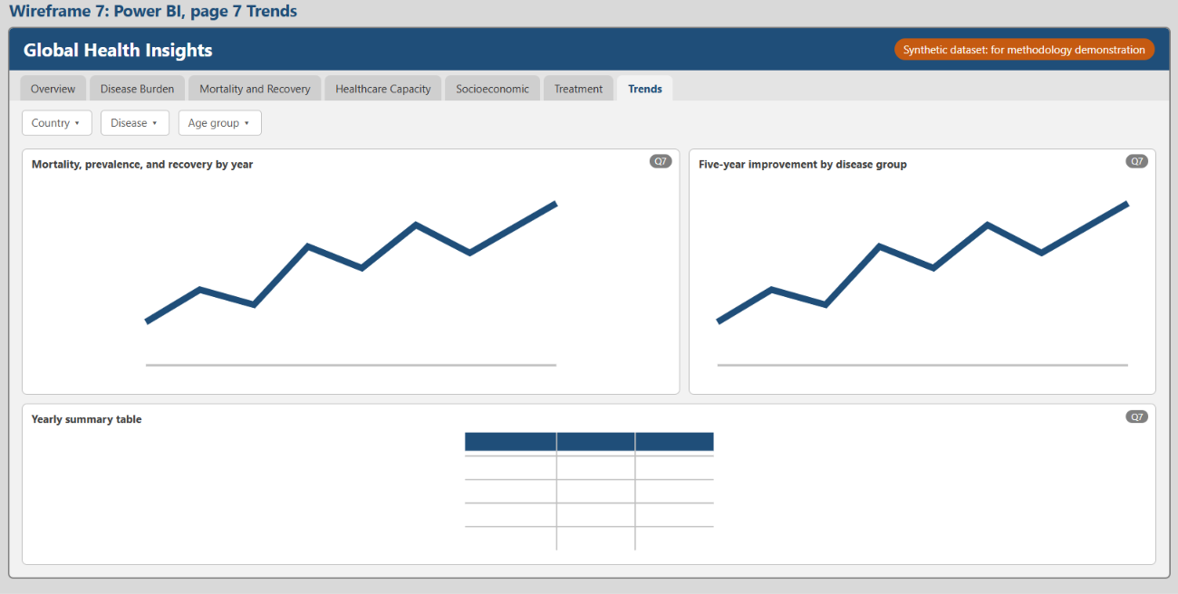Figure 9: Power BI, page 7 Trends.
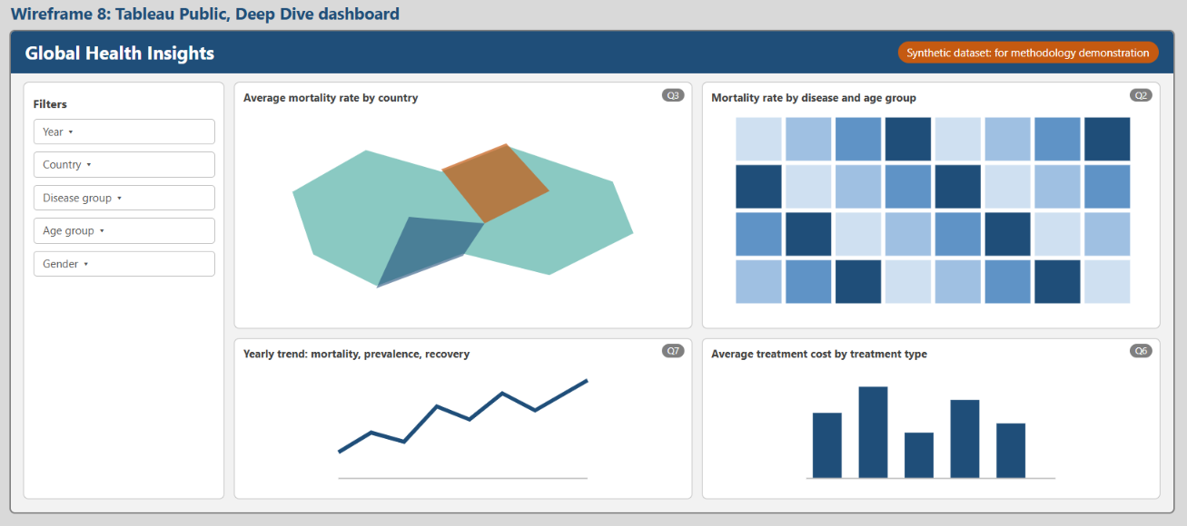
Figure 10: Tableau Public, Deep Dive dashboard.

