Data Model and Pipeline Design
Project: Global Health Insights: An End-to-End Analysis of Global Health Statistics
Version: 1.0 (October 2026)

1. Overview and Pipeline Architecture
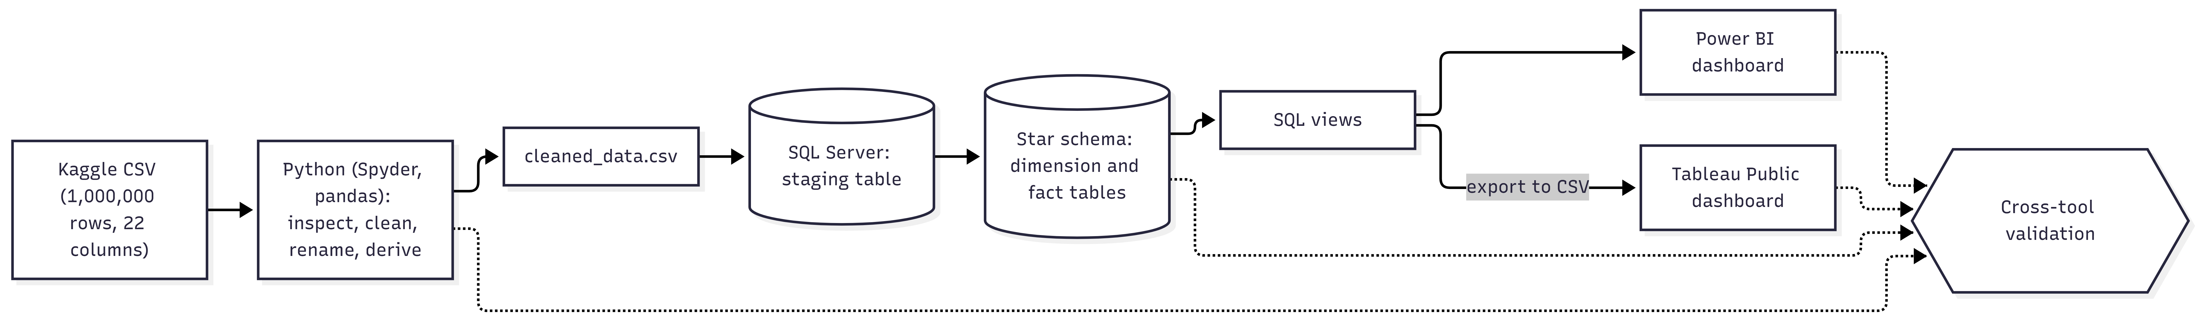
The solution follows a layered pipeline. Raw data from Kaggle is inspected, cleaned, renamed, and enriched with derived attributes in Python. The cleaned file is loaded into a SQL Server staging table, then distributed into a star schema (dimension and fact tables). SQL views expose analysis-ready data to Power BI (direct connection) and Tableau Public (CSV export). A cross-tool validation step compares key figures across Python, SQL, Power BI, and Tableau.

Layer | Tool | Input | Output
Source | Kaggle | none | Global Health Statistics.csv (1,000,000 rows, 22 columns)
Preparation | Python (Spyder, pandas) | Raw CSV | cleaned_data.csv, cleaning log, EDA charts
Storage | SQL Server (SSMS) | cleaned_data.csv | Staging table and star schema tables
Serving | SQL views | Star schema | Analysis-ready views
Presentation | Power BI, Tableau Public | Views (direct connection or CSV export) | Interactive dashboards
Quality | Python, SQL, Power BI, Tableau | Selected metrics | Validation table

2. Design Decisions
# | Decision | Rationale
D1 | Use a star schema (one fact table, eight dimension tables). | It is simple to query and works well with Power BI and Tableau.
D2 | Store disease category in its own dimension, not as an attribute of disease. | The data quality tests showed that every disease appears under all 11 categories, so the category is not a property of the disease.
D3 | Add a derived attribute disease_group (communicable / non-communicable) to the disease dimension. | It supports analysis by disease type. It is created by the team and is not part of the original dataset.
D4 | Keep country indicators (income, education, urbanization, healthcare access, doctors, beds) in the fact table. | These values vary between rows of the same country and year, so they cannot be stored as country attributes.
D5 | Keep a raw staging table. | It preserves the loaded data for traceability and row-count reconciliation.
D6 | Use integer surrogate keys in dimensions. | Faster joins and a stable model if source labels change.
D7 | Derive an income band (low, middle, high) at load time. | It supports comparison by income level in the dashboards.

3. Column Mapping
Original column | Standard name | Notes
Country | country | Dimension: dim_country
Year | year | Dimension: dim_year
Disease Name | disease_name | Dimension: dim_disease
Disease Category | disease_category | Dimension: dim_disease_category
Prevalence Rate (%) | prevalence_rate_pct | Measure
Incidence Rate (%) | incidence_rate_pct | Measure
Mortality Rate (%) | mortality_rate_pct | Measure
Age Group | age_group | Dimension: dim_age_group
Gender | gender | Dimension: dim_gender
Population Affected | population_affected | Measure
Healthcare Access (%) | healthcare_access_pct | Measure
Doctors per 1000 | doctors_per_1000 | Measure
Hospital Beds per 1000 | hospital_beds_per_1000 | Measure
Treatment Type | treatment_type | Dimension: dim_treatment_type
Average Treatment Cost (USD) | avg_treatment_cost_usd | Measure
Availability of Vaccines/Treatment | treatment_available | Yes/No converted to Boolean (bit)
Recovery Rate (%) | recovery_rate_pct | Measure
DALYs | dalys | Measure
Improvement in 5 Years (%) | improvement_5y_pct | Measure
Per Capita Income (USD) | per_capita_income_usd | Measure; also used to derive income band
Education Index | education_index | Measure
Urbanization Rate (%) | urbanization_rate_pct | Measure
(derived) | disease_group | Communicable / Non-communicable
(derived) | income_band | Low / Middle / High

4. Logical and Physical Schema

4.1 Dimension tables
Table | Column | SQL Server type | Key | Description
dim_country | country_id | INT IDENTITY | PK | Surrogate key
dim_country | country_name | NVARCHAR(50) | Unique | Country name (20 values)
dim_disease | disease_id | INT IDENTITY | PK | Surrogate key
dim_disease | disease_name | NVARCHAR(50) | Unique | Disease name (20 values)
dim_disease | disease_group | NVARCHAR(30) |  | Communicable or Non-communicable
dim_disease_category | disease_category_id | INT IDENTITY | PK | Surrogate key
dim_disease_category | category_name | NVARCHAR(50) | Unique | Category (11 values)
dim_age_group | age_group_id | INT IDENTITY | PK | Surrogate key
dim_age_group | age_group_label | NVARCHAR(10) | Unique | 0-18, 19-35, 36-60, 61+
dim_age_group | sort_order | INT |  | Display order
dim_gender | gender_id | INT IDENTITY | PK | Surrogate key
dim_gender | gender_name | NVARCHAR(10) | Unique | Male, Female, Other
dim_treatment_type | treatment_type_id | INT IDENTITY | PK | Surrogate key
dim_treatment_type | treatment_type_name | NVARCHAR(30) | Unique | Medication, Surgery, Therapy, Vaccination
dim_year | year | INT | PK | Calendar year (2000 to 2024)
dim_year | decade | INT |  | Decade (2000, 2010, 2020)
dim_income_band | income_band_id | INT IDENTITY | PK | Surrogate key
dim_income_band | band_name | NVARCHAR(20) | Unique | Low, Middle, High
dim_income_band | min_income | INT |  | Lower bound (USD)
dim_income_band | max_income | INT |  | Upper bound (USD)
The income band thresholds are proposed values and will be confirmed during data preparation.

4.2 Fact table: fact_health_stats (expected 1,000,000 rows)
Column | SQL Server type | Key | Description
health_stat_id | INT IDENTITY | PK | One row per source record
country_id | INT | FK | References dim_country
disease_id | INT | FK | References dim_disease
disease_category_id | INT | FK | References dim_disease_category
age_group_id | INT | FK | References dim_age_group
gender_id | INT | FK | References dim_gender
treatment_type_id | INT | FK | References dim_treatment_type
year | INT | FK | References dim_year
income_band_id | INT | FK | References dim_income_band
prevalence_rate_pct | DECIMAL(5,2) |  | Percentage of population affected
incidence_rate_pct | DECIMAL(5,2) |  | Percentage of new cases
mortality_rate_pct | DECIMAL(5,2) |  | Percentage of affected population that dies
population_affected | INT |  | Number of individuals affected
healthcare_access_pct | DECIMAL(5,2) |  | Percentage with healthcare access
doctors_per_1000 | DECIMAL(4,2) |  | Doctors per 1000 people
hospital_beds_per_1000 | DECIMAL(4,2) |  | Hospital beds per 1000 people
avg_treatment_cost_usd | INT |  | Average treatment cost in USD
treatment_available | BIT |  | Vaccine or treatment available (1 = yes)
recovery_rate_pct | DECIMAL(5,2) |  | Percentage who recover
dalys | INT |  | Disability-adjusted life years
improvement_5y_pct | DECIMAL(4,2) |  | Improvement over five years
per_capita_income_usd | INT |  | Average income per person (USD)
education_index | DECIMAL(3,2) |  | Education index
urbanization_rate_pct | DECIMAL(5,2) |  | Percentage living in urban areas

5. Entity-Relationship Diagram
The fact table is related to each dimension through a one-to-many relationship: one dimension row can appear in many fact rows. 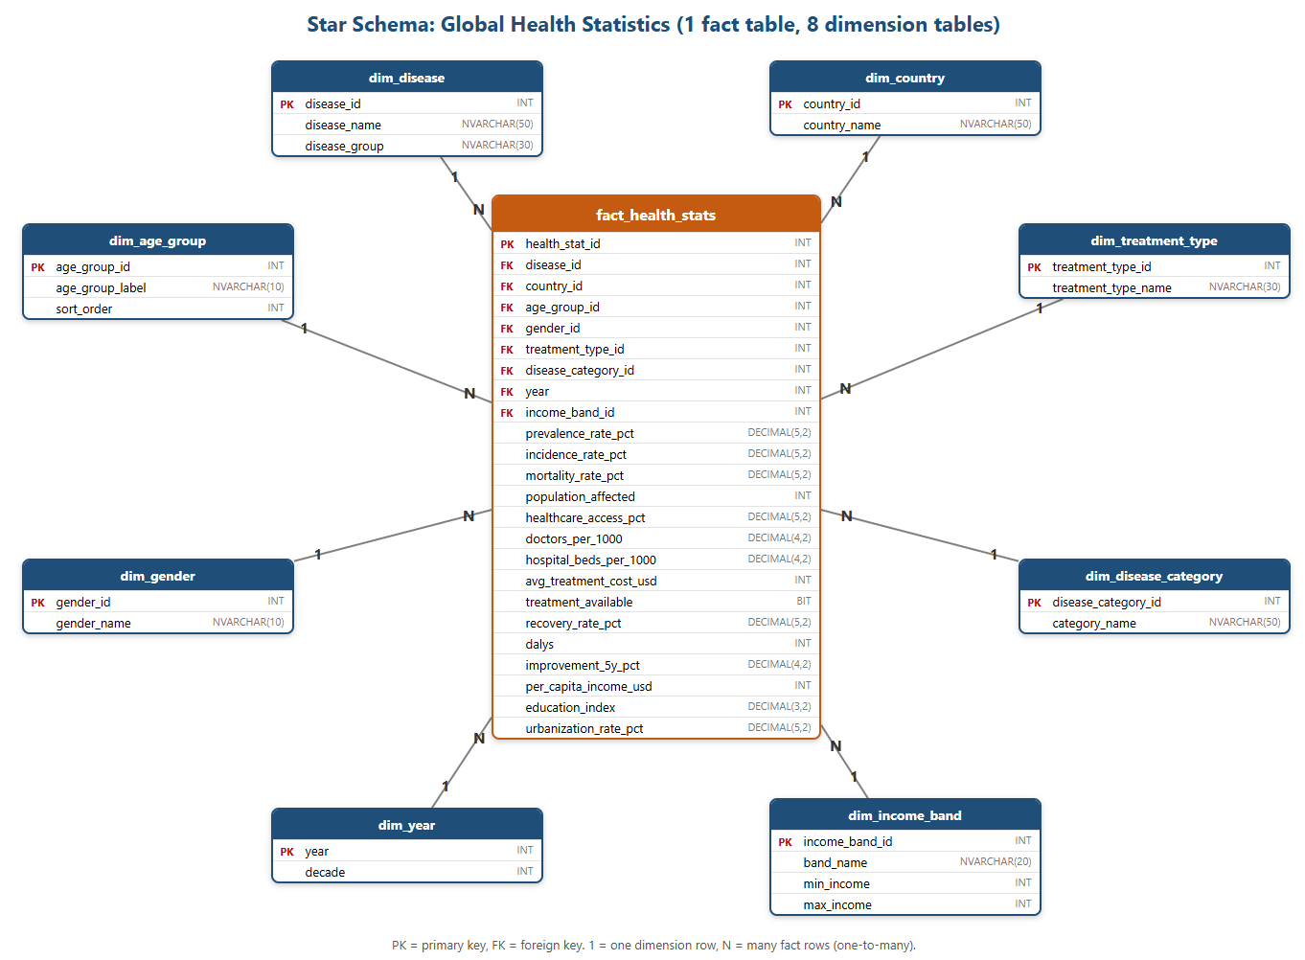
Figure 2: Star schema with the fact table at the center and eight dimension tables around it.

6. Planned SQL Views
View | Purpose | Question
vw_disease_burden | Population affected, DALYs, prevalence, and incidence by country, disease, year, age group, and gender | Q2
vw_mortality_recovery | Mortality and recovery by disease and disease group | Q3
vw_healthcare_capacity | Doctors, beds, and healthcare access by country and year | Q4
vw_socioeconomic | Income, education, and urbanization against access, recovery, and mortality | Q5
vw_treatment | Treatment type, cost, availability, and recovery | Q6
vw_yearly_trends | Yearly averages of mortality, prevalence, and recovery | Q7
vw_validation_metrics | Fixed set of totals and averages used for cross-tool validation | Q8

7. Integrity Checks at Load
# | Check | Expected result
1 | Row count of fact_health_stats | 1,000,000
2 | Row count of the staging table | 1,000,000
3 | Foreign keys with no matching dimension row | 0
4 | Dimension row counts | 20 countries, 20 diseases, 11 categories, 4 age groups, 3 genders, 4 treatment types, 25 years, 3 income bands
5 | Sum of population_affected in fact table versus cleaned file | Identical

