Agentic Code Review: MVP
14 October 2026. A written report of the MVP notebook. It replaces the notebook submitted the first time (CAI5_IND5_G1-agentic-pr-review-mvp.ipynb).

Team members:
- Mohammed Gamal Kenawy (team leader)
- Mahmoud Ayman Mahmoud
- Yahia Ahmed Hamed
- Abdelrahman Ehab
- Mohamed Ali Mahmoud
- Ahmed Shahin

1. What the MVP is
A command-line reviewer for TypeScript and JavaScript changes. One command reads a change set, sends it to a language model in a single pass, and prints findings in which every finding shows its evidence or says it is unverified, followed by what the review did not check. The notebook drives exactly the call that the agentic-review review command makes, from Python, so each step can be read.
Behind the call is a fixed pipeline owned by our code, not by the model. The model is used in one step only, and findings enter the report only through a schema-checked tool call, never by parsing the model's prose:
preflight → resolve the change set → parse and context (stub) → run checks (stub)
→ load project rules (stub) → assemble context → review (the one model step) → build the report
 | State on 14 October 2026
Built | Review of uncommitted changes, of a branch range, and of a public GitHub pull request by its address. Typed evidence on every finding or an "unverified" label. A report of degradations: what was skipped and why. JSON output. Optional Langfuse tracing. 346 offline tests and a CI matrix on Python 3.12/3.13, Linux and Windows
Not built | Running the project's own tests and type-check as evidence; gathering related code; the project's own rules; the regression set that measures a catch rate; posting findings on the pull request (the GitHub Action, version 3)

2. What changed since the first submission
 | First submission (run of 26 September 2026) | This version (9 October 2026)
What it reviews | Uncommitted changes in a local repository | Uncommitted changes, a branch range, and a public pull request named by its address
Tracing | None | Every review can be sent to Langfuse as one trace, with a span per pipeline step and each model call; secrets are masked before anything leaves the machine
Result on the demo | 2 findings; 2 of 6 planted defects found; 2 files never named by the model (reported as a degradation) | 5 findings covering all 6 planted defects, every one labelled "unverified"
Failure cases shown | None | A malformed pull-request address and a repository that does not exist, both stopped before any model call

3. How to run it
- Install with uv sync (Python 3.12 or later) and select the project's .venv kernel.
- Put the provider key in .env as AGENTIC_REVIEW_API_KEY. Optional: LANGFUSE_PUBLIC_KEY, LANGFUSE_SECRET_KEY and LANGFUSE_BASE_URL to trace each review.
- Build the demo repository with scripts/make_review_demo.py, or point REPO at any git repository with uncommitted changes.
- Run the cells from the top. Section 5's range and pull-request runs are skipped unless their settings are filled in.
The settings cell, as saved:
REPO = PROJECT.parent / "review-demo" # the repository to review
SCOPE = None # None = default, or "working-tree" | "range"
MODEL = "qwen/qwen3.8-27b"
BASE_URL = "https://api.groq.com/openai/v1"
The review itself is three lines:
request = ReviewRequest(cwd=REPO, scope=SCOPE, base=BASE)
result = traced_review(request, label="working tree", port_factory=override_model)
# traced_review is run_review inside one Langfuse trace; without Langfuse it is run_review
run_review returns one of two things: a preflight failure (the repository, configuration or key was not usable, and nothing was reviewed), or a review report, which is produced even when something degraded. A silent failure would look like a clean review, so the report always lists its degradations.

4. Run 1: the demo repository with planted defects
The demo is a small TypeScript project with an uncommitted change into which six defects were planted, listed in PLANTED_DEFECTS.md. The run used qwen/qwen3.8-27b through Groq and took 2.7 seconds.
The tool's output, as saved in the notebook (abridged):
Scope: uncommitted changes in the working tree (default) · 7 files
Reviewed (4): src/format.js src/retry.ts src/search.ts src/users.ts
Listed, not reviewed (3):
PLANTED_DEFECTS.md (not TypeScript or JavaScript)
README.md (not TypeScript or JavaScript)
src/legacy.ts (deleted)
Excluded (1): dist/bundle.js (default:build-output)

No checks were run in this build.
No related context was gathered in this build.

src/search.ts:4 blocking security
evidence: unverified: The diff shows the parameterized query was replaced with
string concatenation of untrusted input, but I cannot verify the exact line number ...
src/users.ts:6 important error-handling (the await was removed)
src/users.ts:14-18 blocking correctness (empty-array guard removed; < became <=)
src/format.js:2 nit maintainability (unused variable)
src/retry.ts:1-10 important error-handling (errors swallowed, returns undefined)

Findings: 2 blocking / 2 important / 1 nit
Verdict: blocking. At least one finding is blocking.
Planted defects against findings:
Planted defect | Expected | Found as
src/search.ts:4: parameterised query became string concatenation (SQL injection) | blocking, security | blocking, security
src/users.ts:6: return fetchUser(id) without await; a rejection escapes the try/catch | important or blocking, error-handling | important, error-handling
src/users.ts:15-16: i <= users.length reads one element past the end | blocking, correctness | One finding, src/users.ts:14-18, blocking, correctness, naming both defects
src/users.ts:13-19: empty-array guard removed, averageAge([]) returns NaN | important, correctness | (the same finding as above)
src/retry.ts:5-7: every error swallowed; the caller gets undefined | important, error-handling | important, error-handling
src/format.js:2: unused is computed and never read | nit, maintainability | nit, maintainability

What this run shows, and what it does not. All six planted defects were named, at the expected severity, and the report says plainly that no checks ran and no related context was gathered. But every finding is labelled "unverified": the model says it cannot confirm the line numbers in the new file. The short description of each finding carries only the function's name, with the explanation in the evidence note. This is one run, on a demo whose defects we planted ourselves; it is not a catch rate, and the regression set that would measure one is not built. The first submission's run of the same demo, on another model (openai/gpt-oss-120b), found two of the six.

5. Run 2: a real public pull request
The same call reviews a public GitHub pull request by its address. Here: microsoft/playwright#43199, 16 files, against the repository's default branch.
pr_request = ReviewRequest(cwd=Path.cwd(), pr="https://github.com/microsoft/playwright/pull/43199")
pr_report = show(traced_review(pr_request, label="pull request", port_factory=port_factory))
The pull request is read through a temporary history-only clone. Nothing from it is executed and no configuration is read from it, because a pull request is a stranger's code and the configuration file names where the API key is sent. The clone is deleted when the run ends; the notebook's last line confirms none was left behind.
Scope: pull request microsoft/playwright#43199 against main, the default branch · 16 files
Reviewed (10) Listed, not reviewed (6): workflow, DEPS.list and shell files

packages/playwright-core/src/server/registry/index.ts:1027-1037 important correctness
_prepareLinkTarget
evidence: unverified: The diff shows the new method but not the surrounding code that
calls it; I cannot verify whether the link target is created before the link is written.

Findings: 0 blocking / 1 important / 0 nit
Degradation [CF-6] provider-error: ... HTTP 413 ... Request too large for model
`qwen/qwen3.8-27b` ... input tokens per minute (ITPM): Limit 7000, Requested 7126 ...
Degradation [CF-6] incomplete-file-coverage: No emit_finding call ... ever named: (9 files)
Verdict: findings, none blocking.

14.6s, including the clone
temporary clones left behind: none
Reading it. One finding, labelled unverified, on one of the ten reviewed files. The provider's free tier refused a turn as too large (7,126 input tokens against a 7,000-a-minute limit), and the report says so instead of passing for a clean review; it also names the nine files the model never commented on. The finding has not been confirmed with Playwright's maintainers, and the pull request was later closed without merging.

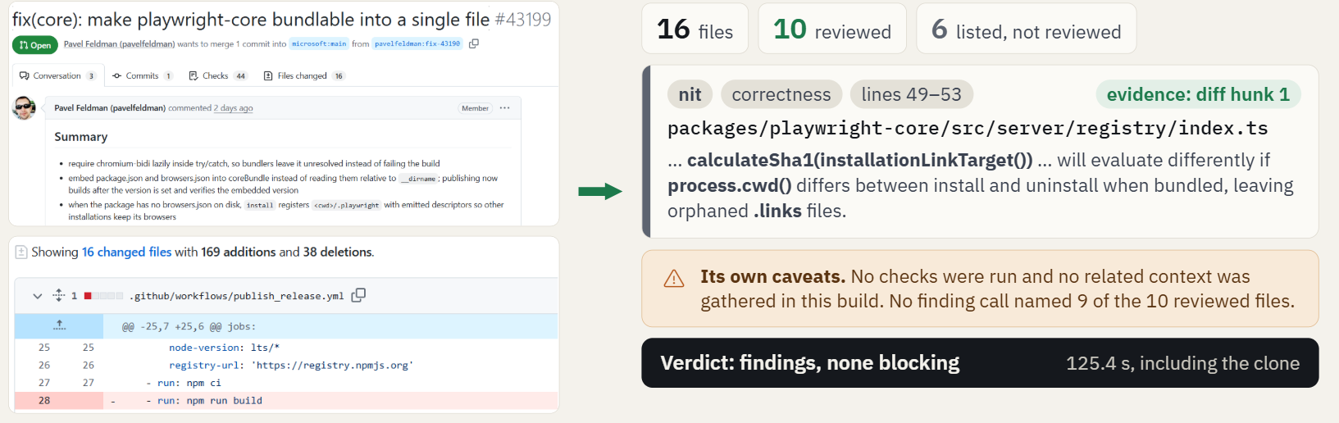

6. Two pull requests that cannot be read
The notebook also shows two preflight failures, both stopped before any model call: a malformed address (acme/widgets#7), and a repository that does not exist, which must fail with a message, never with a login prompt.

7. Tracing with Langfuse (optional)
In the trace | What it is
Name review-change-set | The same for every run; the scope is a tag, the model and system prompt are metadata
Input and output | The request, and the verdict with its finding counts and degradations
One span per pipeline step | preflight, resolve_change_set … build_report
review_agent | Each model call as a generation: model, token usage, messages, and a link to the managed system prompt
Session | Every run of one notebook kernel, side by side

What leaves the machine: the diff under review and the model's replies go to the team's Langfuse project. The provider key and the Langfuse secret are masked out of everything sent, and an automated test checks that no trace carries a credential.

8. Limits to state whenever the MVP is shown
- No checks run yet. Evidence today is the part of the change a finding rests on. Running the project's tests and type-check is specified, not built.
- No measured catch rate. The runs above are demonstrations. On the costing model, Gemini 3.8 Flash, five measured runs reported no finding, and the build could not tell "nothing to report" from "did not use the finding tool".
- The context is shallow. At the depth version 1 reaches, the reviewer can judge whether a change is sound in itself, not whether it breaks an assumption held by code it never looked at.
- The reviewer is only partly served. Version 1 was specified for the author before they push; reading a public pull request is the first thing it does for the reviewer. Nothing is posted on the pull request, and private repositories are out of reach.

