**STATISTICAL THEORY**

**FINAL EXAM**

**Jaybez Renmeire**

**2019151921**

**Github Link: https://github.com/nhale42x/Statistical-Theory/blob/1fc7df4ff99238ecd390874dca5a2057509c57a8/SatsTheory_RENMEIRE_FINALS.r**

1.



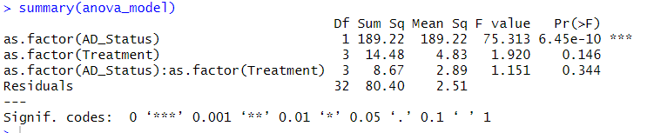

**Main Effect of Mouse Type (AD_Status)**

The main effect of mouse type, represented by the factor `as.factor(AD_Status)`, shows a statistically significant influence on memory errors. With 1 degree of freedom, the F-value is 75.313, indicating a very strong effect. The p-value associated with this effect is 6.45e-10, which is well below the 0.001 threshold for statistical significance. This suggests that the genetic modification in transgenic mice has a substantial impact on memory performance, leading to more memory errors compared to wild-type mice.

**Main Effect of Drug Type (Treatment)**

The main effect of drug type, represented by `as.factor(Treatment)`, was analyzed across four drug levels (3 degrees of freedom). The F-value is 1.920, a relatively small value, and the p-value is 0.146, which exceeds the 0.05 threshold for significance. Therefore, the analysis indicates that drug type does not have a statistically significant effect on memory errors. The findings suggest that, on average, the type of drug administered does not play a major role in influencing memory performance in this dataset.

**Interaction Effect of Mouse Type and Drug Type**

The interaction effect between mouse type and drug type, represented by `as.factor(AD_Status):as.factor(Treatment)`, was also assessed. The F-value is 1.151, and the associated p-value is 0.344, both of which indicate a lack of statistical significance. This suggests that the effect of drug type on memory errors does not depend on whether the mouse is transgenic or wild type. In other words, there is no evidence of a combined influence of mouse type and drug type on memory performance.

**Residuals and Overall Interpretation**

The residuals represent the variability in memory errors not explained by the model, with a mean square value of 2.51 indicating the level of error variability. Overall, the analysis reveals that mouse type significantly affects memory performance, with transgenic mice exhibiting worse memory than wild-type mice. However, the type of drug administered does not have a significant effect on memory errors, nor is there evidence of an interaction between mouse type and drug type.



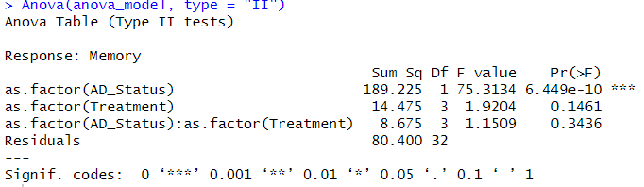

**Main Effect of Mouse Type (`as.factor(AD_Status)`):**

Mouse type significantly impacts memory performance, with transgenic mice (genetically modified for Alzheimer's) making more memory errors than wild-type mice. This is supported by a large F-value (75.3134) and a highly significant p-value (`6.449e-10`), indicating a strong and consistent difference between the two groups.

**Main Effect of Drug Type (`as.factor(Treatment)`):**

Drug type does not significantly affect memory performance, as evidenced by a small F-value (1.9204) and a non-significant p-value (0.1461). This suggests that none of the four drugs tested substantially reduced memory errors in the mice.

**Interaction Effect (`as.factor(AD_Status):as.factor(Treatment)`):**

There is no significant interaction between mouse type and drug type on memory performance, with an F-value of 1.1509 and a p-value of 0.3436. This indicates that the effectiveness of the drugs does not depend on whether the mice are transgenic or wild type.

**Comparison of Training Day Errors Based on Drug Treatments and AD Status:**

* The results of the 2-Factor ANOVA for training day errors show that **AD Status** (whether the mice are transgenic or wild-type) has a significant impact on performance, with a very large F-value of 75.313 and a highly significant p-value (`6.45e-10`), indicating that transgenic mice make more errors than wild-type mice. However, **Treatment** (drug type) does not significantly affect training day errors, as evidenced by the p-value of 0.146, which is greater than 0.05. There is also no significant interaction between **AD Status** and **Treatment** (p = 0.344), suggesting that the effect of drug treatment on training errors does not depend on whether the mice are transgenic or wild-type.

**Comparison of Memory Day Errors Based on Drug Treatments and AD Status:**

* For the memory day errors, the analysis shows that **AD Status** significantly affects performance, with a very large F-value of 75.313 and a p-value of `6.45e-10`, indicating that transgenic mice exhibit more memory errors than wild-type mice. **Treatment**, on the other hand, does not significantly impact memory errors, as indicated by the p-value of 0.146. Additionally, there is no significant interaction between **AD Status** and **Treatment** (p = 0.344), meaning that the effectiveness of the drugs does not vary depending on whether the mice are transgenic or wild-type. Thus, while the drug treatments do not significantly reduce memory errors, the condition of Alzheimer's disease significantly worsens memory performance.

2. Assumptions

* **Independence of Observations**

The assumption of independence of observations means that each subject's response is not influenced by others. In this dataset, each data point represents an independent mouse's performance, with no apparent pairing or relationship between them, thus satisfying this assumption unless there are hidden dependencies not reflected in the data.

* **Normality**

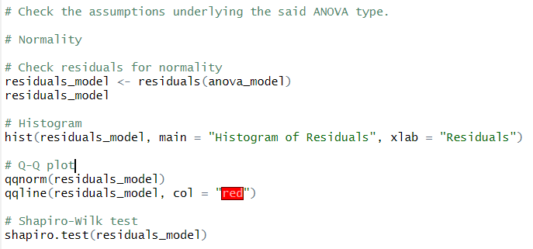

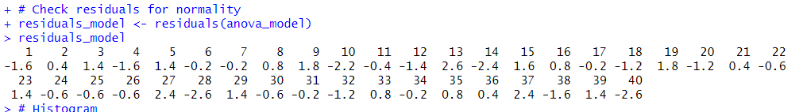

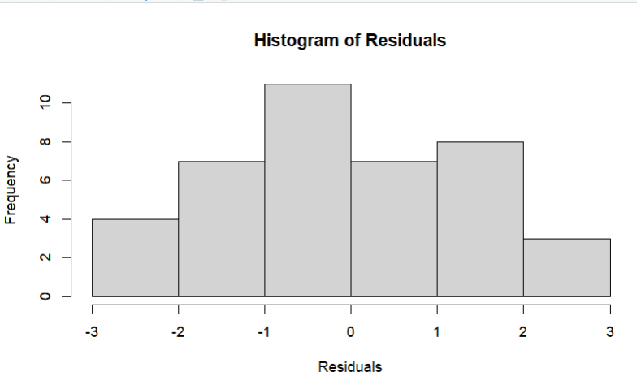

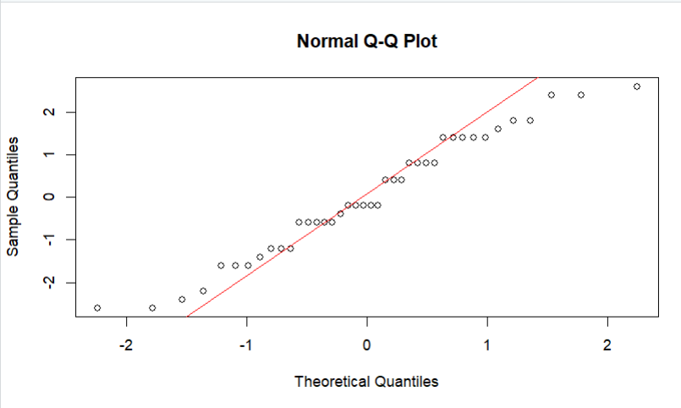

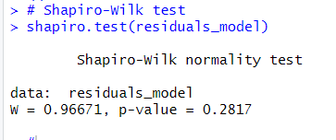

### **Histogram of Residuals**

The histogram of residuals shows a roughly symmetric bell-shaped distribution centered around zero, indicating that the residuals are approximately normally distributed. This visual assessment supports the assumption of normality for residuals in the two-way ANOVA.

### **Normal Q-Q Plot**

The Q-Q plot displays the quantiles of the residuals against the theoretical quantiles of a normal distribution. Most points align closely with the diagonal red line, suggesting that the residuals follow a normal distribution. Only slight deviations are visible at the extremes, which are not concerning.

### **Shapiro-Wilk Test**

The Shapiro-Wilk test for normality yields a W-value of 0.96671 and a p-value of 0.2817. Since the p-value is greater than the standard threshold of 0.05, we fail to reject the null hypothesis of normality. This confirms that the residuals meet the assumption of normality for the two-way ANOVA.

### **Overall Interpretation**

Both the visual inspections (histogram and Q-Q plot) and the statistical test (Shapiro-Wilk) indicate that the residuals are approximately normally distributed. Therefore, the normality assumption for the two-way ANOVA is satisfied.

* **Homogeneity of Variances (Homoscedasticity)**

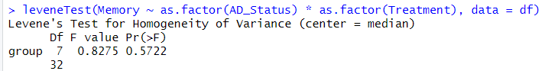

Levene's test for homogeneity of variances resulted in an F-value of 0.8275 and a p-value of 0.5722, indicating that the variances across the groups are not significantly different. Since the p-value exceeds the standard threshold of 0.05, we fail to reject the null hypothesis of equal variances. Thus, the assumption of homogeneity of variances is satisfied for the two-way ANOVA.

* **The Dependent Variable is Measured at the Interval or Ratio Scale**

In the dataset, the dependent variable "Memory" is measured on a ratio scale, as it represents the number of errors made by the mice during the memory task, with meaningful zero and consistent intervals between values. This satisfies the assumption that the dependent variable must be measured at the interval or ratio scale.

* **Fixed Effects for the Independent Variables (Factors)**

The assumption of fixed effects for the independent variables implies that the levels of the independent variables (AD_Status and Treatment) are treated as fixed and not random samples from a larger population. In this study, the independent variables represent specific, predetermined groups (e.g., AD_Status with two levels: 1 and 2, and Treatment with four levels), indicating that the researchers are interested in comparing these particular levels, thus satisfying the assumption of fixed effects.