Database Design for the Web

Noah Hall-Potvin

Assignment: Final Project

Title of project

Version <1.0>

Table Of Contents

Time Log 3

Introduction 4

Purpose 4

Definitions, acronyms, and abbreviations 4

Overall Description 4

Story Board 5

Specific requirements 6

|  |  |  |  |
| --- | --- | --- | --- |
| Time Log | | | |
| Estimated time to complete assignment => | | | 100 Hours |
| Date | Time Spent  (in hours) | Description | Author |
| 08/19/14 | 2.0 | First Version of Software Requirements | Robert Erickson |
| 11/21/14 | 1.0 | First upload | Noah Hall-Potvin |
| 11/23/14 | 8.0 | Updated home and navigation page, put into NetBeans, added generic forms to each page | Noah Hall-Potvin |
| 11/24/14 | 7.0 | Authenticated admin page, connected to database, started work on add page | Noah Hall-Potvin |
| 11/24/14 | 11.0 | Finished the adding process, formatted message to admin | Noah Hall-Potvin |
| 11/25/14 | 14.0 | Created tables from the database, worked exclusively with month.php | Noah Hall-Potvin |
| 11/28/14 | 16.0 | Creating a form for month.php to complete a count | Noah Hall-Potvin |
| 11/29/14 | 8.0 | Concept change, overhauled. No longer doing count, just keeping track of inventory | Noah Hall-Potvin |
| 11/30/14 | 9.0 | Cleaned everything up and completed project specification sheet | Noah Hall-Potvin |
|  |  |  |  |
|  |  |  |  |
|  |  |  |  |
|  |  |  |  |
|  |  |  |  |
|  |  |  |  |
|  |  |  |  |
|  | 76 | <=Total Time Spent |  |
|  |  |  |  |

# Introduction

### Purpose

The purpose of this document is to describe the requirement specification for the web site “Inventory Management System”.

The intended audience for this document is potential developers who would like to create a similar site.

*First it is the contract between you and the client. Second it is for the developer of the site. Two primary goals are:*

1. *Client gets a very good understanding of what you will be delivering.*
2. *Developer has a very good understanding of what they are going to create.*

### Definitions, acronyms, and abbreviations

*Sample for the client:*

HTML – Hypertext markup language – used to define your content.

PHP – Personal Home Page – language that helps to customize html.

CSS – Cascading Style Sheets – used to define the look of a web site.

W3 Validation – refers to both Html and CSS validation tool provided by the W3c.org. the html validator is located at:

<http://validator.w3.org/>

with the CSS validator located at:

<http://jigsaw.w3.org/css-validator/>

# Overall Description

The Inventory Management System is designed to give small businesses the ability to keep track of their inventory throughout the year. It gives them the option to sort it by descriptions and locations.

# Story Board

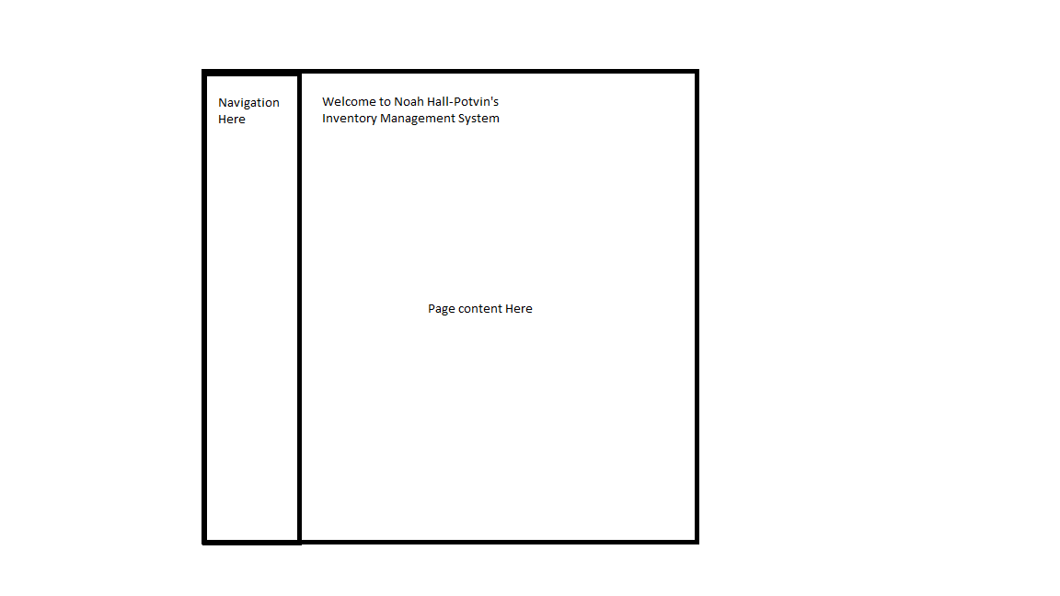

# Specific requirements

1. *Title for main page*: *Inventory Management System*
2. *Meta Description*: *A php app that tracks inventory*
3. *Meta Character set*: UTF - 8
4. *Main page photo*: *warehouse.jpg*
5. *Home*.php: Create this page with some basic information about the company and any images required.
6. *Add*.php: Create a form that allows the user to enter an item’s information (this includes item name, department, total-on-hand, sector, column, and row location). The form information is stored in a database.
7. *viewItems*.php: This page takes the Item table from the database and displays it in a table
8. *viewLocations*.php: This page takes the Location table from the database and displays it in a table
9. *admin*.php: This page is restricted to just users determined to be administrators. The admin can edit and delete records from the database. The admin is also responsible for approving every addition to the database.
10. *Contact*.php: This page is to contact the company through a form. The form is stored in the database.