Cirrhosis

Nicole Hamada

3/5/2021

rm(list=ls())  
library(ggplot2)  
library(GGally)

## Registered S3 method overwritten by 'GGally':  
## method from   
## +.gg ggplot2

library(effects)

## Loading required package: carData

## lattice theme set by effectsTheme()  
## See ?effectsTheme for details.

library(MuMIn)  
library(nlme)  
Cirrhosis=read.csv(file="Cirrhosis.csv", header=TRUE)  
boxplot(Cirrhosis$TNFA, Cirrhosis$TNFB, xlab="TNFA", ylab="TNFB")

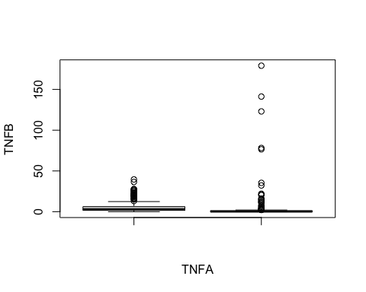

boxplot(Cirrhosis$TNFA~Cirrhosis$TNFB)

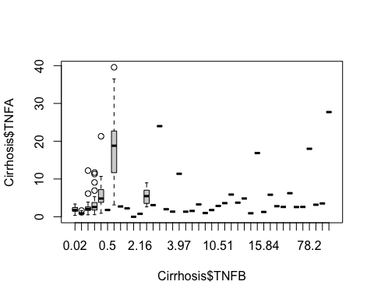

names(Cirrhosis)

## [1] "box" "Dx" "Age" "Wells" "EGF"   
## [6] "FGFB" "EOTAXIN" "TGFA" "GCSF" "FLT3L"   
## [11] "GMCSF" "FRACTALKINE" "IFNA2" "IFNG" "GRO"   
## [16] "IL10" "MCP3" "IL12P40" "MDC" "IL12P70"   
## [21] "PDGFAA" "IL13" "PDGFBB" "IL15" "CD40L"   
## [26] "IL17" "IL1RA" "IL1A" "IL9" "IL1B"   
## [31] "IL2" "IL3" "IL4" "IL5" "IL6"   
## [36] "IL7" "IL8" "IP10" "MCP1" "MIP1A"   
## [41] "MIP1B" "RANTES" "TNFA" "TNFB" "VEGF"

plot(Cirrhosis$TNFA)

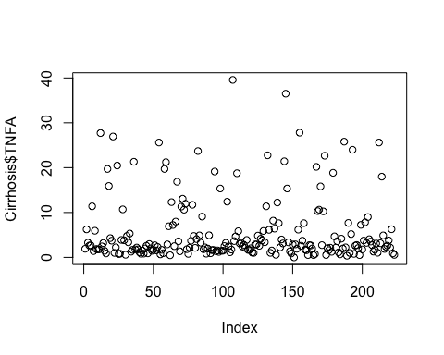

plot(Cirrhosis$TNFA~Cirrhosis$TNFB)

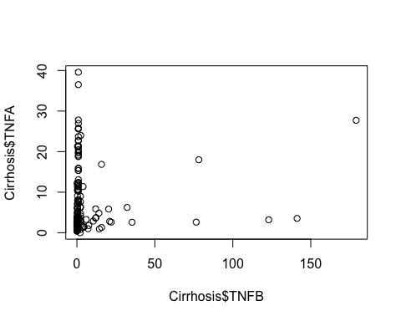

plot(Cirrhosis$TNFB)

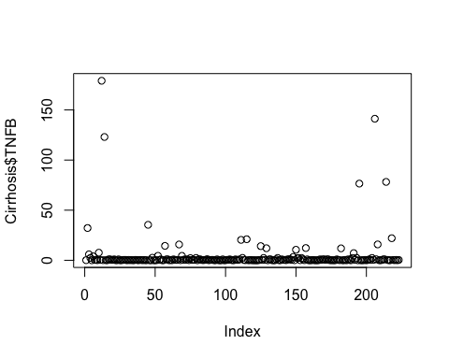

qqnorm(Cirrhosis$TNFA)  
Cirrhosis$lTNFA=log(Cirrhosis$TNFA)  
qqnorm(Cirrhosis$TNFA)  
qqline(Cirrhosis$lTNFA)

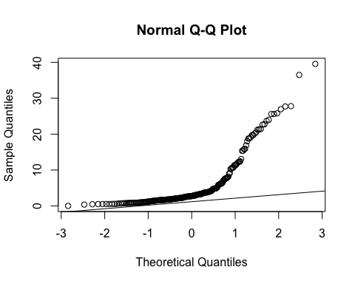

qqnorm(Cirrhosis$TNFB)  
qqline(Cirrhosis$TNFB)

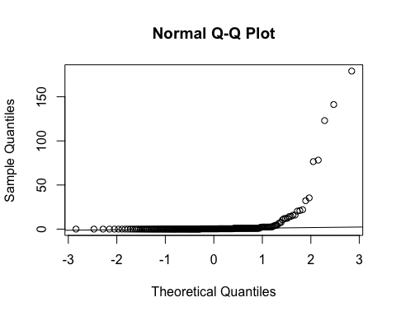

Cirrhosis$lTNFB=log(Cirrhosis$TNFB)  
  
hist(Cirrhosis$TNFB)

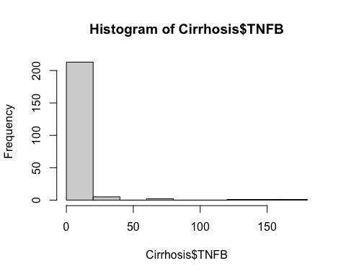

hist(Cirrhosis$TNFA)

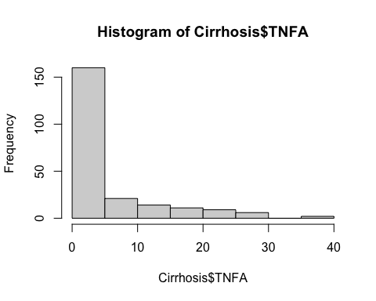

Cirrhosis.aov<-aov(TNFB~TNFA,data=Cirrhosis)  
summary(Cirrhosis.aov)

## Df Sum Sq Mean Sq F value Pr(>F)   
## TNFA 1 1371 1370.9 3.837 0.0514 .  
## Residuals 221 78962 357.3   
## ---  
## Signif. codes: 0 '***' 0.001 '**' 0.01 '*' 0.05 '.' 0.1 ' ' 1

AIC(Cirrhosis.aov)

## [1] 1947.755

plot(allEffects(Cirrhosis.aov))

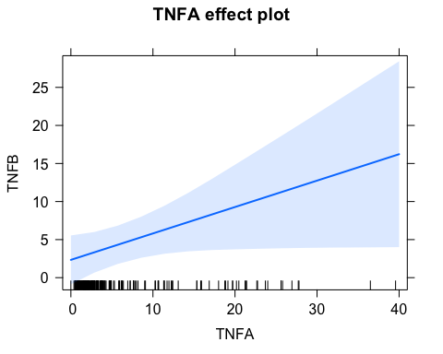

plot(Cirrhosis.aov)

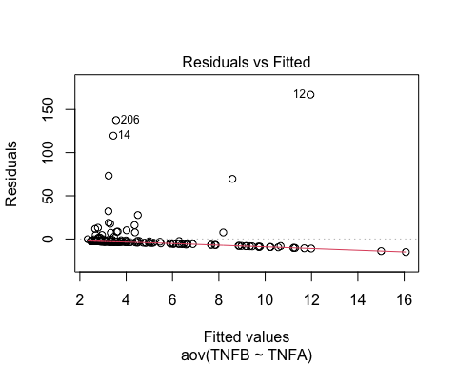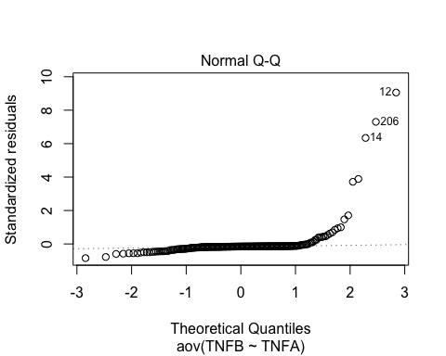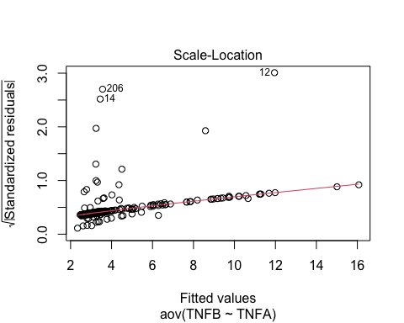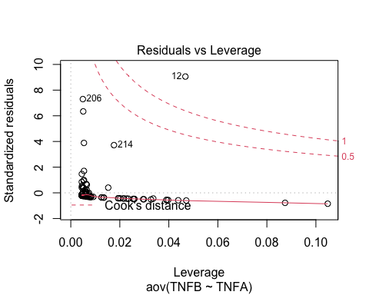

Cirrhosis2.aov <- aov(TNFA~TNFB, data=Cirrhosis)  
summary(Cirrhosis2.aov)

## Df Sum Sq Mean Sq F value Pr(>F)   
## TNFB 1 194 194.23 3.837 0.0514 .  
## Residuals 221 11187 50.62   
## ---  
## Signif. codes: 0 '***' 0.001 '**' 0.01 '*' 0.05 '.' 0.1 ' ' 1

AIC(Cirrhosis2.aov)

## [1] 1511.973

plot(allEffects(Cirrhosis2.aov))

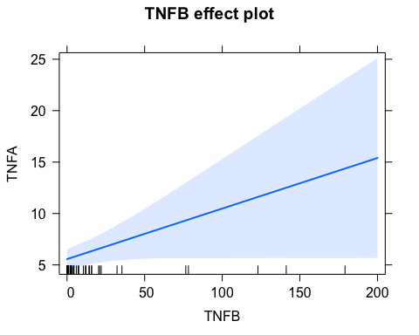

plot(Cirrhosis2.aov)

