File > Open >

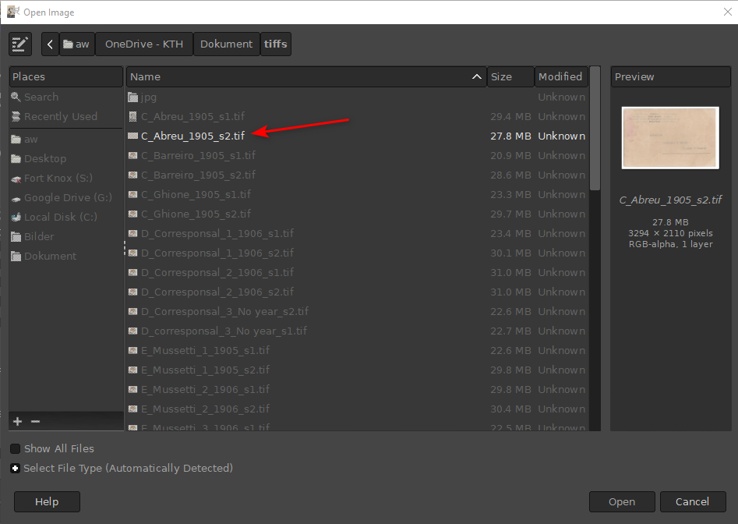

Keep the settings unchanged on the next pop-up box.

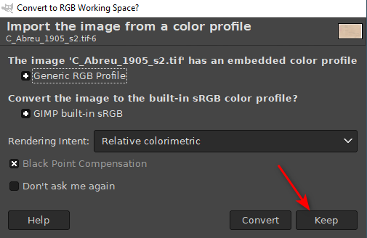

Go to File > Expert As…

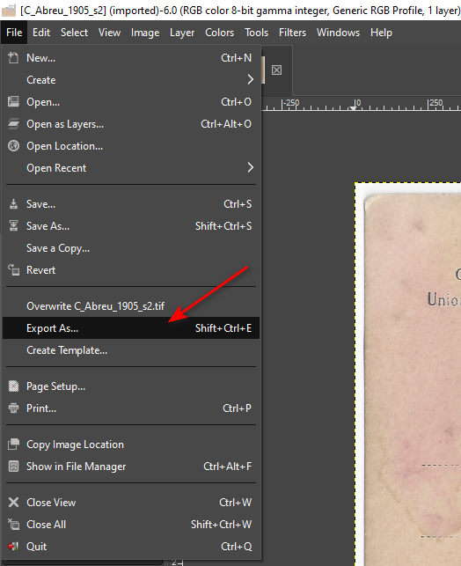

Change the extension of the file to “jpg” and make sure that the “Select File Type (By Extension)” is checked.

