

**Acoustic Noise Test Plan**

**for the**

DOE (GE) 1.5 MW Wind Turbine

**in**

**Golden Colorado**

**by**

**National Wind Technology Center**

**National Renewable Energy Laboratory**

**1617 Cole Boulevard**

**Golden, Colorado 80401**

for

U.S. Department of Energy

**N. Hamilton**

**September 2019**

Approval By:

Nicholas Hamilton, Principle Investigator Date

Approval By:

Jason Roadman, Test Engineer Date

# Test Objective

The primary goal of the Aeroacoustic Assessment project is to characterize the noise emissions of the GE 1.5 SLE MW wind turbine owned by the US Department of Energy (DOE 1.5) to determine the nature and degree of changes of acoustic emissions produced when operating a utility scale wind turbine according to modern wind plant control strategies. Testing will include multiple point measurements located to sample the acoustic emissions including points required and suggested in the International Electrotechnical Commission’s (IEC) standard, *Wind turbines part 11: Acoustic Noise Measurement Techniques*, IEC 61400-11, Edition 3.1, 2018-06 and the Measuring Network of Wind Energy Institutes (MEASNET) standard, *Acoustic Noise Measurement Procedure*, Version 3. Hereafter these documents are referred to as the Standards. This test plan documents the measurement techniques, test equipment, and analysis procedures for the following quantities at integer wind speeds from 6 to 10 m/s:

* apparent sound power level,
* one-third octave band levels, and
* tonality, and
* amplitude modulation.

Measurement data is intended to be of sufficient quality to determine the change in aeroacoustic emissions from a utility scale turbine under yawed operation and validate aeroacoustics models underlying the Standards and incorporated in a module to interface with NREL’s Multiphysics modeling platform, OpenFAST. In addition, the National Wind Technology Center (NREL) plans to conduct this test in accordance with its quality system procedures such that the final test report will meet the full requirements of accreditation by A2LA. NREL’s quality system procedures require that the test meet all applicable requirements specified by A2LA, Measnet, and ISO/IEC 17025 (or to note any exceptions in the test report).

After approval, this test plan represents a commitment by both NREL and DOE to conduct the test according to the methods described herein.

# Test Turbine

Aeroacoustic measurements will be taken around the DOE 1.5 turbine, which is representative of a large segment of the installed wind capacity; more than 18,000 turbines of this make and model are currently in operation in the US. The DOE 1.5 is built on the platform of GE’s 1.5-MW SLE commercial wind turbine model and was installed at NREL’s Flatirons Campus (Flatirons) with the objective of supporting DOE Wind Program research initiatives such as Atmosphere to Electrons (A2e). The DOE 1.5 is a horizontal axis, three bladed, upwind turbine with full span pitch control. provides the key descriptive information of the test turbine.

Table . Test Turbine Configuration

|  |  |
| --- | --- |
| Turbine manufacturer and address | GE Energy  300 Garlington Rd., P.O. 648  Greenville, SC 29602-0648 |
| Model | GE 1.5-MW SLE |
| Rated power (kW) | 1,500 |
| Rated wind speed (m/s) | 14 |
| Serial number | N000780-N / TB059-3 |
| Blade make, type, and serial number | GE37c, fiberglass, S00028, S00029, S00030 |
| Generator make, type, and serial number | Winergy, doubly-fed induction, JFEC-500SS-06A |
| Gearbox make, type, and serial number | GETS, multistage planetary/helical, 7GA87E2, EE0809404 |
| Control software | WindSCADA |
| Wind turbine type | Horizontal axis, upwind |
| Tower type | Tubular |
| Number of blades | 3 |
| Hub height (m) | 80 |
| Rotor diameter (m) | 77 |
| Horizontal distance from rotor center to tower axis (m) | 3.8 |
| Speed control | Pitch control |
| Constant or variable speed | Variable |
| Rotational speeds at standardized integer wind speeds from 6 m/s to 10 m/s (rpm) | 10–20 |

# Test Site

The turbine is located 8 miles south of Boulder, Colorado, USA at Flatirons, on test site 4.0. shows the test turbine and the area downstream according to the prevailing wind direction on site (~285˚). Instrumentation will be arrayed in the area downstream of the DOE 1.5.

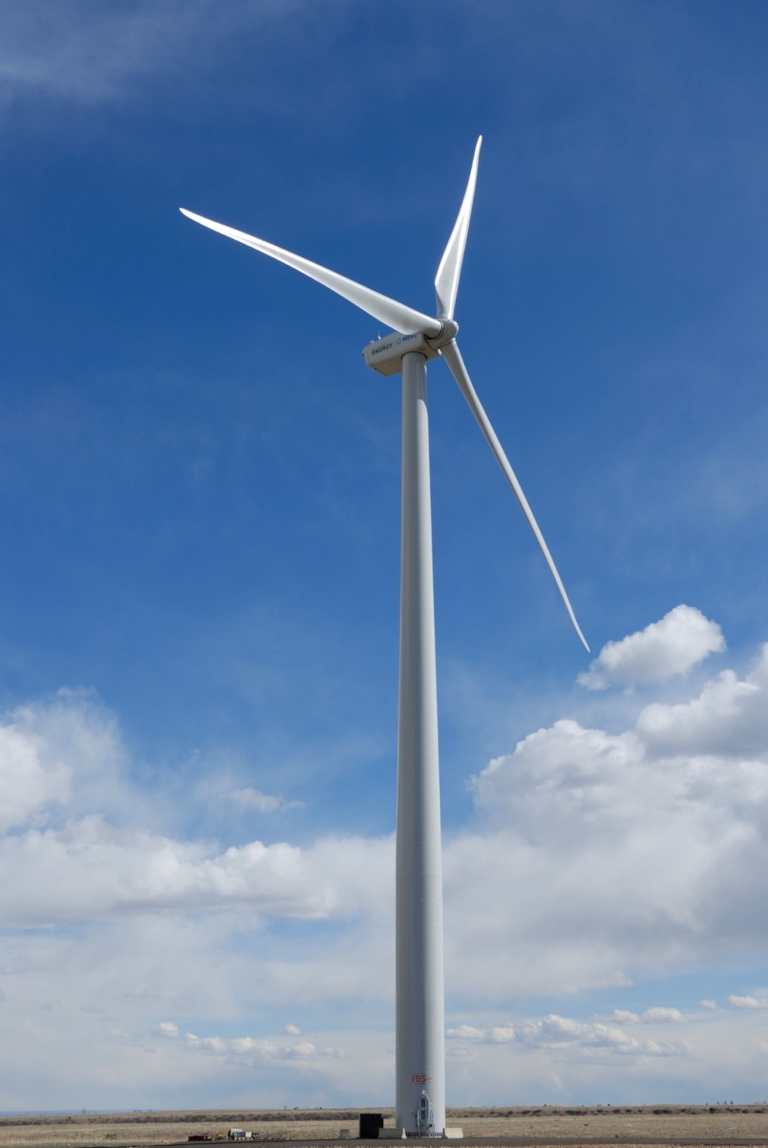

Figure 1. DOE 1.5 located at Site 4.0 at Flatirons. Photo credit: Jeroen van Dam, NREL.

Figure 2 shows the test site with respect to the surrounding geography and the rest of the Flatirons Campus. Red dots indicate the locations of utility-scale and small wind turbines on site, green triangles indicate locations of meteorological masts (met masts).

Figure 2 Map of NFC, site 4.0 and surrounding area.

Nearby sources of noise that might interfere with acoustic testing of the test turbine are given in .

Table . Nearby noise sources

|  |  |  |
| --- | --- | --- |
| **Source** | **Location** | **Shutdown for noise test** |
| CART-3 | 4.3 | Yes |
| CART-2 | 4.3 | Yes |
| Siemens 2.3 MW | 4.4 | Yes |
| Gamesa 2 MW | 4.5 | Yes |

# Instrumentation

Table 3 shows the list of instrumentation that will be used for the test. For acoustic measurements when the turbine is operating below 95% rated power, the power will be measured, and wind speed will be derived from the power curve. For points above 95% rated power, the wind speed will be derived from the correlation between nacelle anemometer and the wind speed derived from power per the standard. For background noise measurements, the wind speed will be measured using the 10 m anemometer and correlated to the wind speed derived from turbine power. A microphone with wind screen will be placed in the downwind reference position to measure the total and background noise.

Table . Prospective Equipment list, subject to change based on instrumentation acquisition

| **Instrument** | **Manufacturer** | **Model Number** |
| --- | --- | --- |
| Signal Analyzer | Delta Acoustics | Noiselab Professional 3.0 |
| Microphone | Bruel & Kjaer | 4964 |
| Preamplifier | Bruel & Kjaer | 2669-L |
| 4-Channel Microphone Conditioner | Bruel & Kjaer | 2829 |
| Calibrator | Bruel & Kjaer | 4230 |
| Digital Recorder | Delta Acoustics | Noiselab Professional 3.0 |
| Anemometer (10m tower) | Thies | First Class |
| Nacelle anemometer | GE controller | NA |
| Wind Vane | Met One | SD-201 |
| Pressure Sensor | Vaisala | PTB110 |
| Temperature Sensor | Vaisala | HM34 |
| Power | Camille Bauer | Sineax M 563 |
| Meteorological Data Acquisition System | National Instruments | EtherCAT |
| Pitch angle | GE controller | NA |
| Rotor speed | GE controller | NA |
| Power | GE controller | NA |

# Test Procedures

Testing will begin once three conditions are fulfilled:

1. This test plan is complete and signed by NREL project manager
2. NREL has completed installation and checkout of meteorological and turbine instrumentation required for the test
3. A safe work permit and NEPA review have been completed for the aeroacoustic tests
4. A test readiness document that indicates that the turbine is ready for testing.

Measurements will conform to the Standards where possible and should continue until the aeroacoustic effects of yawing the turbine can be determined.

* The complete measurement chain shall be calibrated at least at one frequency before and after the measurements, or if the microphones are dis- and reconnected during the measurements.
* All acoustical signals shall be recorded and stored for later inspection.
* Periods with intruding intermittent background noise (as from aircraft) shall be omitted.
* The wind speed range is related to the specific wind turbine. As a minimum it is defined as the hub height wind speed from 0,8 to 1,3 times the wind speed at 85 % of maximum power rounded to wind speed bin centers.
* With the wind turbine stopped, and using the same measurement set-up, the background noise shall be measured immediately before or after each measurement series of wind turbine noise and during similar wind conditions. When measuring background noise, every effort shall be made to ensure that the background sound measurements are representative of the background noise that occurred during the wind turbine noise emission measurements. It is recommended to measure the background noise several times during the measurement period to cover the same wind speed range as for the total noise.
* The measurements shall cover as broad a range of wind speeds as practically possible. To obtain a sufficient range of wind speeds it may be necessary to take the measurements in several measurement series.
* At least 180 measurements shall be made overall for both total noise and background noise covering corresponding wind speed ranges.
* At least 10 measurements shall be made in each wind speed bin for both total noise and background noise.

# Description of Measurements

During the period of time favorable for wind and acoustic measurements, the wind direction is mostly from the WNW. Figures 3 and 4 show wind roses for the autumn quarter (Oct. through Dec.) and for the winter quarter (Jan. – Mar.), respectively. Both figures show that the prevailing wind direction is from the directing bin of 280˚ to 290˚. In the wind figures, only the wind speed bins called out in Table 4 have been colored to highlight the conditions relevant for aeroacoustic testing.



Figure 3. Oct. – Dec. wind rose at 80 m at Flatirons.



Figure 4. Jan. – Mar. wind rose at 80 m at Flatirons.



Figure 5. Locations of acoustic measurements.

Measurement locations (potential sound board locations) are shown in Figure 5 relative to the location of the DOE 1.5 (red dot) and the prevailing wind direction during the fall and winter. In the figure, the prevailing wind direction is assumed to be 285˚, the wind direction with the greatest representation from data recorded at hub height (80 m) by the cup anemometer on the met mast M5. Other dots on the figure represent locations of interest for recording. The blue dot indicates the measurement location required by the IEC standard for noise testing and is *H+D/2* downstream of the turbine in the prevailing wind direction. Green dots correspond to additional suggested measurement locations in the IEC standard. Black dots represent additional measurement locations designed to measure the SPL field produced by the DOE 1.5.

Figure 3 details potential sound board locations. The blue shaded region shows locations that provide appropriate ±15° measurement sectors. This configuration will ensure that data can be collected according to the standard without requiring an exception.

Data of the SPL field will be used to validate predictions made by the aeroacoustics module in OpenFAST. Circles circumscribed around the turbine locations correspond to distances of *H+D/2, H+D,* and *H+3*D/2* (118.5 m, 157 m, and 195.5 m) for the solid, dash-dot, and dotted lines, respectively. Distances separating proximal measurement points are shown in Figure 6. The average distance between proximal measurement points is 83.7 m.

The modeled overall sound pressure level produced by the DOE-1.5 is shown in Figure 7. Prospective measurement locations are overlaid on the directivity field to provide some context of expected measurement results. Measurements locations are spaced such that the expected sound pressure level difference is at least 3 dB between points, when aligned with the flow. Measurement locations are subject to change given constraints on deployment of equipment, and suggested modifications from additional directivity field modeling.



Figure 6. Separation distances between proximal measurement locations in meters.



Figure 7. Measurement locations overlaid onto the modeled overall sound pressure level (directivity field).

# Reporting

Regular updates will be provided as data are recorded and processed. The experiment is intended to run for an extended time period, and regular status updates will be a means of communicating results and ensuring that the experiment is proceeding without error.

Bi-weekly summary reports will be issued within the measurement session. Reports are designed to help researchers determine the amount and quality of data being recorded, and to inform whether or not sufficient data are being collected to quantify differences in acoustic emissions with tolerances of uncertainty. These reports will include comparisons between nominal and yawed operation:

1. A table detailing total acquired data sets to date and sound pressure levels per wind speed bin (1-min averages)
2. A graph of sound pressure level versus hub height wind speed (1-min averages)
3. A graph of sound pressure level versus output power (1-min averages)
4. A graph of sound pressure level versus pitch angle (1-min averages)

A final report be provided within one month of conclusion of the measurements. The final report will aggregate results from the summary reports and is designed to offer a high-level review of the experiment, the test turbine and site, the measurement, and results. The final report will include:

1. Description of the test turbine
2. Description of the test site
3. Description of the test instrumentation
4. Description of the measurement procedure
5. Results with uncertainty including:
   1. A-weighted sound power level (as function of standardized wind speed, rotor speed and power)
   2. Plots of all data and regression lines
   3. One-Third Octave Spectra (graphical and tabular)
   4. Tonal analysis
   5. Low-frequency analysis
6. Quantitative comparison between the acoustic emissions of the DOE 1.5 under nominal and prescribed yaw operating conditions.
7. Raw data will be quality controlled for ease of future use and processed data will be made available to researchers validating aeroacoustics models. Data will be retained internally for future results beyond the original scope of work.
8. Results will be disseminated to the broader wind energy research community through a peer-reviewed publication, to be submitted by FY20 Q4

# Roles and Responsibilities

Table 5 lists the planned test team and identifies roles and responsibilities for each team member.

Table . Roles of Test Participants

|  |  |  |
| --- | --- | --- |
| Title | Name | Role(s) |
| Research Engineer | Nicholas Hamilton  NREL | Overall test management and responsibility  NREL approval of test plan, conduct observations  Analysis of test data  Resolution of problems during testing  Review and report test results  Final report |
| Test Engineer | Jason Roadman  NREL | Test set-up, checkout, conduct observations  Collection of test data  Resolution of problems during testing  Review of test data, results, and report. |
| Test Engineer | David Jager  NREL | Selection of instruments  Installation, maintenance and checkout of test equipment  Implementation of corrective actions for problems  Responsible for ensuring safety of personnel and equipment at test site |
| Research Engineer | Eric Simley  NREL | Analysis of test data  Resolution of problems during testing  Review and report test results  Final report |
| Test  Engineer | Andrew Scholbrock  NREL | Coordination of site operation for aeroacoustic testing  Management and scheduling of wind turbine operations |
| Research Engineer | Jeroen van Dam | Designated area representative of utility-scale wind turbines |
| Wind turbine technician | Mark Murphy | Support coordination of GE wind turbine for aeroacoustic testing |
| Engineering Manager | Arlinda Huskey | Coordinate observations, assess testing plans and procedures, review final report |

# Schedule

Specification of final instrumentation required for the experiment detailed above is currently under way. As soon as a determination on appropriate equipment is made, instrumentation will be acquired and inspected. NREL will begin measurements as soon as equipment has been acquired and installed and will begin data collection as soon as appropriate winds are available, the turbine is in good working order, and the data acquisition system has been checked out after the turbine is repaired. Specific measurement dates will be agreed upon between NREL researcher and test engineers, and DAR for the DOE 1.5 based on the meteorological forecast for Flatirons. Data collection will continue as long as the meteorological conditions remain favorable and until NREL researchers agree that sufficient data has been collected.