**Buffer Overflow on GCC:**

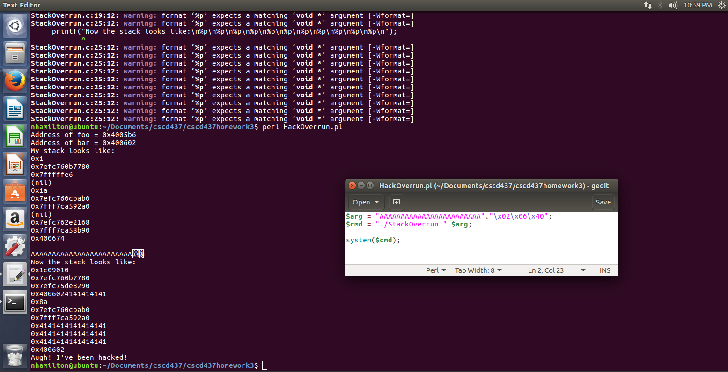

**Buffer Overflow on Borland:**

