Economic development 325
Prof. Nancy Hammond
Northwestern University
Spring 2001 Lecture 9

Romer model of endogenous technological change

Model

Output is constant returns to scale in K and L
increasing returns to scale in K, L, and A

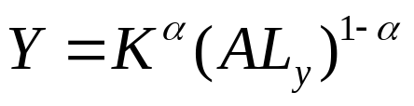 output technology

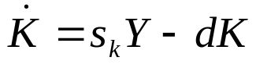 law of motion for capital

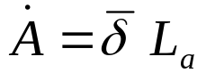 idea technology

What’s new here is the description of a technology of ideas that depends on the stock of ideas in the economy

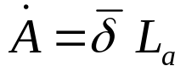

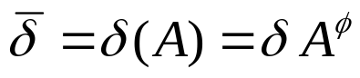

0 < φ < 1 the stock of ideas matters in the production of
new ideas

The benchmark cases
φ = 1 the production of ideas in linear in A
φ = 0 the stock of ideas has no impact on future innovation
φ < 0 new ideas are harder to come by

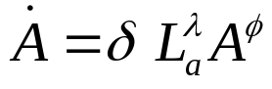

0 < λ < 1 research effort is more or less productive
‘stepping on toes’

λ = 1 there is no duplication of research effort

Along the balanced growth path 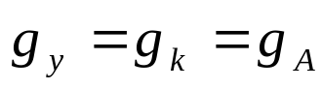

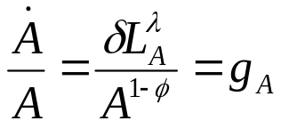

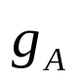is constant only if 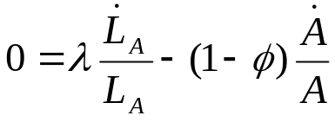

Then , the long run growth rate is determined by

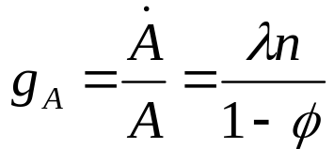

- production function parameters λ and φ

- rate of growth of researchers, 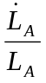, ultimately n, the rate of population growth

Benchmark cases

The final goods sector Y makes use of intermediate goods sector capital goods x

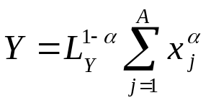

A, the measure of specialization, is the number of capital goods, each of which represents an idea that has been purchased from an inventor

The final goods sector firm’s profit maximization problem determines the demand for labor L and aggregate demand for the range of intermediate capital goods

P(F) 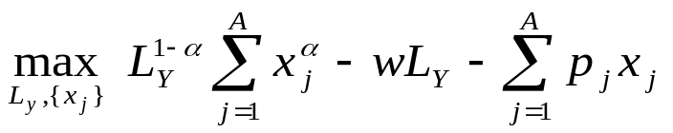

The profit maximizing level of inputs are

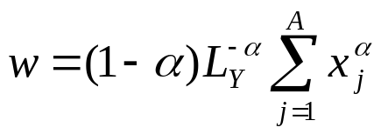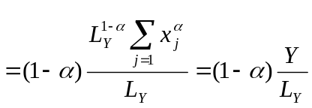

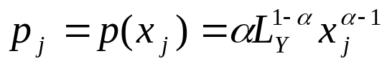

Intermediate goods sector

Characterized by monopolistic competition

- Only one firm produces a distinct capital good after purchasing the idea, a design or blueprint, from an inventor

- The legal system confers monopoly power through patents

P(I) 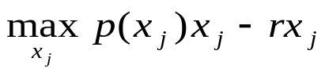

First order condition for optimal choice of x

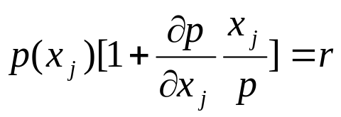

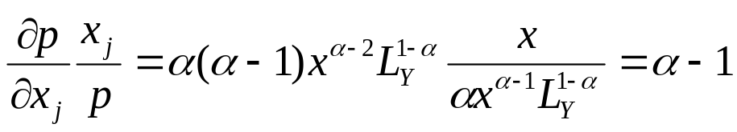

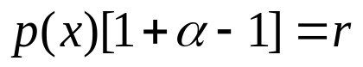

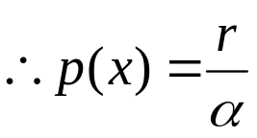

Putting it together: 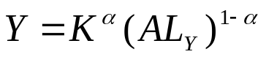

- Total capital stock 

 