<https://www.michaelstults.com/2014/03/how-to-add-html-signature-in-outlook-2010/>

# How To Add HTML Signature In Outlook 2010

MARCH 1, 2014 BY [MICHAEL G. STULTS](https://www.michaelstults.com/author/michael-stults/)[2 COMMENTS](https://www.michaelstults.com/2014/03/how-to-add-html-signature-in-outlook-2010/#disqus_thread)



Image Credit: wikimedia

So you're using Outlook 2010 these days and you need to add a nice professional HTML signature to your outgoing mail? Peaking around the internet looking for “how to add html signature to outlook 2010″…. but you're just getting tired of searching for something straight forward, easy to use.

Been stuck huh? I figured you'd be searching online and needed a good place for a quick reference (also good for me so I can point my friends and other folks there for reference).

It's quite ok… frustrating to say the least if you're on a PC. Up until now you've stuck with the basic text, inserted an image of your company logo or mugshot and you've rolled with it. Then like a kid sitting in front of a candy store, you see all the other kids walking out with their candy… AKA… attractive HTML signature!

I'll spare you the details to a degree but I mainly us Apple/ Mac but I have recently ran into a situation where I was using a client's desktop where I needed to receive mail and they were using Windows 7 on a PC.

## How to Add Your HTML Signature (Outlook)

There are a few ways you can go about it but lets start….here…. [ Steps if you are using a PC ]

* **Clickity Clack the File button in the upper left had corner [ File > Options > Mail > Signatures ]**

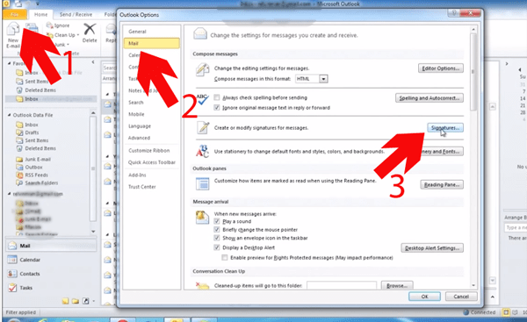

* **For giggles, select “New” to create a signature that you will remember — IE: Mike's New HTML Sig**

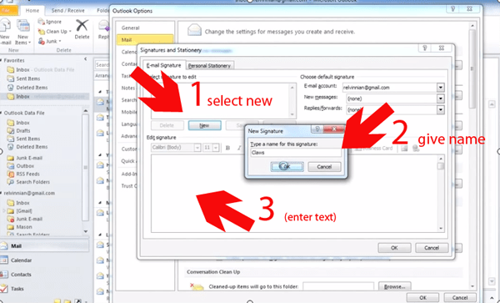

* **In the body where you would go “old school” and type your name and etc… just fill it in with some text, Hit SAVE.**
* **Navigate to your “C Drive”. So IE: C:\Users\NAME-YOU-USE-ON-COMPUTER\AppData\Roaming\Microsoft\Signatures (can't see the folders?>**[**how to see hidden files on PC**](http://www.howtogeek.com/howto/windows-vista/show-hidden-files-and-folders-in-windows-vista/)**)**

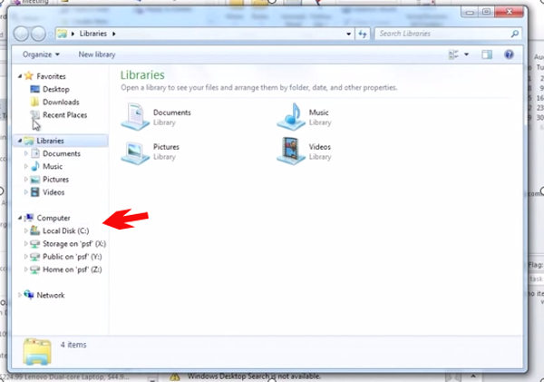

* **In the folder, find “Mike's New HTML Sig.htm” or better yet… whatever name you used, right click with your mouse on that file > open in editor of choice**
* **Now… You will see a few files in there.. just make sure it is a “web document” or the file name has “.htm” at the end of the name you gave the signature**
  + **Some of you will have a code editor like**[**Notepad++**](http://notepad-plus-plus.org/)**, Dreamweaver, [Komoda Edit](http://komodoide.com/komodo-edit/" \o "Komodo Edit" \t "_blank), and etc etc… but if you DON'T > just use text or notepad.**
  + **Select “ALL” in the document… then delete. Leave file open.**
  + **Copy the code of your new fancy smancy HTML email signature for Outlook 2010 >>>> Paste new code in same document**
* **Select “SAVE”. Reboot your Outlook… and BOOM >>>>>>> Should now see your new HTML Email Signature in 2010.**

If you don't see it, you'll need to go back to step 1 & 2… and select which Default signature you want to use for New & Replies. More than likely…. this will be true.

## Create HTML Email Signature

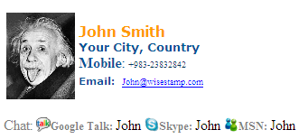

Image Credit: WiseStamp.com

Need some help in creating an HTML email signature? No worries, there are a pleather of options out there. Check out these few if you don't feel you're up to starting from scratch with the code.

* [HTML Email Sig](http://htmlsig.com/) (fill in the blanks, hit view code, presto… copy and paste away)
* [WiseStamp Signature Templates](http://www.wisestamp.com/signature-examples) (alternative to use but could create the code from their site and then copy and paste into the soul purpose you are trying to achieve above)
* [CompanySig.com](http://www.companysig.com/) (free account > create signature > prestola)
* [DigiTechBranding.com](http://www.digitechbranding.com/pages/free-email-signature.html) (choose a design > fill in the blanks > Boom)

## HTML Signature Complete

I hope this has helped in some little way and I've had to keep the post with some humor. Sometimes it gets boring reading an 1800's style way of getting things done. Many people don't actually know you can do something that adds such beauty and aesthetics to your email. Branding is so important when you are representing yourself.

Don't worry about what people think if you do so… because it's not that you have an ego but all you have is your name and reputation. If you have a good one, everyone should know about you! That'll get you in more doors than your resume.

Happy HTML Signature creating or something along those lines.

https://www.youtube.com/watch?v=d1CNxuRKNs8