**UNIVERSITY OF TRANSPORT AND COMMUNICATIONS**

**CAMPUS IN HO CHI MINH CITY**

**DEPARTMENT OF INFORMATION TECHNOLOGY**

**---****---**

**ESSAY REPORT**

**Thematic : Software Technology**

**Topic : YELP RECOMMENDER SYSTEM**

|  |  |
| --- | --- |
| **Instructor :** | ThS. Trần Phong Nhã |
| **Performers :** |  |
| - Huỳnh Xuân Lãm | 6051071062 |
| - Đỗ Thành Chiến | 6051071011 |
| - Võ Quang Vinh | 6051071143 |
| - Lê Quang Sơn | 6051071100 |
| - Nguyễn Thành Nhân | 6051071079 |

**UNIVERSITY OF TRANSPORT AND COMMUNICATIONS**

**CAMPUS IN HO CHI MINH CITY**

**DEPARTMENT OF INFORMATION TECHNOLOGY**

**---****---**

**ESSAY REPORT**

**Thematic : Software Technology**

**Topic : YELP RECOMMENDER SYSTEM**

|  |  |
| --- | --- |
| **Instructor :** | ThS. Trần Phong Nhã |
| **Performers :** |  |
| - Huỳnh Xuân Lãm | 6051071062 |
| - Đỗ Thành Chiến | 6051071011 |
| - Võ Quang Vinh | 6051071143 |
| - Lê Quang Sơn | 6051071100 |
| - Nguyễn Thành Nhân | 6051071079 |

**Contents**

**1** **Business Understanding** 2

**1.1** **Business Problem** 2

**1.2** **An approach to solve the business problem** 2

**1.2.1** **Implicit latent features learning based models** 2

**1.2.2** **Explicit latent features learning based models** 3

**1.2.3** **Converting it into a Regression/Classification Problem** 3

**1.2.4** **Evaluation Metric** 4

**1.2.5** **Scope of the Project** 4

**2** **Dataset** 4

**2.1** **Source** 4

**2.2** **Description and Exploratory Analysis** 4

**2.3** **Merging and Cleaning datasets, and Creating Ratings Matrix** 6

**2.4** **Information about the Rating matrix** 6

**3** **Model Building and Performance Evaluation** 6

**3.1** **Implicit latent features learning based models (Baseline Models)** 6

**3.1.1** **Singular Value Decomposition** 6

**3.1.2** **Cosine similarity based prediction with bias correction** 7

**3.2** **Explicit latent features learning based models** 8

**3.2.1** **Learning Latent Features using Alternating Least Squares** 8

**3.2.2** **Learning Latent Features through Stochastic Gradient Descent** 8

**3.3** **Converting into a regression problem** 9

**3.3.1** **Neural Network based Model** 10

**3.3.2** **Random Forest Regressor** 10

**3.4** **Ensemble of all the predictors** 10

**3.5** **Formulating as an optimization problem – Minimizing the Nuclear Norm** 10

**3.6** **Summary of all the Models** 10

**4** **Deployment and Monitoring** 11

**4.1** **Scaling Up Issues** 11

**4.2** **Testing and monitoring the models in real time** 11

**4.3** **Ethical Issue concerning with the Recommendation Engines** 11

**5** **Code and Data** 11

**6** **References** 12

**7** **Appendix** 12

# **Business Understanding**

## **Business Problem**

Yelp has a huge potential to generate an additional revenue stream by using the vast amount of data it has. Based on the ratings given by Yelp users to various restaurants, and since a single user does not rate all the restaurants, we can predict the rating that a user would have given to an unrated restaurant using collaborative filtering techniques. These insights would be beneficial for any restaurant to identify customers that potentially like their restaurant. Hence, Yelp can provide the restaurants with the list of the users that are highly likely to visit their restaurants in return for a fee.  Moreover, Yelp can also provide a user with a list of restaurants as a recommendation. If the user finds the recommendations accurate, there is a high chance that the user will increasingly use Yelp and rate new restaurants on it. This would again be beneficial for Yelp as it increases Yelp’s usage among the users. There is a positive feedback loop as more users will lead to more advertising revenues, more user information, more insights, and eventually more revenue from selling the customer insights to the restaurant.

## **An approach to solve the business problem**

A recommendation engine that predicts the rating given by the user who previously didn’t visited a particular restaurant would be able to address the business problem mentioned above.

A recommendation engine will help Yelp to learn the user’s likes and dislikes. Based on the likes and dislikes, the user will be recommended a restaurant. The insights of user’s likes and dislikes can be shared with the restaurant so that the restaurant can target appropriate users.

A recommendation engine aims to fill the sparse matrix with rows being the unique users, column being the unique restaurants and the value in the (i,j)th position being the rating given by the ith user to the jth restaurant. The sparse matrix is called the ratings matrix.

The methods to build the recommendation engine broadly falls in two categories: Implicit latent feature learning based models (Unsupervised) and explicit latent feature learning based models (Supervised).

Latent features are those features that characterizes a user or a restaurant.

### **Implicit latent feature learning based models (Unsupervised)**

To fill the ratings matrix, there are traditional matrix-factorization based methods like singular value decomposition and non-matrix-factorization methods like ratings prediction based on the cosine similarity between restaurants (or users). In this methods, the models implicitly learns the latent features of the users and restaurants and use them to predict the unseen ratings.

#### **Singular Value Decomposition**

The singular value decomposition helps to get a low-rank approximation of the ratings matrix. This low-rank approximated matrix is not sparse like the ratings matrix and predicts the previously unseen ratings that might be given by a user to a restaurant.

#### **Cosine Similarity Based Prediction**

Another traditional approach to predict unseen ratings for a restaurant is by comparing the restaurant (the user) to other similar restaurants (users) in the data set and inferring the ratings based on the ratings given the similar restaurants (users).

We estimate the similarity between the restaurants (users) using the cosine similarity. Some modifications to this approach is to correct the ratings matrix for the restaurant (user) biases before finding the similar restaurants (users).

In this project, the singular value decomposition and cosine-similarity based ratings predictions would act as the baseline models.

### **Explicit latent features learning based models (Supervised)**

After implementing the baseline models, the models like Alternating Least Squares based model and Stochastic Gradient Descent based model, where we explicitly learn the latent features are implemented.

#### **Latent Features Learning using Alternating Least Squares (ALS) Method**

In the ALS method, each user is represented by a k-dimensional feature vector where each dimension represents an attribute of the user which is latent. Similarly, each restaurant is also represented using a k-dimensional vector containing k latent features describing the restaurant. These features are learnt by the model and are parameters of the model. Hence, the data instance will be a randomly initialized k-dimensional vector representing the user xi, a randomly initialized k-dimensional vector representing the restaurant yj, the rating given by the user to the restaurant $r_{ij}$. The target variable is $r_{ij}$. The function that predicts rij from xi, yj is a simple dot product between the feature vectors. The loss function will be a mean square loss with L2 regularization on xi, yj since they are the parameters of our model. Given this setup, we can find all xi’s and yj’s and fill the matrix as a typical supervised learning problem.

#### **Latent Features Learning using Stochastic Gradient Descent (SGD) model**

In the SGD model, the setting is similar to ALS where the latent feature for each user and restaurant is learned. In addition to ALS, there is an additional parameter that is learned for each user and restaurant. For each user and restaurant, a bias term is also learned. The intuition behind learning this bias term is many a times some user or restaurant tend to give / receive higher ratings on average as compared to others. So to ensure that the latent feature for each user and restaurant is free from such biases, it is learned as a separate parameter. Essentially, the final rating given by a user i to restaurant j is broken into four components: a global bias (average of all the available ratings), a user bias, a restaurant bias and a component dependent on the interaction between user i and restaurant j. To learn the parameters of the model (all the biases and latent feature vectors), stochastic gradient descent is used. Hence, it is called SGD model.

### **Converting it into a Regression/Classification Problem**

Using the latent features learned for each user and restaurant, the matrix completion problem can be converted to a regression or a classification problem that can be dealt with using powerful techniques like Neural Networks, Random Forest Regressor, etc. In this project, we have tried Neural Network and Random Forest Regressor.

#### **Neural network based model**

The neural network based model builds on the top of the SGD model. In SGD model, the interaction term between a user and a restaurant is calculated by taking a dot product of the learned latent features for each user and restaurant. This assumes that there is a linear interaction.

The latent feature of a user in our case may represent affinity towards certain cuisine. The latent feature of a restaurant may represent different cuisines offered by the restaurant. So the interaction between user and restaurant may not always be linear. The neural network, therefore, helps to learn the non-linear interactions between the user and restaurant. An input data instance for the neural network is not a sparse ratings matrix. If a user i rates a restaurant j as $r_{ij}$, then the latent vectors (learned from SGD) corresponding to the user i and restaurant j are concatenated to give the total input features and rij is the target variable. The shape of the input matrix would, therefore, be (number of reviews x (user latent features + restaurant latent features)).

The neural network have one input layer with (user latent features + restaurant latent features) inputs, one hidden layer that takes (user latent features + restaurant latent features) inputs and gives two outputs and an output layer that take two inputs and outputs one number corresponding to the rating prediction.

The non-linearities used in for network are sigmoid and ReLU (rectified linera unit).

The loss function is the mean square loss with L2 regularization on weights and biases of the neural network.

#### **Random Forest Regressor Based Model**

Random Forest Regressor based model is similar to the neural network based model. Instead of neural network, random forest regressor tries to learn the non-linear dependency between the user latent vectors and restaurant latent vectors. The input features for this model is exactly the same as that of the neural network based model. The target variable is the rating given by user i to restaurant j. It essentially boils down to a regression problem.

### **Evaluation Metric**

The evaluation metric used for comparing the different models is the mean square error (MSE). The mean square error is easy to interpret. The square root of MSE will give the error the recommendation engine makes while predicting an unknown rating. The lower MSE means the model has correctly learned the latent features that characterizes the user and restaurant which can be used by Yelp to generate insights and recommends new restaurants to users and new users to restaurants.

The model selection is based on the best out of sample MSE obtained for a model. The reasons for improvement in the MSE between different models are analyzed and documented in this report.

### **Scope of the Project**

Since the recommendation engine will be used for the recommending restaurants to the users, it doesn’t make sense to build a single recommendation engine for all the restaurants across cities. It would be highly unlikely that a user would travel to just visit a restaurant (unless the user is an avid traveler). Hence, mini-recommendation engine needs to be built for each city. For this project, top two cities with highest number of reviews will be selected for building the recommendation engine.

Github link for the project: [https://github.com/nhan0905585682/Yelp-Recommendation-System](https://github.com/nhan0905585682/Yelp-Recommendation-System%20%20%20)

# **Dataset**

The ‘review.json’ and ‘business.json’ dataset is being used to conduct the analysis, build a recommender system and address the business problem.

## **Source**

The ‘review.json’ and ‘business.json’ dataset were obtained from the Yelp’s website ( <https://www.yelp.com/dataset> ).

## **Description and Exploratory Analysis**

The ‘review’ dataset has following columns: ‘review_id**’,** ‘user_id’, ‘business_id’, ‘stars’, ‘date’, ‘text’, ‘useful’, ‘funny’, and ‘cool’. Below is the snippet of the data:

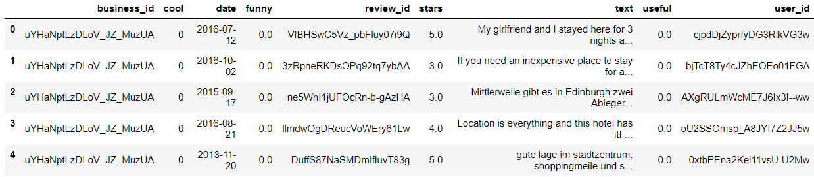

**Figure 1: Snapshot of the 'review' data**

‘business_id’, ‘review_id’ and ‘stars’ are the required column from this dataset.

The ‘business’ file has the details about each business. Yelp has a lot of businesses of different categories like restaurants, medical care services, auto care services, etc. listed on its website. The reviews present in the ‘review’ file contains reviews for all the categories. But, the recommendation engine is to be built only for the restaurants. Hence, the ‘business’ file is used to filter the unwanted reviews from ‘review’ file.

The ‘business’ file have several attributes about the businesses listed on Yelp. Some of them are listed below:

business_id, categories, city, hours_Friday, hours_Monday, is_open, latitude, longitude, name, neighborhood, etc.

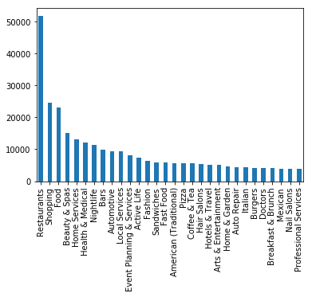Just to get some idea of the reviews, business categories, and city, few histograms are plotted.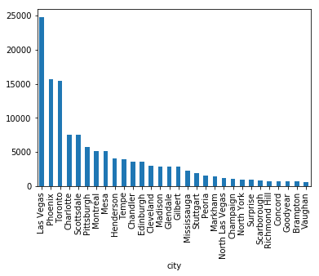

Figure 3: Count for each category of business (in ‘business’ file)

Figure 2: Number of Businesses in each city (‘business’ file)

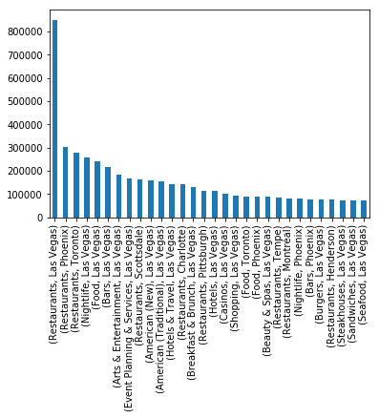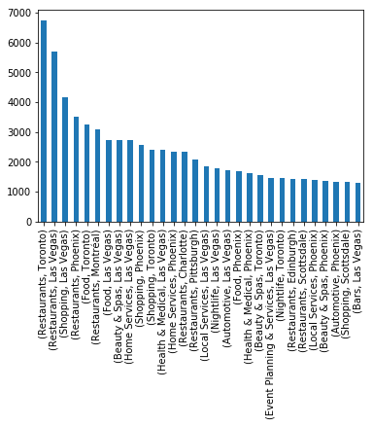

Figure 5: Review count of ordered pair of restaurant and business category in each city

Figure 4: Count of ordered pair of business category and city in the ‘business’ file

As it can be seen, Las Vegas, Phoenix and Toronto have the highest number of unique businesses (Yelp’s data set may be only a part of their complete data that they have released hence we don’t see popular cities like New York, San Francisco, etc.)

Moreover, restaurant as a business category have the most reviews which is a good news as the recommendation engine would have a lot of reviews from which it can learn the user and restaurant latent features and predict the ratings.

Although the restaurants in Las Vegas have the highest number of reviews, we won’t be selecting it as it would be highly probable that the reviews are given by the travelers. Since the travelers are only present in Las Vegas for some time, it don’t make sense to recommend them restaurants in Las Vegas once they have returned to their home cities. We would be selecting the restaurants in Phoenix and Toronto for building the model.

## **Merging and Cleaning datasets, and Creating Ratings Matrix**

**Merging data files**: The ‘business’ file is merged with the ‘review’ file to get information about the businesses and filter out reviews obtained from non-restaurants and restaurants not from the selected city (here Phoenix and Toronto are the selected cities).

**Cleaning the file**: After merging and filtering the ‘review’ file, the file is cleaned to remove the Nan values. There were not many missing values in the dataset.

**Filtering the file for minimum number of reviews**: The dataset is also filtered to only have users who have at least rated ten restaurants. This ensures that we can divide the data set into 2 reviews per user as a test data, two reviews per user as a validation data and at least 6 reviews per user as a part of training data. This would also ensure that the sparsity of the matrix is decreased and recommendation engine will have some signals to learn from.

**Train – Validation – Test Split**: Training, testing and validation data are all matrices of same size (# of unique users x # of unique restaurants). All the three matrices are disjoint i.e. the entries of test and validation matrix are zeroed out in the train matrix. The element-wise multiplication of three matrices returns a zero matrix.

## **Information about the Rating matrix**

|  |  |  |
| --- | --- | --- |
|  | Restaurants in Phoenix | Restaurants in Toronto |
| Shape | (2953, 2219) | (3545, 4375) |
| Sparsity | 99.0409 % | 99.4210 % |
| Number of non-zero entries (Training) | 51305 | 75608 |
| Number of non-zero entries (Validation) | 5906 | 7090 |
| Number of non-zero entries (Testing) | 5906 | 7090 |

As it can be seen from the above table, even after imposing the filter of minimum of ten reviews per user, both the rating matrices are still very sparse. This would be an issue while building a recommender models as there might not be sufficient signals that could be learned by the model.

The model building and performance evaluation are done for both the matrices. But for the discussion purpose and due to space constraint, we would only discuss the outcomes for restaurants in Phoenix. The outcomes were similar for the restaurants in Toronto. The results for the restaurants in Toronto are available in the appendix.

# **Model Building and Performance Evaluation**

## **Implicit latent features learning based models (Baseline Models)**

### **Singular Value Decomposition**

One of the popular methods of doing matrix completion is based on Singular Value Decomposition. The underlying motivation for doing this method is that we expect our matrix to exhibit a low rank structure (as there’ll only be some handful of (often abstract) features which determine how a user rate a restaurant and how a restaurant is rated by a user - this can be thought of as taste of users or type of restaurants). From the spectrum (Elbow Plot) of the matrix, it’s quite clear that most of the power is captured in the first few singular values and we expect to detect the latent features and get a better reconstruction by using the first k singular vectors. Monitoring the validation error, we find that we get the best possible results at k=2. Moreover, we obtain a huge difference between the validation and train MSE at k=2 i.e. diff (MSE) ~ 3.

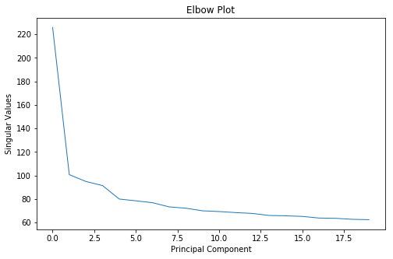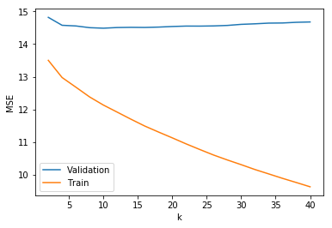

Since the matrix is very sparse and we filled all the Nan values with zero before taking an SVD, the reconstruction is implicitly trying to construct back the matrix with a lot of zero entries instead of actually filling in those missing values. Also, due to the extreme low rank of the matrix, even at k=2, we are able to capture most of the zeros, thus, making SVD based matrix incompetent.

On visualizing the first two components of user and restaurant features, we again find that there isn’t any (observable) structure in these components.

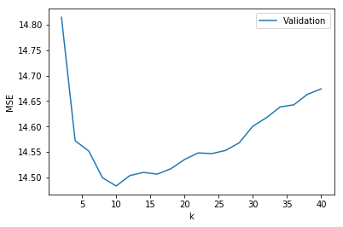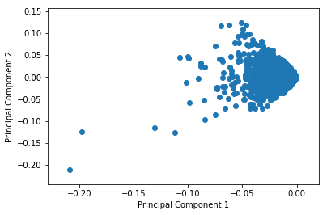

#### **SVD with Bias Correction**

We obtain similar results on decomposing the matrix into $X=u × 1^{T}+1× r+X'$, where u and r, are user and restaurant bias vectors and X’ is the matrix which captures variational information, and performing a matrix completion based on SVD on X’. The best validation MSE we could obtained was SVD (with Bias correction) = 14.47 for k=12.

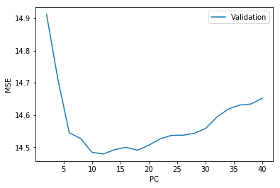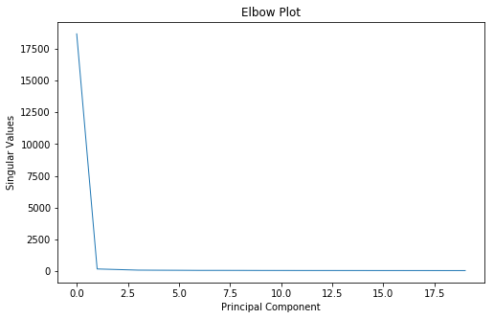

### **Cosine similarity based prediction with bias correction**

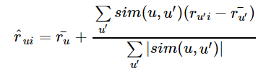A natural way to think about the prediction problem is to assume that the rating r = f(u,v), where u and v are the feature vectors for users and restaurants. One would expect that the rating will be higher if a user’s interests matches with the type of restaurant he/she visits, implying that the rating can be thought of as a weighted combination of the user-restaurant “similarity” measure.  We formulate

We used the restaurant based similarity so that we could tackle the cold-start problem for the new users.

The best out of sample error achieved by the model after hyperparameter tuning was MSE = 14.64 for k=39 which is comparable to that of SVD. We realize that cosine similarity is not a good measure to use at such high dimensions and combined with this, the high sparsity in our data doesn’t give the model enough signal to detect patterns.

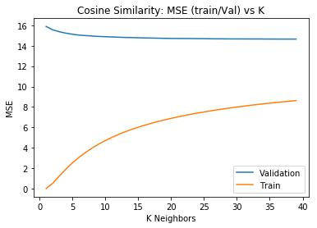

## **Explicit latent features learning based models**

### **Learning Latent Features using Alternating Least Squares**

Another popular method of matrix factorization is to assume that the matrix factorizes into X,Y and then solve for them.

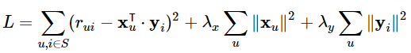

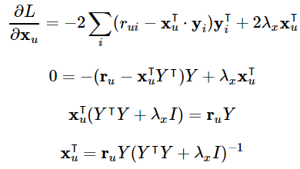

We get the best out of sample error for feature number = 10 and user_reg = res_reg = 0.001.

Best MSE (for ALS) = 14.586

ALS produces similar performances to that of other baseline models which wasn’t surprising given the nature of the data.

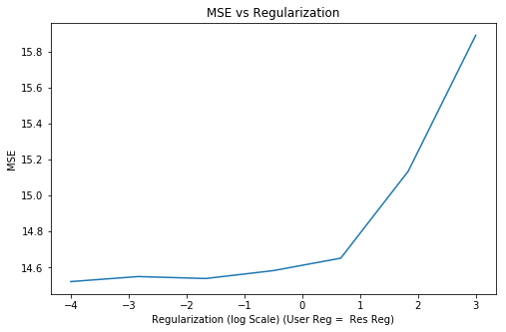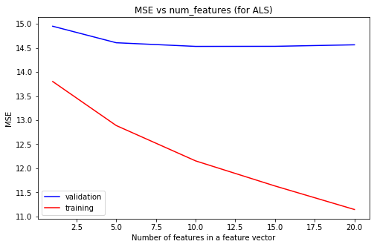

### **Learning Latent Features through Stochastic Gradient Descent**

From the performance of baseline models and ALS, we realized that the high sparsity of our matrix is forcing the baseline models to predict the missing ratings to be zero in even with small number of latent variables for user/restaurant features. This also implies that the underlying matrix is very low rank. We formulate a similar decomposition to that of ALS(and cosine similarity) but with some bias terms all of which learned through gradient descent by minimizing a regularized cost function which only looks at error between the actual non-zero rating and predicted rating, instead of the entire matrix. We thought this was a reasonable model to try as the number of parameters we’ve to learn will be small due to the low rank structure of matrix.



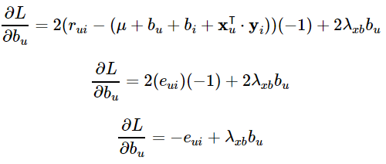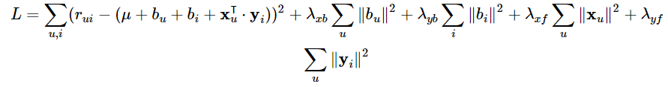

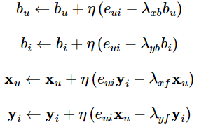

On tuning for the optimal k, we found that we get the best out of sample error at k=2. Over fitting for higher values of k is predictable given the sparsity of matrix. We can also observe that in the spectrum of singular values of the full matrix, we observe inflection points at k=2 and k=7 both of which minimizes the validation error for our method based on SGD as well. In addition to incorporating the bias terms that we learn, we believe that looking at the error of only the actual non-zero values is one of the contributing factors for the good performance we get using this model.

Tuning the hyperparameter like number of iterations and number of features in the latent feature vector, we got minimum MSE of 1.32 for 20 iterations and number of features = 2

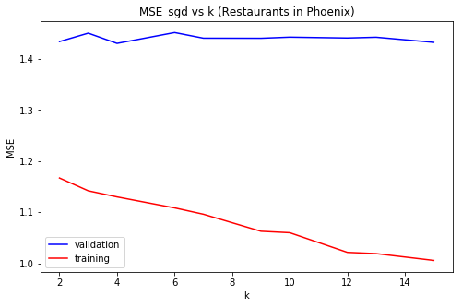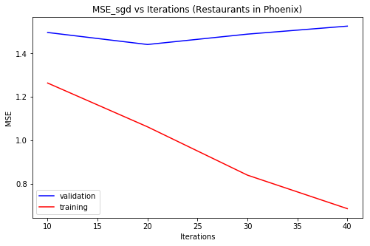

## **Converting into a regression problem**

Given that we have learned latent features using the gradient descent method, we decided to convert the matrix completion problem into a regression/classification problem. For predicting $r_{ij}$, we concatenated the feature vector of user i and restaurant j. We repeated the experiment with feature vectors obtained using SVD and ALS, on which we couldn’t get as good performance as we got from the feature vectors we learned through gradient descent. We try a bunch of methods for regression including a fully connected neural network.

### **Neural Network based Model**

Given that we only have 2k=4 input neurons, we decided go for a fully-connected architecture with 2 hidden neurons with a sigmoid activation function mapping to a single output neuron with ReLU. We observe an out of sample error value of 1.45 which is comparable to that of the performance we had in our gradient descent method.

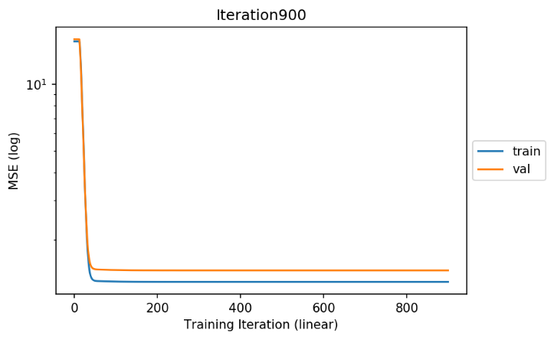Since we failed to detect any observable pattern in the latent features we learned on visual inspection, to convince ourselves that these features actually contain some signal and not just noise, we trained the network to map Gaussian noise to the rating. We ended up obtaining about the same (but slightly higher) MSE as we obtained on training with our features. Furthermore, on training with our features and testing on noise, the MSE wasn’t comparable. From these experiments, we concluded that there is some signal in these latent features but probably, the signal to noise ratio is very low.

### **Random Forest Regressor**

Similar to Neural Network based model, the feature vectors learned from SGD were used as the features for the regression problem. Fitting a Random Forest Regressor with max_depth = 5, we obtained a comparable MSE of 1.433 for the restaurants in Phoenix.

## **Ensemble of all the predictors**

We formulate our final prediction as a linear combination of the predictions of our Gradient based model, neural network based model and random forest. The MSE obtained for the ensemble model was lower than all the individual models. The best validation MSE obtained was 1.2211 for restaurants in Phoenix.

## **Formulating as an optimization problem – Minimizing the Nuclear Norm**

Like how L1 norm is used as a proxy for L0 norm, nuclear norm is often used as a proxy for minimizing the rank of matrix. We tried convex optimization methods to reduce the following cost function:

Cost function = L2 penalty on non-zero terms in matrix and recovered + lambda nuclear norm of matrix

None of the optimization procedures that we tried converged in our laptop often failing in between due to memory error.

## **Summary of all the Models**

|  |  |  |
| --- | --- | --- |
| Model | Validation MSE | |
| Restaurants in Phoenix | Restaurants in Toronto |
| SVD | 14.47 | 13.382 |
| Cosine Similarity based model | 14.64 | 13.54 |
| ALS based model | 14.586 | 13.45 |
| SGD based model | 1.32 | 1.225 |
| Neural Network based model | 1.453 | 1.326 |
| Random Forest Regressor | 1.433 | 1.329 |
| Ensemble of SGD, NN and RF | **1.2211** | **1.154** |

Based on the analysis of all the models, we choose the Ensemble Model for both the Restaurants in Phoenix and for the Restaurants in Toronto as the best model for recommendation.

On testing the models on the Test Data, we got: MSE of 1.173 (for Restaurants in Phoenix) and 1.098 (for Restaurants in Toronto).

# **Deployment and Monitoring**

## **Scaling Up Issues**

In the real world scenario rarely recommendation engines are implemented using Python. Some big data frameworks like Spark is used that helps in parallelizing the computation. As the number of users on the platform increases, it becomes increasing difficult and slow to train the models by using the traditional methods. Spark has an in-built map reduce framework that helps in parallelizing the computation and efficiently deploys the recommendations in the production environment.

Generally, ALS and SGD based models scale up better since its computation can be parallelize, whereas SVD and Cosine Similarity based models’ complexity increase by n^2 hence training these models become increasingly inefficient as the number of users and restaurants increases.

## **Testing and monitoring the models in real time**

Since the model develops recommendation for users, it is very difficult to test if the predictions were correct or not. Many a times some proxy is used. For example, if the recommendation engine provides recommendation of items to purchase, it is pretty straight forward that if the user purchased the item, clicked on the item, etc. it can be termed as a successful recommendation. In our case, if the user reviews the restaurants on Yelp after the model recommends it to the user, it can termed as a success. Another way to monitor the success is by aliasing with the restaurants and getting to know if a customer visited the restaurant after the recommendation.

To test between two different models, A/B testing is generally used to determine the best model. Some population is shown recommendation based on ‘A’ model and other population is shown recommendation based on ‘B’ model. The statistical difference between the model’s successes are analyzed. If the difference is significant, we can term one model better over the other.

Many a times, a new user comes on board, so the model don’t know much about the user. So, it cannot recommend the restaurants to the user. This is called a Cold start problem. To overcome this problem, the meta-data of user like demographic information, location, profession, etc. can be used to find similar users and based on the similarity the model can make recommendations, or the model can recommend the most popular one. In our case, since we don’t have the meta-information about the users that helps in characterizing the user, we might go ahead with recommending the most popular restaurant.

## **Ethical Issue concerning with the Recommendation Engines**

Generally, the recommendation engine also take in account the demographic information of the user. In that case, there are chances that model might become biased towards some caste, gender, profession etc. These biases were learnt from the past data. Hence, the model will only aggravate this discrimination against some set of people. Fortunately, in our case, the model is not using any user specific details. Therefore, the chances of such racial biases creeping into the model is low. Moreover, since it is just a restaurant recommendation, the recommendations made by the model might not have much social implications.

# **Code**

All the code for the project is available on the github repository with the following link:

<https://github.com/nhan0905585682/Yelp-Recommendation-System>

# **References**

* <http://blog.ethanrosenthal.com/2016/01/09/explicit-matrix-factorization-sgd-als/>
* <http://blog.ethanrosenthal.com/2015/11/02/intro-to-collaborative-filtering/>

# **Appendix**

All the plots for the **Restaurants in Toronto**:

**SVD:**

Elbow Plot:

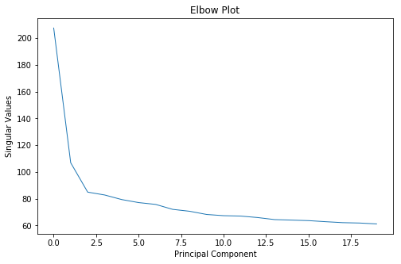

Validation and Training Error for different PCs:

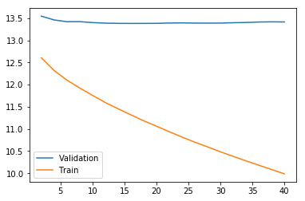

**Cosine Similarity:**

Training and Validation MSE for different K Neighbors:

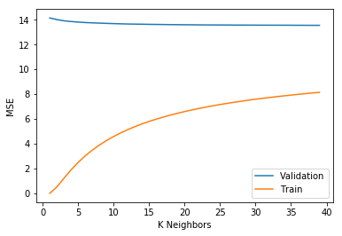

**ALS:**

Training and Validation MSE for different number of features:

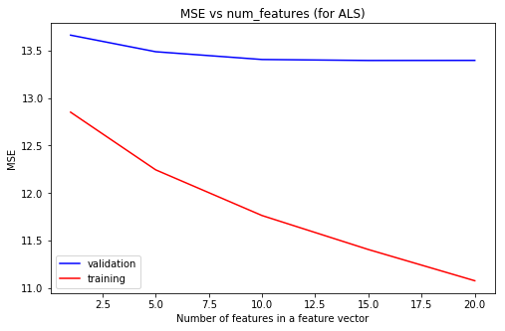

Validation MSE for different User and Restaurant Regularization Parameter:

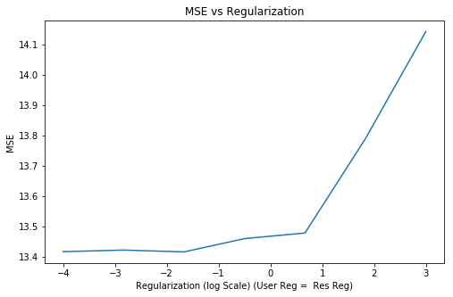

**SGD:**

Training and Validation MSE for different number of iterations:

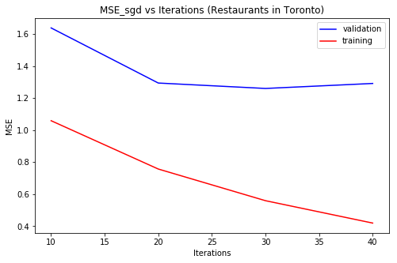

Training and Validation MSE for different number of features in the latent features:

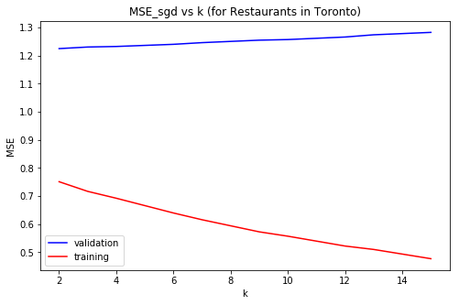

**Neural Network:**

Training and Validation MSE for different epochs (iterations):

