Link web : <https://bachhoakhanhlinh.com/thanh-toan>

**Thông tin cấu hình**

- Địa chỉ Website (Website Url): [https://bachhoakhanhlinh.com/](https://bachhoakhanhlinh.com/" \t "https://mail.google.com/mail/u/0/" \l "inbox/_blank)

- Terminal ID/Mã Website (vnp\_TmnCode): HUUCHIN1

- Secret Key/Chuỗi bí mật tạo checksum (vnp\_HashSecret): KTZHDTLHQARNWSGEDSWPOIHWTPXFUNPL

- Url thanh toán môi trường TEST (vnp\_Url): [https://sandbox.vnpayment.vn/paymentv2/vpcpay.html](https://sandbox.vnpayment.vn/paymentv2/vpcpay.html" \t "https://mail.google.com/mail/u/0/" \l "inbox/_blank)

**Địa chỉ:**[http://sandbox.vnpayment.vn/merchantv2/](http://sandbox.vnpayment.vn/merchantv2/" \t "https://mail.google.com/mail/u/0/" \l "inbox/_blank)

Tên đăng nhập:  [nguyenhuuchin.com@gmail.com](mailto:nguyenhuuchin.com@gmail.com" \t "https://mail.google.com/mail/u/0/" \l "inbox/_blank)

Mật khẩu: Chin@123

1. Tạo nut check thanh toán vn pay

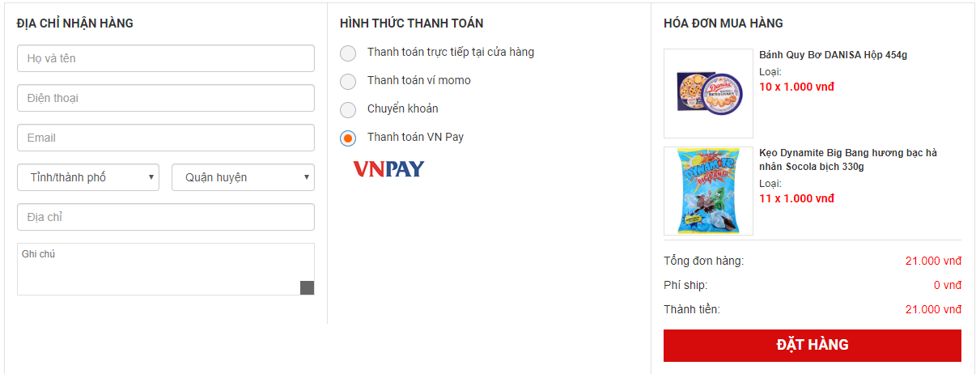

1. sourc thanh toán :

if($mail->Send()){

if($\_POST['httt']=='radio-vnp'){

include\_once "vnpay/vnpay\_create\_payment.php";

}

unset($\_SESSION['cart']);

transfer("Đặt hàng thành công ! ", "https://".$config\_url);

}

1. cấu hình thông tin trong 3 file :

+ vnpay/config.php

+vnpay/vnpay\_create\_payment.php

+vnpay/vnpay\_return.php