Installation
- un-zip Claudo.zip
- Double click file Setup.exe
- Select installation folder, then click OK
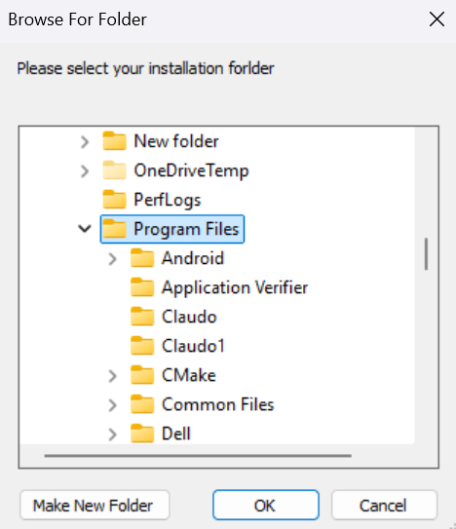
- Claudo icon is created on desktop
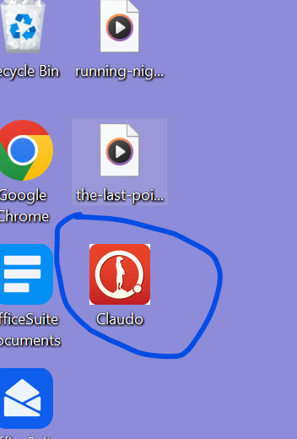
File Encryption
- Open file explore, right click a file which you want to encrypt, then click “open with” --> click “claudo”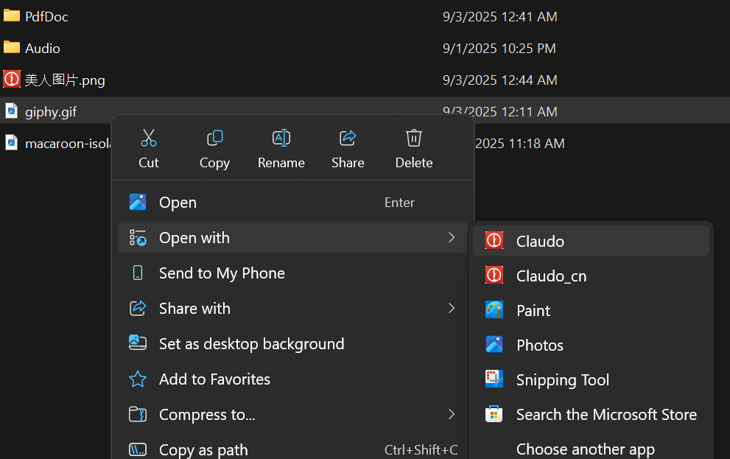
- Enter password (8-16 characters long) on the popup widows dialog 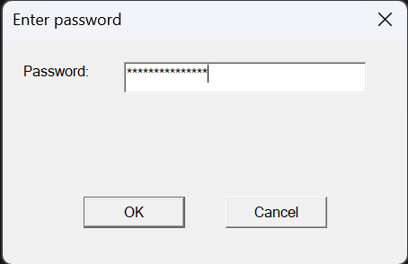
- click “OK”
- A popup message box show up tells you the file is encrypted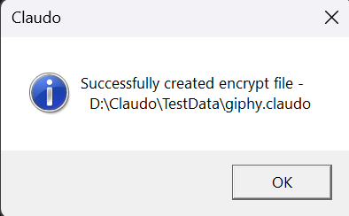
File Decryption
- On file explorer, double click(or right lick, --> then click open with -->claudo) an encrypted file (.claudo file)
- on the popup widows dialog, enter the password used for encrypting the file, then click “OK”
- File is decrypted ( you got the original file back) with a popup message box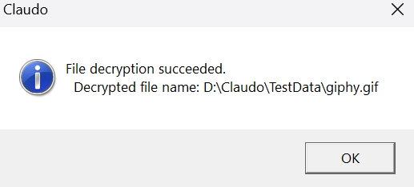

Demo with Windows interface
Under C:\Program Files\Claudo, double click claudo.exe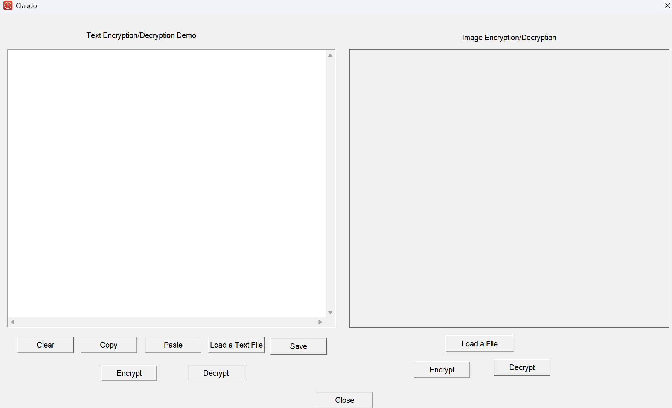

To encrypt/decrypt a text paragraph
- Copy text, and paste text to the text editor 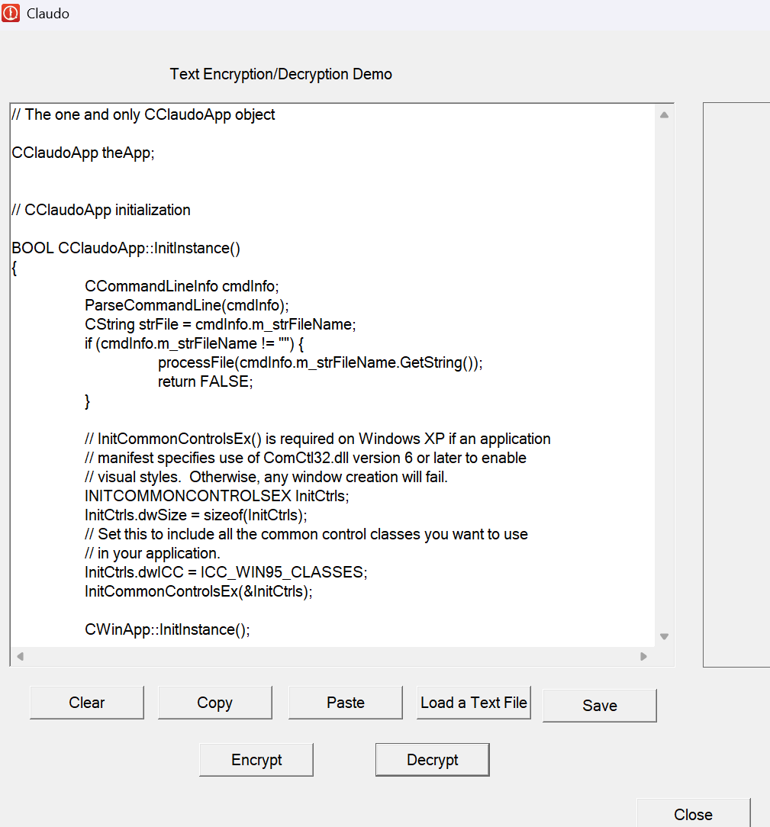
- click“Encrypt”button，encrypted character shown up 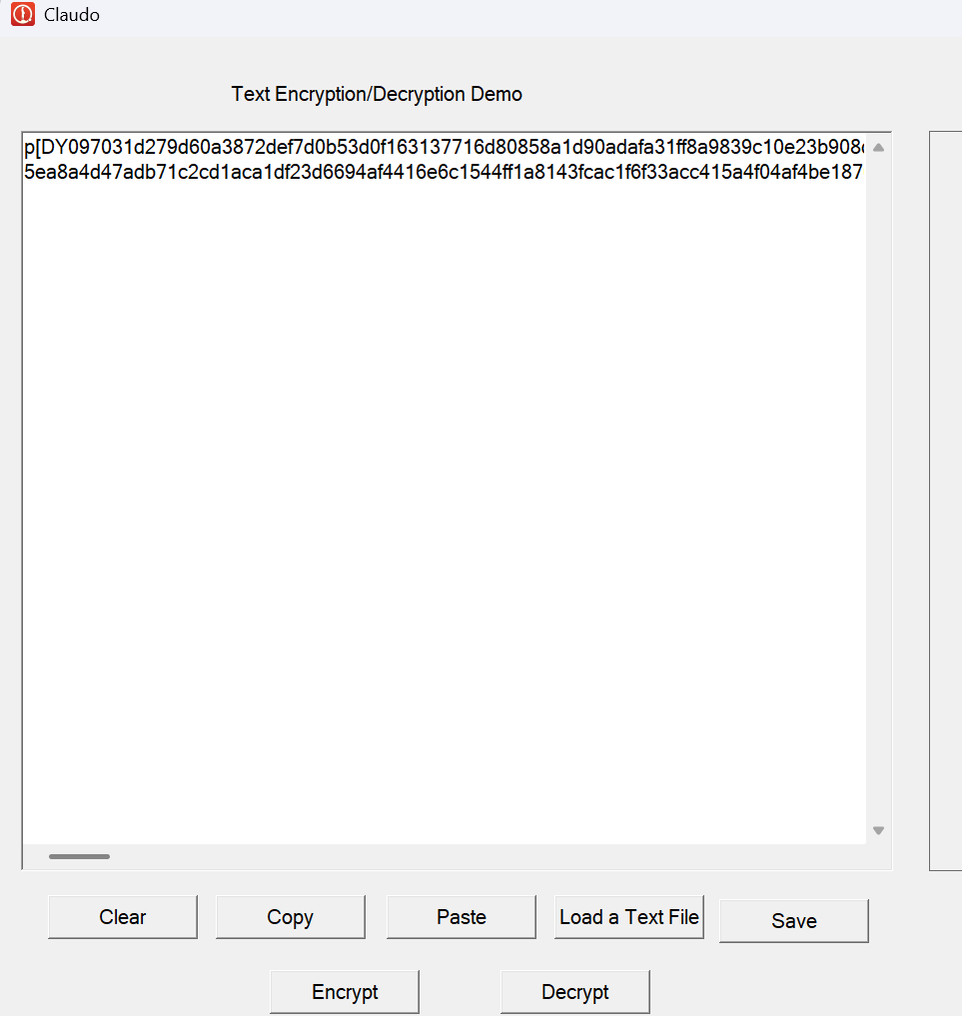
- Click “Decrypt”button，original text displayed on the text editor
Other buttons
- Clicking “Copy” button copy the content in the text edit box
- Clicking “Paste” button to paste the text you copied to the text edit box
- Clicking “Save” button to save the content in the edit box into a file。
- Clicking “Clear” button to clear the text edit box
- Clicking “ button to load a text file” to load a file content into the text edit box for encrypting/decrypting

Encrypt/Decrypt files (could be any file types such as .txt. pdf, .doc, picture, audio, video etc.）
- Clicking “Load a file ”button at right bottom to load a file. If a picture file is loaded，it will be displayed on the picture box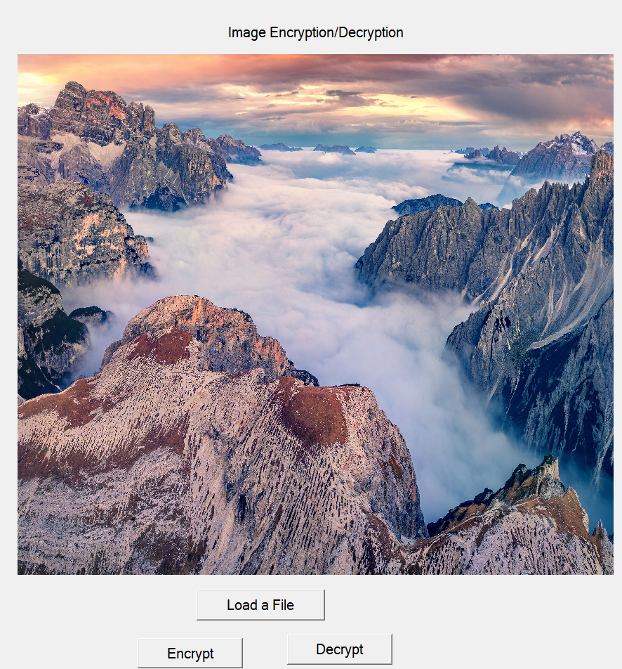
- Click “Encrypt” button, encrypted picture replaced the original one 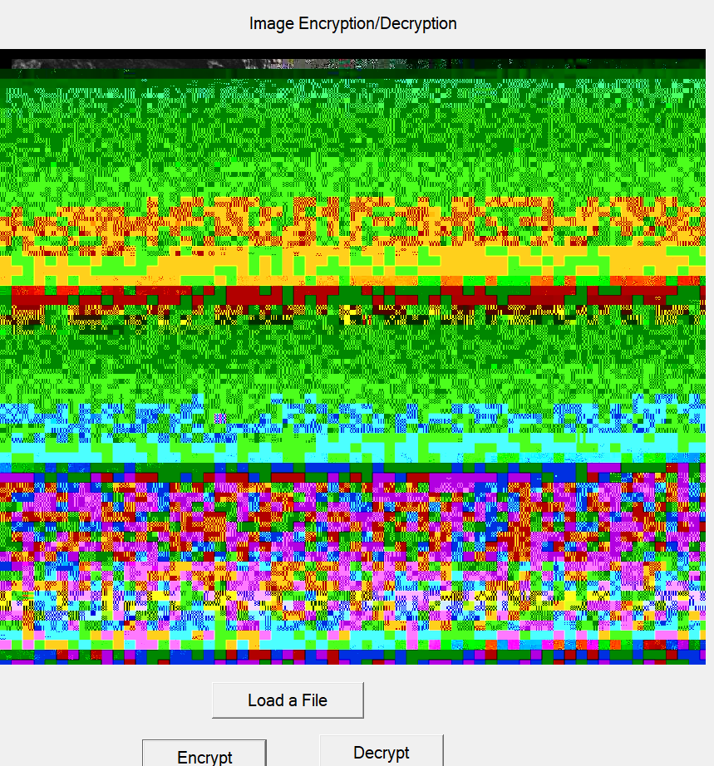
- Click “Decrypt”button, the original picture comes back

