**SCALABLE SYTEM**

---

**CURRENT ARCHITECTURE**

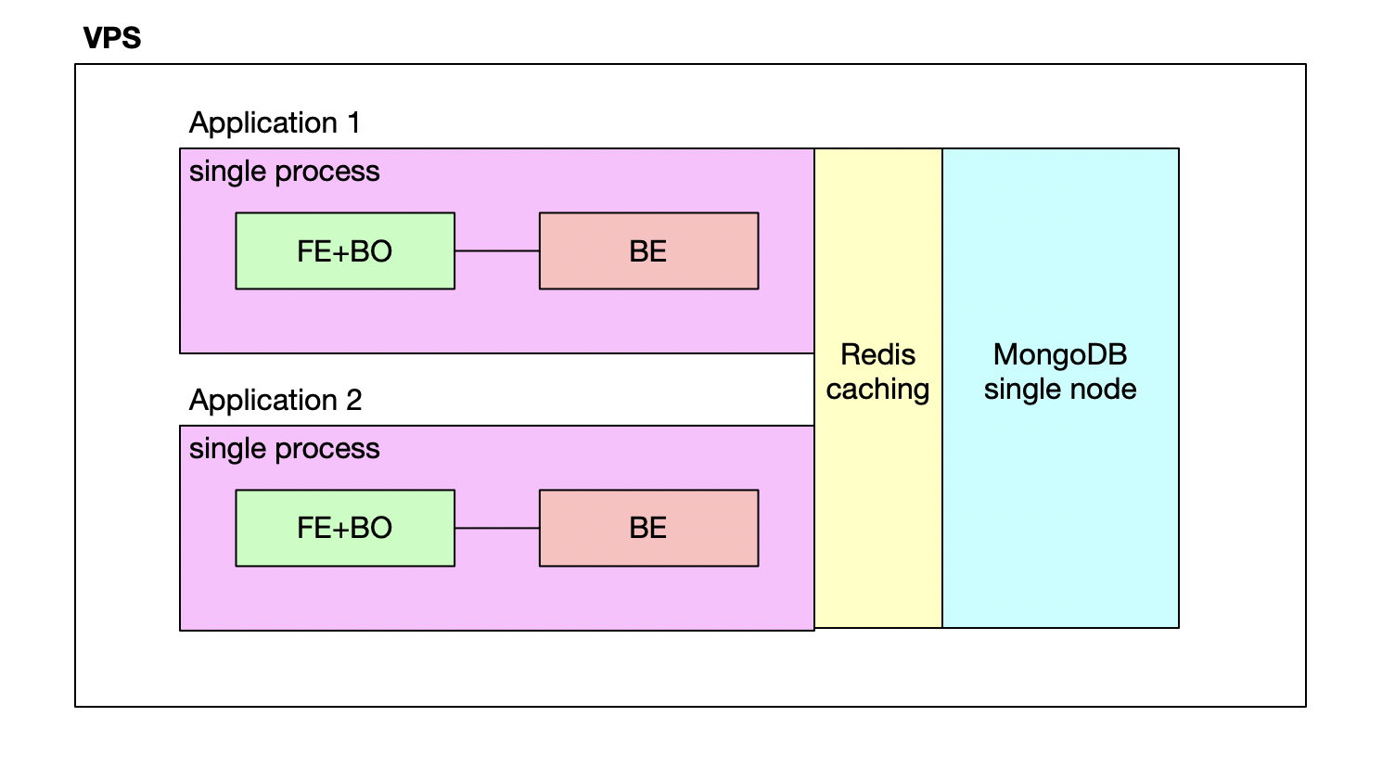

**SCALABLE ARCHITECTURE**

# Stateless Database service => Use only one DATABASE in separated VPS and be clustered

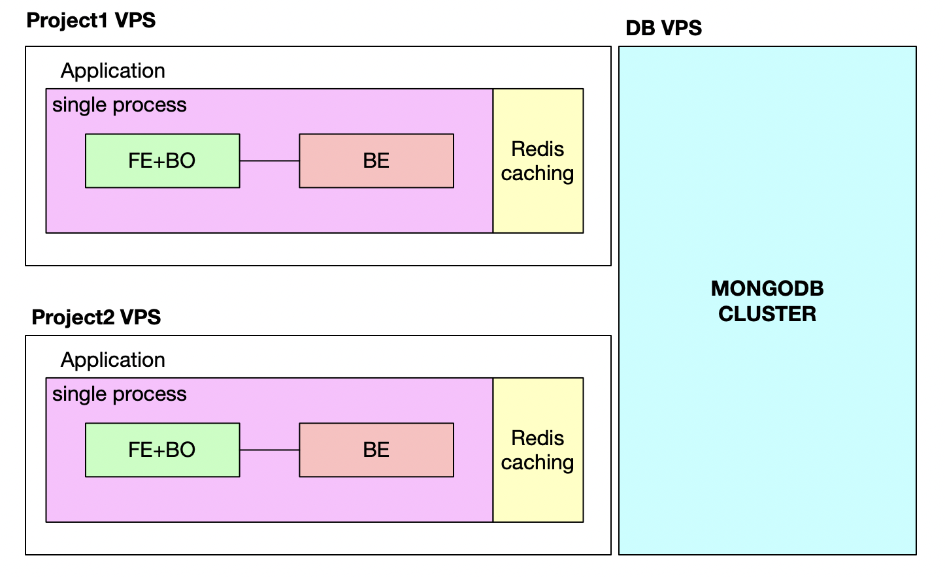

# Stateless Application

* FE+BO are using ReactJS mean static file hosted => does not make heavy load this stage
* BE has to handle logic, access database => take some times maybe problem at this stage => need scale here

## Application caching

Using Redis as caching for application, it shares resource across process

## Scaling application process

Use PM2 cluster to scale application. But need separate cronjob to make stateless in process

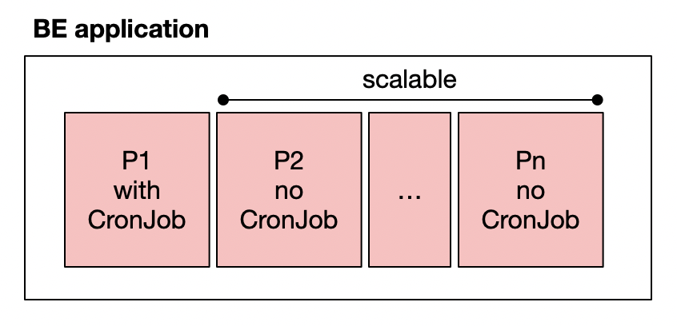

## Traffic balancing

Use Nginx with upstream to share traffic to another VPS

