Derek Nhan

CPE301 – SPRING 2016

Design Assignment 0

**DO NOT REMOVE THIS PAGE DURING SUBMISSION:**

The student understands that all required components should be submitted in complete for grading of this assignment.

|  |  |  |  |
| --- | --- | --- | --- |
| **NO** | **SUBMISSION ITEM** | **COMPLETED (Y/N)** | **MARKS**  **(/MAX)** |
| 0. | COMPONENTS LIST AND CONNECTION BLOCK DIAGRAM w/ PINS |  |  |
| 1. | INITIAL CODE OF TASK 1/A |  |  |
| 2. | INCREMENTAL / DIFFERENTIAL CODE OF TASK 2/B |  |  |
| 3. | INCREMENTAL / DIFFERENTIAL CODE OF TASK 3/C |  |  |
| 4. | INCREMENTAL / DIFFERENTIAL CODE OF TASK 4/D |  |  |
| 5. | INCREMENTAL / DIFFERENTIAL CODE OF TASK 5/E |  |  |
| 6. | SCHEMATICS |  |  |
| 7. | SCREENSHOTS OF EACH TASK OUTPUT |  |  |
| 8. | SCREENSHOT OF EACH DEMO |  |  |
| 9. | VIDEO LINKS OF EACH DEMO |  |  |
| 10. | GOOGLECODE LINK OF THE DA |  |  |
|  |  |  |  |
|  |  |  |  |

|  |  |  |  |
| --- | --- | --- | --- |
| 0. | COMPONENTS LIST AND CONNECTION BLOCK DIAGRAM w/ PINS |  |  |

|  |  |  |  |
| --- | --- | --- | --- |
| 1. | INITIAL CODE OF TASK 1/A |  |  |

.org 0

.def rand_num = r16

.def sum = r17

.def counter = r18

.cseg

sbi DDRB, 2 ;sets port b as output

ldi counter, 0x00 ;initialize counter to 0

ldi sum, 0x00 ;sum to 0

ldi r19, 0 ;r19 to 0

out PORTB, r19 ;leaves port b pin 2 off

random:

ldi rand_num, random%31 ;first random number

subi rand_num, -30

add sum, rand_num ;adds random number

ldi rand_num, ovrflw%31 ;second random number

subi rand_num, -30

add sum, rand_num

ldi rand_num, ovrflw+random %31 ;third random number

subi rand_num, -30

add sum, rand_num

ldi rand_num, done+random %31 ;fourth random number

subi rand_num, -30

add sum, rand_num

ldi rand_num, done %31 ;fifth random number

subi rand_num, -30

add sum, rand_num

brvs ovrflw ;if overflow flag is 1, jmp to ovrflw

jmp done ;otherwise, jump to done

ovrflw:

ldi r19, 4 ;set r19 to 4

out PORTB, r19 ;light pb2

done:

|  |  |  |  |
| --- | --- | --- | --- |
| 6. | SCHEMATICS |  |  |

|  |  |  |  |
| --- | --- | --- | --- |
| 7. | SCREENSHOTS OF EACH TASK OUTPUT |  |  |

TASK 1/A:

Set PB2 as an output

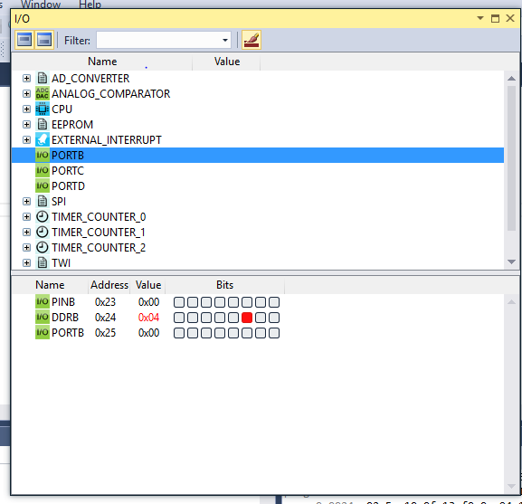

|  |  |  |  |
| --- | --- | --- | --- |
| 8. | SCREENSHOT OF EACH DEMO |  |  |

Task 1/A:

PB4 set to high if overflow occurs

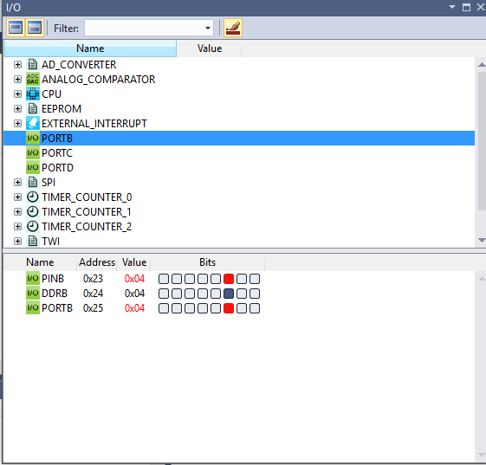

Task b:

CLOCK @ 8Mhz

Execution time/#cycles=0.125 microseconds per cycle

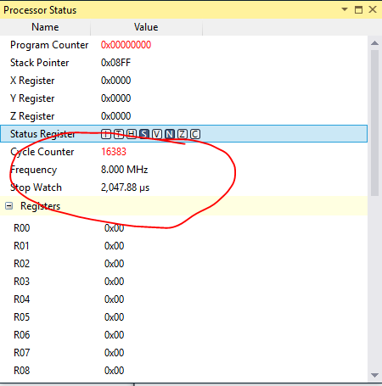

|  |  |  |  |
| --- | --- | --- | --- |
| 9. | VIDEO LINKS OF EACH DEMO |  |  |
| http:// @youtube | | | |
| 10. | GOOGLECODE LINK OF THE DA |  |  |
| https://github.com/nhand2/CPE301Sp16.git | | | |

**Student Academic Misconduct Policy**

<http://studentconduct.unlv.edu/misconduct/policy.html>

“This assignment submission is my own, original work”.

Derek Nhan