Derek Nhan

CPE301 – SPRING 2016

Design Assignment 2

**DO NOT REMOVE THIS PAGE DURING SUBMISSION:**

The student understands that all required components should be submitted in complete for grading of this assignment.

|  |  |  |  |
| --- | --- | --- | --- |
| **NO** | **SUBMISSION ITEM** | **COMPLETED (Y/N)** | **MARKS**  **(/MAX)** |
| 0. | COMPONENTS LIST AND CONNECTION BLOCK DIAGRAM w/ PINS |  |  |
| 1. | INITIAL CODE OF TASK 1 C Code |  |  |
| 2. | INITIAL CODE OF TASK 1 ASM Code |  |  |
| 3. | INCREMENTAL / DIFFERENTIAL CODE OF TASK 2 C Code |  |  |
| 4. | INCREMENTAL / DIFFERENTIAL CODE OF TASK 2 ASM Code |  |  |
| 5. | INCREMENTAL / DIFFERENTIAL CODE OF TASK 3 C Code |  |  |
| 6. | INCREMENTAL / DIFFERENTIAL CODE OF TASK 4 C Code |  |  |
| 7. | SCHEMATICS |  |  |
| 8. | SCREENSHOTS OF EACH TASK OUTPUT |  |  |
| 9. | SCREENSHOT OF EACH DEMO |  |  |
| 10. | VIDEO LINKS OF EACH DEMO |  |  |
| 11. | GOOGLECODE LINK OF THE DA |  |  |
|  |  |  |  |
|  |  |  |  |

|  |  |  |  |
| --- | --- | --- | --- |
| 0. | COMPONENTS LIST AND CONNECTION BLOCK DIAGRAM w/ PINS |  |  |

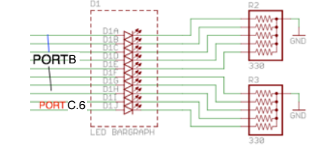

*Diagram provided via DA2 handout*

|  |  |  |  |
| --- | --- | --- | --- |
| 1. | INITIAL CODE OF TASK 1/A C Code |  |  |

#include <avr/io.h>

void sub_delay()

//delay subroutine that creates a 50% duty cycle clock w/ period of 5 seconds

{

TCNT1=63583; //sets counter to 63583, which takes 0.25 s to overflow

TCCR1A=0x00; //normal more operation

TCCR1B=0x05; //prescaler of 1024

while((TIFR1&0x01)==0); //loops until TOV1 is set

TCCR1B=0x00; //stops the timer

TIFR1|=(1<<TOV1); //clear TOV1 flag

PORTC=PORTC ^(0x01); //xor PORTC, PC.0 specifically to toggle a clock

}

int main()

{

DDRC=0x01; //PC.4 and 5 were used to output every 5 and 10 rising //pulses due to availability on the board

PORTC=0x00; //Clears the PORTC to output LOW signal

while(1)

//while loop that will execute forever

sub_delay(); //Subroutine to cause a delay of 0.25s which will cause //a 5s period for the clock

return 1;

}

|  |  |  |  |
| --- | --- | --- | --- |
| 2. | INITIAL CODE OF TASK 1/A ASM Code |  |  |

;================================TASK1=========================================

.dseg

.def XOR1=R24;

.cseg

.MACRO INITSTACK

LDI @0,HIGH(@1)

OUT SPH,@0

LDI @0,LOW(@1)

OUT SPL,@0

.ENDMACRO

INITSTACK R16, RAMEND ;use Macro here

LDI R16,0x01

SBI DDRC, 0 ;PC.0 as an output

LDI R17,0

OUT PORTC,R17 ;PORTC = 0

BEGIN:

RCALL DELAY

EOR R17,R16 ;toggle B0 of R17;

OUT PORTC,R17 ;toggle PC.0

RJMP BEGIN

;TIMER1 DELAY

DELAY:

LDI R20,0xF8

STS TCNT1H,R20 ;TCNT1H = 0xF8 timer1 high

LDI R20,0x5F

STS TCNT1L,R20 ;TCNT1L = 0x5F timer1 low

LDI R20,0x00

STS TCCR1A,R20 ;set normal mode

LDI R20,0x05

STS TCCR1B,R20 ;Normal mode, prescaler = 1024

AGAIN:

IN R20,TIFR1 ;read TIFR1

SBRS R20,TOV1 ;if TOV1 is set skip next instruction

RJMP AGAIN

LDI R20,0x00 ;logic 00 if fed to the register to stop the timer

STS TCCR1B,R20 ;stop Timer1

LDI R20,0x01 ;a logic 1 in the TOV1 bit causes a reset/clear

OUT TIFR1,R20 ;clear TOV1 flag

RET

;=============================END_TASK1========================================

|  |  |  |  |
| --- | --- | --- | --- |
| 3. | INCREMENTAL / DIFFERENTIAL CODE OF TASK 2 C Code |  |  |

#include <avr/io.h>

void sub_delay()

//delay subroutine that creates a 50% duty cycle clock w/ period of 5 seconds

{

TCNT1=63583; //sets counter to 63583, which takes 0.25 s to overflow

TCCR1A=0x00; //normal more operation

TCCR1B=0x05; //prescaler of 1024

while((TIFR1&0x01)==0); //loops until TOV1 is set

TCCR1B=0x00; //stops the timer

TIFR1|=(1<<TOV1); //clear TOV1 flag

PORTC=PORTC ^(0x01); //xor PORTC, PC.0 specifically to toggle a clock

}

int main(void)

{

DDRB=0xFF; //PORTB will be used to output the counter

PORTB=0x00; //Initialize the out to output LOW signal

DDRC=0x31; //PC.4 and 5 were used to output every 5 and 10 rising //pulses due to availability on the board

PORTC=0x00; //Clears the PORTC to output LOW signal

DDRD=0x00; //PD.4 is set to be used at T0 to take input from the //clock generated

TCNT0=0x00; //counter 0 that will output to PORTB

TCCR0A=0x00; //Setting counter to normal mode operation

TCCR0B=0x07; //sets counter to accept external clock (PD4)

while(1)

//while loop that will execute forever

{

sub_delay(); //Subroutine to cause a delay of 0.25s which will cause //a 5s period for the clock

PORTB=TCNT0; //output counter/timer0 to PORTB (8 bit leds)

}

return 1;

}

|  |  |  |  |
| --- | --- | --- | --- |
| 4. | INCREMENTAL / DIFFERENTIAL CODE OF TASK 2 ASM Code |  |  |

.dseg

.def XOR1=R24;

.cseg

.MACRO INITSTACK

LDI @0,HIGH(@1)

OUT SPH,@0

LDI @0,LOW(@1)

OUT SPL,@0

.ENDMACRO

INITSTACK R16, RAMEND ;use Macro here

LDI XOR1,0x01

SBI DDRC, 0 ;PC.0 as an output

LDI R17,0

OUT PORTC,R17 ;PORTC = 0

LDI R17, 0xFF

OUT DDRB, R17 ;loads R17(0xFF) to DDRB, to set as output

LDI R17, 0x00

OUT PORTB, R17 ;initialize PORTB to 0

OUT DDRD, R17 ;sets DDRD as output for use with PD.4

OUT TCNT0, R17 ;initialize TCNT0 to 0

OUT TCCR0A, R17 ;normal mode operation counter

LDI R17, 0x07 ;sets counter to accept external clock (PD4)

OUT TCCR0B, R17

BEGIN:

RCALL DELAY ;calls delay subroutine

EOR R17, XOR1 ;toggle B0 of R17;

OUT PORTC,R17 ;toggle PC.0

IN R16, TCNT0 ;loads TCNT0 to R16

OUT PORTB, R16 ;outputs TCNT0 to PORTB

RJMP BEGIN

;TIMER1 DELAY

DELAY:

LDI R20,0xF8

STS TCNT1H,R20 ;TCNT1H = 0xF8 timer1 high

LDI R20,0x5F

STS TCNT1L,R20 ;TCNT1L = 0x5F timer1 low

LDI R20,0x00

STS TCCR1A,R20 ;set normal mode

LDI R20,0x05

STS TCCR1B,R20 ;Normal mode, prescaler = 1024

AGAIN:

IN R20,TIFR1 ;read TIFR1

SBRS R20,TOV1 ;if TOV1 is set skip next instruction

RJMP AGAIN

LDI R20,0x00 ;logic 00 if fed to the register to stop the timer

STS TCCR1B,R20 ;stop Timer1

LDI R20,0x01 ;a logic 1 in the TOV1 bit causes a reset/clear

OUT TIFR1,R20 ;clear TOV1 flag

RET

|  |  |  |  |
| --- | --- | --- | --- |
| 5. | INCREMENTAL / DIFFERENTIAL CODE OF TASK 3 |  |  |

#include <avr/io.h>

void sub_delay()

//delay subroutine that creates a 50% duty cycle clock w/ period of 5 seconds

{

TCNT1=63583; //sets counter to 63583, which takes 0.25 s to overflow

TCCR1A=0x00; //normal more operation

TCCR1B=0x05; //prescaler of 1024

while((TIFR1&0x01)==0); //loops until TOV1 is set

TCCR1B=0x00; //stops the timer

TIFR1|=(1<<TOV1); //clear TOV1 flag

PORTC=PORTC ^(0x01); //xor PORTC, PC.0 specifically to toggle a clock

}

int main(void)

{

unsigned char toggle1=0; //toggle counter for 5 rising clock edges

unsigned char toggle2=0; //toggle counter for 10 rising clock edges

DDRB=0xFF; //PORTB will be used to output the counter

PORTB=0x00; //Initialize the out to output LOW signal

DDRC=0x31; //PC.4 and 5 were used to output every 5 and 10 rising //pulses due to availability on the board

PORTC=0x00; //Clears the PORTC to output LOW signal

DDRD=0x0C; //PD.4 is set to be used at T0 to take input from the //clock generated

TCNT0=0x00; //counter 0 that will output to PORTB

TCCR0A=0x00; //Setting counter to normal mode operation

TCCR0B=0x07; //sets counter to accept external clock (PD4)

while(1)

//while loop that will execute forever

{

sub_delay(); //Subroutine to cause a delay of 0.25s which will cause //a 5s period for the clock

PORTB=TCNT0;

if ((PORTC&(0x01))==1)

//checks if clock rising edge to increment toggle counters

{

++toggle1;

++toggle2;

}

if (toggle1==5)

//if toggle1=5, toggle PC4

{

PORTC^=(1<<PORTC4); //xor PORTC with 0x10

toggle1=0; //reset toggle1 counter

}

if (toggle2==10)

//if toggle2=10, toggle PC5

{

PORTC^=(1<<PORTC5); //xor PORTC with 0x20

toggle2=0; //clear toggle2

}

}

return 1;

}

|  |  |  |  |
| --- | --- | --- | --- |
| 6. | INCREMENTAL / DIFFERENTIAL CODE OF TASK 4 |  |  |

#include <avr/io.h>

#include <avr/interrupt.h>

void sub_delay()

//delay subroutine that creates a 50% duty cycle clock w/ period of 5 seconds

{

TCNT1=63583; //sets counter to 63583, which takes 0.25 s to overflow

TCCR1A=0x00; //normal more operation

TCCR1B=0x05; //prescaler of 1024

while((TIFR1&0x01)==0); //loops until TOV1 is set

TCCR1B=0x00; //stops the timer

TIFR1|=(1<<TOV1); //clear TOV1 flag

PORTC=PORTC ^(0x01); //xor PORTC, PC.0 specifically to toggle a clock

}

ISR (INT0_vect)

//interrupt routine that toggles PC.4 every 5 rising clock edges

{

PORTC^=(1<<PORTC4);

}

ISR (INT1_vect)

//interrupt routine that toggles PC.5 every 10 rising clock edges

{

PORTC^=(1<<PORTC5);

}

int main(void)

{

unsigned char toggle1=0; //toggle counter for 5 rising clock edges

unsigned char toggle2=0; //toggle counter for 10 rising clock edges

DDRB=0xFF; //PORTB will be used to output the counter

PORTB=0x00; //Initialize the out to output LOW signal

DDRC=0x31; //PC.4 and 5 were used to output every 5 and 10 rising //pulses due to availability on the board

PORTC=0x00; //Clears the PORTC to output LOW signal

DDRD=0x0C; //PD.4 is set to be used at T0 to take input from the //clock generated

TCNT0=0x00; //counter 0 that will output to PORTB

TCCR0A=0x00; //Setting counter to normal mode operation

TCCR0B=0x07; //sets counter to accept external clock (PD4)

//This set of instructions sets the interrupt registers

EICRA=0x0F; //sets interrupts INT0 and INT1 to trigger on rising //edge

EIMSK=0x03; //enables INT0 and INT1 to be used as outputs

sei(); //enables all global interrupts

while(1)

//while loop that will execute forever

{

sub_delay(); //Subroutine to cause a delay of 0.25s which will cause //a 5s period for the clock

PORTB=TCNT0;

if ((PORTC&(0x01))==1)

//checks if clock rising edge to increment toggle counters

{

++toggle1;

++toggle2;

}

if (toggle1==5)

//if toggle1=5, output 1 to PD.2 to trigger INT0

{

PORTD^=(1<<PORTD2); //set PD.2

toggle1=0; //reset toggle1

PORTD^=(1<<PORTD2); //clear PD.2

}

if (toggle2==10)

//if toggle2=10, output 1 to PD.3 to trigger INT0

{

PORTD^=(1<<PORTD3); //set PD.3

toggle2=0; //reset toggle2

PORTD^=(1<<PORTD3); //clear PD.3

}

}

return 1;

}

|  |  |  |  |
| --- | --- | --- | --- |
| 7. | SCHEMATICS |  |  |

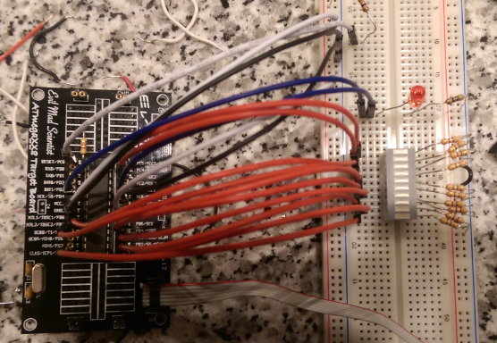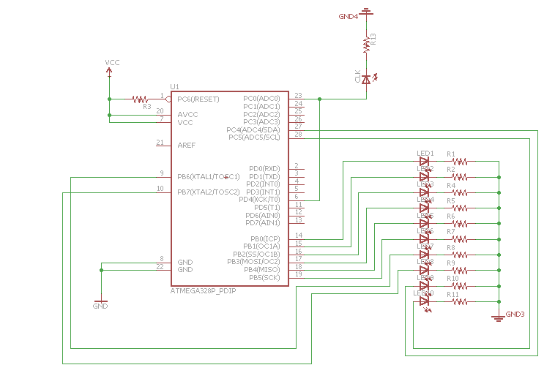

|  |  |  |  |
| --- | --- | --- | --- |
| 8. | SCREENSHOTS OF EACH TASK OUTPUT |  |  |

TASK 1/A:

Verify duty cycle and period: 50% duty cycle, period = 0.5 second

C code

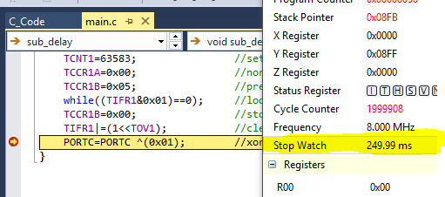

ASM code

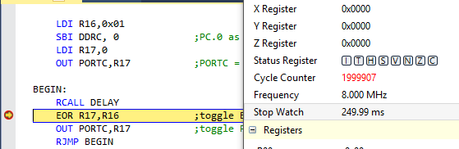

|  |  |  |  |
| --- | --- | --- | --- |
| 9. | SCREENSHOT OF EACH DEMO |  |  |

TASK 1/A: LED blinks every 5 seconds (duty cycle of 50%)

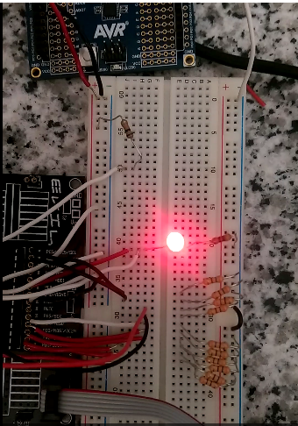

The LED blinks and shows the clock pulses (period 5 seconds)

TASK 2/B: LED blinks every 5 seconds (duty cycle of 50%) and counter counts on rising edge of clock

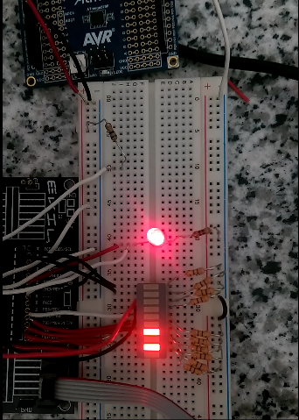

The clock output was also wired to T0 to clock the counter to counter on the rising edge of the clock generated.

TASK 3/C: LED blinks every 5 seconds (duty cycle of 50%) and counter counts on rising edge of clock with toggling of the 9th and 10th bit on every 5 and 10 rising clock pulses, respectively.

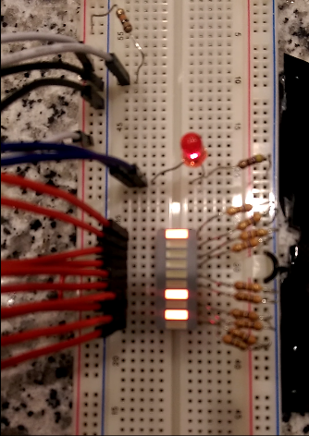 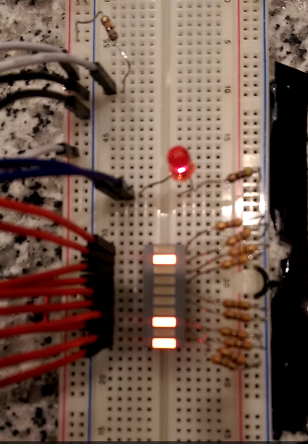

TASK 4/D: LED blinks every 5 seconds (duty cycle of 50%) and counter counts on rising edge of clock with toggling of the 9th and 10th bit on every 5 and 10 rising clock pulses, respectively.

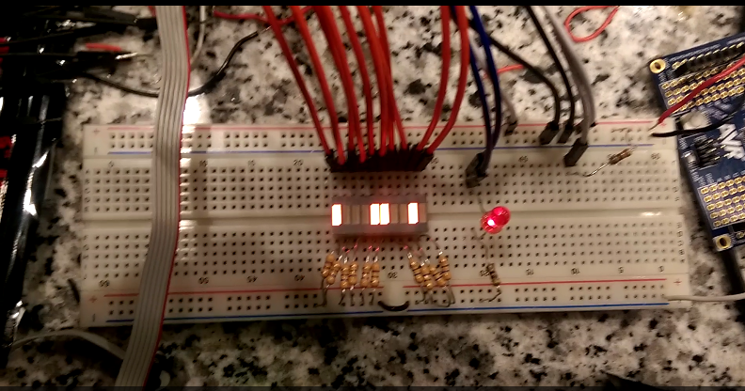

|  |  |  |  |
| --- | --- | --- | --- |
| 10. | VIDEO LINKS OF EACH DEMO |  |  |
| https://www.youtube.com/channel/UCpl-lLLVfaKxzVCt4e2VNoQ | | | |
| 11. | GOOGLECODE LINK OF THE DA |  |  |
| https://github.com/nhand2/CPE301S16 | | | |

**Student Academic Misconduct Policy**

<http://studentconduct.unlv.edu/misconduct/policy.html>

“This assignment submission is my own, original work”.

Derek Nhan