**Home Automation: Final Project**

**Derek Nhan**

**CPE 403**

**Fall 2016**

**Project Goals**

**Main Goal**: The main goal of this project is to create a home automation application using embedded Linux on the Beagle Bone Black board.

**Sub-Goals**

* Implement sensors with the Beagle bone to upload data to a cloud service
* Implementation of TSL2591 Lux sensor to detect changes in luminosity and store the data on a cloud service
* Use the TSL2591 to determine whether to turn on a light
* Implement an IR sensor to detect if a person is at the door
* Use the information to notify the user if there is a person at the door or if they have left

**Accomplishments**

* Implementation of the TSL2591 Lux sensor to detect changes in luminosity and turn on and off an LED based on the data
* Read IR data to determine if a person is within the proximity of the object the IR sensor is mounted on
* Send email notifications to the user during major events (lights on, person at door, etc.)
* Send the data to a cloud service to be plot

**Components**

**TSL2591** This sensor was communicated with by I2C communication. The sensor measures luminosity and send that data to the device reading from it. The TSL2591 was configured with medium gain and 100 ms integration time. The sensor contains two photodiodes that are read by analog to digital conversions. The values are integrated over a period and stored in ch0 and ch1 data buffers. The master can request data to be read from these two channels by calling their data register (0x14/0x15 and 0x16/0x17). Both channels contain two registers that holds the high and low bytes since each register is two bytes.

**Sharp IR sensor**  
 The Sharp IR sensor is interfaced through analog to digital conversion. The ground pin on the sensor is wired to the ADC ground pin on the Beagle bone. The voltage in port is wired to the 3.3V line. Since the Beagle bone’s ADC pins can only handle a maximum voltage of 1.8V, a voltage divider was constructed with two 500 ohm resistors. This forced the output to less than or equal to 1.8V, this protecting the pins. The sensor can measure distances of 0.5 cm to 10 cm. Any object within this range will cause the voltage to drop to close to 0V. When an object is out of this range, the sensor will deliver 1.8V or close to it. These values are read in to the 12 bit ADCs of the Beagle bone and can determine in code.

**Beagle Bone Black Rev C** The Beagle Bone Black board is an embedded Linux board running on an ARM processor. The board acts as the brains of the application and interprets sensor data and sends that data to a cloud service. Since the board can run embedded Linux, the user can interface with sensor and check values before writing code. Each GPIO pin is referenced in a GPIO folder when it contains a variety of information about the state. These are called device overlays. A software called I2C-tools enable users to see the contents of the I2C devices with ease. Likewise, accessing ADC pins is just as simple. ADC values can be viewed through their own device overlays.

**Schematics**

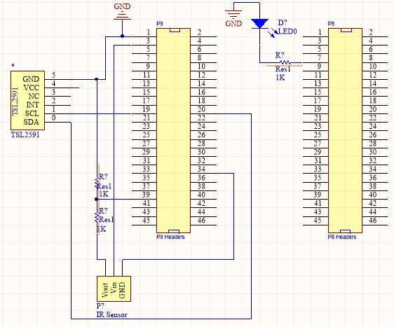

**Tools  
Eclipse**  
Eclipse was used to write code and add the executables to the Beagle Bone. Eclipse was interfaced by downloading a cross compiler and debugger for Windows. Make files were manually generated to allow us to determine the compiler options. Eclipse provided an environment where one can debug and execute code remotely to the Beagle bone.

**Ubuntu (Windows edition)**  
The bash for Windows running Ubuntu was used to secure shell in to the Beagle bone. Ubuntu gave the ability to explore files in the board and to run programs just as we would on a Linux system. This gave us the power to view GPIO values, I2C register data, and other sorts of GPIO information.

**Implementation Details** The TSL2591 lux sensor was interfaced with I2C communication through the Beagle Bone. The Beagle Bone’s pin 19 and 20 act as the SCLK and SDA pins, respectively. These were configured to read data from the TSL2591 and send clock signals. The Beagle bone also provided power to the entire application. The I2C data was viewed manually through the Beagle bone by use of i2c-tools. This application was used to view the contents of the register as well as the address of the device when on the line.

The IR sensor was implemented through one of the six ADCs on the Beagle Bone. The IR sensor was supplied a 3.3V input and output was passed through a voltage divider to drop the voltages to 1.8V, which is safe for the Beagle Bone. The ADC is a 12-bit register that holds the voltage of the sensor in bit form. The bits reverted by to a voltage by multiplying the ADC value by 1.8V and dividing by the maximum (12-bits or 4096).

The Beagle Bone could send data to ThingSpeak using socket communication/code. This code allowed the Beagle Bone to send data through code. E-mail was interfaced similarly. Ssmtp was installed on the Beagle Bone and ran when an E-mail was to be sent to the user.

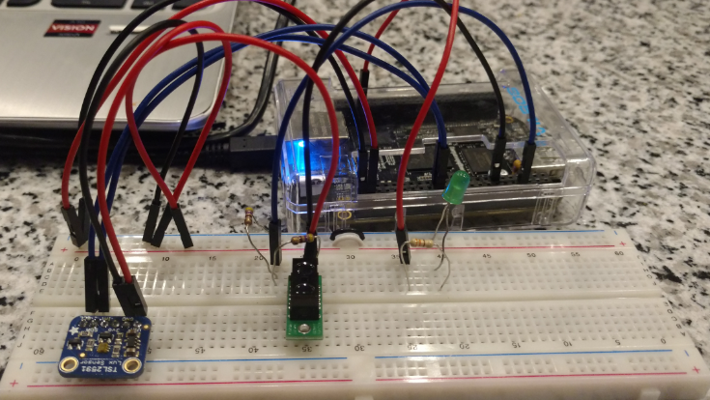

Figure 1: Connected circuit for the application

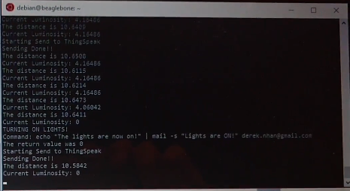

Figure 2: Terminal output displaying luminosity information and IR data; Email command shown to the terminal

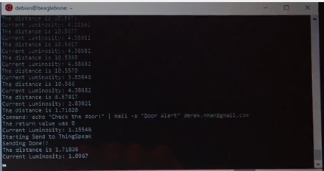

Figure 3: Terminal output displaying e-mail command for the door

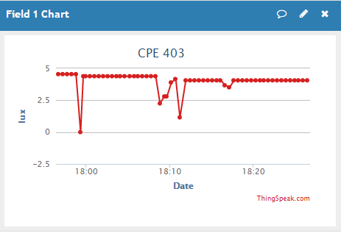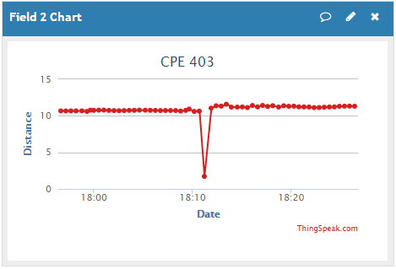

Figure 4: Thingspeak plots, notice the dips are significant events

**Demo:** [**https://youtu.be/bYZIfyEgFkI**](https://youtu.be/bYZIfyEgFkI)

**Results and Conclusions** The results of this application is a device that can detect when a person is within the proximity of the IR sensor and can turn on a light based on the data read from the lux sensor. The application of these sensors can be integrated to add increased convenience to a house hold as well as security. The lux sensor can be integrated with a relay that can turn on and off a house light through the light switch. The IR sensor adds security to a house by notifying a user when a person is at the door or window.

Using an IoT cloud service can help users view timestamps of when significant events occur. The events can range from when someone is at the door and when that person leaves. These events will also send e-mails to the user to notify when someone is at the door or left. The light data can be used to determine how long lights have been on and off in a household.

**References**

<http://tinyurl.com/unlvcpe403f16>

<http://derekmolloy.ie/beaglebone/>

**Github:** <https://github.com/nhand2/CPE403F16>