VIETNAM GENERAL CONFEDERATION OF LABOR  
**TON DUC THANG UNIVERSITY**  
**FACULTY OF INFORMATION TECHNOLOGY**

**ASSIGNMENT**

**INFORMATION SECURITY**

*Instructor* : **Ms. HUYNH NGOC TU**

*Executor* : **NGO DUC HUY – 522H0038**

**DANG THANH NHAN – 522H0006**

Group: **3**

Group in class: **5**

Course  **: 26**

**HO CHI MINH CITY, YEAR 2024**

VIETNAM GENERAL CONFEDERATION OF LABOR  
**TON DUC THANG UNIVERSITY**  
**FACULTY OF INFORMATION TECHNOLOGY**

**ASSIGNMENT**

**INFORMATION SECURITY**

*Instructor* : **Ms. HUYNH NGOC TU**

*Executor* : **NGO DUC HUY – 522H0038**

**DANG THANH NHAN – 522H0006**

Group: **3**

Group in class: **5**

Course  **: 26**

HO CHI MINH CITY, YEAR 2024

ACKNOWLEDGMENT

I would like to express my sincere thanks to you, Faculty of Information Technology of Ton Duc Thang University.

In the process of studying and practicing at school, I have received a lot of attention from the teacher. She is the one who has guided and inspired me to study and help me in the most dedicated way. I would like to thank you for imparting to me a lot of new and useful knowledge for my work in the future. I sincerely thank the teachers and especially Ms.Huynh Ngoc Tu, who directly guided me in the learning process of Information security since I have not been exposed too much to the way I write the Essay, I cannot blame there will be mistakes. If there are any mistakes, I hope to be commented by you so that I can correct and complete as best as possible for the next time.

Finally, I would like to send kind words to you for giving me the opportunity to work on my essay and improve my knowledge.

**THE ESSAY COMPLETED   
AT TON DUC THANG UNIVERSITY**

I hereby declare that this is our own research work, conducted under the scientific supervision of Ms.Huynh Ngoc Tu. The research contents and results in this topic are truthful and have not been previously published in any form. The data presented in tables and figures, serving for analysis, comments, and evaluations, are collected by the author from various sources, clearly referenced in the reference section.

Furthermore, the project also incorporates some comments, evaluations, as well as data from other authors, and different organizations, all of which are appropriately cited and referenced.

**If any misconduct is discovered, I take full responsibility for the content of my project.** Ton Duc Thang University is not liable for any copyright infringements or violations caused by me during the implementation process (if any).

*Ho Chi Minh City, 14 May 2024.*

*Author*

*(*Signature and full name*)*

*Ngo Duc Huy*

*Dang Thanh Nhan*

**Instructor endorsement**

_______________________________________________________________________________________________________________________________________________________________________________________________________________________________________________________________________________________________________________________________________________________________________________________________________________

Ho Chi Minh City, day month year

(Signature and full name)

**Teacher evaluation**

_______________________________________________________________________________________________________________________________________________________________________________________________________________________________________________________________________________________________________________________________________________________________________________________________________________

Ho Chi Minh City, day month year

(Signature and full name)

Summary

The exercise is about the OpenMRS model and is performed on an online website or the application can be downloaded and performed directly on a personal computer. The exercise talks about the topic of managing information about a hospital with ways to install roles and tells us about important things in the OpenMRS model.

**TABLE OF CONTENTS**

ACKNOWLEDGMENT 3

Summary 6

1. Exercise 1. Study different privileges in OpenMRS Demo and list four of them that seems most important to you. 8

**1.** **View Patients** 9

**2.** **Edit Patients** 10

**3.** **Manage Appointments** 11

**4.** **Delete Patients** 12

2. Exercise 2. Study different roles in OpenMRS Demo and name four main roles that have maximum set of privileges. 13

**1.** **System Developer** 14

**2.** **Provider** 15

**3.** **Organizational System Administrator** 16

**4.** **Anonymous and Authenticated** 17

3. Exercise 3. Define the above mentioned roles and users in OpenMRS and attach the screenshot. 18

4. Exercise 4. Reporting your hierarchy. 21

5. Exercise 5. Define your role hierarchy in OpenMRS. 23

6. Challenges and Solutions. 24

REFERENCES 26

1. Exercise 1. Study different privileges in OpenMRS Demo and list four of them that seems most important to you.

* There are several privileges in OpenMRS Demo such as: View patients, Edit patients, Add patients, enter forms, Create batch identification,...
* But I think the four most important functions are: View patients, Edit patients, Add patients.
* Below is manage interface of OpenMRS.

* 1. **View Patients**

**View Patients:**

Allows users to access and view detailed information about patients in the OpenMRS system. This permission is typically granted to medical staff, administrators, or other individuals who have a role in tracking and managing patient records.

**Main function:**

Access patient list, view detailed patient records, search and filter patients, ensure security and privacy, user-friendly interface.

**Benefit:**

Improve work efficiency, medical decision support, improve quality of care, This function helps manage medical records effectively and securely.

* 1. **Edit Patients**

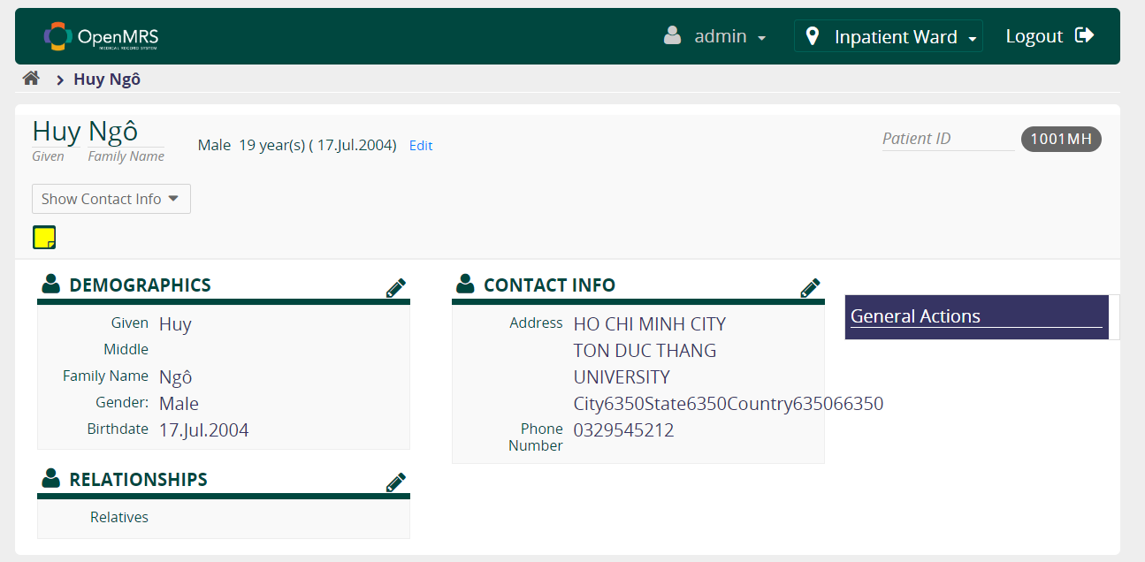

**Edit Patients:**

The “Edit Patient” function allows users to manage patient information easily and effectively. Below is a detailed description of this function:

Allows users to edit patient personal information, including name, age, gender, address, phone number and email.

Update patient medical information such as relationships.

* 1. **Manage Appointments**

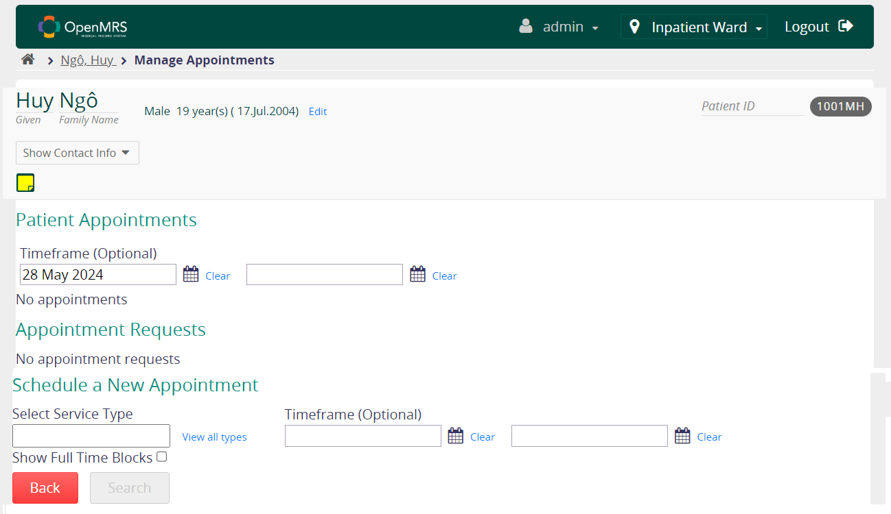

**Manage Appointments:** The "Appointment Management" function in the patient management system is described as follows:

**Display patient appointment information:**

Time Frame (Optional): Allows users to select a specific time period to view patient appointments.

Appointment list: Displays a list of patient appointments within the selected time period. If there are no appointments scheduled, the system will notify "No appointments available".

**Manage appointment requests:**

Appointment requests: Displays a list of appointment requests from patients. If there are no requests, the system will say "No appointment requests".

**Schedule a new appointment:**

Select Service Type: Users can select the type of service they want to schedule (for example: medical examination, health check, test,...). This field can be a list or a data entry box with a "See all types" option to see all available service types.

Time frame (Optional): User can select the desired time period for the new appointment.

Show full time blocks: A toggleable option to show full time blocks used for appointments.

* 1. **Delete Patients**

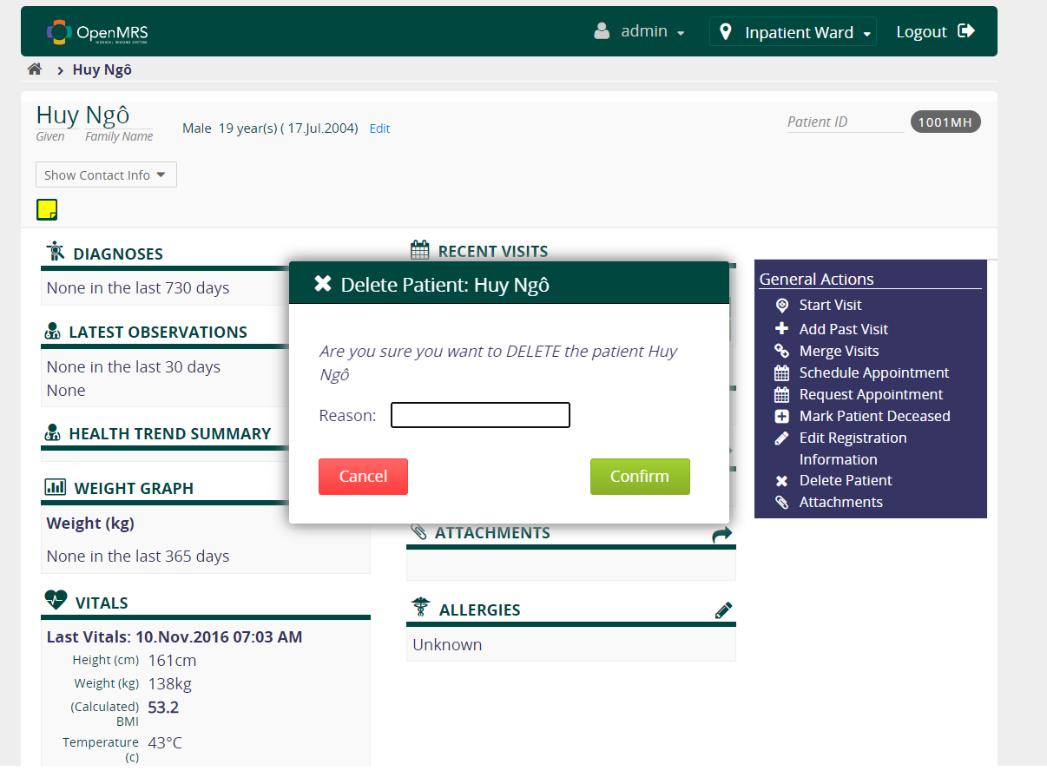

**Delete Patient:**

**Patient identification:**

Users need to find and select a specific patient from a patient list or use the search feature to identify patient records that need to be deleted.

**Warning and confirmation:**

When the user clicks the "Delete Patient" button, the system will display a warning message to enter the reason for deletion.

1. Exercise 2. Study different roles in OpenMRS Demo and name four main roles that have maximum set of privileges.

* There are several privileges in OpenMRS Demo such as: Application, Anonymous and Authenticated, Organizational, Doctor, System Developer, Provider,…
* But I think 4 people have maximum privileges is: System Developer And Provider, Organizational System Administrator, Anonymous and Authenticated.
* Below is manage role interface of OpenMRS.

* 1. **System Developer**

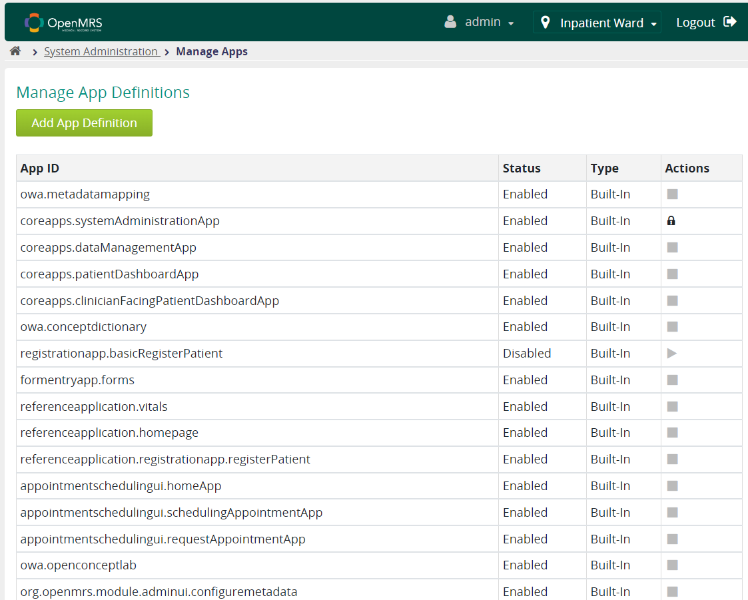

**System Developer**:

OpenMRS system developers have the right to access and change the database structure. This includes adding, modifying, or deleting table data, data fields, and relationships in the database. Developers have the ability to change the core components of the system, improve performance and features, or customize the system to fit the unique requirements of each medical facility.

* 1. A screenshot of a computer

     Description automatically generated**Provider**

Define User Roles: Make sure you have clearly defined the 'Supplier' role in your system. This may involve setting up user groups or assigning specific permissions to users.

Integrate with a User Management System: If your system has a user management system or directory service (such as Active Directory), integrate InfoPath with it to be able to retrieve user information, including their roles.

Customize the InfoPath Form: In your InfoPath form, you need to add a control (like a drop-down list or select people) where the user is with the 'Supplier' role.

* 1. **Organizational System Administrator**

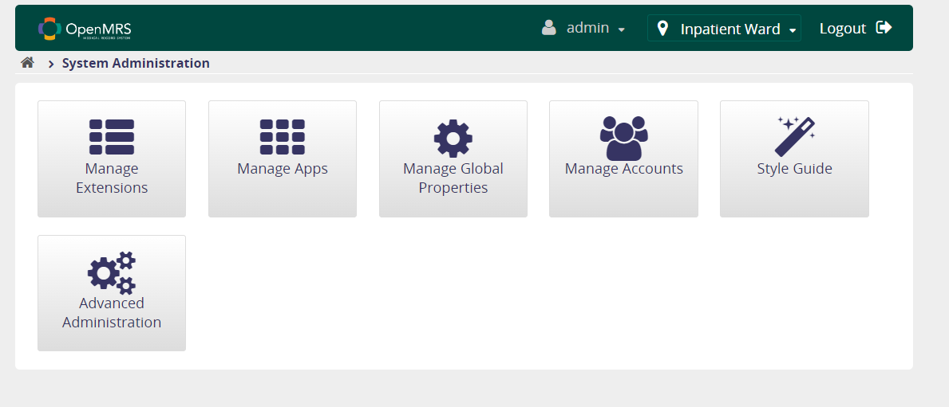

**Organizational System Administrator**:

The dashboard displays important information and statistics related to the system, such as access, recent activity, notifications, and key numbers.

* 1. **Anonymous and Authenticated**

**Anonymous and Authenticated:**

Privileges are achieved after authentication has been established

Determine the main role of system users, add users Ngo Duc Huy assigns each user to the appropriate role.

After successfully adding user Ngo Duc Huy, we will be able to search for Huy account in the system with the password account and roles that have been installed for this user.

1. Exercise 3. Define the above mentioned roles and users in OpenMRS and attach the screenshot.

* 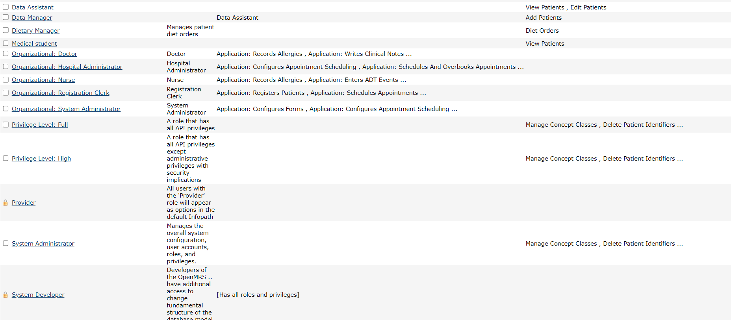In the role management page, the system has many available roles and admins can install these roles with their own custom requirements, create users with password accounts and roles as desired. of the admin himself. For example, the role: Data Manager, Data Assistant will have the functions: View Patients, Edit Patients, Add Patients.
* Inside these roles we can add many functions to the role. For example, if we have a loyal customer role instead of having the rights of a normal customer, we can add functions such as incentives. It is an inheritance relationship.
* The image above shows the roles and functions of each role. With Inherited Roles levels and accompanied by Description.
* For example, if a user account is created with the name Huy and the account is 522h0038, the admin can choose roles for this user according to the requirements and purpose of the account. Below will be an illustration of this example.
* A screenshot of a computer

  Description automatically generatedAfter choosing to agree to create an account, this user information will be updated to the database and displayed on the user management page.

* To see this issue more clearly, I will present it in detail. Here we will manage account on the admin page and we will see that the account has been updated.

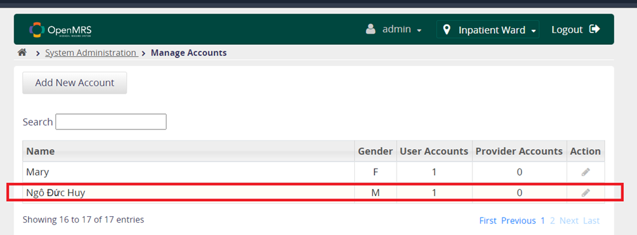

* We can click on the action to see details about this account's information with roles and personal information of this user.

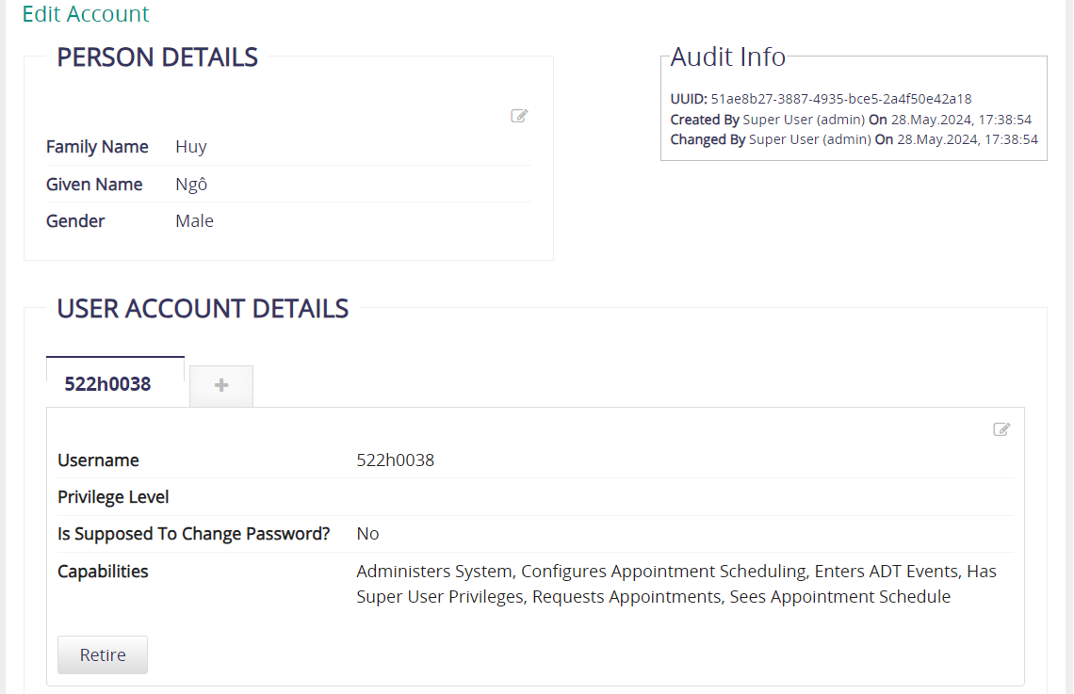

1. Exercise 4. Reporting your hierarchy.

* Order: Grants permission to change type order to re-sort desired attributes.

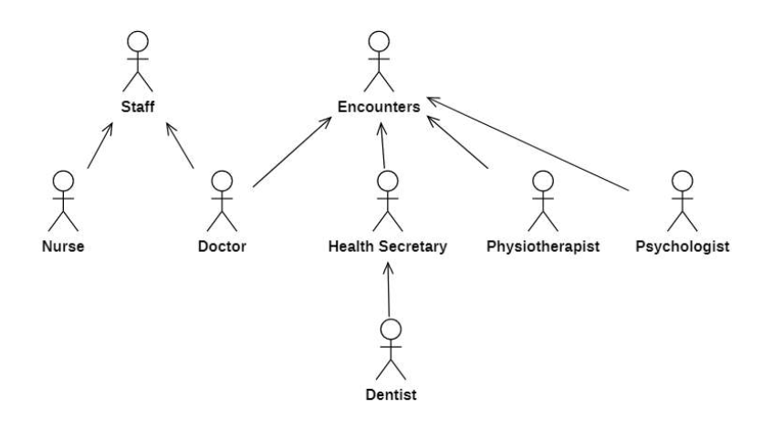

|  |  |  |
| --- | --- | --- |
| Role | Inherit | Privilege |
| Patients / Staff |  | Add/ Edit/ View Patients |
| Laboratory Orders  Staff |  | Add/ Edit/ View Laboratory Orders  Add/ Edit/ View Patients |
| Diet Orders |  | Add/ Edit/ View Diet Orders |
| Encounters |  | Add/ Edit/ View Encounters |
| Users |  | Add / Edit / View Users  Add / Edit User Passwords |
| Nurse | Laboratory Orders; Patients; Staff | Add / Edit / View Patients  Add / Edit / View Laboratory Orders  Add / Edit / View Observations  Add / Edit / View Reports |
| Doctor | Laboratory Orders; Patients; Encounters; Staff | Add / Edit / View Visits  Add / Edit / View Patients  Add / Edit / View Laboratory Orders  Add / Edit / View Encounters |
| Health Secretary | Encounters | Add / Edit / View Observations  Add / Edit / View Reports  Add / Edit / View Encounters |
| Physiotherapist | Encounters | Add / Edit / View Physiotherapy Orders  Add / Edit / View Encounters |
| Psychologist | Encounters | Add / Edit / View Encounters  Add / Edit / View Psychology Orders |
| Radiologist | Laboratory Orders | Add / Edit / View Radiology Orders  Add / Edit / View Laboratory Orders |
| Dentist | Encounters; Diet Orders | Add / Edit / View Encounters  Add / Edit / View Diet Orders |
| Ambulance Personnel |  | View Patients, Add Reports |
| System Administrator | Users | Add/ Edit/ View (Role, Users, Password) |
| Registration Clerk | Users | Add/ Edit/ View (Users, Patients, Appointments) |

1. Exercise 5. Define your role hierarchy in OpenMRS.

* 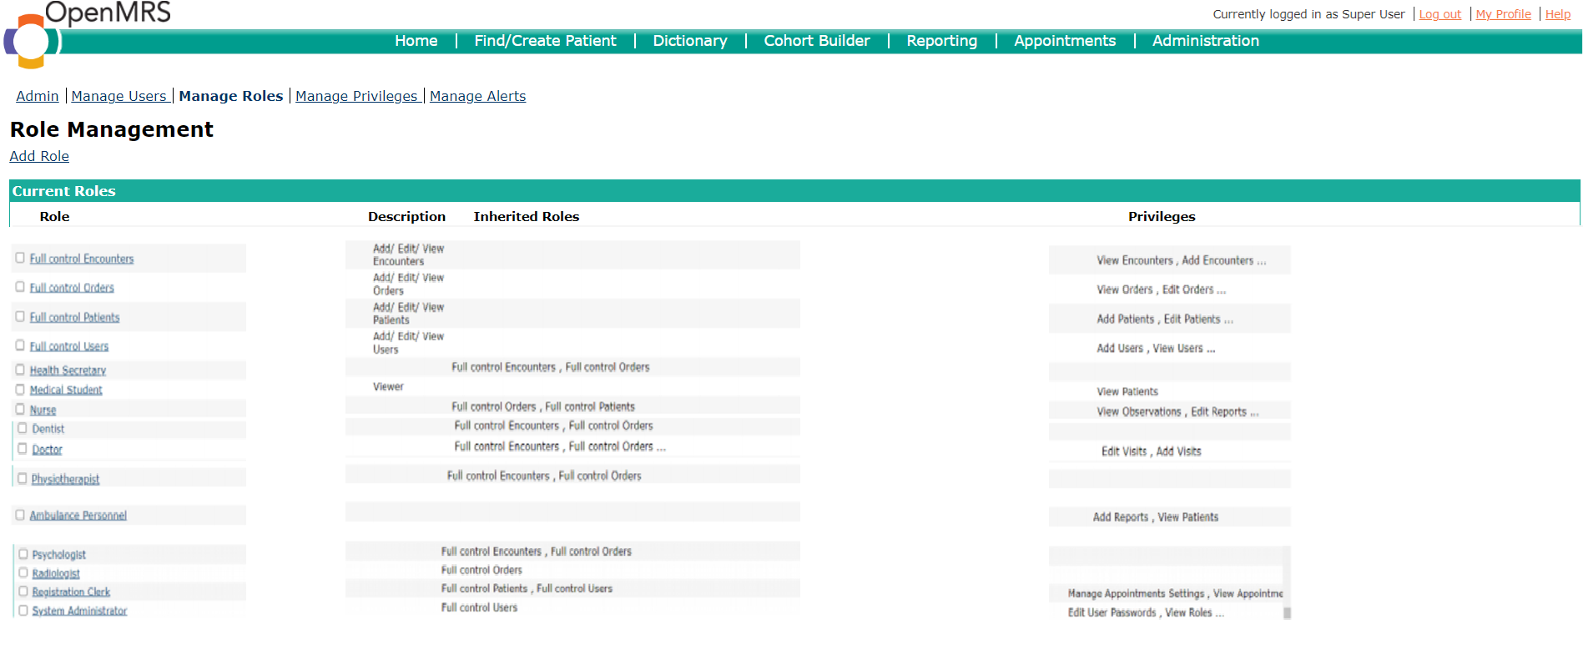Above are the existing and valid roles in exercise 4.
* We can go to Manage Roles inside the admin page to create a role or edit the role's function. Below is an illustration of creating a role.

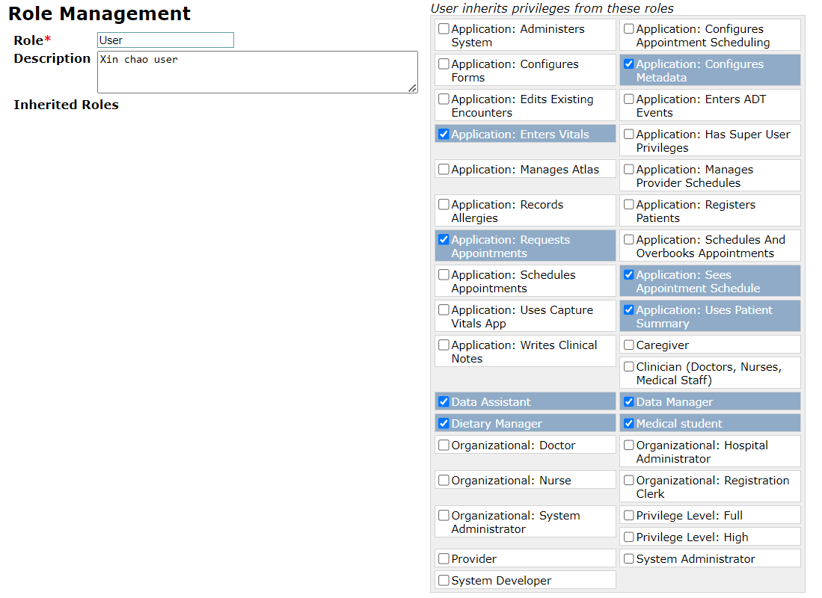

1. Challenges and Solutions.
2. What are the challenges you encounter while working with access control model in OpenMRS?

* For yourself:
  + We felt this OpenMRS model exercise was quite difficult and took a lot of time to learn about it. We spent a lot of time on this OpenMRS model and what I got back was a better experience and understanding of Information security. Although the exercise was quite difficult and time-consuming, I think we tried our best. complete it as best we can.
  + With references to English making it difficult for us to reach the table. Although the exercises are mostly about theory and introducing the OpenMRS model. We sincerely thank Ms. Huynh Ngoc Tu for giving us exercises like this, allowing us to develop thinking skills.
  + Even though we only did it on an existing website, it gave me a lot of knowledge to practice with this exercise.
  + Finally, installing the application encountered many difficulties, including the fact that I had to do this exercise on an existing website because I could not install the application. I think up to 40% of people cannot install the app and do the exercises.
* For OpenMRS model:
  + OpenMRS can be divided into many different permissions and roles. Defining and managing these permissions properly can be complex, especially as the system expands and has many users with different roles. different roles. We are implementing on an existing hospital model, we think it is quite a complex model that requires thoroughness in the working process and a reasonable division of functions of each role.
  + The ability to inherit permissions from one game role to another is sometimes difficult and difficult to control. The role and permission management interface in OpenMRS can be unfriendly and easy to use, especially for gamers. people new to the system.
  + It takes a lot of time to get used to and become proficient in using these management functions.

1. What are your suggestions for improving the access control model of OpenMRS?

* User interface improvements:
  + Optimized the role and permission management interface to make it easier to use and more intuitive.
  + Provides detailed and clear instructions for new users.
* Increased flexibility in rights management:
  + Allows users to customize permissions more flexibly according to their organization's specific needs.
  + Improved ability to create and manage custom permissions.
* Ensuring security and strict control:
  + Provide tools and mechanisms to check and ensure the accuracy of authorization.
  + Implement additional security measures to prevent unauthorized access.
* User training and support:
  + Provide training courses and detailed support documents for administrators and users.
  + Build a user community to share experiences and support each other.
* Improved synchronization system:
  + Ensure that permissions and role changes are efficiently stored and synchronized across the system.
  + Improved backup and restore mechanism to avoid data loss.

# REFERENCES

**English**

The OpenMRS Integration Catalog <[Here](https://openmrs.org/product/integration/)>

Access Control for HER <[Here](http://www.sis.pitt.edu/lersais/research/sahi/resources/labs/ehr/Lab_Access_Control_EHR.pdf)>

OpenMRS Academy: Introduction to the OpenMRS Data Model <Here>

Description and Hierarchy of the OpenMRS Database <[Here](https://medium.com/@aliahmedrohan/description-and-hierarchy-of-the-openmrs-database-e3db4ba7a2ea)>