**COSC25423: MOBILE APPLICATION DEVELOPMENT**

**ANDROID GAME PROPOSAL**

Group number: __________3____________ Game type: _Adventrure________________

1. Game Idea

|  |
| --- |
| We are going to make a game similar to the Swing Helicopter /Flappy Bird (<https://www.youtube.com/watch?v=wuoCeze0B3c>). The player controls the helicopter to avoid obstacles (e.g. flying rockets, cliffs, etc.) while flying through a long cave. |

Example: I am going to make a game similar to “Toki Tori” of iphone game, about the seawolf who hunt other sea animals, and you have to rescue them. The user guides the character to get energy and kill the sea wolves.

1. Game logic/rule (Must have AI – Artificial Intelligent)

|  |
| --- |
| The helicopter has a number of available lives (maybe 5 in total). Each time it hits an obstacle, a life or some points is lost. The game is over when there’s no more lives or points left. In order to gain points, it has to fly through the floating stars. To gain more lives, it must goes through the floating hearts in the middle of the air. The game does not have levels so it increases the difficulty by time.  During the journey, there will be some flying rockets that will detect the position of the plan and hit it. |

Example: Long has blood level. Each time he is attacked, based on the skills of the monsters, he will lose his blood. When his blood level equal 0, he will die. During the scene, there are many weapon items namely A, B and C that Long can pick up to empower his ability and the damage ability is increased too. The game has 4 levels.

1. Environment

|  |
| --- |
| There is only 1 scene in the game: the cave. |

Example: There are three different scenes: sunny day on the beach, bright and peaceful sea ground, and dark deeper village of sea. It will use the magical Ocean Blue colour. The combination of well-designed background (for the game spaces) and 2D models (characters and background objects) will bring very interesting results and a rich and colorful look & feel.

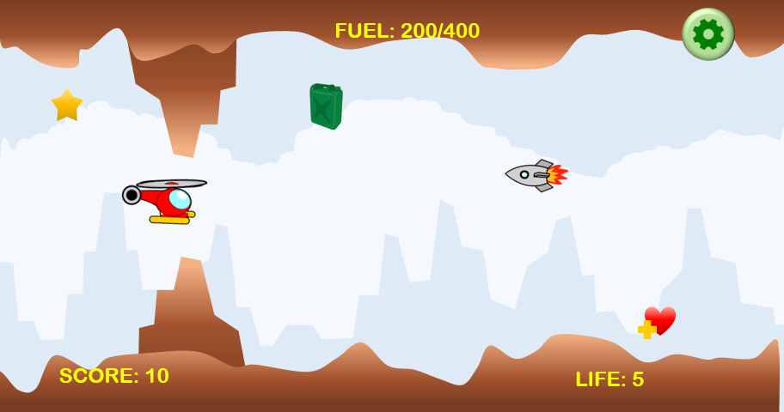

Background A

1. Characters

|  |
| --- |
| The main character in this game is the helicopter. It has to avoid the cave cliffs, floating rocks in the middle of the air, rockets that unexpectedly fly across the scene and stalactite that suddenly soaring from the cave. |

Example: Long is the main character. He is a Chinese dragon boy living in a palace under the sea. He encounters a lot of what he’d rather do without: dangerous creatures, deadly obstacles and treacherous traps! You can also build your own dream character’s look and play three stages as you take the role of Long – a dragon boy with a hero’s heart and adventure flowing through his veins to killing dark seawolves!

Seawolves are the dark power of sea world. They live in a kingdom of seawolf in the deeper sea. They often hunt other sea animals around dragon’s palace. They are ferocious and treacherous.

1. Graphic Design & Animation

|  |
| --- |
| The graphic is 2D. |

Example: My character Long will explore 3 stages, including getting energy near the palace in the sea, playing on the beach and fighting in the dark work (deeper sea).

Graphic design depends on the project 2’s game environment. It will be a graphical, abstract and colorful interface. The user only plays the side view, from middle (Palace in the sea) to top (on the beach) or bottom (deeper dark sea).

Player animation

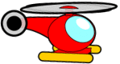

Obstacle animations

 





Other animations

  

1. Sound & Music

|  |
| --- |
| There will be background music and some effect sounds.  The effect sounds may use some environment sound like: the flying sound of the helicopter, the crashing sound when it hits an obstacle, etc. There will also be a sound effect for the Game Over scene.  There are 2 kinds background music: One for the menu and one for the game play. |

Example: The audio comes to voices and character acting. It gives the game its sense of emotion. It includes the beginning of game and simple sound effects. The whole sound source consists of three elements:

1. Background sound

2. Emotional sound (Character or other objects’ movement).

The background sound uses space and environment sound. It will make some slow attacks and short decay through a long sustain level, and fade in and out smoothly. It creates a deep, light and fancy underwater space. The first Level (palace in the sea) will use the fast attack and soft harmonics sounds to create a warm, bright and fancy world. Rhythm is a key point in this stage. The second level (on the beach) will create some natural sounds, such as birds singing, water dropping and wind echo. It will reflect a relaxing, peaceful and happy environment. The third Level (dark world) will require fast attacks and good player timing.

Emotion sound depends on the movements of character or their acting.

1. Control & User interface

|  |
| --- |
| The helicopter will always be pushed down by gravity so in order for it to move up, tap the screen. A tap makes it fly up for a very short distance. To keep it going up, the player has to tap the screen continuously. |

Example: Control is the way of describing the act of using the game. It is looking and how the player causes the character to move and fight. My game is controlled by soft navigation buttons, the character will move when touching soft navigation buttons. Another finger touch controls some high level actions, such as jumping, running and fighting.

*PS: This proposal includes 2 copies: 1 for student, 1 for lecturer*

Student Signatures Lecturer Signature